**How to Use Arbiter**

**Introduction**

Arbiter is a mobile app that lets you build a map to use for situational awareness and geospatial data collection. Once you download your maps and map layers, Arbiter lets you use them offline (no network or wifi connection). When you have connectivity through either 3G or 4G cellular network, or wifi, you can sync your map layers with the server and you’ll receive updates made by others as well.

Arbiter has been developed for Android smart phones and tablets, and has been tested on devices running Android version 4.1 and higher. The application is open source and has been developed by LMN Solutions. You can find it here on GitHub: <https://github.com/ROGUE-JCTD/Arbiter-Android>

**What Can I do With Arbiter?**

With Arbiter you can download maps and map layers to use offline. You can edit the content of the map layers and you can associate photos to the elements in those map layers. Arbiter lets you:

* Create different projects
* Download map tiles from **©** OpenStreetMap to work offline
* Download data from map layers
* Add points, lines, and polygon elements to map layers
* Edit the geometry for map elements
* Edit attributes for point, line, and polygon elements for map layers
* Take a photo and associate it with elements in the map layers
* Use the GPS from your device to find your location on the map
* Send your edits to the server when you have connection (cell or wifi)
* Receive edits from others when you synchronize (cell or wifi)

**Getting Started - Install Arbiter**

# First download the Arbiter.apk file to your device from the GitHub link above.

# Find the Arbiter.apk file in the file manager app on your device.

# Click on the apk icon to install Arbiter.

# You may be prompted to allow installation of apps from outside the Google Play Store. If so, allow permission to complete the installation.

# When the installation is completed, Arbiter will appear as an icon on your device’s home screen or apps window as shown here: .

**Arbiter Layout**

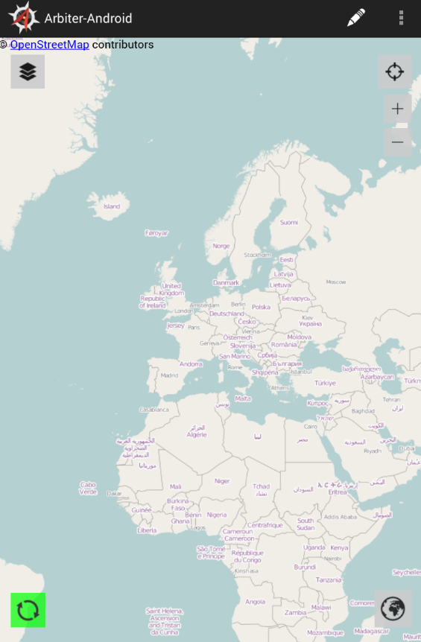When you first launch Arbiter, the system opens the application to a map image. If this is the first run of Arbiter, the map image will be an **©** OpenStreetMap image of the world. After you have prepared a “Project” Arbiter opens with the last project settings and the map area last worked.

*Figure 1* shows the initial layout. Below are the key components of this layout, which we will go into more detail:

* Map area
* Pencil or Add icon, used when placing an element on the map
* Settings icon, used for changing some project settings.
* Layers icon, used for manipulating map layers
* Find Me icon, used for centering the map area to the GPS coordinates of the device
* Plus and Minus icons, used for zoom-in and zoom-out display controls
* Sync icon, used for syncing your data to and from the server
* Globe icon, used for re-positioning the map display to the defined Area of Interest (AOI)

Figure 1

**Project Setup**

A Project is a collection of setup parameters that are stored and saved and made available for subsequent field operations.

***Create a New Project***

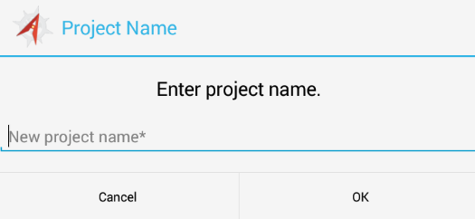To create a new project, select the **Layers**  icon located at the top left corner.

The Arbiter Project setup page appears as shown in *Figure 2*.

Touch on “**New project name*”** and enter a nickname for your project with the popup keyboard. Tap the **OK** button when finished. Your project name is set.

Figure 2

We recommend that you use a short, unique name for your project that will make it simple for you and other users to know what it is used for.

After selecting the **OK** button, Arbiter takes you to the **Add Layers** panel. From here, you select the server then the layers you will be working with out in the field.

***Identify the Server holding the Layers for Editing***

From the Add Layers panel, select the **Add (+)** button to the right of the Server text. This opens the Add Server panel. From here you identify the server where the data layers reside.

(Note: you can select layers from different servers. Not all editable layers have to reside on the same server.)

***Connect to a Server***

The Add Server panel is shown in *Figure 3*. Fill in the information about the location and login information for accessing that server. If you do not have this information, your system administrator should be able to provide it.

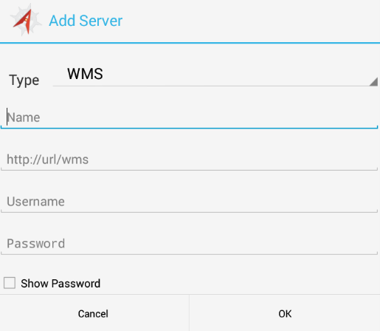At the top of the panel is the “Type” field. The default option is **WMS**, which will be the case for most all users. Some users may have tile data already cached and will want to use these. In these situations, touch the small down arrow to the right and select **TMS**. (Note: The URL data path varies if you use the TMS option.)

In the **Name** text box, enter a nickname for this server as a way of identification. Make it unique and simple for you or other users to know which server you are referring to. This is helpful if you are accessing more than one server for your data.

Next, enter the URL for this server. Be sure to include the “**/geoserver/wms**” portion at the end of the URL.

Finally, enter the login account name and password for accessing this server.

Figure 3

(Note: depending on the permission settings of your server, some layers may not be editable or even viewable by all users. If you do not provide the username or password, you will be logged in as “anonymous” and will have access to only public layers on the server.)

Tap the **OK** button when you have the information filled out. Arbiter then opens the Add Layers panel listing the data layers that reside on that server.

***Select the Editable Layers***

From the Add Layers panel, select one or more layers to add to your project. A checkmark appears beside your selection(s).

Select your layers from the list then touch the **OK** button. Arbiter returns to the Layers panel with your selections, as shown in *Figure 4*. This is a confirmation page. Note that the server nickname appears beneath the layer name.

Select the **OK** button from here to continue with your project setup.

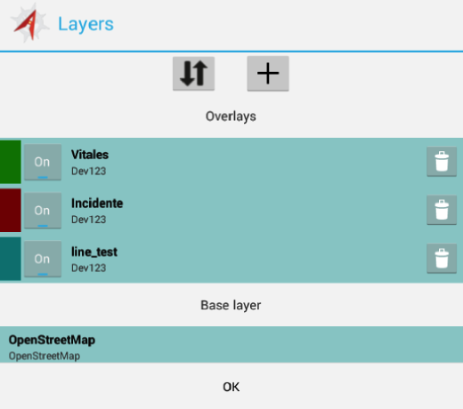If you need to add layers from a different server, select the **Layers** icon again. When the Add Layers panel opens select the **Add (+)** button.

Enter the server information for this different server in the Add Server panel. Once you complete the server information you can then select the additional layer(s) for editing.

If you use an additional server, be sure that your server name is listed in the Server text line. If there are more than one server options, and you don’t see your server name listed, click the small triangle icon to the left of the **Add (+)** sign as shown in *Figure 5*. This pulls down a list of available servers.

Select the server you want from the list and Arbiter automatically opens the layers available to you from that server.

Figure 4

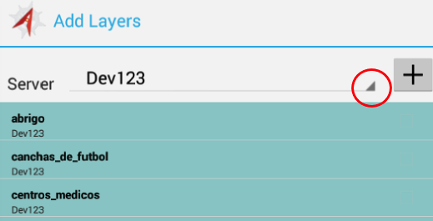Arbiter can work with data layers that are point, line, and polygon elements. Arbiter can also work with multiple-geometry type layers, which are layers that incorporate more than one element for an individual feature. All element types can be added, moved, and deleted in Arbiter. You can also update their attribute values.

If a layer has been set up with a “photos” or “fotos” attribute field, you can associate photographs to an element.

Figure 5

***The Base Map Layer***

One of the layers on your selection list is the **©** OpenStreetMap layer. This is your background map. For now, we recommend that you keep this layer with your map display. It contains key map information that will help identify your location. This background layer is treated as one layer and cannot be edited in any way.

***Select Area of Interest***

Once you select your server and layers, Arbiter prompts you to Choose AOI. This is the map area you will be working from while out in the field.

Use the pan and zoom capabilities to position your desired map area to the screen. To zoom-in, spread apart your thumb and forefinger on the screen, to zoom-out squeeze them together. You may also use the **Zoom-in**  and the **Zoom-out**  icons on the screen. To pan about, touch and drag your finger across the screen in the direction you wish to pan.

Once you set the map image to the area you will be working in, touch the **OK** button. Arbiter then displays a message showing you the number of tiles that will be downloaded to the device. We recommend that the number of tiles be under 300. If the tiles number is too high, cancel the download and re-set your AOI.

Select **Update** if you are satisfied with the AOI. Arbiter loads (or syncs) your data layers and background map panels to the device.

The Syncing panel shows the percent complete for loading your data. When it reaches 100%, your map image resets to the AOI you defined. If there are existing elements in the layers you selected, and these elements are within your AOI, they will be shown on the screen. A red box outlines the AOI extent.

(Note: Map tile download times vary depending on the size of your AOI and the number of tiles.)

**Working Offline**

One important thing to consider is your device’s connectivity while out in the field. Will you remain connected to the data server(s) that you downloaded the map layers from or will you be in a disconnected state?

Arbiter allows you to edit data freely in a disconnected state, but you will need to re-connect to your data server (via cell, wifi, or direct) in order to push your fieldwork back to the server.

**Doing Fieldwork**

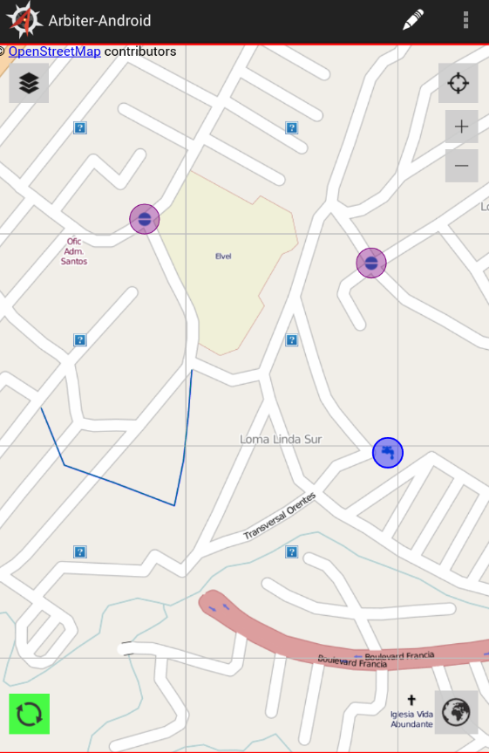The layers you selected for editing are shown as elements on the base map in the different colors, as shown in *Figure 6*. Point elements show a symbol style inside each circle when in a connected state. If you were in a disconnected state, the colored circles would be shown without the symbol style inside.

**Add a Point**

To add a point element, select the **Add**  icon in the upper right margin. The Select Layer panel opens with a list of your active layers.

Touch the point layer name you wish to add the element to and the Select Layer panel disappears.

To place an element, touch the map where you want to add the element. The element’s attribute panel then appears. Touch inside a text box and type the information using the popup keyboard. Next, select the **Save** button. If you want to abort the entry, select the **Cancel** button.

When saved, the Feature Saved panel appears. Click **Return to Map** to add the element and return to your map display. Select **Review Feature** to go back to the attribute panel. Use this option if you want to make modifications to the attribute fields or if you prefer to not enter the element.

Figure 6

If you go back to your attribute panel, select **Edit** to make changes to the attribute values. Select **Back** to return to your map with the element added to the layer. Select **Delete** to remove the element. A panel appears asking you to confirm (or cancel) the delete operation.

Repeat these steps to add more elements to your map.

**Add a Line**

To add line elements, select the **Add** icon then the layer that has been defined as a line type. Touch on the map where the line segment begins then touch the location of each line vertex on your map. When the line segment is complete, select the **Done** button at the top of the screen. As before, the attribute panel appears. Fill in the attribute information and select **Save**. From the confirmation panel, select **Return to Map** or **Review Feature** as described above.

**Add a Polygon**

To add polygon elements, select the **Add** icon then the layer that has been defined as a polygon type. Touch the map at the locations for a vertex. Continue to touch the location of the other vertices. After the last vertex, select the **Done** button. The attribute panel appears. Fill in the information and select **Save**. From the confirmation panel, select **Return to Map** or **Review Feature** as described above.

**Add a Photo**

If a layer has an attribute field named: “photos” or “fotos” you can store photographs to that element. After placing an element on a map, add the photo by selecting the **Camera** icon  at the bottom of the attribute table. This icon only appears if you have the “photos” or “”fotos” attribute field defined.

Touch the icon to activate the camera of the device. Point and snap the photograph using the device’s built-in camera. Then three icons appear at the bottom of the screen. Use the “**checkmark**” icon to accept and save the picture. The “**X**” icon cancels the picture and returns to the attribute table. The “**rotate**” icon removes the picture but returns to the active camera mode so that a new picture can be taken. Some devices may have **Save** or **Cancel** options instead. When you accept a photograph, Arbiter links the image to the feature. It is shown as a thumbnail when the attribute table is open.

You may store multiple pictures with a single element. Select the **Camera** icon again and repeat the steps to snap and accept the additional picture. When you finish entering photographs, select the **Save** button from the attribute table then **Return to Map** or **Review Feature** as described above.

**Move a Point**

To move a point element to a new geographic location, double-touch the element and the attribute table appears on the screen. Select the **Edit** button at the top then select the **Map** button. Arbiter returns to the map image and the element you selected is highlighted a blue color. Touch and drag the feature to the new location then select the **Done** button at the top of the screen. You can abort or reject the move by selecting **Cancel**. After selecting **Done** to approve the move, Arbiter returns to the attribute table. Modify the attributes, if necessary then select the **Save** button. The Feature Saved panel appears where you can **Return to Map** or **Review Feature** as described above. Arbiter returns to the map image and your feature is now moved to the new location.

(Note: You may see the colored dot and the symbol in two locations after a move operation – the dot at the new location and the symbol at the old location. This will be the case until you do the **Sync** operation. Once you perform the **Sync**, the symbol is redrawn inside the colored circle.)

**Move a Line or Polygon Segment**

To move a line (or polygon) segment, double-touch the element you wish to edit. The attribute table appears. Select the **Edit** button then the **Map** button. You are taken back to the map. Touch the element segment a second time to activate the edit operation.

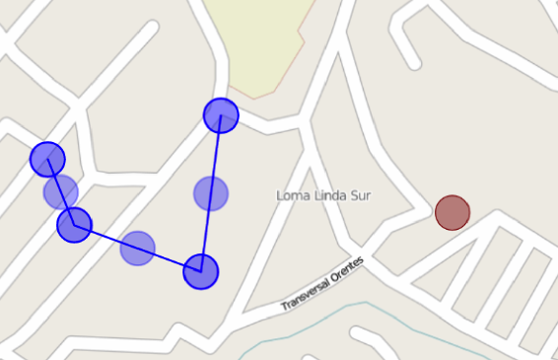When activated, blue dots appear at each vertex with lighter blue dot between each vertex, as shown in *Figure 7*. Touch any one of these blue dots and slide it to the new location. If you select one of the light blue dots, you can slide it along the line and extend it away to create new vertices.

When you are finished with the edits, select the **Done** button. As before, you are taken back to the attribute table. Select **Save** to keep the changes or **Cancel** to abort. When you select **Save**, the Feature Saved panel appears where you can **Return to Map** or **Review Feature** as described above. Arbiter returns to the map image and your line segments are now moved to the new location.

Figure 7

**Modify an Element**

To modify the information associated with an element, double-touch the element you want to modify and the attribute table appears. Select the **Edit** button then touch the text box beside the attribute field you wish to modify. The popup keyboard appears. Type the new information in each text box you wish to modify. Touch the **Save** button when finished. The confirmation panel appears. Select **Return to Map** or **Review Feature** as described above.

**Delete an Element**

To delete an element, double-touch the element and the attribute table appears. Select the **Delete** button at the top of the display and the confirmation panel appears. Select the **Delete** button to remove the feature or select **Cancel** to abort the delete process. If you select **Delete** at the prompt, Arbiter returns to the map display and the feature is removed. If you select **Cancel**, Arbiter returns to the attribute table. Select the **Back** button to get back to your map display.

(Note: When you delete a feature, it is removed from the device but not from the server. You will need to be in a connected state then run the **Sync** operation to completely remove an element.)

Currently, Arbiter deletes the entire line string or polygon but not individual vertices or segments. To delete a line or polygon, use the same operational steps as described above.

**Zoom to AOI**

When working in the field, you will often need to zoom and pan about your work area to get a more accurate location for your elements. To reset your map display back to the full extent of the AOI, select the **Zoom to AOI** icon  in the lower right corner. Arbiter then resets the map image to the original AOI extent.

**Find GPS Location**

Arbiter provides a tool for locating your current position using the GPS receiver built into the device. To activate the GPS locator, select the **Find Me** icon  in the upper right corner. Arbiter places a small dot at your location and centers your map display at the dot. A blue dot indicates that your device is using GPS and wifi. This implies higher accuracy. A yellow dot indicates that it is using wifi only, which implies lower accuracy.

**Sync Your Edits with the Data Server**

Data edits done in the field are stored on your device until a “sync” operation is done. A sync operation uploads your data changes back to the server. It also retrieves the latest updates of your layers from the data server. Other users may be doing edits to the same layers within your AOI from a different device. Once they upload or sync their changes, you will be able to retrieve those updates by your sync operation.

The **Sync**  icon is located in the lower left corner. Make sure that the icon is green and not red. This indicates that you are in a connected state to your data server. Touch the **Sync** icon and the Syncing message panel appears. This panel tells you how many features it has uploaded and downloaded. When the sync operation is complete, the panel disappears.

**Feature Update Notification**

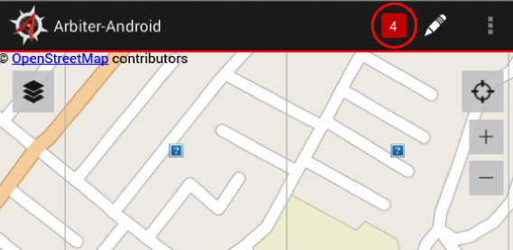Arbiter provides a notification tool to let you know that changes have been made to the active layer(s). When you make updates to any active layer by adding, moving, modifying, or deleting an element, Arbiter keeps track of each of these actions. This includes updates made by other users from different devices done to the same layer(s).

Whey you sync your changes, Arbiter opens the **Notification** icon in the upper right corner, as shown in *Figure 8*. The integer inside is the number of changes that have been made.

Figure 8

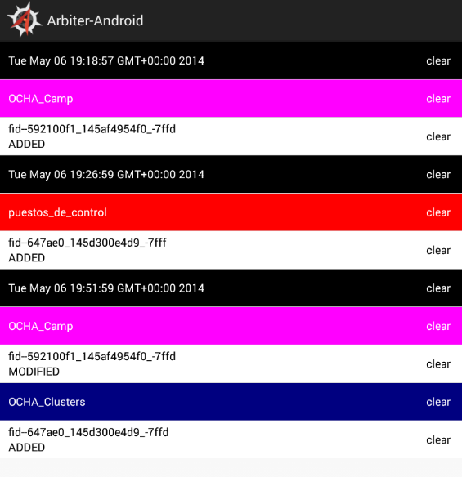Touch the **Notification** icon and Arbiter opens a window listing the changes, as shown in *Figure 9*. It shows the following:

* Layer name: shown in the colored boxes.
* Action taken: shown beneath the layer in the white boxes. It shows the Feature ID (fid-#) for that element and the action that was done (ADDED, MODIFIED, etc.).
* Date text box: Shown in the black boxes. This is the date and time (in GMT) when the sync was done for the layers listed beneath.
* The “clear” button: Allows the user to remove that notification, but not the layer.

Touch a white text box and Arbiter returns to the map display zoomed-in to that element. This allows you to check that the action that was done for that element is valid.

Figure 9

You can return to the Notification list by selecting the icon again. From the list window, you can return to the map display by selecting the **Back**  button on your device.

**Adjust Settings**

Arbiter provides the capability to adjust or change many of the settings to your project that you made initially. You may make changes to the server, layers, and AOI. You may also create a new project at any time. It is important to note that all of these changes and adjustments require that your mobile device be in a connected state to your data server.

**Adjustments to the Server**

During normal operation, it may be necessary to change to another server. This would be the case if you need to switch to data layers that are on a different server.

To change or add a different Server, select the **Settings** icon and select **Servers** from the drop down menu. On most devices, this icon is located in the top right corner. Some mobile devices do not show this icon. If so, the **Settings** menu comes from the **Menu** icon  located at the bottom of the device.

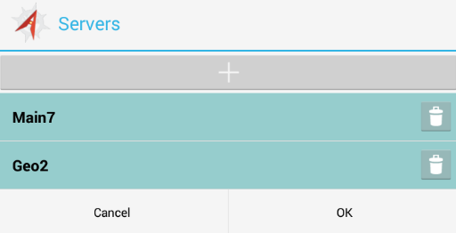After selecting **Servers**, Arbiter opens the Servers panel listing the nicknames of your current server settings, as shown in *Figure 10*. You may change to an existing server by selecting it from the list.

Create a new server by selecting the **Add (+)** button. This opens the Add Server panel that was shown in *Figure 3* above. Fill in the nickname, URL, account, and password as before.

Figure 10

From the Servers panel, you can also modify or remove an existing server. To modify an existing server, select the server name from the list then edit the information about that server from the Add Server panel.

To remove a server from being accessed by Arbiter, select the **Trashcan** icon  to the right of the server name. When you select this icon, Arbiter opens a warning panel asking you to confirm the removal. Select the **Delete** button to continue or the **Cancel** button to abort the operation.

To return to Arbiter operation, select the **OK** (or **Cancel**) button off the Servers panel.

**Adjustments to the Layers**

It is often necessary to make changes to the layers you are working with in the field. You can add, remove, or turn the display of a layer on / off at any time.

To add a new layer for field operation, select the **Layers** icon in the upper left. The Layers panel opens showing a list of your active layers, as was shown in *Figure 4* above. To add a new layer, select the **Add (+)** button. Make sure you are pointing to the correct server. Select the new layer(s) as before. When you finish with your selection, touch the **OK** button. Arbiter syncs that layer to your device then shows a list of your active layers in the Layers panel. From here, select the **OK** button to return to your map and use the new layer(s).

(Note: Currently, Arbiter limits the number of active layers to five. If you exceed this number, Arbiter will issue a warning stating that you have reached the maximum layers per project. Touch anywhere on the screen to return to your layer list if you see this prompt.)

To remove a layer from your active list, select the **Trashcan** icon to the right of the layer name while in the Layers panel. Touching this icon removes the layer from being available for use during your field operations. Select the **OK** button to return to your map.

To turn a layer off from being displayed on your map, select the **On** button  to the left of the layer name while in the Layers panel. The icon changes to **Off.** Now when you select **OK** and return to your map, that layer will not be visible. To turn it back on, simply select the **Layers** icon and touch the **Off** button to change it back to **On**. When a layer is in the **Off** mode, it is still among your active layers.

**Adjustments to the AOI**

While working in the field, it often becomes necessary to adjust your current AOI to a new area. Arbiter will issue a warning message if you try to place an element outside your AOI. To change or adjust your AOI, select the **Settings** or **Menu** icon then select **Area of Interest** from the drop down menu. The Choose AOI window appears showing your current map AOI.

Use the **pan** and **zoom** tools to adjust the display. When your new AOI is set, select the **OK** button. As before, Arbiter displays the number of tiles that make up this AOI. If you are satisfied with everything, select the **Update** button, or select **Cancel** to go back and adjust the AOI again. If you select **Cancel** here, select **Cancel** at the Choose AOI screen to return to your map without changing your AOI.

Once you select **Update**, Arbiter downloads the new map tiles and syncs your data layers again.

**Change the Project**

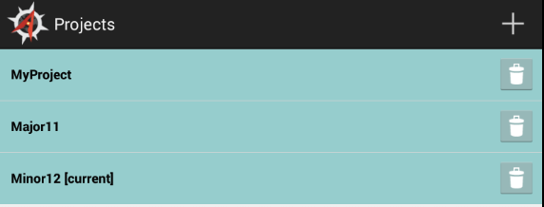As stated before, a project is a set of parameters (server, layers, and AOI) that can be saved and retrieved for subsequent operations without having to go through the setup procedures each time. It is a good idea to set more than one project if you are working with different groups of layers.

To change to a different project select the **Settings** icon then **Projects** from the drop down menu. Arbiter opens the Projects window, as shown in *Figure 11*.

Your active project is identified by the **“[current]”** text beside the project name. To change to a different project, touch the project name. A prompt appears asking if you want to switch to this project. Touch **OK** to confirm or **Cancel** to abort the change.

Figure 11

When changing your active project, all parameters previously defined for that project (its server, layers, and AOI) are set on your mobile device.

You may create a new project at the Projects panel by touching the **Add (+)** icon. When selected, the Project Name panel appears, as was shown in *Figure 2* above. Touch in the name field and enter your new project name or ID with the popup keyboard. Complete your project parameters for server, layers, and AOI as described in the **Project Setup** section above.

To remove a project and all its settings, touch the **Trashcan** icon beside the project name while in the Projects panel. Currently, there is no confirmation panel when removing a project. Touching this icon instantly removes the project and all its settings, so use this option with care.

To return to your map if you remove a project, touch the **Back**  icon located at the bottom of the mobile device.

**Exit Arbiter**

Exit Arbiter as you would any app from your mobile device. Touch the **Recent**  icon located at the bottom of the device. This shrinks your Arbiter display to a thumbnail. Then, simply swipe the thumbnail off the screen to the right or left with your finger. Your Arbiter operation is now terminated.

Start Arbiter again by selecting the app as described above. Once you have a project set, Arbiter automatically open to your most recent project with all its settings, including server, layers, and AOI. This allows you to continue your fieldwork without having to go through the setup operations each time you start the application.