OBIEE Administrator Tool Testing

hi

Two phase to Check the connection pool in OBIEE

1st Phase: Administrator Tool (RPD)

Install OBIEE Client Tool and configure ODBC Connection to access OBIEE Admin Tool(RPD).

Cross check below files:

* Middleware\instances\instance3\config\OracleBIServerComponent\coreapplication_obis1\NQSConfig.ini
* Middleware\instances\instance3\config\OracleBIServerComponent\coreapplication_obis1\DBfeature.ini
* Middleware\instances\instance3\config\OracleBIPresentationServicesComponent\coreapplication_obips1\ instanceconfig.xml (Presentation Server)

Click on “Open Online”

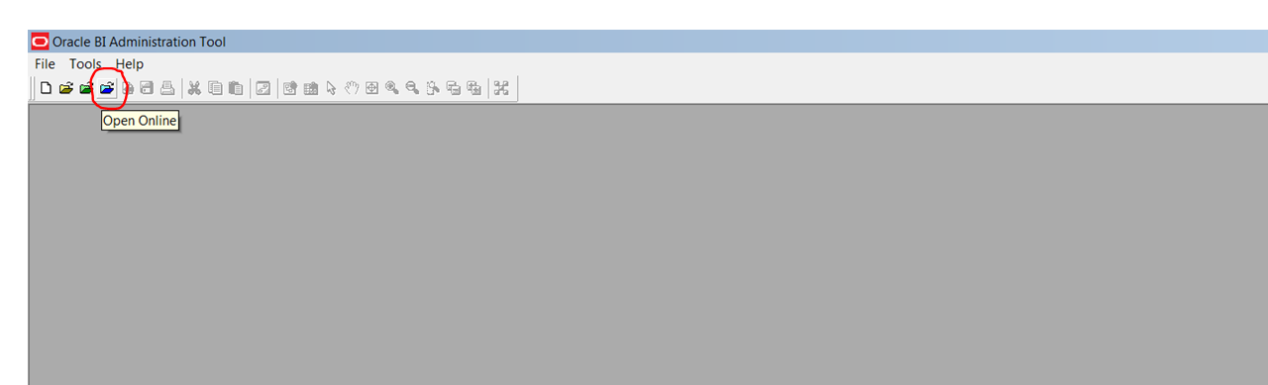

1. ODBC Connection
2. Repository Password
3. Analytics password

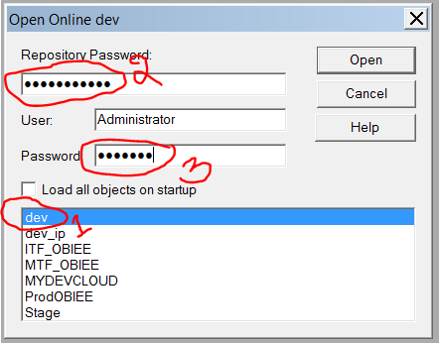

Expand physical layer object and right click highlited column, updated Row Count

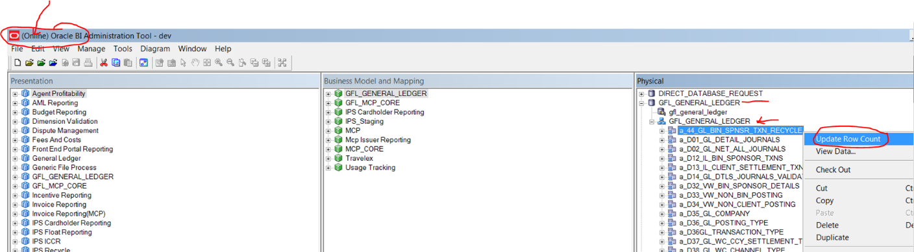

Click on Checkout

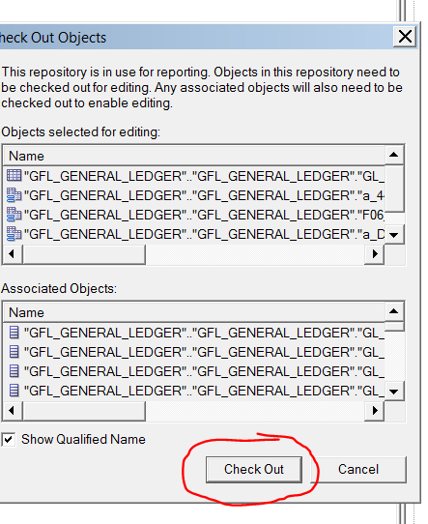

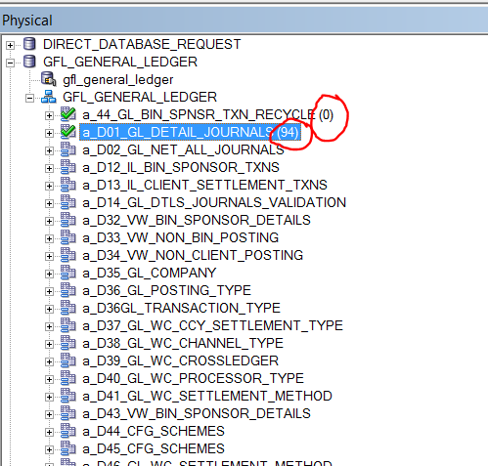

2nd Phase:

Login in to Analysis

<http://cpf0stl90.mastercard.int:9704/analytics/saw.dll?Dashboard>

User id: Administrator

Password:welc0me

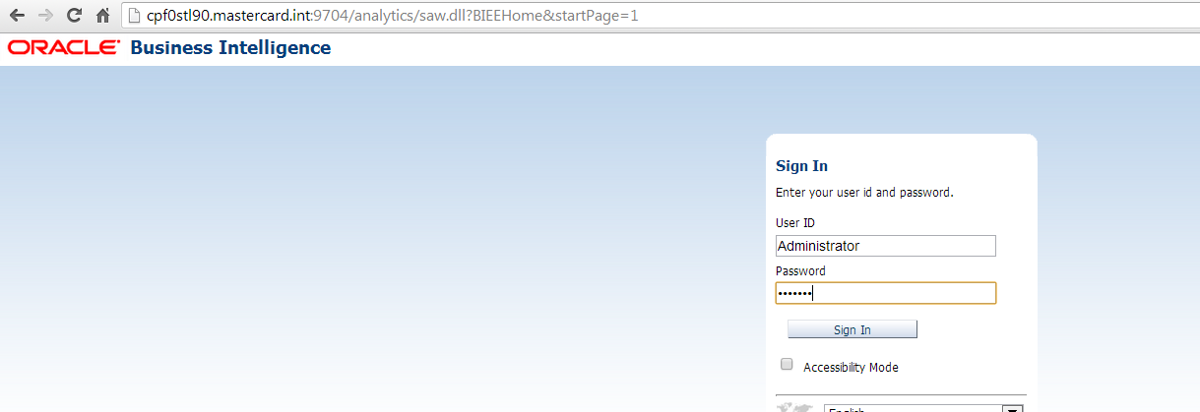

Click New🡪Analysis

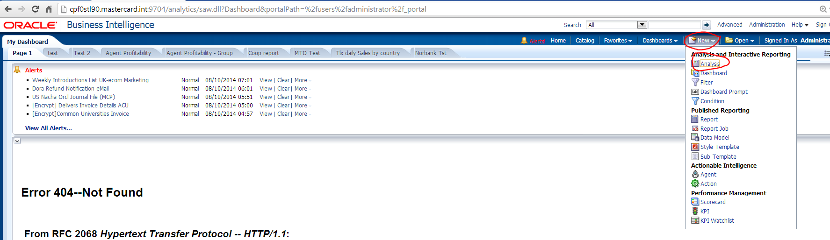

Select one by one Subject Area to validate its pointing to Database

NOTE: Validate every Subject Area

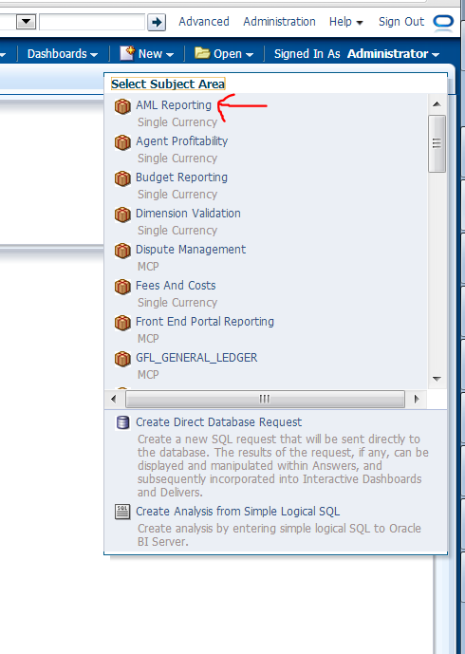

Select any folder under column and click on results

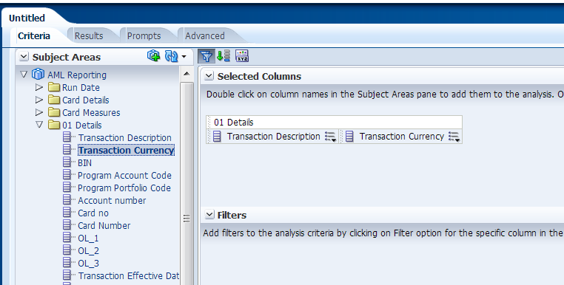

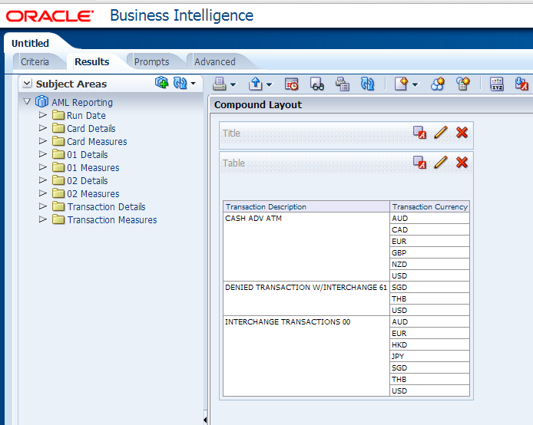

BIPublisher Testing:

<http://cpf0stl90.mastercard.int:9704/xmlpserver/>

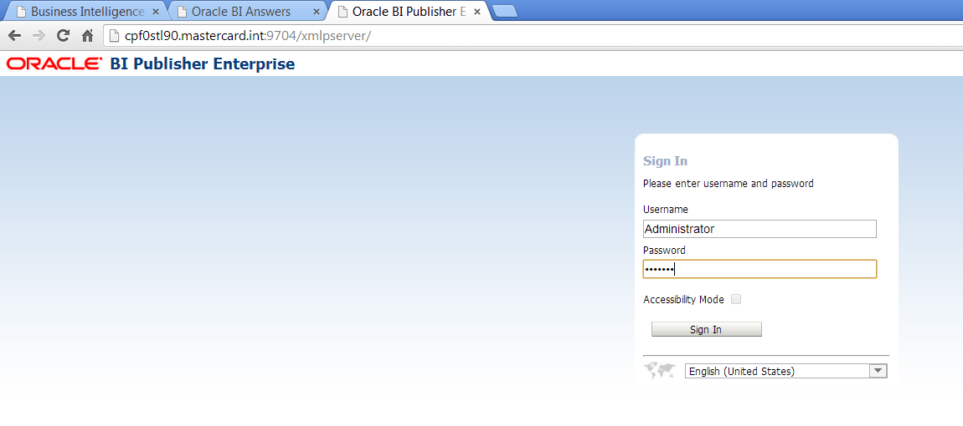

Click on Administrator tab

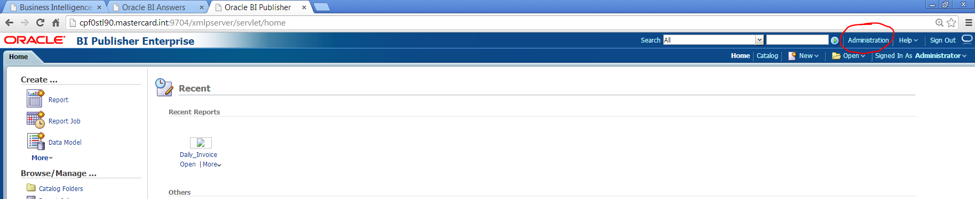

Click on JDBC CONNECTION

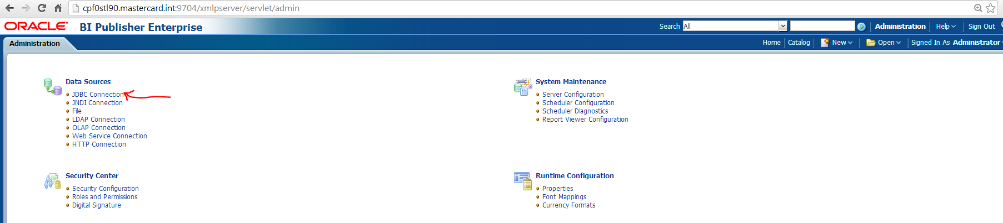

Click on CPRADMIN and check

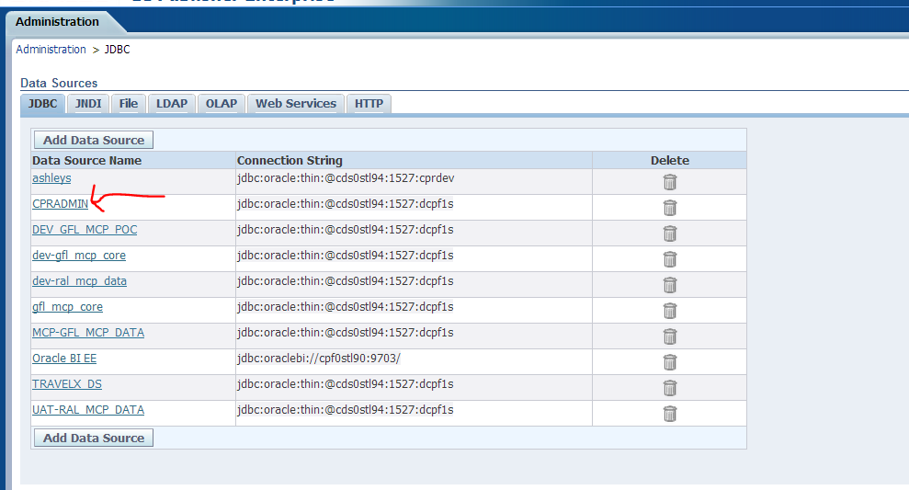

Click on Test connection

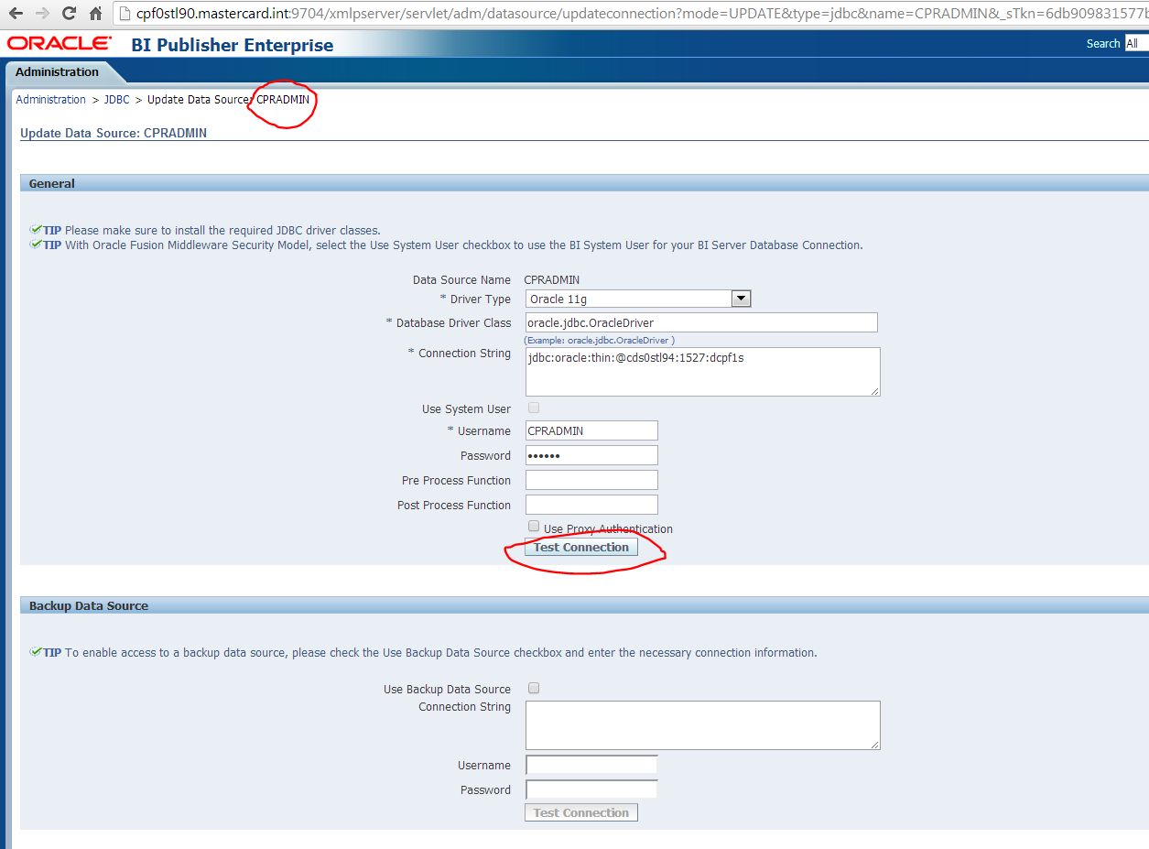

It has to do all schema under JDBC Connection

