Is South Carolina Heating Up?
A look at 60 years of NOAA weather data (1966-2025)

Ankit Saini
Artificial Intelligence
Professor: Dr. Songhui Yue
November 1, 2026

GitHub repository: https://github.com/GITGUD360/P1-data-analysis-and-visualization
Presentation video: https://youtu.be/0NMTInDzIAs

Summary
For this project I downloaded daily weather records for 10 South Carolina weather stations from NOAA's National Centers for Environmental Information (NCEI), covering 1966 to 2025. I cleaned the data, checked the stations against each other, and then looked at how the state's climate has changed from three angles:
- Where: which city has warmed the most? The state as a whole warmed by about 0.49 °F per decade, or roughly 2.9 °F since 1966. Columbia had the fastest trend (+0.58 °F per decade), but Greenville-Spartanburg, Beaufort and Charleston Airport are close enough that I would call it a tie. Every station I trusted warmed significantly.
- When: is it warming more during the day or at night, and in which season? Nights warmed faster than afternoons on average (+0.55 vs. +0.43 °F per decade), especially in downtown Charleston and Columbia. Winter warmed about 1.7 times faster than the other seasons.
- What people feel: are extreme days more common? Warm nights (low of 75 °F or more) went up 47%, freezing nights went down 18%, and the freeze-free season is about three weeks longer than in the 1960s. Heavy rain did not show a significant trend.
I also found that the Sumter station has a faulty temperature record for about ten years, so I left it out of the statewide averages. All the analysis is done in Python (pandas, NumPy, SciPy) and all the charts are made with Matplotlib. Running python run_all.py rebuilds every number and chart in this report.

Summary 2
1. Introduction 4
2. Task 1: Downloading the data 4
2.1 Data source 4
2.2 Choosing the stations 4
2.3 Download script 6
3. Task 2: Cleaning and analyzing the data 6
3.1 Cleaning (src/clean_data.py) 6
3.2 Checking the stations against each other (src/quality_check.py) 6
3.3 Statistics 7
4. The three angles 7
5. Angle 1: Where is South Carolina warming the most? 8
5.1 Method 8
5.2 Results 9
6. Angle 2: When is it warming? 12
6.1 Method 12
6.2 Day vs. night 13
6.3 Which season? 14
7. Angle 3: What do people feel? 14
7.1 Method 14
7.2 Heat and cold 15
7.3 Rain 16
8. Task 3: Visualizing the data with Matplotlib 18
9. Limitations 18
10. Conclusion 19
11. How to run the code 19
References 20

1. Introduction
The assignment pointed to NOAA's past weather page for Charleston, South Carolina, so I decided to stay with South Carolina for the whole project. Charleston is a good example of why local weather matters. Parts of the city flood at high tide, the state had what was called a "1000-year" flood in October 2015, and summers are very hot and humid. Climate change is usually reported as one global number, but people experience it as the weather in their own town. The question I wanted to answer was: what has actually changed in South Carolina's weather over the last 60 years, where has it changed the most, and how would people notice it?
I think this is worth studying for a few reasons. First, the data is real local data. It comes from airport and university weather stations that people in the state know, not from a global model. Second, the answers matter for real decisions. Farmers plan around freeze dates, cities plan for heat waves and power demand, and engineers design drains for heavy rain. Third, it is a good data science problem. Raw weather data has missing values and stations that were moved or got new instruments, so getting a trustworthy answer takes some cleaning and checking, and I needed statistics to tell a real trend apart from normal year-to-year ups and downs.

2. Task 1: Downloading the data

2.1 Data source
All of the data comes from NOAA NCEI's Global Historical Climatology Network Daily dataset (GHCN-Daily). This is the same database that the NOAA "Past Weather" page uses. Each weather station has its own CSV file that can be downloaded directly, without an account or API key:
https://www.ncei.noaa.gov/data/global-historical-climatology-network-daily/access/<STATION_ID>.csv
Each row in the file is one day at one station. I used three of the columns: the daily high temperature (TMAX), the daily low temperature (TMIN) and the daily rainfall (PRCP), plus the quality flag that NOAA stores with each value.

2.2 Choosing the stations
South Carolina has a lot of weather stations, but many of them only have short or patchy records. To choose stations, I downloaded NOAA's station list (ghcnd-stations.txt) and inventory file (ghcnd-inventory.txt) and filtered them to South Carolina stations whose temperature records start before 1955 and continue to 2025. That gave a list of candidates. I downloaded 18 of them and counted how many complete years each one had, where I counted a year as complete if it had at least 330 days of data (about 90% of the year).
I kept 10 stations that are complete for nearly every year from 1966 to 2025 and that cover the three regions people usually divide the state into: the Coast, the Midlands and the Upstate. Charleston has two stations, one at the airport and one downtown. Having both turned out to be useful later because it shows the effect of the city itself.
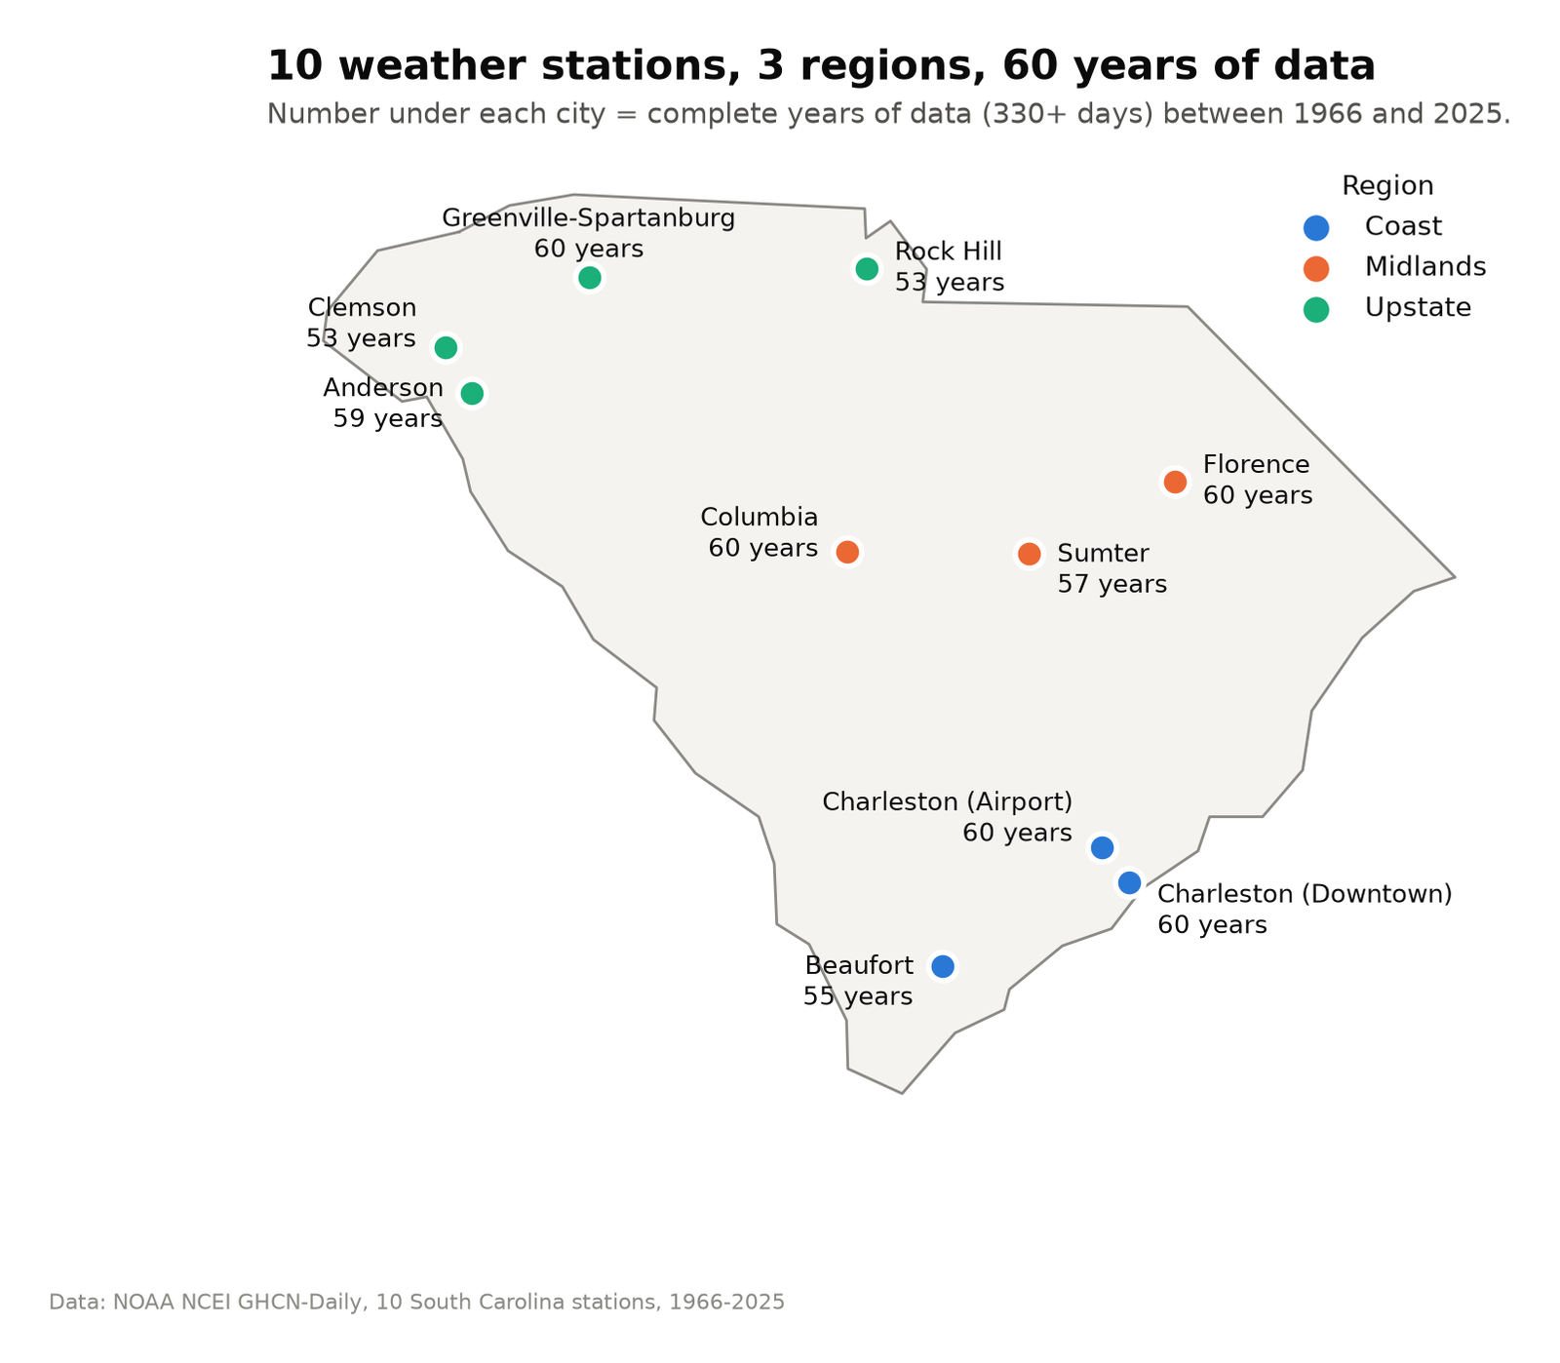
Figure 1. Location of the 10 stations and the number of complete years (at least 330 days) each one has between 1966 and 2025.
Table 1. The 10 stations used and how complete their data is after cleaning.
City | Region | NOAA station ID | Temp. years | Rain years | Missing temp. days
Charleston (Airport) | Coast | USW00013880 | 60 | 60 | 0.0%
Charleston (Downtown) | Coast | USW00013782 | 60 | 60 | 0.2%
Beaufort | Coast | USW00093831 | 55 | 55 | 1.1%
Columbia | Midlands | USW00013883 | 60 | 60 | 0.0%
Florence | Midlands | USW00013744 | 60 | 60 | 0.1%
Sumter | Midlands | USC00388440 | 57 | 59 | 2.6%
Greenville-Spartanburg | Upstate | USW00003870 | 60 | 60 | 0.0%
Anderson | Upstate | USW00093846 | 59 | 59 | 0.1%
Clemson | Upstate | USC00381770 | 53 | 60 | 3.3%
Rock Hill | Upstate | USC00389350 | 53 | 58 | 3.3%

2.3 Download script
The script src/download_data.py loops over the 10 station IDs (listed in src/config.py) and downloads each file with Python's urllib. The full NOAA files have about 100 columns, including wind, snow depth and many others, so the script keeps only the columns this project uses and only the years from 1960 on. It saves the trimmed files in data/raw/. This brings the data down from about 95 MB to 27 MB. The trimmed files are included in the repository, so the analysis runs without an internet connection. Running python run_all.py --download downloads fresh copies first.

3. Task 2: Cleaning and analyzing the data

3.1 Cleaning (src/clean_data.py)
- Unit conversion. NOAA stores temperature in tenths of a degree Celsius and rain in tenths of a millimeter. I converted everything to °F and inches since those are the units used in South Carolina.
- Quality flags. Each value has a flag field in the format "M,Q,S,time". If the quality flag (Q) is set, the value failed one of NOAA's checks, so I removed it. For example, this removed 685 daily lows at Clemson and 533 daily highs at Rock Hill.
- Impossible days. I removed days where the high was lower than the low. After step 2 there were none left.
- Complete years only. Yearly values are only calculated for years with at least 330 valid days. Otherwise a year with a missing summer month would look cooler than it really was.
- Yearly table. For every station and year the script calculates the average temperature, the average high and low, the number of hot days, warm nights and freeze days, the dates of the last spring freeze and first fall freeze, total rainfall, heavy rain days, the wettest day and the longest dry spell. This table (data/processed/annual_metrics.csv) is what all three angles use.

3.2 Checking the stations against each other (src/quality_check.py)
Weather stations sometimes get moved or have their instruments replaced, and that can make a station look like it suddenly got warmer or cooler when the climate did not change. Stations in the same state tend to have warm and cool years at the same time, so I compared each station with the average of the other nine:
difference = station's temperature anomaly - average anomaly of the other 9 stations
For a normal station, the 5-year average of this difference stays near zero. All of the stations stayed within about 2 °F except Sumter. From about 2005 to 2015, Sumter's daily highs read as much as 5 °F colder than the other stations, and then went back to normal. Columbia is only about 40 miles away and does not show anything like this, so it is almost certainly a problem with the station and not real weather. I flagged any station that drifted more than 3 °F as suspect, which only caught Sumter, and left it out of all statewide temperature averages. It still appears on the charts in gray. The rain gauge was not affected, so Sumter's rain data is still used.
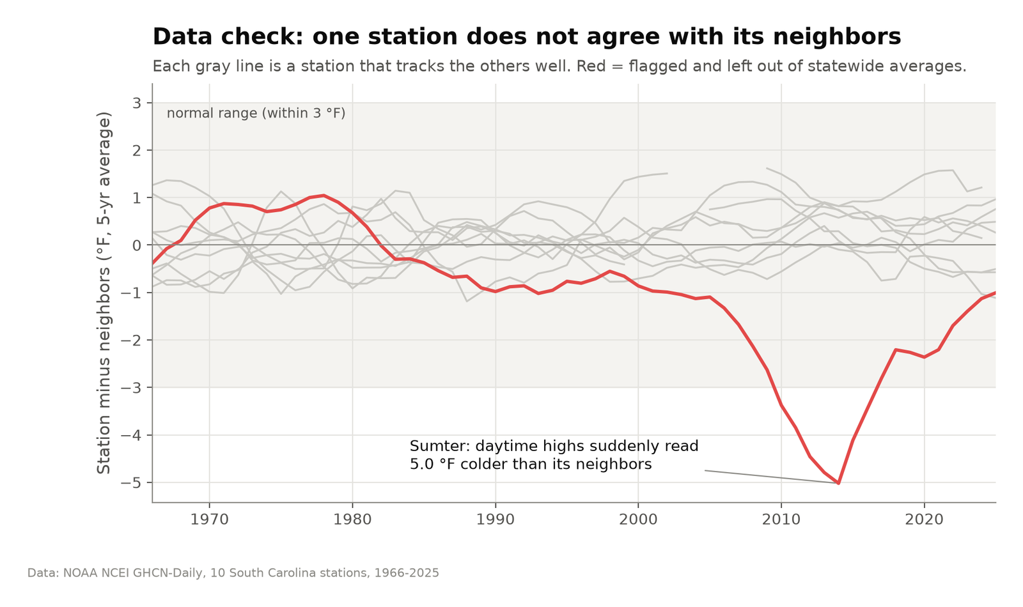
Figure 2. Neighbor check. Each gray line is one station minus the average of the others (5-year average of daily highs). Sumter, in red, drifts well outside the normal range.

3.3 Statistics
- Linear trend. For each series I fit a straight line through the 60 yearly values using least squares (scipy.stats.linregress). The slope times 10 gives the change per decade.
- Confidence interval and p-value. The p-value is the probability of getting a slope this large if there were no real trend and the yearly values were just random variation. I call a trend significant if p < 0.05 and mark it with stars in the charts ( p < 0.05, p < 0.01, ** p < 0.001).
- Then vs. now. I also compared the average of 1966-1995 with the average of 1996-2025. NOAA uses 30-year periods for its climate normals, and this comparison is easy to explain without statistics.
- Anomalies. Before averaging stations together, I converted each station to its difference from its own 1966-1995 average. This lets me average a cool Upstate station with a warm coastal one fairly, and a missing year at one station does not shift the statewide average.

4. The three angles
Saying "the average temperature went up" is true but not very useful on its own. It does not tell a city where the biggest change is, it does not tell a doctor when people are most at risk, and it does not tell a farmer how the seasons are shifting. I chose three angles so that each one answers a question the previous one leaves open.
Table 2. The three angles, the question each one answers, and why I chose it.
Angle | Question | What I measured | Why it makes sense
1. Where | Which South Carolina city has warmed the most? | Trend in each city's yearly average temperature | This is the example question in the assignment. It shows whether warming is local or statewide, and gives a ranking that local governments could use.
2. When | Is it warming more during the day or at night, and in which season? | Separate trends for daily highs and lows, and for each season | The yearly average hides how the warming happens. Day vs. night can point to causes such as city heat, and the season matters for crops, pests and energy use.
3. What people feel | Are extreme days becoming more common? | Counts of hot days, warm nights, freezes, growing season length and heavy rain | People notice thresholds more than averages: a 95 °F afternoon, a night that never cools off, a frost or a flood. This angle also brings in rainfall as a second variable.

The first angle looks at the average change across space, the second looks at timing within the day and the year, and the third looks at extremes. All three use the same cleaned data and the same statistical methods, so the results can be compared. Using three angles also works as a check on the main result. If only one station had warmed, or if the average had gone up without any change in extremes, I would have described the results very differently.

5. Angle 1: Where is South Carolina warming the most?

5.1 Method
For each station I calculated the yearly average temperature (the average of (daily high + daily low) / 2 over all days in the year) and fit a straight-line trend from 1966 to 2025. The statewide line is the average anomaly of the 9 trusted stations.

5.2 Results
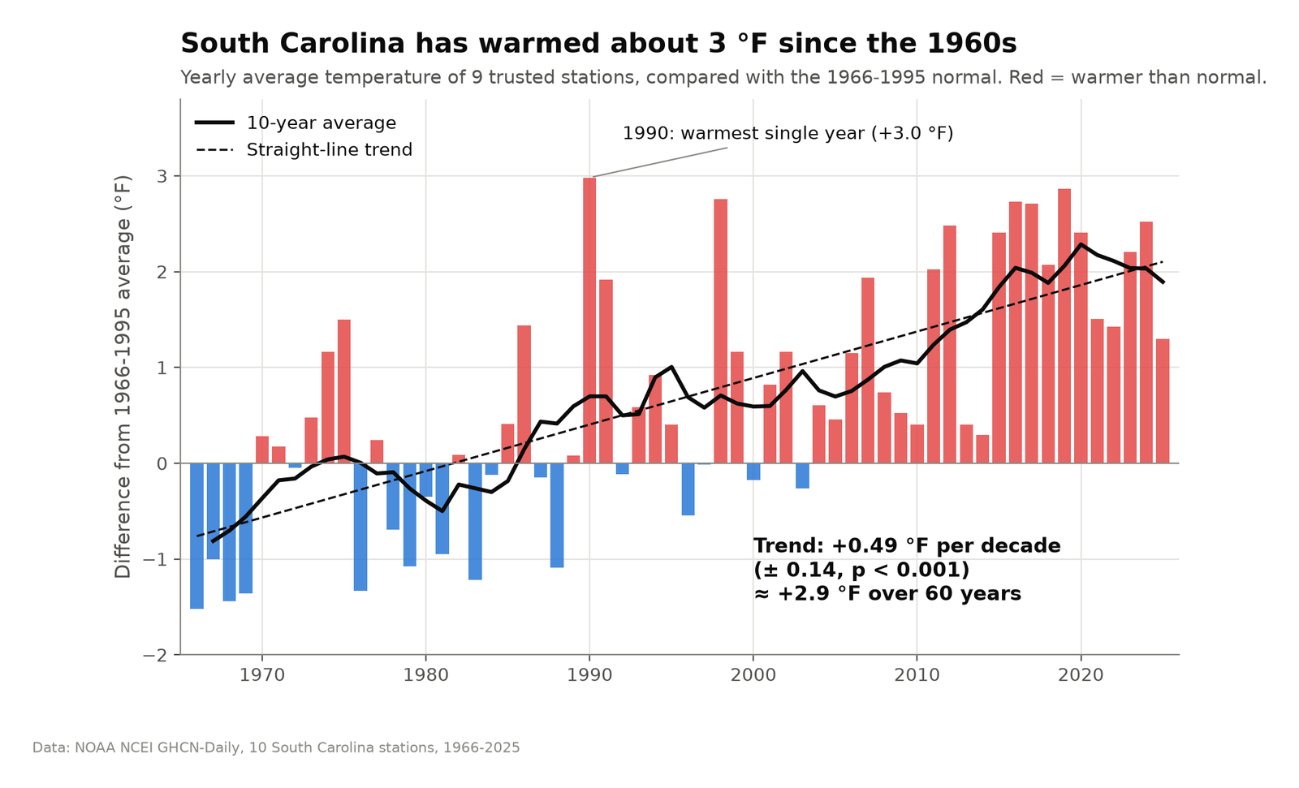
Figure 3. Statewide yearly temperature compared with the 1966-1995 average. Since 2010, nearly every year has been warmer than that average.
South Carolina warmed by 0.49 °F per decade (95% confidence interval ± 0.14, p < 0.001), which comes to about 2.9 °F over the 60 years. The last 30 years were about 1.4 °F warmer on average than the 30 years before them. The single warmest year was 1990, but 8 of the 10 warmest years came after 2010 (2019, 2016, 2017, 2024, 2012, 2020, 2015 and 2023).
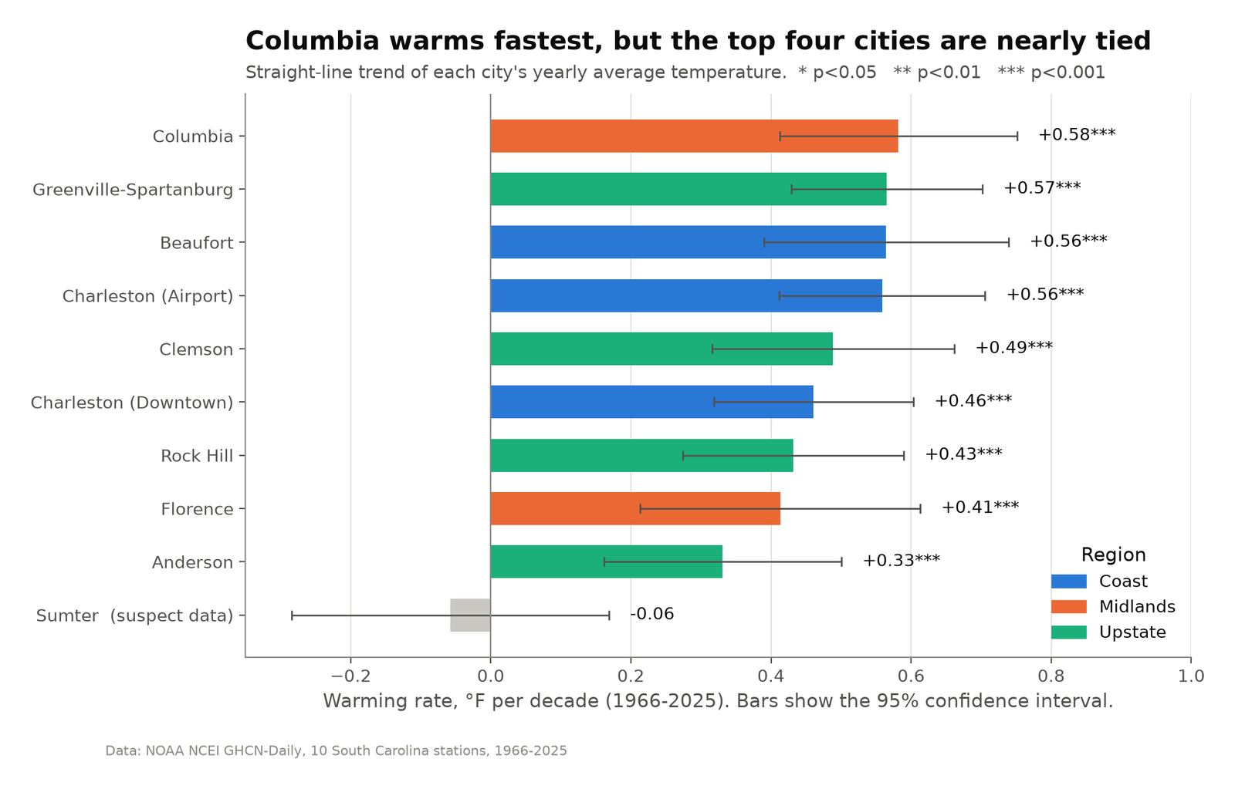
Figure 4. Warming rate of each city with 95% confidence intervals. Bar colors show the region. Sumter (gray) failed the neighbor check.
Table 3. Warming rate of each city, 1966-2025, ranked from fastest to slowest.
Rank | City | Region | °F per decade | 95% CI | Sig. | 1966-95 → 1996-2025 (°F)
1 | Columbia | Midlands | +0.58 | ± 0.17 | *** | 63.3 → 64.9
2 | Greenville-Spartanburg | Upstate | +0.56 | ± 0.14 | *** | 60.0 → 61.8
3 | Beaufort | Coast | +0.56 | ± 0.17 | *** | 66.3 → 67.7
4 | Charleston (Airport) | Coast | +0.56 | ± 0.15 | *** | 65.6 → 66.9
5 | Clemson | Upstate | +0.49 | ± 0.17 | *** | 60.3 → 62.2
6 | Charleston (Downtown) | Coast | +0.46 | ± 0.14 | *** | 66.4 → 67.8
7 | Rock Hill | Upstate | +0.43 | ± 0.16 | *** | 61.3 → 62.7
8 | Florence | Midlands | +0.41 | ± 0.20 | *** | 63.7 → 64.6
9 | Anderson | Upstate | +0.33 | ± 0.17 | *** | 61.6 → 62.4
10 | Sumter (suspect) | Midlands | -0.06 | ± 0.23 | n.s. | 63.2 → 63.0

Answer to Angle 1: Columbia warmed the fastest, at +0.58 °F per decade, which is about 3.5 °F since 1966. However, the top four stations (Columbia, Greenville-Spartanburg, Beaufort, Charleston (Airport)) are within 0.03 °F per decade of each other and their confidence intervals overlap almost completely, so I don't think the data can really separate them. The slowest trusted station was Anderson (+0.33). If I use the change between the two 30-year averages instead of the trend, Clemson (+1.9 °F) and Greenville-Spartanburg (+1.8 °F) come out on top, so Columbia and the Upstate stand out either way.
The bigger finding is that all 9 trusted stations warmed significantly, each with p < 0.001. The regions are also very similar: the Coast averaged +0.53, the Midlands +0.50 and the Upstate +0.45 °F per decade. This suggests the warming is happening across the whole state rather than in just a few places.
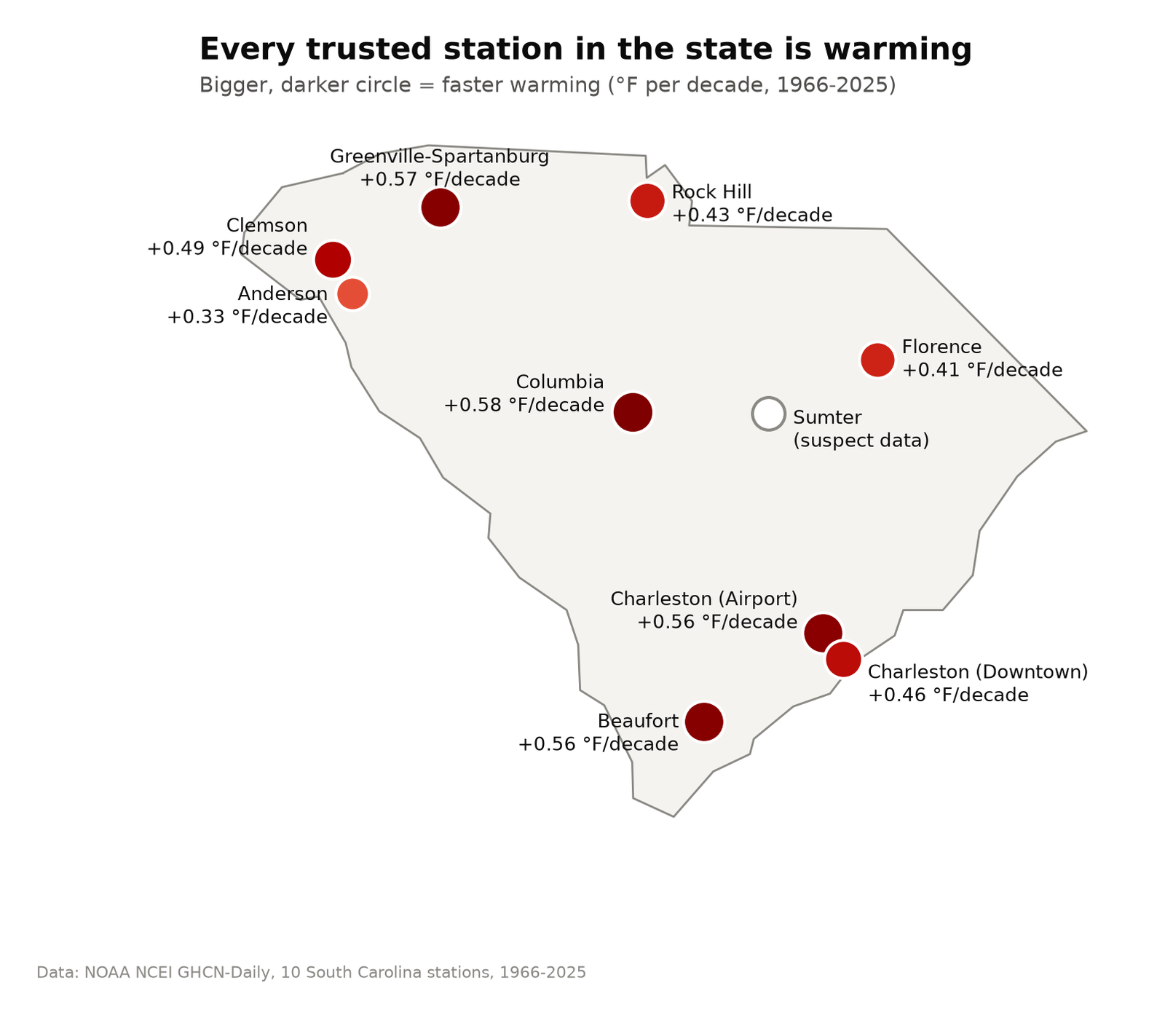
Figure 5. Warming rates on a map. Larger and darker circles mean faster warming.
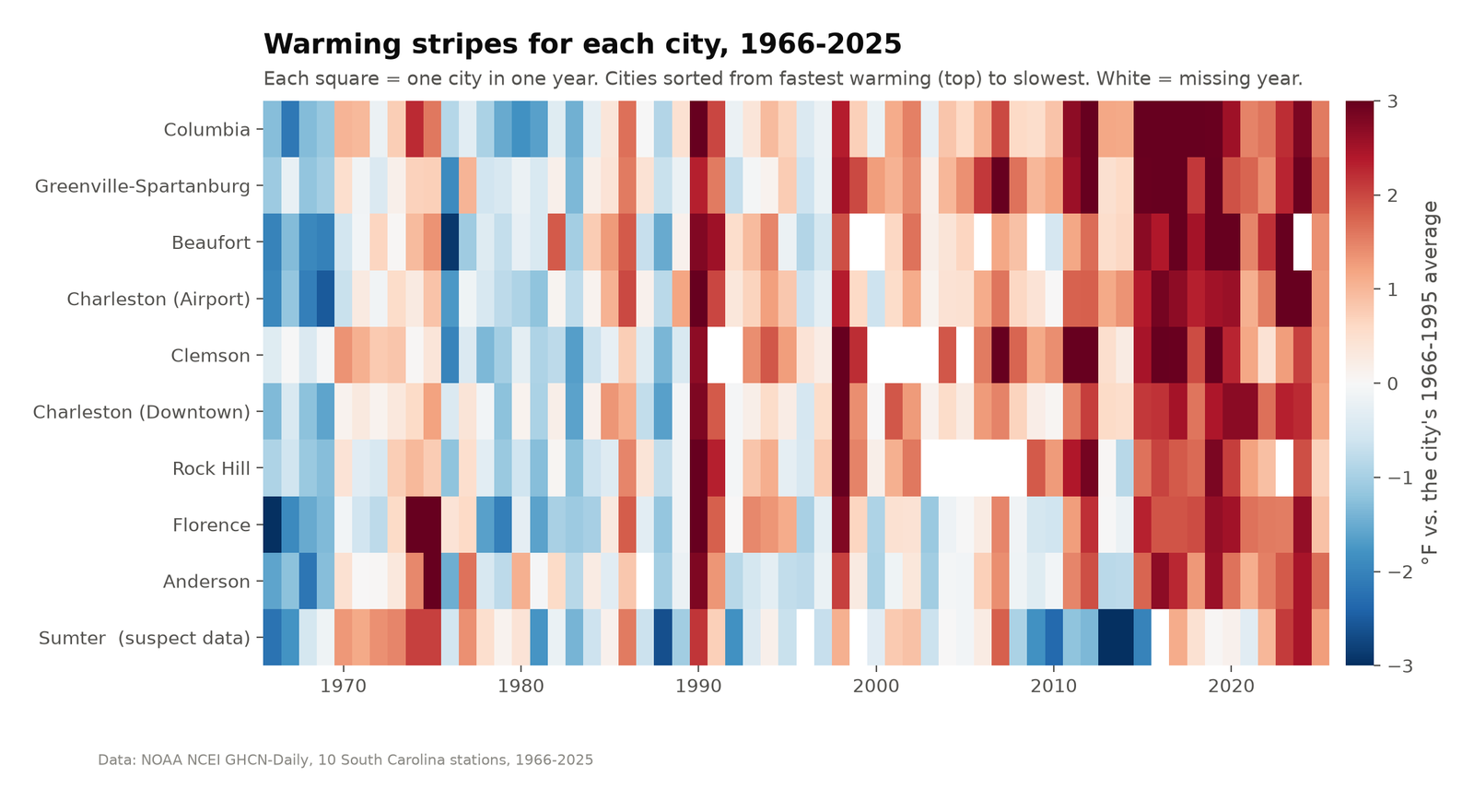
Figure 6. Warming stripes: each row is a city and each column is a year, colored by how much warmer (red) or cooler (blue) that year was than the city's own 1966-1995 average.
Figure 6 shows the same result without any statistics. The left side is mostly blue, the right side is mostly red, and the change happens at roughly the same time at every station. The Sumter problem is also easy to see in this chart, because it is the only row that turns dark blue around 2013-2014.

6. Angle 2: When is it warming?

6.1 Method
Instead of the daily average, I fit separate trends for the daily high (TMAX, which is usually in the afternoon) and the daily low (TMIN, which is usually at night or early morning). I then split each year into the four meteorological seasons and fit a statewide trend for each one. Winter is December to February, and December is counted with the following year's winter. A season was only used if it had at least 80 days of data.

6.2 Day vs. night
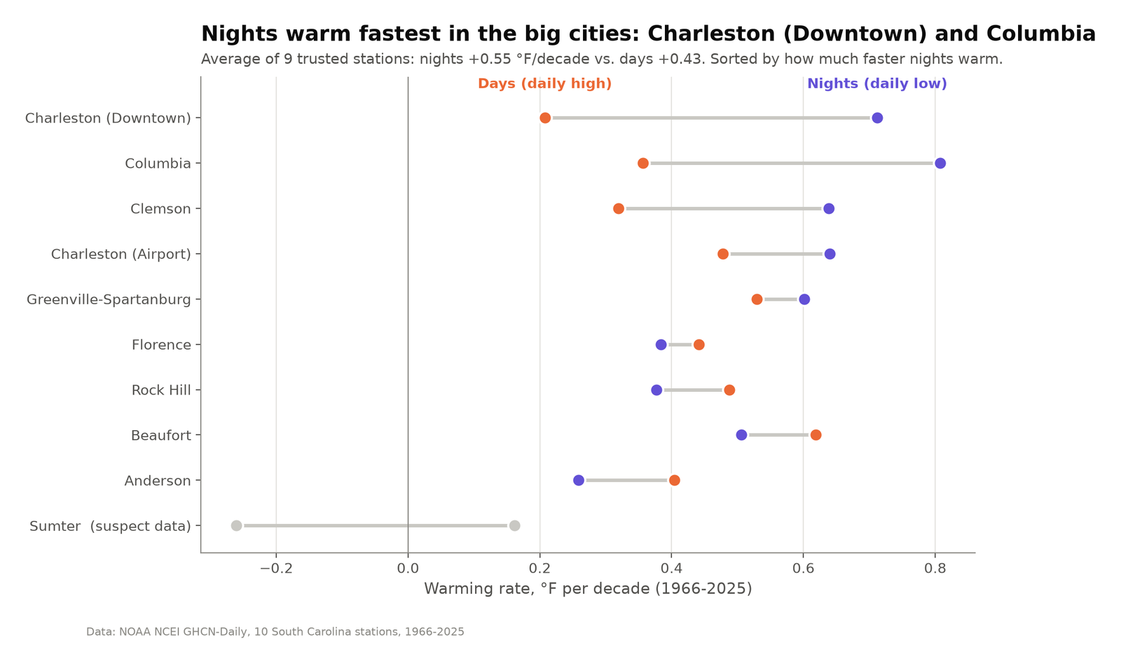
Figure 7. Warming of the daily high (orange) and daily low (purple) at each station, sorted by how much faster the nights warmed than the days.
Averaged over the 9 trusted stations, nights warmed by 0.55 °F per decade and afternoons by 0.43 °F per decade, so nights warmed about 28% faster. The difference is much larger in some places than others. In downtown Charleston, nights warmed 0.71 °F per decade but days only 0.21, which is more than three times faster. In Columbia it was 0.81 vs. 0.36. These are the two most built-up locations in my data set. At the smaller stations (Anderson, Rock Hill, Florence and Beaufort), days and nights warmed by about the same amount, or days warmed slightly more.
This fits with the urban heat island effect. Pavement and buildings absorb heat during the day and release it at night, so cities cool down more slowly after sunset. Humid air can also hold in heat at night. My interpretation is that some of the warming at the city stations is extra warming caused by the city around the thermometer, on top of the regional warming that shows up at every station. I can't prove the cause with this data alone, but the pattern matches what I would expect.

6.3 Which season?
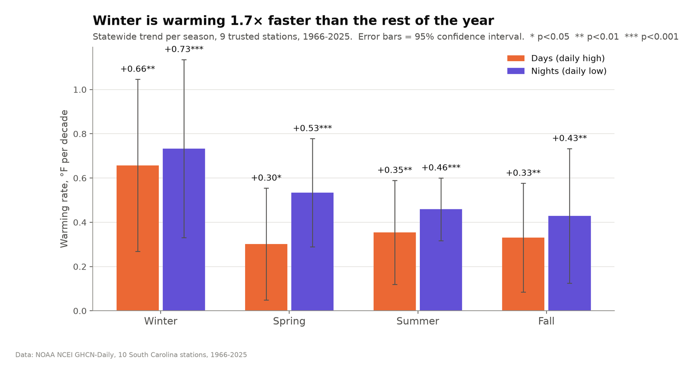
Figure 8. Statewide warming rate for each season, for daily highs and lows, with 95% confidence intervals.
Table 4. Statewide warming by season, 1966-2025 (°F per decade).
Season | Daily high | Sig. | Daily low | Sig.
Winter | +0.66 ± 0.39 | ** | +0.73 ± 0.40 | **
Spring | +0.30 ± 0.25 | * | +0.53 ± 0.24 | ***
Summer | +0.35 ± 0.23 | ** | +0.46 ± 0.14 | ***
Fall | +0.33 ± 0.25 | ** | +0.43 ± 0.30 | **

Winter warmed the fastest, at about +0.66 °F per decade for highs and +0.73 for lows. That is about 1.7 times the average rate of the other three seasons. In spring, summer and fall, the lows warmed faster than the highs (in spring, for example, +0.53 for nights and +0.30 for afternoons). Winter temperatures change a lot from one year to the next, so the winter confidence intervals are wide. The winter trend is significant, but the exact factor of 1.7 is less certain than the other numbers.
Answer to Angle 2: South Carolina is warming most in winter and at night, and the night warming is strongest in the cities. This is something the yearly average from Angle 1 doesn't show. Most of the 2.9 °F increase comes from milder winters and warmer nights rather than hotter summer afternoons.

7. Angle 3: What do people feel?

7.1 Method
For each station and year I counted days that cross thresholds people actually notice: hot days (high of 95 °F or more), warm nights (low of 75 °F or more, when it never really cools off), and freeze days (low of 32 °F or less). I also calculated the freeze-free season (the number of days between the last spring freeze and the first fall freeze, which is roughly the growing season), heavy rain days (2 inches or more in one day, which is enough to cause flash flooding), total yearly rain, the wettest day of the year and the longest dry spell. These are similar to the climate extreme indices used by climate researchers (the ETCCDI indices). As before, I compared 1966-1995 with 1996-2025 and tested the 60-year trend.

7.2 Heat and cold
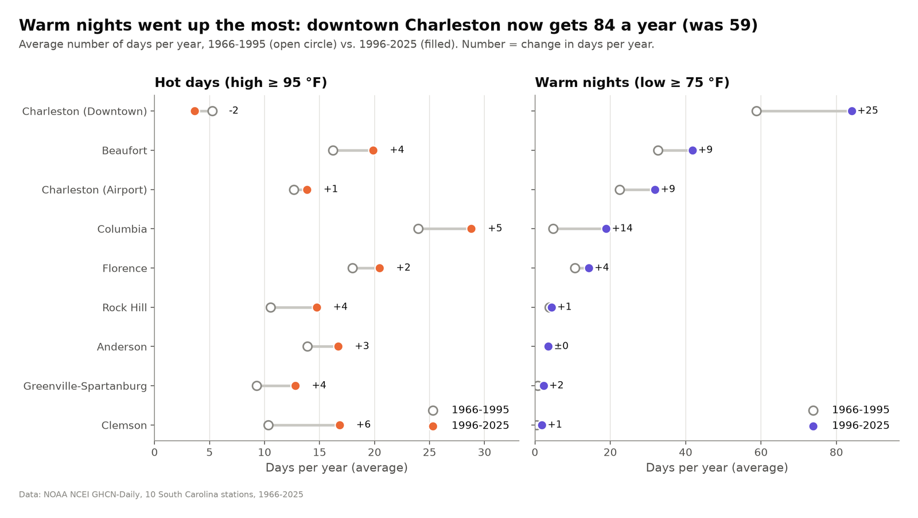
Figure 9. Average number of hot days and warm nights per year in 1966-1995 (open circle) and 1996-2025 (filled circle). The number next to each city is the change in days per year.
Warm nights changed the most. Statewide, they went from 15.6 to 22.9 per year (+47%, p < 0.001). Downtown Charleston now averages 84 nights a year where the temperature stays at 75 °F or above, compared with 59 before, which is almost an extra month. Columbia went from about 5 to 19 per year. Hot days went up less, from 13.4 to 16.2 per year (+21%). That change is only just significant (p = 0.046). Downtown Charleston actually has fewer hot afternoons than before, probably because of the sea breeze, which again suggests that the change there is mostly at night.
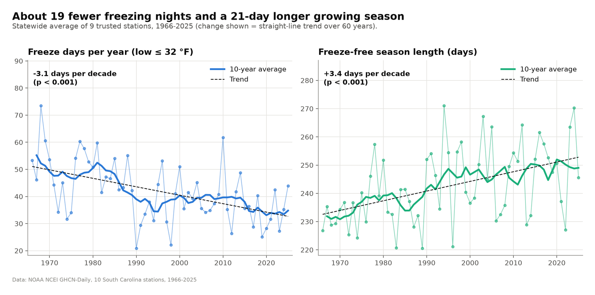
Figure 10. Statewide freeze days per year (left) and length of the freeze-free season (right), with 10-year averages and straight-line trends.
At the cold end, freeze days dropped from 46.0 to 37.7 per year (-18%). The trend is -3.1 days per decade, or about 19 fewer freezing nights over the 60 years. The freeze-free season got longer by 3.4 days per decade, which adds up to about three weeks. Clemson lost the most freezing nights (from 70 to 54 per year), and downtown Charleston's freeze-free season is now about 324 days long.

7.3 Rain
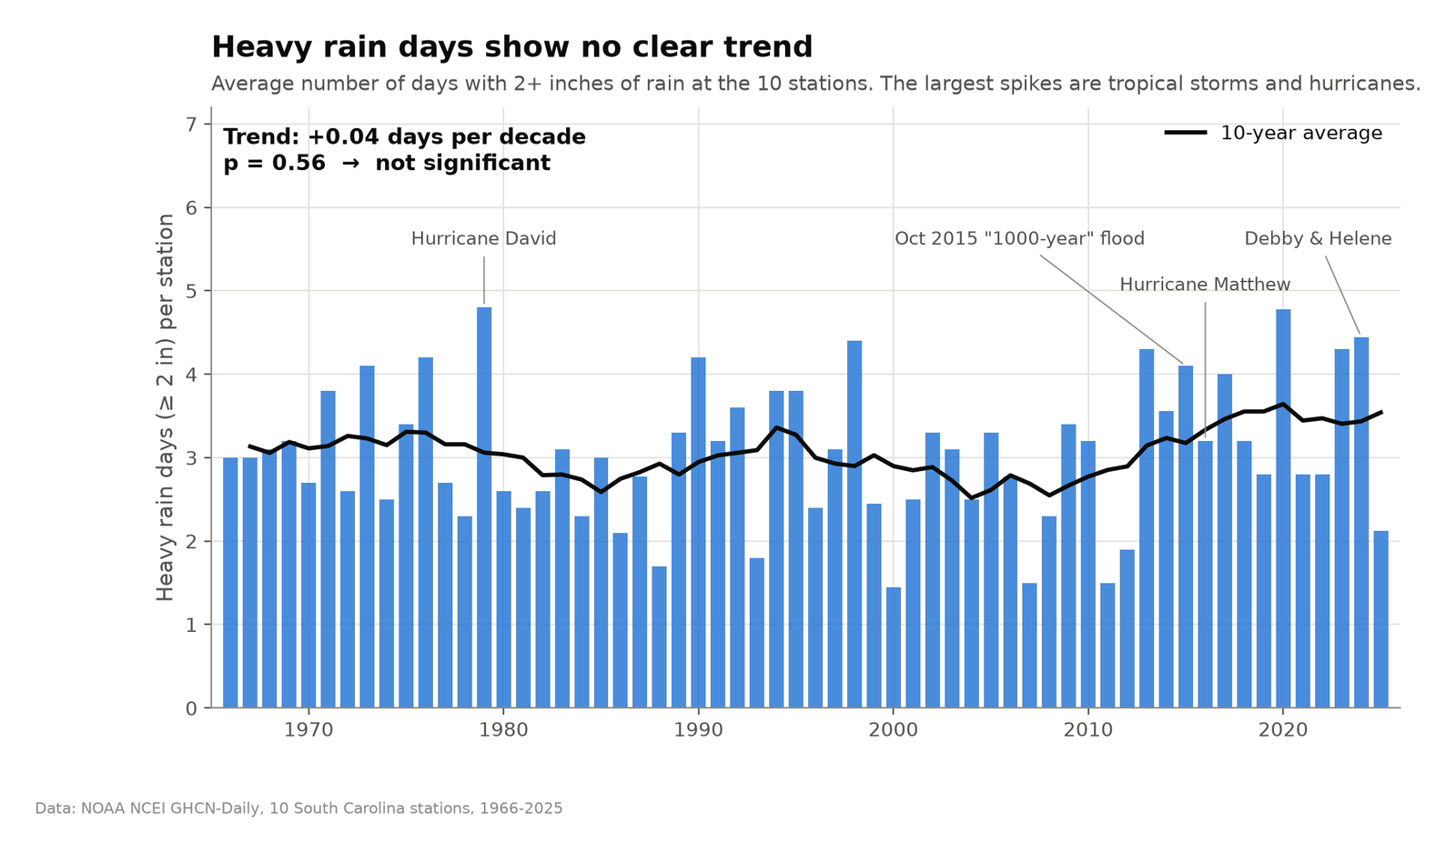
Figure 11. Average number of days with 2 inches of rain or more per station, with some well-known storm years labeled.
The rain results were different from what I expected. The number of heavy rain days has no significant trend (p = 0.56). The biggest spikes come from individual storms, such as Hurricane David (1979), the October 2015 flood, Hurricane Matthew (2016) and Debby and Helene (2024), and years with big storms show up in every decade. The 10-year average has gone up since about 2010, so it is worth keeping an eye on, but with 60 years of data from 10 stations I can't tell it apart from natural variation. Total yearly rain, the wettest day of the year and the longest dry spell also did not change significantly.
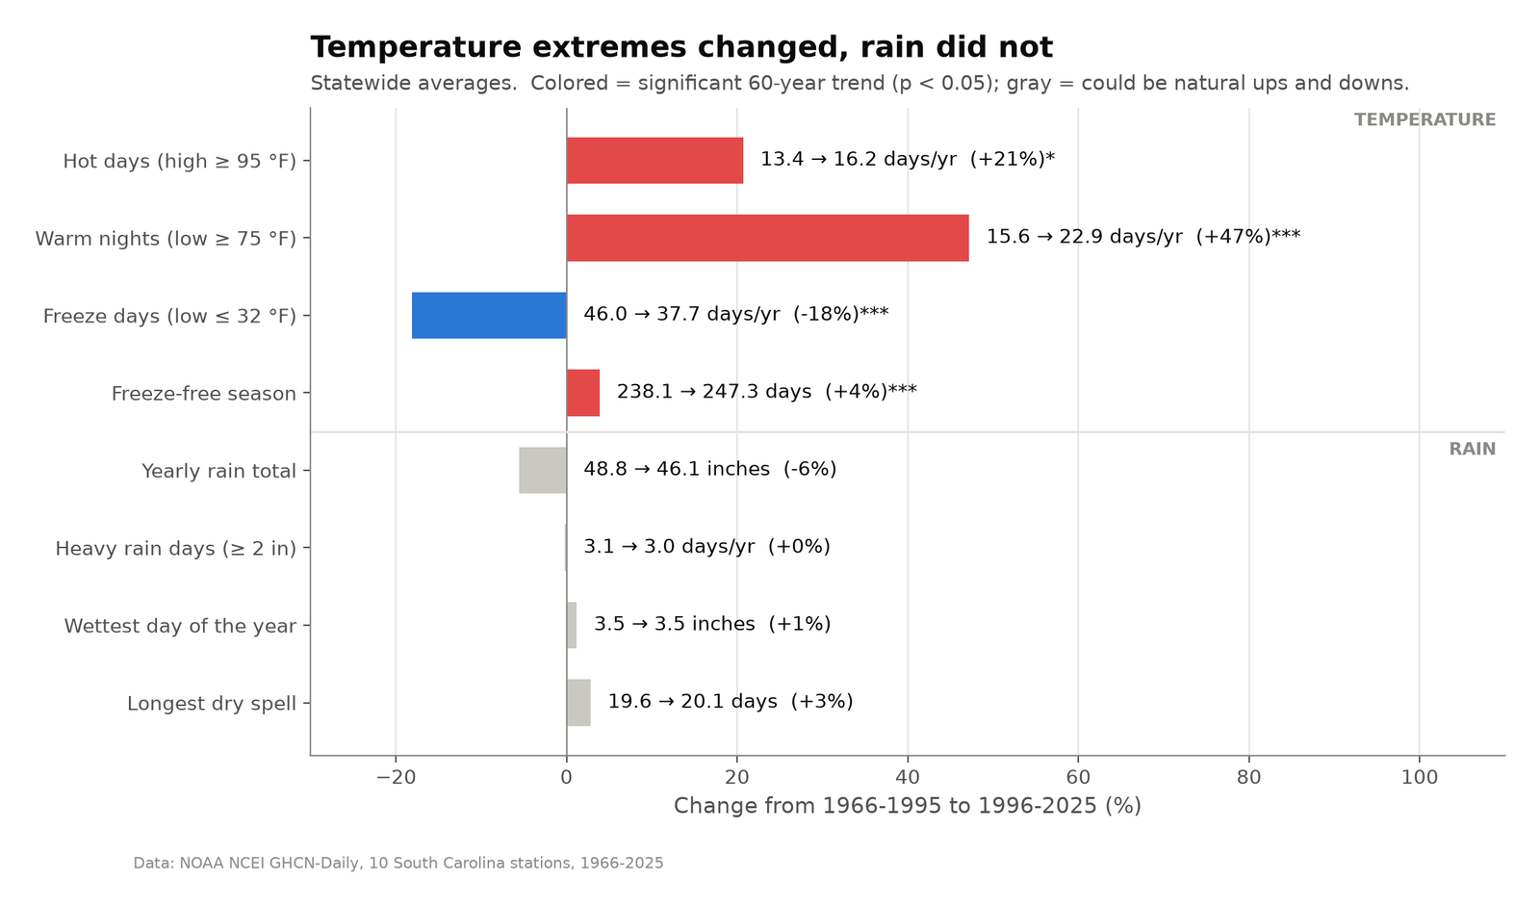
Figure 12. Summary of all the extreme weather measures: statewide change from 1966-1995 to 1996-2025. Colored bars have a significant 60-year trend and gray bars do not.
Table 5. Summary of the extreme weather measures (statewide averages).
Measure | 1966-1995 | 1996-2025 | Change | Trend p-value
Hot days (high ≥ 95 °F) | 13.4 days/yr | 16.2 days/yr | +21% | 0.046
Warm nights (low ≥ 75 °F) | 15.6 days/yr | 22.9 days/yr | +47% | < 0.001
Freeze days (low ≤ 32 °F) | 46.0 days/yr | 37.7 days/yr | -18% | < 0.001
Freeze-free season | 238.1 days | 247.3 days | +4% | < 0.001
Yearly rain total | 48.8 inches | 46.1 inches | -6% | 0.366
Heavy rain days (≥ 2 in) | 3.1 days/yr | 3.0 days/yr | 0% | 0.564
Wettest day of the year | 3.5 inches | 3.5 inches | +1% | 0.531
Longest dry spell | 19.6 days | 20.1 days | +3% | 0.859

Answer to Angle 3: temperature extremes have clearly changed. There are many more warm nights, somewhat more hot days, far fewer freezes and a longer growing season. Rainfall extremes, on the other hand, have not changed in a way this data can detect. I think this difference is a useful result, because it shows that the evidence for change is much stronger for some parts of the weather than for others.

8. Task 3: Visualizing the data with Matplotlib
All 12 figures were made with Matplotlib and saved as 200 dpi PNG files in the figures/ folder. Since the charts were also going to be used in a presentation, I tried to make each one readable in a few seconds. These are the main choices I made:
- Each chart has a title that states the finding (for example "Winter is warming 1.7× faster than the rest of the year") and a gray subtitle that explains how to read it. Titles that include numbers are generated from the data, so they update if the data changes.
- I picked the chart type to match the question: bars for yearly differences, ranked horizontal bars to compare cities, a map for locations, a heat map (warming stripes) to show 600 values at once, dot plots for then vs. now and day vs. night, and a summary bar chart at the end.
- Colors mean the same thing on every chart. Coast is blue, Midlands is orange and Upstate is green. Daytime is orange and nighttime is purple. Red means warmer and blue means cooler. I checked the palette with a color-blindness checker, and the colors are always backed up by text labels.
- I tried to show uncertainty honestly. Bars start at zero, there are no charts with two y-axes, confidence intervals are drawn as error bars, significance is marked with stars, and results that are not significant are shown in gray.
- I labeled data directly on the chart where I could instead of using a legend, kept the gridlines light, and added the data source at the bottom of each figure.
All of the styling is in one function, utils.set_style(), so every figure has the same look. A second function, utils.save(), adds the source note and saves both a report version and a slide version of each chart.

9. Limitations
- I used raw station data. NOAA also publishes adjusted data sets that correct for station moves and instrument changes. My neighbor check caught the obvious problem at Sumter, but smaller jumps at other stations could still be in the data.
- Several stations are at airports or in cities that have grown a lot since 1966. Some of their warming, especially at night, is probably local urban heat and not regional climate change, as Angle 2 suggests.
- A straight line is a simple model, and the p-values assume each year is independent. Real climate data has some year-to-year memory (for example from El Niño), so the real uncertainty is a bit larger than shown. I also tested quite a few measures, which raises the chance of one false positive. The main results have p-values far below 0.05, so I don't think this changes the conclusions.
- I only used 10 stations, and fixed thresholds like 95 °F mean something different in the mountains than at the beach.

10. Conclusion
Using 217,782 days of NOAA weather records from 10 stations, I found that South Carolina has warmed by about 3 °F since 1966, and that every trusted station in the state shows warming. Looking at the data from three angles showed more than the single average would have:
- Where: Columbia warmed the fastest (+0.58 °F per decade), but it is statistically tied with Greenville-Spartanburg, Beaufort and Charleston Airport, and all three regions are warming at a similar rate.
- When: the warming is strongest in winter and at night, and the night warming is strongest at the most urban stations.
- What people feel: there are many more warm nights (+47%), fewer freezes (-18%), a growing season about three weeks longer, and somewhat more hot days. Heavy rain has not changed significantly yet.
For people living in South Carolina, this means milder winters, more summer nights that stay uncomfortably warm, and a longer season for both crops and pests. The project also taught me how important it is to check the data before trusting it. If I had not caught the problem with the Sumter station, some of my results would have been wrong.

11. How to run the code
The repository includes the downloaded data, so the analysis can be run offline:
git clone https://github.com/GITGUD360/P1-data-analysis-and-visualization.git
cd P1-data-analysis-and-visualization
pip install -r requirements.txt
python run_all.py # takes about 20 seconds
python run_all.py --download # optional: download fresh data from NOAA first
Folder structure:
Table 6. Repository structure.
Path | Contents
run_all.py | Runs every step in order
SC_Climate_Analysis.ipynb | The same analysis as a step-by-step Jupyter notebook
src/config.py | Stations, years, thresholds and colors
src/download_data.py | Task 1: downloads the NOAA data
src/clean_data.py | Cleaning and yearly measures
src/quality_check.py | Station map and neighbor check (Figures 1-2)
src/angle1_where.py, angle2_when.py, angle3_extremes.py | The three angles (Figures 3-12)
src/utils.py | Trend statistics and the shared Matplotlib style
data/raw/ | Downloaded NOAA files (trimmed)
figures/, results/ | All charts (PNG) and result tables (CSV)
report/, presentation/ | This report and the presentation slides

References
Hunter, J. D. (2007). Matplotlib: A 2D graphics environment. Computing in Science & Engineering, 9(3), 90-95.
McKinney, W. (2010). Data structures for statistical computing in Python. Proceedings of the 9th Python in Science Conference, 56-61.
Menne, M. J., Durre, I., Vose, R. S., Gleason, B. E., & Houston, T. G. (2012). An overview of the Global Historical Climatology Network-Daily database. Journal of Atmospheric and Oceanic Technology, 29(7), 897-910.
NOAA National Centers for Environmental Information. (n.d.). Global Historical Climatology Network - Daily (GHCN-Daily). https://www.ncei.noaa.gov/products/land-based-station/global-historical-climatology-network-daily
NOAA National Centers for Environmental Information. (n.d.). Past weather: Charleston, South Carolina. https://www.ncei.noaa.gov/access/past-weather/Charleston%2C%20South%20Carolina
Virtanen, P., et al. (2020). SciPy 1.0: Fundamental algorithms for scientific computing in Python. Nature Methods, 17, 261-272.
Zhang, X., Alexander, L., Hegerl, G. C., et al. (2011). Indices for monitoring changes in extremes based on daily temperature and precipitation data. WIREs Climate Change, 2(6), 851-870.

