Document title
Prepared by: < author >, Last updated: < Date of last update >

Heading 1
Lorem ipsum sit dolor amet
- Lorem
- Ipsum
- Sit
- Dolor
- Amet

Heading 2
Lorem ipsum sit dolor amet
Figure 1 A nice example of blue marlin
This is a reference to Figure 1, for what it matters.
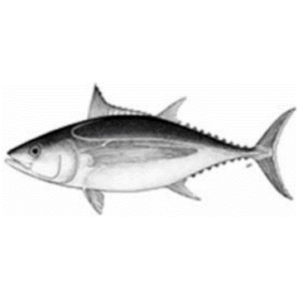
Figure 2 Foobar
Figure 3 A nice specimen of Indo-Pacific sailfish

Heading 3
Lorem ipsum sit dolor amet
Table 1 A not so nice example of table
LOREM | IPSUM | SIT
Lorem | Ipsum | Sit

Heading 4
Lorem ipsum sit dolor amet

Heading 5
Usque tandem abutere, Catilina, patientia nostra?

Table of figures
Figure 1 A nice example of blue marlin 1
Figure 2 A nice specimen of Indo-Pacific sailfish 2

Table of tables
Table 1 A not so nice example of table 2

Table of Contents
Heading 1 1
Heading 2 1
Heading 3 2
Page 2 3
Heading 2 3
Heading 3 3

Page 2
Lorem ipsum sit dolor amet

Heading 2
Lorem ipsum sit dolor amet

Heading 3
Lorem ipsum sit dolor amet

Heading 4
Lorem ipsum sit dolor amet

Amet dolor sit ipsum lorem
Lorem ipsum sit dolor amet

