The Project Gutenberg EBook of The Mathematical-Historical Principles and
the Evolution of Liberty, by Victor Jose Fernandez Bolivar

This eBook is for the use of anyone anywhere at no cost and with
almost no restrictions whatsoever. You may copy it, give it away or
re-use it under the terms of the Project Gutenberg License included
with this eBook or online at www.gutenberg.org

** This is a COPYRIGHTED Project Gutenberg eBook, Details Below **
** Please follow the copyright guidelines in this file. **

Title: The Mathematical-Historical Principles and the Evolution of Liberty

Author: Victor Jose Fernandez Bolivar

Release Date: October 4, 2009 [EBook #30174]

Language: English

Character set encoding: ASCII

*** START OF THIS PROJECT GUTENBERG EBOOK MATHEMATICAL-HISTORICAL PRINCIPLES ***

Produced by Al Haines

The Mathematical-Historical Principles
and the Evolution of Liberty

eBook First Edition in English

Víctor José Fernández Bolívar

Translation to English by
Asunción Ferrer de Domínguez

Published by Jesús Javier Fernández Minguero
8431 Greenbank Boulevard. Windermere, FL 34786

The Mathematical-Historical Principles
and the Evolution of Liberty

This book is distributed under a Creative Commons Attribution-Noncommercial-Share Alike 3.0 United States license.

You are free:
- to Share — to copy, distribute and transmit the work
- to Remix — to adapt the work

Under the following conditions:
- Attribution. You must attribute the work in the manner specified by the author or licensor (but not in any way that suggests that they endorse you or your use of the work).
- Noncommercial. You may not use this work for commercial purposes.
- Share Alike. If you alter, transform, or build upon this work, you may distribute the resulting work only under the same or similar license to this one.
- For any reuse or distribution, you must make clear to others the license terms of this work. The best way to do this is with a link http://ivenezuela.com
- Any of the above conditions can be waived if you get permission from the publisher.

More info here: http://creativecommons.org/licenses/by-nc-sa/3.0/us/

See the end of this file for the complete license.

ISBN 0-9728861-3-3

Translated from the first edition in Spanish

Los Principios Matemático-Históricos

y la Evolución de la Libertad

ISBN 0-9728861-0-9

CONTENTS

CONTENTS i
DEDICATION 1
MAXIMS 3
BY MEANS OF A PROLOGUE 5
THE MATHEMATICAL-HISTORICAL, STRATEGIC AND POLITICAL CONCEPT 9
BACKGROUND AND SUMMARY 9
MATHEMATICAL-HISTORICAL PRINCIPLES 12
DECISIVE WORLD BATTLES. 18
THE MATHEMATICS OF HISTORY 34
BIOLOGICAL PROCESSES ARE MATHEMATICAL PROCESSES 38
THE CYCLICAL CONCEPT OF HISTORY 43
SOCIAL CYCLE 51
WORLD PROSPECTIVE OF THE XXI CENTURY 55
THE EVOLUTION OF LIBERTY 69
MATHEMATICAL-HISTORICAL CYCLE MODEL OF A HISPANIC-AMERICAN COUNTRY: VENEZUELA 77
ANNEX NO. 1 79
CHARTS AND GRAPHS 83
CURRICULUM VITAE OF THE AUTHOR 116
BIBLIOGRAPHY 124
Creative Commons License 127

DEDICATION

To Dr. ALEJANDRO DEULOFEU TORRES

Born in Catalonia, Spain.

Died on December 27, 1978.

To my father JEREMÍAS FERNÁNDEZ FERNÁNDEZ

Born in Humocaroalto, Lara State, Venezuela.

Died on October 24, 1965.

MAXIMS

“Truth is History, History is Truth, these two domains should not be separated”.

JEAN GUITTON

“Only truth is logical. Truth never stands out more than when it is next to the event from which it is born”.

CECILIO ACOSTA

“It is never too soon for the knowledge of exact sciences, for they show us to analyze everything, starting from that which we know to that which we do not know, in this manner we learn to think and to relate to logic”.

“Before anything we should use reason”.

SIMON BOLIVAR

“Anything that is not based on physically and mathematically exact foundations, should be banished by reason”.

“It is always necessary to conduct oneself by reason and calculation”.

“Reason, logic above all, should be the constant guide and objective”.

NAPOLEON BONAPARTE

BY MEANS OF A PROLOGUE

It is a pleasure to present a work based on facets that discover, or once again manifest, the Liberator’s prodigious personality and work.

Providence, which seems to pamper the tasks of historians, since they are who best show God’s maximum work when studying men’s acts, has placed the inexhaustible quarry of Simon Bolivar's life and work before Venezuelans and foreigners. A long and deep historical process is condensed within his person. Like the great men of humanity to whose lineage the genial citizens of Caracas belong, the Bolivarian campaign becomes universal and overflows the limits of a whole continent to take the message of faith in liberty to men throughout the world.

When the historic current towards the Liberator is considered, in my opinion it only examines it under the sole prism of Venezuelan, Great Colombian or American events. This sole prism would mutilate his thought. Furthermore, it would provide a half understanding of the finality of his work. By the right that his genius concedes to him, Bolivar is a man through universal autonomasy. More than a presentment, he truly knows that South American liberty to which he consecrates himself, involves a gift of future progressive development the beneficiaries of which should be, jointly with the Americans, men of all climates and of all races. For the artisans of five nations who owe him their liberty, these lands cannot constitute a closed ark where its inhabitants develop themselves outside of the universal process that can and should unite men and Nations. Tightly closed regional structures that are not solidary to the world that surrounds them, do not have a place in his thought and for this reason, he goes on to broaden his work and provide new fields to his wide and generous action. Caracas, Bogotá, Quito, Lima and La Paz, constitute the wide and rocky Andean platform where his universal personality shines. He searches for changes of a destiny in God’s own roads: the roads of men’s liberty, the personal or community potter of every historical process.

In the work that whoever reads these lines holds in his hands, the reader may appreciate the valor of a historian who has been formed by persistence, intelligence, very solid indeed, and serene and clear meditation that flows by means of his own style without the pretension of shining in vain.

Years ago I had the honor of meeting General Víctor José Fernández Bolívar. From this first moment we agreed, when we focused, during long talks, on various cultural matters. And above all, on matters regarding ancient and contemporary history. Since then, I realized that his forte was not light chronicles or partial anecdotes that, although it is true, help much, but cannot impart on their own, the scientific thought of history. In this field he was seen as a good plainsman of our fascinating Apure, always looking forward without resting and retiring to meditate, with silent seclusion, on the experience of that vital content with the past and the present. With that attitude of life, an austere Fernández Bolívar arises who, having an indomitable internal discipline, coincides with his work, now having a universal quality, with the scientific conclusions that defend the so called mathematical interpretation of history. Mathematics that, on the other hand, explains the processes of human events so that man, the basic unit of history, does not have his liberty reduced.

General Víctor José Fernández Bolívar, a good Venezuelan military man, seems obsessed by his historical research, that is, by the overflowing force of the life and work of the Liberator. How could he escape from this obsession when his research and work move within the great historical synthesis of universal dimensions? By only reading the simple summary of this work we can see what I have just pointed out. In one sole precision piece to which I would describe as admirable, we are given the basic concepts of the author’s thought, the particular process of the meeting between Bolivar and San Martin, so many times focused on various criteria of interpretation, and its conclusions, a true analytical jewel, of that memorable act where the magnanimous Liberators taught the Americans a lesson of understanding the sacred interests of this Continent to those who wish to search and find, by means of dialog.

This dense and keen research is quite current. Let us not forget that the integration of our Andean Countries, today on the way to completeness, tends to be geared towards a Latin American integration, as a prior step, and that, in its historical-vital center, the already far reality of the Guayaquil meeting is brought to mind.

Only two years ago, in the Spain we carry deep in our hearts, the author and I, talked about the matter of what this work would be like. Before us was the ancient façade of the Cathedral of Toledo. Everything wrapped us into a distant past the prints of which, in the present, made us foresee the future of our civilization. Then, we understood one more time that, in the scheme of history, we cannot do without the past threads that try to unite us under an always-latent ecumenism, even though we often pretend to ignore it. The mathematics of history discovers those threads for us and, when it places them in our hands to prolong them towards the future, it makes us work towards achieving a better world.

The message of this work by General Víctor José Fernández Bolívar, with the interpretation of history that he poses herein, constitutes a message of optimistic and conscientious seriousness. If we want to think, we should visit its pages. Only he who seriously and sincerely thinks can guide us through the roads of true history.

“The meeting between Bolívar and San Martín”, when it makes us think, is true and constructive history.

ENRIQUE DIAZ RUIZ

THE MATHEMATICAL-HISTORICAL, STRATEGIC AND POLITICAL CONCEPT

BACKGROUND AND SUMMARY

This first part of the strategic analysis of the Mathematics of History of Dr. Alejandro Deulofeu, constituted my thesis when I was a student at the Superior War School of Paris, being for me an honor to have had 106 French Officers as co-disciples and one officer for every country as follows: The United States, Germany, Great Britain, Italy, Spain, Belgium, Switzerland, Greece, Israel, Turkey, Iran, Thailand, Cambodia, South Africa, Peru, Brazil and Argentina.

Then, in May of 1963, leaving the normal road of these academic school assignments, the thesis was studied by an organism higher than the Institute, in addition to having been read by Monsieur Le Ministre des Armées (Minister of Defense), which was a great honor for me.

It woke up such an interest, that I was asked for the French publication and it was delivered to the United States of America in July, 1963.

With pleasure I met requests from interested parties from various countries of Europe, Asia, North and South Africa, once this first part was edited in Spanish as a supplement to the magazine of the Armed Forces of Venezuela (August, 1964).

The Strategic Interpretation of the Mathematics of History, is the first synthesis of this nature that is done in the world of the mathematics of history (The Law of History), that was discovered by Dr. Deulofeu, a native of Catalonia, Spain. During five years at the Montpellier University (France), in history courses and assignments, he began these studies, on a different road from that taken by other historians, who, in general, conclude that starting from stone age man, humanity has been following a painstaking uphill road in order to reach levels that are increasingly higher through diverse civilizations.

They have also not given attention to the time factor, accepting that this process does not obey fixed and determined laws either in their evolution or in the time to execute it. They have concluded that human evolution cannot be measured nor is it predictable, that the factors that govern the process can vary at a given moment and change the direction of the evolution of nations and that, whether or not an exceptional man appears, it can change the course of history at any time.”

“With such conceptions it is impossible to reach an historical synthesis: man is the only one responsible for his acts, it is he who decides the future and the sense of history. It is not determined but subject to unexpected changes.”

“These basic ideas are the ones that have generally presided historical studies and have lead to certain conclusions that make human history a true chaos. Discord has been seen where there is perfect harmony, liberty or action where everything is subject to the laws, chaos has been seen where perfect order governs.”

“The conclusions of the Mathematics of History are totally opposed to those of the historians and philosophers who have preceded us” exposes Dr. Deulofeu. “Humanity does not follow a constantly ascending road, it instead follows an oscillating process; these oscillations lead to the creation of great civilizations that fall in order to be substituted by other new ones and that they are not developed arbitrarily or have a variable duration, but rather appear at the precise moment, and develop following the same phases, employing therefor the same space of time, that there is nothing indeterminate in the human process but everything obeys a mathematical precision. That humanity does not progress but simply goes through phases of maximum civilization followed by others of minimum civilization and so forth, notwithstanding that between these peaks and valleys remarkable differences are indicated where the degree of progress and culture is concerned”.

As a point of departure, thinkers had taken the most changeable character of these civilizations, that is, its soul and culture, and the conclusion had been that instead of reaching a total synthesis, they had done it to get the opposite result, as Dr. Deulofeu has proven in his complete work of the mathematics of history (24 volumes), still not published, placing in chronological order the historical facts of the different nations, for which he places the first part of this work outside of any discussion since they are historical events and the Mathematics of History is not a philosophical interpretation or a special vision of history.

Accordingly, once the mathematical law has been understood, dear reader, in the pages of historical text of your library, you can mark and refer to the curve corresponding to historical events and you will obtain the curve of the empire, of the individual liberty and the mathematical-sociological law of the country or countries you are interested in, said mark being left in your book to verify in this manner, objectively, that the mathematics of history is the Law of History and wherefore, its true concept.

Neither its degree of creative power nor its mentalities, nor its religion may serve as a base to achieve the causes and the evolution of nations. This total lack of orientation is manifested by Oswaldo Spengler in The Decadence of the West; he says: “An uncontainable mass of human beings, a shore less torrent that is born in the gloomy past, there where our feeling of time loses its sense of effective order and the restless fantasy, or terror, evokes the image of geological periods, to hide an undecipherable enigma behind it, a torrent that will be lost in a future that is so dark and out of time as the past, such is the background on which the Faustian image of human history is based. The uniform surge of innumerable generations moves the wide surface. Radiant flashes of light cut through the areas. Uncertain lights excitedly shake, making the clear mirror muddled, they are confused, they shine, they disappear. We have called them races, people, tribes. They make up a series of generations in a limited circle of the historical surface and when the creative force is extinguished within them, a very variable force – which prefixes on those phenomena a duration and plasticity that is also quite variable – they extinguish themselves, the features, the linguistic, spiritual characters and the historical concretion again dissolves itself in the case of generations”.

These words express that failure in search of a law that would order the evolution of these cultures, could not be more absolute, however, the law existed, what was missing was finding the regular and constant variable in all nations and in all cultures that determine it.

Neither Spengler, nor Toynbee, nor any one who may have preceded the author of the Mathematics of History in this excursion within history, were able to find it, and, as he himself says, it is understandable that they did not find it, since they searched for it in those changeable unstable abilities of men, starting from factors of psychological, intellectual or moral order, since each one of us is different. However, if we observe that the birth of a child is followed by his growth, his complete development, his old age and his death, on these bases we can affirm that other children will follow a similar process and the possibility of deducing a law from these events can be found. Similarly, in activities in which a common law cannot be found in the moral or intellectual order, it may be found in its biological aspect. This is where Dr. Deulofeu found the mathematical law that arranges the evolution of nations and the appearance of great cultures.

MATHEMATICAL-HISTORICAL PRINCIPLES

- Great Strategic Victories with the domain of phases corresponding to great aggressive processes. Victory is a constant and it is the conclusion of every attack. It is the phase of Great Offensives.

- Victory in the defense is a characteristic of the era of Great Demographic Fractionation. Strategic victories are reserved to the defensive. An offensive with success is only obtained in order to enforce the defense of the region. It is the defense and the counter-offense phase.

- The strongest strategic weakness is characteristic of the Great Depression.

- Disintegration is the phase where strategic offensives are useless to back up the continental or intercontinental empire. The strategic potential is effective for the imperial body or nation, but it is always useless for the second empire of the cycle, that is, when the nation is about to enter the era of great demographic fractionation.

- Conservation is the maintenance phase of the empire. Any military operation in this phase should be closely studied and analyzed, including the human means factor. Victories and defeats alternate with each other. It is more a phase of the defensive in order to maintain conquered geographical regions.

- In the Relative Independence phase, the strategic potential is equal to that of a nation, depending on the country’s military, economic and strategic ability.

- Military disaster is an inexorable defeat, whether it is a campaign or a complete war.

- The territory of a nation maintains its military potentiality towards territorial defense and an offensive potentiality, according to its geographical position, in the corresponding social cycle and in the social phase of the cycle.

- There should be no friction between classical principles and mathematical-historical principles. These give results of the war or, in other cases, govern the total or High strategy. They are a strategic synthesis of the Law of History, that is, eternal Laws of the Art of war, that dominate the whole set. Accordingly, they are a determining factor in all strategic operations throughout the planet, not only in times of peace but also in times of war.

The author of Mathematics of History, Dr. Deulofeu, started on a different road than the one followed by other historians. The mathematics of history shows in an analysis of 5,100 years that humanity does not follow a road of ascending but oscillating progress that obeys mathematical precision.

The mathematical-historical cycle is 1,700 years, distributed thus: six and one-half centuries for the Era of Great Demographic Fractionation, and ten and one-half centuries for the Era of Great Unification, separated by a phase of Relative Independence that is indicated by a straight line. Each nucleus of union or empire, has a first aggressive process or first Period of Great Strategic Victories, as an ascending line, followed by a Great Depression, afterwards, a second aggressive process that has a unifying character, different from the first one, that is a federal characteristic. Afterwards, there follows a Military Disaster, that only affects the Armed Forces factor, afterwards, a Conservation phase and finally, Decadence or Disintegration.

If this nucleus is the first one, then the Relative independence phase follows, and if it is the second one, then the era of Great Union of ten and one-half centuries ends, and the era of Great Fractionation of the following 1,700 years begins, and so forth.

The empire Unification nuclei have an approximate duration of between five and five and one-half centuries.

In the second period of great strategic victories or second aggressive process, that is characterized by its centralization or unification of the corresponding empire, there appeared the so called Great Captains: Hannibal, in the Carthaginian Empire, Alexander the Great, in the Macedonian Empire, Julius Caesar, in the Roman Empire, Napoleon in the French Empire, etc.

Man is an expression of the historical phase. Wars took place not as a function of the result of men against men, but of empires against empires, or nations against nations, each one in precise mathematical-historical phases, mentioned before, which have their own characteristics and are the reasons for the results of the wars fought.

The first period of great strategic victories, is a federal phase in which the empire is formed. Before beginning the first aggressive process, there may be a loss of territory as, for example, in the Polish Empire, that together with the Kingdom of Boleslas I (992-1025), the conquests made thereby, are almost totally lost during the Kingdom of his successor Mieszko II (1025-1034).

The aggressive process is characterized by peaceful victory or war, where territorial extension is concerned. Conquests and geographical domain extension are a constant. Strategic victory is predominant. With the second Punic War (218-202 B.C.), Rome in its period of great strategic victories, conquers Carthage. Likewise, in the third Roman-Macedonian War, the Macedonian Empire ends (146).

The first period of great strategic victories of the Roman Empire lasts 141 years (270-129 B.C.). The Macedonian Empire was constituted in 750 B.C., with the hegemony over the Lyngestis and other people. Its first aggressive process lasts until the year 506 B.C. The Carthaginian Empire starts its first aggressive process at the beginning of the VII century and ends in the year 340 B.C.

The great depression presents a remarkable social struggle, anarchy, civil war, defeats and lots of conquered territory being possible. The empire can be invaded almost to total ruin in some extreme cases.

The Carthaginian Empire is conquered in the great defeat of Mylae in the year 260. It confronts the Roman Empire in its first period of great strategic victories, Carthage had to surrender and accept the peace imposed by Rome (242). The Muscovite Empire in the great depression is invaded by the second Swedish Empire. The Polish Empire, in the 2nd period of great strategic victories also invades the Muscovite Empire.

The era of great demographic fractionation is characterized by the different fractions in which the empire has been transformed, and in the maintenance of a precise independence, as in the case of the people of Greece between 2700-2050 B.C., 1000-350 B.C., 700-1350 A.D. These people in these eras are not conquered and they cannot do it either. The Medic Wars represent a typical example that is also analyzed in detail in the book “Mathematical-Historical Principles”.

The Peloponnesian War represents interior wars between different nations in an era of great demographic fractionation. The second period of great strategic victories, military disaster and conservation, are the other phases of each unification nucleus.

During the great depression, the empire unifies, the army is organized and conquests and victories begin once more, characteristics of this second aggressive process. The recovery of lost territories with greater territorial expansion. Afterwards, the aspiration of a greater hegemony, looking for new conquests and military disaster takes place. However, this disaster is overcome but with the desire of conquest lessened. The empire is at its conservation phase, its only thought is to maintain the imperial domains. There can still be conquest, but this time having peaceful and benefactor qualities.

Strategic victories alternate with defeats. Afterwards there is an internal imbalance, the spirit of conquest is lost, there is disintegration of the empire, reduction of the imperial body and afterwards, the development of the era of great demographic fractionation; if the nucleus of the empire is disintegrated, it is the second cycle. If it were the first, it would follow an evolution up to the phase of relative independence.

A typical example of this last mentioned case is the interval between the 1st and 2nd Empire of Thebes (approx. 1,700 years B.C.) in the Egyptian culture. Likewise, the interval between the Han Dynasty or Mongolian Empire (approx. 200 years B.C.). When the empire is in its second cycle, that is, when the cycle of 1,700 years is about to end, then the nation begins the phase of great demographic fractionation, as in the case of the Byzantine Empire, disintegrated in a large number of small kingdoms, and as will be the case of the present Muscovite Empire, where the Slavic Nations will undergo an evolution towards the great era of great demographic fractionation.

As an example of the process of a nucleus we present the case of Rome in its first period of great strategic victories (270-139 B.C.), with the second Punic war it defeats Carthage. This Empire is founded in the year 879 B.C. and had undergone its period of great strategic victories (beginning of the VII Century up to 349 B.C.). Carthage, now in its first Punic war, manifested the spirit of indifference of the Carthaginians and of the Senate. In the year 382, it was full of the spirit of domination (the first period of Great Strategic Victories), in the year 255 it shows to be completely indifferent up to the extreme of abandoning its fleet. Thus, in spite of it all and having great Generals at its disposal, it had a defeat at Mylae in the year 260.

Afterwards there were new military losses until there was total ruin. The Empire was leaving the great depression when Hamilcar reorganizes the army and begins the conquests to thus enter its second period of great strategic victories, which arrives with Hannibal at his best. Immediately following comes the conquest of Italy (218).

It should be noted that Carthage had already gone through a long period in the first of great victories, and in these cases the second period of great triumphs, conservation and disintegration, are short in order to compensate the time of duration of the empire and, in this manner arrive at its end of approximately five and one-half centuries, with a very logical precipitation. Furthermore, Carthage had not had a military disaster. On its part, Rome presented itself thus: first Punic War (264-241), it conquers Sicily, Corsica and Sardinia. The first Roman-Macedonian War (221-205), where Macedonia is defeated. The time and its characteristics in victory, classified it in the first period of great strategic victories.

To summarize: Carthage launched itself into an offensive war with Hannibal, but with an already advanced Empire reaching its end and without a military disaster. It was about to confront another empire of lesser prestige at that time, but with youth and in its first period of great strategic victories. The Italian campaign by Hannibal begins with his triumphs in the battles of Mount Tesina, Trebbia, Trasimene and Cannae, returning to Carthage where he is defeated in Zama by Scipio.

Studying the enemy from the point of view of the mathematical-historical concept, is then, a new factor of the decision that should be analyzed and that completely influences the results in war.

The Macedonian Empire, constituted in the year 750 B.C., ends its first period of great strategic victories in the year 506, with the kingdom of Amintas I, after the great depression (506-413). This Empire is defeated by the Persian Empire. In the second period of great strategic victories (413-323), the Athenians are defeated and the Ionian colonies go on to become part of the Macedonian power. In the year 338 the dominion over Greece is complete.

Under the leadership of Alexander the Great (334-325) in the second period, the Macedonian Empire reaches its maximum point. In the year 221, Phillip the III, confronts the Roman Empire. The latter formed in 270, had its first victory in the first Punic War.

As a summary: Phillip the III with his Empire in its stage of disintegration, against the Roman Empire in its first period, which destroys the Macedonian fleet. The war begins again in the year 211 and is prolonged until 205 B.C., when Phillip made peace in Rome. In the space of time 200-197, Phillip is conquered in Cynoscephalae. The third Roman-Macedonian War ends the Macedonian Empire, which is totally absorbed by Rome in 146.

DECISIVE WORLD BATTLES.

- In the mathematical-historical concept, the Marathon result, one of the fifteen decisive world battles, was due to the historical phase that the Greeks were developing, the era of great demographic fractionation in which nations are not conquered, the Persians met the mathematical-historical process in the phase known as military disaster, after having gone through its first period.

- That of Arbella (331) which, along with the Battles of Granicus (334), Issus (333) and other strategic victories, constituted the second period of great victories of the Macedonian Empire of Alexander the Great. This battle of Arbella is part of the victory of Macedonia against Persia, an Empire going through a phase of decadence and disintegration. That is, an Empire undergoing expansion, Macedonia, fulfilling or developing the second aggressive process, against an Empire going through its last phase of disintegration: Persia.

It is a fact of the conquest and struggle of two Empires in the field of supremacy. It is the development of the historical process in which an empire substitutes another one and the battles that in succession form a set in order to fulfill the process, and not Arbella alone, that is: Granicus (334 B.C.), Issus (333 B.C.) and Arbella (331 B.C.).

The Battle of Metaurus, year 207 B.C., between the Romans and the Carthaginians is a precursor to the defeat of Hannibal in Zama. In the historical process: displacement of the creating force (strategic and not metaphysical concept), from the East to the West and from the South to the North, in the area adjacent to Europe, and in this continent, the chronological order of the development of the empires was as follows: Persia, Carthage, Macedonia, Rome, the Visigoth and the Teutonic Empires, this latter one in the Germanic area.

In this manner, the Roman Empire replaced the Carthaginian and Macedonian Empires. The Romans in the first period of great strategic victories, conquered Macedonia in the phase of decadence and disintegration, in the 1st, 2nd and 3rd Roman-Macedonian War, and reduced it to a Roman province (164 .B.C.). Likewise, Rome in the first period conquers Carthage, first in Metaurus and then in Zama.

The first battle mentioned, along with Zama, is responsible for the military disaster of the Carthaginian Empire. This Empire had a very short conservation phase since it had a long first period of great victories between 650-340 B.C., as a consequence, the result of the Battle of Metaurus was due to the phases of the two first Empires confronting each other, this articulated to the general process of displacement of the creative force of Rome vs. Carthage.

- The Battle of Arminius (year 9 of our era), was that in which Hermann, digitized by the Germanics with the name of Irminsul and later Latinized into Arminius, defeated the Roman legions commanded by Quintilius Varus, at the Teutoberg Forest or Teutoburgiensis Saltus. The Roman Empire had fulfilled the process of the first period of great victories and, as the mathematics of history indicates, having accomplished these three phases, the Empire tries to extend its rule and is stopped by the so called military disaster phase.

On the enemy’s side, the Teutonics or Germanics were undergoing a period of great demographic fractionation, where, according to mathematical principles, people are not conquered but are rather absorbed by people unified into empires or nations. The mentioned mathematical-historical principle says that “Victory in the defense is a characteristic of Great Demographic Fractionation. Strategic victories are reserved to the successful defense, they are only obtained to execute the region’s defense. It is the defense and counter offense phase”.

Among those we have analyzed up to now in the mathematical-historical concept, Arminius is as much a battle for liberty as Marathon. Both battles are also decisive.

- The battle of Châlons-Sur-Marne (451 B.C.) or the battle of the Catalunian Plains, was a victory over Attila, the King of the Huns. I should first explain that in the mathematics of history, the Roman Empire began in the year 270 B.C. and lasted up to 129 B.C. (a duration of 141 years), it had a Great Depression era from 129 to 59 B.C. (a duration of 188 years), a second period of great strategic victories from 59 B.C. to 161 A.D. (a duration of 102 years). The Empire’s total duration was 575 years.

As a consequence, Attila did not fight against the real Roman Empire, as Joaquín Izquierdo Creselles states in his Summary of General History (Volume I, page 156): “Invasions begin. The barbarians took advantage of this disorganization to invade the Empire. The army was not even close to what it had once been; nobody wanted to be a soldier. The infantry was being recruited from among the lowest classes and the cavalry was almost totally made up of Barbarians. In reality, towards the end of the III Century there was no Roman Army to speak of”.....“ Barbarian gangs appeared in the IV and V Century, wherefore, it is not worth saying that the barbarians defeated the Roman army since it no longer existed in the era of invasions and on the contrary, it was the Barbarians who made up the new army that substituted the real one, the old one of the Republic and of the Empire”.

“In the V Century entire nations were confederated, as were the Burgundians and the Visigoths. There was nothing but Barbarian armies, commanded by Barbarian chiefs and that, nevertheless, were called Roman and fought for Rome. But in fact, the Roman power did not exist and the last invasions had to end with the shadow of the authority that remained in the Eternal City”.

The Huns entered Europe crossing the Tanais in the year 375. They defeated and conquered the Alanos, the Ostrogoths and other tribes, who populated the margins of the Danube. In the year 450, Attila founded Buba at the shores of the Danube extending his domicile to the North of this river and the Black Sea, as well as to the West of the Caucasian, including areas having Slav and Gothic populations of and Teutonic origins. The South of the Danube was also a Hun province, from the Sau River to Novi, in Thrace.

Attila, having an army of 700,000 men crosses the Rhine and defeats the King of the Burgundians, who intended to detain his advance. He divides his forces into two armies: one advances on Tongress and Airras, the other one, under his command, towards the Moselle Valley. He destroys Besançon and other cities of the Bourgogne. He conquers the Eastern part of France and in the year 451, places Orleans under siege. The Roman General Aetius and his ally Theodoricus, King of the Visigoths, gather and organize an army that they called the Roman Legions. Regarding the King of the Visigoths, we should note that he was in the second period of great strategic victories. His process was the following first period of great strategic victories, 150-300 (lasted 150 years), great depression, 300-402 (101 years), second period of great strategic victories 401-507 (106 years) and disintegration, 507-713 (206 years). Its total duration was 563 years.

Upon the advance of Aetius and Theodoricus, Attila lifts the siege on Orleans and executed a retreat behind Marne, concentrates his forces on the plains of Châlons, where his extraordinary cavalry had advantages in its actions. Aetius commanded the right wing and Theodoricus the left one, Sangipan, King of the Alans being in the center. The attack is initiated by Attila charging over the right wing and being rejected by Aetius.

Simultaneously, Theodoricus attacked the right wing of the Huns, successfully destroying it, but it cost his life. Facing this situation, Attila decided to retreat towards an area that he had previously fortified. There he maintained his position, until he retreated towards Italy with the rest of his army. In his march he left desolation and death everywhere. He is said to have expressed: “Grass will never grow again under the hoofs of my horse”.

He destroyed Aquilea and many other cities of the North of Italy. Due to the eloquence and majesty of San Leone, he stopped at the doors of Rome. He demanded a tribute from the Emperor Valentino III and afterwards, returned to the jungles of the Danube.

Victory over Attila was due to the mathematical-historical phase of the Visigoths in their second aggressive process or second period of Great Strategic Victories. The historical phase of the Romans also contributed to it. The Roman Empire disappears substituted by four rival Constantine kingdoms and the wars between them (306-337). In the year 405, the remains of the Roman Empire fall under the domination of the Germanic Empires, that is, it had its phase of disintegration (161-305) and afterwards, of relative independence until the year 405, in which the Germanics dominate.

This means that the Romans did not develop their own second nucleus upon finishing the independence phase mentioned, that in this case corresponds to the last of this era of unification of six and one-half centuries, and then begins the era of great demographic fractionation of six and one-half centuries, for a total of 1,700 years of the mathematical-historical cycle. In this manner then, with the Romans a second and last nucleus of self unification did not take place, different from the case of China in which there was one which started in the year 1950.

History does not repeat itself but the process does repeat, as shown by the mathematics of history, which does not condemn the future, posing for man the domination of his destiny when he improves mentally and spiritually.

We are going to present two historical perspectives in the plane of world strategy: the Chinese developed from 2850 B.C. up to 1150 B.C., their first mathematical-historical cycle of 1,700 years. During it, they lived six and one-half centuries in an era of Great Demographic Fractionation, and ten and one-half centuries in an era of Great Unification. The mathematics of history law is fulfilled in said eras. Thus, in unification, two nuclei or empires were developed: the Hsia Dynasty or Empire, afterwards, the phase of relative independence and then the second nucleus or empire, with the Shang Dynasty or Empire.

The second mathematical-historical cycle, from 1150 B.C. to the year 550 A.D., year of great demographic fractionation, lasting six and one-half centuries, with the Chou and Laotse Dynasties, the era of unification, with the Chan and Han Dynasties, after the phase of relative independence and after the Mongolian Empire. In the mentioned cycles, 1st and 2nd, the process exactly repeats itself.

The third cycle begins in the year 550 A.D. with Shui, Tang and Sung, having a duration of six and one-half centuries, that of unification that presently develops and that should last six and one-half centuries (up to the year 2,250), follows the same process, exactly the same as the first and second mathematical-historical cycles. The first nucleus, with the Mongolian Empire, Ming era and Manchu era, that ended in the year 1912 and from that date the First Aggressive Process (Continental China) begins, after its Great Depression, Military Disaster, Conservation and Decadence or Disintegration.

It is estimated that this third historical cycle will end in the year 2250, that is, the year 550 was the end of the second cycle, plus 1,700 years, the duration of a mathematical-historical cycle, total 2,250 years. The end of the first aggressive process is estimated in the years 2,016 to 2,050, or 2,150, based on the historical precedent that the process of the 1st or the 2nd will be exactly repeated, likewise, the development of this third one is being fulfilled. If we should add the year of the mentioned battle (451) to the duration of the cycle (1,700 years), it results in the year 2151, date on which the process should be repeated, notwithstanding it condemning the future in the mathematical-historical concept.

This date of 2151 is included in the expansion and aggressiveness of Continental China, for which it is worth estimating that it could be the Military Disaster at the end of the second period of Great Strategic Victories.

The invasion of Attila began in the year 375, then 1,700 + 375 = 2,075. That is, Continental China would invade Europe approximately in the year 2075. If it were the Military Disaster, it would mean that in that year, they would have already gone through the Great Depression and the second period of Great Strategic Victories. There is another hypothesis regarding the present nucleus and development of this empire that began its first Aggressive Process in 1950, and it is when we can estimate that once the year 2000 ends, the development of its first period of Great Victories would be at its highest point, and an invasion of such a nature would be possible without estimating the date, but observing its development it could begin in the year 2151.

Summarizing, based on the historical precedent of the Great Depression, the most probable deduced dates would be 2016, 2050 and 2150, since there would be three probable curves related to the year 2151:

- Process or period of Great Strategic Victories (1950-2016), Great Depression (2016-2026) and second period of Great Victories (2026-2050).

- First Process, Military Disaster, Conservation and Decadence (2060- 2250).

- First Aggressive Process (1950-2150), Great Depression (2150-2160), second Aggressive Process, Military Disaster, Conservation and Decadence (2160-2250).

One-fourth curve at an open date, is also possible: first process 1950-2000, invasion of the U.S.S.R., Conservation and Decadence 2000-2250. That is, the first aggressive process, the great depression and the military disaster, are done before the year 2000 and afterwards, the other phases are developed until the Empire ends and so the 4th mathematical-historical cycle of Continental China. It is obvious that border problems with the U.S.S.R. will continue to worsen and it is perfectly conceivable, due to the situation posed in this Chinese nucleus, that there could be an invasion of the U.S.S.R., occupying territories that are not Slavic, since these nations are about to end their historical cycle.

The U.S.S.R had its era of Great Unification, first federal phase nucleus, from the year 850 to 1050, the Unitary phase from1050 to 1250, Decadence between 1250-1350, following Disintegration from 1350-1450. Afterwards, the Relative Independence phase and then, the second nucleus and empire, with the City of Moscow, first aggressive process 1462-1580, the Great Depression 1580-1645, second period of Great Victories, Military Disaster and Conservation 1645-1904 and finally Disintegration, approximately 1904-2000. This last phase began in the Russian-Japanese War in the year 1904.

Returning to the matter of the Chinese invasion of Europe, the resistance nucleus in this cycle is the Federal Republic of Germany, nation whose process has been as follows:

The era of great demographic fractionation, first cycle 550 B.C. until 100 A.D., era of Unification from 100 until 1150. The second cycle, era of great fractionation 1150 until 1800, era of unification 1800-2850, in which it has developed its first nucleus up to the War of 1870, first period of great strategic victories and military disaster.

At the present time it is in the Conservation phase and its highest point will last approximately some 300 years. Compared and matched like two drops of water, Hitler played the role of Othon II in the first phase of the Teutonic Empire, the first mathematical-historical cycle of Europe. In this continent, the creative force then is in the Federal Republic of Germany. In Asia, in Continental China (the region between Huanho and Weiho) and also in Japan.

In the Americas, it started in the United States of America since 1783, date of the beginning of its first Period of Great Strategic Victories, and soon to go on to the next phase, the Great Depression, to continue with its second period of Great Victories and so forth, according to the Mathematical Law of History. Henceforth, the force will also go on to South America, which we have called the Great Colombia of the XXI Century, due to the historical precedent of Simón Bolívar, then to Brazil and to the Rio de la Plata area.

In reference to the next phase of the United States of America (Great Depression), other prospective concepts are exposed: Continental China will invade the Unites States of America in the mentioned phase (possible and probable hypothesis). The Mathematics of History shows that in depressive phases, the great nuclei invade each other when they are in these phases within the general processes that follow, as well as other nations that may have a historical relationship due to borders, nearby zones or other interests, with the great nucleus in a depression.

It is the dynamics of history, its development and process, the comings and goings of nations in their respective phases, is the oscillation of man, of cultures and civilizations, that reach their maximum and afterwards a minimum level.

- The Battle of Tours in the year 732, Charles Martel against the Arabs, the latter commanded by the brave Abderraman. It was a warlike action of the second aggressive process of the French Empire against the Arabs. The French Empire developed its first aggressive process from the year 250 to 561 (a duration of 311 years), its great depression from 561 to 688 (a duration of 125 years), the second period of great strategic victories from 688 to 815 (a duration of 129 years) and disintegration from 815 to 879 (64 years), resulting in a total of 629 years. The Arabs, owners of Spain and after one century of victories, attack Gaul in the year 732. After the defeat of Tours, they retreat to Spain for eight centuries until they return to their continent due to Hispanic weapons.

- The Battle of Saratoga (October 7, 1778). This battle decides the independence of the United States of America. Great Britain was practically at the beginning of its great depression when it faced its then colony in this decisive battle.

- The Battle of Lepanto (October 7, 1571). In the historical process of Europe and adjacent areas, where it concerns the first mathematical-historical cycle, in chronological order, the Persian, Carthaginian, Macedonian, Roman, Visigoth, French, and Teutonic Empires developed. It was the mathematical substitution of the supremacy of some for others respectively. The second mathematical-historical cycle begins with the Turkish Empire, then the Spanish, French, English Empires and the Federal Republic of Germany. The Turkish Empire is followed by the Spanish, so that the Battle of Lepanto, a warlike decisive event in this process, expresses the phase of decadence and disintegration of the Turkish Empire and the first period of great victories of the Spanish Empire. This is the reason for the result of this battle.

“Great strategic victories belong to the phases corresponding to two great aggressive processes. Victory is a constant and it is the conclusion of every attack. That is the phase of great offensives”. This was the phase of the Spanish Empire.

“Decadence and disintegration is the phase in which strategic offensives are useless to back up the continental or intercontinental empire. Effective strategic potentiality is effective for the imperial body or nation, but it is always useless for the second empire of the mathematical-historical cycle, that is, when the nation is about to go through the era of great demographic fractionation”.

The Turkish Empire had gone through the phases of the first period of great victories (1250-1392), the great depression (1392-1422), second period of great victories (1432-1572) and was about to develop the phase of decadence and disintegration with a brief duration of the conservation phase. Although Lepanto was at the end of 1571 is it considered as the beginning of the phase of decadence.

- The Battle of Valmy (September 28, 1792). The ethnic group of the Germanic area was undergoing the Great Demographic Fractionation era. France was ending its phase of Great Depression (1697-1793), in which, generally, the Empire is invalid in order to afterwards be able to expel the invaders. At the end of this phase, begins the second period of great victories in 1793. “Victory in the defense is a characteristic of the era of great demographic fractionation. Strategic victories are reserved for the defensive. Successful offensive is only achieved in order to enforce the defense of the region. It is the defense and counter-offense phase”.

According to this mathematical-historical principle, the Germanic ethnic group did not have an offensive strategic ability. On the other hand, France was about to end its second period of Great Strategic Victories.

- The Battle of Bailen (July 15, 1808). The result of this battle was due to the independent value that territories in the historical process of the corresponding ethnic group have. An empire is developed, it expands towards its neighbors, when they are undergoing the depressive phase, but when they recover they expel the invader. There is no permanent occupation but it is rather temporary. Thus, there exists a historical force that provides unity and sovereignty to each geographical area, with its corresponding ethnic group. To the expansion of the French Empire in its second period of Great Victories, there follows a setback that is known as the Military Disaster, which was the Battle of Waterloo in the year 1815. Likewise, as in the French retreat from Spain, essentially marked by the Battle of Bailen.

“Conservation is a phase of Empire maintenance. Any strategic operation in this phase should be closely analyzed, including the human means factor. Victories and defeats alternate with each other. It is more a phase of the defensive in the maintenance of conquered geographical regions of the imperial body”. This mathematical-historical principle was influential in the victory of Bailen.

- The Battle of Bleinheim (August 15, 1704). This Battle that is called, Hochsted by the French and Belinheim, by the Germans, gather a series of European Countries, among which was the British Empire, in the phase of the first period of Great Strategic Victories (1609-1783).

- The Battle of Orleans (May 7, 1942). At this time, the English and French were undergoing an era of Great Demographic Fractionation, and, according the mathematical-strategic concept, England did not have a strategic offensive capacity and, as we have already seen: “Victory in the defense if a characteristic of the era of great demographic fractionation. Strategic victories are reserved to the defensive. A successful offensive is only obtained to enforce the defense of the region”. It was thus impossible to detain the French mathematical-historical process.

The destruction of the undefeatable Armada of Phillip II in the year 1558. The Spanish Empire was at that time in the first period of great strategic victories (1479-1643). However, England was in an era of Great Fractionation and soon to begin the year 1783, year in which that phase was to end. We already know by the mathematical-historical principles of the characteristics of nations during that era and, in this case, furthermore, the advance of the creative force, developing, in chronological order the Turkish, Spanish, British Empires and the Federal Republic of Germany, and this second cycle of Europe and its adjacent area.

This is then the mathematical-historical reason for the result of this Battle, the truth and its pure cause.

- The Battle of the Boyne (July 1, 1690). The British Empire was in the phase of the first period of Great Victories (1609-1783) and so was the French Empire, but the phase was coming to an end, so that in 1697 the Great Depression ended. The reason for the result of this Battle is that the phase which the English were undergoing, has as a characteristic, the unification of the geographical area with ethnic groups, that is, Great Britain. In this manner, then, the mathematical-historical process of the era of Unification in its second cycle of 1,700 years, had begun in the year 1609 to end various centuries later, estimated to be five or five and one-half centuries later.

- The Battle of Syracuse (year 413 B.C.). In this Battle the Syracusans defeated the Athenians. The reason for this was that Athens was in the year of Great Demographic Fractionation, in its first mathematical-historical cycle, and by concept and principle, nations in this phase do not have a strategic offensive capacity to conquer, occupy and overcome. The Italian nations were also developing the era of great fractionation of the first mathematical-historical cycle of Europe.

The term “decisive battles” is a very broad concept. It must be determined if they are decisive in a war between empires, nations in conquest, or liberty of a continent or geographical areas, that make up large or medium spaces.

The battles in the 1st or 2nd period of Great Victories are, in their majority, decisive in the conquest of an empire or nation. Also in the phase of great depression, whether to occupy or to expel the enemy. Likewise in the military disaster, if it is one sole battle or the last one, if they are various from one or another part of the adversaries. In the phase of decadence or disintegration, the first battle that is fought indicates the beginning of the phase, and the last one, marks the end of the empire.

Lastly, in the phase of relative independence, the last one is the decisive battle to begin the phase and that provides liberty to the country. Man is the expression of the historical phase, battles are historical events that express said phase and they form the whole of the nation’s process. Everything is continuity in time and in space. Everything is decisive in the thread of the historical process.

In the field of Operational Strategy battles would be defined by the three Clausewitz rules: “The concentration of effort, the strong man’s actions and the decision for the battle in the principal theater of operations”.

In the area of National Strategy, High or Grand Strategy, its definition is given with precision, the mathematical-historical concept, the mathematical-historical principle and the mathematics of history, as has been exposed and analyzed in this modest work.

In the mathematical-historical concept, we could say that it is a mathematical and humanistic world, in which the first determines the general process of cultures and civilization, of the creations, development and duration of empires and nations, where man is the expression of historical phases. Man can change his destiny only by mental and spiritual excellence.

Evolutions and revolutions follow each other without improvisation or delay, nothing is the work of chance. In cultures, civilizations and processes of man’s life in the planet, historical happenings and events occur as a chain reaction, as a great gear of a perfect machine, and an operation having a continuity and permanence in time and space. Everything is exactly fulfilled with an admirable precision. The process of a mathematical world framed within a humanistic field, of a man who oscillates from a maximum civilization to a minimum one.

Dr. Deulofeu says: “Today we have discovered a law that arranges the evolution of nations in the same manner as we know the law that governs the evolution of the individual. Perhaps one day we may know the circumstances that have caused collective evolution, as we know the physiological circumstances that produce birth, but it is possible that man will never know what is the profound origin of life”. That is, that perhaps the cycle of life or evolutionary cycle may not be modified, neither from the individual or from the collective point of view. Be that as it may, at the present time, man has been smoothing out the individual process protecting himself more and more against the inclemency of weather and illnesses.

In like manner, he can ensure as of now that the evolution of nations be done without bloody and violent struggles, without external or internal wars. What can man do to modify his destiny? “Man follows a defined evolution, he is born, he grows up, he reaches adulthood, enters decadence and finally dies. From the individual event, lets go on to the collective one. It has been shown that nations go through phases of winter inactivity, through phases of spring growth, through summer phases of complete creativity and finally through fall phases of decadence, to again enter into the winter phase and begin the cycle again”.

“Nations follow a cyclical process that is analogous to that of plants, but just as the cycle of plants lasts 365 days, that of nations is 1,700 years. If we compare the human process with that of irrational animals, we observe a fundamental difference where they do not know how to come out of their determinism, while man constantly breaks it. Cats and dogs have been defending themselves with their nails and fangs from time immemorial, man, on the other hand, constantly modifies his means of defense. Analogically, animals walk on their hoofs starting from their origin while man discovers other means of locomotion. With plants, the same or almost the same happens when collectively considered, they continue their vegetable cycle in an identical manner through the centuries, as long as the solar system is not modified. But man, at the same time as he has been discovering the laws of nature, has modified his way of life and has progressed as a result. Why should he not progress the day he discovers the laws that govern the life of collectivities? Human progress has been evidenced in the extinction and management of great epidemics with the discoveries of bacteriology. The same progress should be expected in the political, social and cultural arena, with the discovery of the mathematical law that has been governing the life of nations up to the present time”.

“While it was not known it was not possible to do anything in this sense. All societies or nations that have been built through time in order to avoid war, have resulted to be inoperative. But knowing said law, knowing before hand what will happen, it is absurd to think that men would voluntarily launch themselves into a precipice being able to modify the trajectory. Today we know where we are and where we are going. Is it in the hands of man to deviate the helm and change the course? The transcendental operation of turning the destiny of the world, advises us to study the process and system to be followed to execute this change of course”.

“At once a fundamental need arises: to tone down the convulsions that entail the foreseen process; once this has been accomplished, the possibilities of totally modifying it can be considered. When he develops from infancy to old age, man does not follow a smooth and easy course, on the contrary, he, in fact, has to sustain a constant struggle in order to defend himself in the environment that surrounds him (climate, illnesses, survival). He has been improving in this struggle, that is, modifying his natural condition of life and greatly reducing natural difficulties. Housing and hygiene conditions to a great extent have lessened mortality and human suffering; medical progress tends to diminish pain. And if it has been this way, capable of eliminating collective calamities such as cholera and yellow fever, it is possible to conceive that the day will come when all illness will be eliminated and man will be able to go on with his life without these perturbances”.

“Nations, when they begin their evolutional cycle, follow a road of progress and creation, but this road is not smooth, on the contrary, in order to progress they need to sustain a constant struggle against themselves. Extinct institutions do not disappear if it were not for violence. Exhausted regimes do not resign themselves to be voluntarily substituted and fight to the death to persist. Nations in full growth, if they want to extend themselves, have to forcibly drown decadent empires. Decrepit institutions, due to their instinct of conservation and because they think that by fighting they can lengthen their time, resist disappearing”.

“But institutions and their men, if they knew the fate that awaited them in the struggle before hand, would stop fighting if they knew they were going to be defeated. As soon as they knew of the catastrophes that would be produced and their results, the nations of the world should suppress wars. Will men abolish calamities in the same manner as violence has been abolished from individual combat and taking justice by one’s own hand be replaced by the creation of courts of justice?”

So man improves mentally and spiritually in order to have a better life, is our greatest desire when we pose bellicose subjects.

THE MATHEMATICS OF HISTORY

The universality of the law of History.

The law of History governs the process in all domains of human activity. Nations evolve, progress, decline and rise again, following some perfect cycles in the political, social, artistic, philosophical and scientific arenas. Nothing is the work of chance. The appearance and disappearance of great empires, the creation of architectural styles, the great discoveries, the great philosophical conceptions, obey a mechanism that is as precise as a clock. Up to now men have ignored it. Some have suspected it but up to now nobody had defined it. For this reason, men and nations have been following a road that, unknown to them, was traced beforehand.

Declarations of the mathematical law that determine the evolution of nations: We can resume that law in the following paragraphs:

- All nations go through eras of Great Demographic Fractionation, alternating with other of Great Unification or imperialist eras.

- Eras of Great Fractionation have a duration of six and one-half centuries. Eras of Great Unification last ten and one-half centuries. The cycle of evolution is made up of seventeen centuries.

- During this process of evolution, nations go through perfectly established phases so that at the end of the cycle they occupy the same position it had at the beginning thereof.

- The cycle of evolution covers all areas of human activity, that is, in addition to the political cycle, we must consider the social, artistic, philosophical and scientific ones.

- All nations follow the same evolution, but it is ahead or behind, according to the geographical position of each country.

- The creative force is not the same for all nations.

- Imperialist nuclei that give way to eras of Great Political Unification, follow perfect biological processes that are identical to each other and with one same longevity that lasts from five to six centuries.

- The transformation of political-social regimes is not done according to a constant ascending or descending line, but through alternative advances or reversals, some more intense than others, that produce a broken line as a result. The result of this line is equivalent to an advance in a determined sense. This is given the name of “Law of two paces towards the front and one towards the back” or “Oscillating Law”.

We are going to precisely determine and explain these paragraphs through a graphical representation of the evolutionary cycle. If in a system of Cartesian Coordinates we mark time over the X axis (horizontal axis) and the changes nations go through, from every point of view of human activity, over the Y axis (vertical axis), we can represent the evolutionary process thereof, as seen in Chart 1.

Marked on the horizontal axis, we see seventeen divisions that correspond to the seventeen centuries, that is the total duration of the cycle. The first six and one-half centuries correspond to the era of great fractionation. During this one there are no great political units, that is, nations or empires, such as we know them in our day, but, in fact, each city, with the small region that surrounds it, constitutes a real Independent State. During this era and starting from its origin (A), nations follow a life of progress in all areas of human activity, until they reach a maximum (B). We represent the evolutionary process of this first era by the ascending line that goes from A to B, that coincides with the end of this era of great fractionation.

Afterwards, an important political change occurs: nations lose their political liberty that reached up to a director nucleus. At the beginning, it will establish a military hegemony without intervening in the internal political organization of the cities, or in their particular governments. A broadly federal organization is then created. Gradually, the political regime changes and the hegemonic one accentuates its influence and intervention takes place in the local governments and, after a process of unification that lasts two centuries we see the particular governments disappearing.

Local languages and laws are substituted by the laws and languages of the hegemonic nucleus, at least in written documents, by the government.

We will call this first phase of the imperial era the Federal Phase, and is represented in the chart by the descending line B-C. Afterwards, we enter the unitary phase of great nations or empires.

The cities that form part of the empire have completely lost the conscience of their own personality and they feel identified with the hegemonic nucleus. This phase represent a regime that is completely opposed to the era of great fractionation and, in the chart it is represented by the line that goes from C to D.

From this moment on, that is, four centuries after the imperialist era began, the hegemonic nucleus starts its disintegration. The perfect unity achieved starts to deteriorate until it reaches total decomposition and substitution of the first imperial nucleus for a hegemonic one, which the unitary regime will maintain during a space of four and one-half centuries, that is, until the end of the cycle.

The two imperial nuclei do not present the same characteristics. The second enters the scene in a fully unitarian or absolute phase. The first empire considers its subjects as citizens, whether they belong to the imperial nucleus or to the other nations that form part of the empire, only with the condition that they waive their own characteristics and adopt the imperial language and law.

The disintegration of this first empire is manifested, as we have said, by a weakening of the central power, by the lack of discipline in the army, by civil war and by anarchy. Nations that make up part of the empire wish to make themselves independent and recover their own personality. Finally, disintegration of the empire is produced but the country immediately falls under the dominion of the new imperial nucleus. This one will act from the beginning as a true tyrant, will take power as well as wealth into its own hands, and will reduce the former citizens of the empire into the condition servants and slaves.

The new imperial nucleus will fulfill its evolutionary process and will enter into a phase of disintegration and decomposition. The weakening of the central power will result in turning over power into the hands of governors and sub-governments of the regions and cities until reaching the complete disintegration of the empire and to a regime known as “Feudal or Over imposed Powers”. With this one, we enter in the new era of Great Demographic Fractionation. We then begin a new cycle.

In the fourth paragraph of the law, this political cycle that we have just presented, is completed in the social, artistic, philosophical and scientific aspect, that is, that parallel to the first, we should consider a social, artistic, philosophical and scientific cycle.

The last phase of the cycle, as we have just seen, is that of the imperial and feudal aristocracy, that is, that of governors and sub-governors who have declared themselves independent from the imperial nucleus. These personalities conserve a certain vassalage with respect to their immediate superior, and he, at the same time, considers himself the vassal of the one above him. Under this type of aristocracy, the nation is subject to a regime of servants or slaves, without any material or spiritual power.

From the cultural point of view, we find ourselves without any spiritual activity. On one hand, there is a corrupt and degenerate aristocracy, which doesn’t have any other worry or desire but to satisfy its appetite for material things. On the side of the subjected class we find ourselves with a nation that does not have any possibility of instruction and who lives under submission.

We are about to enter the fifth paragraph of the law. If its fulfillment were as simple as we exposed and there were no other complications, this law would have already been discovered many years ago. But the case is given that, although said law is fulfilled with all precision in all the nations of the Earth, cycles are not simultaneous for all of them, but are advanced or delayed in some with respect to the others.

This advance or delay is determined as a function of the geographical position. As a consequence, as long as there are nations that are in the fractionation era, others are in the imperial era, and while some are going through the phase of democracy, other live in the absolutist or priestly phase, or in the regime of servitude.

This mixture is what gives the sensation of chaos that history presents, a purely apparent chaos, since it is enough to know the law that governs the evolution of nations, so that chaos may be transformed into an order for which nations are developed obeying a perfect clock movement.

BIOLOGICAL PROCESSES ARE MATHEMATICAL PROCESSES

It is an undeniable fact that, up to now, little importance has been given to the precise regularity with which biological processes are unfolded and, on the other hand, it is an absolute evidence that said processes are true mathematical processes. Starting from cariokinesis up to the movement of great collectivities, mathematics govern the evolution of living beings.

If we were to study cellular reproduction, we would always see how, starting from the fertilization of the egg up to the division of the fertilized cell, it goes through precise phases, perfectly defined, using for each one of them the same space of time. If from the fertilization of the egg we follow the process of multicellular beings until a new being appears, we observe how each animal specie always repeats the same phases and for this it uses the same space in time. It is well known that in the human being, the gestation period lasts exactly nine months and that for each specie there is an equally fixed and determined period. This gestation process of living beings is then, mathematical.

If we go on from gestation to the evolution of living beings, from their birth to their death we see has all go through the same phases of growth, completeness, decadence and death.

In man, for example, we know that children born today will continue a generation that will follow a process through precise stages of infancy, youth, completeness and death, that permits us to predict that in 20 years they will be youths like today’s 20-year-old individuals, that when they reach between 40 and 50 years old they will have reached completeness and that in a quite fixed age, determined by the arithmetic medium of the life of today’s man on the earth, his death will take place. With this, it is evidenced that human generations also obey a mathematical process. We are going to study this process that is not isolated but global, through the centuries of history.

As in the physiological and functional aspect, all generations obey the indicated rhythm, if we study them in the order of their intellectual activities (artistic, philosophical and scientific), we will observe remarkable differences. We would see that in one same region of earth there have been generations where some have manifested great creative activity while others have remained inactive and impenetrable to all intellectual activity.

However, these differences are not arbitrary but obey a precise rhythm to an exact mathematics. In a society, in a given moment, an awakening is initiated, that awakening is transmitted to successive generations, a creative breath begins to manifest itself and the contributions accumulate themselves in forthcoming generations until a maximum creative power is accomplished that afterwards, begins a decrease of activity, diminishing the creative power and, after a very precise and determined decadence, as that in the individual being, there appears another society undergoing an ascending process that, through its generations, will repeat the same springtime growth, creative fullness and winter phases.

After the winter phase a new creative cycle begins that will follow the same stages as the prior one, using, therefor, the same space in time, made up of seven centuries.

This second cycle will give way to a new creative phase that is even more important than the first one. Once the second cycle ends, another one will begin, also creative and of a duration that is equal to the ones that came before, but with a marked decadent creative force. Once this third cycle ends, nations return to the state of primitive societies with the loss of not only the creative power, but absolutely forgetting the creative force of past generations. Within these 17 centuries, nations live a first era of Great Demographic Fractionation of six and one-half centuries and then, an era of Unification of ten and one-half centuries, for a total of the 17 centuries of a historical cycle.

In the era of great fractionation, the geographical area of the ethnic group has a material and intellectual progress that keeps accentuating with certain characteristics and laws that govern this era of the nations.

In the unification era, a city imposes itself over the other ones in the geographical area, forming the imperial power and the first unification nucleus of the era or first empire, in the true sense of the word. This first nucleus presents a first phase that is its first aggressive process, it then falls, this would be its phase of great depression, afterwards it rises again: second process. Now the military disaster follows so that the empire enters in its phase of conservation and afterwards in the phase of disintegration.

All the great Captains have appeared in the second aggressive process: Hannibal, Alexander, Julius Caesar and Napoleon.

Rome imposes and unifies dominating the whole Italian Peninsula, thus forming the imperial body, afterwards the first aggressive process begins (the Roman Republic), afterwards it falls and great defeats take place. It rises again during the second period of great military victories (the Roman Empire), afterwards the military disaster takes place in the Battle of Teutoberg, while it tried to extend its empire in order to dominate the Germanic nations. Being that it was only a military disaster, it immediately recovers and enters into a phase of conservation and, then, disintegration.

After finishing this period of unification or first empire, there is an independence phase at the end of which a second imperial nucleus begins, having the same phases as the prior one, but more or less weak in its development, depending on the nation’s geographical position within the historical cycle in which it is being developed.

Analyzing the empires of this land since Egypt (4600 B.C.), those of Inner Asia (3700-3150 B.C.), China (2900 B.C.), Greece (2700 B.C.), Memphite (3150-2650), Sumerian (2900-2350 B.C.), Theban (2000-1450 B.C.) and Assyrius (1200-612 B.C.), all have followed the mathematical-Historical Process already mentioned in this strategic interpretation.

I would like to indicate three points before continuing:

- Once again I would like to thank Dr. Deulofeu for making it easy for me to commit to his mathematical law, letting me have the files of his complete work, for without the summary of the published mathematics of history and the other books that cover the subject, it would not have been possible for me to make and present a complete Strategic Analysis, in such a broad domain.

- I have worked with this law since 1961, and as involved as I am with it, I affirm one more time that we have in front of us The Law of History, Dr. Deulofeu being worthy of all the honors when he discovered in the historical process a social, artistic, philosophical and scientific cycle, in this manner covering all aspects of the life and history of the population of our planet.

- Once the Mathematical Law has been read and comprehended, it should be directly verified in any history book, marking in the pages of text the phase that corresponds and thus obtain the desired historic curve and personally verify that we are before the true concept of history. The events of history cannot be discussed as such, at the margin of the process herein posed.

In reference to the historical past that we referred to in this first part, it is convenient to retain that if wars and battles have had a determined result due to the phases each nation was undergoing, and that these were not real struggles but disputes between an empire or ethnic group against another one, each one in determined phases with characteristics and precise laws and not as it was thought and is still thought today, then, we can project the historical event to the future in a prospective field, with the phases of those nations and reason, in this plane of High Strategy, in order to take up the matter with truth as a principle.

In the cold war or in the hot war, I have reasoned one section of the Army Staff of the National Defense, determining thus a second part or partial synthesis of the immediate and mediate future. In the third part, I continue reasoning and studying in the same plane the historical curves of the future of the already mentioned powers and with them I have a final synthesis for the cold war and the hot war of the continuity of the world’s present situation.

B.H. Liddell says in his work “Historie Mondiale de la Strategie”: “If the horizon of the strategy is limited by war, the Great or High Strategy looks beyond war, towards peace that should follow it. It should not only dedicate itself to combine the diverse instruments of was, but also regulate its employment in order to avoid that which could be prejudicial to future peace that should be solid and prosperous”.

The deplorable state of peace in which both parties participate right after the majority of wars, could be due to the fact that, contrary to strategy, the air of high strategy mostly remains in an “unknown land“ that hopes to be explored and comprehended. In the second and third part, I have explored that “unknown land” with the mathematical-historical principles and with the human means as a strategic synthesis of the mathematics of history, thus opening a new field without prospection and leaving the mathematics of history as an basic element of future studies, in its application for war and for peace.

It should be remembered that this is a High Strategy or National Strategy work, which is formed by four particular strategies: Political, economical, psycho-social and armed force. Wherefore, it is a work of general interest. And to end, I quote from the Mathematical-Historical Principles deduced in my strategic synthesis:

“There should not be friction between these and classical principles. They give the result of war or, in other cases, govern the global strategy or high strategy, since they are a military synthesis of the law of history, that is, eternal laws of the art of war that dominated the whole set. Accordingly, it is necessary to keep them in mind in times of peace and in times of war in this planet”.

THE CYCLICAL CONCEPT OF HISTORY

The principal currents in the conceptions regarding the course of history can be reduced to two. One of them seen in history as a cycle or series of cycles that follow each other and, the other, sees an infinite straight line, without a beginning nor a foreseen end.

The concept of cycle is something very ancient and permanent in the human spirit. In the Brahmanian theory, cycles form the calendar of the gods. In ancient India the human year is made up of 360 days, without including the interpolated ones; the divine year is made up of 360 human years. One Haha Yuga is formed by 120,000 divine years and is divided into four eras of unequal duration and similar rhythm. An era is preceded by an ascending period and is followed by a phase of expiration; each one of them lasts one tenth of the principal era. The Krita Yuga is composed of 400 divine ascending years, 4,000 divine years of a principal year and 400 divine years of expiration.

The periods of the Near East are nearer to the current concepts of time. They are based on the direct observation of the stars, their interpretation of sacred books, cabalistic multiplications of the magic number, seven.

One Jewish historian in Rome during the I century, Josephus Flavius, says that the most ancient times were divided into eras of 600 years.

Sirius’ traslation movement of 1,461 years, that was the great astronomical discovery of the Egyptians, gave way to the appearance of mythological-historical conceptions on the sky. Within this period of 1,461 years, not only the processes are repeated but also the lands, in the same order of succession.

Another Egyptian cycle has a structure similar to the Indian divine year. It is made up of 36,525 years and it is said that once this cycle ends, the Golden Age will begin again on earth.

The Greeks have worked on this, they were searching for the “great cosmic year”, the rhythmic unit of universal evolution. From the era of Plato comes the idea of a universal cycle of 700.000 years, after which everything begins again. A later calculation to the II Century gives the universal year a duration of 9,977 earth years.

The conceptions of Plato and Aristotle are also cyclical. For Plato the perfect number by which universal events are governed is the “cycle of that which is created by God”. At the same time it is converted into one of the fundamental laws of ethics. Aristotle reaches similar results through very different roads: the mathematical and physical reflection. He said that there is only one perfect and lasting form of movement, that is circular, such as is shown by celestial bodies with the greatest purity. The transformation of terrestrial things are nothing more than movements in circles that are more or less perfect.

The Stoa that during 500 years has had a maximum influence on the intellectual formation of the Greeks and the Romans, proclaim the cyclical rhythm of universal events, explaining them as an eternal return to what is equal and not only similar. When stars return to being in the same position, a Socrates and Plato will appear again, and each individual person will be born again with the same friends and fellow citizens, he will suffer identically and will perform the same activities and, each city, place, nation and field will again arise in the same manner. Epicurean rejects as superstition the search for the great universal year and the theory of the third rebirth. “In nature, everything can return, but not in human life. Every human life is unique and individual and only for this reason does it have a value and an incentive. Man’s birth and death are accidents”.

In reference to this, says Richard Lewinsohn in his book “The revelation of the future”: “Now then, if millions of individual lives are not the same it would not be possible for entire repeated eras to exist for humanity”. It is true that the conception of the typical world of Epicurean does not leave an adequate margin for historical studies, because, what lessons could be taken out of history? The conception of Epicurean could be debated with multiple arguments. Isn’t man a living being? Is he exempt of the law that governs everything? I think that the mathematics of history of Dr. Deulofeu, that are facts, make the school of philosophy of the epicurean fall on the wayside.

In the Christian arena, in the beginnings of Christian literature, the 22 books of Saint Augustine “On the City of God”, it can be considered that the idea of the cyclical event is still alive. It is found with little change in the ecclesiastical texts: “.... that terrestrial states appear and succumb as a result of men’s sins”. In the “History of the Future” of the Jesuit Priest Antonio Vieira: “.... but at the end, there is always God’s kingdom, that which is terrestrial flows into the supernatural where everything is perfect and eternal, and where periodical catastrophes are already impossible”.

In the Renaissance the ancient example again starts the search for the great universal year. The word renaissance itself gives out a sense of cycle. The Italian humanist, Julio Cesar Scaliger, combines astronomical cycles with the tax collecting Roman period of fifteen years, period that is still used today as a unit of time in the papal bulla of 15 years. He thus obtains a cycle of 7,890 years. This cycle, that has the name of its discoverer: “The Julian Period”, had begun in the year 5,713 B.C., so that in Scaliger’s time in order to reach its end, 1,700 years would have to pass.

Nietzsche in his “Will to Power”, where he shows a magnificent song on the return to that which is equal, makes us understand that the cycle, for him, is no more than a vital principle, not a measurable magnitude. Other intellectuals of lesser importance found strength in their own era and showed that universal happenings are developed according to a fixed rhythm. In 1937 we have the case of a book that had the honor of being presented in the Academy of Moral and Political Sciences of France by one of its members, “Les Rythmes dans l’Historie”, by Gaston Georgel. It is part of a cabalistic number upon discovering in a passage of the Bible the formula 77 x 7, being a product that is equal to 539. This figure provides the author with the key to the true knowledge of the course of history. Every 539 years, its duplicate (1,078) and its quadruplicate (2,156), also years derived from the same figure, historical events of the same type are to repeat themselves. Georgel, using his formula, has closely studies history and has discovered multiple parallels therein, some of them having small deviations, facts that, according to him, imply an affirmation of the thesis.

More persuasive parallels could be discovered using Sirius’ cycle of 1,461 years. If we go back as many years from the first world war, we arrive at the V Century, in which the expeditions of the Catalunian fields take place (451), the scene of the Battle of Marne, which is of extreme historical importance. Going back from the Second World War we arrive almost exactly to the year 476, considered to be the year on which the Western Roman Empire ends.

In the year 1725, the Neapolitan historian, Giambattista Vico, in his work “Principles of a New Science on the Common Nature of Nations”, he supports his views on an Egyptian formula and gives the names of “divine, heroic and human age”, to the three stages that every nation goes through.

In the cycle of state regimes that are founded in the Aristotelian division, democracy is followed by tyranny, the latter by the oligarchy, which is followed by democracy, and so forth. One hundred years after the appearance of “Scienza Nuova” by Vico, Augusto Compte considers that the European community goes through three spiritual phases: Theological, in which faith dominates everything; another Theological, in which critical reason acts harassed by doubt, and another, Positive in which the only determining factor of action is scientific knowledge.

Herbert Spencer, a disciple of Darwin, who formulated a general law of evolution, that is valid for the natural and universal history, says that “.... evolution is absolutely continuous, it has no beginning nor end, there are no periods nor other subdivisions of a rhythmic character”.

The most acute criticism was presented by the French philosopher, Charles Renouvier, who, in a very ingenious manner, reduced Spencer’s extreme evolutionism into the absurd. In his book, “Uchronia”, he shows that in the history of humanity there is no infinite continuity, but that once and again cisures are produced and where from something finished something new is started.

Let us now see the cyclical aspect to war and peace. The periodicity of approximately 50 years has been found in wars having worldly importance, only in the XVIII, XIX centuries and the beginning of the XX century. In the space of approximately 200 years, five great warlike periods: the Spanish War of Succession, the three Sicilian Wars, the fist Napoleonic Wars, the Crimean War, the National Wars for the Unity of Italy and Germany, the American War of Secession, and the First World War. Toybee himself does not want to believe or admit the very optimistic forecast that the chart presents: Finding ourselves in the beginning of a great period of universal peace.

Toybee’s scheme is even less useful for prediction than the most ancient theory of the 50-year cycle. There is also the interpretation of the 1:2 relationship. After thirteen years of the Spanish War of Succession (1701-1714), there followed 26 years of peace; the period of the Sicilian Wars which, with varied intervals lasted 23 years, were followed by 33 years of peace; the period of 19 years of the Napoleonic wars (1796-1815), was followed by a period of 38 years of peace that extended until the Crimean War in 1853. The period of war that begins lasts 18 years until the end of the Franco-Prussian conflict in 1871, followed by an era of relative tranquility that lasts 40 years and extends until the Italo-Turkish war in 1911.

Afterwards, in Eastern Europe, before and after the First World War, there are almost uninterrupted warlike actions that extend until 1920. Peace follows this stage of 9 years. The Second World War lasted 6 years, but the annexations of Austria and Czechoslovakia in 1938 made by Hitler, without bloodshed must be added. Then, if a period of 7 to 8 years must be followed by one of peace of a double duration, according to a 1:2 relation, it could be said that in 1960 a new era of war should have begun.

This 1:2 relationship regarding the periods of war and peace, coincide with a very approximate rhythm in the economic juncture. Here each period of crises is followed by one of prosperity of a double duration. This is based on good human, physiological and psychological reasons. After a stage of extreme tension, danger and scarcity, double time would be needed to recover, rest and gather new energy. This rhythm has more probability of fulfillment than the ancient formula that one same generation does not go two times to war. There exists the period of centralization and decentralization. At the beginning, great wars, as the First World War, have an annexing and centralizing character but, afterwards, they end with the dismemberment of ancient and great empires and with the formation of numerous new states.

After the recognition of the independence of the United States of America by England in 1783, a first centralizing period begins in 1787, that goes beyond the French Revolution and the first decade of the Napoleonic Wars. Many small states disappear, the few states founded by Napoleon are merely vassal states. But in 1810, a new series is constituted, first in South America, where up to 1822 independent states begin, and afterwards in Europe with Greece and Belgium (1830).

In 1833, with the German Customs Union, a centralized period begins that ends in the union of Italy and Germany, period that extends until 1871. But starting from then and, especially in Central and Eastern Europe, the tendency towards the independence of nations is imposed: creation of the Balkan States (1878), independence of Czechoslovakia and Yugoslavia, resurrection of Poland, foundation of the Balkan States, Syria and Irak (1.918-1.920).

Afterwards, there comes the other centralistic wave that leads Italy to annex in 1936; Germany does the same with Austria and Czechoslovakia (1938-1939), and Russia takes over the Baltic States during the Second World War. Starting in 1947, a great movement of independence begins: India, Pakistan, Indonesia, Morocco, Tunisia and the foundation of Israel.

Together and during a period of more than 170 years, three periods of union have alternated with each other with three periods of separation:

PERIOD TENDENCY DURATION

1787 - 1809 Union 23 years
1810 - 1832 Separation 23 years
1833 - 1877 Union 45 years
1878 - 1921 Separation 44 years
1922 - 1946 Union 25 years
1947 - Separation

The present period of decentralization has lead to the dissolution of unions with a determined state system, such as Yugoslavia in 1948 and the failed coup in Hungary in 1956. It could be predicted with great probabilities of certainty, that this period has not yet ended.

Professor Gaston Bouthoul, of the High Social Studies School of France, member of the International Institute of Sociology, says in his work “Wars”: “In short, the presence of war in all types of known civilizations, the fact that it is inseparable from the most diverse mentalities and institutions and, above all, its analogy with certain biological functions, poses the question regarding its periodicity”, and continues to say: “An analogy merits, however, to be indicated: It is that of war with economic crises, they all present the same aspect of sudden eruption starting from a completely defined and identifiable point of rupture”, “....this analogy confirms the hypothesis of a certain periodicity in wars”, “....those of crisis are also elastic enough, since the classic interval among them varies in a medium value of between seven and eleven years, that is, approximately from single to double”.

Once we have gone over the horizon regarding the cyclic and linear system with a very positive balance for the cyclic one, I will now enter into Don Alejandro’s system of the mathematics of history.

Let us see what he says as a brief introduction: “If we observe that the birth of a child is followed by his growth, youth, his complete development, his old age and his death, on this base we can affirm that other children will follow a similar process and this can be seen as a possibility to deduce a law...” “.... It is an undeniable fact that biological processes are mathematical processes. From cariokinesis to the movements of the great collectivities, mathematics governs the evolution of living beings” and concludes: “Analogically, in collectivities in which we cannot find a common law in the moral or intellectual order, we can find the mathematical law that organizes the evolution of nations, the appearance and disappearance of great cultures”.

The mathematics of history provides a most solid basis, reinforces the supports for future research of universal history, of war and peace, of the economy, finance, military history for the development and future of humanity. The cyclical conception comes from the most prudent, authorized and conscientious opinions coming from serene reasoning.

If linear conceptions come from thinking minorities, that drown the words and opinions of men and, if there were still doubts that mathematics exists in universal history, let us observe the logic of the considerations of the mathematics of history, its sense, its organization of the events and its support in history itself, that are events.

The mathematics of history is a human reality. We are facing an undeniable fact, the logical organization of the events of history, without a pure mathematics that is not derived from one that is integral or from a differential equation but, within the mathematical concept of applied sciences where pure results are not achieved with the “Standard Meter”, the model unit of measure that is in Paris that, although it is kept hermetically sealed, is always under the influence of that which is material.

Remembering one of Plato’s maxim: “Vital force has been given to us by God, so that, by observing the sky’s circular motion, we may apply it to the cyclical form of the kingdom of our own thoughts, for they both are their relatives, the difference being that ours are perturbed whilst theirs are free from all perturbation”.

SOCIAL CYCLE

At the beginning of the cycle we warned of a remarkable change. The ancient nation reduced to a state of servitude has remarkably improved its position and already has a small participation in the harvest. From this moment on, its material and spiritual progress accentuates itself. Since the worker obtains a benefit from his work, his interest increases and, accordingly, improves his tools, worked more and production intensifies.

By this phenomenon repeating itself in all servants, the result is a general increase in wealth. Some more intelligent or more active, specialize. This is how trades are born. The use of money is extended. Thus, wealth, which was then motionless in the hands of the dominating class, can pass on to the servile class and, a minority, made up of the most intelligent, active or fortunate, begins to become wealthy. With this, there appears a new wealthy aristocracy.

We observe that the ancient division of society changes, giving room so that part of the ancient servants go on to constitute a middle class. One of these minorities, already wealthy, will make up the new aristocracy of wealth or high middle class. Very soon, the high middle class will not be happy with its wealth and will want to invest in city governments. From this moment on, the struggle between the new aristocracy and the old one begins.

This struggle will also follow a law, which is the one we know as “The Law of two steps forward and one step backwards” or Oscillating Law. In this struggle, the new aristocracy is supported by the nation from where it came. Four centuries after the beginning of the cycle, the new aristocracy is the winner and the government of the city is turned over to it. At this time, the middle class or petit bourgeoisie, has organized in unions or trades, and also wants its place in the government. One new struggle begins between these classes and the high middle class, and through successes and reversals, always obeying the oscillating law, the petit bourgeoisie finally joins the city governments.

At this moment all social classes participate in city government, with the preponderance of the petit bourgeoisie, we then arrive at the democratic regime, with the participation of all citizens in the government through popular assemblies. It is the government of the people. It meets in the public square or in the temple. All citizens intervene with their right to vote, and they decide whether there will be war or peace, the number of officials in the city or the election of its magistrates. The town deals out justice. This democracy does not include the whole town, since one part of the old servile class is left out, but the condition of those dispossessed has sensibly improved.

During the democratic regimes of the eras of great demographic fractionation, it is the citizens who resolve all city matters as an independent state, by a direct vote.

Human evolution does not ever stop. Once the apex is reached decadence begins. We observe, in the first place, that general interest for city matters is followed by the citizens’ great indifference. They begin to tire of intervening in the assemblies and, in an ever increasing number, stop attending them. Each day, the assembly sees the number of attendees reduced. On the other hand, a new spirit dominates social life. Up to then wealth was shared, there were neither great potentates nor great misery. Each one within his profession dedicated hours of rest to the manifestations of the spirit. But very soon, a great desire for wealth dominates the high lineage of the middle class, that, in its great majority continues to attend the assemblies and soon modifies the laws to protect itself and increase its wealth.

Commercial and industrial progress also contributes to the concentration of wealth. Great companies are born, while small commerce and industry disappear. Then, great fortunes and magnates of industry make their appearances, while small merchants and industrialists, ruined, go on to increase the humble classes. In short, society will have changed its aspect and the preponderance of the middle class will be substituted by that of a very rich class vis-à-vis a famished people. Such a change brings with it the intensification of class hatred and, forthwith, anarchy and civil war. This struggle presents the characteristics of terrible savagery. Hatred towards the enemy makes them forget their love for the city.

Old local patriotism disappears and, even rival parties will ask for the intervention of a foreign power, if in this manner they can destroy the enemy within. A similar anarchy and civil war, takes control of the cities towards a foreign power, to a dominating center that rapidly extends its hegemony on a great number of cities and on a great territorial extension. We enter into the imperial era.

We have indicated its characteristics, that is, a loss of the personality of the nations that go on to make up part of the empire and acquisition by those subject to the rights of the citizens. Afterwards, under a new imperial domination, comes the political and social regime that it had at the beginning.

The chart clearly indicates the phases of the social evolutions that begin by a first one, that has a duration of four centuries, during which the nation’s gradual progress arises under the domination of the imperial aristocracy. There follows a second phase in which power is taken over by the wealthy aristocracy until the middle class intervenes.

This phase of wealth and democracy aristocracy, has a duration of two and one-half centuries and, therewith, ends the first era of great fractionation that then had a total duration of six and one-half centuries. Then comes the phase of anarchy, civil war or decadence of democracy, and the cities, free until now, fall under the hegemony of an imperial nucleus. This federal phase has a duration of two centuries.

The unitary absolutist phase follows with the ascending process of the centuries, after which the decadence of the regime begins. A central power debilitation process is produced and, finally, disintegration comes and the nations of the empire remain under the domination of the new imperial nucleus that will subject the old citizens to the regime of servitude and slavery with which the century ends.

WORLD PROSPECTIVE OF THE XXI CENTURY

I.- a) From remote times, currents of culture are produced that are displaced over the surface of the earth, originating civilizations of diverse grades of advance, among others, some as advanced as the present ones and that, at the same time, develop great unification nuclei, empires or great nations.

In addition to the discovery of the great prehistoric civilizations, it should be added that the constitution of present-day skulls, is analogous to those of 400,000 years ago B.C., and so the utilization of fire, the date of which goes back to 250,000 B.C. In this sense, we should immediately study and research what man did in that space of time.

With the results of the excavations and works of Schliemann (Archeologist), Homer and the characters of The Iliad, stopped belonging to mythology and now are part of Greek history.

Likewise, the works of Evans (English Archeologist), the German Egyptologist, Lepsius, the French Egyptologist, Mariette and the English Archeologist and Egyptologist, Petrie, constitute a great headway.

b) Referring to the development of Assyrian, Babylonian, Egyptian and Cretan cultures, note the proportions and grandeur of their constructions, superior to others in any manner of comparison.

Luxury, refinement and sumptuousness reached extremes that have not been surpassed up to our time, an example of this is the Palace of Knossos, in the Island of Crete, comparable to the grandest palaces in modern and contemporary Europe, with its white columns, walls decorated with frescoes, rooms having overflowing luxury, beautiful bathrooms with water ducts and aeration devices.

People having garments and fashion that were superior to those of modern civilization. “Thus, in the frescoes one can see young people in a gracious and “nonchalant” attitude, lazily spread out in garden swings, playing or talking with Parisian wit in their eyes and their expression”. (The Mathematics of History).

In relation to the scientific field, Greek and Egyptian alchemists had a concept of matter and of atomic energy that is the same as those we have today. For atomic transmission, they used a simple retort and a universal crystallizer called a Philosophal Stone, that heretofore, has been impossible to reconstruct.

The mathematics of history shows that during the imperial phase of their second historic cycle and at a time that is symmetrical to ours, Egyptians perfectly knew the economic structure and its practical applications, as well as Einstein’s formula.

In India, the worry that we feel regarding atomic energy as a danger that can lead to the destruction of humanity, already existed near the year 275 B.C., at the beginning of the Kingdom of the Emperor Asoka (273-232 B.C.).

The Pyramid of Keops, built between 2700 and 2600 years B.C., is an encyclopedia of very advanced knowledge, as well as the geometric numeric system of exact sciences that was the origin of ancient units of measure. Rauston Skinner says that Parker’s reason was a foundation. This Astronomer found the integral reason between circumference and diameter, discovered by John Parker, 6,561, for the diameter and 20,612 for the circumference which brought forth the “Pi” result, that is, 3.14169265....

Aside from other data and measures regarding exact sciences, I hereby transcribe the following from the mathematics of history: “That is, that in the year 2700 B.C., the laws that were afterwards described by Kepler, were perfectly known, as well as Copernicus’ system, that is, after the Egyptian civilization, the great knowledge of their mathematicians and astronomers were lost, and the Greek culture ignored the Egyptian knowledge and, it is only upon its disappearance and in his attempt to explain the world, that Ptolemy of Alexandria, who lived in the II Century, discovers the geocentric system, this meaning the earth was considered the center of the solar system”.

This doctrine, based on mere appearance, was a concept that had forgotten the great knowledge of their ancestors, and we have to reach Kepler and Copernicus (1530), in order to rediscover the laws that govern the movement of the planets and that the Egyptians knew well in the era of the Pyramids.

Saniland Wake in his work “The origin and significance of the great pyramid”, affirms that a geometrically, numerically and astronomically exact scientific system, founded on the mathematical relations of “Pi”, formed part of a language that he thinks was contained and hidden within the type of the Hebrew text of the Bible.

II.- a) The mathematics of history shows that cultures and civilizations that are substituted with mathematical precision existed and still exist, giving way to a transcript or current, that keeps moving on the surface of the earth. A regular and precise succession of the vitality of nations mathematically carried out on this planet.

Thus, after the Sumerian, towards the East there is the Indian Culture, the Chinese culture and that of Japan; towards the West there is the Egyptian, Greek and Romantic-Gothic cultures.

It has been observed that each one begins in a region, extending themselves through the neighboring regions to which they arrive with relation to their point of origin, which means the transfer of the same culture.

The Sumerian culture is born in the junction of the Euphrates and Tigris rivers, and existed throughout Elam, the Iran, Baluchistan... until it occupied the area limited by two vertical lines: one that comes down from the shores of the Caspian Sea reaches the Persian Gulf, and another, starting from its source at the Euphrates and continues towards the West throughout the valley of the same river.

The Indian culture originated in the north-eastern part, extending throughout the whole Hindu Valley. The Egyptian culture was born in the Nile delta where the first urban nuclei appeared.

The Chinese culture came about in the valley formed by the Huang-Ho and Wei-Ho rivers, while the Greek culture has its birth in the Island of Crete, after this awakening it is transmitted to the coasts of Asia Minor and to the Cyclade Islands. Afterwards to the North, in Ionia, Eolida and after a century, it arrives in Greece. This advance in the creative current continues towards the West and arrives in Sicily and the South of Italy.

Western or Roman-Gothic culture has its origin in the Southeast of the Iberian Peninsula. Its area of extension in the second cycle that is presently being developed is in the mouth of the Ebro and Rhine rivers.

b) A culture gets ahead of another in an approximate cycle of 1700 years, and a delay in transmission regarding the second cycle is between 150 to 200 years.

While the first cycle of the Egyptian culture is produced, the nations of the rest of the Mediterranean are in a state of primary life and when the second cycle of the Egyptian culture begins, the awakening of the Greek culture by the Island of Crete begins (2700 B.C.), with a delay of transmission regarding the beginning of the second Egyptian cycle, of some 150 to 200 years, with that difference in time they develop in a manner that is parallel to the second Egyptian cycle that reaches Thesalia. The rest of the Mediterranean nations still continue in a state of primary life.

Let us go on to the third Egyptian cycle (1250 B.C.). In an evident and parallel manner, with the already known delay due to geographical transfer, the second cycle of the Greek culture is produced, which will not be limited to the previous area but that crossing Thesalia it arrives in Sicily and Meridional Italy or Great Greece, that is, that once more the culture transfer event is manifested.

While this phenomenon is being produced, the appearance of a new culture takes place, the Western or Roman-Gothic culture, with the delay of a cycle with respect to the culture immediately before, in this case, the Greek culture, in addition to the delay of transfer in time of 150 to 200 years (annex 1).

In this manner, then, the cultures researched by the mathematics of history and totally extinguished are: the Sumerian, Egyptian, Peruvian and Mexican cultures, that lasted 5,100 years, that is, three cycles of 1,700 years each. The first one of them, the creative cycle, the second, splendor and, the third, rebirth.

The Indian, Chinese and Greek cultures are reaching the end of the three cycles of their process, while the Western Roman-Gothic culture at the present time is developing the era of unification of the second cycle.

c) In the era of great fractionation of each first historic cycle, culture is created. The second is the phase of splendor and the third, rebirth. In the unification eras culture having no creativity whatsoever is created.

In today’s world, the development of the era of great unification predominates, that is, of the nuclei of unification or nations. Practically, the era of fractionation is not developed and, accordingly, there is no creativity process, only the culture that civilization already has is applied.

Culture, its creativity, its process, is akin to the era of great demographic fractionation (six and one-half centuries), corresponding to each ethnic group in the geographic area in which it is developed.

Thus, for example, in Europe:
Ionia, from 1100 B.C. to 450 B.C.
Greece, from 1000 B.C. to 350 B.C.
Italy, from 920 B.C. to 270 B.C.
Iberian Peninsula, from 880 B.C. to 230 B.C.
Gaul, from 770 B.C. to 120 B.C.
British Isles, 700 B.C. to 50 B.C.
Germany, from 550 B.C. to 100 B.C.

The imperial eras of great unification were:
Ionia, from 450 B.C. to 500 B.C.
Greece, from 350 B.C. to 700 B.C.
Italy, up to the mouth of the Rhine River.

As we can see, the creative center displaces itself in the same sense as the general process. The creative process is not manifested for each cycle and for every region with the same intensity. Although the political and social evolution may be the same and uses the same time in both cycles, the creative power, however, is variable.

The creative process always follows the same evolution: birth, growth and completeness, decadence and death, that is, an identical transformation. In its first cycle a creative process having little intensity will appear, in the second cycle it will be more intense and, in the third, it will be less intense, like a rebirth.

According to the mathematics of history, it can be deduced that three cycles are perfectly distinguished in cultures-civilizations, no matter what the region in the planet may be. Since each cycle lasts 1,700 years, the total duration of each culture-civilization is 5,100 years.

In the first cycle, art and culture in general, although they may have their own seal, manifest an influence of a prior creative process, as in the case of Mycene vis-à-vis Cretan art, or Iberian vis-à-vis Greek.

In the second cycle, the creative personality is manifested with all its splendor and originality. It is like a new style.

In the third there is no creation, it is a rebirth of the art and culture of the prior two cycles. It is then the second cycle that defines the characteristic of a culture.
Iberian Peninsula 230 B.C.- 820 A.D.
Gaul 120 B.C. - 930 A.D.
The British Isles 50 B.C.- 1000 A.D.
Germany 100 B.C.- 1150 A.D.
Ionia 1100 B.C. - 450 A.D.

It may be observed that Greece starts the century 100 years after Ionia, that is, in 1000 B.C., thus, the process for Italian and Iberian nations of Gaul.

Not only is the chronological difference manifested but also that this delay is perfectly regular and results as a function of the geographic position. It is a very important fact that the creative process does not manifest the same intensity in these diverse regions but that the creative center appears in Ionia in order to reach maximum intensity in Greece.

After the unifying wave that began in the Eastern Mediterranean with the Persian Empire and that ended with the nuclei of the Byzantine and the Germanic Empires, with the disintegration of the latter a new wave of great fractionation arises that extended throughout Europe, advancing through exactly the same road as the former one.

17 centuries from the beginning of the first historic cycle, European nations find themselves in the same social organization of the first cycle and go through exactly the same evolution. Thus, in this second cycle, in their great fractionation era we have:
Ionia, from 600 A.D. to 1250 A.D.
Greece, from 700 A.D. to 1350 A.D.
Italy, from 780 A.D. to 1430 A.D.
The Iberian Peninsula, from 820 A.D. to 1470 A.D.
Gaul, from 930 A.D. to 1580 A.D.
British Isles, from 1000 A.D. a 1650 A.D.
Germany, from 1150 A.D. to 1800 A.D.

In the era of great unification we have:
Ionia, 1,250 - 2,300
Greece, 1,350 - 2,400
Italy, 1,430 - 2,480
Iberia, 1,470 - 2,520
Gaul, 1,580 - 2,630
The British Isles, 1,650 - 2,700
Germany, 1,800 - 2,850

It may be observed that the cycle is exactly repeated with identical characteristics, but with the difference that the creative center is at the mouth of the Ebro River, from where the creative process will be extended in order to show its maximum exposure in the lands of Gaul.

III.- a) From the beginning of the so called historic era up to the present time, in the phase of unification of ten and one-half centuries of the cycle of 1,700 years, unification nuclei have been developing and continue to do so, nations that follow a process in its formation and development, going through a series of precise phases, with an identical general evolution.

Thus, all empires that have existed from the beginning of historic times up to the present time, have followed the mathematical law of history and its process, including the Egyptian Empires and those of Inner Asia, as well as those of Thinitian (3700-3150 B.C.), Memphite (3150-2650 B.C.), Thebaic (2000-1450 B.C.) and Assyrian (1200-612 B.C.) (see attached empire chart).

b) Europe.

1.- In this continent the first historical cycle developed with an era of great demographic fractionation lasting six and one-half centuries, and an era of great unification, in which, in chronological order, the Macedonian, Roman, Visigoth and Teutonic Empires were developed.

Afterwards, the second cycle in the middle ages that in general lines is made up of what the mathematics of history defines as an era of great demographic fractionation and is still being fulfilled at the present time. The following unification nuclei have been developed and are still developed, in chronological order: The Spanish, French, English and German Empires, the creative force being found in the latter nation.

This geographical area, that of the Germanic, has followed its process thus: Its first cycle in the fractionation era (550-100 B.C.), the unification era (100 B.C.-1150 A.D.), in which the Teutonic Empire was developed (800-1300); its second cycle, era of great fractionation (1150-1800), that of unification (1800-2850) and the one where the present nucleus develops. Around the year 1850, the Germanic confederation is created, after the French campaign of 1814 to 1815. Prussia goes on to be the central nucleus of the new Empire, initiating its first strategic victories with the Schesvig Holstein conquest (1866). Austria is defeated in Sadowa (1866) and France in Sedan (1870).

This historic phase takes place in a Federal regime. The great depression (1918-1935), with the characteristic internal civil war, uprising of the Empire nations against Russia’s dominion and the invasion up to the Rhine of the allied armies, in the continuation of the process of this phase, and later begins the second period of great victories with the occupation of Austria (1933), Poland, Norway, Holland, Belgium, France, The Balkan Peninsula, Russia and North Africa.

Afterwards follows the military disaster phase in the year 1945, with the defeat of the Second World War and the known consequences.

2.- Culture. Regarding this field we observe that its creative area and the power of this continent, is France, while the geographical area of the romantic-Gothic culture or Western culture, is made up of the area between the mouth of the Ebro River and that of the Rhine, that is, it covers Spain, France, Belgium and Holland.

3.- The Slavic towns fulfilled their first cycle of the process with their great fractionation era and that of unification, under the hegemony of the Varangians, Veraics, Vikings and, afterwards, the Kev Empire. They go through their Federal phase under this nucleus (850-1350), followed by the disintegration phase (1350-1450).

In the year 1462, the Principality of Moscow extends its hegemony above the nations of Russia initiating its first period of great victories, the Tartars are defeated and Kahn Ibrahim goes on to be Ivan III’s vassal and tributary (1470).

The domination of the new Empire reaches the Urals. During this kingdom the conquest of Siberia begins with expeditions and explorations. This period continues with Vasily IV (1505-1533) and Ivan IV (1533-1583).

In 1558, the rich Merchant of Novgorod, George Straganoff, obtained some 150,000 Km2 in the shores or the Kama river and one of his agents conquered a zone further to the East, with the victory of the seizing of Sibir. The whole region on the other side of the Urals took the name of Sibir, Siberia.

This phase takes place within a broadly Federal regime. The power of the Emperor resulted from the power of the people, who manifested themselves in the Assemblies. Thus, Ivan IV, even called the representatives of the cities, noblemen, merchants, and in agreement with them, carried out his expansive work and published a Code of Laws.

The Great Depression, (1580-1645), begins in the Kingdom Ivan IV, with the loss of Smolenks and Livonia, Carelia, Ingria and all the space between it and Novgorod. The Empire is invaded by the Polonaise and the Swedes.

The second period of victories began in the regime of Alexis Mikaylovitch (1645-1676), the conquest of Smolenks, Vitebsk, Molhiof, Polosk, Kiev and thus, all Lithuania, follows the conquest of Carelia, Ingria and Livonia, the seize of Neufchatel, Dorpal, Narva. The military disaster occurs when the Polonaise and the Tartars defeat Alexis (1667). In the phase of strategic conservation, the highest integral point: defeat with the Austrians.

The defeat of Czarmova occurs in Austerlitz (1805); in Morugen (1807). The well supplied Russian troops defeat Napoleon (1812) in the Crimean War, conquer Central Asia from the Caucasian up to the Himalayas, Tashkent (1867), Bokova and Kiva (1873), and Meru (1884).

The phase of decadence begins with the Russian- Japanese War in 1904, the loss of Port Arthur and Sakhalin Island, the War with Finland, the German invasion during the Second World War and the Allies’ fundamental aid, acceptance of the UN decision regarding Greece and Azerbaijan, the giving up of Manchuria and the separation of Yugoslavia in 1948.

Thus, the Slav Nations are finishing their first historical cycle with their Moscow nucleus, to begin the second one in its era of great demographic fractionation.

c) Continental China is developing the last unification nucleus of its third mathematical-historical cycle. The creative force is between the Huang-Ho and Wei-Ho rivers and, this great unified group over Beijing, as well as Japan, develops one of the greatest Asian powers.

This People’s Republic of China, fulfilled the process of its first cycle between 2900 B.C. and 1150 B.C., the second cycle between 150 B.C. and 550 A.D., and its third one, that began on this last date and should end in the year 2200, during this term developing the great nucleus that exists at the present time with its Capital in Beijing.

So that in the year 1912, the Manchurian Empire ends, the phase of relative independence beginning and lasting up to the year 1950, date on which the first period of great victories of the present Continental China or the Peoples Republic of China begins in this third mathematical-historical cycle of 1,700 years.

d) Japan is another place in Asia where the creative force is developed. This Country is in the same phase of strategic conservation and at its highest integral point.

IV.- a) The precision of displacement and development of the creative wave in the European and Asian cultures, was confirmed by Dr. Deulofeu. Thus we have as an example that the three cycles of Chinese culture correspond to the three cycles of Indian culture and the first cycle of Japan follows.

In the Americas the third cycle of indigenous cultures. From the study of these pre-Columbian cultures we learned that the Toltec, Aztec, Mayan and Inca cultures exactly obeyed the mathematics of the history of our civilization.

In the second cycle, year of great fractionation in the Mexican culture, we have the Oomecan art and, in its third cycle in the same era, the Mayan art; in the unification era, we have the Toltec and Aztec Empires, with which the third cycle ends. In the Peruvian culture, the first in its era of great fractionation we find the Pre-Chimu art, then Tiahuacu art with which this cycle ends.

In the third cycle, era of great fractionation, there are the Tahuantinsuyo and Inca Empires in the era of unification, thus ending this cycle.

b) With regards to the unification nuclei in our continent, we learn that once the Spanish Empire extended its hegemony in America, the American cultures were reaching the end of their third cycle and, for this reason, were easily substituted for those of the Conquistadors, reducing the autochthonous population in favor of the new population:
Spanish, French, English, Europeans in general.

Now then, what happens in the regions after having gone through the creative wave?

African cultures have returned to primitive life, at least up to our days. The Egyptian culture fulfilled the three cycles, in this manner finishing a great expression of civilization developed in our planet.

In the Americas, the autochthonous population has been reduced to tribes that tend to extinguish. In this manner, the American lands having been populated by European races, have constituted a series of nations that form the so called “world of Columbus”. In this sense, Dr. Deulofeu maintains the hypothesis that the new settlers would follow the historical rhythm and process of their countries of origin.

The mathematics of history precisely states that when Empires are in a depressive phase, they lose their colonies, the new countries begin their so called relative independence phase, characterized by political effervescence and instability and, once it ends, enter into a phase of progress, the first period of great strategic victories.

Thus as in the case of the scientific prediction of Dr. Deulofeu, of the creation of a great nucleus in the North of South America, it is estimated that, as with the Spanish Empire, the formation of the Great Colombia of Bolívar (Bolivarian Federation) is initiated in the year 1479, plus five and one-half centuries, could not have happened before the year 2029 (1479 + 550 = 2029).

If we study the birth and progress of the North American Nation, according to the mathematics of history, we know that it should follow its country of origin, at a time contrary to the great ex-Portuguese-American colonies. The British Empire was then leaving its Great Depression; in the development of the exacerbation of its hegemonic spirit, and was in its second period of great strategic victories. As a consequence for the United States of America, its first period of great victories, era of great unification, begins in 1780, developing what we know today as the planet’s first and greatest power, with an integral world hegemony estimated to be at least three hundred years into the future.

We see that it is different in the Hispanic-Portuguese-American area, in that, as each nation became unified, the capital of each country on the corresponding date, began the phase of relative independence, due to the depressive stages in the Spanish and Portuguese Empires.

The year 2050 is estimated as the initial date of the first period of great strategic victories of the new Great Colombia, an immediate date that is rounded off from the year 2029, that is the end of the mother Empire.

Bolívar’s Great Colombia, was an event that, after conducting mathematical-historical research, it is concluded that is was temporary, and that should be formed again due to the following reasons:
- The chronological rhythm of the appearance of the great unification nuclei in the continent, 1780 for the United States of America and 1819 for Bolívar’s Great Colombia, did not fit due to the date of the displacement of the creative force.
- The process that occurred on said dates was not adequate to form nations having historical permanence.
- The era of great unification that is being developed in the Americas is the indicated phase for the creation of great nations.
- According to the mathematics of history, upon the liberation of a nation like Colombia from its mother empire, the new country begins the phase of relative independence (political instability), a stage that these nations are going through at the present time.
- Starting at the end of this phase of relative independence the great unification nuclei are developed, according to the location and development of the creative force that, in this case, according to Dr. Deulofeu, points to the North of South America and that has been referred to as Bolívar’s Great Colombia of the XXI century (year 2050).
- In this manner, the first great nucleus for the North of America having been formed in the year 1780, the year 2050 would be estimated for the second great nucleus.

The event of the creation of the Great Colombia of the past century (1819-1830), represents the first moment for another one that is more permanent. An announcing event in the geopolitical and geohistorical area, a success and a triumph for the Liberator, at the time and in the space of the Continental American prospective.

This is how then, the United States of America from 1780, and the year 2050 as the second time for the formation of this Great Colombia of Bolívar that, with Brazil and the area of Rio de la Plata would develop the first mathematical-historical cycle of Columbus’ continent: America.

THE EVOLUTION OF LIBERTY

Generations have succeeded themselves on one same region of the earth that while some have manifested a great creative activity, others have remained inactive and impenetrable to all activity. In a primary society, suddenly, an awakening begins that is transmitted to generations in the future until a maximum creative power is reached, later observing a decrease of activity, a descent of the mentioned power, decadence, prostration and ignorance.

Man and his generations, the individual and his collectivities, all obey a mathematical process. Nations evolve, progress, decline and rise again, following cycles that are politically, socially, artistically, philosophically and scientifically perfect. Nothing is attributable to chance. The appearance or disappearance of the great empires, the creation of architectural styles, the great discoveries, the great philosophical concepts obey a mechanism that is as precise as that of a clock.

Thus, Cecilio Acosta says: “What is difficult in history is not the events that are picked up like grains in a full granary; what is difficult is being able to choose them and, with them, form one whole”.

The mathematics of history chronologically presents events and their regular variations, the mathematical historical cycle of humanity’s past up to the present time. Man with his ability and knowledge can conquer the negative aspects of his history as he has been able to do in other fields, with mental and spiritual improvement that he can develop and thus improve his destiny, not condemning himself to the future.

Liberty evolves and its various laws are positive bases and structures of good, that allow to sublimate man’s life, projecting with mathematical precision his progress and free exercise to act.

The mathematics of history makes its analysis since the beginning of the so called historical era: Iran’s culture, between the Caspian Sea and the Persian Gulf (5000 years B.C.), the Sumerian, the Chaldean in the Mediterranean Coast, the Egyptian, the Greco-Roman, the Roman-Gothic (Western), with its creative zone between the Ebro river (Spain) and the mouth of the Rhine river (France, Belgium and Holland); that of India, China, Japan; that of the Nordic Countries and, the Slavic culture, the pre-Columbian cultures: the Mayan and Inca, as well as the process in the Columbian era with the United States of America up to the process of the Hispanic-Portuguese-American countries.

The mathematical law of history is applied, showing itself as the creative force of the great nations it moved in Europe and adjacent areas, originating the Persian, Carthaginian, Roman, Macedonian, Visigoth, French and Teutonic Empires in the first cycle. The Turkish, Spanish, French, English and German ones in the second historical cycle, in chronological order.

In the area of the Slavic Nations, they are ending the first cycle of 1,700 years by the year 2000 and begin the phase of Great Demographic Fractionation. Continental China or People’s Republic of China develop the last nucleus of Unification starting in the year 1950, in its second cycle of 1700 years. Japan is at its highest phase, developing its first nucleus of Unification of the first cycle of 1700 years.

In the Americas it moves from North to South: The United States of America, the North of South America: the Great Colombia of the XXI Century, Brazil and the area of Rio de la Plata.

The mathematics of history is not the historical determinism that we already know. Bolivarian thought was in use and will be in use in the time and in the space of mathematics.

In the Spanish American section of the November, 1970 issue of the European magazine SP, there is an article by the name: “Bolívar: Witness 70” that says in part: “However, and as Ernesto Jiménez Caballero states, this process of integration, the Liberator’s dream, would have been forged even without Spain. On the one hand, the liberal bourgeoisie proceeding from the revolutions of 1776 in North America and 1789 in France, would succeed in having a United Nations and an Organization of American States. Bolívar, in his conception, would have united NATO and the Common Market at a Hispanic American scale, under one sole agreement”.

“If the proposal made by Bolívar for the creation of a block of political ideology was important, the creation of an economic community was just as important”. “... it is debated in the formation of economic blocks: ALALO, the Andean Pact, the Central American Common Market, geared towards achieving, as much as possible, economic independence from the powerful North Continental Nation”.

With regards to the Great Colombia of the XIX Century, it was not consolidated as is shown in the book “Mathematical-Historical Principles”, due to the lack of a process at the end of which great nations are formed, but it is an historical fact that indicates ahead of time the geopolitical, geoethnic, geohistorical and geostrategic conceptions of his genius and that will be developed for the XXI Century.

From the “Inter Continental acknowledgement of the book Mathematical-Historical Principles” and of its 122 pages of letters, I transcribe the following:
- From the Cultural Attaché of the German Embassy: “...I know well the works of Spengler and Toynbee, but I must confess that I have been precisely impressed by the mathematical component and its determination of 1,700 years. I only have the knowledge that, a short time ago the thesis formulated by Professor Wilhelm Fuks of the Higher Technical School of Aquisgran in his work “Formenl Zur Macht” found extraordinary attention in Germany. In it, the diverse elements that are of importance to the political weight of a nation or of a group of nations have been analyzed and, from them, consequences have been extracted on future projections for the next decades. Surely the point of departure of the mathematics of history is different but, as I understand, its intention is analogous where its goal is concerned. There may even be determinate points o contact”.
- From the Superior School of War of the Federal Republic of Germany: “You have undertaken an interesting trial, to demonstrate maturity in history that is dependent on mathematical legality, in a way that this trial is a prominent and magnificent finding that is demonstrated in your work”.
- From the Superior School of War of France: “The Colonel Director of the School’s Third cycle, directs his warmest congratulations to Colonel Fernández Bolívar, of the Venezuelan Army, for the noteworthy report that he has prepared regarding the application of the mathematics of history in the case of the French Nation. He hopes that he will continue his impassionate studies in this sense which have caught the attention of the Highest National Authorities”.
- From the Director of the Military Staff of the Inter-Forces of Italy: “...the difficulty in the language has only delayed its reading, but it has not decreased the interest that was awakened in me by the synthesis. The conclusions that you reach applying the original method of analysis have been for me a motive for deep meditation”.

The author and discoverer of the Mathematics of History, Dr. Alejandro Deulofeu, says in one of his conclusions: “All nations are the same.... there are no privileged nations and unfortunate nations, nor nations having a dominating spirit and peaceful nations, nor creative nations and incapable nations...far from it, all nations are creative and stop being so, according to certain conditions of space and time...certain mathematical conditions”.

The Mathematics of History shows that liberty evolves. In an analysis, ever since 5100 years B.C., the beginning of the so called historical era, Dr. Deulofeu, in the cycle of 1700 years and, concretely in the phase of Great Demographic Fractionation, observes that liberty, in that geohistorical framework, ascends, and thus it is seen in the attached culture model graph.

In the following phase of Great Unification that completes the cycle of 1700 years, liberty declines up to a point, and ascends once again. This curve in its totality approximates or is almost the same to a sinusoid (the graph of the function of the sine function in trigonometry).

These changes are due to the geographic-historical factor of independent cities, states or provinces up to the formation of the nation (era of great unification), because the national authority of the corresponding capital exercises its domination throughout the country.

In the area of the town, city or province, state or nation, the direct election of the executive and legislative authorities gives liberty and progress a remarkable evolution to the rights of man. Dr. Deulofeu calls this tendency Oscillating Law (two steps forward and one backwards) and clearly indicates that this is due to the modifications of the laws in effect, and in cases originated by force, it is a passing situation due to the lack of culture and education.

Regarding culture and education Dr. Deulofeu says: “If we join Ionia, Greece and the Magna Graecia or Meridional Italy by a straight line, we find a length that is sensibly equal to the line that, starting from the mouth o the Ebro river (Spain), reaches the mouth of the Rhine river (France, Belgium and Holland), that is, that the creative zones of the cycles are sensibly equal in extension”.

We are at the projection of the so called Western Culture, whose mother continent is Europe. He continues to say: “History is developed by the historical phases of each nation, its progress, its stability, difficulties and high points, it is not due to men in a particular or providential manner. Its historical process and socioeconomic development expresses the historical phase of the nation. Political wars have not been won or lost due to an individual person but rather are consequence of the historical phase that the country develops”.

In the Americas, the Columbian period, and up to the present time, the Unification phase is not produced after the era of Great Fractionation within the evolution of a culture, nor an empire that substitutes another one that is disintegrated within one of the cycles, but it is an empire that is formed with elements coming from other empires, in a full expansive or decadent phase, over a country in the state of primary life. Dr. Deulofeu says: “.... the constitution of a nucleus of unification in these conditions stands back from those that, up to the present time, I have been able to precisely state, that is, those already included within the cultures that unfailingly and with an impressive precision obey the mathematical-historical process. In any case, from the study of the territories that today make up the different nations of the American Continent, from the moment that the Conquistadors arrived and up to the present time, it can be deduced that the constitution of these nuclei over countries in a state of primary life, is the same followed by nuclei within a culture when it reaches the end of its era of Great Demographic Fractionation. Thus, in fact, with the conquistadors the colonizers arrive and they begin to take hold of the country, taking the lands that are pleasing to them and cultivating them. At the beginning these families are totally independent, having no laws except for those they impose on themselves.

The aspect is then the patriarchal regime, with the father as the absolute head of the family. As families increase, territories are occupied, and an organization is soon imposed, regulations between families and the fatherland. In the centers where merchants and businessmen meet population nuclei begin to constitute themselves and cities begin to be formed; each time a more precise organization is imposed, and governors and some states will follow.

Finally an assembly constituted by representatives of each one of the states is established. It is exactly the same evolution that we have seen in all known civilizations starting from the feudal phase, serfs and slaves also existing also in them”.

In addition to the historical cycle, there are artistic, philosophical, social phases, etc. “Man is basically what education makes of him”, said the great philosophers.

Then, cycles, their internal articulations and changes are normally peaceful. Dr. Deulofeu indicates that the difference between the beginning and the development of the United States, the Latin American Countries and Brazil, is due to the fact that when they became independent from their fatherlands, the phase in Great Britain was that of expansion while the Spanish and Portuguese Empires were declining.

In the mathematics of history, there takes place the beginning of the relative Independence phase that is characterized by an effervescence, political and social instability so that afterwards a period of progress begins.

In conclusion: Hispanic American Countries evolve towards a Unification, integration, in an era of expansion and highest degree of perfection, to a greater or lesser extent, according to their own geographical location and geostrategic, geopolitical and mathematical-historical characteristics

The historical process indicated in the work of Dr. Deulofeu, has been mathematically fulfilled, 50 years having already passed since the publication of his first book in Catalan.

My thesis of Paris and the book “Mathematical Historical Principles”, published in 1967, already 30 years ago, ratifies the international success and projection of the mathematics of history. In the second edition of this book (1993), the pertinent indications of events already fulfilled were made, among others: the fractionation of the U.S.S.R., the unification of Germany, the historical process of Japan, China and the United States of America.

MATHEMATICAL-HISTORICAL CYCLE MODEL OF A HISPANIC-AMERICAN COUNTRY: VENEZUELA

The Pre-Columbian stage, the Colony, 1st, 2nd, 3rd and 4th Republic, that begins in 1830 with the separation of the Great Colombia (the Constitution of December 24), make up Venezuelan History.

The 4th Republic has four defined stages or cycles:

- General José Antonio Páez (1831-1863), including the sub-period of the Monagas Generals.

- General Guzmán Blanco (1870-1888).

- Generals Castro and Gómez (1899-1935).

- Initiated on October 18, 1945.

Páez, Guzmán Blanco, Castro, Gómez and Pérez Jiménez- Betancourt, are the men who are the central points of their stage, each one within his political framework. In these cycles we find that, in the Presidency, there are alternating persons, who do not repeat their term.

Some transition periods between the mentioned phases, complete the historical scenario: between Páez and Guzmán Blanco (1863-1870), between Guzmán Blanco and Castro-Gómez (1888-1899) and between Gómez and 10/18/1945 (Generals López Contreras and Medina).

Three cycles have already been fulfilled, and the 4th, initiated with Pérez Jiménez- Betancourt, is under evolution.

Gil Fortoul writes: “The date of August 29 marks the agony of the régime established in 1830”.

Of General Páez, Dr. Quintero states in his manifest, before leaving for Curazao: “It has been already evidenced that there is no government possible for Venezuela, while General Páez resides in it”.

Siso Martínez writes of Guzmán Blanco: “He constitutes the most outstanding political personality in the second half of the XIX Century”.

In “The Man and his History”, Gil Fortoul writes: “Guzmán governed 18 years, either as President, either as one who inspired national politics, imitating with this the role that Páez represented from 1830 to 1848”. Díaz Sánchez states: “In his personality the most mysterious forces of history and geography are found”, when he wrote about Guzmán Blanco.

Of General Gómez, Siso Martínez writes in his History of Venezuela: “The Gómez autocracy that exists since 1908 up to December, 1935, constitutes the most dilated power concentrated in the hands of one man throughout our restless history, it is a consequence of a political and social evolution”.

From the new edition of syntheses of world history congresses and different works and files of this nature, by Henry Berr, I have concluded: “History has begun because it is life, life is a continuing history. In reality, the past and the present are indissoluble”. “Man will never understand well his present but through his past, his past and then his present”. “The work of the historian is to unite more closely to the past, the future to the present; he should live from his time, he should remember and study the past in order to search a better and more fertile future”.

ANNEX NO. 1

FIRST CYCLE | SECOND CYCLE
1st Great demographic fractionation wave. | 2nd Great demographic fractionation wave.
900 B.C. | 17 Centuries later. 800 A.D.
Power is in the hands of the sacerdotal aristocracy.  Priests govern the cities. The Autochthonous population is in a régime based on clientele régime. Cultural inactivity. | Power is in the hands of the feudal aristocracy. Bishops are the ones who govern. The population is under the serfdom régime. Cultural inactivity.
From 900 to 500 B.C. | 17 Centuries later. 800 to 1200 A.D.
The clientele gradually improves its condition and goes on to constitute in its majority a middle class, a minority becomes rich with the development of commerce and industry and constitutes a new class: the rich aristocracy. | The serfs of the soil gradually improve their condition and go on to constitute, in their majority, a middle class, a minority becomes rich with commerce and industry and constitutes a new class: the aristocracy of the rich.
From 500 to 250 B.C. | 17 Centuries later. 1200 to 1400 A.D.
Power goes to the hands of the aristocracy of the rich or high bourgeoisie, and afterwards to the middle class or petit bourgeoisie (democracy). | Power goes to the hands of the high bourgeoisie and forthwith, to the middle class (democracy).

THE TWO IMPERIALIST WAVES

With the two imperial waves we reach our time. In order to know with more detail the events that came about, we are going to follow the same parallel but stopping at each one of the nations.

1st Wave. | 2nd Wave.
450 B.C. | 17 Centuries later. 1250 A.D.
The Cities of Ionia fall under the hegemony of the Persian Empire. | The Cities of Ionia fall under the hegemony of the Turkish Empire.

G R E E C E

350 B.C. | 1350 A.D.
The Macedonian Empire extends its hegemony over Greece. | The Turkish Empire extends its hegemony over Greece.
270 y 230 B.C. | 17 Centuries later. 1430 and 1470 A.D.
The Empires of Rome and Carthage establish their hegemony over the Italian and Iberian Peninsulas. | The Austrian and Spanish Empires establish their hegemony over the Italian and Iberian Peninsulas.

We observe this interesting event: in the first Imperial process, the unifying wave advances thanks to the appearance of four different Empires of Persia, Macedonia, Carthaginian and Rome, and end with one sole empire, the Roman. But in the second wave the contrary occurs, the unifying process starts only with the Turkish Empire and ends with the four Empires of Austria, Spain, France and England. In the Germanic zone a similar phenomenon is produced; in principle, the unifying process of the first cycle is carried out thanks to the Visigoth and French Empires, by one only Empire: that of Prussia.

123 B.C. | 17 Centuries later. 1577 A.D.
The Cities of Gaul fall under the hegemony of Rome. | The Cities of Gaul fall under the hegemony of the new imperial nucleus of the Island of France.
54 B.C. | 17 Centuries later, 1646 A.D.
The Roman Empire extends its hegemony over the British Isles. | The English Empire extends its hegemony over the British Isles.
29 B.C. | 17 Centuries later, 1671
Limits in the Rhine. | Limits in the Rhine (Kingdom of Luis XIV).
From 29 B.C. to 9 A.D. | 1671 - 1709
Tentative of expansion of the Empire on the Germanic people and failure (the Battle of Teutoberg). | Tentative of expansion of the Austrian Empire on the Germanic people and failure (Thirty Years War).
From 98 to 117 A.D. | 17 Centuries later, 1798 - 1817
With Trajan, the Mediterranean and Atlantic zones made up of the British Isles, reach their maximum expansion. | With Napoleon and Austria, the Mediterranean and Atlantic zones reach their maximum points.

Starting from these last dates, the Mediterranean zone loses its aggressive force, while in the Germanic zone’s imperialist nuclei make their appearance who begin their attacks against the Mediterranean zone.

165 to 180 | 17 Centuries later, 1865 - 1880
The Germanics cross the Danube and the Rhine. | The Germans defeat the Austrian Empire at Sadowa and the French Empire at Sedan, and cross the two rivers.
214 to 218 | 17 Centuries later, 1914 - 1918
New attacks of which there are no details. | European War.
223 to 247 | 17 Centuries later, 1933 - 1947
The Germanics cross the two Rivers, invade Iliria, Gaul, Mesia, Thrace and Pannonia. | Saar comes to form part of the Reich. The Germans invade Austria, Poland, Norway, Holland, Belgium, France, the U.S.S.R., the Balkan Peninsula and North Africa.

CHARTS AND GRAPHS

List of charts and graphs:

- Chart No. 1. Chronological Empire Chart.
- Chart No. 2A. Historical Chart of the Presidents of the Republic. 1st Cycle.
- Chart No. 2B. Historical Chart of the Presidents of the Republic. 2nd Cycle.
- Chart No. 2C. Historical Chart of the Presidents of the Republic. 3rd Cycle.
- Chart No. 2D. Historical Chart of the Presidents of the Republic. 4th Cycle.
- Graph No. 1. Historical Cycle.
- Graph No. 2A. Cycle of Greek Culture.
- Graph No. 2B. Cycle of Chinese Culture.
- Graph No. 2C. Cycle of Egyptian Culture.
- Graph No. 3A.
- Graph No. 3B.
- Graph No. 4. Chaldean Culture.
- Graph No. 5.
- Graph No. 6.
- Graph No. 7A.
- Graph No. 7B.
- Graph No. 8A. Military Curve of the Unification Era.
- Graph No. 8B. Persian Empire.
- Graph No. 8C. Carthaginian Empire.
- Graph No. 8D. Macedonian Empire.
- Graph No. 8E. Roman Empire.
- Graph No. 8F. Muscovite Empire.
- Graph No. 9. Strategic Curve of France.
- Graph No. 10. Strategic Curve of Great Britain.
- Graph No. 11. Strategic Curve of Germany.
- Graph No. 12. Strategic Curve of the United States of America.
- Graph No. 13. Mathematical-Historical Curve of Japan.
- Graph No. 14. Empire of China.
- Graph No. 15. Mathematical-Historical-Strategic Curve of present day Israel.

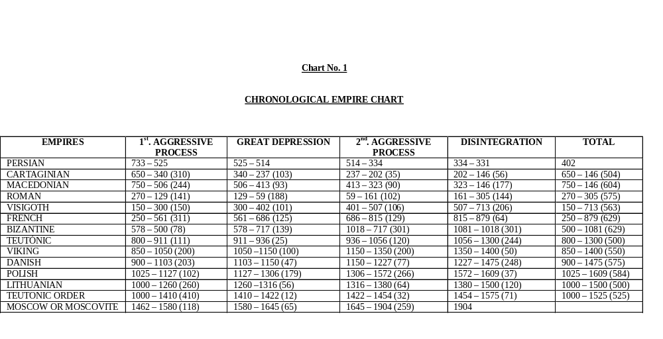

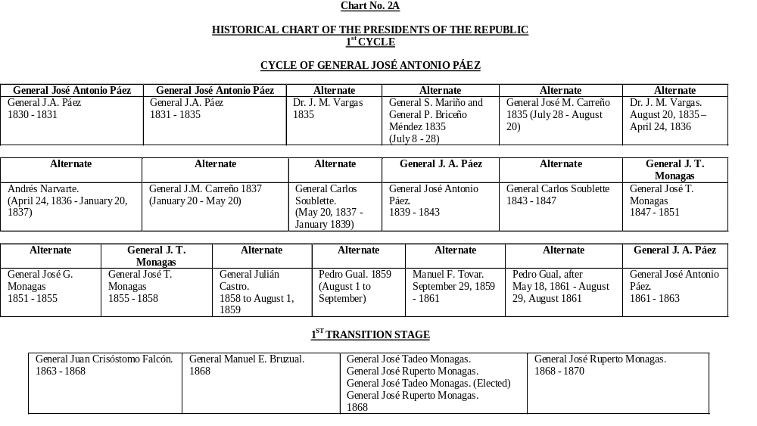

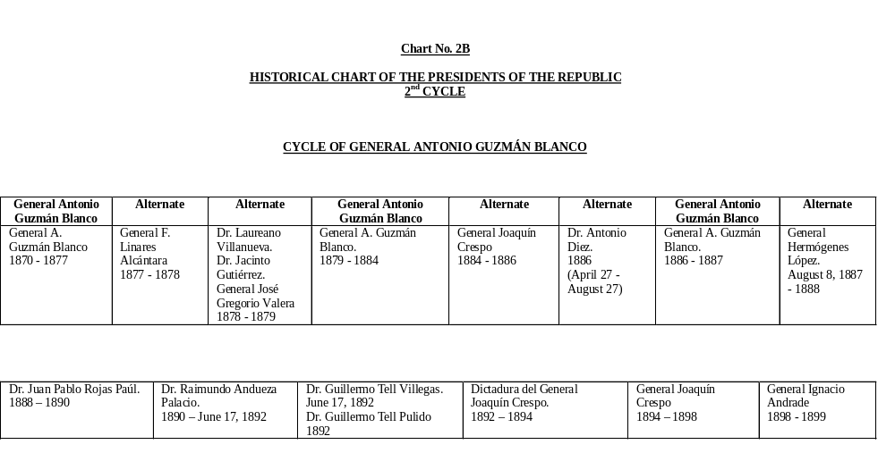

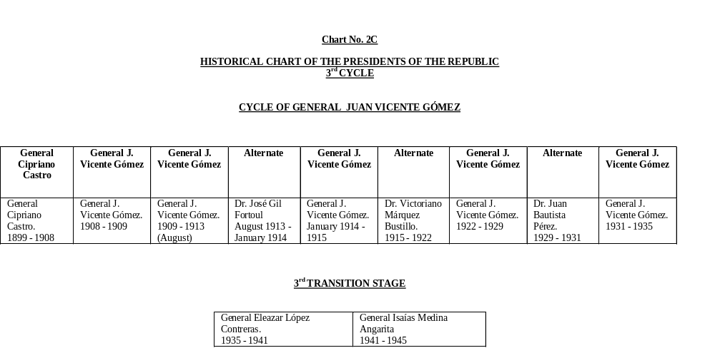

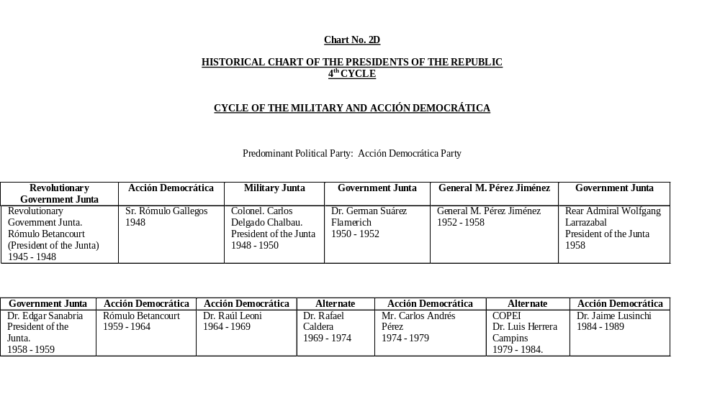

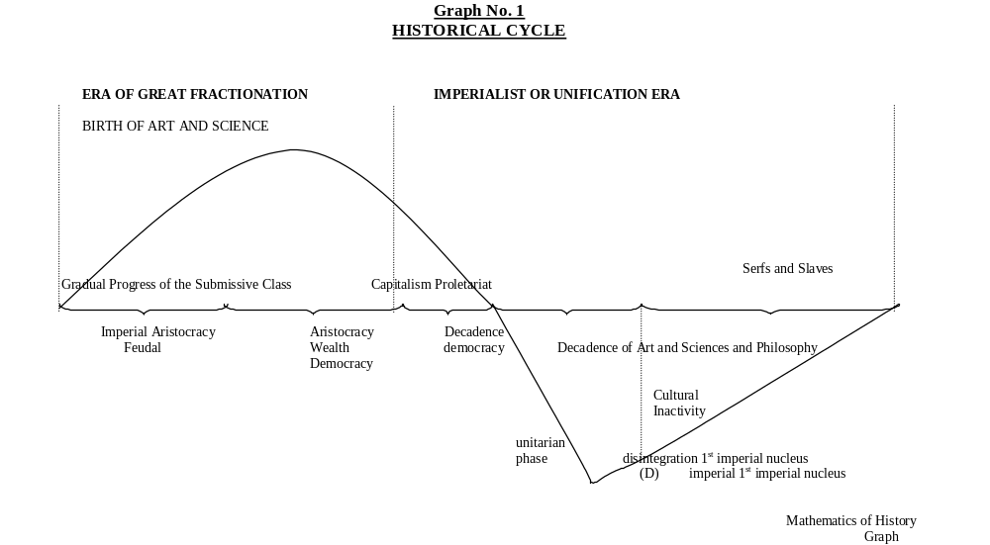

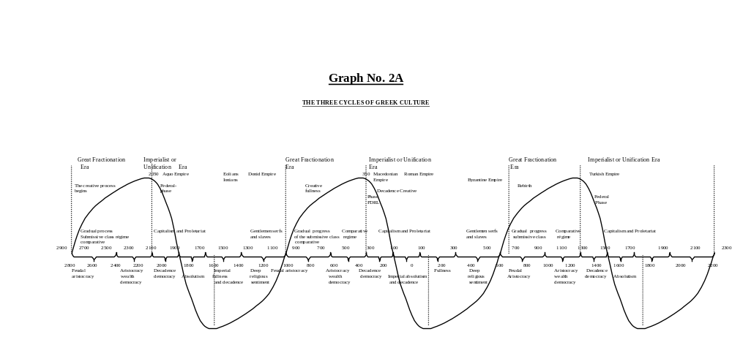

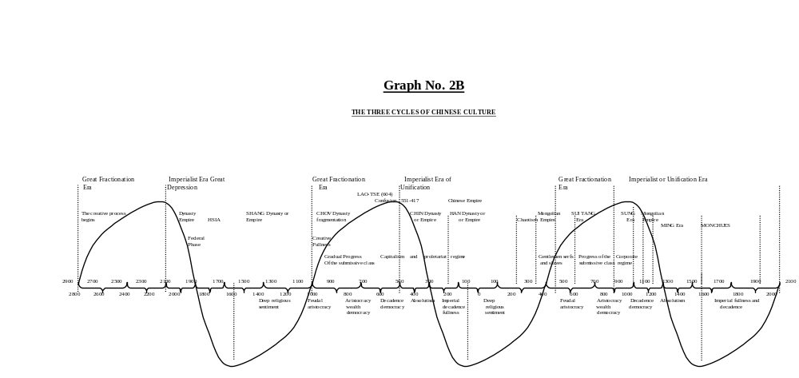

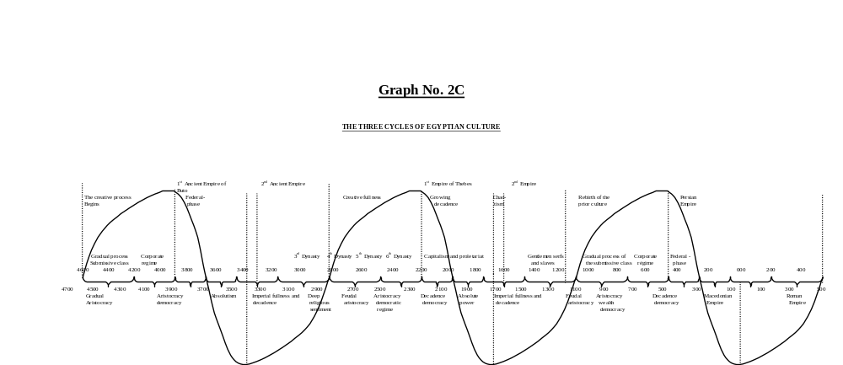

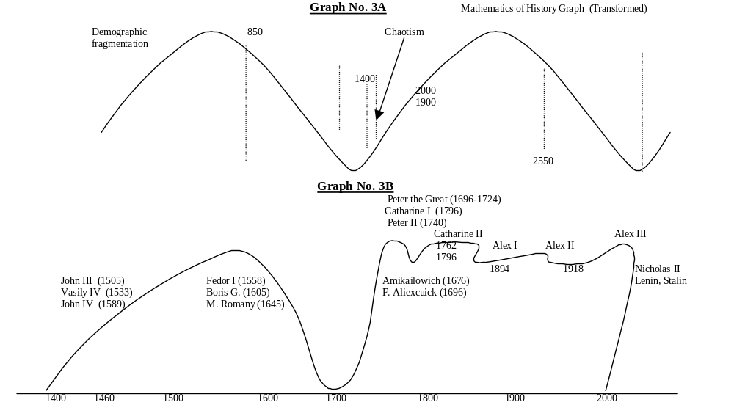

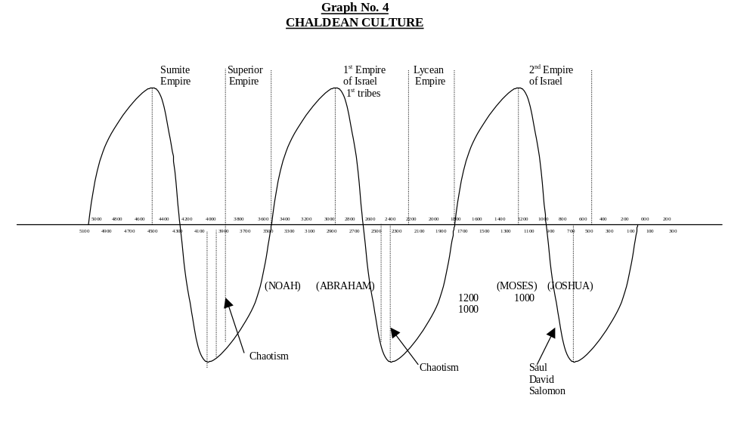

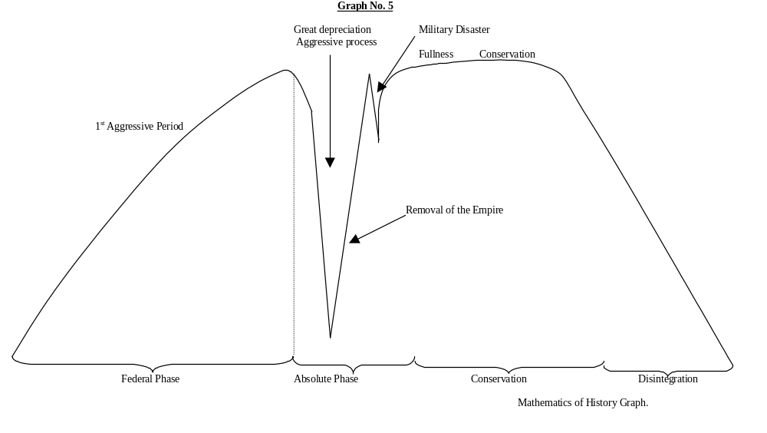

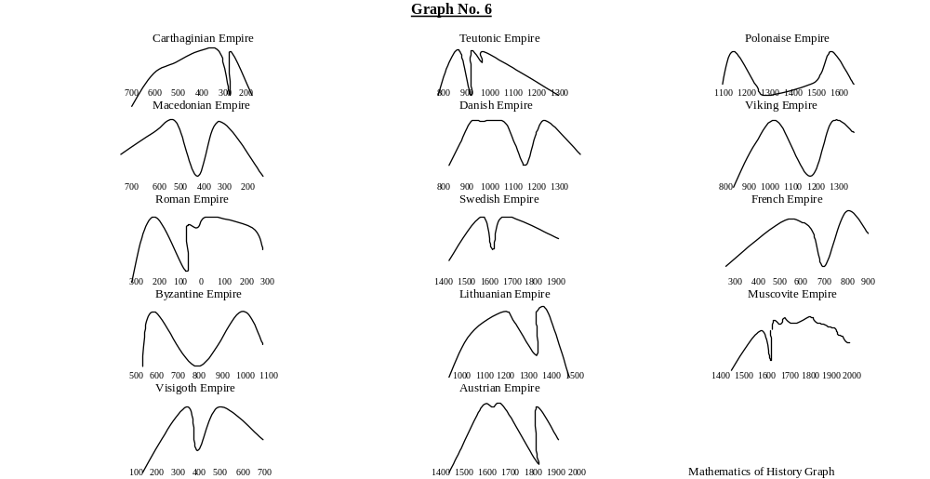

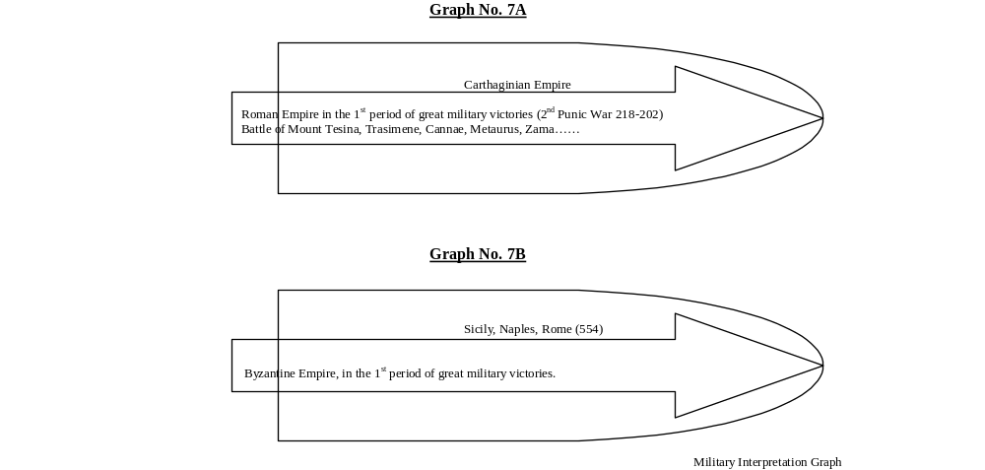

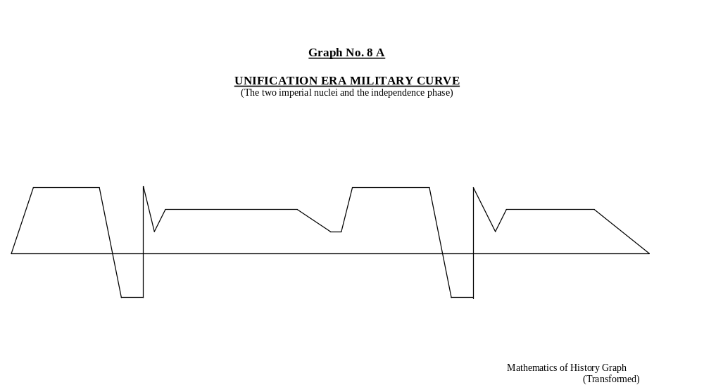

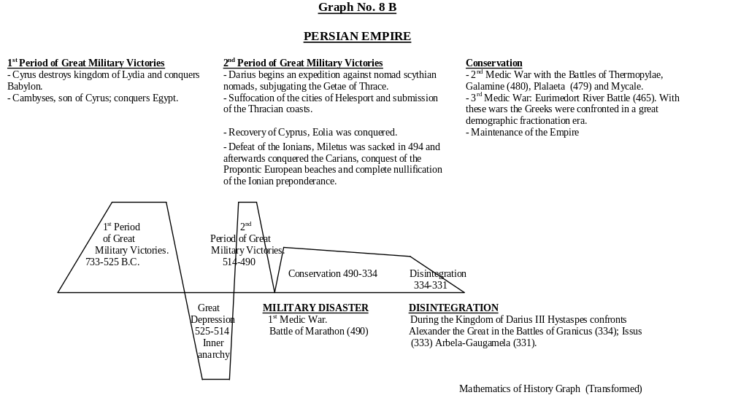

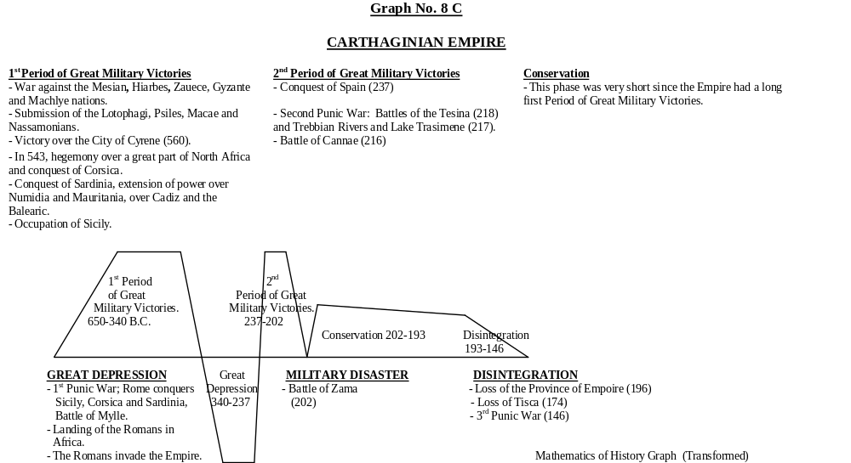

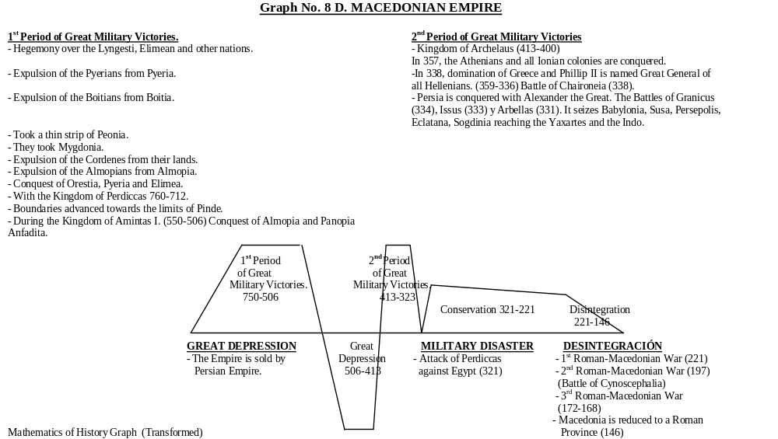

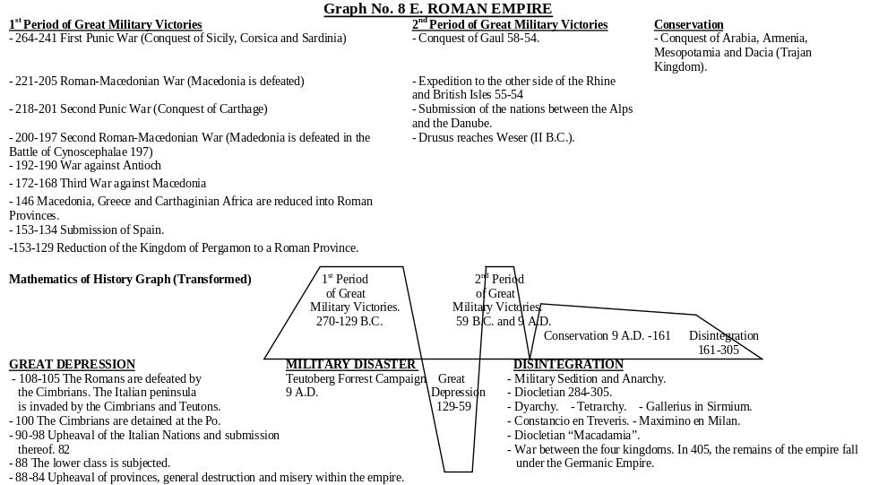

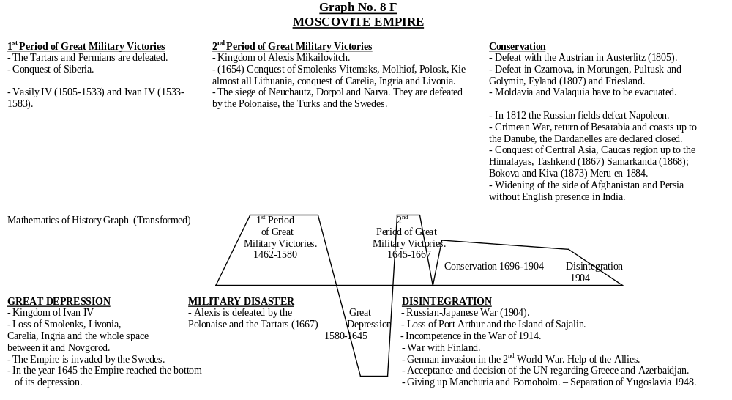

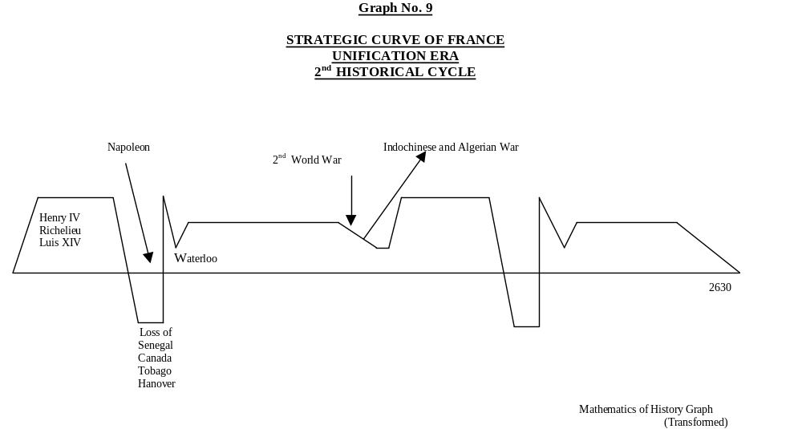

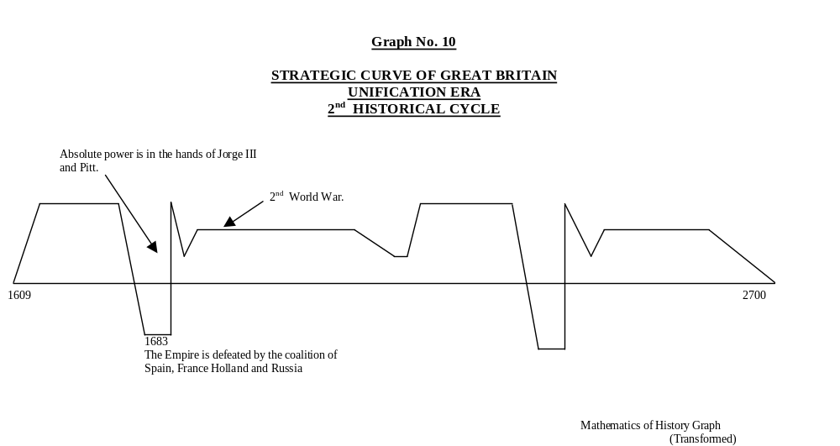

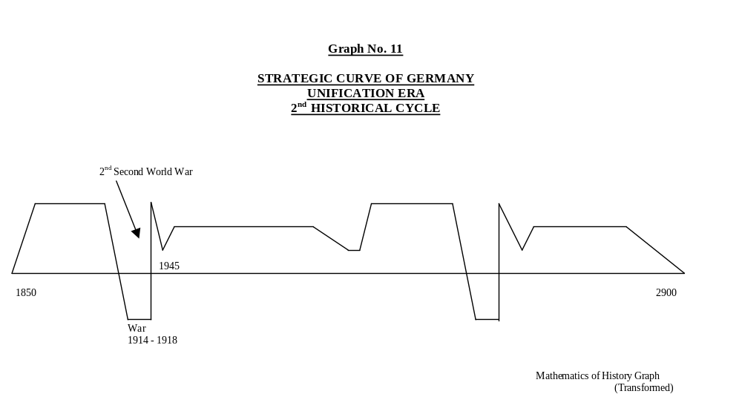

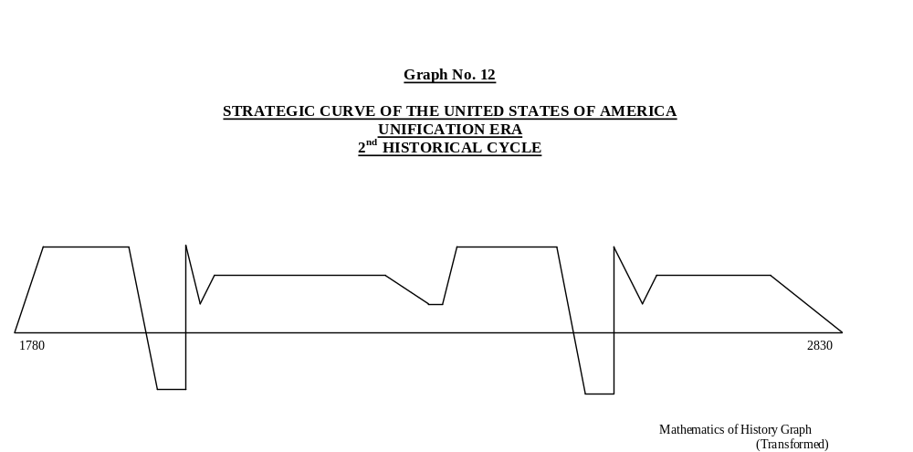

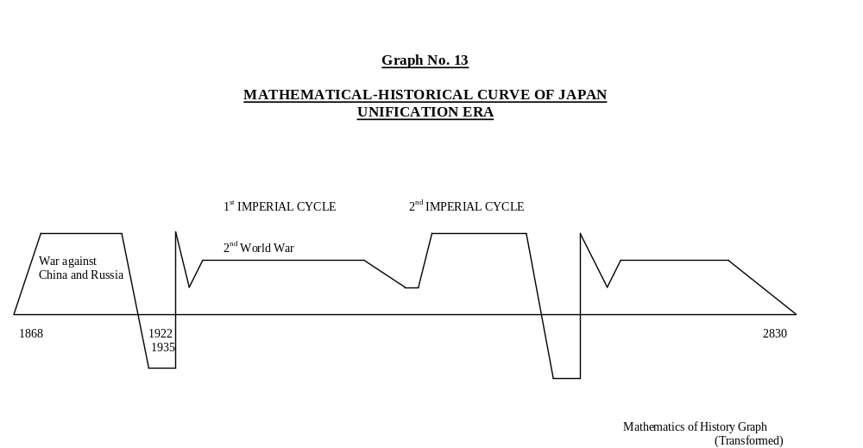

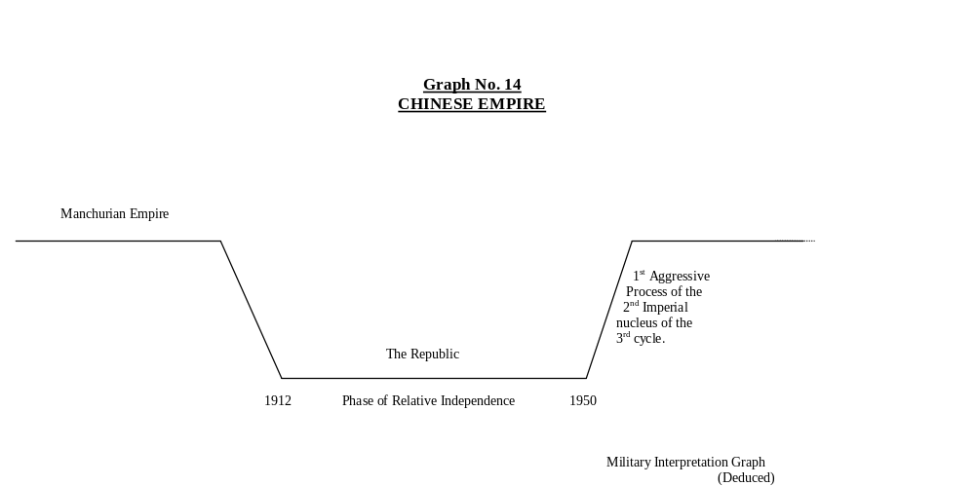

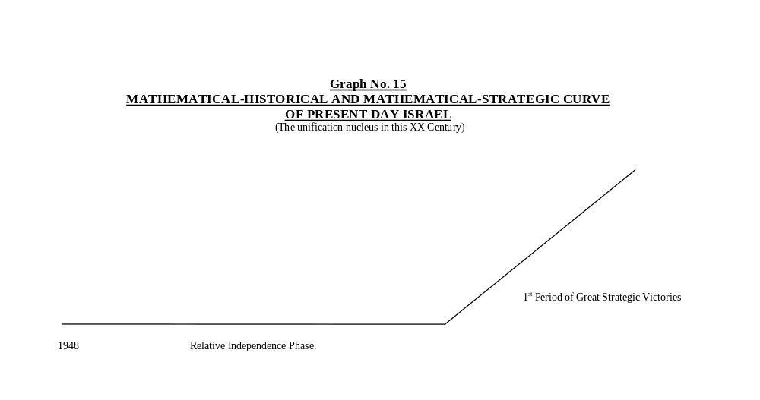

CURRICULUM VITAE OF THE AUTHOR

Names: | Víctor José Fernández Bolívar
Grade: | Brigadier General (Retired)
Force: | Venezuelan Army
Arm: | Engineering
Date and Place of Birth: | December 23, 1923, San Fernando de Apure, Venezuela.
Positions held: | Second Lieutenant, Platoon Commander of the Battalion of the Military School of Venezuela.
 | Captain, Third Interim Commander of the Francisco Avendaño No 1 Battalion.
 | Captain, Chief of the Department of Statistics and Official Real Estate Registry of the of Military Engineering Service of the Ministry of Defense.
 | Captain, Chief of the Engineering Section of the Infantry School.
 | Major, Second Director of the School of Military Engineering (in charge of the Direction).
 | Lieutenant Colonel, Director Founder of the School of Military Engineering.
 | Colonel, Chief of the Department of Command Projects, Army School.
 | Brigadier General, Chief of Command Staff, Army School.
 | Military Attaché to the Venezuelan Embassy in Madrid, Spain.
 | President of the Permanent Commission of Pre-mobilization and Mobilization of the National Armed Forces.
Commissions: | Chief of the Military Engineering Mission visiting the Republic of Peru.
 | Chief of the Study Commission in the Army of the National Defense Law Project.
 | Member of the Delegation for the inauguration of the Statue of the Liberator, Simón Bolívar, in Madrid, Spain.
Civilian Studies: | Grammar School: Colegio Teresa Hurtado. Instituto San Fernando, San Fernando de Apure. Escuela Ramón Isidro Montes and República del Ecuador, Caracas.
 | High School: Liceo Fermín Toro, Caracas.
Military Studies: | Military School of Venezuela, Caracas.
 | XIV Aptitude Course for promotion to Chief of Engineers in the Engineering Application School of the Spanish Army (Combat and Construction).
 | Military Staff School of Paris, France, 23rd Graduating Class.
 | Superior School of War in Paris, 76th Graduating Class.
 | Higher Inter-Force Course in Paris, 15th Session.
Professorship: | Held a Chair and gave Conferences in the following Armed Forces School:  - Military Academy of Venezuela.  - Superior Army School.  - Navy War School.  - Superior Aviation School.  - Military Engineering School, Infantry and Armor.  - Officer Formation School of the Cooperation Armed Forces.  - Application School of the Cooperation Armed Forces.
Chairs and Conferences were on the following subjects:
Mathematics, Physics, Roads and Bridges, Materials Resistance, use of Engineers, Reading of Correspondence, Strategic Intelligence, Organization, History and Mobilization.

Publications: | Books:  - Mathematical Historical Principles.  - International Recognition of the Book “Mathematical Historical Principles”.  - Mathematical Strategic Balance in the Middle East.  - Mathematical-Historical Curve and Electoral Tendencies of Venezuela.  - Venezuela.  - Oscillating Law in the Americas.  - Mathematical-Historical Chronological Chart of Prehistory and History.  - Military Interpretation of the Mathematics of History Modifies Fundamental Concepts of the Art-Science of War  - The Interview of Bolívar and San Martín in the Mathematical-Historical Concept.
Brochures:
- Decisive Battles of Liberty in the World in the Mathematical Historical Concept.
- Mathematical-Historical Process of the Americas.
- Bridge Calculation and Design (supplement of the Magazine of the Armed Forces).
- Synthesis of the Army’s Educational System (supplement of the Army Magazine).
- The Battle of Carabobo and the Democratic Destiny of the Hispanic-American States.
- Ideals of Liberty of Simón Bolívar in favor of the American Nations.
- The Economy, a factor of the Mathematical-Historical curve of a Nation.
- Strategic Evaluation of the Battle of Carabobo, Culmination and Great Campaign that Decided and Sealed the Independence of Venezuela.
- Geopolitics, Geohistory and Geostrategy, elements of the Mathematical-Historical Process of a Nation.
Articles:
- Historical Process of the Hispanic World.
- Comments of Sociology and the Mathematical-Sociological Concept (published by El Universal-Caracas).
- Mathematical-Sociological Oscillations.
- Mathematical-Economic Oscillations.
- Mathematical-Historical Oscillations are Normally Peaceful.
- Simón Bolívar in the Mathematical-Historical Concept (published in the news paper Ultimas Noticias-Caracas).
- Restructuring of the Command of the Army Schools.
- The Battle of Lepanto in the Mathematical-Historical Concept.
- Decisive Campaigns in the Liberating Campaign of Simón Bolívar.
- The Accomplishment of Pan Americanism of Bolívar for the XXI Century and its Mathematical-Historical Process.
- Attila in the Mathematical-HistoricalConcept
- The United States of America and its Mathematical-Historical Prospective.
- Venezuela in the Mathematical-Historical Concept.
- The Battles of Carabobo and of Lake Maracaibo.
- The Mathematics of History.
- The Mathematical-Strategic Concept.
- The Mathematical-Historical Concept of Cultures and Civilizations.
- The Teachings of Isostatic and Hyper static Structures for Military Engineering Officers.
- Some Mathematical-Historical Oscillations in Venezuela. Military Subjects I, II.
- Alejandro Deulofeu Torres.
- The Great or High Strategy of Simón Bolívar and his Prospection (published in the Bulletin of the National Academy of History of Venezuela).
- Brother Néctario María’s Notes on General Páez and the End of the Battle of Carabobo.
- The Siege of Puerto Cabello in the Classical Concept and in the Mathematical-Historical Concept.
- General José Antonio Páez in the Mathematical-Historical Concept.
- Fast Calculation of Military Capacity in Bridges of the Roads of Venezuela.
- A Mathematical World.
Other:
- Prologue of the Work of Strategy of the Ecuadorian Army Colonel, Alfonso Littuma “ The National Security Doctrine”.

Societies: | Member of the Bolivarian Society of Madrid, Second Secretary during the Period 1970-1972.
Member of the Association of Naval and Air Force Military Attachés credited in Spain, 1970-1972 (Vice President during the period from April 16-September 27-1971).
Chaired the Commission for the Study and Reform of the By-laws of said Association.

 | Member of the Association of Diplomats in Spain (1971-1972).
 | Knight of Corpus Christi of Toledo, Spain (endowed on June 8, 1971).
 | Member of the Order Noblemen of Vivar and sons of noble birth of Ubierna (order founded in the XI Century by the father of El Cid Campeador, endowed on July 4, 1971 in the Monastery of Cerdeña, Spain).
 | Association of Writers of Venezuela, August 1972.
 | Member of the Francisco Suárez Juridical Historical Institute of Spain.
 | Member of the Institute for the Purity of the Spanish Language with Headquarters in Spain.
 | Members of the Venezuelan Association of former Spanish Students.
 | Member of the Venezuelan Institute of Hispanic Culture.
 | Member of the Bolivarian Society of Venezuela.
Decorations: | Order of the Liberator 3rd Class (Knight Commander).
 | Order of Francisco de Miranda 3rd Class.
 | Order of General Rafael Urdaneta 1st, 2nd and 3rd Class.
 | Army Cross 3rd Class.
 | Great Military Merit Cross in Spain with a White Ribbon.
Honor Insignias: | Honor Roll of the Military Engineering School of Venezuela.
 | Honor Roll of the Officer Formation School of the Cooperation Armed Forces of Venezuela.
Plaques: | Military Engineering School of Venezuela.
 | Of the Engineering Application School of the Spanish Army.
 | Facsimile of Engineering Towers of the Military Engineering School, Venezuelan Army.
Certificates of Studies and Diplomas: | Military School, Porras Porras Graduating Class, Caracas, Venezuela.
 | Military Staff Course, 23rd Graduating Class, Paris, France.
 | Course of the Superior War School, 76th Graduating Class, Paris, France.
 | Inter-Force Superior Course, 15th Session, Paris, France.
 | XIV Aptitude Course for promotion to Chief of Engineers, Spain.
 | Institute of French Studies, Tours, France.
Honor Diplomas: | Infantry School, Venezuelan Army.
 | Application School of the Co-operations Armed Forces, Caracas, Venezuela.
 | Military Engineering School, Venezuelan Army.
 | Francisco Avendaño Engineering Battalion No 1, Venezuelan Army.

BIBLIOGRAPHY

- L’Art de la Guerre. Colonel C. de Bourcet.
- Historie de la Russie. Pierre Pascal.
- Historie de la Grande Bretagne. André J. Bourde.
- Historie Mondiale de la Strategie. B. H. Liddel Hart.
- Historie de France. Jacques Bainville.
- Historia de los Estados Unidos de Norteamérica. William Miler.
- Historia General de América. Luis Alberto Sánchez.
- Historia de Venezuela. Guillermo Morón.
- Historia de Venezuela. J. M. Siso Martínez.
- Historia de Venezuela. Hermano Nectario María.
- Historia de Venezuela. Presbítero Manuel Montaner.
- Historia de Grecia. Heinrich Seoboda.
- Historia de Italia. Pietro Orsi.
- Compendio de Historia de Colombia. J. M. Henso y G. Arrubia.
- La Matemática de la Historia. Alejandro Deulofeu.
- Nacimiento, Desarrollo y Muerte de las civilizaciones. Alejandro Deulofeu.
- Europa al desnudo. Alejandro Deulofeu.
- Los Grandes Errores de la Historia. Alejandro Deulofeu.
- La Paz Mundial por la Matemática de la Historia. Alejandro Deulofeu.
- Cartas de Dr. Deulofeu, autor y descubridor de la Matemática de la Historia.
- Maximes de Guerre et Pensees. Napoleon I.
- Des Principes de la Guerre. Mariscal Foch.
- Principes de la Stratégie. General Bertaut.
- Stratégie, Tactique et Politique. General IUNG.
- L’Evolution de L’Humanite. Henry Bert.
- Les Lois Eternelles de la Guerre. General Arthur Boucher.
- La Revelación del Futuro. Richards Lewinsohn.
- Revue Francaise de Sociologie. Article de Pierre Naville.
- Le Pensée Hegéliene et la Conduite de la Guerre. Jean Guitton.
- Le Potentiel Economique de L’ URSS. Conferencia de Lubrano Lavadera.
- Le Psicologie de L’Homme Russe. Conferencia de Comandant Michant.
- Romade. Nack- Wagner.
- Paix et Guerre entre les Nations. Raymond Aron.
- Fundamentos Doctrinales de Defensa Nacional. Coronel Alfonso Lituma Arizaga (Ejército Ecuatoriano).
- Lecciones de Historia Universal. Roberto Martínez Centeno.
- Bolívar, El Libertador. Michel Vancaire.
- Introducción a la Estrategia. General Beafre.
- Las Batallas Decisivas de la Libertad. Aníbal Galindo.
- Los Principios Matemático Históricos. General de Brigada, Víctor Fernández Bolívar.
- Curva Matemático Histórica y Tendencias Matemático Históricas Electorales. Gral. Fernández Bolívar.
- Pensamientos del Libertador, Simón Bolívar.
- Los Principios de la Guerra. C. Clausewitz.
- Proclamas y Discursos del Libertador. Vicente Lecuna.
- Almanaque Mundial de 1.965. Eduardo Cárdenas, Selecciones del Reader’s Digest.

Creative Commons License

Attribution-NonCommercial-ShareAlike 3.0 Unported

CREATIVE COMMONS CORPORATION IS NOT A LAW FIRM AND DOES NOT PROVIDE LEGAL SERVICES. DISTRIBUTION OF THIS LICENSE DOES NOT CREATE AN ATTORNEY-CLIENT RELATIONSHIP. CREATIVE COMMONS PROVIDES THIS INFORMATION ON AN "AS-IS" BASIS. CREATIVE COMMONS MAKES NO WARRANTIES REGARDING THE INFORMATION PROVIDED, AND DISCLAIMS LIABILITY FOR DAMAGES RESULTING FROM ITS USE.

License

THE WORK (AS DEFINED BELOW) IS PROVIDED UNDER THE TERMS OF THIS CREATIVE COMMONS PUBLIC LICENSE ("CCPL" OR "LICENSE"). THE WORK IS PROTECTED BY COPYRIGHT AND/OR OTHER APPLICABLE LAW. ANY USE OF THE WORK OTHER THAN AS AUTHORIZED UNDER THIS LICENSE OR COPYRIGHT LAW IS PROHIBITED.

BY EXERCISING ANY RIGHTS TO THE WORK PROVIDED HERE, YOU ACCEPT AND AGREE TO BE BOUND BY THE TERMS OF THIS LICENSE. TO THE EXTENT THIS LICENSE MAY BE CONSIDERED TO BE A CONTRACT, THE LICENSOR GRANTS YOU THE RIGHTS CONTAINED HERE IN CONSIDERATION OF YOUR ACCEPTANCE OF SUCH TERMS AND CONDITIONS.

1. Definitions

1. "Adaptation" means a work based upon the Work, or upon the Work and other pre-existing works, such as a translation, adaptation, derivative work, arrangement of music or other alterations of a literary or artistic work, or phonogram or performance and includes cinematographic adaptations or any other form in which the Work may be recast, transformed, or adapted including in any form recognizably derived from the original, except that a work that constitutes a Collection will not be considered an Adaptation for the purpose of this License. For the avoidance of doubt, where the Work is a musical work, performance or phonogram, the synchronization of the Work in timed-relation with a moving image ("synching") will be considered an Adaptation for the purpose of this License.

2. "Collection" means a collection of literary or artistic works, such as encyclopedias and anthologies, or performances, phonograms or broadcasts, or other works or subject matter other than works listed in Section 1(g) below, which, by reason of the selection and arrangement of their contents, constitute intellectual creations, in which the Work is included in its entirety in unmodified form along with one or more other contributions, each constituting separate and independent works in themselves, which together are assembled into a collective whole. A work that constitutes a Collection will not be considered an Adaptation (as defined above) for the purposes of this License.

3. "Distribute" means to make available to the public the original and copies of the Work or Adaptation, as appropriate, through sale or other transfer of ownership.

4. "License Elements" means the following high-level license attributes as selected by Licensor and indicated in the title of this License: Attribution, Noncommercial, ShareAlike.

5. "Licensor" means the individual, individuals, entity or entities that offer(s) the Work under the terms of this License.

6. "Original Author" means, in the case of a literary or artistic work, the individual, individuals, entity or entities who created the Work or if no individual or entity can be identified, the publisher; and in addition (i) in the case of a performance the actors, singers, musicians, dancers, and other persons who act, sing, deliver, declaim, play in, interpret or otherwise perform literary or artistic works or expressions of folklore; (ii) in the case of a phonogram the producer being the person or legal entity who first fixes the sounds of a performance or other sounds; and, (iii) in the case of broadcasts, the organization that transmits the broadcast.

7. "Work" means the literary and/or artistic work offered under the terms of this License including without limitation any production in the literary, scientific and artistic domain, whatever may be the mode or form of its expression including digital form, such as a book, pamphlet and other writing; a lecture, address, sermon or other work of the same nature; a dramatic or dramatico-musical work; a choreographic work or entertainment in dumb show; a musical composition with or without words; a cinematographic work to which are assimilated works expressed by a process analogous to cinematography; a work of drawing, painting, architecture, sculpture, engraving or lithography; a photographic work to which are assimilated works expressed by a process analogous to photography; a work of applied art; an illustration, map, plan, sketch or three-dimensional work relative to geography, topography, architecture or science; a performance; a broadcast; a phonogram; a compilation of data to the extent it is protected as a copyrightable work; or a work performed by a variety or circus performer to the extent it is not otherwise considered a literary or artistic work.

8. "You" means an individual or entity exercising rights under this License who has not previously violated the terms of this License with respect to the Work, or who has received express permission from the Licensor to exercise rights under this License despite a previous violation.

9. "Publicly Perform" means to perform public recitations of the Work and to communicate to the public those public recitations, by any means or process, including by wire or wireless means or public digital performances; to make available to the public Works in such a way that members of the public may access these Works from a place and at a place individually chosen by them; to perform the Work to the public by any means or process and the communication to the public of the performances of the Work, including by public digital performance; to broadcast and rebroadcast the Work by any means including signs, sounds or images.

10. "Reproduce" means to make copies of the Work by any means including without limitation by sound or visual recordings and the right of fixation and reproducing fixations of the Work, including storage of a protected performance or phonogram in digital form or other electronic medium.

2. Fair Dealing Rights. Nothing in this License is intended to reduce, limit, or restrict any uses free from copyright or rights arising from limitations or exceptions that are provided for in connection with the copyright protection under copyright law or other applicable laws.

3. License Grant. Subject to the terms and conditions of this License, Licensor hereby grants You a worldwide, royalty-free, non-exclusive, perpetual (for the duration of the applicable copyright) license to exercise the rights in the Work as stated below:

1. to Reproduce the Work, to incorporate the Work into one or more Collections, and to Reproduce the Work as incorporated in the Collections;

2. to create and Reproduce Adaptations provided that any such Adaptation, including any translation in any medium, takes reasonable steps to clearly label, demarcate or otherwise identify that changes were made to the original Work. For example, a translation could be marked "The original work was translated from English to Spanish," or a modification could indicate "The original work has been modified.";

3. to Distribute and Publicly Perform the Work including as incorporated in Collections; and,

4. to Distribute and Publicly Perform Adaptations.

The above rights may be exercised in all media and formats whether now known or hereafter devised. The above rights include the right to make such modifications as are technically necessary to exercise the rights in other media and formats. Subject to Section 8(f), all rights not expressly granted by Licensor are hereby reserved, including but not limited to the rights described in Section 4(e).

4. Restrictions. The license granted in Section 3 above is expressly made subject to and limited by the following restrictions:

1. You may Distribute or Publicly Perform the Work only under the terms of this License. You must include a copy of, or the Uniform Resource Identifier (URI) for, this License with every copy of the Work You Distribute or Publicly Perform. You may not offer or impose any terms on the Work that restrict the terms of this License or the ability of the recipient of the Work to exercise the rights granted to that recipient under the terms of the License. You may not sublicense the Work. You must keep intact all notices that refer to this License and to the disclaimer of warranties with every copy of the Work You Distribute or Publicly Perform. When You Distribute or Publicly Perform the Work, You may not impose any effective technological measures on the Work that restrict the ability of a recipient of the Work from You to exercise the rights granted to that recipient under the terms of the License. This Section 4(a) applies to the Work as incorporated in a Collection, but this does not require the Collection apart from the Work itself to be made subject to the terms of this License. If You create a Collection, upon notice from any Licensor You must, to the extent practicable, remove from the Collection any credit as required by Section 4(d), as requested. If You create an Adaptation, upon notice from any Licensor You must, to the extent practicable, remove from the Adaptation any credit as required by Section 4(d), as requested.

2. You may Distribute or Publicly Perform an Adaptation only under: (i) the terms of this License; (ii) a later version of this License with the same License Elements as this License; (iii) a Creative Commons jurisdiction license (either this or a later license version) that contains the same License Elements as this License (e.g., Attribution-NonCommercial-ShareAlike 3.0 US) ("Applicable License"). You must include a copy of, or the URI, for Applicable License with every copy of each Adaptation You Distribute or Publicly Perform. You may not offer or impose any terms on the Adaptation that restrict the terms of the Applicable License or the ability of the recipient of the Adaptation to exercise the rights granted to that recipient under the terms of the Applicable License. You must keep intact all notices that refer to the Applicable License and to the disclaimer of warranties with every copy of the Work as included in the Adaptation You Distribute or Publicly Perform. When You Distribute or Publicly Perform the Adaptation, You may not impose any effective technological measures on the Adaptation that restrict the ability of a recipient of the Adaptation from You to exercise the rights granted to that recipient under the terms of the Applicable License. This Section 4(b) applies to the Adaptation as incorporated in a Collection, but this does not require the Collection apart from the Adaptation itself to be made subject to the terms of the Applicable License.

3. You may not exercise any of the rights granted to You in Section 3 above in any manner that is primarily intended for or directed toward commercial advantage or private monetary compensation. The exchange of the Work for other copyrighted works by means of digital file-sharing or otherwise shall not be considered to be intended for or directed toward commercial advantage or private monetary compensation, provided there is no payment of any monetary compensation in con-nection with the exchange of copyrighted works.

4. If You Distribute, or Publicly Perform the Work or any Adaptations or Collections, You must, unless a request has been made pursuant to Section 4(a), keep intact all copyright notices for the Work and provide, reasonable to the medium or means You are utilizing: (i) the name of the Original Author (or pseudonym, if applicable) if supplied, and/or if the Original Author and/or Licensor designate another party or parties (e.g., a sponsor institute, publishing entity, journal) for attribution ("Attribution Parties") in Licensor's copyright notice, terms of service or by other reasonable means, the name of such party or parties; (ii) the title of the Work if supplied; (iii) to the extent reasonably practicable, the URI, if any, that Licensor specifies to be associated with the Work, unless such URI does not refer to the copyright notice or licensing information for the Work; and, (iv) consistent with Section 3(b), in the case of an Adaptation, a credit identifying the use of the Work in the Adaptation (e.g., "French translation of the Work by Original Author," or "Screenplay based on original Work by Original Author"). The credit required by this Section 4(d) may be implemented in any reasonable manner; provided, however, that in the case of a Adaptation or Collection, at a minimum such credit will appear, if a credit for all contributing authors of the Adaptation or Collection appears, then as part of these credits and in a manner at least as prominent as the credits for the other contributing authors. For the avoidance of doubt, You may only use the credit required by this Section for the purpose of attribution in the manner set out above and, by exercising Your rights under this License, You may not implicitly or explicitly assert or imply any connection with, sponsorship or endorsement by the Original Author, Licensor and/or Attribution Parties, as appropriate, of You or Your use of the Work, without the separate, express prior written permission of the Original Author, Licensor and/or Attribution Parties.

5. For the avoidance of doubt:

1. Non-waivable Compulsory License Schemes. In those jurisdictions in which the right to collect royalties through any statutory or compulsory licensing scheme cannot be waived, the Licensor reserves the exclusive right to collect such royalties for any exercise by You of the rights granted under this License;

2. Waivable Compulsory License Schemes. In those jurisdictions in which the right to collect royalties through any statutory or compulsory licensing scheme can be waived, the Licensor reserves the exclusive right to collect such royalties for any exercise by You of the rights granted under this License if Your exercise of such rights is for a purpose or use which is otherwise than noncommercial as permitted under Section 4(c) and otherwise waives the right to collect royalties through any statutory or compulsory licensing scheme; and,

3. Voluntary License Schemes. The Licensor reserves the right to collect royalties, whether individually or, in the event that the Licensor is a member of a collecting society that administers voluntary licensing schemes, via that society, from any exercise by You of the rights granted under this License that is for a purpose or use which is otherwise than noncommercial as permitted under Section 4(c).

6. Except as otherwise agreed in writing by the Licensor or as may be otherwise permitted by applicable law, if You Reproduce, Distribute or Publicly Perform the Work either by itself or as part of any Adaptations or Collections, You must not distort, mutilate, modify or take other derogatory action in relation to the Work which would be prejudicial to the Original Author's honor or reputation. Licensor agrees that in those jurisdictions (e.g. Japan), in which any exercise of the right granted in Section 3(b) of this License (the right to make Adaptations) would be deemed to be a distortion, mutilation, modification or other derogatory action prejudicial to the Original Author's honor and reputation, the Licensor will waive or not assert, as appropriate, this Section, to the fullest extent permitted by the applicable national law, to enable You to reasonably exercise Your right under Section 3(b) of this License (right to make Adaptations) but not otherwise.

5. Representations, Warranties and Disclaimer

UNLESS OTHERWISE MUTUALLY AGREED TO BY THE PARTIES IN WRITING AND TO THE FULLEST EXTENT PERMITTED BY APPLICABLE LAW, LICENSOR OFFERS THE WORK AS-IS AND MAKES NO REPRESENTATIONS OR WARRANTIES OF ANY KIND CONCERNING THE WORK, EXPRESS, IMPLIED, STATUTORY OR OTHERWISE, INCLUDING, WITHOUT LIMITATION, WARRANTIES OF TITLE, MERCHANTABILITY, FITNESS FOR A PARTICULAR PURPOSE, NONINFRINGEMENT, OR THE ABSENCE OF LATENT OR OTHER DEFECTS, ACCURACY, OR THE PRESENCE OF ABSENCE OF ERRORS, WHETHER OR NOT DISCOVERABLE. SOME JURISDICTIONS DO NOT ALLOW THE EXCLUSION OF IMPLIED WARRANTIES, SO THIS EXCLUSION MAY NOT APPLY TO YOU.

6. Limitation on Liability. EXCEPT TO THE EXTENT REQUIRED BY APPLICABLE LAW, IN NO EVENT WILL LICENSOR BE LIABLE TO YOU ON ANY LEGAL THEORY FOR ANY SPECIAL, INCIDENTAL, CONSEQUENTIAL, PUNITIVE OR EXEMPLARY DAMAGES ARISING OUT OF THIS LICENSE OR THE USE OF THE WORK, EVEN IF LICENSOR HAS BEEN ADVISED OF THE POSSIBILITY OF SUCH DAMAGES.

7. Termination

1. This License and the rights granted hereunder will terminate automatically upon any breach by You of the terms of this License. Individuals or entities who have received Adaptations or Collections from You under this License, however, will not have their licenses terminated provided such individuals or entities remain in full compliance with those licenses. Sections 1, 2, 5, 6, 7, and 8 will survive any termination of this License.

2. Subject to the above terms and conditions, the license granted here is perpetual (for the duration of the applicable copyright in the Work). Notwithstanding the above, Licensor reserves the right to release the Work under different license terms or to stop distributing the Work at any time; provided, however that any such election will not serve to withdraw this License (or any other license that has been, or is required to be, granted under the terms of this License), and this License will continue in full force and effect unless terminated as stated above.

8. Miscellaneous

1. Each time You Distribute or Publicly Perform the Work or a Collection, the Licensor offers to the recipient a license to the Work on the same terms and conditions as the license granted to You under this License.

2. Each time You Distribute or Publicly Perform an Adaptation, Licensor offers to the recipient a license to the original Work on the same terms and conditions as the license granted to You under this License.

3. If any provision of this License is invalid or unenforceable under applicable law, it shall not affect the validity or enforceability of the remainder of the terms of this License, and without further action by the parties to this agreement, such provision shall be reformed to the minimum extent necessary to make such provision valid and enforceable.

4. No term or provision of this License shall be deemed waived and no breach consented to unless such waiver or consent shall be in writing and signed by the party to be charged with such waiver or consent.

5. This License constitutes the entire agreement between the parties with respect to the Work licensed here. There are no understandings, agreements or representations with respect to the Work not specified here. Licensor shall not be bound by any additional provisions that may appear in any communication from You. This License may not be modified without the mutual written agreement of the Licensor and You.

6. The rights granted under, and the subject matter referenced, in this License were drafted utilizing the terminology of the Berne Convention for the Protection of Literary and Artistic Works (as amended on September 28, 1979), the Rome Convention of 1961, the WIPO Copyright Treaty of 1996, the WIPO Performances and Phonograms Treaty of 1996 and the Universal Copyright Convention (as revised on July 24, 1971). These rights and subject matter take effect in the relevant jurisdiction in which the License terms are sought to be enforced according to the corresponding provisions of the implementation of those treaty provisions in the applicable national law. If the standard suite of rights granted under applicable copyright law includes additional rights not granted under this License, such additional rights are deemed to be included in the License; this License is not intended to restrict the license of any rights under applicable law.

Creative Commons Notice

Creative Commons is not a party to this License, and makes no warranty whatsoever in connection with the Work. Creative Commons will not be liable to You or any party on any legal theory for any damages whatsoever, including without limitation any general, special, incidental or consequential damages arising in connection to this license. Notwithstanding the foregoing two (2) sentences, if Creative Commons has expressly identified itself as the Licensor hereunder, it shall have all rights and obligations of Licensor.

Except for the limited purpose of indicating to the public that the Work is licensed under the CCPL, Creative Commons does not authorize the use by either party of the trademark "Creative Commons" or any related trademark or logo of Creative Commons without the prior written consent of Creative Commons. Any permitted use will be in compliance with Creative Commons' then-current trademark usage guidelines, as may be published on its website or otherwise made available upon request from time to time. For the avoidance of doubt, this trademark restriction does not form part of this License.

Creative Commons may be contacted at http://creativecommons.org/.

<a rel="license" href="http://creativecommons.org/licenses/by-nc-sa/3.0/us/"><img alt="Creative Commons License" style="border-width:0" src="http://i.creativecommons.org/l/by-nc-sa/3.0/us/88x31.png" /></a><br /><span xmlns:dc="http://purl.org/dc/elements/1.1/" href="http://purl.org/dc/dcmitype/Text" property="dc:title" rel="dc:type">The Mathematical-Historical Principles and the Evolution of Liberty</span> by <a xmlns:cc="http://creativecommons.org/ns#" href="www.ivenezuela.com" property="cc:attributionName" rel="cc:attributionURL">Victor Jose Fernandez Bolivar</a> is licensed under a <a rel="license" href="http://creativecommons.org/licenses/by-nc-sa/3.0/us/">Creative Commons Attribution-Noncommercial-Share Alike 3.0 United States License</a>.

End of the Project Gutenberg EBook of The Mathematical-Historical Principles
and the Evolution of Liberty, by Victor Jose Fernandez Bolivar

*** END OF THIS PROJECT GUTENBERG EBOOK MATHEMATICAL-HISTORICAL PRINCIPLES ***

***** This file should be named 30174-doc.doc or 30174-doc.zip *****
This and all associated files of various formats will be found in:
http://www.gutenberg.org/3/0/1/7/30174/

Produced by Al Haines

Updated editions will replace the previous one--the old editions will be
renamed.

Creating the works from public domain print editions means that no one
owns a United States copyright in these works, so the Foundation (and
you!) can copy and distribute it in the United States without permission
and without paying copyright royalties. Special rules, set forth in the
General Terms of Use part of this license, apply to copying and
distributing Project Gutenberg-tm electronic works to protect the
PROJECT GUTENBERG-tm concept and trademark. Project Gutenberg is a
registered trademark, and may not be used if you charge for the eBooks,
unless you receive specific permission. If you do not charge anything
for copies of this eBook, complying with the rules is very easy. You may
use this eBook for nearly any purpose such as creation of derivative
works, reports, performances and research. They may be modified and
printed and given away--you may do practically ANYTHING with public
domain eBooks. Redistribution is subject to the trademark license,
especially commercial redistribution.

*** START: FULL LICENSE ***

THE FULL PROJECT GUTENBERG LICENSE
PLEASE READ THIS BEFORE YOU DISTRIBUTE OR USE THIS WORK

To protect the Project Gutenberg-tm mission of promoting the free
distribution of electronic works, by using or distributing this work
(or any other work associated in any way with the phrase "Project
Gutenberg"), you agree to comply with all the terms of the Full Project
Gutenberg-tm License (available with this file or online at
http://www.gutenberg.org/license).

Section 1. General Terms of Use and Redistributing Project Gutenberg-tm
electronic works

1.A. By reading or using any part of this Project Gutenberg-tm
electronic work, you indicate that you have read, understand, agree to
and accept all the terms of this license and intellectual property
(trademark/copyright) agreement. If you do not agree to abide by all
the terms of this agreement, you must cease using and return or destroy
all copies of Project Gutenberg-tm electronic works in your possession.
If you paid a fee for obtaining a copy of or access to a Project
Gutenberg-tm electronic work and you do not agree to be bound by the
terms of this agreement, you may obtain a refund from the person or
entity to whom you paid the fee as set forth in paragraph 1.E.8.

1.B. "Project Gutenberg" is a registered trademark. It may only be
used on or associated in any way with an electronic work by people who
agree to be bound by the terms of this agreement. There are a few
things that you can do with most Project Gutenberg-tm electronic works
even without complying with the full terms of this agreement. See
paragraph 1.C below. There are a lot of things you can do with Project
Gutenberg-tm electronic works if you follow the terms of this agreement
and help preserve free future access to Project Gutenberg-tm electronic
works. See paragraph 1.E below.

1.C. The Project Gutenberg Literary Archive Foundation ("the Foundation"
or PGLAF), owns a compilation copyright in the collection of Project
Gutenberg-tm electronic works. Nearly all the individual works in the
collection are in the public domain in the United States. If an
individual work is in the public domain in the United States and you are
located in the United States, we do not claim a right to prevent you from
copying, distributing, performing, displaying or creating derivative
works based on the work as long as all references to Project Gutenberg
are removed. Of course, we hope that you will support the Project
Gutenberg-tm mission of promoting free access to electronic works by
freely sharing Project Gutenberg-tm works in compliance with the terms of
this agreement for keeping the Project Gutenberg-tm name associated with
the work. You can easily comply with the terms of this agreement by
keeping this work in the same format with its attached full Project
Gutenberg-tm License when you share it without charge with others.
This particular work is one of the few copyrighted individual works
included with the permission of the copyright holder. Information on
the copyright owner for this particular work and the terms of use
imposed by the copyright holder on this work are set forth at the
beginning of this work.

1.D. The copyright laws of the place where you are located also govern
what you can do with this work. Copyright laws in most countries are in
a constant state of change. If you are outside the United States, check
the laws of your country in addition to the terms of this agreement
before downloading, copying, displaying, performing, distributing or
creating derivative works based on this work or any other Project
Gutenberg-tm work. The Foundation makes no representations concerning
the copyright status of any work in any country outside the United
States.

1.E. Unless you have removed all references to Project Gutenberg:

1.E.1. The following sentence, with active links to, or other immediate
access to, the full Project Gutenberg-tm License must appear prominently
whenever any copy of a Project Gutenberg-tm work (any work on which the
phrase "Project Gutenberg" appears, or with which the phrase "Project
Gutenberg" is associated) is accessed, displayed, performed, viewed,
copied or distributed:

This eBook is for the use of anyone anywhere at no cost and with
almost no restrictions whatsoever. You may copy it, give it away or
re-use it under the terms of the Project Gutenberg License included
with this eBook or online at www.gutenberg.org

1.E.2. If an individual Project Gutenberg-tm electronic work is derived
from the public domain (does not contain a notice indicating that it is
posted with permission of the copyright holder), the work can be copied
and distributed to anyone in the United States without paying any fees
or charges. If you are redistributing or providing access to a work
with the phrase "Project Gutenberg" associated with or appearing on the
work, you must comply either with the requirements of paragraphs 1.E.1
through 1.E.7 or obtain permission for the use of the work and the
Project Gutenberg-tm trademark as set forth in paragraphs 1.E.8 or
1.E.9.

1.E.3. If an individual Project Gutenberg-tm electronic work is posted
with the permission of the copyright holder, your use and distribution
must comply with both paragraphs 1.E.1 through 1.E.7 and any additional
terms imposed by the copyright holder. Additional terms will be linked
to the Project Gutenberg-tm License for all works posted with the
permission of the copyright holder found at the beginning of this work.

1.E.4. Do not unlink or detach or remove the full Project Gutenberg-tm
License terms from this work, or any files containing a part of this
work or any other work associated with Project Gutenberg-tm.

1.E.5. Do not copy, display, perform, distribute or redistribute this
electronic work, or any part of this electronic work, without
prominently displaying the sentence set forth in paragraph 1.E.1 with
active links or immediate access to the full terms of the Project
Gutenberg-tm License.

1.E.6. You may convert to and distribute this work in any binary,
compressed, marked up, nonproprietary or proprietary form, including any
word processing or hypertext form. However, if you provide access to or
distribute copies of a Project Gutenberg-tm work in a format other than
"Plain Vanilla ASCII" or other format used in the official version
posted on the official Project Gutenberg-tm web site (www.gutenberg.org),
you must, at no additional cost, fee or expense to the user, provide a
copy, a means of exporting a copy, or a means of obtaining a copy upon
request, of the work in its original "Plain Vanilla ASCII" or other
form. Any alternate format must include the full Project Gutenberg-tm
License as specified in paragraph 1.E.1.

1.E.7. Do not charge a fee for access to, viewing, displaying,
performing, copying or distributing any Project Gutenberg-tm works
unless you comply with paragraph 1.E.8 or 1.E.9.

1.E.8. You may charge a reasonable fee for copies of or providing
access to or distributing Project Gutenberg-tm electronic works provided
that

- You pay a royalty fee of 20% of the gross profits you derive from
the use of Project Gutenberg-tm works calculated using the method
you already use to calculate your applicable taxes. The fee is
owed to the owner of the Project Gutenberg-tm trademark, but he
has agreed to donate royalties under this paragraph to the
Project Gutenberg Literary Archive Foundation. Royalty payments
must be paid within 60 days following each date on which you
prepare (or are legally required to prepare) your periodic tax
returns. Royalty payments should be clearly marked as such and
sent to the Project Gutenberg Literary Archive Foundation at the
address specified in Section 4, "Information about donations to
the Project Gutenberg Literary Archive Foundation."

- You provide a full refund of any money paid by a user who notifies
you in writing (or by e-mail) within 30 days of receipt that s/he
does not agree to the terms of the full Project Gutenberg-tm
License. You must require such a user to return or
destroy all copies of the works possessed in a physical medium
and discontinue all use of and all access to other copies of
Project Gutenberg-tm works.

- You provide, in accordance with paragraph 1.F.3, a full refund of any
money paid for a work or a replacement copy, if a defect in the
electronic work is discovered and reported to you within 90 days
of receipt of the work.

- You comply with all other terms of this agreement for free
distribution of Project Gutenberg-tm works.

1.E.9. If you wish to charge a fee or distribute a Project Gutenberg-tm
electronic work or group of works on different terms than are set
forth in this agreement, you must obtain permission in writing from
both the Project Gutenberg Literary Archive Foundation and Michael
Hart, the owner of the Project Gutenberg-tm trademark. Contact the
Foundation as set forth in Section 3 below.

1.F.

1.F.1. Project Gutenberg volunteers and employees expend considerable
effort to identify, do copyright research on, transcribe and proofread
public domain works in creating the Project Gutenberg-tm
collection. Despite these efforts, Project Gutenberg-tm electronic
works, and the medium on which they may be stored, may contain
"Defects," such as, but not limited to, incomplete, inaccurate or
corrupt data, transcription errors, a copyright or other intellectual
property infringement, a defective or damaged disk or other medium, a
computer virus, or computer codes that damage or cannot be read by
your equipment.

1.F.2. LIMITED WARRANTY, DISCLAIMER OF DAMAGES - Except for the "Right
of Replacement or Refund" described in paragraph 1.F.3, the Project
Gutenberg Literary Archive Foundation, the owner of the Project
Gutenberg-tm trademark, and any other party distributing a Project
Gutenberg-tm electronic work under this agreement, disclaim all
liability to you for damages, costs and expenses, including legal
fees. YOU AGREE THAT YOU HAVE NO REMEDIES FOR NEGLIGENCE, STRICT
LIABILITY, BREACH OF WARRANTY OR BREACH OF CONTRACT EXCEPT THOSE
PROVIDED IN PARAGRAPH F3. YOU AGREE THAT THE FOUNDATION, THE
TRADEMARK OWNER, AND ANY DISTRIBUTOR UNDER THIS AGREEMENT WILL NOT BE
LIABLE TO YOU FOR ACTUAL, DIRECT, INDIRECT, CONSEQUENTIAL, PUNITIVE OR
INCIDENTAL DAMAGES EVEN IF YOU GIVE NOTICE OF THE POSSIBILITY OF SUCH
DAMAGE.

1.F.3. LIMITED RIGHT OF REPLACEMENT OR REFUND - If you discover a
defect in this electronic work within 90 days of receiving it, you can
receive a refund of the money (if any) you paid for it by sending a
written explanation to the person you received the work from. If you
received the work on a physical medium, you must return the medium with
your written explanation. The person or entity that provided you with
the defective work may elect to provide a replacement copy in lieu of a
refund. If you received the work electronically, the person or entity
providing it to you may choose to give you a second opportunity to
receive the work electronically in lieu of a refund. If the second copy
is also defective, you may demand a refund in writing without further
opportunities to fix the problem.

1.F.4. Except for the limited right of replacement or refund set forth
in paragraph 1.F.3, this work is provided to you 'AS-IS,' WITH NO OTHER
WARRANTIES OF ANY KIND, EXPRESS OR IMPLIED, INCLUDING BUT NOT LIMITED TO
WARRANTIES OF MERCHANTIBILITY OR FITNESS FOR ANY PURPOSE.

1.F.5. Some states do not allow disclaimers of certain implied
warranties or the exclusion or limitation of certain types of damages.
If any disclaimer or limitation set forth in this agreement violates the
law of the state applicable to this agreement, the agreement shall be
interpreted to make the maximum disclaimer or limitation permitted by
the applicable state law. The invalidity or unenforceability of any
provision of this agreement shall not void the remaining provisions.

1.F.6. INDEMNITY - You agree to indemnify and hold the Foundation, the
trademark owner, any agent or employee of the Foundation, anyone
providing copies of Project Gutenberg-tm electronic works in accordance
with this agreement, and any volunteers associated with the production,
promotion and distribution of Project Gutenberg-tm electronic works,
harmless from all liability, costs and expenses, including legal fees,
that arise directly or indirectly from any of the following which you do
or cause to occur: (a) distribution of this or any Project Gutenberg-tm
work, (b) alteration, modification, or additions or deletions to any
Project Gutenberg-tm work, and (c) any Defect you cause.

Section 2. Information about the Mission of Project Gutenberg-tm

Project Gutenberg-tm is synonymous with the free distribution of
electronic works in formats readable by the widest variety of computers
including obsolete, old, middle-aged and new computers. It exists
because of the efforts of hundreds of volunteers and donations from
people in all walks of life.

Volunteers and financial support to provide volunteers with the
assistance they need are critical to reaching Project Gutenberg-tm's
goals and ensuring that the Project Gutenberg-tm collection will
remain freely available for generations to come. In 2001, the Project
Gutenberg Literary Archive Foundation was created to provide a secure
and permanent future for Project Gutenberg-tm and future generations.
To learn more about the Project Gutenberg Literary Archive Foundation
and how your efforts and donations can help, see Sections 3 and 4
and the Foundation web page at http://www.pglaf.org.

Section 3. Information about the Project Gutenberg Literary Archive
Foundation

The Project Gutenberg Literary Archive Foundation is a non profit
501(c)(3) educational corporation organized under the laws of the
state of Mississippi and granted tax exempt status by the Internal
Revenue Service. The Foundation's EIN or federal tax identification
number is 64-6221541. Its 501(c)(3) letter is posted at
http://pglaf.org/fundraising. Contributions to the Project Gutenberg
Literary Archive Foundation are tax deductible to the full extent
permitted by U.S. federal laws and your state's laws.

The Foundation's principal office is located at 4557 Melan Dr. S.
Fairbanks, AK, 99712., but its volunteers and employees are scattered
throughout numerous locations. Its business office is located at
809 North 1500 West, Salt Lake City, UT 84116, (801) 596-1887, email
business@pglaf.org. Email contact links and up to date contact
information can be found at the Foundation's web site and official
page at http://pglaf.org

For additional contact information:
Dr. Gregory B. Newby
Chief Executive and Director
gbnewby@pglaf.org

Section 4. Information about Donations to the Project Gutenberg
Literary Archive Foundation

Project Gutenberg-tm depends upon and cannot survive without wide
spread public support and donations to carry out its mission of
increasing the number of public domain and licensed works that can be
freely distributed in machine readable form accessible by the widest
array of equipment including outdated equipment. Many small donations
($1 to $5,000) are particularly important to maintaining tax exempt
status with the IRS.

The Foundation is committed to complying with the laws regulating
charities and charitable donations in all 50 states of the United
States. Compliance requirements are not uniform and it takes a
considerable effort, much paperwork and many fees to meet and keep up
with these requirements. We do not solicit donations in locations
where we have not received written confirmation of compliance. To
SEND DONATIONS or determine the status of compliance for any
particular state visit http://pglaf.org

While we cannot and do not solicit contributions from states where we
have not met the solicitation requirements, we know of no prohibition
against accepting unsolicited donations from donors in such states who
approach us with offers to donate.

International donations are gratefully accepted, but we cannot make
any statements concerning tax treatment of donations received from
outside the United States. U.S. laws alone swamp our small staff.

Please check the Project Gutenberg Web pages for current donation
methods and addresses. Donations are accepted in a number of other
ways including checks, online payments and credit card donations.
To donate, please visit: http://pglaf.org/donate

Section 5. General Information About Project Gutenberg-tm electronic
works.

Professor Michael S. Hart is the originator of the Project Gutenberg-tm
concept of a library of electronic works that could be freely shared
with anyone. For thirty years, he produced and distributed Project
Gutenberg-tm eBooks with only a loose network of volunteer support.

Project Gutenberg-tm eBooks are often created from several printed
editions, all of which are confirmed as Public Domain in the U.S.
unless a copyright notice is included. Thus, we do not necessarily
keep eBooks in compliance with any particular paper edition.

Each eBook is in a subdirectory of the same number as the eBook's
eBook number, often in several formats including plain vanilla ASCII,
compressed (zipped), HTML and others.

Corrected EDITIONS of our eBooks replace the old file and take over
the old filename and etext number. The replaced older file is renamed.
VERSIONS based on separate sources are treated as new eBooks receiving
new filenames and etext numbers.

Most people start at our Web site which has the main PG search facility:

http://www.gutenberg.org

This Web site includes information about Project Gutenberg-tm,
including how to make donations to the Project Gutenberg Literary
Archive Foundation, how to help produce our new eBooks, and how to
subscribe to our email newsletter to hear about new eBooks.

EBooks posted prior to November 2003, with eBook numbers BELOW #10000,
are filed in directories based on their release date. If you want to
download any of these eBooks directly, rather than using the regular
search system you may utilize the following addresses and just
download by the etext year.

http://www.ibiblio.org/gutenberg/etext06

(Or /etext 05, 04, 03, 02, 01, 00, 99,
98, 97, 96, 95, 94, 93, 92, 92, 91 or 90)

EBooks posted since November 2003, with etext numbers OVER #10000, are
filed in a different way. The year of a release date is no longer part
of the directory path. The path is based on the etext number (which is
identical to the filename). The path to the file is made up of single
digits corresponding to all but the last digit in the filename. For
example an eBook of filename 10234 would be found at:

http://www.gutenberg.org/1/0/2/3/10234

or filename 24689 would be found at:
http://www.gutenberg.org/2/4/6/8/24689

An alternative method of locating eBooks:
http://www.gutenberg.org/GUTINDEX.ALL

*** END: FULL LICENSE ***

