# How to use A Veracity container as data source in Power BI and how to set it up from VAP

When you develop your Power BI report to use data from a Veracity container there are some steps to be aware of. When this description is written there are limitations in functionality both from Microsoft Power BI REST API used by VAP and from Veracity. This document describes how you currently can set it up both from a Veracity Container, from Power BI and from VAP version 2.4.

When you build a Power BI report on top of data from a container, the data source, access key and file name are stored as settings in your Power BI report. The Veracity container access key used when building the report has a maximum validity of 6 months. Once the key in your report expires, it will not be possible to refresh the report. Here you will learn the steps you have to take to make sure VAP can always refresh your report.

## Upload data source file to your container

We assume you have Data Steward access to a container on Veracity (if not, please contact Veracity).

Make sure you have uploaded at least one file to your Container. We will use myContainerData.csv as an example.

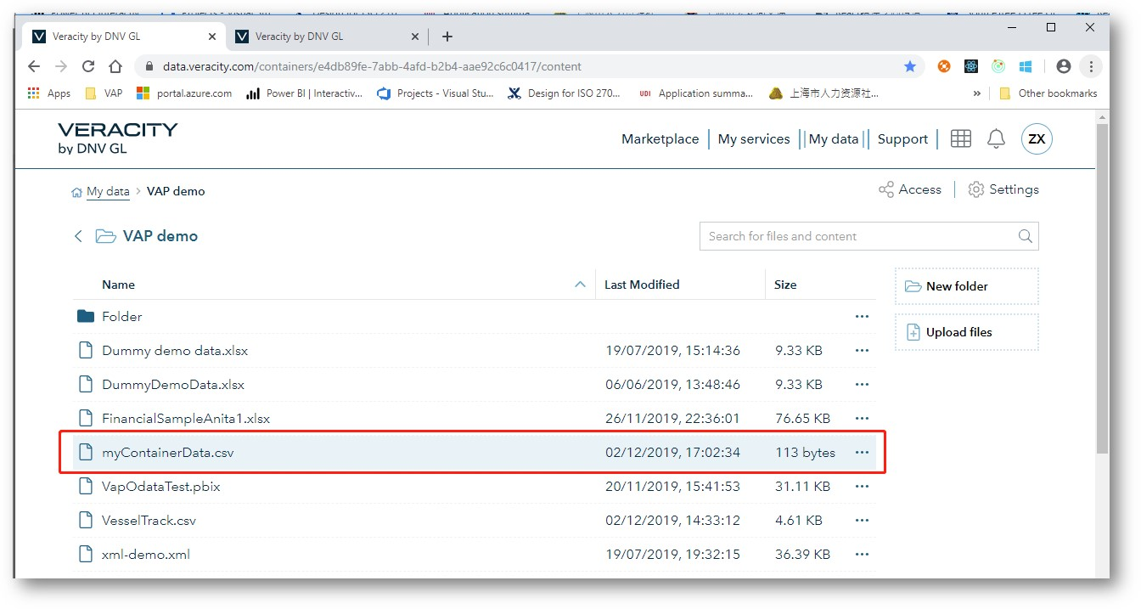

## Share access to VAP service account

A Veracity container access key has a maximum validity of 6 months.

When you develop a Power BI report and use data from a Veracity container, VAP needs to have access to your container in order to refresh the report.

To allow VAP to get a new access token/key to the container automatically you have to share a key from your container to the VAP Service account [VAP@veracity.com](mailto:VAP@veracity.com). Please click Access as shown in the image below.

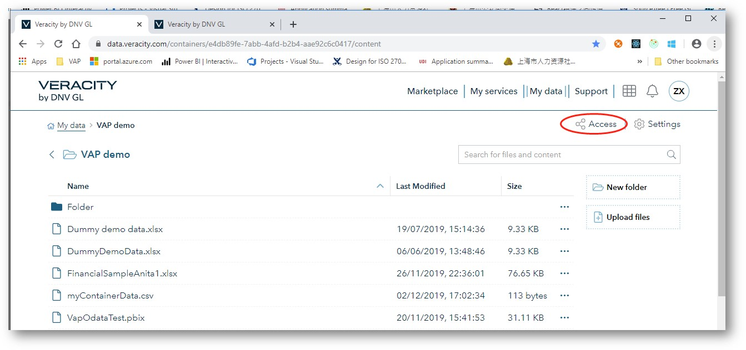

When sharing the key, please select 'Set key as recurring', set access level to 'Read and list' and set duration to 1hour. Then click Share.

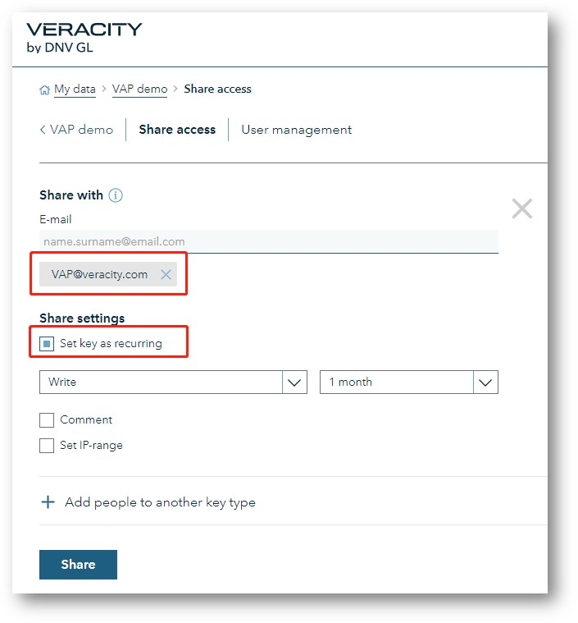

# There are two ways to connect to A Veracity data source when building A power BI report

You can select either ‘Web’ or use ‘OData feed’. This section will describe what to do for both cases. Both alternatives require workaround actions due to limitations from Microsoft, but both ways let you connect to the data in the container, renew the access key and change the file name of your data file. These two options let VAP change the data source information stored in your Power BI file.

## Alternative 1 – from Get data from ‘Web’

The current limitation from Microsoft is that the data source information stored in your Power BI file can only be changed if you define a Parameter when building your report in Power BI. Because of this we must do some workaround steps as described here.

Select the menu ‘Edit Queries’ to define your parameter.

Untitled- Power 81 Desktop 
Home 
X Cut 
Copy 
Paste 
s" Format Painter 
Clipboard 
View 
Modeling 
Help 
Get Recent 
Enter 
Data • Sources • Data Queries • 
Edit Queries 
Data source settings 
Edit Parameters 
Edit Variables 
Refresh 

The next selection is ‘Manage Parameters’ - select ‘New Parameter’. Define a Parameter and add the file URL in the field named ‘Current Value’. How to find the file URL is described in section 3. You can give the parameter a name of your choice, preferably something that describes the content of the file as it will be the default name on your data table. Set other options as in below image.

- Power Query Editor 
Close & 
Apply • 
Close 
Untitled 
Home 
New 
Source • 
Transform 
Add Column 
Data source 
settings 
Data Sources 
View 
Recent 
Sources • 
New Query 
Enter 
Data 
Manage 
Parameters • 
Parameters 
Help 
Refresh 
Preview • 
Properties 
Advanced Editor 
Manage • 
Query 
Choose Remove 
Columns • Columns • 
Manage Columns 
Name 
ContainerReportCSV 
Description 
Keep Remove 
Rows • Rows • 
Reduce Rows 
Split 
Column • 
Sort 
Queries CC) 
Group 1 
x 
Parameters 
A C Container ReportCSV 
New 
x 
To be able to change the file URL including the SAS key' 
we set up this parameter 
Required 
Suggested Values 
Any value 
Current Value 
URL of the file 
Cancel 

Then save your parameter and click ‘Close & Apply’

Untitled - Power Query Editor 
Close & 
Apply • 
Close 
Home 
New 
Source • 
Transform 
Recent 
Sources • 
New Query 
Enter 
Data 
Add Column 
Data source 
settings 
Data Sources 
Current Value 
View 
Help 
Manage 
Refresh 
Parameters • 
Preview • 
Parameters 
Properties 
Advanced Editor 
Manage • 
Query 
Queries (1) 
ContainerReportCSV (htt 
h ttps://we I dnvgIpstgcusOOOOcgk8z. blob core.wi n dows. 
Manage Parameter 

We are now ready to connect to the data and start building the report.

Select ‘Get data’, then ‘Web’ and ‘Parameter’:

x 
From Web 
@ Basic 
Text 
Parameter 
Cancel 
New Parameter... 

From the dropdown menu you will find your newly created parameter. Please select it and click ‘OK’.

Home 
X Cut 
Copy 
Paste 
s" Format Painter 
Clipboard 
View 
Modeling 
Help 
Get Recent 
Enter 
Data • Sources • Data Queries • 
External data 
From Web 
@ Basic 
Container ReportCSV 
Refresh 
New 
Page • 
New 
Visual 
E] Text box 
Image 
As k A Buttons 
Shapes • 
Question 
Insert 
From 
From 
Marketplace File 
Custom visuals 
Cancel 
Switch 
Theme • 
Themes 
x 

Finally make sure ‘Anonymous’ is selected and then ‘Connect’.

x 
Anonymous 
Windows 
Web API 
Organizational account 
Access Web content 
9 https://weldnvg I pstgcus0000c9k8z. blob.core.windo.. 
use anonymous access for this Web content 
Select which level to apply these settings to 
h I dnvgIpstgcusOOOOc9k8z. blob core.wi n dows. net/ 
Cancel 

You have successfully connected to the file in the Container when you see the values and can click ‘Load’.

x 
ContainerReportCSV 
File Origin 
65001: Unicode (UTF-8) 
subjectA 
UserName 
alice 
Jeffery 
Delimiter 
Comma 
subjectC 
Data Type Detection 
Based on first 200 rows 
subjectB 
Transform Data 
Cancel 

If you have several files in the container you have to repeate all these steps for each file.

## The second example we use OData Feed

The current limitation from Microsoft is that the data source information stored in your Power BI file can be changed if you select OData Feed when building the report in Power BI Desktop. But when using OData feed the file content type cannot be text or csv.

There coms the current Veracity Container limitation into play. You cannot change the file content type when uploading a file into you’re a Veracity container. That’s why we must do some workaround steps as described here.

### Change file content type

Open Microsoft Azure Storage Explorer to check your file. If the Content Type is not **application/octet-stream**, it must be modified. Please click the file, then select Properties. From the example below you see the content type is text/csv and how to modify it.

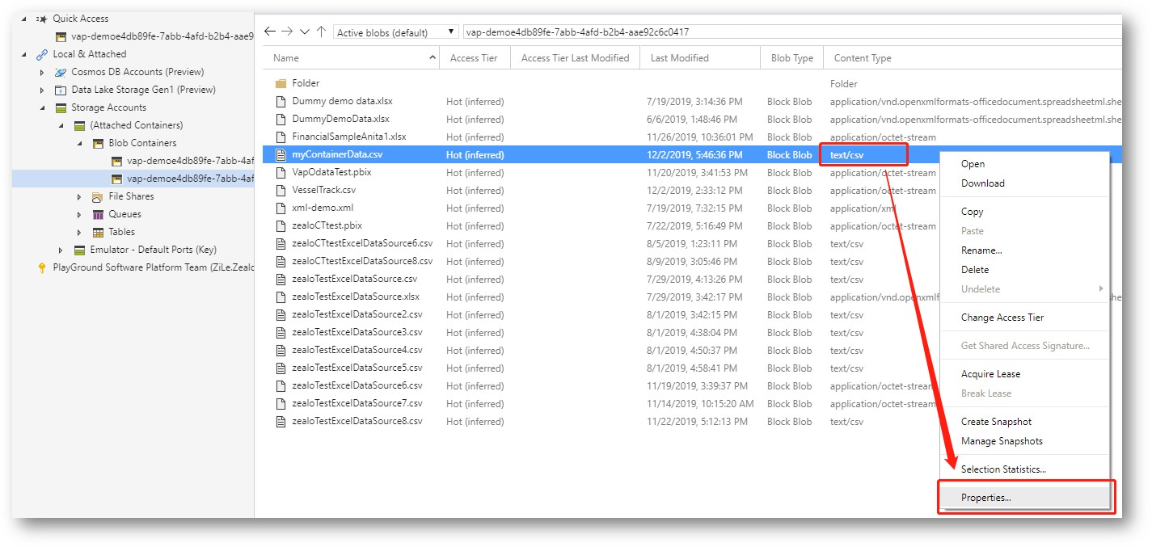

Change to application/octet-stream, then click Save button

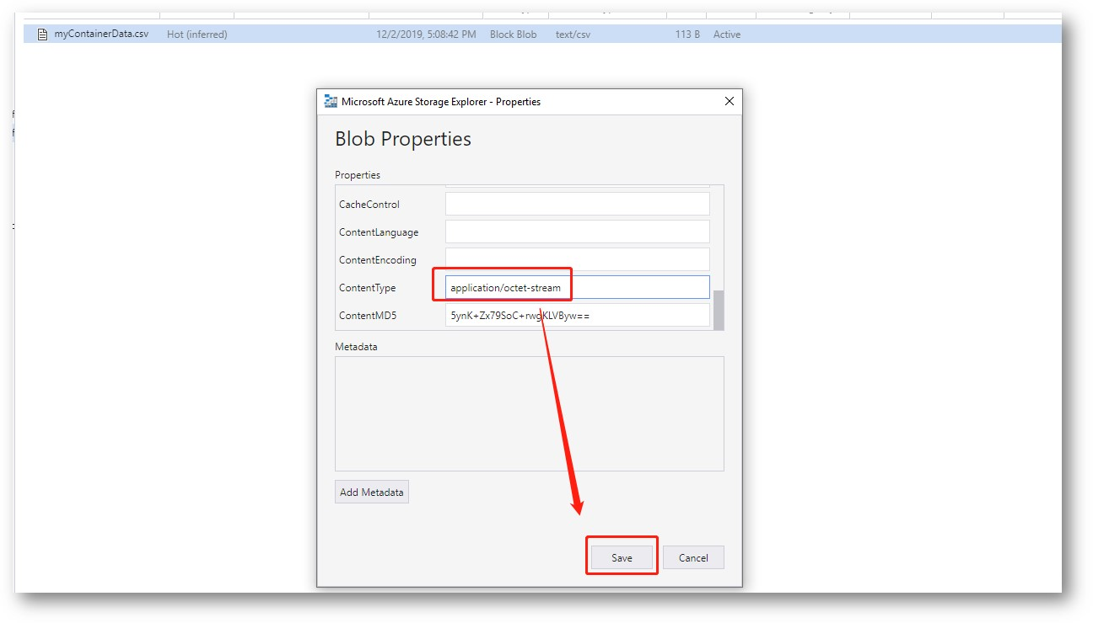

# For Veracity Container we need the file URL to be used in your Power BI report

You will later use the key when building the report from Power BI Desktop.

## First, we need to find the key

Click User management, then click “View key” to copy your key.

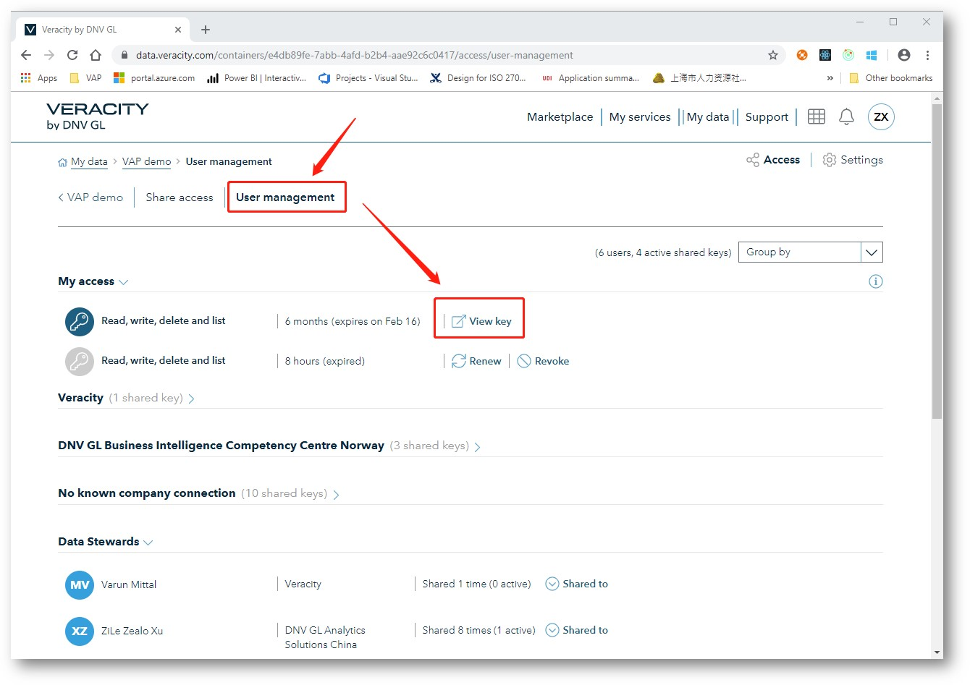

Click Copy key

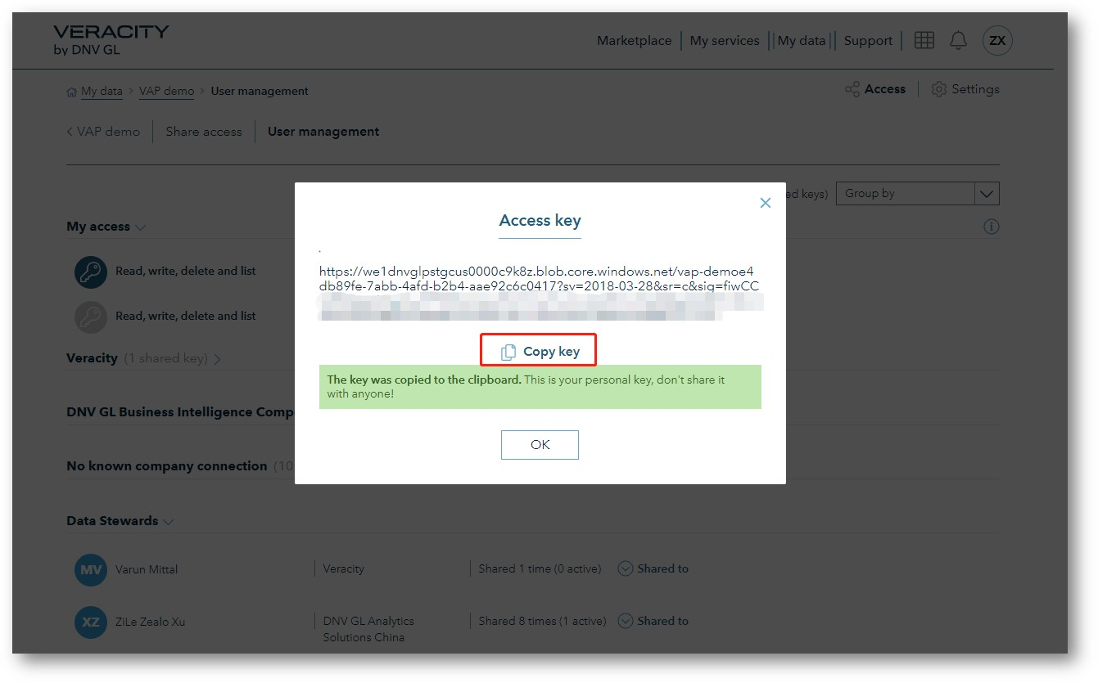

The key you copied contains of 3 parts

1. Resource part: https://we1dnvglpstgcus0000c9k8z.blob.core.windows.net
2. Container part:  /vap-demoe4db89fe-7abb-4afd-b2b4-aae92c6c0417
3. Key part: ?sv=2018-wCCK7E5WgdTJqby7KPNNkw6gxKVzSmerSw4w…………………

## Second you need to add the filename and path into the key

Now we have the key to the container. But to build a Power BI report you also need the filename to your data source.

Please add / type your file name and path into the key. In our example the filename is myContainerData.csv and the folder name simply is just Folder.

So the file URL to be used in your Power BI Desktop when building your report should consist of: Resource part + Container part + Folder + filename + key

The correct file URL is:

<https://we1dnvglpstgcus0000c9k8z.blob.core.windows.net/vap-demoe4db89fe-7abb-4afd-b2b4-aae92c6c0417/Folder/myContainerData.csv?sv=2018&sr=c&sig=fiwCCK7E5WgdTJq>...................

Please note the URL is case-sensitive

# create your Power BI Report using the file URL

Go to Power BI Desktop, to create your report.

## We will continue using OData feed and select it from Get Data

Click Get Data in Home panel, then select OData feed, if you cannot find it, please click More…

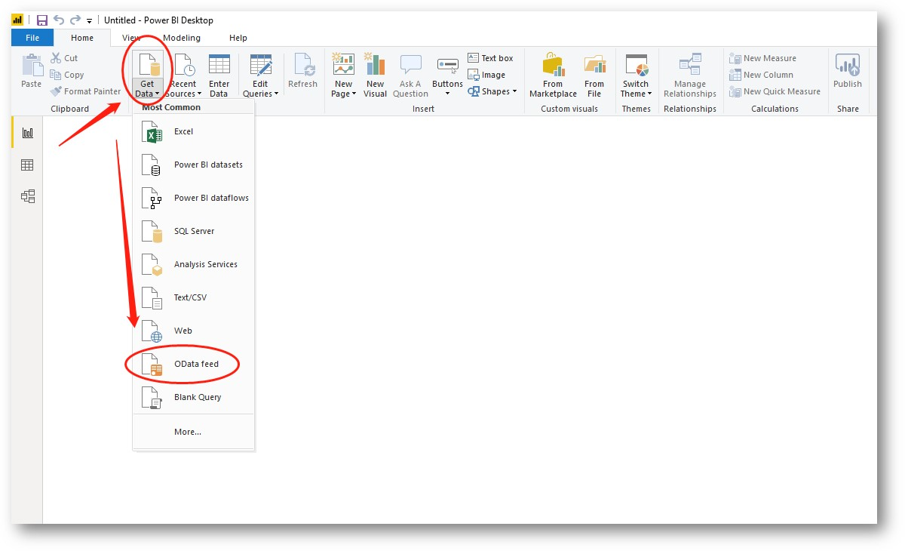

Paste the file URL into the URL area.

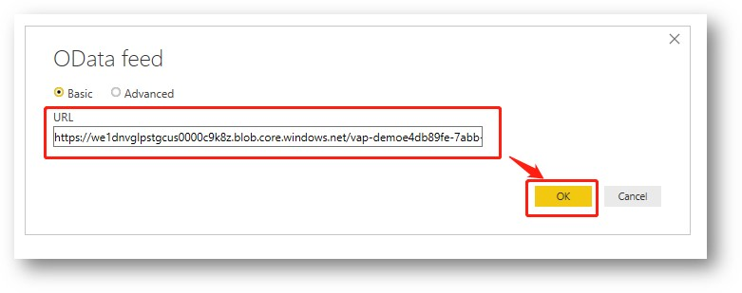

It’s successfully set up if you can see the data shown. Please click Load the data to be used.

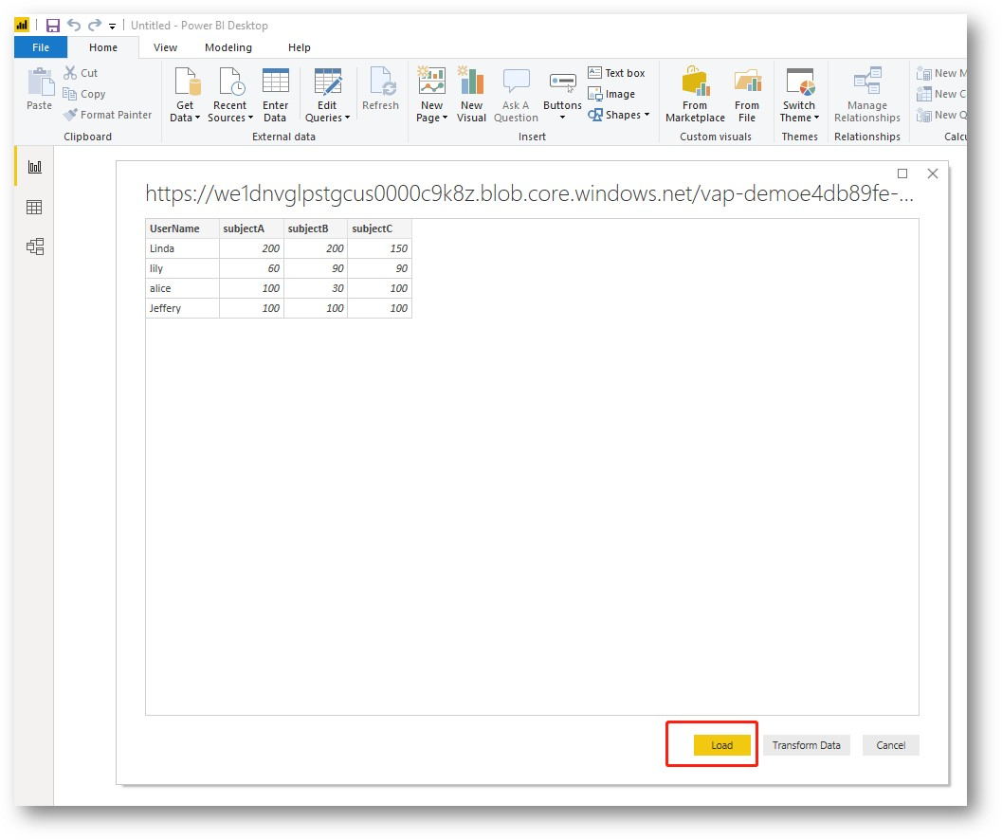

## Build your visuals and save the file as usual

Save the file to your favorite storage folder as a .pbix file.

# Upload the Power BI file in VAP

Log in to your VAP service. Click ‘Manage Files’ to upload the file.

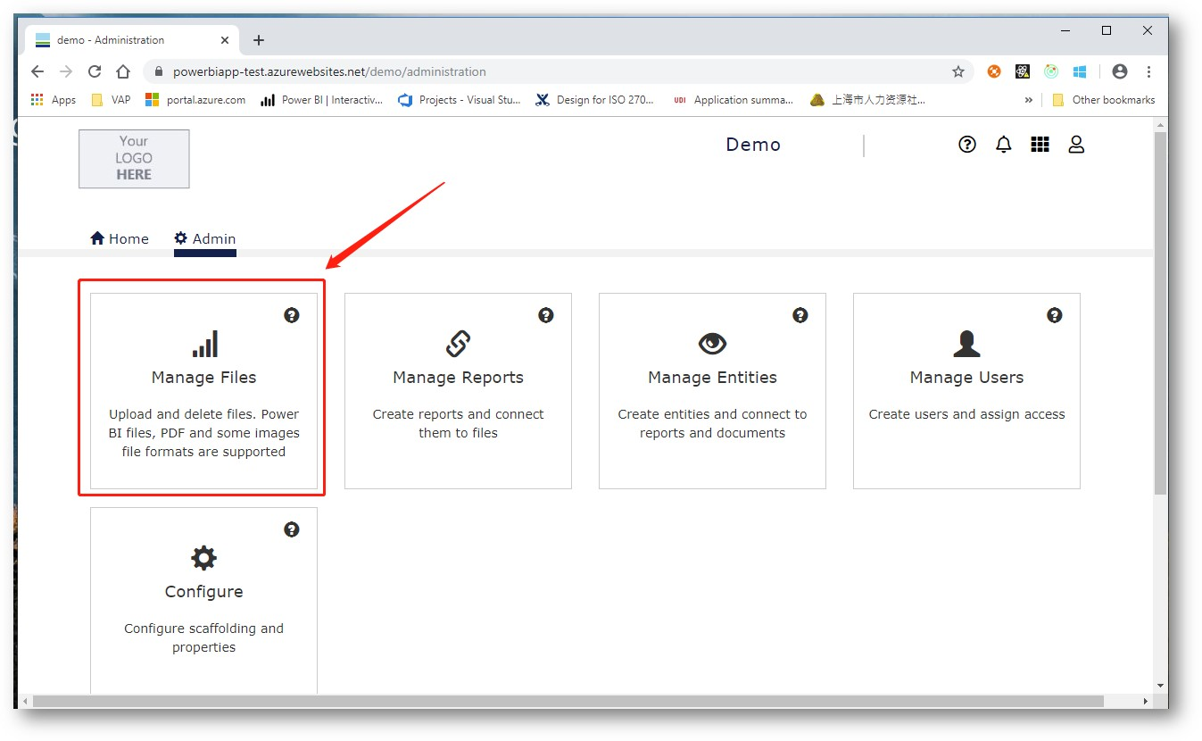

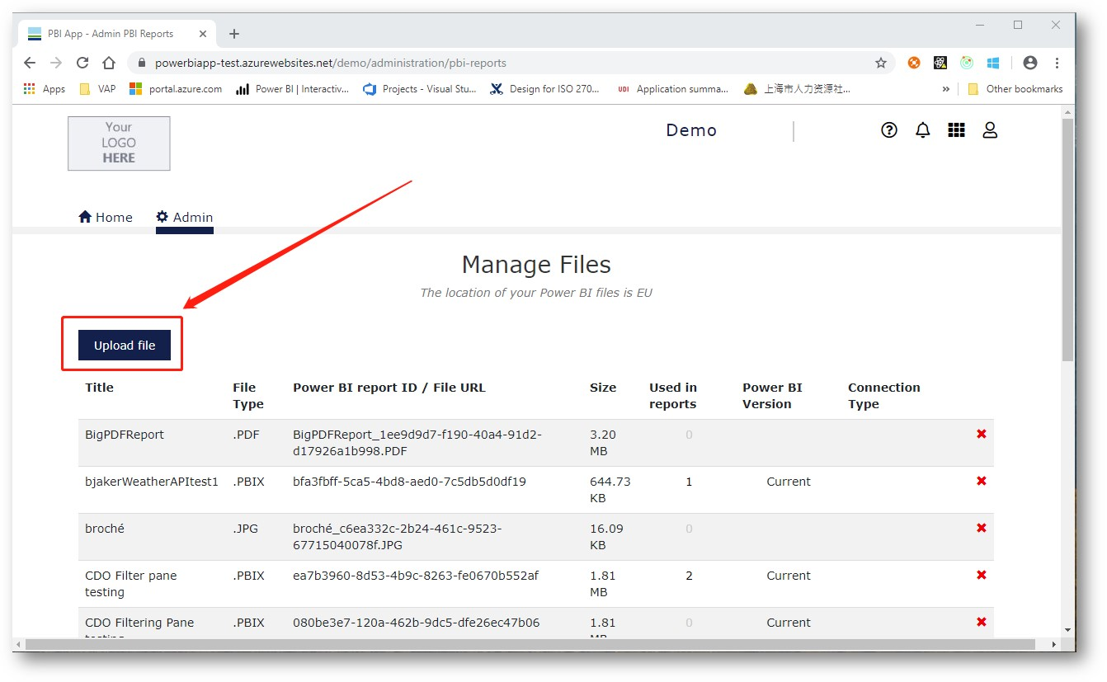

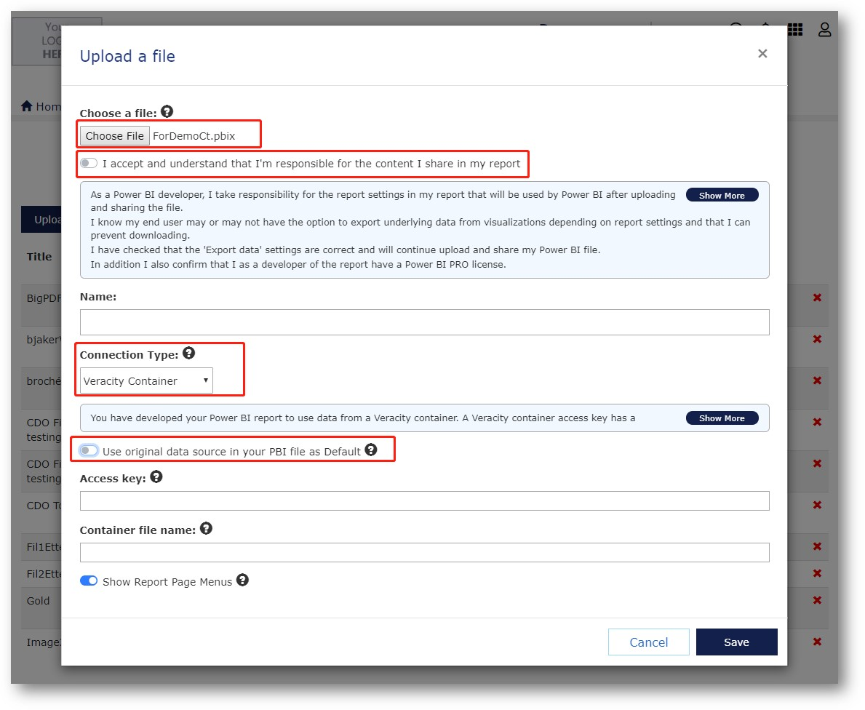

Choose your .pbix file

Click show more to read the terms and tick on “I accept and understand that I'm responsible for the content I share in my report”. Give it a name.

## Tick on “Use original data source in your PBI file as Default”

Now the original data source will be used, and the access key is only available 6 months after you created the Power BI report.

## Tick off “Use original data source in your PBI file as Default”

When you want VAP to renew the access key each time a user views your report you have to specify it. You can also specify a new file name to let VAP change the original file name you used when building your report.

Release: V 2.4

Date: 13nd December 2019