Does size generalization imply disruption robustness? A pre-registered study of GNN–PPO scheduling policies for the dynamic flexible job shop
Joseph Javier Sánchez Acuña^{a,*}, Luis Tarazona Torresª, David Álvarez Martínezª
ª Department of Industrial Engineering, Universidad de los Andes, Bogotá, Colombia
* Corresponding author: Joseph Javier Sánchez Acuña, jj.sancheza1@uniandes.edu.co · ORCID 0009-0007-2008-823X
E-mail addresses: jj.sancheza1@uniandes.edu.co (J.J. Sánchez Acuña), le.tarazona@uniandes.edu.co (L. Tarazona Torres), d.alvarezm@uniandes.edu.co (D. Álvarez Martínez)
ORCID: J.J. Sánchez Acuña 0009-0007-2008-823X; L. Tarazona Torres 0000-0003-0567-6926; D. Álvarez Martínez 0000-0001-8411-1936

Abstract
Graph neural network (GNN) policies trained by deep reinforcement learning have been shown to generalize to job-shop instances larger than those seen in training and, separately, to be trainable for robustness against a single type of disruption. Whether both properties emerge in the same policy has not been tested jointly under a pre-registered protocol. We train a relational graph isomorphism network with proximal policy optimization (PPO) for the dynamic, stochastic flexible job-shop problem and test five hypotheses whose decision rules were frozen before any evaluation, against nine dispatching rules, a genetic algorithm and the CP-SAT solver on the Fisher–Thompson, Lawrence and Brandimarte benchmarks. Four hypotheses are rejected. The policy does not beat the best dispatching rule on static instances (mean relative deviation 24.82% versus 18.96%, N = 43, p = 4.0 × 10⁻⁵); it is less robust than the rules in all nine disruption regimes combining breakdowns, stochastic processing times and arrivals (p ≤ 0.006 with a consistent nominal reference); a disruption-aware reward penalty raises nominal deviation by 46.6–106.0 percentage points without improving robustness; and its latency advantage over CP-SAT, although one to two orders of magnitude on large hard instances, does not hold on every instance. Size generalization is accepted under the pre-registered rank criterion on instances 1.5–3.0 times the training size, although an exploratory pooled test shows that the policy’s deviation remains 7.6 percentage points above the best rule’s. Size generalization and multi-disruption robustness are therefore separable properties of GNN–PPO schedulers, and each must be verified independently.
Keywords: Deep reinforcement learning; Graph neural networks; Flexible job-shop scheduling; Stochastic scheduling; Robustness; Size generalization; Pre-registration

1. Introduction
The fourth industrial revolution has turned discrete manufacturing into a data-intensive, interconnected system of sensors, programmable controllers, and cyber-physical production platforms. Within this environment, production scheduling — the assignment of operations to machines over time — remains one of the most consequential, and at the same time one of the hardest, decision functions to automate robustly on a real shop floor (Pinedo, 2022). The flexible job-shop scheduling problem (FJSP) generalizes the classical job-shop scheduling problem (JSSP) by allowing each operation to be processed on more than one candidate machine, adding a routing decision on top of the traditional sequencing decision (Brandimarte, 1993). This flexibility is operationally desirable — it improves resource utilization and operational resilience — but it substantially increases combinatorial complexity: the JSSP is already strongly NP-hard for three or more machines (Garey, Johnson, & Sethi, 1976), and the FJSP contains it as a special case.
The motivation for this study, however, is not combinatorial hardness on its own, but a more specific and industrially relevant gap: real shop floors are neither static nor deterministic. Machines break down, processing times deviate from nominal estimates, and jobs arrive without complete advance notice. Exact methods — constraint programming, mixed-integer programming — guarantee optimality only at a computational cost that grows prohibitively with instance size; priority dispatching rules (PDR) and metaheuristics trade solution quality for speed; and neither family adapts natively to events that occur during schedule execution (Pinedo, 2022; Graham, Lawler, Lenstra, & Rinnooy Kan, 1979).
In recent years, deep reinforcement learning (Sutton & Barto, 2018) combined with graph neural networks has emerged as an alternative paradigm: rather than resolving each instance from scratch, a policy is trained once and applied, in amortized fashion, to the partial state of a shop represented as a graph. Zhang et al.'s (2020) L2D showed that a graph-isomorphism-network (GIN) encoder paired with a proximal policy optimization (PPO) policy (Schulman, Wolski, Dhariwal, Radford, & Klimov, 2017), trained on small instances, can outperform classical dispatching rules and approach the solution quality of an exact solver on static job-shop instances of increasing size, with decision times orders of magnitude below those of exact search. Subsequent work extended this paradigm to the FJSP through heterogeneous graph representations that capture both operation–operation and operation–machine relations (Song, Chen, Li, & Cao, 2023; Lei et al., 2022).
However, a systematic review of the 2015–2026 literature (Section 2) shows that the large majority of this line of work evaluates policies under static, deterministic conditions, or introduces at most one type of disruption at a time — machine breakdowns, or dynamic arrivals, or stochastic processing times, but rarely more than one simultaneously — and never jointly with a size-generalization claim tested under a common statistical protocol. Two recent threads come closest, each covering a single axis: Smit, Wu, Troubil, Zhang, and Nuijten (2025b) demonstrate strong size generalization under a single source of uncertainty (stochastic processing times); Lassoued, Lier, and Schwung (2026) combine two disruption types (breakdowns and arrivals) but report no size-transfer experiment and use no graph encoder at all. To our knowledge, no published work tests both axes — size generalization and multi-disruption robustness — jointly, under a pre-registered, pre-registered statistical protocol. This is the gap the present study addresses.
We train a relational-GIN, PPO-based policy for the dynamic and stochastic FJSP and pre-register five hypotheses — H1 (static competitiveness), H2 (size generalization), H3 (robustness under disruption), H4 (whether a disruption-aware reward term improves robustness without a large nominal-performance cost), and H5 (decision-latency advantage) — with decision rules frozen before any experiment was run, following the anti-HARKing (hypothesizing after results are known) discipline increasingly expected in empirical machine-learning research. Our central contribution is not a positive result: four of the five hypotheses are rejected. It is a diagnosed, statistically rigorous characterization of exactly where, and why, the joint objective of generalization and robustness fails. Specifically, this study contributes:
(i) the first, to our knowledge, jointly pre-registered test of size generalization and multi-type disruption robustness for a GNN–PPO scheduling policy, with accept/reject rules frozen before any result existed;
(ii) a non-parametric comparison — Wilcoxon signed-rank and Friedman–Nemenyi tests with reported effect sizes — against nine dispatching rules, a tuned genetic algorithm, and an exact solver under a matched time budget, a combination rarely reported jointly in the literature reviewed;
(iii) a root-cause diagnosis for every rejected hypothesis rather than an unexplained negative result, including a concrete, transferable mechanism — domain-randomized training without nominal-episode exposure — for why disruption-aware reward shaping collapses static performance; and
(iv) direct empirical evidence that architectural size-invariance transfers rank-relative competitiveness even from a weak base policy, supporting a multiplicative reading of permutation-invariance-based GNN generalization theory (Xu, Hu, Leskovec, & Jegelka, 2019).
The remainder of this article is organized as follows. Section 2 reviews the related literature and formalizes the research gap. Section 3 details the problem formulation, policy architecture, baselines, and pre-registered experimental protocol. Section 4 reports the results for H1–H5. Section 5 discusses the findings in relation to prior work, their theoretical and practical implications, and the study's limitations. Section 6 concludes.

2. Literature Review

2.1 Deep reinforcement learning and graph neural networks for job-shop scheduling (2020–2023)
The paradigm of solving combinatorial problems through learned policies, rather than hand-designed heuristics, originates outside scheduling proper, with sequence-to-sequence pointer networks for the traveling-salesman problem (Vinyals, Fortunato, & Jaitly, 2015) and attention-based construction heuristics trained with policy gradients (Kool, van Hoof, & Welling, 2019; Kwon et al., 2020). The foundational application to job-shop scheduling is Zhang et al.'s (2020) L2D, which pairs a disjunctive-graph representation with a GIN encoder (Xu et al., 2019) and a PPO policy that decides, at each decision epoch, which operation to dispatch. L2D reports optimality gaps of 13.6–29.2% against OR-Tools on generated and Taillard (1993) instances, outperforming classical dispatching rules on 87.5–92% of evaluated instances, and — critically for the present study — demonstrates out-of-distribution size generalization: a policy trained on 20×20/30×20 instances retains a 9.4% gap when evaluated zero-shot on 100×20 instances, far below the best dispatching rule's 33.7–54.9% gap at that size. Park, Chun, Kim, Kim, and Park (2021) independently formalize a similar representation-and-policy-learning approach, reporting a 14.7% mean relative error against a battery of classical and neural baselines. Both works are restricted to static, deterministic JSSP with fixed machine routing. Recent contributions in this journal have combined graph neural encoders with deep reinforcement learning for the static FJSP (Liu et al., 2025; Zhang et al., 2025) and have addressed dynamic job shops with new job arrivals and dynamic flexible job shops with multi-agent formulations (Wu & Yan, 2023; Yu et al., 2026; Wang et al., 2026).
Extending this paradigm to the FJSP requires representing two distinct entity types — operations and machines — with distinct relations between them. Song et al. (2023) propose a heterogeneous graph that augments the disjunctive graph with explicit machine nodes processed via heterogeneous attention layers, paired with a PPO policy; Lei et al. (2022) propose a multi-action, dual-PPO scheme over a disjunctive-graph encoding, evaluated on the Brandimarte (1993) benchmark. Both report qualitative superiority over dispatching-rule baselines, although the exact figures could not be independently re-verified from open-access sources at the time of this review. This period also produced open-source infrastructure — Gymnasium-compatible environments (Tassel, Gebser, & Schekotihin, 2021), reusable experiment frameworks (Waubert de Puiseau, Peters, Dörpelkus, Tercan, & Meisen, 2023), and unified benchmarks (Reijnen et al., 2026) — that makes independent reproduction and extension of this line of work tractable outside dedicated laboratories, including the pipeline underlying the present study.

2.2 Size generalization and the homogeneous–heterogeneous architecture spectrum
The theoretical basis for size generalization in GNN-based policies rests on permutation invariance and a parameter count that is independent of instance size: a sufficiently expressive message-passing scheme distinguishes graph structures up to the Weisfeiler–Lehman test, and a GIN encoder attains this bound (Xu et al., 2019); related message-passing architectures include graph convolutional networks (Kipf & Welling, 2017), GraphSAGE (Hamilton, Ying, & Leskovec, 2017), and graph attention networks (Veličković et al., 2018). Smit et al.'s (2025a) survey of GNN applications to job-shop and flexible job-shop scheduling offers the most current taxonomic map of this design space and is adopted here as a classification reference. Architecturally, the literature spans a spectrum rather than a binary choice: at one end, L2D's fully homogeneous graph aggregates every edge type with a single set of weights; at the other, Song et al.'s (2023) and related heterogeneous designs assign distinct transformations and attention mechanisms to each node and edge type. A third position, of very recent origin, directly challenges the near-universal 2022–2024 assumption that heterogeneity is a precondition for scalability: Hoss, Link, and Klarmann (2026) propose a feature-based homogenization that projects distinct node roles into a shared latent space, reporting linear complexity on industrial-scale instances without sacrificing performance. This debate is directly relevant to the architectural choice made in Section 3.2.
On the generalization-under-uncertainty axis specifically, Smit et al.'s (2025b) SPM-DAN extends a heterogeneous deep-attention-network architecture with a scenario-processing module that aggregates, via attention, multiple sampled realizations of stochastic processing times; trained on 20×10 instances, it maintains a −7.10% to −7.07% gap against CP-SAT when transferred, without retraining, to 30×10/40×10 instances — a markedly stronger absolute generalization result than reported in Section 4.2 below, obtained under a single uncertainty source with an architecture purpose-built for it. Infantes, Roussel, Pereira, Jacquet, and Benazera's (2024) Wheatley similarly targets generalization and scalability for JSSP with uncertain durations, minimizing expected rather than deterministic makespan. Neither work addresses multiple simultaneous disruption types.

2.3 Robustness to disruption in dynamic and stochastic scheduling
Beyond the static-generalization literature, work on dynamic scheduling with reinforcement learning can be organized by how uncertainty enters the Markov decision process: purely reactive schemes, where the agent simply re-decides at each new epoch with no explicit anticipation mechanism; risk-aware schemes, where the training objective incorporates a tail measure of the outcome distribution (e.g., SPM-DAN's value-at-risk surrogate or Wheatley's expected-makespan objective) rather than the expectation alone; and anticipatory schemes, where the agent receives explicit distributional information about future events — a direction that remains largely unresolved in the reviewed literature. Lassoued et al. (2026) combine machine breakdowns (Weibull time-to-failure) and dynamic arrivals (Gamma process) over a colored-timed-Petri-net representation with a maskable-PPO policy — no graph encoder, no size-transfer experiment — reporting 1.1–3% improvement over the best heuristic under breakdowns alone and up to 8% under the combined regime. This is, to our knowledge, the closest prior demonstration that a policy-gradient method can outperform dispatching rules under multi-type disruption when robustness is the sole training objective, uncontested by a shared size-generalization budget — a contrast we return to in Section 5.1. On reward design specifically, Zhang, Yan, Yang, and Hu (2024) propose a heterogeneous multi-agent D3QN scheme with disruption-aware reward shaping for the dynamic FJSP under stochastic transport times — the closest precedent to the instability-penalty mechanism evaluated in Section 3.3 — but designed and evaluated for a single disruption type in a non-GNN, non-policy-gradient architecture.
A pattern recurs across this literature: the large majority of technical works isolate a single uncertainty axis by experimental design, even where the underlying architecture could plausibly support more than one. A partial exception is Lassoued et al. (2026) (breakdowns and arrivals jointly, without size generalization or a graph encoder); in a methodologically distinct paradigm, large-language-model scheduling agents have also been evaluated under multiple simultaneous event types without parametric training (Cao & Yuan, 2025).

2.4 An emerging, methodologically distinct paradigm: LLM-based scheduling agents
A rapidly growing body of 2025–2026 work applies pretrained large language models (LLMs), guided by prompting, simulated rollouts, or supervised fine-tuning, directly to scheduling decisions rather than training a fixed-parameter policy by reward gradient (Abgaryan, Cazenave, & Harutyunyan, 2025; Cao & Yuan, 2025). Their relationship to size generalization is qualitatively different from a GNN's: rather than an architectural invariance to instance dimensions, these agents inherit generalization from large-scale language pretraining. We treat this paradigm as a point of discursive contrast in Section 5 rather than a direct methodological competitor, since the policy evaluated here is a trained, fixed-parameter GNN–PPO model, not a prompted language-model agent.

2.5 Research gap and hypotheses
Table 1 synthesizes the gap analysis underlying this study, drawn from a structured search of the 2015–2026 literature (arXiv, Semantic Scholar, DBLP, and open-access publisher indices) using four query strings combining reinforcement-learning, graph-neural-network, job-shop/flexible-job-shop, and dynamic/stochastic/disruption terms.
Table 1. Research gap synthesis: identified gaps, representative 2024–2026 evidence, and status after this review.
Identified gap | Representative evidence | Status after this review
Joint test of size generalization and multi-disruption robustness | Smit et al. (2025b) and Infantes et al. (2024) generalize in size under one uncertainty source; Lassoued et al. (2026) combine two disruption types with no size-transfer test and no graph encoder | Confirmed open; central axis of this study (H2 + H3/H4 jointly)
Disruption-aware reward shaping restricted to a single event type | Zhang et al. (2024) design reward shaping for one disruption type in a non-GNN, multi-agent architecture | Narrowed, not closed; H4 tests generalization to a multi-disruption regime
Simultaneous, time-matched comparison against CP-SAT, a genetic algorithm, and PDR | No 2024–2026 work identified in this review reports all three baseline families jointly under a matched time budget | Confirmed open; addressed by the experimental design (Section 3.4)
Non-parametric statistical protocol with effect sizes and critical-difference diagrams | Not reported in any 2024–2026 work identified in this review | Confirmed open; addressed throughout Section 4
Assumption that a heterogeneous graph representation is necessary for size generalization | Near-universal assumption 2022–2024; directly challenged by Hoss et al. (2026) via linear-complexity homogenization | Emerging, unsettled; informs the architectural choice in Section 3.2
Across the technical works surveyed, the specific combination this study investigates — size generalization and robustness to multiple simultaneous disruption types, tested jointly and statistically on a single pre-registered policy — remains unresolved. Guided by this gap, the study tests five hypotheses: static competitiveness against the best dispatching rule (H1); generalization to instances 1.5×–3.0× the training size (H2); robustness, relative to dispatching rules, under nine disruption regimes spanning machine breakdowns, stochastic processing times, and dynamic arrivals (H3); whether an explicit disruption-aware reward term improves robustness without an unacceptable nominal-performance cost (H4); and whether decision latency remains far below that of an exact solver as instance size grows (H5). Section 3.6 states the exact, pre-registered decision rule for each hypothesis.

3. Materials and Methods

3.1 Problem formulation
This study addresses the dynamic, stochastic FJSP. A set of jobs J = {1, …, n} is defined, each a fixed-precedence sequence of operations O_{j,h}; each operation is processable on any machine in an eligible subset M_{j,h} ⊆ M, with machine-dependent processing time p_{j,h,k}. Three sources of uncertainty extend the deterministic base problem: (i) dynamic job arrivals, modeled as a Poisson process calibrated to a target utilization ρ; (ii) stochastic processing times, a log-normal multiplier of unit mean applied to the nominal duration; and (iii) machine breakdowns, with exponential time-to-failure and log-normal time-to-repair, parameterized by a target steady-state availability A_{k}. The environment is realized as a discrete-event simulation exposed through a Gymnasium-compatible interface (cf. Tassel et al., 2021); each decision epoch corresponds to one step() call, with a legality mask recomputed at every step to exclude infeasible operation–machine assignments.

3.2 Policy architecture
At decision epoch t, the state is represented as a heterogeneous graph G_{t} over operation nodes and machine nodes, connected by three typed relations: intra-job precedence, shared-machine competition among undispatched operations, and operation–machine eligibility. We adopt a relational GIN — node embeddings in a shared latent space, with a separate linear transformation per relation and direction (Eqs. 1–2), aggregated by summation before a GIN update — rather than the fully homogeneous graph of L2D (Zhang et al., 2020) or the fully heterogeneous, attention-based graph of Song et al. (2023). This is a deliberate midpoint of the homogeneous–heterogeneous spectrum discussed in Section 2.2: more expressive than a single shared adjacency, because it distinguishes the opposing semantics of each relation (a predecessor constrains, a successor is constrained, a machine competitor contests the same resource), without the parameter and computational cost of full heterogeneity — and consistent with Hoss et al.'s (2026) evidence that heterogeneity is not a strict precondition for scalable generalization. Sum aggregation, rather than mean or max, is used throughout, following the expressiveness argument of Xu et al. (2019) — a property required for the policy to distinguish, for instance, a lightly loaded machine from a heavily loaded one.
Message passing at layer l for an operation node v and a machine node k is given by:
hvl=MLPOl1+ϵl hvl−1+Wpredu→v​hul−1+Wsuccv→u​hul−1+Wmachu∼v​hul−1+Welig hmvl−1 1
hkl=MLPMl1+ϵMl hkl−1+Wcandv: mv=k​hvl−1 2
where $h$ denotes a node embedding, $u→v$ a precedence arc, $u∼v$ two undispatched operations competing for the same machine, $m\left(v\right)$ the machine currently associated with operation $v$, $ϵ^{\left(l\right)}$ and $ϵ_{M}^{\left(l\right)}$ learnable GIN self-weighting scalars, and $W_{pred},W_{succ},W_{mach},W_{elig},W_{cand}$ relation-specific linear maps.
A per-node actor head, shared across all operation embeddings, produces one logit per candidate operation regardless of instance size, softmax-normalized over legal actions only, with the mask applied before log-probability computation rather than as a reward penalty (Huang & Ontañón, 2022). The actor's parameter count is, by construction, independent of the number of operations N — the architectural property underlying the size-generalization hypothesis (H2). The critic consumes a mean-pooled graph embedding. Training uses MaskablePPO (Raffin et al., 2021) with a clipped surrogate objective and generalized advantage estimation (Schulman, Moritz, Levine, Jordan, & Abbeel, 2016), with discount factor γ = 1, justified by the reward's telescoping-sum structure described next.
Training protocol. The encoder stacks three relational GIN layers with 64-dimensional embeddings and two-layer MLPs with learnable ε. The JSSP policy evaluated for H1 (JSSP), H2 and H3 was trained by a 20-stage progressive curriculum over the Lawrence instances la01–la20, transferring all network weights from each stage to the next; a second track continued the curriculum over five Brandimarte instances (mk01–mk05) to obtain the checkpoint used for the FJSP arms of H1. Training ran on CPU only, on an 8-core machine (Python 3.11.9, PyTorch 2.12.1, Stable-Baselines3 and sb3-contrib 2.9.0, OR-Tools 9.15.6755), and took 114 min of wall-clock time for the 20 JSSP stages and 29 min for the five FJSP stages. For H4, the two κ > 0 policies were obtained by a two-stage fine-tuning curriculum (ft06 → la01, 100,000 timesteps per stage) warm-started from the 20-stage JSSP checkpoint, with the disruption regime resampled at random among the nine regimes at every episode reset.
Train–test overlap. Twenty of the 43 instances in the JSSP arm of H1 (la01–la20) and five of the seven Brandimarte instances (mk01–mk05) were seen during curriculum training; the H2 tiers (la21–la40), the Fisher–Thompson instances and mk07 are strictly zero-shot. In-sample exposure can only favour the policy, so the rejection of H1 is conservative, and H2 is unaffected because its tiers are entirely out-of-sample.

3.3 Disruption-aware reward
The base reward is dense and potential-based,
$$r_{t}=\left(H\left(s_{t}\right)−H\left(s_{t+1}\right)\right)⋅c, \left(3\right)$$
with scaling constant $c$, where H(s) is a state-dependent lower-bound estimate of the makespan (an optimistic job-chain propagation that ignores machine contention on undispatched operations), guaranteeing r_{t} ≤ 0 and a telescoping return t​rt=Hs0−Cmax⋅c; maximizing undiscounted return is therefore exactly equivalent to minimizing makespan (Ng, Harada, & Russell, 1999). To test H4, this reward is extended with an instability penalty:
$$r_{t}=\left(H\left(s_{t}\right)−H\left(s_{t+1}\right)\right)⋅c−κ Δ_{inst}⋅c, \left(4\right)$$
where $Δ_{inst}$ is the deviation from previously planned start times induced by re-planning after a disruption event, and κ ∈ {0, 0.5, 1.0}; κ = 0 recovers the base reward exactly (verified by unit test).

3.4 Baseline methods
Nine priority dispatching rules (PDR) are evaluated: shortest processing time (SPT), longest processing time (LPT), most work remaining (MWKR), least work remaining (LWKR), most operations remaining (MOR), least operations remaining (LOR), first-in-first-out (FIFO), earliest due date (EDD), and critical ratio (CR); the last two require synthesized due dates via the total-work-content rule, d_{j} = r_{j} + 1.5 × Σ_{h} p_{j,h}, since the benchmark families used carry no published due dates. A genetic algorithm (permutation-with-repetition encoding, precedence-order crossover, swap mutation, tournament selection with elitism, population size 80 scaled down for larger instances, and a 5% random-immigrant rate against premature convergence) and CP-SAT (Perron, Didier, & Gay, 2023), Google OR-Tools' constraint-programming solver, serve as the metaheuristic and exact/near-exact references. All methods except the PDRs, which are effectively instantaneous, operate under a wall-clock budget matched to CP-SAT's (60 seconds) for a fair comparison. Two dispatching schemes are involved and are reported explicitly because they affect the absolute level of several rules. In the static evaluations (H1, H2) each rule selects among the next unscheduled operation of every job and places the selected operation at its earliest feasible start, so a rule may choose an operation that cannot start until later while another could start now (a semi-active, delay-permitting list-scheduling scheme). In the disrupted evaluations (H3, H4) the rules run inside the event-driven simulator, where only operations whose machine is idle and whose job predecessor has completed at the current decision epoch are eligible; without disruption this simulator produces exactly the non-delay schedules of Giffler and Thompson (1960). Section 4.5 quantifies the consequences of this difference.

3.5 Experimental design and statistical protocol
Evaluation spans 43 JSSP instances (Fisher–Thompson ft06/ft10/ft20, Fisher & Thompson, 1963; Lawrence la01–la40, Lawrence, 1984) and two FJSP arms: a synthetic arm (the same 43 base instances extended with machine flexibility) and seven of the eight Brandimarte (1993) instances (mk06 excluded after an upstream benchmark-mirror inconsistency — 15 machines instead of the published 10 — was traced during instance loading). The disruption experiments (H3, H4) use the two instances on which the disruption machinery was validated, ft06 and la01, with 30 seeds per regime and all nine rules as candidate comparators except under dynamic arrivals, where the pre-registered comparator set is restricted to the four arrival-safe rules (FIFO, LOR, LWKR and MOR). All pairwise comparisons use the exact Wilcoxon signed-rank test; joint comparisons across the ten methods (the policy plus nine PDRs) use the Friedman test with Nemenyi post-hoc analysis and critical-difference diagrams (Demšar, 2006); effect sizes (r = Z/√N) are reported throughout.

3.6 Pre-registration and hypotheses
Five hypotheses were pre-registered, with quantitative accept/reject rules frozen in a timestamped document before any policy-evaluation result was generated (freeze timestamp 2026-07-29 05:22 UTC; the earliest result file in the repository is time-stamped 16:28 UTC the same day). The document and its single dated amendment (2026-07-31, which clarifies the hardware on which H5 latency is measured and leaves every threshold unchanged) are publicly available in the study repository (thesis/PreRegistration.md; https://github.com/GIUSEPPESAN21/Tesis-Paper-Code) — a discipline intended to guard against hypothesizing after results are known (HARKing), and one that Table 1 shows to be largely absent from the works surveyed in Section 2. Table 2 states each hypothesis and its exact decision rule.
Table 2. Pre-registered hypotheses and frozen decision rules.
Hyp. | Claim | Accept criterion (frozen before evaluation)
H1 | The policy outperforms the best PDR in mean RPD on static instances | Wilcoxon p<0.05 and median(RPD_{bestPDR} − RPD_{RL}) > 0, per instance family
H2 | RPD on 1.5×–3.0× larger instances stays competitive with the best PDR | Friedman–Nemenyi: the policy's rank not significantly worse than the best PDR's, in every size tier
H3 | Robustness index (RI) is lower than PDRs' under breakdowns, stochastic times, and arrivals | Wilcoxon p<0.05 and median(RI_{PDR} − RI_{RL}) > 0, in all 9 disruption regimes (conjunctive rule)
H4 | κ>0 reduces RI without increasing nominal RPD by more than 2 percentage points | ΔRI<0 significant in ≥5/9 regimes and ΔRPD_{nominal} < 2pp (both required)
H5 | Decision latency stays far below CP-SAT's as instance size grows | median(ms/decision_{RL}) < 1% × median(ms/decision_{CP-SAT}), for every instance
Note. For the two FJSP arms of H1, the frozen comparator is the better of GA and CP-SAT on raw makespan, since none of the nine dispatching rules selects machines; for H3, the comparator under dynamic arrivals is restricted, also by pre-registration, to the four arrival-safe rules (FIFO, LOR, LWKR and MOR).

4. Results
Table 3 summarizes the verdict for all five pre-registered hypotheses; Sections 4.1–4.4 detail each in turn, and Section 4.5 reports an exploratory sensitivity analysis of the dispatching-rule implementation that was not part of the pre-registration.
Table 3. Hypothesis verdicts (all tests two-sided, α = 0.05).
Hypothesis | Test | Statistic | Verdict
H1 (JSSP) | Wilcoxon, N=43 | W=133, p=4.03×10⁻⁵, r=−0.63 | REJECT
H1 (FJSP synthetic) | Wilcoxon, N=43 | W=0, p=1.12×10⁻⁸, r=−0.87 | REJECT
H1 (FJSP Brandimarte) | Wilcoxon, N=7 | W=0, p=0.0156, r=−0.91 | REJECT
H2 (4 size tiers) | Friedman + Nemenyi | rank gap ≤1.00 < CD=6.06 in all tiers | ACCEPT
H3 (9 disruption regimes) | Wilcoxon ×9 | p<1.7×10⁻¹¹ in all 9 | REJECT
H4 (κ=0.5) | Wilcoxon ×9 + ΔRPD | 0/9 significant; ΔRPD_{nom}=+106.0pp | REJECT
H4 (κ=1.0) | Wilcoxon ×9 + ΔRPD | 1/9 significant; ΔRPD_{nom}=+46.6pp | REJECT
H5 (latency, strict) | threshold, N=43 | 42/43 instances fail 1% rule | REJECT

4.1 H1 — Static competitiveness (rejected)
Mean RPD over the 43 JSSP instances is 24.82% for the policy, 18.96% for the best PDR per instance, 5.52% for the GA, and approximately 0% for CP-SAT (Figure 1; Table 4 gives the full per-method breakdown). The policy beats the per-instance best PDR on only 8 of 43 instances (18.6%) and loses on every instance of both FJSP arms: mean RPD against the better of {GA, CP-SAT} is 48.76% on the synthetic arm (0/43 wins) and 89.65% on the Brandimarte arm (0/7 wins). All three tests reject H1 with large effect sizes (r = −0.63 to −0.91). We note explicitly that the GA — under the same 60-second wall-clock budget as CP-SAT — outperforms both the policy and the best PDR by an even larger margin than the PDR comparison alone suggests (Table 4); we return to this training-time-compute-versus-evaluation-time-search asymmetry in Section 5.1. Table 4 also substantiates a claim used throughout this article: FIFO is the strongest of the nine dispatching rules by a wide margin (mean RPD 19.15% versus 39.83% for the next best, MOR), and is therefore the dominant comparator in most of the size-generalization results below. This ordering holds for the semi-active implementation used in the pre-registered tests; under a non-delay implementation MWKR and MOR overtake FIFO and the rejection of H1 becomes stronger (Section 4.5).
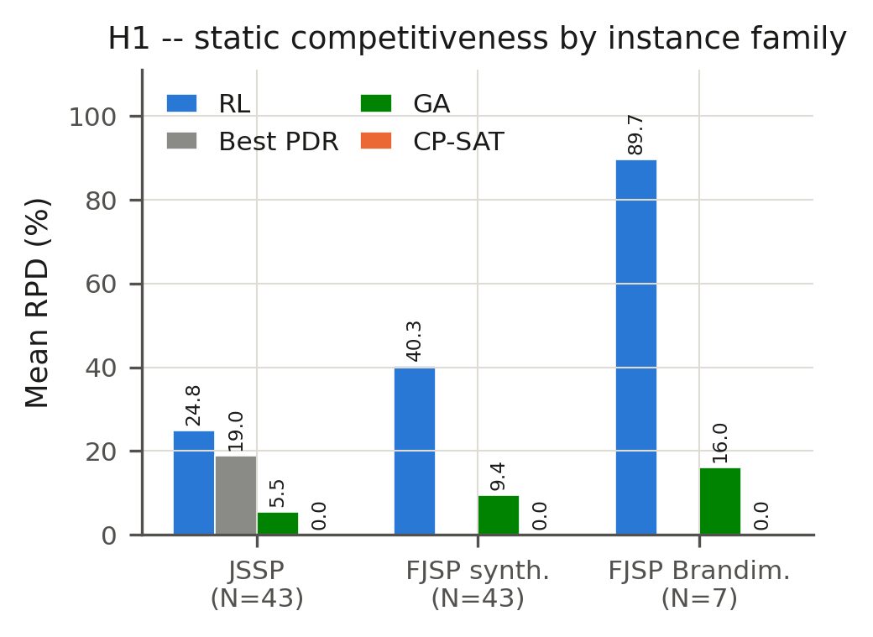
Fig. 1. Mean relative percentage deviation (RPD) by method and instance family. RPD is computed against CP-SAT's makespan as the near-optimal reference within each family; the H1 test compares the policy against the best PDR (JSSP) or the better of {GA, CP-SAT} (FJSP arms) on a per-instance basis (see text). In the FJSP arms the comparator is the better of GA and CP-SAT on raw makespan, as fixed in the pre-registration (§2), because no dispatching rule in the set includes a machine-selection component.
Table 4. Mean and standard deviation of RPD (%) by method, JSSP arm (N=43 instances, seed-0 deterministic evaluation; dispatching rules in the semi-active implementation of the pre-registered tests, see Table 6 for the non-delay values).
Method | Type | Mean RPD (%) | SD (%)
CP-SAT | Exact | 0.02 | 0.13
GA | Metaheuristic | 5.52 | 5.31
FIFO | PDR | 19.15 | 11.10
RL (this study) | GNN–PPO policy | 24.82 | 12.92
MOR | PDR | 39.83 | 16.91
MWKR | PDR | 42.59 | 16.19
SPT | PDR | 268.23 | 114.01
LPT | PDR | 281.88 | 116.91
EDD | PDR | 387.34 | 177.00
LWKR | PDR | 391.91 | 177.61
LOR | PDR | 401.15 | 174.56
CR | PDR | 430.31 | 183.62

4.2 H2 — Size generalization (accepted)
Across four size tiers (1.5×–3.0× the training size, la21–la40), the Friedman test decisively rejects equal performance in each tier (p<3.4×10⁻⁶), and in every tier the policy's mean rank is not significantly different from the best PDR's (Δrank 0.20–1.00 against a Nemenyi critical difference of 6.06; Figure 2). The critical-difference diagrams place the policy in the same statistically indistinguishable cluster as FIFO, MWKR, MOR, and SPT in all four tiers. Two qualifications apply. First, each tier contains only five instances (la21–la40), and with ten methods the Nemenyi critical difference (6.06 rank units on a 1–10 scale) is so wide that the pre-registered criterion has little power to detect a difference; the acceptance of H2 therefore means that no difference was detected, not that equivalence was demonstrated. As an exploratory check that was not part of the pre-registration, pooling the 20 out-of-sample instances shows that the policy’s deviation exceeds FIFO’s by 7.6 percentage points on average (90% confidence interval 5.0–10.3; exact Wilcoxon W = 18, p < 0.001), with the policy ahead of FIFO on only 4 of the 20 instances. The absolute gap to the best rule is therefore real; what transfers across sizes is the policy’s position relative to the rest of the field. Second, this is an acceptance of rank-relative, not absolute, competitiveness: the policy's mean RPD (23.9–32.9% across tiers) remains numerically above FIFO's (12.7–26.8%) at every tier. The size–RPD relationship is non-monotonic: the 3.0× tier has the lowest mean RPD of the four (23.86%), below even the 1.5× tier's (32.55%) — a pattern that, with five instances per tier, should be treated as descriptive, and one that cautions against assuming degradation is strictly monotonic in instance size for this architecture.
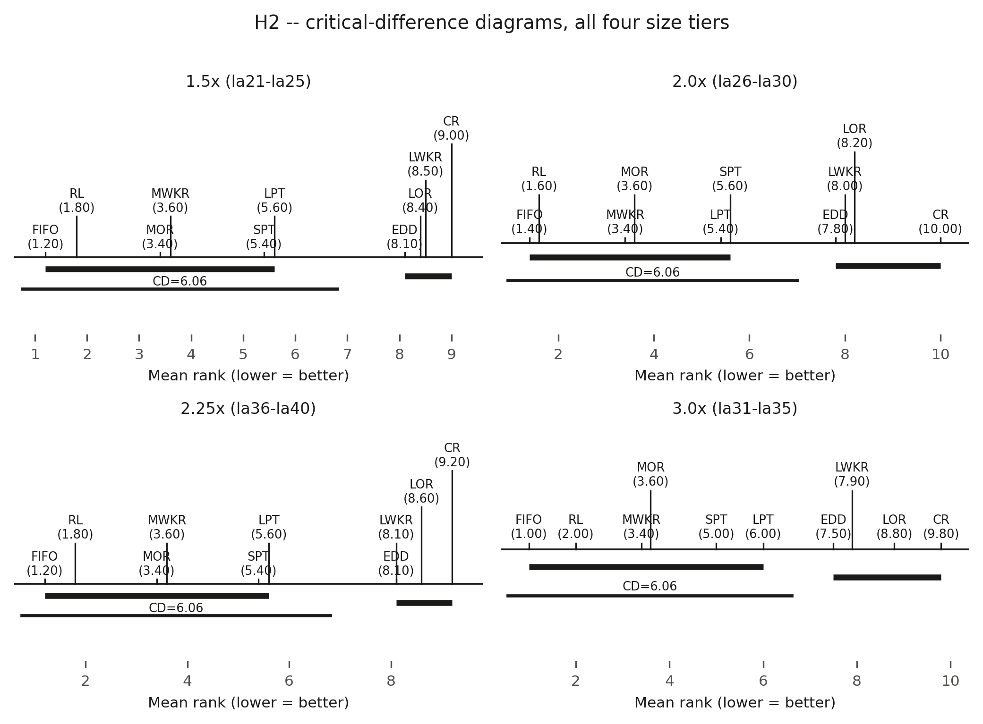
Fig. 2. Friedman–Nemenyi critical-difference diagrams for all four size tiers (1.5×, 2.0×, 2.25×, 3.0× the training size). Methods connected by a horizontal bar are not significantly different in mean rank (CD = 6.06). The policy (RL) falls in the same top cluster as FIFO, MWKR, MOR, and SPT in every tier.

4.3 H3/H4 — Robustness and disruption-aware reward (rejected)
The policy's robustness index (RI) is worse than the best PDR's in all nine disruption regimes, with large and uniformly consistent effect sizes (r ≈ −0.87 in all nine; Fig. 3). Each regime-level test pairs N = 60 observations (instances ft06 and la01 × 30 seeds, as fixed in the pre-registration), and W = 0 in all nine regimes: the best rule’s RI was lower than the policy’s in every one of the 540 paired observations. Section 4.5 shows that the size of these effects is inflated by the nominal reference used for the rules, and that the rejection survives its correction. The arrivals axis is the most severe (RI ≈ 1.65–1.82 for the undisturbed, κ=0 policy, versus 0.26–0.28 for the best PDR) — the axis furthest from the policy's training distribution, since dynamic arrivals present genuinely unseen mid-episode job insertions, whereas breakdowns and stochastic processing times only perturb the timing of operations the policy already expects to see. Extending the reward with the $κ Δ_{inst}$ instability penalty does not rescue robustness. At κ = 0.5, all nine regimes show significantly worse robustness, not better; at κ = 1.0, only one of nine regimes improves significantly, short of the pre-registered five-of-nine threshold. Critically, both κ values collapse nominal, undisturbed performance: nominal RPD increases by 106.0 percentage points at κ = 0.5 and 46.6 percentage points at κ = 1.0. We diagnose the likely root cause: both κ>0 policies were trained under domain-randomized sampling across all nine disruption regimes without ever including an undisturbed episode, which is sufficient on its own to explain the nominal collapse independent of whatever the $Δ_{inst}$ term itself contributes — a finding with direct, transferable implications for any attempt to extend single-disruption-type reward shaping (Zhang et al., 2024) to a multi-disruption training regime.
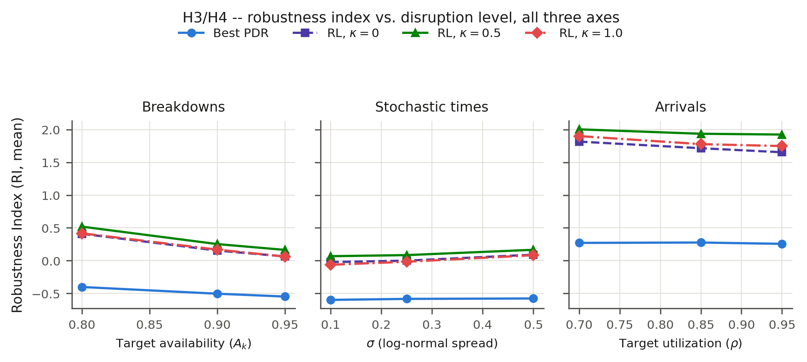
Fig. 3. Robustness index (RI, mean) versus disruption level, one panel per axis (breakdowns, stochastic processing times, arrivals). Lower RI is better. The best PDR (blue) remains well below all three RL variants (κ = 0, 0.5, 1.0) on every axis and every level. RI is computed with the pre-registered nominal reference; the corrected values are reported in Section 4.5.

4.4 H5 — Decision latency (rejected under the strict threshold)
The policy's per-decision latency is essentially flat across the full instance-size range — typically 4–11 ms, and never exceeding 44 ms even on the largest instances tested — while CP-SAT's total solve time is highly variable: near-instant on small, easy instances and saturating its 60-second budget on large or structurally hard ones (Figure 4). Under the strict pre-registered criterion — the 1% threshold must hold for every instance — 42 of 43 instances fail, driven largely by small instances where CP-SAT's near-instantaneous solve produces an artificially tiny per-decision denominator, a construct-validity limitation of dividing a one-shot solver's total solve time by operation count rather than evidence that the policy itself is slow. One large instance's CP-SAT measurement (la40: 32,074 ms/decision, a 1,773× ratio against the policy) was traced to a measurement anomaly via a raw-log audit; the value is physically impossible under the protocol, since 32,074 ms per decision over 225 operations implies about 7,217 s of solver time, roughly 120 times the 60-s budget, whereas la38’s 266.91 ms × 225 ≈ 60.1 s matches the budget exactly; a sensitivity check substituting a structurally comparable instance's value (la38, same 225-operation size class, both solved to a time-limited FEASIBLE result under the identical 60-second budget) reduces the ratio to 14.76× but still rejects H5 under the strict threshold (Table 5) — the correction makes the rejection more, not less, decisive, and is reported here precisely to make that transparent rather than to explain the result away. For genuinely large, hard instances that saturate CP-SAT's time budget, the policy retains a real one-to-two-order-of-magnitude latency advantage, a qualitative finding consistent with H5's motivating intuition even though the literal all-instances threshold is not met.
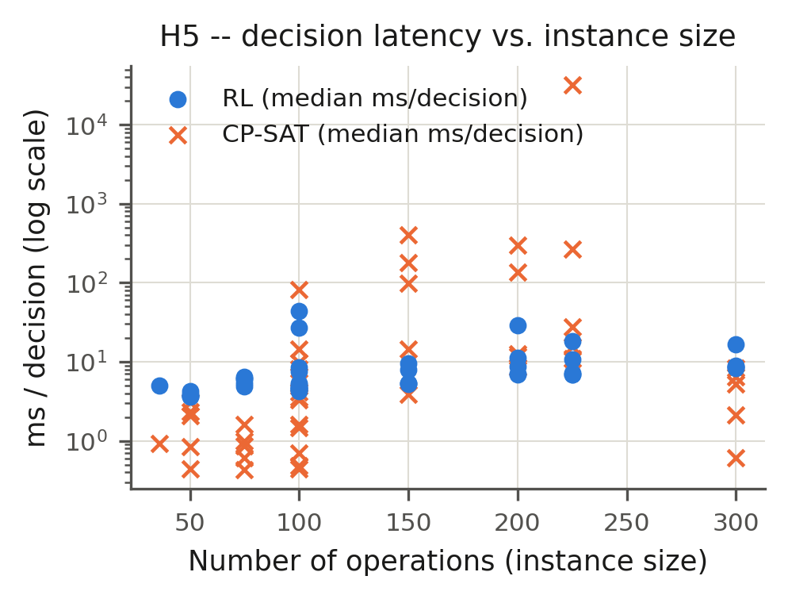
Fig. 4. Per-decision latency (ms, log scale) versus instance size for the policy (RL) and CP-SAT. The policy's latency is essentially flat; CP-SAT's grows erratically with instance size and structural hardness.
Table 5. Sensitivity check for the la40 CP-SAT latency measurement, substituting la38's wall-clock time (same size class, same FEASIBLE status under the identical 60 s budget).
Reading | RL (ms/decision) | CP-SAT (ms/decision) | Ratio | H5 passes (of 43)
Raw (as measured) | 18.09 | 32,074.09 | 1,773.5× | 1
Sensitivity-corrected (la38 substituted) | 18.09 | 266.91 | 14.8× | 0

4.5 Sensitivity to the dispatching-rule implementation (exploratory)
Because the static evaluations use a semi-active, delay-permitting dispatching scheme (Section 3.4), we re-ran the nine rules on the 43 JSSP instances with a non-delay restriction, under which only operations that can start at the earliest possible start time among all candidates are eligible (Giffler & Thompson, 1960). Table 6 shows that the semi-active scheme inflates the deviation of every rule whose priority is not correlated with start time: SPT, LPT, EDD, CR, LOR and LWKR fall from 268–430% to 22–36%, values in the range usually reported for these rules, while FIFO, whose priority is itself a start-time order, changes by only 1.5 percentage points. Under the non-delay scheme the strongest rules are MWKR (12.93%) and MOR (14.38%), not FIFO.
H1. Against the per-instance best non-delay rule (mean RPD 9.59%), the policy (24.82%) is better on 2 of the 43 instances instead of 8, and the Wilcoxon test rejects H1 more strongly (W = 3, p = 1.1 × 10⁻¹², r = −0.87). The pre-registered rejection is therefore conservative.
H2. Repeating the Friedman–Nemenyi analysis with the non-delay rules, the Friedman test again rejects equal performance in every tier (p ≤ 2.6 × 10⁻⁴), and the policy’s rank gap to the best rule widens from 0.20–1.00 to 3.40–4.80, still below the critical difference of 6.06; H2 would therefore still be accepted under the frozen criterion. The pooled exploratory comparison is, however, considerably less favourable: the policy’s RPD exceeds that of the per-instance best non-delay rule on all 20 out-of-sample instances, by 17.2 percentage points on average (exact Wilcoxon W = 0, p = 1.9 × 10⁻⁶). This reinforces the qualification already given in Section 4.2: H2’s acceptance reflects the low power of a five-instance tier, not demonstrated equivalence.
H3. The pre-registered robustness index takes each method’s nominal makespan from the static evaluation of H1, whereas the disrupted rollouts of the rules run in the event-driven simulator. For the rules, the nominal and the disrupted makespans therefore come from different dispatching schemes. The effect is largest for CR, the comparator selected in the six breakdown and processing-time regimes: its static nominal deviation is 210.9% on ft06 and 229.3% on la01, against 23.6% and 40.1% in the event-driven simulator without disruption, so its disrupted makespan lies far below its nominal one and its median RI is strongly negative (−0.40 to −0.60). That negative RI is an artefact of the reference, not evidence of robustness. Re-computing RI with each rule’s nominal makespan taken from the same simulator without disruption (Table 7), the best rule becomes LOR in all nine regimes and the median RI difference shrinks from −0.56 to −1.50 to between −0.06 and −0.27, but the policy remains less robust in all nine regimes (p ≤ 0.006, r = −0.36 to −0.64). H3 is therefore rejected under both references. Two further observations qualify the result. First, LOR is selected because its nominal schedule is among the weakest, which illustrates the known tendency of a self-normalized index to favour poor nominal plans. Second, on realized quality, which is comparable across methods, the policy is statistically indistinguishable from the best rule under breakdowns (MWKR; p ≥ 0.51) and arrivals (MOR; p ≥ 0.26) and worse under stochastic processing times (MWKR; median 2.4–5.7 percentage points, p = 0.026, 0.030 and 0.137). The policy is thus less robust than the rules in relative terms and no better than the best rule in absolute terms, but it is not decisively worse in realized makespan. One asymmetry remains: the policy’s own nominal reference is still its static rollout from H1, since the stored results do not include a rollout of the trained checkpoint in the event-driven simulator without disruption. The policy’s slightly negative RI at σ = 0.10 (−0.031) indicates that its event-driven nominal makespan is lower than its static one, because for a fixed dispatching sequence the makespan is a convex function of the processing times and unit-mean noise cannot lower its expectation (Jensen’s inequality). Correcting this asymmetry would therefore raise the policy’s RI and could only strengthen the rejection of H3.
Table 6. Mean RPD (%) of the nine dispatching rules over the 43 JSSP instances (seed 0) under the two implementations.
Rule | Semi-active (pre-registered tests) | Non-delay | Difference (pp)
MWKR | 42.59 | 12.93 | −29.66
MOR | 39.83 | 14.38 | −25.45
FIFO | 19.15 | 17.62 | −1.53
SPT | 268.23 | 21.81 | −246.42
CR | 430.31 | 29.06 | −401.25
LPT | 281.88 | 32.78 | −249.10
EDD | 387.34 | 33.74 | −353.60
LOR | 401.15 | 34.21 | −366.94
LWKR | 391.91 | 36.21 | −355.70
Table 7. H3 re-tested with a consistent nominal reference for the dispatching rules (exploratory). The best rule (lowest median RI among the pre-registered candidates) is LOR in every regime, and RI columns give medians; N = 60 pairs per regime; r = Z/√N. H3 is rejected in all nine regimes.
Regime | RI (LOR) | RI (policy) | W | p | r
Breakdowns, A = 0.95 | −0.030 | 0.010 | 418 | 2.5×10⁻⁴ | −0.47
Breakdowns, A = 0.90 | 0.036 | 0.115 | 477 | 1.3×10⁻³ | −0.42
Breakdowns, A = 0.80 | 0.258 | 0.405 | 534 | 5.0×10⁻³ | −0.36
Stochastic, σ = 0.10 | −0.102 | −0.031 | 347 | 2.9×10⁻⁵ | −0.54
Stochastic, σ = 0.25 | −0.054 | −0.017 | 541 | 5.9×10⁻³ | −0.36
Stochastic, σ = 0.50 | −0.041 | 0.067 | 452 | 6.5×10⁻⁴ | −0.44
Arrivals, u = 0.70 | 1.554 | 1.726 | 246 | 8.4×10⁻⁷ | −0.64
Arrivals, u = 0.85 | 1.483 | 1.706 | 347 | 2.9×10⁻⁵ | −0.54
Arrivals, u = 0.95 | 1.457 | 1.631 | 432 | 3.8×10⁻⁴ | −0.46

5. Discussion

5.1 Positioning against prior work
Relative to L2D. The comparator used for H1 (the minimum RPD across nine PDRs, evaluated per instance) is intrinsically harder to beat than L2D's three fixed rules (SPT, MWKR, MOPNR) — FIFO, the dominant rule for the large majority of instances in the pre-registered semi-active implementation, is not among L2D's comparators, and MWKR, the strongest rule under a non-delay implementation, is (Section 4.5) — so the raw win-rate figures (18.6% here versus L2D's 87.5–92%) are not directly comparable across studies. Training budget likely also differs by orders of magnitude, though Zhang et al. (2020) do not report a figure that would allow a verified comparison. H1's rejection is best read as “this instantiation, under this training budget, is not competitive,” not as a categorical claim about the relational-GIN architecture.
Relative to L2D and SPM-DAN on generalization. L2D's own generalization gap (9.4% at 4–5× training size) stays far below the best PDR's gap at that size (33.7–54.9%) — the same qualitative pattern observed here — but starting from a far more competitive base policy, so L2D's generalization preserves absolute competitiveness where the present result preserves only rank. This is consistent with, and illustrates cleanly, a reading of GNN generalization theory (Xu et al., 2019) in which size-invariance is a multiplicative property acting on whatever competitiveness the base policy already has, rather than a mechanism that improves it outright. SPM-DAN (Smit et al., 2025b) generalizes far more strongly in absolute terms (−7.10% versus 23.9–32.9% here) but under a single uncertainty source and with a scenario-processing module purpose-built for that axis — suggestive evidence that a dedicated architectural mechanism for the specific uncertainty axis being generalized outperforms a generic relational encoder without one.
H3/H4 as the first joint test of the generalization–robustness combination. Lassoued et al. (2026) show that a plain maskable-PPO policy can outperform dispatching rules under combined breakdown-and-arrival disruption when robustness is the only training objective, with no size-generalization requirement sharing the same architecture and training budget. The policy evaluated here, pursuing both objectives simultaneously, is less robust than the same class of dispatching rules in every disruption regime and, in realized makespan, does no better than the best rule in any of them (Section 4.5). Read together, this is, to our knowledge, the first quantitative evidence that the joint objective is not free: a policy whose capacity and training regime are spent entirely on one axis can beat dispatching rules on that axis; a policy splitting the same budget across two axes fails to beat the rules on the robustness axis. This does not prove the joint objective is unattainable in principle — no architectural ablation isolating the relational encoder's specific contribution to each axis was run in this study — but it is, to our knowledge, the first controlled demonstration that the tension between the two objectives is real and measurable rather than merely assumed. The mechanism diagnosed for H4 (domain-randomized training without nominal-episode exposure) is itself a transferable caution for the broader disruption-aware reward-shaping literature (Zhang et al., 2024), which has not previously needed to confront a multi-disruption training regime.

5.2 The central finding: generalization and robustness as separable properties
Taken together, the pattern across H1–H5 supports a specific, falsifiable reading of GNN–PPO scheduling policies: size-invariant architecture (Section 3.2) transfers rank-relative competitiveness — H2 is accepted even though the underlying policy is, by H1, not itself competitive in absolute terms — while robustness to disruption does not emerge as a free byproduct of that same architecture (H3 rejected) and cannot be induced by a naïvely multi-disruption-trained reward term without an unacceptable competitiveness cost (H4 rejected, with a diagnosed cause). We hold this pattern, rather than any single accepted or rejected hypothesis in isolation, as the study's central and most defensible contribution. It does not depend on the policy “winning” any individual comparison, and is therefore not undermined by the fact that it loses to PDR and GA baselines on most measures; that loss is part of the finding, not a threat to it. It is grounded in a pre-registration timestamp and frozen decision rules, which pre-empts the most common concern raised against negative-result reinforcement-learning studies — that hypotheses or thresholds were adjusted after seeing the data. And it directly answers the specific, citable gap identified in Section 2.5: no prior work identified in our review jointly tests size generalization and multi-disruption robustness for a GNN–PPO scheduling policy under one pre-registered statistical protocol.

5.3 Threats to validity and limitations
Several limitations qualify these conclusions. The dispatching rules were evaluated with a semi-active scheme in the static experiments and a non-delay scheme in the disrupted experiments, and the pre-registered robustness index mixed the two for the rules’ nominal reference; Section 4.5 shows that the rejections of H1 and H3 and the acceptance of H2 survive a consistent implementation, but the magnitude of the H3 effects in Table 3 is overstated and should be read through Table 7. The pre-registration was frozen in a timestamped document inside the study repository rather than lodged with a third-party registry, and the repository was first made public on 20 August 2026, after the experiments; its timing is therefore verifiable through the internal timestamps of the pre-registration and result files, not through an independent registry, and future confirmatory studies should use one (e.g. OSF). The disruption grid covers two instances (ft06, la01), which bounds the generality of H3 and H4 even though the effects are uniform across all 540 paired observations. A single training seed per κ condition limits the precision, though not necessarily the direction, of the H4 magnitudes; multi-seed replication is identified as priority future work. A structural asymmetry between the κ=0 condition (a statically trained policy evaluated through an adapter against the dynamic environment) and the κ>0 conditions (trained natively against the dynamic contract) means ΔRI is not a fully clean isolation of the reward term's effect from this training-regime difference. All evaluation is simulation-only, using three parametric disruption generators (exponential/log-normal breakdowns, log-normal processing-time noise, Poisson arrivals) whose fidelity to disruption processes on a real shop floor is assumed from the wider simulation literature (Law, 2024; Sargent, 2011) rather than validated against field data; any claim about deployability should be read strictly within this simulation-only scope. Finally, H3's rejection is diagnosed in this study primarily through the arrivals axis being furthest from the training distribution, but the present design does not include an architectural ablation that would isolate the relational encoder's specific contribution to robustness from the training regime's contribution — a natural next step, discussed below.

5.4 Theoretical and practical implications
Theoretically, the H1/H2 contrast offers a clean empirical illustration that size-invariant architecture and base-policy competitiveness are separable design axes: an architecture can be permutation-invariant enough to preserve relative rank under scale-up while remaining, in absolute terms, an uncompetitive policy — consistent with a multiplicative reading of GNN generalization theory in which the architecture transfers whatever competitiveness the base policy already has, rather than manufacturing competitiveness on its own. The H3/H4 result extends this logic to a second axis: robustness to disruption is not a passive byproduct of a size-invariant encoder, and a reward term explicitly designed to induce it can fail not because the term is wrong in principle, but because of an identifiable interaction with the training regime around it (domain randomization without nominal exposure). Both findings argue for treating generalization, robustness, and reward design as separable axes to be evaluated and engineered independently, rather than assuming that solving one implies progress on the others — a methodological caution directly relevant to the growing body of GNN-based scheduling research surveyed in Section 2.
Practically, the contrast between H1/H3's quality weakness and H5's qualitative speed strength motivates, without itself fully evaluating, a hybrid deployment pattern for real scheduling systems: a fast reactive policy could serve as an immediate decision bridge in the seconds following a disruption event, while an exact or metaheuristic re-optimizer computes a higher-quality replacement schedule in parallel — assigning each method the role its own results in this study actually support (the policy as a fast, immediately available fallback; CP-SAT or the GA as the quality-of-solution engine), rather than requiring a single method to be simultaneously the fastest and the best. For practitioners evaluating GNN–DRL scheduling tools, the results also caution against inferring disruption robustness from a size-generalization claim alone: this study's own evidence is that the two do not co-occur automatically, and each should be requested and verified as a separate, explicitly tested capability.

6. Conclusion
This study pre-registered and tested five hypotheses about whether a relational-GIN, PPO-based scheduling policy can jointly generalize across instance sizes and remain robust to multiple simultaneous disruption types in the dynamic, stochastic flexible job-shop problem. Four of five hypotheses are rejected, one is accepted, the three verdicts that depend on the dispatching-rule baselines (H1–H3) are unchanged under a consistent re-implementation of those baselines, and, critically, every rejection is diagnosed to a concrete, actionable mechanism rather than left as an unexplained negative result: the arrivals axis being furthest from the training distribution for H3, a domain-randomized training regime that never exposes the policy to undisturbed operation for H4, and a per-decision latency metric with a construct-validity weakness for one-shot solvers for H5. The accepted hypothesis, H2, demonstrates that size-invariant architecture transfers rank-relative competitiveness even from a base policy that is not itself competitive in absolute terms — direct empirical support for permutation-invariance-based GNN generalization theory, independent of the underlying policy's absolute strength. Taken together, we hold this pattern — architectural transfer of one property, no automatic transfer of the other, with a diagnosed and actionable cause for the gap in every case — as the study's central, defensible contribution: to our knowledge, the first statistically rigorous, pre-registered evidence that size generalization and multi-disruption robustness are separable properties of GNN–PPO scheduling policies, not a package deal. Future work includes an architectural ablation isolating the relational encoder's specific contribution to each axis independently of training regime; a corrected domain-randomization training procedure that preserves nominal-episode exposure; multi-seed replication of the κ ablation to sharpen the precision of the H4 magnitudes; and, ultimately, validation against disruption data from a real production environment, since every result reported here is obtained under simulation.

CRediT authorship contribution statement
Joseph Javier Sánchez Acuña: Conceptualization, Methodology, Software, Validation, Formal analysis, Investigation, Data curation, Visualization, Writing – original draft, Writing – review & editing. Luis Tarazona Torres: Supervision, Methodology, Writing – review & editing. David Álvarez Martínez: Supervision, Validation, Writing – review & editing.

Declaration of competing interest
The authors declare that they have no known competing financial interests or personal relationships that could have appeared to influence the work reported in this paper.

Funding
This research did not receive any specific grant from funding agencies in the public, commercial, or not-for-profit sectors.

Data availability
The simulation environment, policy implementation, raw per-run results (E1–E8), statistical pipeline, pre-registration document and figures are publicly available under an MIT licence at https://github.com/GIUSEPPESAN21/Tesis-Paper-Code. The script that reproduces the exploratory sensitivity analysis of Section 4.5 (Tables 6 and 7) from the public repository is provided as supplementary material (COR_sensitivity_analysis.py). The trained checkpoints, which the git repository excludes because of their size, will be deposited together with a tagged release of the repository in a permanent archive (Zenodo) upon acceptance and are available from the corresponding author on request in the meantime.

Declaration of generative AI and AI-assisted technologies in the manuscript preparation process
During the preparation of this work the authors used Claude (Anthropic) to assist with the translation of the original Spanish draft into English, language editing and the structural editing of the text. After using this tool, the authors reviewed and edited the content as needed and take full responsibility for the content of the publication.

Preprint
An earlier version of this work is available on Research Square: https://doi.org/10.21203/rs.3.rs-10563574/v1. The present version adds L. Tarazona Torres as co-author and reports the training protocol, the train–test overlap and the pre-registration record in full.

References
Abgaryan, H., Cazenave, T., & Harutyunyan, A. (2025). Starjob: Dataset for LLM-driven job shop scheduling. arXiv:2503.01877.
Brandimarte, P. (1993). Routing and scheduling in a flexible job shop by tabu search. Annals of Operations Research, 41(3), 157–183. https://doi.org/10.1007/BF02023073
Cao, S., & Yuan, Y. (2025). ReflecSched: Solving dynamic flexible job-shop scheduling via LLM-powered hierarchical reflection. arXiv:2508.01724.
Demšar, J. (2006). Statistical comparisons of classifiers over multiple data sets. Journal of Machine Learning Research, 7, 1–30.
Fisher, H., & Thompson, G. L. (1963). Probabilistic learning combinations of local job-shop scheduling rules. In J. F. Muth & G. L. Thompson (Eds.), Industrial Scheduling (pp. 225–251). Prentice-Hall.
Garey, M. R., Johnson, D. S., & Sethi, R. (1976). The complexity of flowshop and jobshop scheduling. Mathematics of Operations Research, 1(2), 117–129. https://doi.org/10.1287/moor.1.2.117
Giffler, B., & Thompson, G. L. (1960). Algorithms for solving production-scheduling problems. Operations Research, 8(4), 487–503. https://doi.org/10.1287/opre.8.4.487
Graham, R. L., Lawler, E. L., Lenstra, J. K., & Rinnooy Kan, A. H. G. (1979). Optimization and approximation in deterministic sequencing and scheduling: A survey. Annals of Discrete Mathematics, 5, 287–326.
Hamilton, W. L., Ying, R., & Leskovec, J. (2017). Inductive representation learning on large graphs. In Proceedings of the 31st Conference on Neural Information Processing Systems (NeurIPS) (pp. 1024–1034).
Hoss, J., Link, M., & Klarmann, N. (2026). Scalable production scheduling: Linear complexity via unified homogeneous graphs. arXiv:2604.23841. In Proceedings of the IEEE 22nd International Conference on Automation Science and Engineering (CASE 2026). https://doi.org/10.1109/CASE69030.2026.11704154
Huang, S., & Ontañón, S. (2022). A closer look at invalid action masking in policy gradient algorithms. In Proceedings of the 35th International FLAIRS Conference.
Infantes, G., Roussel, S., Pereira, P., Jacquet, A., & Benazera, E. (2024). Learning to solve job shop scheduling under uncertainty. In Proceedings of the 21st International Conference on the Integration of Constraint Programming, Artificial Intelligence, and Operations Research (CPAIOR). arXiv:2404.01308.
Kipf, T. N., & Welling, M. (2017). Semi-supervised classification with graph convolutional networks. In Proceedings of the International Conference on Learning Representations (ICLR).
Kool, W., van Hoof, H., & Welling, M. (2019). Attention, learn to solve routing problems! In Proceedings of the International Conference on Learning Representations (ICLR).
Kwon, Y.-D., Choo, J., Kim, B., Yoon, I., Gwon, Y., & Min, S. (2020). POMO: Policy optimization with multiple optima for reinforcement learning. In Proceedings of the 34th Conference on Neural Information Processing Systems (NeurIPS).
Lassoued, S., Lier, S., & Schwung, A. (2026). Policy-based reinforcement learning with action masking for dynamic job shop scheduling under uncertainty: Handling random arrivals and machine failures. arXiv:2601.09293.
Law, A. M. (2024). Simulation Modeling and Analysis (6th ed.). McGraw Hill.
Lawrence, S. (1984). Resource constrained project scheduling: An experimental investigation of heuristic scheduling techniques (Technical report). Graduate School of Industrial Administration, Carnegie-Mellon University.
Lei, K., Guo, P., Zhao, W., Wang, Y., Qian, L., Meng, X., & Tang, L. (2022). A multi-action deep reinforcement learning framework for flexible job-shop scheduling problem. Expert Systems with Applications, 205, 117796. https://doi.org/10.1016/j.eswa.2022.117796
Liu, X., Chen, X., Chau, V., Musial, J., & Blazewicz, J. (2025). Flexible job shop scheduling problem using graph neural networks and reinforcement learning. Computers & Operations Research, 182, 107139. https://doi.org/10.1016/j.cor.2025.107139
Ng, A. Y., Harada, D., & Russell, S. (1999). Policy invariance under reward transformations: Theory and application to reward shaping. In Proceedings of the 16th International Conference on Machine Learning (ICML) (pp. 278–287).
Park, J., Chun, J., Kim, S. H., Kim, Y., & Park, J. (2021). Learning to schedule job-shop problems: Representation and policy learning using graph neural network and reinforcement learning. International Journal of Production Research, 59(11), 3360–3377. https://doi.org/10.1080/00207543.2020.1870013
Perron, L., Didier, F., & Gay, S. (2023). The CP-SAT-LP solver. In Proceedings of the 29th International Conference on Principles and Practice of Constraint Programming (CP 2023), LIPIcs, 280, Article 3.
Pinedo, M. L. (2022). Scheduling: Theory, Algorithms, and Systems (6th ed.). Springer.
Raffin, A., Hill, A., Gleave, A., Kanervisto, A., Ernestus, M., & Dormann, N. (2021). Stable-Baselines3: Reliable reinforcement learning implementations. Journal of Machine Learning Research, 22(268), 1–8.
Reijnen, R., Smit, I. G., Zhang, H., Wu, Y., Bukhsh, Z., & Zhang, Y. (2026). Job shop scheduling benchmark: Environments and instances for learning and non-learning methods. Annals of Mathematics and Artificial Intelligence. https://doi.org/10.1007/s10472-026-10007-3
Sargent, R. G. (2011). Verification and validation of simulation models. In Proceedings of the 2011 Winter Simulation Conference (pp. 183–198). IEEE. https://doi.org/10.1109/WSC.2011.6147750
Schulman, J., Moritz, P., Levine, S., Jordan, M., & Abbeel, P. (2016). High-dimensional continuous control using generalized advantage estimation. arXiv:1506.02438.
Schulman, J., Wolski, F., Dhariwal, P., Radford, A., & Klimov, O. (2017). Proximal policy optimization algorithms. arXiv:1707.06347.
Smit, I. G., Wu, Y., Troubil, P., Zhang, Y., & Nuijten, W. P. M. (2025b). Neural combinatorial optimization for stochastic flexible job shop scheduling problems. Proceedings of the AAAI Conference on Artificial Intelligence, 39(25), 26678–26687. https://doi.org/10.1609/aaai.v39i25.34870
Smit, I. G., Zhou, J., Reijnen, R., Wu, Y., Chen, J., Zhang, C., Bukhsh, Z., Zhang, Y., & Nuijten, W. (2025a). Graph neural networks for job shop scheduling problems: A survey. Computers & Operations Research, 176, 106914. https://doi.org/10.1016/j.cor.2024.106914
Song, W., Chen, X., Li, Q., & Cao, Z. (2023). Flexible job-shop scheduling via graph neural network and deep reinforcement learning. IEEE Transactions on Industrial Informatics, 19(2), 1600–1610. https://doi.org/10.1109/TII.2022.3189725
Sutton, R. S., & Barto, A. G. (2018). Reinforcement Learning: An Introduction (2nd ed.). MIT Press.
Taillard, E. (1993). Benchmarks for basic scheduling problems. European Journal of Operational Research, 64(2), 278–285. https://doi.org/10.1016/0377-2217(93)90182-M
Tassel, P., Gebser, M., & Schekotihin, K. (2021). A reinforcement learning environment for job-shop scheduling. arXiv:2104.03760.
Veličković, P., Cucurull, G., Casanova, A., Romero, A., Liò, P., & Bengio, Y. (2018). Graph attention networks. In Proceedings of the International Conference on Learning Representations (ICLR).
Vinyals, O., Fortunato, M., & Jaitly, N. (2015). Pointer networks. In Proceedings of the 29th Conference on Neural Information Processing Systems (NeurIPS) (pp. 2692–2700).
Wang, B., Xia, L., & Chen, Y. (2026). Machine-aligned multi-agent reinforcement learning for dynamic flexible job shop scheduling. Computers & Operations Research, 194, 107555. https://doi.org/10.1016/j.cor.2026.107555
Waubert de Puiseau, C., Peters, J., Dörpelkus, C., Tercan, H., & Meisen, T. (2023). schlably: A Python framework for deep reinforcement learning based scheduling experiments. SoftwareX, 22, 101383.
Wu, X., & Yan, X. (2023). A spatial pyramid pooling-based deep reinforcement learning model for dynamic job-shop scheduling problem. Computers & Operations Research, 160, 106401. https://doi.org/10.1016/j.cor.2023.106401
Xu, K., Hu, W., Leskovec, J., & Jegelka, S. (2019). How powerful are graph neural networks? In Proceedings of the International Conference on Learning Representations (ICLR).
Yu, H., Gu, W., Tang, N., & Guo, Z. (2026). A deep reinforcement learning approach for dynamic job-shop scheduling problem considering time variable and new job arrivals. Computers & Operations Research, 185, 107263. https://doi.org/10.1016/j.cor.2025.107263
Zhang, C., Song, W., Cao, Z., Zhang, J., Tan, P. S., & Xu, C. (2020). Learning to dispatch for job shop scheduling via deep reinforcement learning. In Proceedings of the 34th Conference on Neural Information Processing Systems (NeurIPS).
Zhang, L., Yan, Y., Yang, C., & Hu, Y. (2024). Dynamic flexible job-shop scheduling by multi-agent reinforcement learning with reward-shaping. Advanced Engineering Informatics, 62, 102872. https://doi.org/10.1016/j.aei.2024.102872
Zhang, W., Bao, X., Geng, H., Zhang, G., & Gen, M. (2025). Graph neural network and expert-guided deep reinforcement learning for solving flexible job-shop scheduling problem. Computers & Operations Research, 183, 107155. https://doi.org/10.1016/j.cor.2025.107155

