The price of optimality under uncertainty: a predictive–reactive robustness analysis of exact, metaheuristic and dispatching-rule scheduling for the dynamic job shop
Joseph Javier Sánchez Acuña^{1,2,*} · Luis Tarazona Torres¹ · David Álvarez Martínez¹
¹ Department of Industrial Engineering, Universidad de los Andes, Bogotá, Colombia
² Corporación Universitaria Minuto de Dios (UNIMINUTO), Bogotá, Colombia
* Corresponding author: Joseph Javier Sánchez Acuña, jj.sancheza1@uniandes.edu.co · ORCID 0009-0007-2008-823X
Co-authors: Luis Tarazona Torres (Universidad de los Andes), le.tarazona@uniandes.edu.co, ORCID 0000-0003-0567-6926; David Álvarez Martínez (Universidad de los Andes), d.alvarezm@uniandes.edu.co, ORCID 0000-0001-8411-1936

Abstract
Exact solvers, metaheuristics and priority dispatching rules are usually compared on deterministic job-shop instances, where the exact solver is the quality ceiling by construction. Real shops, however, face machine breakdowns, stochastic processing times and unplanned job arrivals, and a schedule that is optimal on nominal data may not remain preferable once it is executed under disruption. This study measures that question directly. A discrete-event predictive–reactive harness executes the committed schedules of a constraint-programming solver (CP-SAT) and of a genetic algorithm under right-shift repair, alongside nine online dispatching rules, across nine disruption regimes (three severities each of breakdowns, processing-time variability and arrivals) on sixteen Fisher–Thompson and Lawrence instances with thirty replications per cell (47,520 simulated executions). Robustness is measured by a relative-degradation index and by realized deviation from the certified optimal makespan. The central finding is an inversion. The CP-SAT schedule, best on nominal data (3.1% above the optimum versus 12.1% for the best rule), is the least robust method (mean Friedman rank 10.1 of 11, versus 3.9–5.8 for the rules; pairwise Wilcoxon p < 10⁻⁴). Under breakdowns the most-work-remaining and most-operations-remaining rules overtake it in realized quality, and under dynamic arrivals all online rules outperform it. Nominal optimality and robustness therefore conflict on the dynamic job shop, and in disruption-prone shops a computation-free dispatching rule is often the better deployed policy.
Keywords: job-shop scheduling; robust scheduling; predictive–reactive scheduling; constraint programming; dispatching rules; discrete-event simulation

1. Introduction
Production scheduling is among the decision functions most exposed by the transition to instrumented, data-rich manufacturing, and among the hardest to automate reliably on an actual shop floor (Pinedo, 2022). The job-shop scheduling problem (JSSP) and its flexible generalization (FJSP) are canonical formulations: a set of jobs, each an ordered chain of operations, must be sequenced on shared machines to minimize the makespan. The problem is strongly NP-hard for three or more machines (Garey et al., 1976), and decades of operations-research effort have produced three broad solution paradigms, each occupying a distinct point on the quality–speed frontier: exact methods (mixed-integer and, increasingly, constraint programming) that certify optimality at a computational cost that grows steeply with instance size; metaheuristics (genetic algorithms, tabu search, simulated annealing) that trade a fixed computational budget for high-quality but uncertified solutions (Pezzella et al., 2008; Nowicki & Smutnicki, 1996; Van Laarhoven et al., 1992); and priority dispatching rules (PDRs) that construct a schedule online, one dispatch at a time, in negligible time but with no optimality guarantee (Panwalkar & Iskander, 1977; Haupt, 1989).
On deterministic benchmark data the ranking among these paradigms is settled and, in a sense, uninteresting: an exact solver is by construction the quality ceiling, a well-tuned metaheuristic approaches it, and dispatching rules trail. The premise of this study is that this ranking is an artifact of the deterministic assumption. Real shop floors are neither static nor deterministic: machines fail, processing times deviate from their nominal estimates, and jobs arrive without complete advance notice (Ouelhadj & Petrovic, 2009; Aytug et al., 2005). An exact solver and a metaheuristic are offline, or predictive, methods: they commit to a complete schedule computed from nominal data, which must then be executed, and repaired, as reality diverges from the plan. A dispatching rule is online, or reactive: it commits to nothing in advance and simply re-decides at each event. Whether the optimality of a committed schedule is an asset or a liability once that schedule is exposed to disruption is not a question the deterministic benchmark can answer, and it is the question this paper addresses. Formally, the study answers two research questions. RQ1: how does the robustness of committed schedules produced by an exact solver and by a metaheuristic compare with that of online dispatching rules under machine breakdowns, processing-time variability and dynamic job arrivals? RQ2: does the exact solver’s nominal quality advantage survive execution under disruption and, if not, at what disruption severity does it reverse?
The robust- and stable-scheduling literature has long recognized that a nominally optimal schedule can be fragile, and has proposed slack-based and flexibility-based methods to build protection into a predictive schedule (Leon et al., 1994; Mehta & Uzsoy, 1998; Davenport et al., 2001; Artigues et al., 2005; Herroelen & Leus, 2005). What is comparatively rare is a paradigm-level comparison that places an exact solver, a metaheuristic, and the full complement of standard dispatching rules on a common, statistically controlled footing, and asks not “which produces the best nominal schedule” but “which produces the best realized schedule once the plan meets a disrupted shop floor.” This study provides such a comparison, and reports a result that runs against the intuition the deterministic benchmark encourages. Specifically, this study contributes:
(i) a controlled, paradigm-level robustness comparison of an exact solver (CP-SAT), a genetic algorithm, and nine priority dispatching rules under three simultaneous classes of disruption at three severities each, on a common discrete-event predictive–reactive harness with thirty replicate scenarios per cell;
(ii) direct evidence of an optimality–robustness inversion: the exact-solver schedule is simultaneously the best nominal method and the least robust one, with the ranking on robustness essentially the reverse of the ranking on nominal quality;
(iii) identification of a disruption threshold beyond which the exact solver’s nominal advantage not only erodes but reverses — dispatching rules overtake it in realized quality under machine breakdowns and dominate it under dynamic arrivals; and
(iv) an actionable managerial conclusion for disruption-prone shops, supported by a non-parametric statistical protocol (Wilcoxon, Friedman–Nemenyi with critical-difference diagrams): the most-work-remaining and most-operations-remaining rules deliver the best realized quality under disruption despite being computation-free.
The remainder of the paper is organized as follows. Section 2 reviews the three solution paradigms and the robust/predictive–reactive scheduling literature and states the gap. Section 3 defines the problem, the disruption models, the three method families, the predictive–reactive execution harness, and the statistical protocol. Section 4 reports the nominal-quality frontier, the robustness ranking, and the realized-quality crossover. Section 5 discusses the price of optimality under uncertainty, the managerial implications, and the study’s limitations. Section 6 concludes.

2. Background and Related Work

2.1 Three solution paradigms for the job shop
Exact methods solve the JSSP/FJSP to certified optimality. The disjunctive mixed-integer formulation (Graham et al., 1979) is the classical statement; modern constraint-programming solvers such as CP-SAT (Perron et al., 2023) express each operation as an interval variable and each machine as a no-overlap constraint, proving optimality on small and medium instances and returning strong bounds on larger ones. Metaheuristics accept the loss of an optimality certificate in exchange for a bounded, tunable computational budget: tabu search (Nowicki & Smutnicki, 1996), simulated annealing (Van Laarhoven et al., 1992), and, for the FJSP in particular, genetic algorithms with a two-vector (sequencing and routing) chromosome (Kacem et al., 2002; Pezzella et al., 2008; Chaudhry & Khan, 2016). Priority dispatching rules occupy the opposite pole: at each decision epoch a rule assigns a priority index to every dispatchable operation and selects the best, an O(1)–O(|queue|) operation requiring no search (Panwalkar & Iskander, 1977; Haupt, 1989; Sels et al., 2012). Recent contributions in this journal continue to refine dispatching rules, for instance by automatically evolving preference-based rules for multi-objective job shops (Zeiträg & Figueira, 2023) or by allocating several rules in real time through data mining, genetic algorithms and simulation (Habib Zahmani & Atmani, 2021), and to address machine failures in the dynamic flexible job shop (Peng et al., 2025). Comparative studies of the three families are numerous, but almost uniformly evaluate solution quality on deterministic instances, where the exact solver necessarily dominates.

2.2 Predictive–reactive scheduling and robustness
Once execution is subject to disruption, a committed (predictive) schedule must be revised. The taxonomy of revision strategies — from complete rescheduling to simple right-shift repair, in which affected operations are delayed but their relative order is preserved — is well established (Vieira et al., 2003; Ouelhadj & Petrovic, 2009; Aytug et al., 2005). Two schedule properties are of interest under uncertainty: robustness, the insensitivity of the realized objective to disruption, and stability, the insensitivity of the realized schedule (start times) to disruption (Leon et al., 1994; Goren & Sabuncuoglu, 2008; Sabuncuoglu & Goren, 2009). A recurring theme is that nominal optimality and robustness are in tension: an optimally compact schedule leaves no idle time to absorb a delay, so slack-based and flexibility-based methods deliberately sacrifice nominal quality to insert protective buffers (Mehta & Uzsoy, 1998; Davenport et al., 2001; Herroelen & Leus, 2005; Artigues et al., 2005). This tension is the conceptual backdrop of the present study; our contribution is to measure it, at the level of whole solution paradigms, on the dynamic job shop.

2.3 Gap and positioning
The robustness literature is largely internal to the predictive paradigm: it compares a nominal predictive schedule against a protected predictive schedule, both offline. The dispatching-rule literature, conversely, studies online policies largely in isolation. What is scarce is a head-to-head comparison in which an exact solver and a metaheuristic — executed under a realistic repair policy — are placed against the full set of online dispatching rules under multiple simultaneous disruption classes, evaluated with a non-parametric statistical protocol and reported not only in relative-degradation terms but in realized quality against the certified optimum. Table 1 summarizes the gap. Addressing it is the object of Sections 3 and 4.
Table 1 Positioning relative to the three literatures the study connects.
Literature | Typical scope | What is missing here
Exact vs. metaheuristic vs. PDR comparisons | Deterministic benchmark quality; exact solver is the ceiling by construction | No disruption; nominal ranking only
Robust / predictive–reactive scheduling | Nominal vs. slack-protected predictive schedule, offline; single disruption class | Rarely benchmarks against online dispatching rules as competitors
Dispatching-rule studies | Online rules compared to each other, often under one disruption source | Rarely benchmarked against executed exact / metaheuristic schedules
This study | Exact, GA, and 9 PDRs on one predictive–reactive harness; 3 disruption classes × 3 severities; realized quality + robustness index; Wilcoxon / Friedman–Nemenyi | —

3. Problem, Methods, and Experimental Design

3.1 Problem and disruption models
We address the dynamic, stochastic JSSP. A set of jobs, each a fixed-precedence chain of operations with machine-specific processing times, is to be scheduled to minimize makespan C_{max}. Three independent disruption generators extend the deterministic base problem, each parameterized by an operationally interpretable severity rather than a raw distributional parameter. Machine breakdowns follow a renewal process with exponential time-to-failure and log-normal time-to-repair, calibrated to a target steady-state availability A_{k} ∈ {0.95, 0.90, 0.80} via Eqs. (1)–(2); an interrupted operation is preserved under a preempt-resume policy (it pauses and later resumes for its remaining duration). Stochastic processing times multiply each nominal duration by a unit-mean log-normal factor with shape s ∈ {0.10, 0.25, 0.50} (Eq. 3), drawn once at dispatch. Dynamic arrivals introduce new jobs as a Poisson process calibrated to a target utilization ρ ∈ {0.70, 0.85, 0.95} (Eq. 4), with a cutoff at 80% of the nominal horizon guaranteeing termination. The three severities per axis span a high-reliability, a moderate, and a severe/near-saturation regime, giving nine disruption regimes in total.
$${MTBF}_{k}=\frac{1}{λ_{k}}, MTTR=exp​\left(μ_{r}+\frac{σ_{r}^{2}}{2}\right), A_{k}=\frac{{MTBF}_{k}}{{MTBF}_{k}+MTTR} \left(1\right)$$
$$MTTR=c_{r} \overset{‾}{p}, μ_{r}=ln\left(MTTR\right)−\frac{σ_{r}^{2}}{2}, {MTBF}_{k}=\frac{A_{k} MTTR}{1−A_{k}}, λ_{k}=\frac{1}{{MTBF}_{k}} \left(2\right)$$
$$P_{j,h,k}={\overset{‾}{p}}_{j,h,k} ξ, ξ∼Lognormal\left(−\frac{s^{2}}{2}, s^{2}\right), E\left[ξ\right]=1 \left(3\right)$$
$$λ_{a}=\frac{ρ m}{\overset{‾}{L}} ⇔ ρ=\frac{λ_{a} \overset{‾}{L}}{m} \left(4\right)$$
Equations (1)–(2) give the breakdown availability identity and its calibration to a target $A_{k}$; (3) the unit-mean log-normal processing-time multiplier; and (4) the Poisson arrival rate calibrated to a target utilization $ρ$. Here $c_{r}$ is the mean-repair-time multiplier, $\overset{‾}{p}$ the mean nominal processing time, $s$ the processing-time variability, $m$ the number of machines and $\overset{‾}{L}$ the mean total workload per job. Both repair parameters are set as in the reference generator of the companion reproducibility package (Sánchez Acuña, 2026): $c_{r}=2$, so that the mean repair time equals twice the mean processing time, and $σ_{r}=0.5$.
The three generators were verified in isolation before use (5,000 draws per assertion): a Kolmogorov–Smirnov test did not reject the exponential time-to-failure hypothesis, steady-state availability recovered each target A_{k} to within 0.01%, the processing-time sampler matched its theoretical mean and variance to within 1.4–2.6%, and the calibrated arrival rate matched its target utilization to within 0.8% — verification in the sense of Sargent (2011) and Law (2015).

3.2 The three method families
Exact solver (CP-SAT). Each operation is modeled as an interval variable and each machine as a no-overlap constraint over its intervals, the direct translation of the disjunctive formulation (Perron et al., 2023). CP-SAT is run once per instance with a long, fixed wall-clock budget, and its incumbent is taken as the committed schedule; within that budget the solver reaches the proven literature optimum on 7 of the 16 instances (mean gap 3.08%, maximum 8.70%); its predictive schedule is the tightest (least-slack) schedule in the study and serves as the exact-solver reference. On the larger 10×10 and 15×10 instances the reference is therefore near-optimal rather than provably optimal (Section 5.5). Genetic algorithm (GA). A permutation-with-repetition chromosome is decoded by list scheduling; precedence-preserving order crossover, swap mutation, and tournament selection with elitism follow standard FJSP practice (Kacem et al., 2002; Pezzella et al., 2008). The GA returns a high-quality but looser predictive schedule under a fixed computational budget. Nine priority dispatching rules. Shortest and longest processing time (SPT, LPT), most and least work remaining (MWKR, LWKR), most and least operations remaining (MOR, LOR), first-in-first-out (FIFO), earliest due date (EDD), and critical ratio (CR); the last two use total-work-content synthesized due dates, since the pure-makespan benchmarks carry none. Ties are broken uniformly at random. The rules are online policies and require no predictive schedule.

3.3 Predictive–reactive execution harness
All methods are evaluated on one discrete-event simulator, so that no method is favored by implementation. The two offline methods (CP-SAT, GA) are executed under a right-shift repair policy (Vieira et al., 2003): the per-machine operation sequence of the committed schedule is fixed, and each operation begins at the later of its machine becoming available (in planned order) and its job-predecessor completing, so that a disruption delays but never reorders the plan; under no disruption this reproduces the offline makespan exactly, giving a clean baseline. Dynamically arrived jobs, which cannot appear in a schedule computed before they existed, are absorbed into idle machine intervals. The nine dispatching rules are executed online, re-deciding at every event. This design realizes each paradigm as it would actually be deployed — a committed schedule that is repaired, versus a rule that reacts — which is precisely the comparison of interest.
The dispatching rules are executed online inside the same simulator: at each decision epoch only operations whose machine is idle and whose job predecessor has completed are eligible, so without disruption the rules generate non-delay schedules (Giffler & Thompson, 1960), the setting in which dispatching rules are normally reported.

3.4 Metrics, instances, and statistical protocol
Two complementary metrics are reported. The robustness index
$$RI=\frac{E\left[C_{max}∣\text{perturbed}\right]−C_{max}∣\text{nominal}}{C_{max}∣\text{nominal}} \left(5\right)$$
measures each method’s relative self-degradation, computed against its own nominal makespan over thirty replicate scenarios per cell, together with the conditional-value-at-risk of the worst 10% (CVaR₀.₉₀). Because RI is normalized by each method’s own nominal makespan — which differs across methods — it is supplemented by the cross-method-comparable realized relative percentage deviation (RPD) of the mean perturbed makespan against the certified optimum, which answers directly which method yields the best schedules under disruption. Under dynamic arrivals the reference optimum is that of the original instance, which excludes the arriving jobs; absolute RPD values in that class are therefore inflated for every method and only the between-method comparison is meaningful. Evaluation spans sixteen Fisher–Thompson (Fisher & Thompson, 1963) and Lawrence (Lawrence, 1984) instances from 6×6 to 20×10 (the ft and la families), 9 regimes, 11 methods, and 30 scenarios — a full grid of 47,520 simulated executions. Pairwise comparisons use the exact Wilcoxon signed-rank test (Wilcoxon, 1945); the joint comparison across methods uses the Friedman test (Friedman, 1937) with Nemenyi post-hoc analysis and critical-difference diagrams (Demšar, 2006).

4. Results

4.1 The nominal-quality frontier
Under nominal (undisrupted) data the paradigm ranking is exactly as the deterministic literature predicts (Fig. 1). The exact solver is best, at a mean 3.08% above the certified optimum (reaching the proven optimum on 7 of 16 instances, worst-case gap 8.70%), followed by the GA at 6.28%. The dispatching rules trail, led by most-work-remaining (MWKR, 12.07%) and most-operations-remaining (MOR, 14.15%), with first-in-first-out at 17.59% and the weakest rules (LWKR, LOR) above 32%. On nominal data, in short, paying for an exact solve buys a 3.9-fold reduction in optimality gap relative to the best dispatching rule (3.08% versus 12.07%) and a 5.7-fold reduction relative to FIFO. Table 2 lists the full frontier alongside the robustness results that follow.
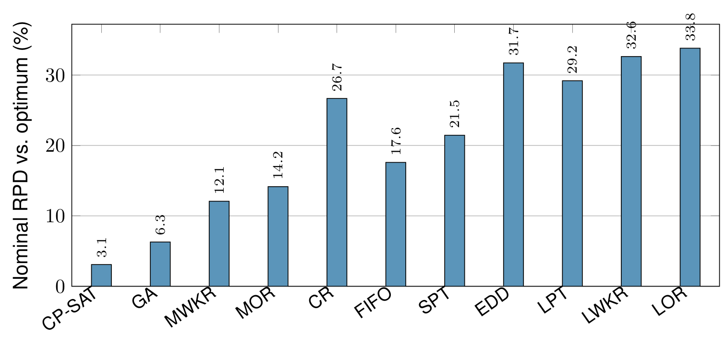
Fig. 1 Nominal quality frontier: mean relative percentage deviation from the certified optimum, by method, over the sixteen instances (no disruption). The exact solver (CP-SAT) and the GA dominate the nine online dispatching rules.

4.2 The robustness ranking is the inverse of the quality ranking
Measured by relative degradation under disruption, the ranking inverts. Pooled over the nine regimes and sixteen instances, the exact schedule has the highest robustness index of all eleven methods (RI = 0.732), immediately followed by the GA (0.708); every dispatching rule is more robust, ranging from 0.432 (EDD) to 0.515 (CR). The Friedman test across the eleven methods is decisive (χ² = 542.8, df = 10, N = 144 cells; Nemenyi critical difference CD = 1.26 at α = 0.05): the exact solver and the GA occupy the two worst mean ranks (10.14 and 9.82), separated from the entire cluster of dispatching rules (ranks 3.95–5.77) by far more than the critical difference (Fig. 2). Pairwise, the exact schedule is significantly less robust than every other method, including the GA (Wilcoxon p = 1.4×10⁻⁵; versus each dispatching rule p < 10⁻¹⁰, median RI difference +0.14 to +0.20). The mechanism is the one the robust-scheduling literature predicts (Leon et al., 1994; Mehta & Uzsoy, 1998): an optimally compact schedule has no idle slack, so every delay propagates in full, whereas a looser schedule — and still more an online rule that never commits — absorbs it. Even within the predictive paradigm the tighter schedule is the more fragile: the exact solver is significantly less robust than the looser GA.
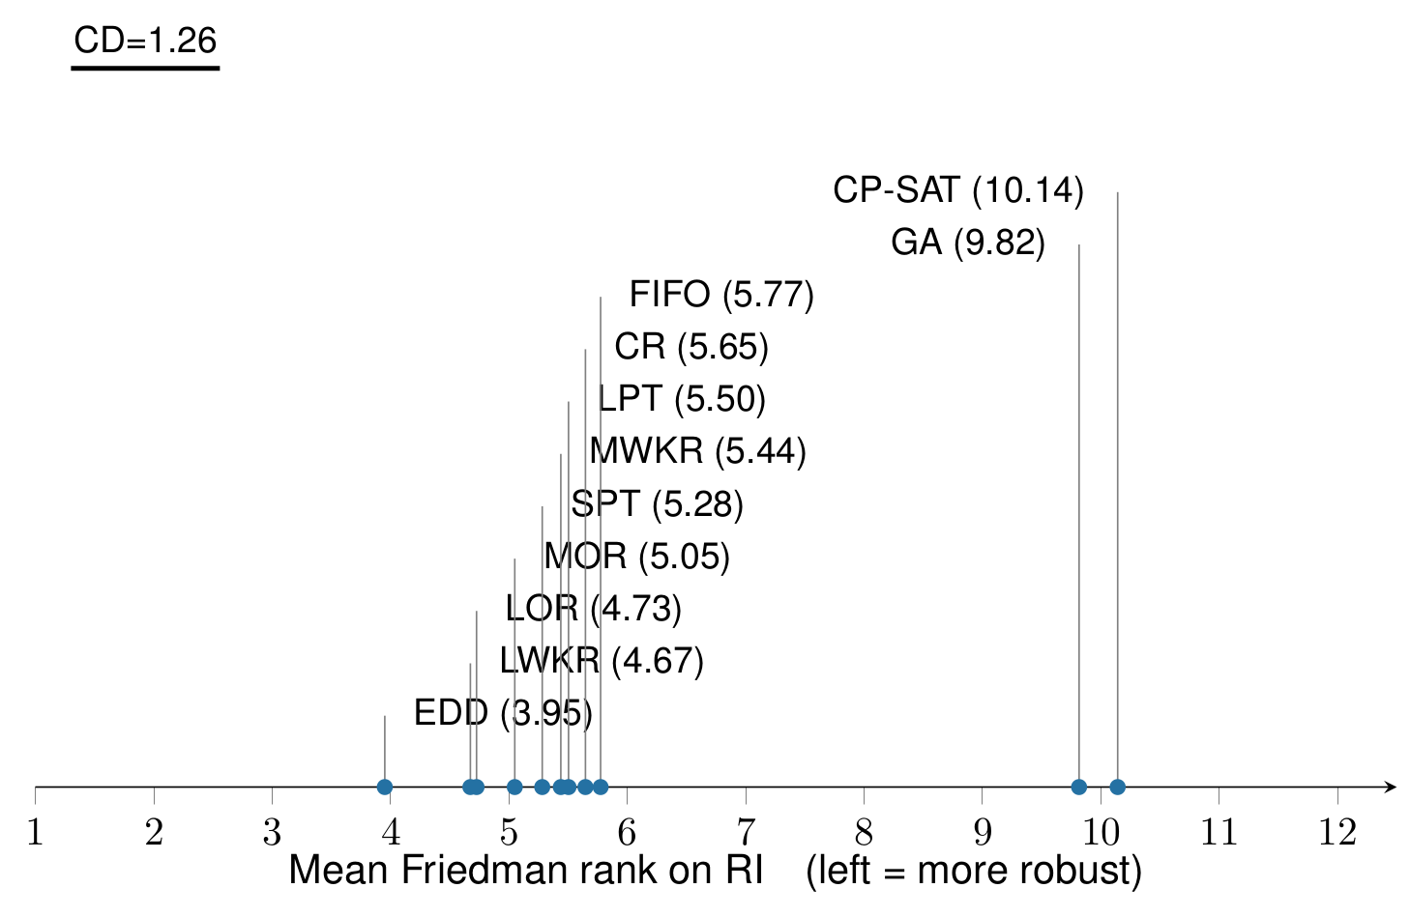
Fig. 2 Friedman–Nemenyi critical-difference diagram of robustness (RI ranks; left = more robust). The exact solver (CP-SAT, 10.14) and GA (9.82) are the two least robust methods, separated from all nine dispatching rules (3.95–5.77) by well over the critical difference CD = 1.26.
Fig. 3 resolves the ranking by disruption class and severity. The two committed methods lie above every dispatching rule at every severity of every axis, and the gap widens with severity: under breakdowns the exact schedule’s RI climbs from 0.19 (A_{k} = 0.95) to 0.69 (A_{k} = 0.80), against 0.09 to 0.44–0.49 for the rules; the arrivals axis is the most punishing for every method (RI ≈ 1.6–1.7 for the committed schedules) precisely because an arriving job cannot be anticipated by any pre-computed plan.
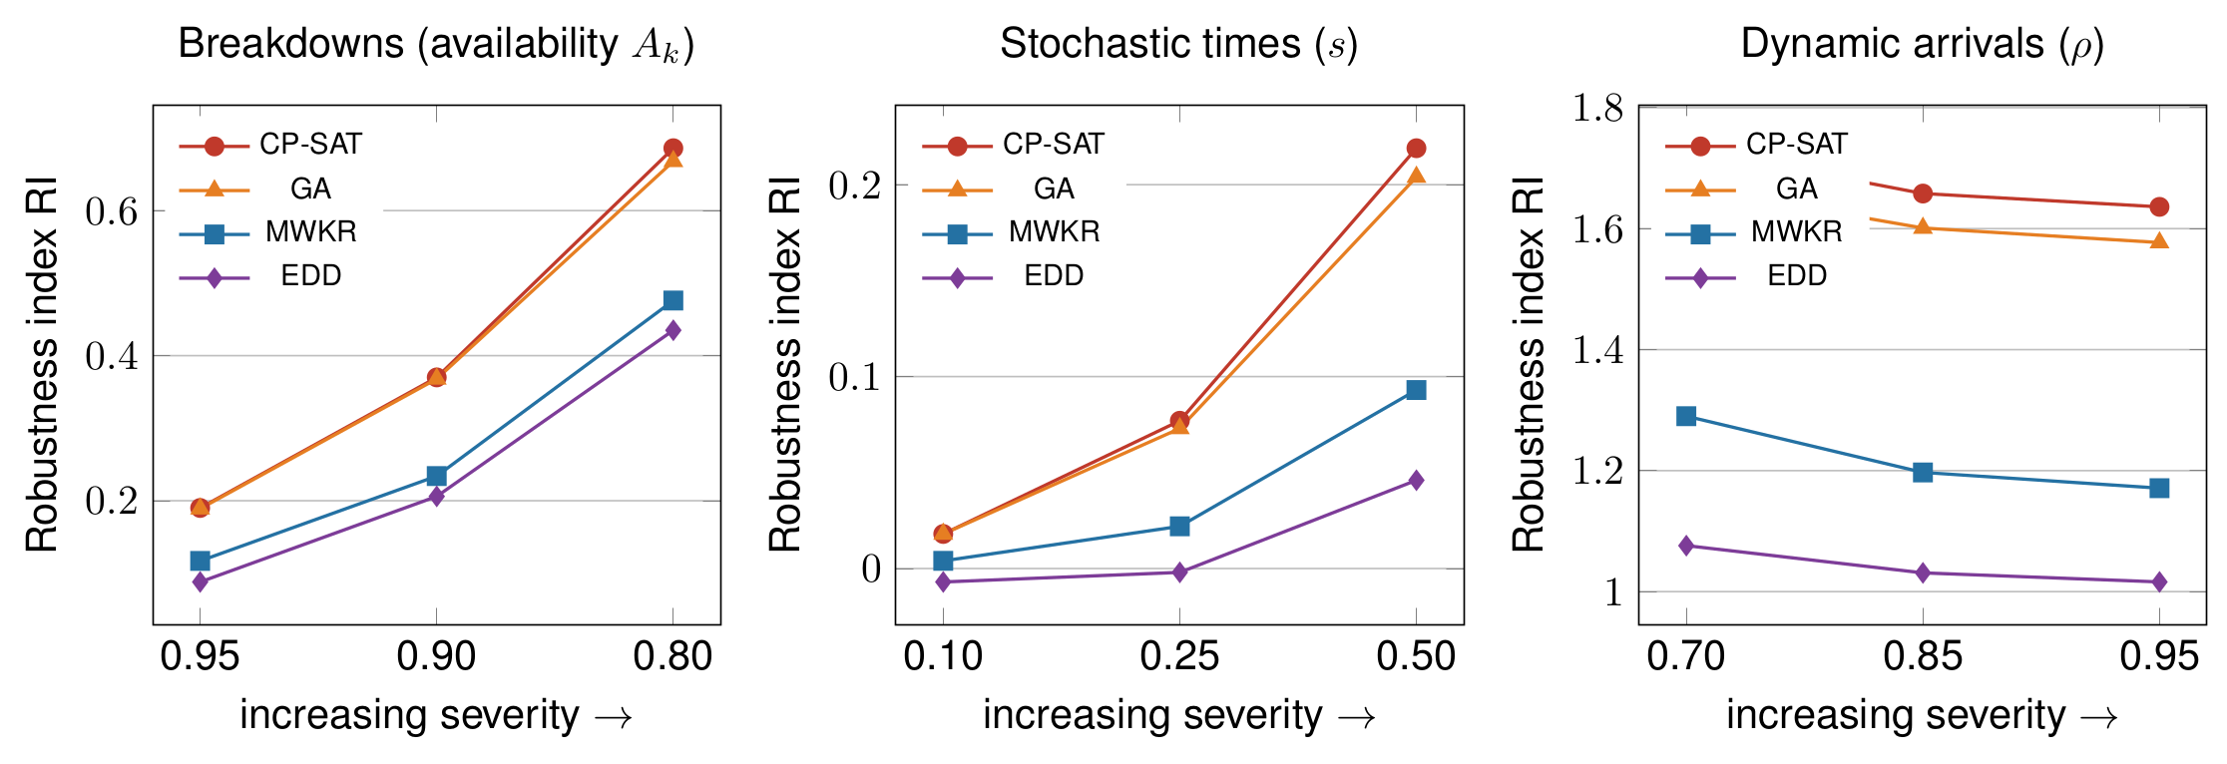
Fig. 3 Robustness index versus disruption severity, one panel per disruption class. The committed schedules (CP-SAT, GA) degrade more than the online rules (MWKR shown as a strong rule, EDD as the most robust) at every severity, and the gap grows with severity.

4.3 Realized quality: the exact solver’s advantage does not survive execution
Relative degradation normalizes away each method’s starting point, so the decisive question is realized quality: once disrupted, which method actually delivers the shortest schedules? Fig. 4 and Table 2 answer it. The exact solver’s commanding nominal lead (3.08% versus 12.07% for MWKR) collapses and, under two of the three disruption classes, reverses. Under machine breakdowns, the most-work-remaining and most-operations-remaining rules overtake the exact schedule in mean realized deviation (42.97% and 43.20% versus 46.07%); the GA, the second-best nominal method, is worst of these five (49.90%). Under stochastic processing times the exact schedule retains a narrow lead (13.94% versus 16.53% for MWKR), but the nominal margin of roughly nine percentage points has shrunk to under three. Under dynamic arrivals the reversal is emphatic: the online rules dominate (MOR 147.59%, MWKR 147.72%) while the exact solver and the GA are the two worst methods in the entire study (175.30% and 177.02%), because a committed schedule cannot plan for jobs it has never seen.
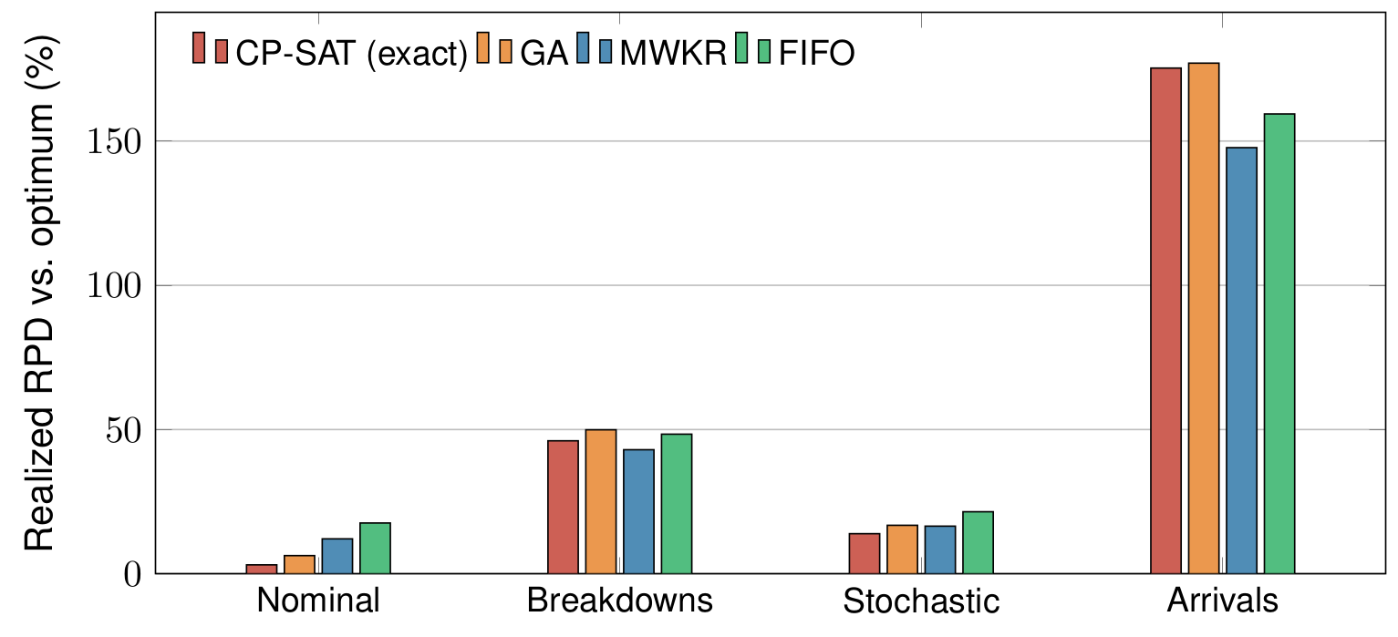
Fig. 4 Realized quality (mean RPD from the certified optimum) by disruption class for the exact solver, the GA, and two representative dispatching rules. The exact solver dominates only nominally; MWKR overtakes it under breakdowns and, with FIFO, dominates under arrivals.
The crossover can be located precisely. Against the middling FIFO rule, the exact schedule retains an absolute realized-makespan lead through mild and moderate breakdowns and across all processing-time variability, and is overtaken only at the severe breakdown level (A_{k} = 0.80) and at every arrival level. Against the strong MWKR/MOR rules the reversal arrives earlier: they already match or beat the exact schedule at moderate breakdowns and dominate under arrivals. The practical reading is that the exact solver is the correct choice only in a near-deterministic regime; as soon as disruption is more than mild, a computation-free dispatching rule — specifically MWKR or MOR — delivers equal or better realized schedules.
Table 2 Nominal quality, robustness, and realized quality under disruption, by method (means over 16 instances; realized values are mean RPD from the certified optimum, %). Lower is better throughout. Best value in each column in bold.
Method | Nominal RPD | RI (all) | Friedman rank | Real. breakdowns | Real. stochastic | Real. arrivals
CP-SAT (exact) | 3.08 | 0.732 | 10.14 | 46.07 | 13.94 | 175.30
GA | 6.28 | 0.708 | 9.82 | 49.90 | 16.81 | 177.02
MWKR | 12.07 | 0.512 | 5.44 | 42.97 | 16.53 | 147.72
MOR | 14.15 | 0.493 | 5.05 | 43.20 | 17.74 | 147.59
FIFO | 17.59 | 0.504 | 5.77 | 48.37 | 21.52 | 159.39
SPT | 21.45 | 0.484 | 5.28 | 53.22 | 24.75 | 160.06
CR | 26.67 | 0.515 | 5.65 | 61.76 | 30.19 | 180.00
EDD | 31.72 | 0.432 | 3.95 | 62.95 | 32.71 | 167.23
LPT | 29.19 | 0.509 | 5.50 | 65.58 | 33.29 | 184.23
LWKR | 32.63 | 0.482 | 4.67 | 68.16 | 36.31 | 183.88
LOR | 33.81 | 0.465 | 4.73 | 67.39 | 35.30 | 184.22
Two features of Table 2 deserve emphasis. First, the columns tell opposite stories: the method that leads the nominal column (CP-SAT) is last-but-one in the robustness rank and is beaten in two of three realized-disruption columns. Second, no single dispatching rule is uniformly best — EDD is the most robust by relative degradation yet mediocre in realized quality because its nominal schedule is poor, whereas MWKR and MOR combine a strong nominal schedule with strong realized quality under disruption. This distinction between relative degradation and realized quality, discussed next, is essential to reading robustness results correctly.

5. Discussion

5.1 The price of optimality under uncertainty
The results give a quantitative form to a tension the robust-scheduling literature has long described qualitatively (Leon et al., 1994; Mehta & Uzsoy, 1998; Herroelen & Leus, 2005): nominal optimality and disruption robustness are conflicting objectives on the dynamic job shop. The exact solver purchases its nominal advantage precisely by eliminating idle time — an optimal makespan schedule is, by definition, maximally compact — and it is that same compactness that leaves no buffer to absorb a breakdown, a stretched processing time, or an unplanned arrival. The inversion documented in Section 4.2 is therefore not an anomaly but the expected consequence of optimization under the wrong (deterministic) model of the shop floor. The novel element here is the magnitude and paradigm scope of the effect: measured across whole solution paradigms and reported in realized quality, the exact solver’s almost four-to-one nominal advantage over the best dispatching rule does not merely shrink under disruption — it reverses.

5.2 Relative degradation is not realized quality
A methodological caution follows from Table 2 and is, we argue, a transferable lesson for robustness studies. The robustness index, being normalized by each method’s own nominal makespan, systematically flatters methods with a poor nominal schedule: the earliest-due-date rule is the “most robust” method by RI and by Friedman rank, yet it delivers some of the worst realized schedules under every disruption class, because a schedule that is already far from optimal has little further to degrade in relative terms. The effect is structural rather than empirical. Writing $r$ and $q$ for a method’s nominal and realized deviations from the same certified optimum $C^{*}$, so that $C_{max}∣\text{nominal}=C^{*}\left(1+r\right)$ and $E\left[C_{max}∣\text{perturbed}\right]=C^{*}\left(1+q\right)$, Eq. (5) becomes
$$RI=\frac{q−r}{1+r}, \frac{∂ RI}{∂r}|_{q}=−\frac{1+q}{{\left(1+r\right)}^{2}}<0. \left(6\right)$$
At equal realized quality, the index is strictly decreasing in the nominal deviation: the worse a method plans, the more robust it appears. Reporting robustness solely as relative degradation — as is common — would therefore have recommended exactly the wrong rule. Only the cross-method-comparable realized-quality metric identifies the rules that are actually worth deploying (MWKR, MOR), which combine a competitive nominal schedule with graceful degradation. We recommend that paradigm-level robustness comparisons always report a realized-quality metric against a common reference, not relative degradation alone.

5.3 Why most-work-remaining and most-operations-remaining win under disruption
That MWKR and MOR emerge as the best deployed policies under disruption is interpretable rather than incidental. Both are load-balancing rules: by always advancing the job with the most remaining work (or operations), they keep long jobs moving and avoid the end-of-horizon congestion that inflates makespan when a disruption has displaced work. Because they re-evaluate this priority at every event, they naturally re-route effort around a broken machine or a newly arrived job without any replanning machinery — the adaptivity that a committed schedule, however optimal, structurally lacks. This is consistent with the long-standing finding that work-content rules are among the strongest single-pass heuristics for makespan on the ft/la families (Sels et al., 2012), and extends it to the disrupted setting.

5.4 Managerial implications
For practice, the study supports a disruption-contingent policy rather than a single best method. In a near-deterministic, high-reliability environment — mild breakdowns, low processing-time variability, few unplanned arrivals — an exact solve remains worthwhile and delivers materially better schedules. As disruption intensifies, the case for the exact solver weakens rapidly, and beyond a moderate threshold a computation-free dispatching rule (MWKR or MOR) is not a fallback but the superior deployed policy, delivering better realized schedules at negligible computational cost and with none of the replanning burden of a committed schedule. A natural hybrid follows and is consistent with the results without being separately tested here: solve exactly to seed a high-quality initial schedule, but hand execution to a load-balancing dispatching rule once the shop is running under disruption, or re-solve only when accumulated deviation warrants it (Vieira et al., 2003; Ouelhadj & Petrovic, 2009). Where a committed schedule must be retained — for coordination with suppliers or downstream stages — the robust-scheduling toolkit of deliberate slack insertion (Mehta & Uzsoy, 1998; Davenport et al., 2001; Artigues et al., 2005) is the appropriate remedy, at a nominal-quality cost this study helps to quantify.

5.5 Threats to validity and limitations
Several limitations qualify these conclusions. All results are simulation-based: the three disruption generators, though calibrated and statistically verified against their own target parameters (Section 3.1), are stylized models whose fidelity to a particular shop floor is not established, and no claim is made about any specific facility (Sargent, 2011). The exact-solver predictive schedules were obtained by a long-budget optimizer and verified against the certified literature optima, which they attain on 7 of 16 instances (mean gap 3.08%); on the harder 10×10 and 15×10 instances the exact reference is near- rather than provably optimal, a gap that if anything understates the reported fragility, since a still tighter optimal schedule would have even less slack. Under dynamic arrivals the comparison is structurally unfavourable to the committed schedules, which can only absorb new jobs into idle intervals, whereas the online rules re-decide at every event; the arrivals result should therefore be read as a statement about committed schedules under minimal repair rather than about exact optimization per se. The right-shift repair policy is the simplest of the predictive–reactive family (Vieira et al., 2003); a more aggressive partial-rescheduling policy would recover some of the committed methods’ realized quality, at the cost of the stability that right-shift preserves, and is a natural extension. Finally, the instance families are limited to Fisher–Thompson and Lawrence; the flexible job shop, larger Taillard (Taillard, 1993) instances, and tardiness-based objectives (Sels et al., 2012) are left to future work. None of these limitations bears on the qualitative finding, whose direction is consistent across all sixteen instances and nine regimes.

6. Conclusion
This study asked whether an optimal schedule is still the right schedule once the shop floor is subject to breakdowns, stochastic processing times, and dynamic arrivals, and answered it with a controlled, paradigm-level comparison of an exact constraint-programming solver, a genetic algorithm, and nine priority dispatching rules on a common predictive–reactive harness across nine disruption regimes. The answer is a clear inversion: the exact-solver schedule, best on nominal data by an almost four-to-one margin over the strongest dispatching rule, is the least robust method tested and the most fragile even relative to a looser metaheuristic schedule, because optimal compactness leaves no slack to absorb disruption. Its nominal advantage does not survive execution: under machine breakdowns the most-work-remaining and most-operations-remaining rules overtake it in realized quality, and under dynamic arrivals the online rules dominate it outright, leaving the exact solver and the GA the two worst methods in the study. In terms of the research questions, the evidence answers RQ1 unambiguously (the committed schedules are the least robust methods at every severity of every disruption class) and RQ2 negatively (the exact solver’s nominal advantage survives only near-deterministic conditions and reverses from moderate breakdowns onward against the strongest rules and under every level of dynamic arrivals). Exact optimality and disruption robustness are, on the dynamic job shop, conflicting objectives; and for any environment where disruption is more than mild, a simple load-balancing dispatching rule is not merely a computationally cheap fallback but frequently the better deployed policy. Future work includes extension to the flexible job shop and to tardiness objectives, evaluation of intermediate repair policies between pure right-shift and full rescheduling, explicit quantification of the slack-versus-robustness trade-off for protected predictive schedules, and validation against disruption data from a physical production environment.

Statements and Declarations
Funding. The authors did not receive support from any organization for the submitted work.
Competing interests. The authors have no relevant financial or non-financial interests to disclose.
Ethics approval. Not applicable: the study uses public benchmark instances and simulation only, and involves no human participants or animals.
Author contributions. Joseph Javier Sánchez Acuña: Conceptualization, Methodology, Software, Formal analysis, Investigation, Visualization, Writing – original draft. Luis Tarazona Torres: Supervision, Methodology, Writing – review & editing. David Álvarez Martínez: Supervision, Validation, Writing – review & editing.
Data availability. The simulation harness, disruption generators, solver and dispatching-rule implementations, and the complete experimental results and analysis code are held in a version-controlled repository and will be made publicly available upon acceptance; they are available from the corresponding author on reasonable request in the meantime.
Use of generative AI. During the preparation of this work the authors used Claude (Anthropic) to assist with the translation of the original Spanish draft into English, language editing and the structural editing of the text. After using this tool, the authors reviewed and edited the content as needed and take full responsibility for the content of the publication.
Preprint. An earlier, single-author version of this manuscript is available as a preprint on Research Square: https://doi.org/10.21203/rs.3.rs-10568538/v1

References
Artigues, C., Billaut, J.-C., & Esswein, C. (2005). Maximization of solution flexibility for robust shop scheduling. European Journal of Operational Research, 165(2), 314–328. https://doi.org/10.1016/j.ejor.2004.04.004
Aytug, H., Lawley, M. A., McKay, K., Mohan, S., & Uzsoy, R. (2005). Executing production schedules in the face of uncertainties: A review and some future directions. European Journal of Operational Research, 161(1), 86–110. https://doi.org/10.1016/j.ejor.2003.08.027
Chaudhry, I. A., & Khan, A. A. (2016). A research survey: Review of flexible job shop scheduling techniques. International Transactions in Operational Research, 23(3), 551–591. https://doi.org/10.1111/itor.12199
Davenport, A. J., Gefflot, C., & Beck, J. C. (2001). Slack-based techniques for robust schedules. In Proceedings of the Sixth European Conference on Planning (ECP-01) (pp. 7–18).
Demšar, J. (2006). Statistical comparisons of classifiers over multiple data sets. Journal of Machine Learning Research, 7, 1–30.
Fisher, H., & Thompson, G. L. (1963). Probabilistic learning combinations of local job-shop scheduling rules. In J. F. Muth & G. L. Thompson (Eds.), Industrial scheduling (pp. 225–251). Prentice-Hall.
Friedman, M. (1937). The use of ranks to avoid the assumption of normality implicit in the analysis of variance. Journal of the American Statistical Association, 32(200), 675–701. https://doi.org/10.1080/01621459.1937.10503522
Garey, M. R., Johnson, D. S., & Sethi, R. (1976). The complexity of flowshop and jobshop scheduling. Mathematics of Operations Research, 1(2), 117–129. https://doi.org/10.1287/moor.1.2.117
Goren, S., & Sabuncuoglu, I. (2008). Robustness and stability measures for scheduling: Single-machine environment. IIE Transactions, 40(1), 66–83. https://doi.org/10.1080/07408170701283198
Giffler, B., & Thompson, G. L. (1960). Algorithms for solving production-scheduling problems. Operations Research, 8(4), 487–503. https://doi.org/10.1287/opre.8.4.487
Graham, R. L., Lawler, E. L., Lenstra, J. K., & Rinnooy Kan, A. H. G. (1979). Optimization and approximation in deterministic sequencing and scheduling: A survey. Annals of Discrete Mathematics, 5, 287–326. https://doi.org/10.1016/S0167-5060(08)70356-X
Habib Zahmani, M., & Atmani, B. (2021). Multiple dispatching rules allocation in real time using data mining, genetic algorithms, and simulation. Journal of Scheduling, 24(2), 175–196. https://doi.org/10.1007/s10951-020-00664-5
Haupt, R. (1989). A survey of priority rule-based scheduling. OR Spektrum, 11(1), 3–16. https://doi.org/10.1007/BF01721162
Herroelen, W., & Leus, R. (2005). Project scheduling under uncertainty: Survey and research potentials. European Journal of Operational Research, 165(2), 289–306. https://doi.org/10.1016/j.ejor.2004.04.002
Kacem, I., Hammadi, S., & Borne, P. (2002). Approach by localization and multiobjective evolutionary optimization for flexible job-shop scheduling problems. IEEE Transactions on Systems, Man, and Cybernetics, Part C, 32(1), 1–13. https://doi.org/10.1109/TSMCC.2002.1009117
Law, A. M. (2015). Simulation modeling and analysis (5th ed.). McGraw-Hill.
Lawrence, S. (1984). Resource constrained project scheduling: An experimental investigation of heuristic scheduling techniques (Technical report). Graduate School of Industrial Administration, Carnegie-Mellon University.
Leon, V. J., Wu, S. D., & Storer, R. H. (1994). Robustness measures and robust scheduling for job shops. IIE Transactions, 26(5), 32–43. https://doi.org/10.1080/07408179408966626
Mehta, S. V., & Uzsoy, R. M. (1998). Predictable scheduling of a job shop subject to breakdowns. IEEE Transactions on Robotics and Automation, 14(3), 365–378. https://doi.org/10.1109/70.678447
Nowicki, E., & Smutnicki, C. (1996). A fast taboo search algorithm for the job shop problem. Management Science, 42(6), 797–813. https://doi.org/10.1287/mnsc.42.6.797
Ouelhadj, D., & Petrovic, S. (2009). A survey of dynamic scheduling in manufacturing systems. Journal of Scheduling, 12(4), 417–431. https://doi.org/10.1007/s10951-008-0090-8
Panwalkar, S. S., & Iskander, W. (1977). A survey of scheduling rules. Operations Research, 25(1), 45–61. https://doi.org/10.1287/opre.25.1.45
Peng, C., Zhang, Z., Liao, T. W., Zhao, H., & Cai, Y. (2025). A hybrid approach for the dynamic flexible job shop scheduling problem considering machine failures. Journal of Scheduling, 28(4), 407–424. https://doi.org/10.1007/s10951-025-00839-y
Perron, L., Didier, F., & Gay, S. (2023). The CP-SAT-LP solver. In 29th International Conference on Principles and Practice of Constraint Programming (CP 2023), LIPIcs 280, Article 3. https://doi.org/10.4230/LIPIcs.CP.2023.3
Pezzella, F., Morganti, G., & Ciaschetti, G. (2008). A genetic algorithm for the flexible job-shop scheduling problem. Computers & Operations Research, 35(10), 3202–3212. https://doi.org/10.1016/j.cor.2007.02.014
Pinedo, M. L. (2022). Scheduling: Theory, algorithms, and systems (6th ed.). Springer. https://doi.org/10.1007/978-3-031-05921-6
Sabuncuoglu, I., & Goren, S. (2009). Hedging production schedules against uncertainty in manufacturing environments with a review of robustness and stability research. International Journal of Computer Integrated Manufacturing, 22(2), 138–157. https://doi.org/10.1080/09511920802209033
Sánchez Acuña, J. J. (2026). GNN+PPO for dynamic flexible job-shop scheduling under stochastic perturbations: Reproducibility package (Version 1.0.0) [Computer software]. GitHub. https://github.com/GIUSEPPESAN21/Tesis-Paper-Code
Sargent, R. G. (2011). Verification and validation of simulation models. In Proceedings of the 2011 Winter Simulation Conference (pp. 183–198). IEEE. https://doi.org/10.1109/WSC.2011.6147750
Sels, V., Gheysen, N., & Vanhoucke, M. (2012). A comparison of priority rules for the job shop scheduling problem under different flow time- and tardiness-related objective functions. International Journal of Production Research, 50(15), 4255–4270. https://doi.org/10.1080/00207543.2011.611539
Taillard, E. (1993). Benchmarks for basic scheduling problems. European Journal of Operational Research, 64(2), 278–285. https://doi.org/10.1016/0377-2217(93)90182-M
Van Laarhoven, P. J. M., Aarts, E. H. L., & Lenstra, J. K. (1992). Job shop scheduling by simulated annealing. Operations Research, 40(1), 113–125. https://doi.org/10.1287/opre.40.1.113
Vieira, G. E., Herrmann, J. W., & Lin, E. (2003). Rescheduling manufacturing systems: A framework of strategies, policies, and methods. Journal of Scheduling, 6(1), 39–62. https://doi.org/10.1023/A:1022235519958
Wilcoxon, F. (1945). Individual comparisons by ranking methods. Biometrics Bulletin, 1(6), 80–83. https://doi.org/10.2307/3001968
Zeiträg, Y., & Figueira, J. R. (2023). Automatically evolving preference-based dispatching rules for multi-objective job shop scheduling. Journal of Scheduling, 26(3), 289–314. https://doi.org/10.1007/s10951-023-00783-9

