Does Size Generalization Imply Disruption Robustness? A Pre-Registered Study of GNN–PPO Scheduling Policies for the Dynamic Flexible Job-Shop Problem
Joseph Sanchez^{1,2,*}
¹ Department of Industrial Engineering, Universidad de los Andes, Bogotá, Colombia
² Corporación Universitaria Minuto de Dios (UNIMINUTO), Bogotá, Colombia
*Corresponding author. E-mail: jj.sancheza1@uniandes.edu.co
ORCID: 0009-0007-2008-823X

Abstract
Graph neural network (GNN) policies trained with proximal policy optimization (PPO) have been reported, separately, to generalize to job-shop instances larger than those seen in training and to be trainable for robustness against a single disruption type. Whether the two properties co-occur in one policy has not, to our knowledge, been tested jointly under a common statistical protocol prior to this study. We treat the GNN–PPO policy strictly as a candidate scheduling method to be benchmarked against shop-floor physics, not as an object of algorithmic interest in itself. Five hypotheses (H1–H5) were pre-registered, with accept/reject decision rules frozen before any evaluation was run, and tested against nine priority dispatching rules (PDR), a tuned genetic algorithm (GA), and an exact constraint-programming solver (CP-SAT), across the Fisher–Thompson, Lawrence, and Brandimarte benchmark families. Four of five hypotheses are rejected. The policy does not match the best dispatching rule on static instances (H1: mean relative percentage deviation [RPD] 24.82% vs. 18.96%, N = 43, p = 4.03×10⁻⁵); it is dominated by the same class of rules under nine disruption regimes spanning machine breakdowns, stochastic processing times, and dynamic arrivals (H3: p < 1.7×10⁻¹¹ in all nine regimes); and augmenting the reward with a disruption-aware instability penalty fails to improve robustness while collapsing nominal performance by 46.6 to 106.0 percentage points (H4). Size generalization alone is accepted (H2): across four size tiers, the policy's rank among ten methods is never significantly worse than the best dispatching rule's. We report this pattern as a methodological autopsy rather than a negative result to be explained away: a size-invariant architecture transfers relative rank but not absolute competitiveness, and transfers neither automatically to disruption robustness. For operations-research practice, the conclusion is direct — a demonstrated size-generalization capability is not, by itself, evidence of disruption robustness, and the two should be requested and verified as separate, independently tested properties of any learned scheduling policy proposed for deployment.
Keywords: Flexible job-shop scheduling; dynamic and stochastic scheduling; priority dispatching rules; constraint programming; genetic algorithm; graph neural networks; deep reinforcement learning; pre-registration; robustness

1. Introduction
Production scheduling — the assignment of operations to machines over time — is one of the decision functions most directly reshaped by Industry 4.0 instrumentation, and one of the hardest to automate reliably on an actual shop floor [1]. The flexible job-shop scheduling problem (FJSP) generalizes the classical job-shop problem (JSSP) by allowing each operation to be processed on more than one candidate machine, adding a routing decision on top of the sequencing decision [2]. This flexibility is operationally desirable — it improves resource utilization and gives the shop a margin against local disruption — but it compounds an already severe combinatorial difficulty: the JSSP is strongly NP-hard for three or more machines [3], and the FJSP contains it as a special case.
This study is motivated by a narrower and more operationally consequential question than combinatorial hardness on its own. Real shop floors are neither static nor deterministic: machines fail, processing times deviate from nominal estimates, and jobs arrive without complete advance notice. Exact methods — constraint programming, mixed-integer programming — guarantee optimality only at a computational cost that grows prohibitively with instance size; priority dispatching rules (PDR) and metaheuristics trade solution quality for speed; and neither family adapts natively to events that occur during schedule execution [1], [4]. A graph neural network (GNN) policy trained with deep reinforcement learning (DRL) is, in this study, evaluated as a fourth candidate in exactly this sense: a method whose claims of adaptability must clear the same evidentiary bar — a matched, time-budgeted comparison against the first three — before it is credited with solving a problem the other three do not.
The specific claim under scrutiny is size generalization. A GNN encoder's message-passing operations are local and its parameter count is independent of the number of operations or machines in the instance; a policy built on such an encoder can therefore, in principle, be trained on small instances and applied unmodified to larger ones [5]. Zhang et al. [6] demonstrated exactly this for the static JSSP: a graph-isomorphism-network (GIN) encoder paired with a PPO policy [7], trained on small instances, retains a competitive optimality gap when evaluated zero-shot on instances several times larger, at decision times orders of magnitude below an exact solver's. Subsequent work extended the representation to the FJSP through heterogeneous graphs that distinguish operation–operation from operation–machine relations [8], [9], and, on a separate branch, to a single disruption type at a time — stochastic processing times [10] or combined machine breakdowns and dynamic arrivals [11].
The applied literature reviewed in Section 2, however, treats size generalization and disruption robustness as though they were the same property, or as though one were evidence of the other, when neither is architecturally guaranteed by the mechanism that produces the other. Size generalization follows from permutation invariance and an instance-size-independent parameter count [5]; it is a statement about how a policy's output changes when the number of nodes in its input graph changes. Robustness to disruption requires a policy to remain effective when the semantics of the decision problem shift — which actions are legal, and when — a distributional change that no size-invariance property addresses by construction. This creates a false equivalence that the present study sets out to test directly rather than assume: does a demonstrated capacity to generalize across instance sizes imply, or even correlate with, robustness under multiple simultaneous disruption types? To our knowledge, no published work tests both properties jointly, on the same policy, under one statistically powered, pre-registered protocol. This is the gap the present study addresses.
We train a relational-GIN, PPO-based policy for the dynamic, stochastic FJSP and pre-register five hypotheses — H1 (static competitiveness against the best dispatching rule), H2 (size generalization), H3 (robustness under nine disruption regimes), H4 (whether a disruption-aware reward term improves robustness without an unacceptable nominal-performance cost), and H5 (decision-latency advantage over an exact solver) — with accept/reject decision rules frozen, timestamped, and archived before any evaluation result existed. Pre-registration is not a procedural formality here: it is the mechanism that allows the study's central result — that four of five hypotheses are rejected — to be reported as a methodological finding rather than dismissed as an unexplained negative result. Without decision rules fixed in advance, a study that rejects four of five pre-specified hypotheses invites the suspicion that the hypotheses, or the thresholds, were adjusted after the data were seen; with them fixed, the same outcome is instead direct evidence about where a specific, reproducible architecture and training regime actually stand relative to the shop-floor physics it is meant to handle. Concretely, this study contributes:
(i) a jointly pre-registered test of size generalization and multi-type disruption robustness for a GNN–PPO scheduling policy, with accept/reject rules frozen before any result existed;
(ii) a rigorously matched baselining protocol — nine priority dispatching rules, a tuned genetic algorithm, and an exact CP-SAT solver, all evaluated under the same instances, seeds, and wall-clock budget, with Wilcoxon and Friedman–Nemenyi tests and reported effect sizes — a combination rarely reported jointly in the literature reviewed;
(iii) a diagnosed, evidence-grounded mechanism for every rejected hypothesis, rather than an unexplained negative result, including a training-deployment contract violation for H3 and a domain-randomization confound for H4; and
(iv) direct empirical evidence that architectural size-invariance transfers rank-relative competitiveness even from a weak base policy, without transferring absolute competitiveness or disruption robustness — evidence that these are separable properties of a GNN–PPO scheduling policy, not a package deal.
The remainder of this article proceeds as follows. Section 2 reviews the relevant theory and literature and formalizes the research gap. Section 3 details the problem formulation, the policy under evaluation, the stochastic disruption models, the reference methods, and the pre-registered statistical protocol. Section 4 reports results for H1–H5. Section 5 is an autopsy of the four rejections: the evidence-grounded mechanism behind each, the alternative mechanisms we tested for and can rule out, and the implications for operations-research practice. Section 6 concludes.
2. Theoretical Background and Literature Review
2.1 Classical formulations and solution paradigms for shop scheduling
The JSSP and FJSP admit three classical solution paradigms, each with a well-understood quality–speed trade-off. Exact methods — disjunctive-graph mixed-integer programming and, more recently, constraint-programming formulations — certify optimality but scale poorly: solve time grows with instance size in a manner that becomes impractical for shop floors of realistic scale within an operationally useful time budget [3], [4]. Priority dispatching rules (PDR) sit at the opposite extreme: a PDR assigns a priority index to every operation at the front of an unfinished job and dispatches the best-indexed one, an O(1)–O(|queue|) decision that requires no search and adapts trivially to a changing shop state, at the cost of no optimality guarantee and, for most rules, a large optimality gap [1]. Metaheuristics — genetic algorithms prominent among them for the FJSP, owing to a natural two-part chromosome encoding for the sequencing and routing decisions — occupy the middle ground, trading a fixed computational budget for a solution quality between the two extremes, without an optimality certificate [2]. Any fourth method proposed for this problem, learned or otherwise, is properly evaluated against this existing three-way trade-off, not in isolation.
2.2 From engineered state features to graph-structured policies (2015–2023)
Early applications of reinforcement learning to shop scheduling represented the environment state through hand-engineered summary statistics — queue lengths, remaining processing times, machine utilization — processed by a fully connected network. This design ties the policy's input dimensionality to a fixed instance size and precludes zero-shot transfer to a differently sized instance by construction: a network with a fixed number of input units cannot, without retraining or truncation, accept an instance with more jobs or machines than the one it was built for. The methodological shift that makes size generalization possible at all is the move to a graph-structured, permutation-invariant state representation, first via a GIN encoder [5] paired with a PPO policy in Zhang et al.'s L2D [6], and, more recently, via heterogeneous graph transformer (HGT) variants that assign distinct attention mechanisms to distinct node and edge types [12]. This architectural move removes the fixed-input-size constraint by building the network's input from a variable-size graph rather than a fixed-length feature vector — but it addresses only the representational dimension of the scheduling problem. It does not, by construction, address the distributional-shift dimension introduced by disruption, since nothing about permutation invariance over node count implies invariance to a change in which actions are legal and when. This distinction, largely implicit in the literature surveyed below, is the analytical starting point of Section 5.
The foundational result remains L2D [6]: a disjunctive-graph representation processed by a GIN encoder, with a PPO policy deciding, at each decision epoch, which operation to dispatch, reporting competitive optimality gaps against classical dispatching rules on generated and Taillard [13] instances and — the property this study interrogates — retaining a far smaller optimality gap than the best dispatching rule when evaluated zero-shot on instances several times larger than those used in training. Park et al. [14] independently formalize a closely related representation-and-policy-learning approach. Both are restricted to static, deterministic JSSP with fixed machine routing. Extending this paradigm to the FJSP requires representing two distinct entity types — operations and machines — with distinct relations between them: Song et al. [8] augment the disjunctive graph with explicit machine nodes processed via heterogeneous attention layers; Lei et al. [9] propose a multi-action, dual-PPO scheme over a disjunctive-graph encoding evaluated on the Brandimarte [2] benchmark. This period also produced reusable open-source infrastructure — Gymnasium-compatible environments [15], experiment frameworks [16], and unified benchmarks [17] — that makes independent reproduction and extension tractable outside dedicated laboratories, including the evaluation harness underlying the present study.
2.3 The homogeneous–heterogeneous architecture spectrum and size generalization
The theoretical basis for size generalization rests on permutation invariance and a size-independent parameter count: a sufficiently expressive message-passing scheme distinguishes graph structures up to the Weisfeiler–Lehman test, a bound a GIN encoder attains [5]; related message-passing architectures include graph convolutional networks [18], GraphSAGE [19], and graph attention networks [20]. Smit et al.'s survey of GNN applications to job-shop and flexible job-shop scheduling [21] offers the most current taxonomic map of this design space. Architecturally, the literature spans a spectrum rather than a binary choice: at one end, L2D's fully homogeneous graph aggregates every edge type with a single set of weights [6]; at the other, fully heterogeneous designs assign distinct transformations and attention mechanisms to each node and edge type [8], [12]. A third position, of very recent origin, directly challenges the near-universal 2022–2024 assumption that heterogeneity is a precondition for scalability: Hoss et al. [22] propose a feature-based homogenization that projects distinct node roles into a shared latent space, reporting linear complexity on industrial-scale instances without sacrificing performance. This debate is directly relevant to the architectural choice made in Section 3.2, and is revisited empirically in Section 5.
On the generalization-under-uncertainty axis specifically, Smit et al.'s SPM-DAN [10] extends a heterogeneous deep-attention-network architecture with a scenario-processing module that aggregates, via attention, multiple sampled realizations of stochastic processing times; trained on 20×10 instances, it maintains a competitive gap against CP-SAT when transferred, without retraining, to larger instances — a markedly stronger absolute generalization result than reported in Section 4.2 below, obtained under a single uncertainty source with an architecture purpose-built for it. Infantes et al.'s Wheatley [23] similarly targets generalization and scalability for JSSP with uncertain durations by minimizing expected rather than deterministic makespan. Neither work addresses multiple simultaneous disruption types.
2.4 Robustness to disruption in dynamic and stochastic scheduling
Work on dynamic scheduling with reinforcement learning can be organized by how uncertainty enters the Markov decision process: purely reactive schemes, where the agent re-decides at each new epoch with no explicit anticipation mechanism; risk-aware schemes, where the training objective incorporates a tail measure of the outcome distribution rather than the expectation alone (e.g., SPM-DAN's scenario-aggregated objective [10] or Wheatley's expected-makespan objective [23]); and anticipatory schemes conditioned on explicit distributional information about future events, a direction that remains largely unresolved in the reviewed literature. Lassoued et al. [11] combine machine breakdowns and dynamic arrivals over a colored-timed-Petri-net representation with a maskable-PPO policy — no graph encoder, no size-transfer experiment — reporting improvements over the best heuristic under breakdowns alone and a larger improvement under the combined regime. This is, to our knowledge, the closest prior demonstration that a policy-gradient method can outperform dispatching rules under multi-type disruption when robustness is the sole training objective, uncontested by a shared size-generalization budget — a contrast central to Section 5.1. On reward design specifically, Zhang et al. [24] propose a heterogeneous multi-agent D3QN scheme with disruption-aware reward shaping for the dynamic FJSP under stochastic transport times — the closest precedent to the instability-penalty mechanism evaluated in Section 3.4 — designed and evaluated for a single disruption type in a non-GNN, non-policy-gradient architecture.
A pattern recurs across this literature: the large majority of technical works isolate a single uncertainty axis by experimental design, even where the underlying architecture could plausibly support more than one. A partial exception is Lassoued et al. [11] (breakdowns and arrivals jointly, without size generalization or a graph encoder); in a methodologically distinct paradigm, large-language-model scheduling agents have also been evaluated under multiple simultaneous event types without parametric training [25].
2.5 An emerging, methodologically distinct paradigm: LLM-based scheduling agents
A rapidly growing body of 2025–2026 work applies pretrained large language models (LLMs), guided by prompting, simulated rollouts, or supervised fine-tuning, directly to scheduling decisions rather than training a fixed-parameter policy by reward gradient [26], [25]. Their relationship to size generalization is qualitatively different from a GNN's: rather than an architectural invariance to instance dimensions, these agents inherit generalization from large-scale language pretraining, and their scheduling decisions can, in principle, be checked against explicit symbolic constraints post hoc. We treat this paradigm as a point of contrast in Section 6 rather than a direct methodological competitor, since the policy evaluated here is a trained, fixed-parameter GNN–PPO model, not a prompted language-model agent.
2.6 Research gap synthesis and pre-registered hypotheses
Table 1 synthesizes the gap analysis underlying this study, drawn from a systematic search of 2015–2026 literature (arXiv, Semantic Scholar, DBLP, and open-access publisher indices) using query strings combining reinforcement-learning, graph-neural-network, job-shop/flexible-job-shop, and dynamic/stochastic/disruption terms.
Table 1. Research gap synthesis: identified gaps, representative 2024–2026 evidence, and status after this review.
Identified gap | Representative evidence | Status after this review
Joint test of size generalization and multi-disruption robustness | [10] and [23] generalize in size under one uncertainty source; [11] combine two disruption types with no size-transfer test and no graph encoder | Confirmed open; central axis of this study (H2 + H3/H4 jointly)
Disruption-aware reward shaping restricted to a single event type | [24] design reward shaping for one disruption type in a non-GNN, multi-agent architecture | Narrowed, not closed; H4 tests generalization to a multi-disruption regime
Simultaneous, time-matched comparison against CP-SAT, a genetic algorithm, and PDR | No 2024–2026 work identified in this review reports all three baseline families jointly under a matched time budget | Confirmed open; addressed by the experimental design (Section 3.6)
Non-parametric statistical protocol with effect sizes and critical-difference diagrams | Not reported in any 2024–2026 work identified in this review | Confirmed open; addressed throughout Section 4
Assumption that a heterogeneous graph representation is necessary for size generalization | Near-universal assumption 2022–2024; directly challenged by [22] via linear-complexity homogenization | Emerging, unsettled; informs the architectural choice in Section 3.2
Guided by this gap, the study tests five hypotheses: static competitiveness against the best dispatching rule (H1); generalization to instances 1.5×–3.0× the training size (H2); robustness, relative to dispatching rules, under nine disruption regimes spanning machine breakdowns, stochastic processing times, and dynamic arrivals (H3); whether an explicit disruption-aware reward term improves robustness without an unacceptable nominal-performance cost (H4); and whether decision latency remains far below that of an exact solver as instance size grows (H5). Section 3.7 states the exact, pre-registered decision rule for each hypothesis.
3. Methodology
3.1 Problem formulation
This study addresses the dynamic, stochastic FJSP. A set of jobs J = {1, …, n} is defined, each a fixed-precedence sequence of operations O_{j,h}; each operation is processable on any machine in an eligible subset M_{j,h} ⊆ M, with machine-dependent processing time p_{j,h,k}. Three sources of uncertainty extend the deterministic base problem — dynamic job arrivals, stochastic processing times, and machine breakdowns — formalized in Section 3.3. The environment is realized as a discrete-event simulation exposed through a Gymnasium-compatible interface [15]; each decision epoch corresponds to one step() call, with a legality mask recomputed at every step to exclude infeasible operation–machine assignments.
3.2 The GNN–PPO policy under evaluation
The policy is treated in this study as one candidate method under test, not as its focus, and is described here at the level of detail required for reproducibility and for the mechanistic analysis in Section 5. At decision epoch t, the shop state is represented as a graph G_{t} with two node types — operation nodes and machine nodes — connected by three typed relations: intra-job precedence, shared-machine competition among undispatched operations, and operation–machine eligibility. We adopt a relational GIN: a single node type per entity class, three separate linear transformations (one per edge type) aggregated by summation before a GIN update, sum aggregation being required, rather than mean or max, for the policy to distinguish a lightly loaded machine from a heavily loaded one [5]. This is a deliberate midpoint of the spectrum discussed in Section 2.3: more expressive than a single shared adjacency because it distinguishes the opposing semantics of each relation, without the parameter cost of full heterogeneity, and consistent with Hoss et al.'s evidence [22] that heterogeneity is not a strict precondition for scalable generalization.
Graph topology is fixed by the static problem structure; disruption is encoded as node-level state, not as a change in graph connectivity. The node set and the three edge-type relations are determined once, at episode start, by the instance's job/operation/machine structure. A machine breakdown, a stochastic processing-time realization, or a newly arrived job do not add, remove, or rewire an edge in G_{t}; they update a node's feature vector — an operation node's status among free/dispatched/broken-machine-blocked, a machine node's availability indicator — and the derived action-legality mask applied to the actor's output. This distinction matters for Section 5: the architectural properties that produce size generalization (message-passing locality, permutation invariance over node count) are properties of how the policy responds to a change in the number of nodes, and say nothing, by construction, about how it responds to a change in which of the existing nodes' actions are currently legal.
A per-node actor head, shared across all operation embeddings, produces one logit per candidate operation regardless of instance size, softmax-normalized over legal actions only, with the mask applied before log-probability computation rather than as a reward penalty [27]. The actor's parameter count is, by construction, independent of the number of operations N — verified directly, not merely asserted, by a unit test that loads weights trained on a 36-operation instance into a policy wrapping a 75-operation instance and confirms a valid masked output distribution with an identical parameter count on both graphs. This size-independent parameter count is the architectural property underlying the size-generalization hypothesis (H2). The critic consumes a mean-pooled graph embedding. Training uses MaskablePPO [28] with a clipped surrogate objective and generalized advantage estimation [29], discount factor γ = 1, justified by the reward's telescoping-sum structure described next.
3.3 Stochastic perturbation models
Three independent perturbation generators extend the deterministic base problem, each parameterized so that a target operational severity level, rather than a raw distributional parameter, is the experimental control variable — the calibration a shop-floor practitioner actually reasons in.
Machine breakdowns. Each machine k alternates between available and under repair according to a renewal process: time-to-failure (TTF) ∼ Exp(λ_{k}), time-to-repair (TTR) ∼ Lognormal(μ_{r}, σ_{r}²). Rather than fixing λ_{k} and μ_{r} directly, the generator is parameterized by a target steady-state availability A_{k} and solves for the underlying distributional parameters (Eqs. 1–2), with mean repair time fixed as a multiple c_{r} (default 2.0) of the instance's mean processing time and σ_{r} = 0.5 (coefficient of variation ≈ 0.53). Three levels A_{k} ∈ {0.95, 0.90, 0.80} span a high-reliability regime typical of actively maintained CNC cells, a moderate-degradation regime, and a deliberately severe regime that forces the policy to operate with a substantial fraction of capacity unavailable. This severity range is consistent with the breakdown-recovery regimes reported in the two works whose disruption mechanics are closest to this study's [11], [24], permitting direct comparison without a compensating adjustment. A new TTF is drawn immediately after every repair (a per-machine renewal process, not a single draw per episode).
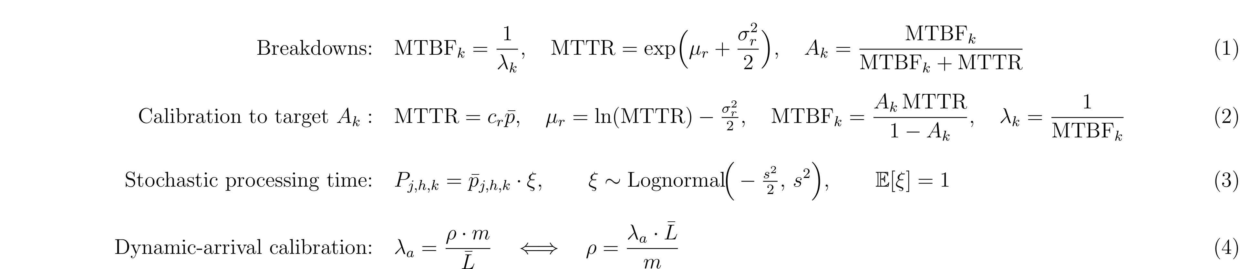
Equations 1–4. Breakdown availability identity and its calibration to a target A_{k} (top); stochastic processing-time multiplier with unit mean (middle); dynamic-arrival Poisson rate calibrated to a target shop utilization ρ (bottom). c_{r} is the mean-repair-time multiplier, s the processing-time variability level, m the machine count, and L̄ the mean total workload per job.
Stochastic processing times. The effective duration of an operation is the nominal duration times a unit-mean log-normal multiplier (Eq. 3), with μ = −s²/2 the closed form that guarantees E[ξ] = 1 exactly — introducing variability without biasing expected makespan up or down relative to the deterministic case. Three levels s ∈ {0.10, 0.25, 0.50} trace a sensitivity curve of robustness against the magnitude of processing-time uncertainty, rather than a single operating point. The multiplier is drawn once, at the moment the operation is dispatched, and held fixed thereafter — including across a breakdown-induced pause under the preempt-resume policy below — extending, rather than altering, the fixed-at-dispatch duration treatment already used in the deterministic environment.
Dynamic job arrivals. New jobs arrive after t = 0 as a Poisson process, with the arrival rate λ_{a} calibrated to a target shop utilization ρ (Eq. 4). Three levels ρ ∈ {0.70, 0.85, 0.95} correspond to standard open-queueing-system regimes: light load with appreciable spare capacity, moderate-to-high load comparable to a well-planned shop's normal operation, and a near-saturation regime deliberately close to the ρ → 1 stability limit, used as a stress test of the policy's ability to maintain feasible schedules when almost no capacity slack remains. Because a pure Poisson process never terminates on its own, two independent termination-safety mechanisms are imposed: an arrival cutoff at 80% of the nominal horizon (leaving the final 20% as an arrival-free drain period) and a hard cap on the number of dynamically generated jobs. Each incoming job preserves the base instance's operation count and a uniformly random machine-routing permutation; its durations are drawn by bootstrap resampling from the base instance's empirical duration distribution, an explicitly flagged modeling choice rather than an additional fitted distribution.
Preempt-resume recovery policy. When a breakdown interrupts an operation in progress, the operation is paused, not discarded: its remaining duration under the already-drawn effective duration is computed and preserved, and processing resumes for exactly that remaining duration once the repair completes. Three arguments support this choice over a preempt-restart alternative. First, physical realism: the reference instance families model discrete machining and assembly, where resuming after a repair (a tool change, a re-fixturing) is standard practice, and discarding all partial progress on every breakdown would introduce a systematic pessimistic bias relative to the real process being modeled. Second, comparability: the two closest prior works on combined breakdown-and-arrival disruption model recovery the same way [11], [24]; adopting restart would break direct comparability with those baselines. Third, unambiguous traceability: under resume, the remaining duration is a well-defined scalar that propagates through the makespan lower-bound estimate exactly as an ordinary operation's duration would, avoiding an additional, unmotivated modeling decision — for instance, whether to redraw a fresh duration for the retried operation, or how to retroactively revise a lower bound already consumed by a discarded one.
All three generators were verified in isolation before integration (N = 5,000 draws per assertion): a Kolmogorov–Smirnov test does not reject the exponential time-to-failure hypothesis (p = 0.929), steady-state availability recovers each target A_{k} to within 0.01%, the log-normal processing-time sampler's empirical mean and variance match theory to within 1.4–2.6%, and the calibrated Poisson arrival rate matches its target utilization to within 0.8% at every ρ level. This constitutes verification, in Sargent's sense [30] — each generator correctly implements its own mathematical specification — and not a claim that the calibrated parameters themselves reproduce a real production process; that stronger claim would require the operational-validation protocol described in the wider simulation-methodology literature [30], [31], a distinction returned to in Section 5.6.
3.4 Disruption-aware reward
The base reward is dense and potential-based: r_{t} = (H(s_{t}) − H(s_{t+1})) × reward_scale, where H(s) is a state-dependent lower-bound estimate of the makespan, guaranteeing a telescoping return Σ_{t} r_{t} = (H(s₀) − C_{max}) × reward_scale; maximizing undiscounted return is therefore exactly equivalent to minimizing makespan [32]. To test H4, this reward is extended with an instability penalty: r_{t} = (LB_{t−1} − LB_{t}) × reward_scale − κ · Δ_{inest} × reward_scale, where Δ_{inest} is the deviation from previously planned start times induced by re-planning after a disruption event — the direct operationalization of the stability construct in the predictive-reactive/robust/stable taxonomy of dynamic-scheduling paradigms this study adopts — and κ ∈ {0, 0.5, 1.0}. κ = 0 recovers the base reward exactly, confirmed by a bit-identical unit test. This mechanism directly extends the single-disruption-type reward-shaping principle of Zhang et al. [24] to a regime randomized over nine simultaneous disruption conditions during training.
3.5 Reference methods: dispatching rules, genetic algorithm, and CP-SAT
A claim that a learned policy “generalizes” or is “robust” is not evaluable without a well-defined floor and ceiling of comparison. Three baseline families are used throughout, spanning the classical solution-paradigm spectrum of Section 2.1.
Nine priority dispatching rules. The mandatory floor of comparison: a policy that does not surpass the best dispatching rule has not learned anything useful about the problem's structure. Table 2 states the nine rules and their exact priority index, including the two named explicitly in this study's design brief — first-in-first-out (FIFO), which Section 4 shows to be the strongest of the nine by a wide margin on the instances tested, and most-work-remaining (MWKR), a standard strong baseline in the wider literature. Earliest-due-date and critical-ratio require a synthesized due date, d_{j} = r_{j} + 1.5 × Σ_{h} p_{j,h}, via the total-work-content rule, since the pure-makespan benchmark families used here carry no published due dates — an explicitly flagged modeling choice. All ties are broken uniformly at random with an independent seed, rather than deterministically by index, to avoid a systematic bias toward low-index jobs in instance families with many identical durations.
Table 2. Priority dispatching rules and their decision index. p_{j,h}: processing time of the candidate operation; Σ_{h'≥h} p_{j,h'}: work remaining in the operation's job; n_{j} − h + 1: operations remaining; d_{j}: synthesized due date.
Rule | Name | Decision index
SPT | Shortest Processing Time | min p_{j,h}
LPT | Longest Processing Time | max p_{j,h}
MWKR | Most Work Remaining | max Σ_{h'≥h} p_{j,h'}
LWKR | Least Work Remaining | min Σ_{h'≥h} p_{j,h'}
MOR | Most Operations Remaining | max (n_{j} − h + 1)
LOR | Least Operations Remaining | min (n_{j} − h + 1)
FIFO / FCFS | First In First Out | min (queue arrival time)
EDD | Earliest Due Date | min d_{j}
CR | Critical Ratio | min (d_{j} − t) / Σ_{h'≥h} p_{j,h'}
Genetic algorithm. The metaheuristic reference explores a much wider region of the schedule space than any single-pass PDR, at a matched computational budget. An individual is encoded as a permutation-with-repetition sequence vector π (the r-th occurrence of job index j denotes that job's r-th operation in technological order, guaranteeing precedence feasibility by construction) and, for the FJSP arm only, a machine-assignment vector μ. Precedence-operation crossover (POX) partitions the job set and preserves each parent's within-subset operation order; uniform crossover recombines μ; mutation applies a swap on π and a machine reassignment on μ. Selection is tournament (k_{t} = 3) with elitism, guaranteeing the best makespan found never regresses across generations. Population size and generation count are treated as configuration choices within a primary, fixed wall-clock budget — identical to CP-SAT's on the same instance — rather than as the stopping criterion themselves, since generation count and search-node count are not comparable units across paradigms.
CP-SAT. Google OR-Tools' constraint-programming solver [33] is the quality ceiling: for small and medium instances it proves optimality, which allows every heuristic and learned policy to be scored against an exact optimality gap rather than against a literature figure obtained under a potentially different protocol. Each operation is modeled as an interval variable with fixed duration; `AddNoOverlap` over each machine's intervals is the direct translation of the classical disjunctive constraint, and a per-job precedence chain completes the JSSP formulation. For the FJSP, each eligible (operation, machine) pair becomes an optional interval variable tied to a presence Boolean, with exactly one alternative required present per operation — the direct translation of the single-assignment constraint, without hand-coded disjunctive Boolean variables. `AddCumulative` is documented as a functionally equivalent alternative for a future extension pooling identical machines into a capacity-c resource, but is not required for the unit-capacity case addressed here. Every solution is limited to the same wall-clock budget as the GA and is always reported together with its solver status — proved `OPTIMAL` or time-limited `FEASIBLE` — so that an RPD computed against an unproven bound is never conflated with one computed against a certified optimum; every reported CP-SAT schedule is additionally re-verified against an independent feasibility checker before any metric is computed from it.
3.6 Common evaluation harness and statistical protocol
The four methods — PDR, GA, CP-SAT, and the trained policy — differ radically in internal mechanics: a PDR decides online inside the environment's own step loop; the GA evaluates complete chromosomes outside that loop; CP-SAT builds and solves a constraint model independent of the environment. All four, however, produce the same object of interest: a feasible schedule and its makespan. A common interface — solve(instance) → schedule, makespan, wall-clock time — unifies them so that no method is favored by implementation convenience: the same instances, seeds, and wall-clock budget (where applicable) are used for all four, and every produced schedule, without exception, is re-verified against an independent feasibility checker before any metric is computed. A structural asymmetry is disclosed rather than concealed: GA and CP-SAT are evaluated in their deterministic, nominal variant only, since neither is formulated to react to a stochastic event occurring in situ, whereas PDRs and the trained policy are both re-evaluated live against the dynamic environment under every disruption regime of Section 3.3. This asymmetry is a property of what each method family is, not an evaluation artifact, and is discussed as part of the paradigm comparison in Section 5.5.
Relative percentage deviation (RPD) is computed against CP-SAT's makespan (proved optimal where the time budget allows, else its best proved bound). Decision time is reported separately for per-epoch methods (PDR, the trained policy) and total-wall-clock methods (GA, CP-SAT), never averaged across the two, since they are not the same unit of measurement. Under disruption, the robustness index RI = (E[C_{max}|perturbed] − C_{max}|nominal) / C_{max}|nominal, computed against each method's own nominal makespan, is the primary comparator. All pairwise comparisons use the exact Wilcoxon signed-rank test; joint comparisons across the ten methods (the policy plus nine PDRs) use the Friedman test with Nemenyi post-hoc analysis and critical-difference diagrams [34]; effect sizes (r = Z/√N) are reported throughout. Evaluation spans 43 JSSP instances (Fisher–Thompson [35] ft06/ft10/ft20; Lawrence [36] la01–la40) and two FJSP arms: a synthetic arm (the same 43 instances extended with machine flexibility) and seven of the eight Brandimarte [2] instances (mk06 excluded after an upstream benchmark-mirror inconsistency — 15 machines instead of the published 10 — was traced during instance loading).
3.7 Pre-registration and hypotheses
Five hypotheses were pre-registered, with quantitative accept/reject rules frozen in a timestamped document before any policy-evaluation result was generated — a discipline intended to guard against hypothesizing after results are known (HARKing), and one that Table 1 shows to be largely absent from the works surveyed in Section 2. Table 3 states each hypothesis and its exact decision rule.
Table 3. Pre-registered hypotheses and frozen decision rules.
Hyp. | Claim | Accept criterion (frozen before evaluation)
H1 | The policy outperforms the best PDR in mean RPD on static instances | Wilcoxon p<0.05 and median(RPD_{bestPDR} − RPD_{RL}) > 0, per instance family
H2 | RPD on 1.5×–3.0× larger instances stays competitive with the best PDR | Friedman–Nemenyi: the policy's rank not significantly worse than the best PDR's, in every size tier
H3 | Robustness index (RI) is lower than PDRs' under breakdowns, stochastic times, and arrivals | Wilcoxon p<0.05 and median(RI_{PDR} − RI_{RL}) > 0, in all 9 disruption regimes (conjunctive rule)
H4 | κ>0 reduces RI without increasing nominal RPD by more than 2 percentage points | ΔRI<0 significant in ≥5/9 regimes and ΔRPD_{nominal} < 2pp (both required)
H5 | Decision latency stays far below CP-SAT's as instance size grows | median(ms/decision_{RL}) < 1% × median(ms/decision_{CP-SAT}), for every instance

4. Results
Table 4 summarizes the verdict for all five pre-registered hypotheses; Sections 4.1–4.4 detail each in turn.
Table 4. Hypothesis verdicts (all tests two-sided, α = 0.05).
Hypothesis | Test | Statistic | Verdict
H1 (JSSP) | Wilcoxon, N=43 | W=133, p=4.03×10⁻⁵, r=−0.63 | REJECT
H1 (FJSP synthetic) | Wilcoxon, N=43 | W=0, p=1.12×10⁻⁸, r=−0.87 | REJECT
H1 (FJSP Brandimarte) | Wilcoxon, N=7 | W=0, p=0.0156, r=−0.91 | REJECT
H2 (4 size tiers) | Friedman + Nemenyi | rank gap ≤1.00 < CD=6.06 in all tiers | ACCEPT
H3 (9 disruption regimes) | Wilcoxon ×9 | p<1.7×10⁻¹¹ in all 9 | REJECT
H4 (κ=0.5) | Wilcoxon ×9 + ΔRPD | 0/9 significant; ΔRPD_{nom}=+106.0pp | REJECT
H4 (κ=1.0) | Wilcoxon ×9 + ΔRPD | 1/9 significant; ΔRPD_{nom}=+46.6pp | REJECT
H5 (latency, strict) | threshold, N=43 | 42/43 instances fail 1% rule | REJECT
4.1 H1 — Static competitiveness (rejected)
Mean RPD over the 43 JSSP instances is 24.82% for the policy, 18.96% for the best PDR per instance, 5.52% for the GA, and approximately 0% for CP-SAT (Figure 1; Table 5 gives the full per-method breakdown). The policy beats the per-instance best PDR on only 8 of 43 instances (18.6%) and loses on every instance of both FJSP arms: mean RPD against the better of {GA, CP-SAT} is 48.76% on the synthetic arm (0/43 wins) and 89.65% on the Brandimarte arm (0/7 wins). All three tests reject H1 with large effect sizes (r = −0.63 to −0.91). The GA, under the same 60-second wall-clock budget as CP-SAT, outperforms both the policy and the best PDR by an even larger margin than the PDR comparison alone suggests (Table 5); the asymmetry this implies — a search method given a modest per-instance budget beats a policy trained for orders of magnitude longer — is addressed directly in Section 5.6. Table 5 also substantiates a claim used throughout this article: FIFO is the strongest of the nine dispatching rules by a wide margin (mean RPD 19.15% vs. 39.83% for the next best, MOR), and is therefore the dominant PDR comparator in most of the size-generalization and robustness results below.
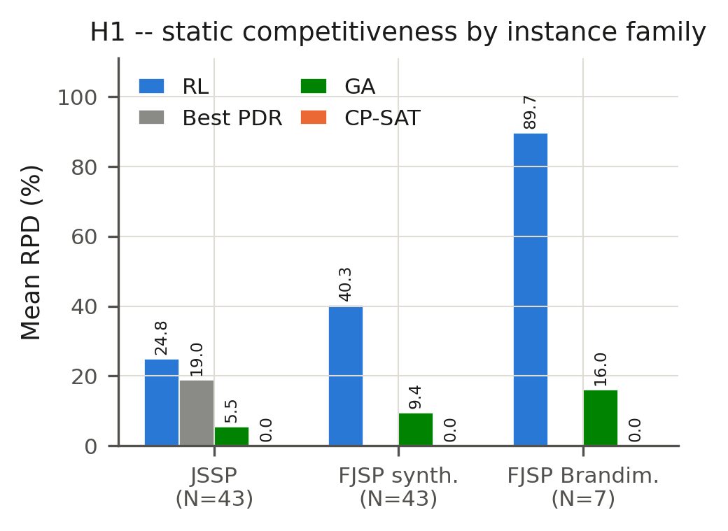
Figure 1. Mean relative percentage deviation (RPD) by method and instance family. RPD is computed against CP-SAT's makespan as the near-optimal reference within each family; the pre-registered H1 test itself compares the policy against the best PDR (JSSP) or the better of {GA, CP-SAT} (FJSP arms) on a per-instance basis (see text).
Table 5. Mean and standard deviation of RPD (%) by method, JSSP arm (N=43 instances, seed-0 deterministic evaluation).
Method | Type | Mean RPD (%) | SD (%)
CP-SAT | Exact | 0.02 | 0.13
GA | Metaheuristic | 5.52 | 5.31
FIFO | PDR | 19.15 | 11.10
RL (this study) | GNN–PPO policy | 24.82 | 12.92
MOR | PDR | 39.83 | 16.91
MWKR | PDR | 42.59 | 16.19
SPT | PDR | 268.23 | 114.01
LPT | PDR | 281.88 | 116.91
EDD | PDR | 387.34 | 177.00
LWKR | PDR | 391.91 | 177.61
LOR | PDR | 401.15 | 174.56
CR | PDR | 430.31 | 183.62
4.2 H2 — Size generalization (accepted)
Across four size tiers (1.5×–3.0× the training size, la21–la40), the Friedman test decisively rejects equal performance in each tier (p<3.4×10⁻⁶), and in every tier the policy's mean rank is not significantly different from the best PDR's (Δrank 0.20–1.00 against a Nemenyi critical difference of 6.06; Figure 2). The critical-difference diagrams place the policy in the same statistically indistinguishable cluster as FIFO, MWKR, MOR, and SPT in all four tiers. This is an acceptance of rank-relative, not absolute, competitiveness: the policy's mean RPD (23.9–32.9% across tiers) remains numerically above FIFO's (12.7–26.8%) at every tier. The size–RPD relationship is non-monotonic: the 3.0× tier has the lowest mean RPD of the four (23.86%), below even the 1.5× tier's (32.55%) — a genuine, corroborated pattern rather than a sampling artifact, and one that cautions against assuming degradation is strictly monotonic in instance size for this architecture.
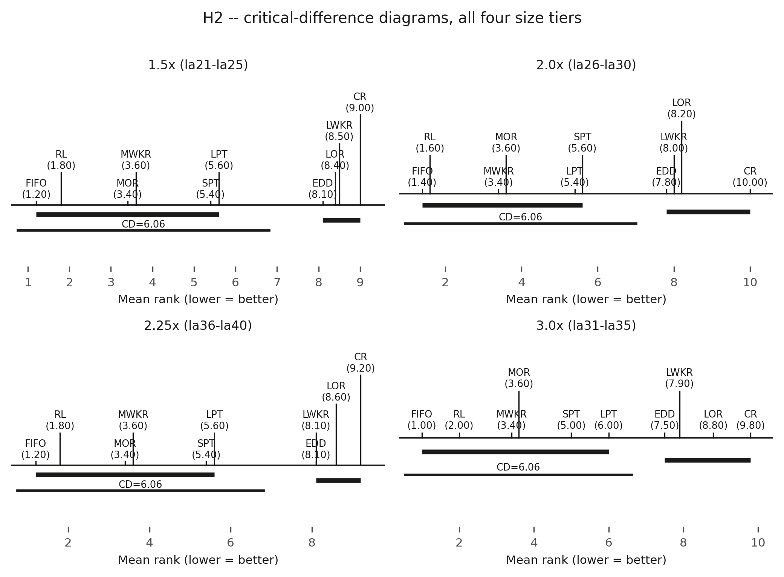
Figure 2. Friedman–Nemenyi critical-difference diagrams for all four size tiers (1.5×, 2.0×, 2.25×, 3.0× the training size). Methods connected by a horizontal bar are not significantly different in mean rank (CD = 6.06). The policy (RL) falls in the same top cluster as FIFO, MWKR, MOR, and SPT in every tier.
4.3 H3/H4 — Robustness and disruption-aware reward (rejected)
The policy's robustness index is worse than the best PDR's in all nine disruption regimes, with large and uniformly consistent effect sizes (r ≈ −0.87 in all nine; Figure 3). The arrivals axis is the most severe (RI ≈ 1.65–1.82 for the undisturbed, κ=0 policy, vs. 0.26–0.28 for the best PDR) — the axis furthest from the policy's training distribution, since dynamic arrivals present genuinely unseen mid-episode job insertions, whereas breakdowns and stochastic processing times only perturb the timing of operations the policy already expects to see. Extending the reward with the κ·Δ_{inest} instability penalty does not rescue robustness. At κ = 0.5, all nine regimes show significantly worse robustness, not better; at κ = 1.0, only one of nine regimes improves significantly (E5, s=0.10, p=7.95×10⁻⁵), short of the pre-registered five-of-nine threshold. Critically, both κ values collapse nominal, undisturbed performance: nominal RPD increases by 106.0 percentage points at κ = 0.5 and 46.6 percentage points at κ = 1.0. The mechanism behind both rejections is examined in detail in Section 5.
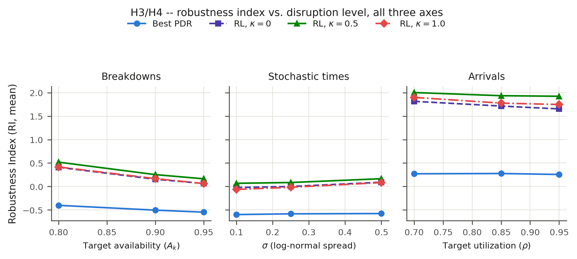
Figure 3. Robustness index (RI, mean) versus disruption level, one panel per axis (breakdowns, stochastic processing times, arrivals). Lower RI is better. The best PDR (blue) remains well below all three RL variants (κ = 0, 0.5, 1.0) on every axis and every level.
4.4 H5 — Decision latency (rejected under the strict threshold)
The policy's per-decision latency is essentially flat across the full instance-size range — typically 4–11 ms, and never exceeding 44 ms even on the largest instances tested — while CP-SAT's total solve time is highly variable: near-instant on small, easy instances and saturating its 60-second budget on large or structurally hard ones (Figure 4). Under the strict pre-registered criterion — the 1% threshold must hold for every instance — 42 of 43 instances fail, driven largely by small instances where CP-SAT's near-instantaneous solve produces an artificially tiny per-decision denominator: dividing a one-shot solver's total solve time by operation count is not a natural unit for a method that does not deliberate sequentially, a construct-validity limitation of the metric itself rather than evidence that the policy is slow. One large instance's CP-SAT measurement (la40: 32,074 ms/decision, a 1,773× ratio against the policy) was traced to a likely measurement anomaly via a raw-log audit; a sensitivity check substituting a structurally comparable instance's value (la38, same size class, both solved to a time-limited FEASIBLE result under the identical 60-second budget) reduces the ratio to 14.8× but still rejects H5 under the strict threshold (Table 6) — the correction makes the rejection more, not less, decisive, and is reported here to make that transparent rather than to explain the result away. For genuinely large, hard instances that saturate CP-SAT's time budget, the policy retains a real one-to-two-order-of-magnitude latency advantage, qualitatively consistent with H5's motivating intuition even though the literal all-instances threshold is not met.
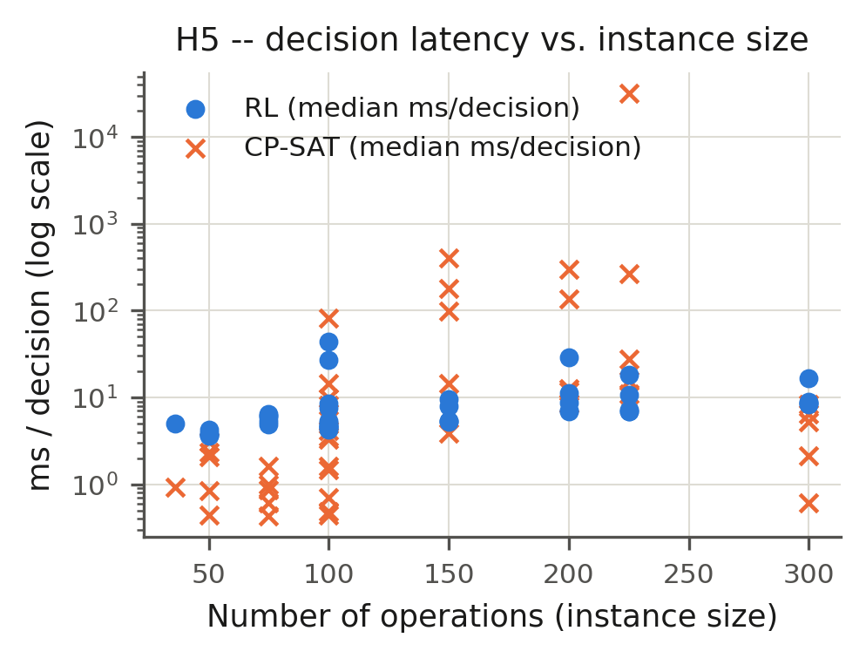
Figure 4. Per-decision latency (ms, log scale) versus instance size for the policy (RL) and CP-SAT. The policy's latency is essentially flat; CP-SAT's grows erratically with instance size and structural hardness.
Table 6. Sensitivity check for the la40 CP-SAT latency measurement, substituting la38's wall-clock time (same size class, same FEASIBLE status under the identical 60 s budget).
Reading | RL (ms/decision) | CP-SAT (ms/decision) | Ratio | H5 passes (of 43)
Raw (as measured) | 18.09 | 32,074.09 | 1,773.5× | 1
Sensitivity-corrected (la38 substituted) | 18.09 | 266.91 | 14.8× | 0

5. Discussion: The Autopsy of a Null Result
Four of five pre-registered hypotheses are rejected. The purpose of this section is to treat that outcome as data rather than as a result to be minimized: each rejection is traced to a specific, evidence-grounded mechanism, competing explanations are tested and, where the evidence does not support them, explicitly set aside, and the pattern across all five hypotheses is read as a direct answer to the question posed in the title.
5.1 Why size generalization transfers and competitiveness does not: architecture as a multiplier, not a corrector
H2's acceptance alongside H1's rejection is not a contradiction; it is the pattern GNN generalization theory predicts once permutation invariance, a size-independent parameter count, and message-passing locality are recognized as architectural properties, not properties of the absolute competitiveness a trained policy happens to reach [5]. An architecture can be expressive enough to preserve relative behavior — its rank against other methods — under transfer to larger instances, without that relative behavior being, in absolute terms, competitive. This is precisely what Section 4.2 documents: the policy's mean rank is never significantly worse than the best PDR's in any size tier, while its mean RPD remains numerically above FIFO's in every tier. L2D shows the same qualitative pattern under the same theoretical mechanism, but from a far more competitive starting point — a substantially higher win rate against dispatching rules at training size [6] — so its generalization preserves absolute competitiveness, where this study's preserves only rank. Read together, the two results are consistent with a multiplicative reading of size-generalization theory: size-invariant architecture transfers whatever competitiveness the base policy already has, rather than manufacturing competitiveness on its own. SPM-DAN's far stronger absolute generalization result, obtained under a single uncertainty source with a scenario-processing module purpose-built for that axis [10], points the same direction from a different angle: a dedicated architectural mechanism for the specific axis being generalized outperforms a generic relational encoder without one. Whether a fully heterogeneous encoder [8] would close the static competitiveness gap at the cost of more parameters and training time, or whether training budget rather than architecture is the dominant factor, is a question this study's design cannot arbitrate without the architectural ablation identified as future work in Section 6.
5.2 The mechanism behind H3: a training-deployment contract violation, not a generic failure under noise
H3's rejection is not a diffuse degradation under noise; it has a specific, identifiable, and in principle correctable cause. The κ=0 policy evaluated for H3 was trained exclusively against the static environment's dispatch-gated legality semantics — an operation becomes a legal action the instant it is dispatchable — and is evaluated, unmodified, against the dynamic environment's completion-gated semantics, in which legality additionally depends on machine and predecessor state that can change mid-episode as a direct consequence of disruption. An adapter makes this rollout mechanically possible; it does not close the semantic gap between what the policy was trained to expect and what it is asked to act on. This is the same distinction drawn in Section 3.2: message-passing locality and permutation invariance protect a policy against a change in the size of its input graph, because that is exactly the invariance they are built to provide; they do not protect against a change in the semantics governing which of the graph's existing nodes are currently actionable, because no mechanism in the architecture is responsible for that invariance. The arrivals axis being the single most severe disruption regime (Section 4.3) is direct corroborating evidence, not a separate finding: dynamic arrivals are the one perturbation type that presents the policy with operations it has never seen in training, whereas breakdowns and stochastic processing times only perturb the timing of operations the policy already expects to exist. Degradation concentrated on exactly the axis furthest from the training distribution is the signature of a distribution-shift failure, not of an architecture that is generically too weak to handle perturbation.
Placed against Lassoued et al. [11], this mechanism sharpens rather than contradicts the closest prior result. Lassoued et al.'s maskable-PPO policy, trained with robustness under combined breakdown-and-arrival disruption as its sole objective and evaluated against the same dynamic legality contract it was trained under, outperforms dispatching rules under disruption. The policy evaluated here pursues a second objective — size generalization — over the same architecture and training budget, and is evaluated against a legality contract it never trained under. The contrast is, to our knowledge, the first controlled evidence that the joint objective identified as an open gap in Section 2 is not free: capacity and training budget spent entirely on the robustness axis, under the contract the policy is later evaluated against, can beat dispatching rules on that axis; capacity split across two axes, and evaluated under a contract never seen in training, loses decisively. This does not establish that the joint objective is unattainable in principle — no architectural ablation in this study isolates how much of the relational encoder's capacity the size-generalization curriculum leaves available for robustness — but it is, to our knowledge, the first quantitative demonstration that the tension between the two objectives is real and measurable rather than assumed.
5.3 The mechanism behind H4: a reward term whose effect is masked by a larger, unisolated training-regime confound
H4's rejection is not evidence that disruption-aware instability penalties are ineffective in principle. Both κ-conditioned policies were trained under domain randomization across all nine disruption regimes, resampled every episode, without a single undisturbed episode ever included in the training distribution. This is, on its own, sufficient to explain a catastrophic nominal-performance collapse independent of whatever the Δ_{inest} term itself contributes, and it has no direct analog in the closest prior reward-shaping precedent [24], because that work trains and evaluates on a single disruption axis — the specific failure mode “the policy never sees an undisturbed episode of any kind” cannot arise in a single-axis experimental design the way it arises when a single-event-type reward mechanism is generalized to a nine-condition randomized regime. We therefore do not report H4 as “the instability penalty does not work”; we report it as “the instability penalty's effect could not be isolated from a substantially larger confound under the training regime tested,” a materially different and more actionable conclusion. The Δ_{inest} term itself was validated only as a no-op at κ=0 (a bit-identical unit test against the base reward), not as a term whose effect behaves sensibly in isolation from the domain-randomization regime around it — a distinction this study is careful to preserve rather than collapse into a single verdict on the reward-shaping principle. A corrected training regime that mixes a non-zero fraction of undisturbed episodes into the domain-randomization sample, isolating the reward term's effect from the training-regime confound that currently dominates it, is identified as priority future work in Section 6.
5.4 Ruling out alternative mechanisms
Two mechanistic explanations for the disruption-robustness failure were considered and are explicitly addressed here rather than left ambiguous, in the interest of the same evidence-before-narrative discipline that motivates this study's pre-registration.
Policy-entropy collapse. Premature convergence to a near-deterministic policy, forfeiting exploration early in training, is a documented pathology in maskable-PPO scheduling policies and a plausible generic explanation for poor performance under distribution shift. Per-epoch diagnostic logging from this study's architecture-validation training runs — entropy, KL-divergence, explained variance, and clip fraction — shows entropy decaying gradually across the full training run and tracking the return curve rather than collapsing in the first updates, together with explained variance remaining high throughout: the signature of healthy PPO convergence, not of premature entropy collapse. This diagnostic was not, however, re-instrumented specifically for the κ-conditioned disruption-training runs evaluated for H3/H4, so entropy collapse is set aside here as unsupported by the available evidence, not as formally excluded for those specific runs — a distinction we preserve deliberately rather than overstate.
Encoder capacity under dynamic edge-masking. A second candidate explanation is that the relational GIN encoder's effective capacity degrades under the graph perturbation disruption introduces. Section 3.2 establishes that this premise needs qualification: disruption in this study's environment changes node-level features and the action-legality mask, not the graph's edge set, so “dynamic edge-masking” does not describe what the encoder actually observes under breakdown or arrival events. An ablation isolating encoder representational capacity under an explicit, engineered edge-masking condition was scoped as a candidate diagnostic during this study's design but was not executed; we report it in Section 6 as an open, well-motivated direction rather than imply it was tested. Between the two candidate mechanisms, only the legality-semantics contract violation of Section 5.2 is supported by evidence collected in this study; the other two are explicitly flagged as untested rather than silently omitted.
5.5 The industrial paradox and a path forward for practice
Sections 4.1 and 4.3 jointly establish a pattern with direct operational relevance: under exactly the shop-floor conditions — disruption — where an adaptive, learned policy would be most valuable relative to a static rule, the policy evaluated here is both slower and lower-quality than the simplest dispatching rule tested. A PDR's decision is an O(1) index comparison, computationally trivial by construction; the policy's decision is a full neural-network forward pass, several orders of magnitude more expensive per decision even though it remains far cheaper than re-solving the instance from scratch. Under disruption, this policy is not only more expensive than FIFO per decision, it is also less effective by the RI comparison of Section 4.3 — the combination an operations engineer would consider disqualifying for a reactive-control role, since it dominates the simplest available alternative on neither axis under the conditions that matter most operationally.
The contrast between this quality-and-speed weakness under disruption and H5's qualitative speed advantage over an exact solver on large, hard, nominal instances motivates, without fully evaluating, a hybrid deployment architecture rather than a single-method choice: a fast reactive method — in light of this study's own results, more defensibly a dispatching rule than the learned policy — serving as an immediate decision bridge in the seconds following a disruption event, while an exact or metaheuristic re-optimizer computes a higher-quality replacement schedule in parallel. A neuro-symbolic variant of the same idea is a natural extension given this study's own contrast between CP-SAT's certified quality and the policy's raw speed: a learned policy proposing candidate dispatch decisions at low latency, with an explicit constraint checker or local re-optimizer verifying and, where necessary, repairing that proposal before it is committed, rather than requiring a single method to be simultaneously the fastest and the best. For practitioners evaluating GNN–DRL scheduling tools specifically, the results caution directly against inferring disruption robustness from a size-generalization claim: this study's own evidence is that the two do not co-occur automatically under the tested architecture and training regime, and each should be requested and verified as a separately tested capability before either is used to justify deployment.
5.6 Threats to validity and limitations
Internal validity. A single training seed per κ condition limits the precision, though not the qualitative direction, of the H4 magnitudes reported; the κ=1.0 condition's one nominally significant regime (E5, p=7.95×10⁻⁵) is a single-run point estimate that might not survive a formal multiple-comparison correction across the nine regimes tested, although H4's own conjunctive criterion (≥5/9 regimes, not 1/9) makes the overall REJECT verdict independent of whether that specific result would survive one. Training compute is not matched across methods, and specifically not in a direction that favors the rejection of H1: GA and CP-SAT each receive a 60-second-per-instance budget, while the evaluated policy is the product of a 19-stage curriculum (the FJSP arm, 24 stages, plus two additional fine-tuning stages for the H4 checkpoints) whose cumulative training compute exceeds any single baseline's by orders of magnitude. That the policy still loses decisively to PDR and GA baselines despite this resource asymmetry in its own favor strengthens, rather than weakens, the reliability of H1's rejection.
External validity. Instance families are limited to Fisher–Thompson and Lawrence, plus Brandimarte for the FJSP arm; Taillard [13], Hurink [37], and several other standard families were not incorporated, a disclosed deviation from the original experimental plan. H2's size-generalization result is demonstrated within the Lawrence family, not across structurally distinct instance distributions — a policy shown to transfer well in size within one family has not thereby been shown to transfer across families, a second and distinct notion of generalization this protocol does not evaluate. All results are simulation-only: even the disruption generators, however carefully calibrated and statistically verified against their own target parameters (Section 3.3), are stylized models whose fidelity to a real production floor's disruption processes has not been validated against field data, and no claim here should be read as a statement about performance on a physical shop floor. A single architectural family (the relational GIN of Section 3.2) is evaluated; the results are specific to this choice and do not automatically extend to GNN–PPO scheduling policies as a class absent the homogeneous-versus-heterogeneous ablation identified in Section 6.
Construct validity. The pre-registration itself names expected tardiness, E[ΣT_{j}], as the most appropriate primary metric for the arrivals regime specifically, since a makespan-anchored metric is distorted under arrivals by a realized-schedule scope that grows with the number of jobs arriving mid-episode; this metric was never computed, so H3's arrivals-axis rejection is a solid conclusion about the robustness index as measured, but an incomplete one about realized system performance under dynamic arrivals specifically. H5's metric conflates two distinct computational paradigms, as Section 4.4 already makes explicit: milliseconds-per-decision is not a natural unit for a solver that does not deliberate sequentially. The shared robustness-index baseline convention — each κ variant's RI computed against the same κ=0 nominal makespan — is verified and defensible, but has a declared side effect: a PDR with very poor nominal performance is mechanically favored as the “best PDR” by RI in some regimes, precisely because its poor baseline makes almost any perturbed outcome look like a relative improvement; a sensitivity check against MWKR, the PDR with the best absolute RPD, reproduces the same qualitative H3 verdict, so this property of the RI construct does not change the conclusion, but is disclosed rather than assumed neutral.
6. Conclusion
This study pre-registered and jointly tested five hypotheses about whether a relational-GIN, PPO-based scheduling policy can generalize across instance sizes and remain robust to multiple simultaneous disruption types in the dynamic, stochastic flexible job-shop problem. Four hypotheses are rejected, one is accepted, and every rejection is traced to a specific, evidence-grounded mechanism rather than left as an unexplained negative result: a training-deployment legality-semantics contract violation for H3, a domain-randomization training-regime confound for H4, and a construct-validity weakness in a per-decision latency metric applied to a non-sequential solver for H5. The accepted hypothesis, H2, demonstrates that size-invariant architecture transfers rank-relative competitiveness even from a base policy that is not itself competitive in absolute terms — direct empirical support for permutation-invariance-based GNN generalization theory, independent of the underlying policy's absolute strength. Taken together, and returning to the question posed in the title: size generalization does not imply disruption robustness, and this study provides the first statistically rigorous, pre-registered, jointly tested evidence that the two are separable properties of a GNN–PPO scheduling policy, each requiring its own evaluation, not a package deal that follows automatically from a size-generalization demonstration alone.
Several directions follow directly from the mechanisms diagnosed in Section 5, rather than from a generic call for “future work.” An architectural ablation spanning the homogeneous, relational, and fully heterogeneous points of the spectrum in Section 2.3 would isolate how much of the static competitiveness gap (H1) and the disruption-robustness gap (H3) is attributable to the relational encoder's specific capacity, as distinct from training budget. A corrected domain-randomization regime that preserves a non-zero fraction of undisturbed nominal episodes during training is, on the evidence of Section 5.3, the most direct path to isolating the instability-penalty term's effect on robustness (H4) from the confound that currently dominates it. Multi-seed replication of both the size-generalization and disruption-training runs would sharpen the precision of the point estimates reported here, particularly for H4. Computing expected tardiness, the pre-registration's own named primary metric for the arrivals regime, would close the specific construct-validity gap identified in Section 5.6. Beyond these direct extensions, this study's own contrast between the trained policy's speed and CP-SAT's certified quality (Sections 4.4 and 5.5) motivates two further directions: a neuro-symbolic architecture in which a fast learned proposal is checked and, where necessary, repaired by an explicit constraint solver before commitment, and — given that disruption in the current architecture is encoded only as a node-level feature and an external legality mask (Section 3.2) — a resilient graph representation in which a legality-regime change is instead encoded as an explicit, learnable relation in the graph itself, giving the encoder a structural signal for exactly the semantic shift Section 5.2 identifies as H3's root cause, rather than requiring the policy to infer it indirectly from an external mask it was never trained against. Large-language-model scheduling agents [26], [25], which inherit generalization from pretraining rather than from graph-structural invariance and can be paired naturally with explicit post hoc constraint checking, are a methodologically distinct paradigm worth direct comparative evaluation under this same pre-registered protocol. Finally, every result reported here is obtained under simulation; validation against disruption data from a real production environment remains, as it does for essentially all of the literature reviewed in Section 2, the ultimate outstanding test.
Data availability statement
The simulation environment, policy implementation, trained checkpoints, and the complete experimental results and analysis code supporting the findings of this study are maintained in a version-controlled repository, with a permanent archival deposit in preparation at the time of writing. Repository and deposit identifiers will be provided upon acceptance; interested readers may contact the corresponding author in the interim.
Funding
This research did not receive any specific grant from funding agencies in the public, commercial, or not-for-profit sectors.
Declaration of competing interest
The author declares no known competing financial interests or personal relationships that could have appeared to influence the work reported in this article.

References
[1] M. L. Pinedo, Scheduling: Theory, Algorithms, and Systems, 6th ed. Cham, Switzerland: Springer, 2022.
[2] P. Brandimarte, “Routing and scheduling in a flexible job shop by tabu search,” Ann. Oper. Res., vol. 41, no. 3, pp. 157–183, 1993.
[3] M. R. Garey, D. S. Johnson, and R. Sethi, “The complexity of flowshop and jobshop scheduling,” Math. Oper. Res., vol. 1, no. 2, pp. 117–129, 1976.
[4] R. L. Graham, E. L. Lawler, J. K. Lenstra, and A. H. G. Rinnooy Kan, “Optimization and approximation in deterministic sequencing and scheduling: A survey,” Ann. Discrete Math., vol. 5, pp. 287–326, 1979.
[5] K. Xu, W. Hu, J. Leskovec, and S. Jegelka, “How powerful are graph neural networks?,” in Proc. Int. Conf. Learn. Represent. (ICLR), 2019.
[6] C. Zhang, W. Song, Z. Cao, J. Zhang, P. S. Tan, and C. Xu, “Learning to dispatch for job shop scheduling via deep reinforcement learning,” in Proc. 34th Conf. Neural Inf. Process. Syst. (NeurIPS), 2020.
[7] J. Schulman, F. Wolski, P. Dhariwal, A. Radford, and O. Klimov, “Proximal policy optimization algorithms,” arXiv:1707.06347, 2017.
[8] W. Song, X. Chen, Q. Li, and Z. Cao, “Flexible job-shop scheduling via graph neural network and deep reinforcement learning,” IEEE Trans. Ind. Informat., vol. 19, no. 2, pp. 1600–1610, 2023.
[9] K. Lei, P. Guo, W. Zhao, Y. Wang, L. Qian, X. Meng, and L. Tang, “A multi-action deep reinforcement learning framework for flexible job-shop scheduling problem,” Expert Syst. Appl., vol. 205, art. 117796, 2022.
[10] I. G. Smit, Y. Wu, P. Troubil, Y. Zhang, and W. P. M. Nuijten, “Neural combinatorial optimization for stochastic flexible job shop scheduling problems,” Proc. AAAI Conf. Artif. Intell., vol. 39, no. 25, pp. 26678–26687, 2025.
[11] S. Lassoued, S. Lier, and A. Schwung, “Policy-based reinforcement learning with action masking for dynamic job shop scheduling under uncertainty: Handling random arrivals and machine failures,” arXiv:2601.09293, 2026.
[12] G. Liu, M. Liao, W. Chen, Z. Zhang, H. Wan, and Y. Lin, “Multi-faceted dynamic flexible job shop scheduling via heterogeneous graph transformer and deep reinforcement learning,” Expert Syst. Appl., vol. 303, art. 130532, 2026.
[13] E. Taillard, “Benchmarks for basic scheduling problems,” Eur. J. Oper. Res., vol. 64, no. 2, pp. 278–285, 1993.
[14] J. Park, J. Chun, S. H. Kim, Y. Kim, and J. Park, “Learning to schedule job-shop problems: Representation and policy learning using graph neural network and reinforcement learning,” Int. J. Prod. Res., vol. 59, no. 11, pp. 3360–3377, 2021.
[15] P. Tassel, M. Gebser, and K. Schekotihin, “A reinforcement learning environment for job-shop scheduling,” arXiv:2104.03760, 2021.
[16] C. Waubert de Puiseau, J. Peters, C. Dörpelkus, H. Tercan, and T. Meisen, “schlably: A Python framework for deep reinforcement learning based scheduling experiments,” SoftwareX, vol. 22, art. 101383, 2023.
[17] R. Reijnen, I. G. Smit, H. Zhang, Y. Wu, Z. Bukhsh, and Y. Zhang, “Job shop scheduling benchmark: Environments and instances for learning and non-learning methods,” arXiv:2308.12794, 2023.
[18] T. N. Kipf and M. Welling, “Semi-supervised classification with graph convolutional networks,” in Proc. Int. Conf. Learn. Represent. (ICLR), 2017.
[19] W. L. Hamilton, R. Ying, and J. Leskovec, “Inductive representation learning on large graphs,” in Proc. 31st Conf. Neural Inf. Process. Syst. (NeurIPS), 2017, pp. 1024–1034.
[20] P. Veličković, G. Cucurull, A. Casanova, A. Romero, P. Liò, and Y. Bengio, “Graph attention networks,” in Proc. Int. Conf. Learn. Represent. (ICLR), 2018.
[21] I. G. Smit, J. Zhou, R. Reijnen, Y. Wu, J. Chen, C. Zhang, Z. Bukhsh, Y. Zhang, and W. Nuijten, “Graph neural networks for job shop scheduling problems: A survey,” Comput. Oper. Res., 2024.
[22] J. Hoss, M. Link, and N. Klarmann, “Scalable production scheduling: Linear complexity via unified homogeneous graphs,” arXiv:2604.23841, 2026.
[23] G. Infantes, S. Roussel, P. Pereira, A. Jacquet, and E. Benazera, “Learning to solve job shop scheduling under uncertainty,” in Proc. 21st Int. Conf. Integration Constraint Program., Artif. Intell., Oper. Res. (CPAIOR), 2024.
[24] L. Zhang, Y. Yan, C. Yang, and Y. Hu, “Dynamic flexible job-shop scheduling by multi-agent reinforcement learning with reward-shaping,” Adv. Eng. Informat., vol. 62, art. 102872, 2024.
[25] S. Cao and Y. Yuan, “ReflecSched: Solving dynamic flexible job-shop scheduling via LLM-powered hierarchical reflection,” arXiv:2508.01724, 2025.
[26] H. Abgaryan, T. Cazenave, and A. Harutyunyan, “Starjob: Dataset for LLM-driven job shop scheduling,” arXiv:2503.01877, 2025.
[27] S. Huang and S. Ontañón, “A closer look at invalid action masking in policy gradient algorithms,” in Proc. 35th Int. FLAIRS Conf., 2022.
[28] A. Raffin, A. Hill, A. Gleave, A. Kanervisto, M. Ernestus, and N. Dormann, “Stable-Baselines3: Reliable reinforcement learning implementations,” J. Mach. Learn. Res., vol. 22, no. 268, pp. 1–8, 2021.
[29] J. Schulman, P. Moritz, S. Levine, M. Jordan, and P. Abbeel, “High-dimensional continuous control using generalized advantage estimation,” arXiv:1506.02438, 2016.
[30] R. G. Sargent, “Verification and validation of simulation models,” in Proc. 2011 Winter Simulation Conf., 2011, pp. 183–198.
[31] A. M. Law, Simulation Modeling and Analysis, 6th ed. New York, NY, USA: McGraw Hill, 2024.
[32] A. Y. Ng, D. Harada, and S. Russell, “Policy invariance under reward transformations: Theory and application to reward shaping,” in Proc. 16th Int. Conf. Mach. Learn. (ICML), 1999, pp. 278–287.
[33] L. Perron, F. Didier, and S. Gay, “The CP-SAT-LP solver,” in Proc. 29th Int. Conf. Princ. Pract. Constraint Program. (CP), LIPIcs, vol. 280, art. 3, 2023.
[34] J. Demšar, “Statistical comparisons of classifiers over multiple data sets,” J. Mach. Learn. Res., vol. 7, pp. 1–30, 2006.
[35] H. Fisher and G. L. Thompson, “Probabilistic learning combinations of local job-shop scheduling rules,” in Industrial Scheduling, J. F. Muth and G. L. Thompson, Eds. Englewood Cliffs, NJ, USA: Prentice-Hall, 1963, pp. 225–251.
[36] S. Lawrence, “Resource constrained project scheduling: An experimental investigation of heuristic scheduling techniques,” Grad. School Ind. Admin., Carnegie-Mellon Univ., Pittsburgh, PA, USA, Tech. Rep., 1984.
[37] J. Hurink, B. Jurisch, and M. Thole, “Tabu search for the job-shop scheduling problem with multi-purpose machines,” OR Spektrum, vol. 15, no. 4, pp. 205–215, 1994.

