TECHIN512 Lab 2 DC Circuits and Voltage Dividers Lab

**Introduction**

The purpose of this lab is to learn about applications of Ohm's Law to some basic resistive circuits.

**Background**

**Write-Up**

The writeup for this lab should contain the following outline:

1. Title page (see template in the folder ‘Requirement of Lab Reports’)
2. Introduction   
   ⅓ of a page describing the purpose and goals of this lab *in your own words.* **Do not reproduce any material from this assignment document in any section of your writeup.**
3. Results  
   First include the Pre-lab computations. Then, each location in the instructions below marked with “>” indicates some data which must appear in your report. Separate each result or related set of results with a section header indicating what it is. For any numerical data or graph describe the meaning of the data.
4. Discussion and Conclusions:

* In ½ to 1 page, summarize the key learning points from the Results above.

**Preparation**:

> Pre-lab computations:

1. > A 1000 Ohm resistor is connected to 20 V. Find the current through the resistor:
2. > Two 2K Ohm resistors are connected in series. The current through them is 1.5mA. Find the voltage across the two and also across each one separately.
3. > A 2K and a 500 Ohm resistor are connected in parallel across a 1.5V battery. Find the current draw from the battery and also the current in each resistor.
4. > A 100 Ohm and 900 Ohm resistor are connected in series across a 9V battery. Find the voltage across the 100 Ohm resistor.

Parts, tools, supplies required:

* Resistors: 2x1000 Ohm, 500 Ohm,
* Alligator clip leads (power supply to resistors)
* Protoboard
* DMM

**Procedure**:

1. **Ohm’s Law**
   1. Set the DMM to measure resistance and measure the resistance of your 1000 Ohm resistor.
   2. > compare measured resistance with “1000 Ohms”. What is the percentage of error? (Tip: it is better to always check the resistance of a resistor before using it.)
   3. Set up the power supply for +10 V, connect 1000 Ohm resistor across power supply.
   4. Set DMM to Voltage mode, and verify +10V DC across 1K Ohm resistor.
   5. Switch your DMM to **current mode** (change Red lead to A)
   6. Connect your DMM between resistor and power supply ground as follows:

* Disconnect the resistor from power supply GND
* Connect the red lead (A) of DMM to the resistor
* Connect the black lead (COM) of DMM to power supply GND

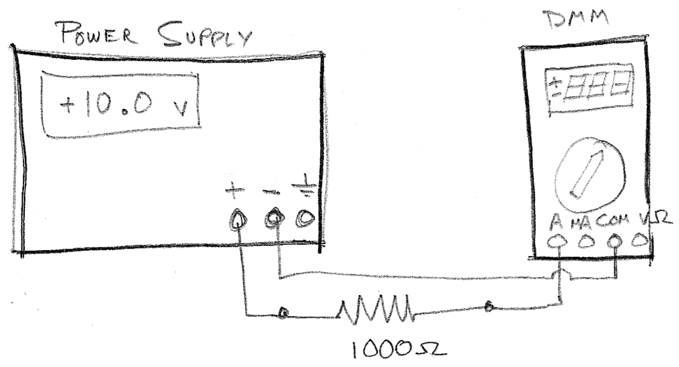

> Diagram your circuit (without the DMM)

> Record the Current reading and indicate your measured current with a directional arrow on the circuit.

> Compare the reading to expected current from Ohm’s Law. What is the current error if you use the measured vs specified (1000 Ohm) resistance?

* 1. Change the voltage to {5.0V, 2.5V, 0.2V}
  2. > Record the current in each case and graph voltage (Y axis) vs. Current (X axis). Label your graph with units.
  3. > Fit a line to your data and compute its slope. Compare with 1000 Ohms.

1. **Parallel Resistors**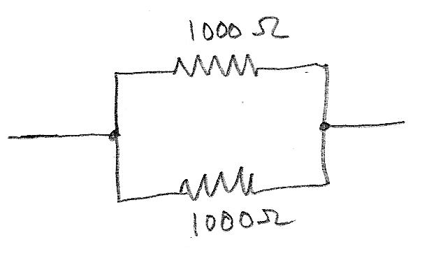
   1. Connect two 1000 Ohm resistors in parallel (connect the two resistors at both ends) with alligator clips or simply twist them together, connect them between +10V DC and GND   
      > what is power supply current readout?
   2. Set up your DMM for current measurement. Plug red lead into **“A”** (see instructions/diagram, 1.5/1.6, above)
   3. Measure the current between the power supply ground and the pair of resistors (i.e. total current of both resistors).
   4. Reconnect resistors and DMM as necessary to measure voltage across the two resistors, and the current in each resistor separately.   
      > record your measurements.  
      > compare your measurement with sum of the two resistor currents.
   5. > Use Ohm’s law to find the equivalent resistance of the two resistors in parallel.
   6. Disconnect the resistors from the power supply and use the DMM in Resistance mode to measure the resistance of the two resistors in parallel.   
      > Compare measured resistance with result from part 2.5
   7. > Diagram the circuit and label all voltages and currents.
   8. > Verify that each resistor follows Ohm’s Law. i.e. For each resistor, measure the voltage between the two ends and the current goes through it, then plug it into the formula.
2. **Series Resistors**
   1. Connect the 1000 Ohm and 500 Ohm resistors in series (connect only one end)
   2. Set your DMM to **current mode** and plug the red lead to **A** accordingly.
   3. Open the circuit at three points and measure the current at each gap:
      1. Power supply ground connection
      2. Connection between the two resistors
      3. Power supply positive connectionR
   4. > Use your DMM in Resistance mode to measure the resistance of the two series connected resistors.
   5. > Diagram the circuit and label all voltages and currents.
   6. > Verify that each resistor follows Ohm's Law.

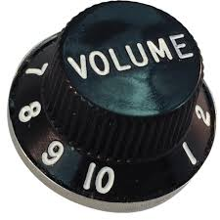

1. **Voltage Dividers**

Voltage dividers are an important and very useful circuit to scale a voltage (signal) by a factor between 0 and 1.0. The most famous application of voltage dividers is an audio volume control.

* 1. Connect 1000 Ohm and 500 Ohm resistors in series.
  2. The 1000 Ohm resistor should connect to +5V, the 500 Ohm resistor should connect to GND
  3. > Measure and record the voltage between ground and:
     1. Ground (should be 0.0!!)
     2. Junction between the two resistors
     3. > compare voltage measured in 4.3.2 to prediction of voltage divider equation.
     4. Power (should be 5.0V!!)
     5. Compare your measurement with predicted voltage divider output voltage
  4. Connect a second 1000 Ohm, “load” resistor between your voltage divider output (junction between 1000 + 500 Ohm resistors) and ground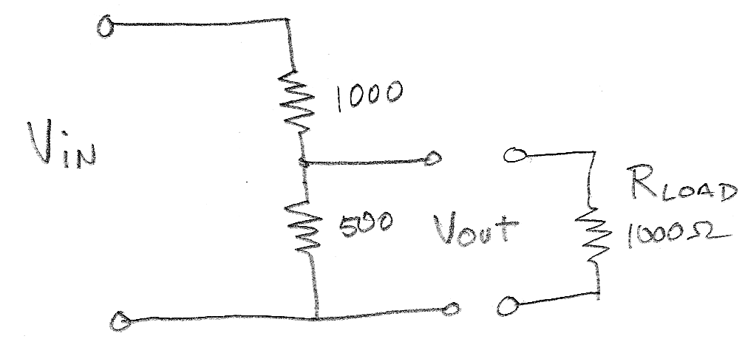
  5. > Measure current in the load resistor and voltage across the load resistor.
  6. > Explain why this voltage divider does not follow the 4.3.2 voltage prediction now that a load resistor has been added

1. **Arduino – Blink a LED**
   1. Open the ‘SIK Guide‘ book of your Arduino Starter Kit. Go to page 21 and finish Circuit 1 – ‘Blinking a LED’

* 1. > After you finish the circuit. Ask a TA to check it.