Solution Architecture Document (SAD) — Confidant
Product: Confidant — Sovereign AI Sandbox
Version: 2.0 · Date: 2026-07-19 · Status: Deployed & acceptance-tested
Environment: Azure subscription goneset (0f94670d-1eff-45a0-a2f8-8215eb135886), West Europe
Related docs: SPEC.md · HANDOFF.md · ARCHITECTURE.md · DOCS_UPDATE_TRACE.md

1. High-Level Solution Overview

1.1 Purpose
Confidant lets a provider (clinic, bank, advisory firm) hand a single client a private, disposable AI workspace tied to a specific document and to the provider's expertise. The client reads the document and asks a local AI model questions; no data is ever sent to an external LLM provider, and the entire workspace is destroyed when the engagement ends.

1.2 Business value
Driver | How Confidant delivers
Data sovereignty as a sellable promise | The model runs on an isolated VM with no outbound internet; the VM is provably destroyed. The pitch is physical, not just contractual.
Regulated-industry fit | Health/finance clients who cannot feed documents into public AI get an auditable, in-tenant alternative.
Client-facing self-service | A client answers their own questions 24/7 against the exact document and the provider's knowledge base, reducing back-and-forth.
Demand intelligence | The provider gets a persistent, anonymized dashboard of what clients actually worry about — sharpening sales and service — without seeing personal data (unless the client opts in).

1.3 Core objectives
- Sovereign inference — 100% local model per engagement; no external LLM egress.
- Ephemerality — one VM per client; automatic hard-deletion on session close or 15-minute inactivity.
- Persistent, privacy-preserving insight — high-level topic analytics survive VM destruction; personal content only with explicit consent.
- Cost control — near-zero idle cost; sandboxes billed only while a client is active; one-command teardown.
- Fast, self-service UX — invite → verify → read/ask/download in minutes.

1.4 Scope (v2)
In: single-client PDF sandboxes (≤200 pages), local RAG Q&A with citations, document view/download + conversation-summary appendix, consent-based sharing, anonymized provider dashboard, full spin-up/tear-down automation.
Out (v2): multi-client rooms, persistent provider identity across sandboxes, GPU inference, mobile-native apps, custom-domain/branded email (deliverability open item).

2. Technical Architecture

2.1 Topology — two planes
A persistent control plane (cheap, always-on) orchestrates and outlives many ephemeral sandboxes (one per client engagement).
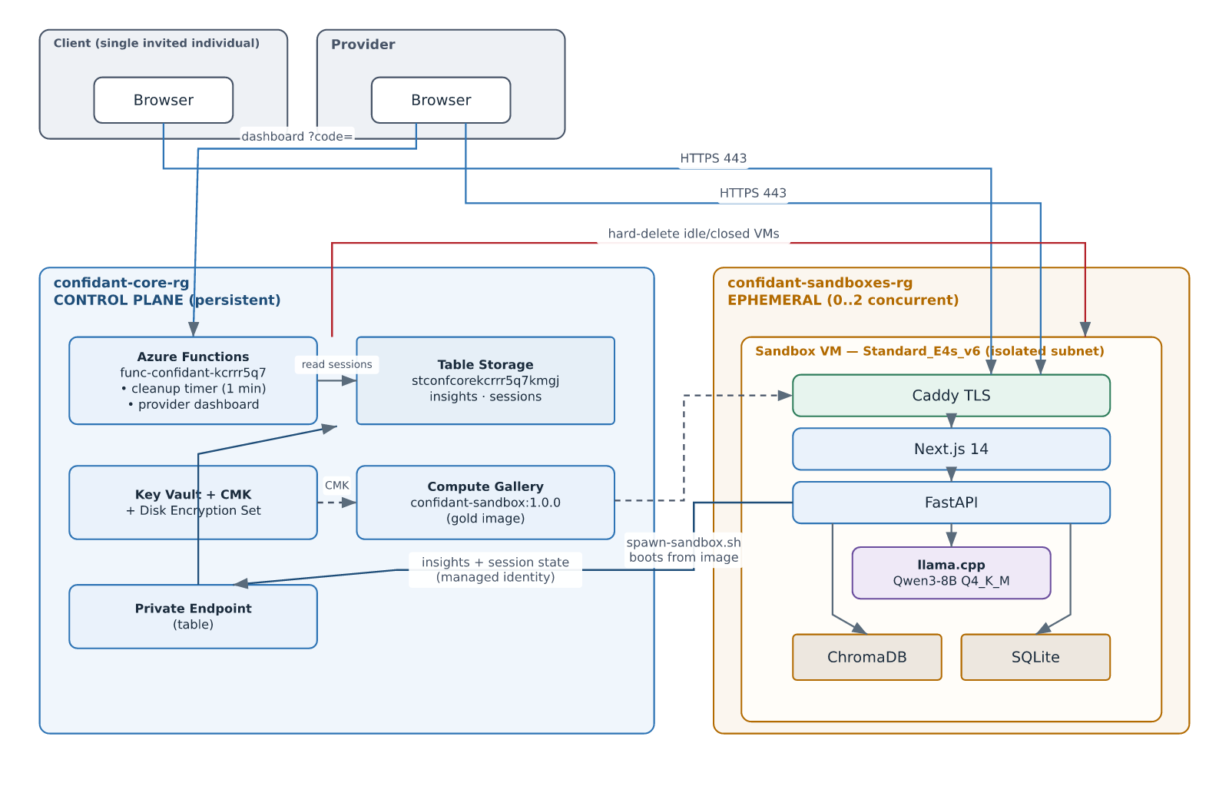

2.2 Cloud infrastructure inventory
Plane | Resource | Name / SKU | Role
Control | Resource group | confidant-core-rg | Persistent platform
Control | Storage + tables | stconfcorekcrrr5q7kmgj (Standard_LRS; tables insights, sessions) | Analytics + session state; Entra-RBAC-only (shared-key disabled)
Control | Private endpoint + DNS | pe-...-table + privatelink.table.core.windows.net | In-VNet table access
Control | Function app | func-confidant-kcrrr5q7 (Linux Y1, Python 3.12, system MI) | Cleanup timer + dashboard
Control | Key Vault / key / DES | kv-conf-kcrrr5q7kmgj / cmk-gallery (RSA-3072) / des-confidant-gallery | Customer-managed encryption
Control | Compute Gallery | confidant_gallery/confidant-sandbox:1.0.0 (Gen2, CMK) | Gold master image
Control | VNet | vnet-confidant-core 10.20.0.0/16 (snet-sandbox, snet-endpoints) | Network isolation
Sandbox | Resource group | confidant-sandboxes-rg | Holds live sandboxes (empty when idle)
Sandbox | VM (per client) | vm-confidant-<id> — Standard_E4s_v6 (4 vCPU/32 GB), CMK Premium OS disk deleteOption: Delete | Runs the whole app + local model
Sandbox | NSG | nsg-sandbox | Inbound 443 only; outbound denied except DNS+ACME
Landing | Resource group | confidant-landingpage-rg | goneset-swa + confidant-acs
Legacy | Resource group | confidant-rg | confidant-email (unmovable EmailServices)

2.3 Application stack (inside each sandbox)
Layer | Technology
Reverse proxy / TLS | Caddy 2 (automatic ACME on the VM FQDN)
Frontend | Next.js 14 · TypeScript · Tailwind (built same-origin)
Backend | FastAPI · Python 3.12 · SQLAlchemy
Vector store | ChromaDB (persistent, local) · all-MiniLM-L6-v2 embeddings
LLM runtime | llama.cpp server · Qwen3-8B Q4_K_M GGUF · -t 4 --mlock --ctx-size 8192
Relational store | SQLite (rooms, members, documents, audit, qa_insights, session_activity)
Doc processing | pypdf (extraction + page count) · reportlab (appendix)
Auth | JWT (provider) · URL-safe session tokens (client)

2.4 Third-party / platform integrations
- Azure Communication Services (confidant-acs + confidant-email) — verification-code email (azure-communication-email). Deliverability is an open item.
- Azure Table Storage — insights + session mirror via azure-data-tables + DefaultAzureCredential (managed identity).
- Azure Compute Gallery + CMK — immutable, encrypted gold image; no runtime weight fetches.
- Optional external LLM — Anthropic API or OpenAI-compatible Foundry endpoint via config switch (not the default).

3. Data Flow & System Integration

3.1 Engagement lifecycle (spawn → destroy)
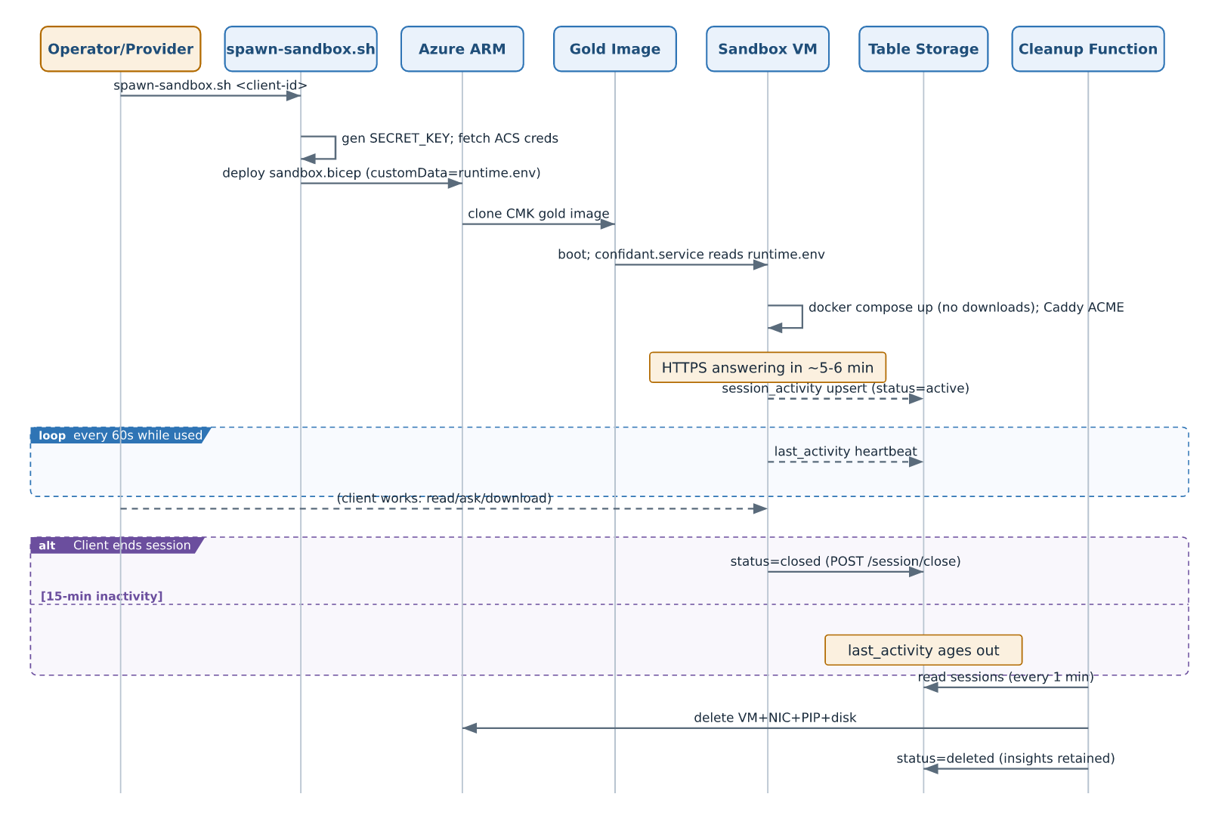

3.2 Q&A request flow (fully local)
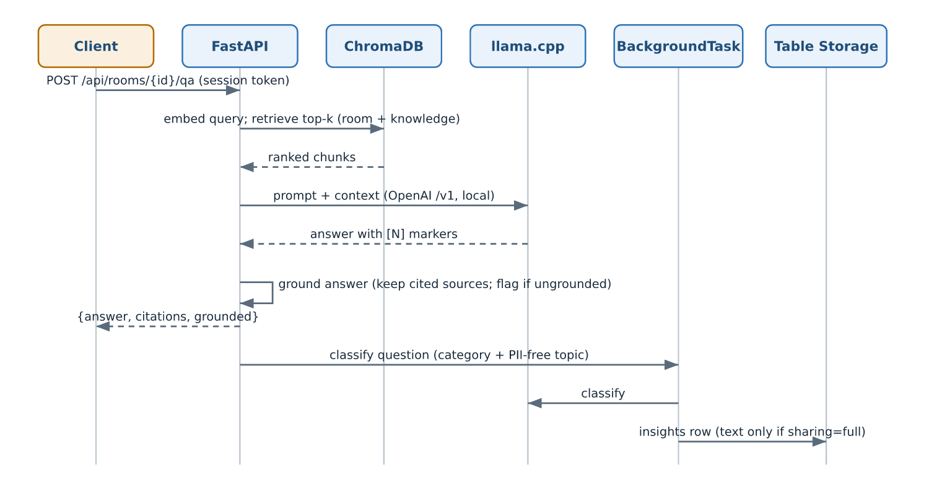

3.3 Communication protocols & endpoints
- Client/Provider ↔ Sandbox: HTTPS 443 only (Caddy TLS). REST/JSON; multipart for uploads; PDF blob for file downloads.
- Sandbox ↔ Table Storage: HTTPS via private endpoint, DefaultAzureCredential (managed identity), no keys.
- Provider ↔ Dashboard: HTTPS to Function app, function-key (?code=) protected.
- Intra-VM: Docker bridge network; backend ↔ llama.cpp over http://llamacpp:8080/v1.
- Key REST endpoints: see SPEC.md §3; dashboard: GET /api/dashboard, GET /api/dashboard-data.

3.4 Data classification & residency
Data | Store | Residency | Lifecycle
Document (PDF), vector index, chat | Sandbox VM disk (SQLite/Chroma/fs) | On VM only | Destroyed with VM
Anonymized topic + category | Table insights | Control plane (West Europe) | Persists
Full question/answer text | Table insights | Control plane | Persists only if client opted into full sharing
Session heartbeat/state | Table sessions | Control plane | Persists (marked deleted)
Model weights | Gold image (CMK) | Azure tenant | Immutable

4. UX & Functional Architecture

4.1 End-to-end user journeys
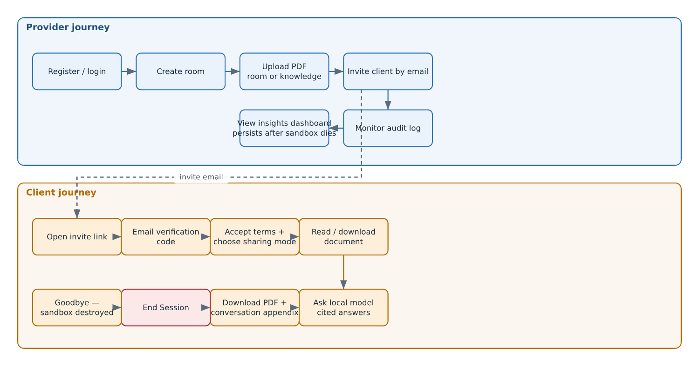

4.2 Interface map (routes → purpose → backend triggers)
Surface | Route | User action → backend event
Landing | / | Marketing; entry to login
Provider auth | /login | register/login → JWT
Provider dashboard | /dashboard | list/create rooms; link to /insights
Room mgmt | /dashboard/rooms/[roomId] | upload PDF (POST .../documents), invite (POST .../invites), audit (GET .../audit)
Insights | /insights | GET /api/insights → charts
Client join | /join/[token] | verify (/verify,/confirm) → accept + sharing (/accept)
Client room | /room/[roomId] | view/download (.../file[?with_appendix=1]), ask (/qa), change sharing (/sharing-mode), end (/session/close)
Provider (control plane) | Function /api/dashboard | server-rendered analytics HTML

4.3 Key interaction patterns
- Document viewer: auth'd fetch → blob → object URL → <iframe> (headers can't ride an iframe src).
- Sharing consent: two-radio step at accept; anonymized default; discreet in-chat toggle; every change audited.
- End Session: explicit button (confirm → goodbye screen) and navigator.sendBeacon on pagehide (survives CORS preflight via text/plain).
- Sovereignty signaling: persistent "Local model · qwen3-8b — data never leaves the sandbox" badge.
- Charts: plain SVG/Tailwind (no charting library), light/dark friendly.

5. Non-Functional Requirements (NFRs)

5.1 Security
Control | Implementation
Network isolation | Sandbox NSG: inbound 443 only; outbound denied except Azure DNS + ACME; VM↔VM blocked
No external LLM egress | Local llama.cpp; weights baked into image; no runtime fetches
Encryption at rest | CMK (Key Vault RSA-3072) on gold image + sandbox OS disk; TLS 1.2 + HTTPS-only storage
Storage data plane | Entra-RBAC only (allowSharedKeyAccess=false); managed identity; private endpoint for in-VNet
Least-privilege RBAC | Function MI scoped to VM/Network Contributor on sandboxes RG + Table Data Contributor on core storage
Auth | JWT (provider, bcrypt passwords, password policy); URL-safe session tokens with TTL (client)
Input hardening | PDF-only + size/page caps; filename sanitization; rate limiting; code TTL + attempt cap + one-time use
Secrets | Per-sandbox SECRET_KEY generated at spawn; injected via cloud-init; never baked into the image
Auditability | Append-only audit log (views, downloads, questions, governance, session close)

5.2 Availability & resiliency
- Sandbox: single-VM, single-user, ephemeral by design — no HA target; failure → re-spawn (~5–6 min from gold image).
- Control plane: Azure Functions + Table Storage (LRS) managed availability; cleanup timer is idempotent and self-healing (missed runs caught next minute; VM-absent → mark deleted).
- Insight durability: analytics mirrored off-VM before destruction; survive sandbox loss.
- Cost-safety: automatic destruction bounds runaway spend even if a client abandons a session.

5.3 Performance
Metric | Target / observed
Spawn → HTTPS answering | ~5–6 min (no runtime downloads)
Q&A latency (local, 4 vCPU) | ~8 tok/s generation; ~25 s for a cited multi-part answer (observed in e2e)
Cleanup latency | ≤ ~90 s after session close (1-min timer + delete)
Document limits | PDF ≤ 200 pages, ≤ 50 MB

5.4 Scalability
- Concurrency: max 2 sandboxes today (10-vCPU regional cap ÷ 4 vCPU); raise via quota.
- Horizontal model: one VM per client — scales by spawning more, not bigger; naturally multi-tenant-isolated (no shared runtime).
- Upgrade levers: GPU SKU (NCASv3_T4) for faster/larger models; E4ds_v6 ephemeral-OS-disk variant; larger gold-image model versions published as new gallery versions.

5.5 Cost (West Europe, approx.)
State | Cost
Control plane idle | ~€7.5/mo (private endpoint €6.8; rest <€1) — or ~€0.7/mo without the PE
Active sandbox | ~€0.29/h (VM + Premium disk + PIP), billed only while alive
Fully torn down | €0 (rebuild from infra/v2/)

5.6 Maintainability & operability
- IaC: Bicep (control plane + sandbox template) + parameterized bash "buttons"; OPERATIONS.md runbook.
- Immutable images: app + model shipped as a versioned gallery image; config injected at boot.
- Observability: Function invocation logs; VM az vm run-command for triage; append-only audit log per sandbox.
- Docs: SPEC (what/why), SAD (this), ARCHITECTURE (app internals), HANDOFF (pickup), DOCS_UPDATE_TRACE (history).

5.7 Compliance & privacy posture
- Data minimization: personal content persists off-VM only with explicit opt-in; default is anonymized categories/topics with PII excluded by the classifier prompt.
- Right-to-erasure alignment: engagement data is destroyed by construction at session end.
- Residency: all processing and persistence in West Europe.
- Open compliance items: email deliverability (SPF/DKIM/branded domain), application-level (not cryptographic) audit immutability, legal review of terms.

End of SAD v2.0.

