Calculator

Producer: Groza Ionut
Professor: Lupea Mihaiela
Implementation: Python Programming Language

Content

- Problem Statement

- Subalgorithm’s diagram

- Used data types

- Specification and pseudocode for algorithms

- Tests and test data

Problem Statement

  - Build an application that performes arithmetic operations for integers: addition, subtraction, multiplication and division by one digit, in a base p∈{2,3,...,9,10,16}

Subalgorithm’s diagram

n – number of digits in the greatest number
carry – we start with an initial carry equal to 0
p – representing the power of ten, used in concatenating digits to form a number; initially it has the value 1
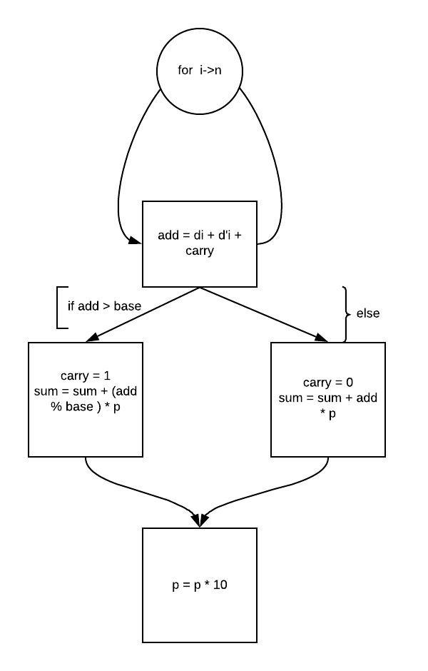
Used data types

The data types are:
Lists- for representing the numbers and the result (number1, number2, _sum)
strings- for representing the digits in a list ( [‘6’, ‘3’, ‘3’,’0’])
integer- for representing the base
dictionary- for representing the digits in base 16 and their correspondant in base 10 and viceversa
ex:
digits = {
'A':10,
'B':11,
'C':12,
'D':13,
'E':14,
'F':15
}

digits = {
10:'A',
11:'B',
12:'C',
13:'D',
14:'E',
15:'F'
}

Specification and pseudocode for algorithms
ADDITION:
- def addition(base, number1, number2):
- # adds two numbers in a certaine base
- _sum = [] # sum will be computed as a vector with entities representing its digits
- carry = 0 # we need a carry in case of adding two letter which have a sum greater or equal than the base. in this case, carry will be set to 1
- n = len(number1) # the length of the first number( since the two numbers are equal in length as a consequence of filling the smallest number wit non-significat zeros)
- for i in range(n):# parse the vectors representing the digits of the two numbers, in reverse order
- digit1 = get_digit_base_10(number1[i])# if the symbol of the digit is a leeter from base 16 digits, it will be converted in base 10
- digit2 = get_digit_base_10(number2[i])#
- add_in_10 = carry + digit1 + digit2# we perform addition in base ten between the two digits
- if add_in_10 >= base:# if the sum of the two digits is greater or equal to the base
- carry = 1# set carry to one
- digit = add_in_10 % base # get the actual digit of the actual sum
- else:# otherwise
- carry = 0# we set the carry to it's initial value, 0
- digit = add_in_10# and the digit of the actual sum does not need to be modified
- if base > 10 and digit > 9:# if the digit is a number representing a digit in base 16
- digit = turn_digit(digit)#we convert it into a letter symbol
- _sum.append(str(digit))# and add it as a valid digit of the actual sum
- _sum.append(str(carry))# if the last operation provides a set-to-1 carry we wiil consider it as the last digit of the actual sum
- _sum.reverse()# we reverse the digit to get the sum, because we performed operation starting from the last digits of the numbers
- return _sum# finally return the sum

Pseudocode:
- for i->n
- | add <- di + d'i + carry
- | if add > base
- | | carry <- 1
- | | sum <- sum + (add % base ) * p
- | | else
- | | | carry <- 0
- | | | sum <- sum + add * p
- | | |_()
- | |_()
- |_()

SUBTRACTION
- def subtraction(base, number1, number2):
- #subtract two numbers in a certain base
- carry = 0# start with an initial carry of value 0
- _sub = []# the subtraction of the two numbers will be hold in a list
- n = len(number1)# get the length of the numbers, equal as number of digits
- for i in range(n):# parse the numbers
- digit1 = get_digit_base_10(number1[i])# making sure there are actually digits and not letters from the repres in base 16
- digit2 = get_digit_base_10(number2[i])
- sub_in_10 = carry + digit1 - digit2# subtract the two digits and add the carry which can be -1 in case of "barrow"
- if sub_in_10 < 0:#if the subtraction of the digits provided a negative value
- carry = -1# it means we have to barrow from a higher level digit in our number and set carry to -1
- digit = base + sub_in_10# # get the actual digit in the final value
- else:# otherwise set carry to 0
- carry = 0
- digit = sub_in_10# and add the digit as it is
- if base > 10 and digit > 9:
- digit = turn_digit(digit)# making sure first, if it is a digit in base sixteen, to represent it with the proper symbol
- _sub.append(digit)
- _sub.reverse()# reverse the digits to get the final value
- return _sub

Pseudocode

- for i->n
- | digit<- carry + di - d'i
- | if digit < 0
- | | carry <- -1
- | | sub <- sub + (base + digit) * p
- | | else
- | | | carry <- 0
- | | | sub <- sub + digit * p
- | | |_()
- | |_()
- |_()

MULTIPLICATION:

- def multiplication(base, number1, number2):
- #multiplicate a number with a digit in a certain base
- _prod = []# product will be hold in a list
- carry = 0# start with an initial carry
- n = len(number1)# get the length of the number
- digit2 = get_digit_base_10(number2[0])# making sure that the digit we multiply with is in base ten, since the operation will be in base ten
- for i in range(n):# parse the number's digits
- digit1 = get_digit_base_10(number1[i])
- mul_in_10 = carry + digit1 * digit2# multiply the digit and number2 in base ten
- carry = mul_in_10 // base# carry will get the value of the integer division between the product and the base
- digit = mul_in_10 % base# the actual digit will get the value of the remainder of the division
- if base > 10 and digit > 9:
- digit = turn_digit(digit)# making sure we have the correct representation symbol
- _prod.append(digit)# append the digit to the final product
- _prod.append(carry)# append the carry as well
- _prod.reverse()# reverse to get the actual value
- return _prod

Pseudocode

- for i->n
- | digit<- carry + di * d'i
- | carry = digit div base
- | mul = mul + (digit mod base) * p
- | p = p * 10
- |_()

DIVISION:
- def division(base, number1, number2):
- #divides two values in a certain base
- number1.reverse()# reverse the reversed number to get the initial one
- divisor = get_digit_base_10(number2[0])# convert the divisor into base 10 because the operation will be made in base 10
- quotient = []# the quotien will be hold into a list
- remainder = 0# remainder is 0 at first
- group = []# we need to divide a group of two digits if the divisor is greater than just one digit
- digit1 = get_digit_base_10(number1[0])#checking that case; it can happen only with the first letter
- if digit1 >= divisor:# bc after this it will get the value of the remainder
- div_in_10 = digit1 // divisor# of the division between the group and the divisor
- group.append(digit1 % divisor)#which is less then the divisor
- if base > 10 and div_in_10 > 9:
- div_in_10 = turn_digit(div_in_10)
- quotient.append(str(div_in_10))# finally add it to the quotient and continue with thw remaining digits
- else:#otherwise just add it to the quotient
- group.append(str(digit1))
- n = len(number1)
- for i in range(1, n):# since we have already manage to deal with the first letter we start cotinue with the second one
- digit1 = get_digit_base_10(number1[i])
- group.append(digit1)# getting that two digits group
- newnr = convert_to_ten_list(base, group)# convert it into base 10
- div_in_10 = newnr // divisor# do the division
- newnr = newnr % divisor# save the remainder
- remainder = str(newnr)# which in the end will be the final remainder
- if base > 10 and div_in_10 > 9:
- div_in_10 = turn_digit(div_in_10)
- quotient.append(str(div_in_10))# add the result of the division into the quotient
- group = []# clear the group
- group.append(newnr)# and add to it the remainder
- if base > 10 and int(remainder) > 9:
- remainder = turn_digit(int(remainder))# finaly making sure of the correct representation in any base
- quotient = get_string(quotient, None)
- return [quotient, remainder]# and return the quotient and the remainder

Tests and test data
ADDITION:
- def test_addition():
- number1 = ['6', '3', '4', '1']
- number2 = ['6','5', '0', '0']
- base = 7
- add = addition(base, number1, number2)
- string = get_string(add, addition)
- assert(string == '1525')
- number1 = ['F', '6', 'B', 'A', '4', '5']
- number2 = ['D', '7', '9', '0', 'D', 'C']
- base = 16
- add = addition(base, number1, number2)
- string = get_string(add, addition)
- assert (string == '121B4EC')

the data for the test are lists of string, representing the numbers with their digits in reverse order.
The smallest number is filled with 0 until it gets the same number of digits as the larger one.
number1 = ['6', '3', '4', '1'] # 1436(7) +
number2 = ['6','5', '0', '0'] # 56(7) =
# 1525(7)

SUBTRACTION:

- def test_subtraction():
- number1 = ['6', '3', '4', '1']
- number2 = ['6', '5', '0', '0']
- base = 7
- sub = subtraction(base, number1, number2)
- string = get_string(sub, subtraction)
- assert (string == '1350')
- number1 = ['4', '5', '3', '0', '1', '2']
- number2 = ['6', '6', '4', '5', '5', '0']
- base = 7
- sub = subtraction(base, number1, number2)
- string = get_string(sub, subtraction)
- assert (string == '121555')

the data for the test are lists of string, representing the numbers with their digits in reverse order.
The smallest number is filled with 0 until it gets the same number of digits as the larger one.
number1 = ['6', '3', '4', '1'] # 1436(7) +
number2 = ['6','5', '0', '0'] # 56(7) =
# 1350(7)

MULTIPLIACATION:
- def test_multiplication():
- number1 = ['5', '4', '3', '2', '1']
- number2 = ['5', '0', '0', '0', '0']
- base = 6
- mul = multiplication(base, number1, number2)
- string = get_string(mul, multiplication)
- assert (string == '111101')
- number1 = ['4', 'F', '3', '2', 'A']
- number2 = ['B', '0', '0', '0', '0']
- base = 16
- mul = multiplication(base, number1, number2)
- string = get_string(mul, multiplication)
- assert (string == '6F8B7C')

the data for the test are lists of string, representing the numbers with their digits in reverse order.
The smallest number is filled with 0 until it gets the same number of digits as the larger one.
number1 = ['5', '4', '3', '2', '1']# 12345(6) *
number2 = ['5', '0', '0', '0', '0']# 5(6) =
#111101(6)

DIVISION:
- def test_division():
- number1 = ['1', '0', '1', '0', '2']
- number2 = ['2', '0', '0', '0', '0']
- base = 6
- div = division(base, number1, number2)
- assert (div == ['10030', '1'])
- number1 = ['6', '8', 'F', '0', 'A', '2']
- number2 = ['E', '0', '0', '0', '0', '0']
- base = 16
- div = division(base, number1, number2)
- assert (div == ['3011B', 'C'])

the data for the test are lists of string, representing the numbers with their digits in reverse order.
The smallest number is filled with 0 until it gets the same number of digits as the larger one.
number1 = ['6', '8', 'F', '0', 'A', '2']#2A0F86(16) /
number2 = ['E', '0', '0', '0', '0', '0']# E(16) =
#Q: 3011B(16) r: C(16)

