Programming with C/C++

Academic year: 2024-2025, Fall semester

Programming assignment

Battle C

Student name: Gert-Jan Kuijsten
Student number: 2104680

Overview of project results

In this project, I aimed to develop a functional Battleship game with human and AI players. To achieve this, key features such as ship placement, shooting mechanics, and an intelligent AI opponent were implemented.

To keep it clear, I divided the project into two main components which are the board and the players. The board class manages the game state where ships are placed and shots are fired. Each cell on the board tracks whether it contains a ship or not, and it updates with either a hit or a miss after each shot. The player class handles the actions for both the human and the AI (A. Smith). For the human player, it allows manual input, while for the AI, I implemented a hill climbing algorithm that enables the AI to select the next cell to shoot at, based on the results of previous moves. Initially, the AI makes random moves, but once it hits a ship, it starts searching the surrounding cells, increasing the likelihood to find the rest of the ship.

There were a few challenges while developing the game. One of the most difficult aspects was to implement the hill-climbing algorithm to make the AI intelligent in its decision-making. I have never used a hill-climbing algorithm before, so I had to figure out how to do it first. Additionally, validating player inputs and ensuring that ships were placed correctly on the board, without overlap or out-of-bounds errors, was a bit tricky. It took a lot of time to debug the code and find out what code was creating errors and why it created errors. Another challenge was ensuring that hits, misses and ships that were destroyed were updated correctly on the player’s board. I did not try to implement Salvo mode and Fog of war due to time shortage.

I started coding in one file, but I soon noticed that this became very confusing, so I divided it in three cpp files. One for the Board class (with header), one for the Player class(with header), and then one main file to serve as the orchestrator between the files. I also put the constant numbers in a header file, which made it more clear.

My idea was to get the game functional first, so I started with coding tasks 1-2, as these provide the basis of the game. After I did these tasks, I started with task 3 to implement turn-taking. I did this first without implementing an AI, but used a second human player, but that was kind of confusing and therefore, I started learning how to implement the AI using a hill-climbing algorithm.

Tasks and objectives
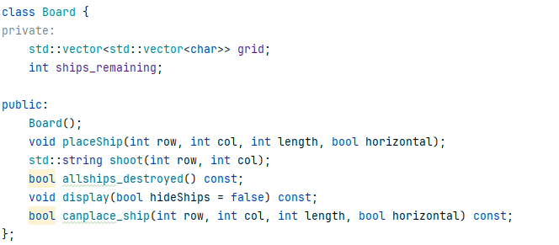
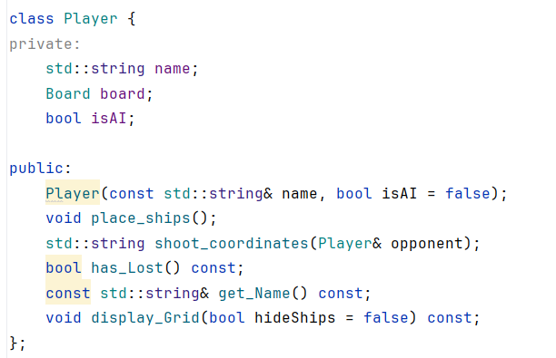

(see image above):
To create the boards, I used a Board class that manages ship placement and maintains the board. On the board empty cells are represented as ‘~’, ships as ‘S’, and hits as ‘X’ or ‘O’. The Board class contains functions with which the players can place a ship or shoot their shot. It also has functions to display the board(with or without ships), check if all ships are destroyed, and a function to check if the ship can be placed on the given coordinates.

The Player class handles all the functionalities of the player(human or AI). It is responsible for storing and managing the player’s name, type (AI or human), and the game board of the players. The player class contains with which the players can place their ships, shoot at the opponent’s board, and check if a player has lost. The function display_Grid allows players to
view their own boards with or without ships.

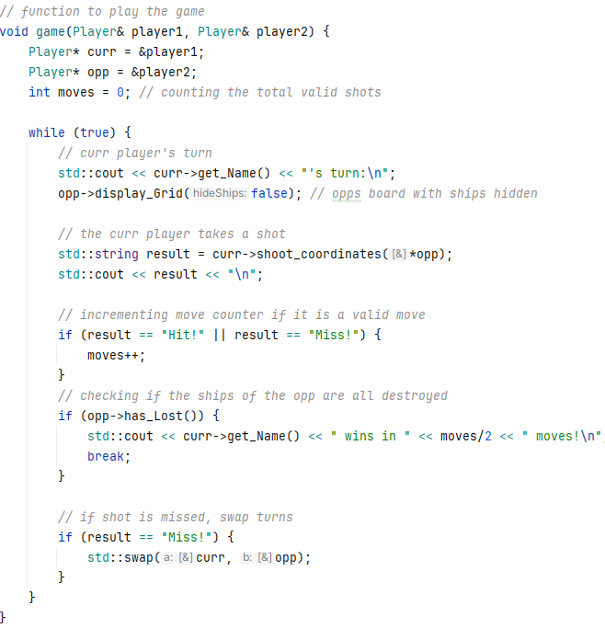
(see image on the right):
The Game function takes care of the turn taking
between the players, tracking the number of moves,
and checking the win conditions. When a ship is
missed, the turns are swapped. The game continues
until one of the players sinks all their opponent’s ships,
which is a victory. The game enters a loop where each
player take turns to shoot at the opponents board.
After each shot, the result is displayed(Hit! Or Miss!) and
the move counter gets incremented with 1. The function
checks if all of their ships have been sunk. If so, the
player gets declared the winner, and the game ends. If
the shot was miss, the turns are swapped, and the
opponent can take a shot. The loop continues until one
player wins and the total valid moves are printed.

(see image below):
To make the AI smart I used a hill-climbing algorithm that is defined in the shoot_coordinates function. The AI starts by randomly selecting a unvisited cell to shoot at on the opponent’s board. It keeps track of already visited cells by updating ‘visited_cell’. Once the AI hits a ship, the hill climbing algorithm gets triggered and the AI focuses on neighboring cells to continue attacking the same ship. To determine the best neighboring cells to shoot at, I created a function called heuristic_func (see image) that assigns a score to each neighboring cell based on how many unvisited neighbors it has. The score gets incremented for each neighboring cell that hasn’t been visited yet. This comes from the idea that a cell with more unvisited neighboring cells is more likely to be part of a larger ship. Once the best neighbor is selected, the AI shoots at the corresponding cell and marks it as visited(adding it to visited_cell). If the AI hits the ship again, it continues the process of finding new neighboring cells to attack(following the hill climbing path). If the AI cannot find any valid neighboring cells after hitting a ship or if it runs out of new unvisited cells to attack, it goes back to randomly selecting a new unvisited cell. This process continues until one of the players wins.
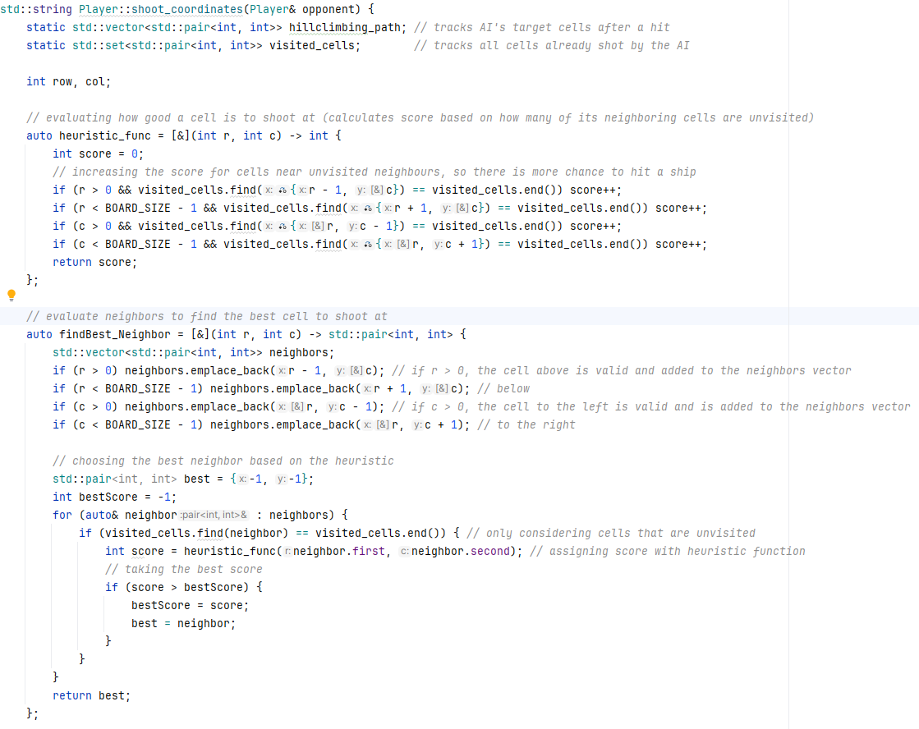

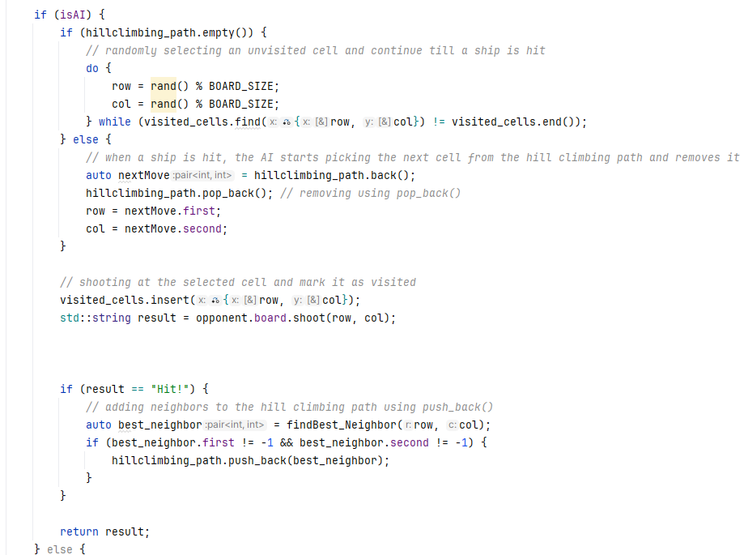

Challenges

Challenges solved | Solved | Not solved
Implementing an intelligent AI using hill climbing | I searched for information about hill climbing algorithms online and watched videos about people implementing it. I created two other functions to use: heuristic_func and findBest_neighbor. I combined these to implement the strategic decision making in the AI. | -
Validating player inputs and ensuring that ships were placed correctly on the board, without overlap or out-of-bounds errors | By checking if the coordinates of the shot or ship are valid, including orientation and length of the ship, board size and occupied cells. If the input is invalid, a prompt will be triggered and the player can re-enter their input. | -
Ensuring that hits, misses and ships that were destroyed were updated correctly on the player’s board. | Each cell is represented by a state: Hit (X), Miss (O), Empty (~), Ship (S). When a player takes a shot, the code determines whether the cell contains a ship or is empty. If it is a hit, the cell gets marked as X, if the shot missed, the cell gets marked as O. | -
Implementing Salvo mode |  | Not attempted due to time shortage
Implementing Fog of War |  | Not attempted due to time shortage

Discussion and future work
The game uses an object-oriented approach, meaning everything is organized into ‘objects’ like players, boards and ships. This makes it easier to manage the code and change it if needed. If I used a functional approach, it would involve passing data between independent functions, which is harder to manage.

The code performs well for the functionality of this project. The hill-climbing algorithm for the decision-making of the AI balances runtime performance and complexity effectively, but there is room for improvement. There are areas where efficiency can be improved. For example, the AI’s hill climbing algorithm works well for targeting nearby cells but can be slow in identifying new targets after destroying a ship.
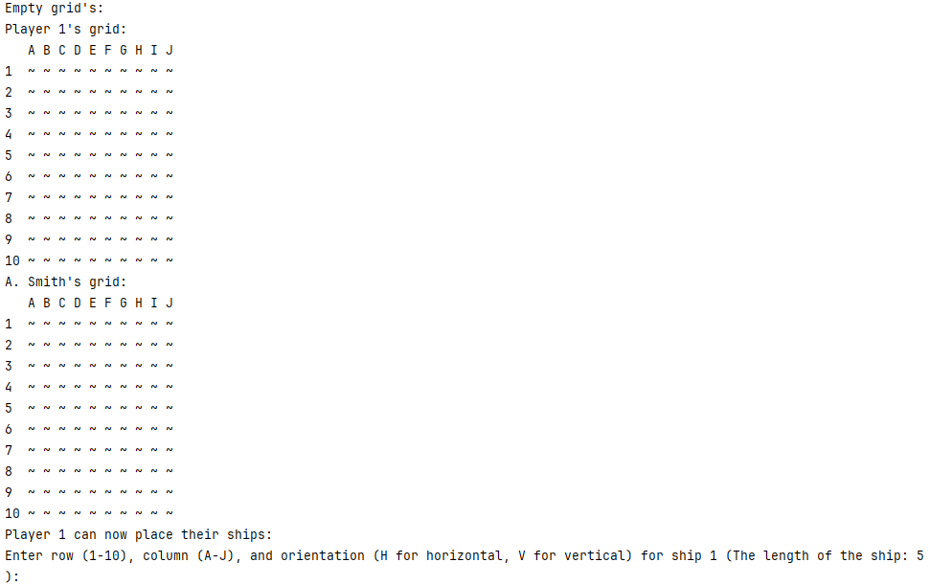
An example of a new feature that could be added is a better interface that makes the game look more appealing and more fun to play, because a text-based interface does not make it look like it is fun to play (see image above). Another example could be features like sound effects for hits, misses, and destroyed ships, or player stats that tracks things like accuracy or how many times this player has won. These ideas would help bring the game to life and make it more attractive to play.

