Syndome AR Intelligence Dashboard Specification

- Parameter
Parameter | Default | SQL
Year  v_in_year | ปีปัจจุบัน | BEGIN  select distinct YEAR(invoice_date)  from ar_invoice  order by 1 desc;  END
Month  v_in_month | เดือนปัจจุบัน | BEGIN  select distinct month(invoice_date), monthname(invoice_date)  from ar_invoice  order by 1;  END

- Chart Query
1.2.1 สรุปการวางบิล
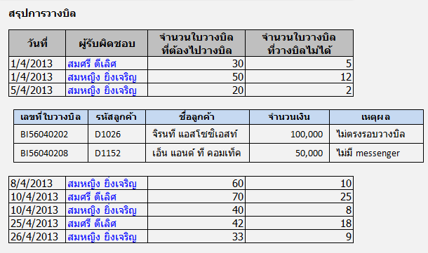
Event | Default | SQL
กดปุ่ม OK |  | bill_summary_list  BEGIN  declare p_unbill_date VARCHAR(20);  set p_unbill_date = '1899-12-30';  select billing_date as bill_date  , person_in_charge  , sum(bill) as total_bill  , sum(unbill) as total_unbill  from  (select billing_date, person_in_charge  ,1 as bill  ,IF(appoint_date='1899-12-30',1,0) as unbill  from ar_bill  where year(billing_date) = v_in_year  and month(billing_date) = v_in_month  ) as bill_summary  group by billing_date , person_in_charge  order by billing_date , person_in_charge;  END  unbill_detail_list  BEGIN  select bill_no  , customer_code  , customer_name  , bill_amount  , bill_remark  from ar_bill  where billing_date = v_bill_date  and person_in_charge = v_person_in_charge  and appoint_date = '1899-12-30'  order by bill_no;  END

1.2.2 สรุปการรับชำระหนี้
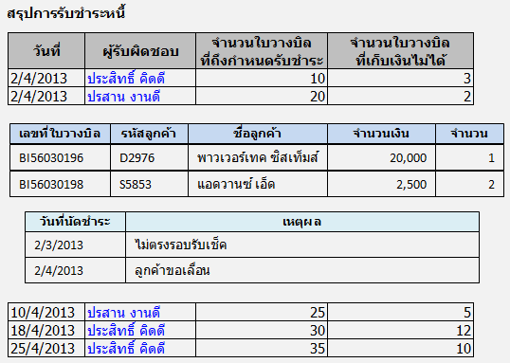
Event | Default | SQL
กดปุ่ม OK |  | dued_bill_summary_list  BEGIN  select appoint_date, person_in_charge  , sum(dued_bill) as total_dued_bill  , sum(uncollected_bill) as total_undued_bill  from  (select appoint_date, person_in_charge  , 1 as dued_bill  ,IF(bill_status = "ยังไม่ชำระ",1,0) as uncollected_bill  from ar_bill  where year(appoint_date) = v_in_year  and month(appoint_date) = v_in_month  ) as dued_bill_summary  group by appoint_date , person_in_charge  order by appoint_date , person_in_charge;  END  uncollected_bill_detail_list  BEGIN  select b1.bill_no  , b1.customer_code  , b1.customer_name  , b1.bill_amount  , (select count(*)  from ar_bill b2  where b2.bill_no = b1.bill_no  ) as no_of_postpone  from ar_bill b1  where b1.appoint_date = v_appoint_date  and b1.person_in_charge = v_person_in_charge  and b1.bill_status = "ยังไม่ชำระ"  order by b1.bill_no;  END  uncollected_bill_remark_list  BEGIN  select appoint_date, bill_remark  from ar_bill  where bill_no = v_bill_no ที่เลือกจาก uncollected_bill_detail_list  order by billing_date;  END

1.2.3 ประสิทธิภาพการวางบิล
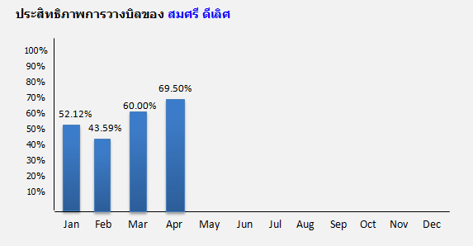
Event | Default | SQL
กดปุ่ม OK |  | bill_performance_chart  BEGIN  select monthname(billing_date)as month_name  , sum(accept_bill)/ sum(bill)*100 as performance_percent  from  (select billing_date  , 1 as bill  ,IF(appoint_date != '1899-12-30',1,0) as accept_bill  from ar_bill  where year(billing_date) = v_in_year  and month(billing_date) <= v_in_month  and person_in_charge = v_pname  ) as bill_performance  group by year(billing_date),month(billing_date)  order by year(billing_date),month(billing_date);  END

1.2.4 จำนวนเงินที่วางบิล
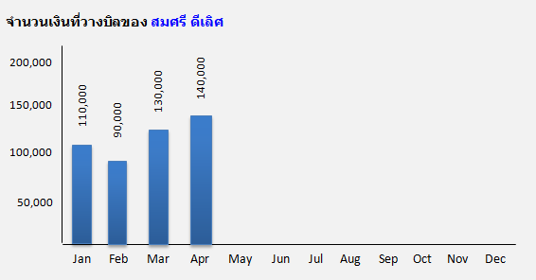
Event | Default | SQL
กดปุ่ม OK |  | accept_bill_chart  BEGIN  select monthname(billing_date) as month_name  , sum(bill_amount) as bill_amount  from ar_bill  where year(billing_date) = v_in_year  and month(billing_date) <= v_in_month  and person_in_charge = v_pname  and appoint_date != '1899-12-30'  group by year(billing_date),month(billing_date);  END

1.2.5 ประสิทธิภาพการเก็บเงิน
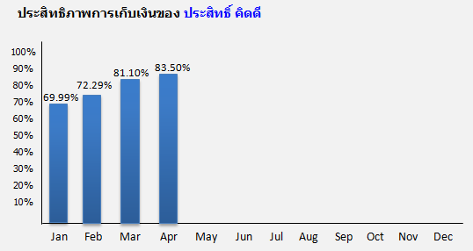
Event | Default | SQL
กดปุ่ม OK |  | collection_performance_chart  BEGIN  select monthname(appoint_date) as month_name  , sum(collected_bill)/ sum(dued_bill)*100 as collection_percent  from  (select appoint_date  , 1 as dued_bill  ,IF(bill_status != "ยังไม่ชำระ",1,0) as collected_bill  from ar_bill  where year(appoint_date) = v_in_year  and month(appoint_date) <= v_in_month  and person_in_charge = v_pname  ) as collection_performance  group by year(appoint_date),month(appoint_date)  order by year(appoint_date),month(appoint_date);  END

1.2.6 จำนวนเงินที่เก็บได้
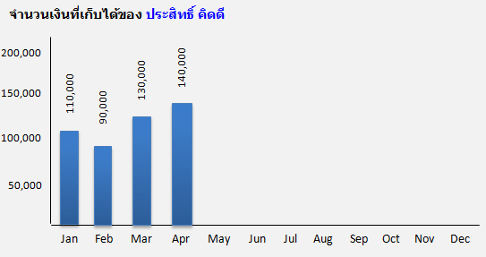
Event | Default | SQL
กดปุ่ม OK |  | collection_chart  BEGIN  select monthname(appoint_date) as month_name, sum(receipt_amount) as receipt_amount  from ar_bill  where year(appoint_date) = v_in_year  and month(appoint_date) <= v_in_month  and person_in_charge = v_pname  and bill_status <> "ยังไม่ชำระ"  group by year(appoint_date),month(appoint_date);  END

1.2.7 AR Ratio
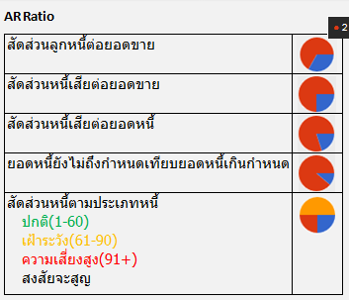
Event | Default | SQL
กดปุ่ม OK |  | ar_ratio  BEGIN  select ratio_id  , ratio_name  , ratio_value1  , ratio_value2  , ratio_value3  , ratio_value4  from ar_ratio_monthly  where ratio_year = v_in_year  and ratio_month = v_in_month  and ratio_id between 1 and 5  order by ratio_id;  END  หมายเหตุ คำต่อไปนี้จะไม่ได้ return มาจาก store procedure ให้เขียนโดย Dashboard  - ปกติ(1-60)  - เผ้าระวัง(61-90)  - ความเสี่ยงสูง(91+)  - สงสัยจะสูญ

1.2.8 Drilldown
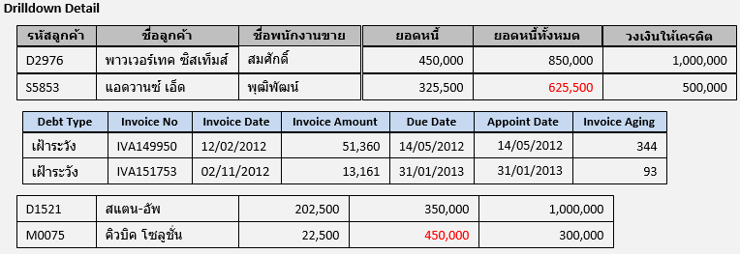
เพิ่ม field
Appoint Date
Event | Default | SQL
กดปุ่ม OK |  | เมื่อคลิกลิ้งค์ใต้สัดส่วนหนี้ตามประเภทหนี้ ที่ไม่ใช่ฟอนต์สีดำ ระบบจะแสดงข้อมูลรายละเอียดลูกหนี้ ประกอบไปด้วยข้อมูลต่อไปนี้  - รหัสลูกค้า  - ชื่อลูกค้า  - ชื่อพนักงานขาย  - ยอดหนี้  - ยอดหนี้ทั้งหมด (ถ้ายอดหนี้ทั้งหมดมากกว่าวงเงินเครดิตให้แสดงเป็นฟอนต์สีแดง)  - วงเงินเครดิต  drilldown_by_customer  select customer_code, customer_name, salesman_name, debt_amount,  total_debt_amount, credit_limit  from ar_snapshot  where snapshot_year = year parameter  and snapshot_month = month parameter  and debt_type = debt type ที่กดเลือก  order by customer_code  debt type ที่ส่งมามีค่าดังนี้  - ปกติ(1-60)  - เผ้าระวัง(61-90)  - ความเสี่ยงสูง(91+)  - สงสัยจะสูญ  drilldown_by_invoice  select debt_type, invoice_no, invoice_date, invoice_amount,  due_date, appoint_date, aging_by_invoice_date  from ar_invoice_snapshot  where snapshot_year = year parameter  and snapshot_month = month parameter  and debt_type = debt type ที่กดเลือก  and customer_code = customer code ที่กดเลือก  order by invoice_no

1.2.9 Debt by invoice aging
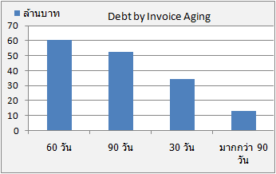
Event | Default | SQL
กดปุ่ม OK |  | debt by invoice aging  select seq,aging,cast(coalesce(debt_amt,0) as decimal(20,2)) as debt_amt  from  (select 1 as seq, '30 วัน' as aging, sum(invoice_amount)-sum(receipt_amount) as debt_amt  from ar_invoice_snapshot  where aging_by_invoice_date <= 30  and snapshot_year = year parameter  and snapshot_month = month parameter  union  select 2 as seq, '60 วัน' as aging, sum(invoice_amount)-sum(receipt_amount) as debt_amt  from ar_invoice_snapshot  where aging_by_invoice_date between 31 and 60  and snapshot_year = year parameter  and snapshot_month = month parameter  union  select 3 as seq, '90 วัน' as aging, sum(invoice_amount)-sum(receipt_amount) as debt_amt  from ar_invoice_snapshot  where aging_by_invoice_date between 61 and 90  and snapshot_year = year parameter  and snapshot_month = month parameter  union  select 4 as seq, 'มากกว่า 90 วัน' as aging, sum(invoice_amount)-sum(receipt_amount) as debt_amt  from ar_invoice inv  where aging_by_invoice_date >= 91  and snapshot_year = year parameter  and snapshot_month = month parameter  ) as aging  order by seq;

1.2.10 Yearly AR Turnover
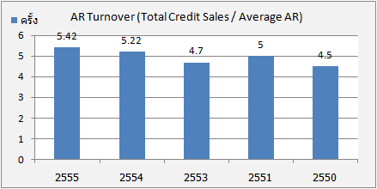
Event | Default | SQL
กดปุ่ม OK |  | yearly_ar_turnover  BEGIN  select ratio_year, ratio_value1/ratio_value2 as ratio_rate  from ar_ratio_yearly  where ratio_year between v_in_year-5 and v_in_year  and ratio_id = 1  order by ratio_year;  END

1.2.11 Yearly AR Collection Period
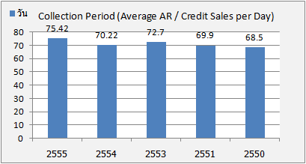
Event | Default | SQL
กดปุ่ม OK |  | yearly_ar_collection_period  BEGIN  select ratio_year, ratio_value1/ratio_value2 as ratio_rate  from ar_ratio_yearly  where ratio_year between v_in_year-5 and v_in_year  and ratio_id = 2  order by ratio_year;  END

1.2.12 Monthly AR Turnover
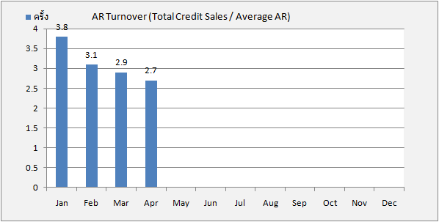
Event | Default | SQL
กดปุ่ม OK |  | monthly_ar_turnover  BEGIN  select ratio_month_name  , ratio_value1/ratio_value2 as ratio_rate  from ar_ratio_monthly  where ratio_year = v_in_year  and ratio_id = 6  order by ratio_month;  END
1.2.13 Monthly AR Collection Period
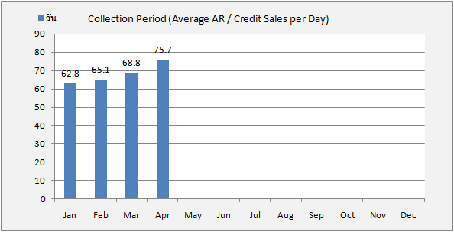
Event | Default | SQL
กดปุ่ม OK |  | monthly_ar_collection_period  BEGIN  select ratio_month_name, ratio_value1/ratio_value2 as ratio_rate  from ar_ratio_monthly  where ratio_year = v_in_year  and ratio_id = 7  order by ratio_month;  END

