**Software Requirements Specification**

For

**Image Segmentation**

Prepared by

|  |  |  |
| --- | --- | --- |
| **Specialization** | **SAP ID** | **Name** |
| AIML | 500076426 | Jay Gupta |
| AIML | 500076502 | Gaurav Sharma |
| AIML | 500075381 | Dev Singh |
| AIML | 500075382 | Ketan Chawla |



Department of Informatics

School Of Computer Science

UNIVERSITY OF PETROLEUM & ENERGY STUDIES,

DEHRADUN- 248007. Uttarakhand

Table of Contents

|  |  |  |
| --- | --- | --- |
| **Topic** | | **Page No** |
| Table of Content | |  |
| Revision History | |  |
| 1 | Introduction |  |
|  | Purpose |  |
|  | Motivation |  |
|  | Methodology |  |
|  | References |  |
| 2 | Project Description |  |
|  | Reference Algorithm |  |
|  | SWOT Analysis |  |
|  | Design diagrams |  |
| 3 | System Requirements |  |
|  | Hardware requirement |  |
|  | Software requirement |  |

**Revision History**

|  |  |  |  |
| --- | --- | --- | --- |
| **Date** | **Change** | **Reason for Changes** | **Mentor Signature** |
|  |  |  |  |
|  |  |  |  |
|  |  |  |  |
|  |  |  |  |

INTRODUCTION

Purpose

Image processing is something that has been very popular and widely used in last few decades and lots of research is still going on how to improve its performance further. As so many applications and working domains are highly dependent on it, its requirements is increasing day by day. Image segmentation is one of the core parts of image processing. Image segmentation is the process of partitioning an image into different regions based on their features. This separates out the objects of interest from the rest of the image thereby makes the analysis of the image easier. Computer vision which is so popular nowadays and has made the systems performance as good as human at dealing with images, uses image segmentation. Image segmentation has lots of application in different areas, like it is used in the face recognition technology which is used in security systems, image segmentation is used in object detection, in the medical science as a way to locate and identify fractures, damaged tissues and cells and also used in search engines that offers image-based searches. There are different techniques through which image segmentation can be done. Following are some of them: • Thresholding-based segmentation • Region-based segmentation • Clustering-based segmentation • Edge detection-based segmentation

Motivation

Image segmentation is an important image processing, and it seems everywhere if we want to analyze what inside the image. For example, if we seek to find if there is a chair or person inside an indoor image, we may need image segmentation to separate objects and analyze each object individually to check what it is. Image segmentation usually serves as the preprocessing before image pattern recognition, image feature extraction and image compression. Researches of it started around 1970, while there is still no robust solution, so we want to find the reason and see what we can do to improve it.

Methodology

In this project we use the iterative method to build our project. By using this approach, we built our project, test and review it and if we need some changes then we iterate the model again, test review it and after each iteration we will get a better model from the earlier.

References

1. There is a research paper in which there is comparison of region-based segmentation. In this paper there is a comparison of two segmentation algorithm i.e., region growing and region merging.

Title: Region growing and region merging segmentation

Link: <https://ieeexplore.ieee.org/abstract/document/628077/references#references>

1. There is a research paper in which there is comparison of every segmentation algorithm and find out how to combine these algorithms and use effectively.

Title: Image Segmentation Algorithms Overview

Link: <https://arxiv.org/abs/1707.02051>

1. There is a research paper in which there is a comparison of each and every algorithm and finding the complexity, segmentation effect, flaws and improvements scope in those segmentation algorithms and also find which image is suitable for which algorithm.

Title: The Comparative Research on Image Segmentation Algorithms

Link: <https://ieeexplore.ieee.org/abstract/document/4959132>

1. There is a research paper in which there is detail study of clustering segmentation.

Title: Clustering Techniques for Digital Image Segmentation

Link:[https://www.ijser.org/researchpaper/Clustering-Techniques-for-Digital-Image- Segmentation.pdf](https://www.ijser.org/researchpaper/Clustering-Techniques-for-Digital-Image-%20%20Segmentation.pdf)

PROJECT DESCRIPTION

Reference Algorithm

There are four algorithms used in this project

1. Otsu thresholding

Otsu’s algorithm is a thresholding-based segmentation algorithm. Image thresholding is a technique in which the image is binarized based on pixel intensities. The Otsu Algorithm converts a grey scale image (input) to a binary image (output). It is a global image thresholding algorithm as a single threshold is used globally for the complete image. This algorithm basically comprises of 4 steps:-

Step 1. The input image is processed.

Step 2. Image histogram is obtained by distribution of pixels.

Step 3. Compute the threshold value T. The threshold value(T) is determined                   using midpoint method.

Step 4. Image pixels are replaced into white in those areas where the saturation             is greater than the threshold value(T), and black in those areas where             the saturation is lower than the threshold value(T).

A bimodal image (an image having two distinct image values) is considered, and the histogram generated contains two peaks. A generic condition would be to choose a threshold value that lies in the middle of both the histogram peak values.

1. K-means Clustering

It is a clustering based image segmentation technique. Similar pixel values will be present in same cluster/region.

1. Edge detection

Sobel operator is a edge detection operator. It comprises of two 3x3 matrices, one to detect horizontal edge and the other to detect vertical edge. This operator is applied on the pixels of the image to detect edges in it.

1. Region growing

Region-based segmentation is a technique for determining the region directly. Region growing is a simple region-based image segmentation method. It is also classified as a pixel-based image segmentation method since it involves the selection of initial seed points. Region growing is a procedure that groups pixels or sub regions into larger regions. The simplest of these approaches is pixel aggregation, which starts with a set of seed points and from these grows regions by appending to each seed points those neighboring pixels that have similar properties (such as gray level, texture, color, shape). Region growing based techniques are better than the edge-based techniques in noisy images where edges are difficult to detect

SWOT ANALYSIS:

Strength: The strengths are:

* Content-based image retrieval.
* Machine vision
* Medical Imaging
* Recognition task
* Traffic Control System
* Video Surveillance

Weakness: The image segmentation problem can be stated as the division of an image into regions that separate different objects from each other, and from the background.

Opportunities: Image segmentation is typically used to locate objects and boundaries (lines, curves, etc.) in images. When applied to a stack of images, typical in medical imaging, the resulting contours after image segmentation can be used to create 3D reconstructions with the help of interpolation algorithms like marching cubes.

Design diagrams

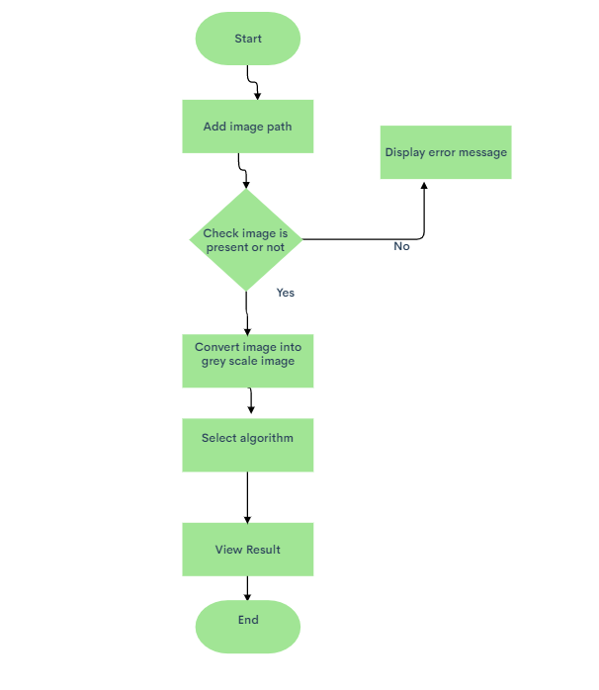

SYSTEM REQUIREMENTS

Hardware requirements:

* Min. 1 Gb ram (or higher)
* Intel core i3 processor (or equivalent) (or higher)

Software Requirements:

* Windows 7 (or equivalent) (or higher)
* Visual studio 2019