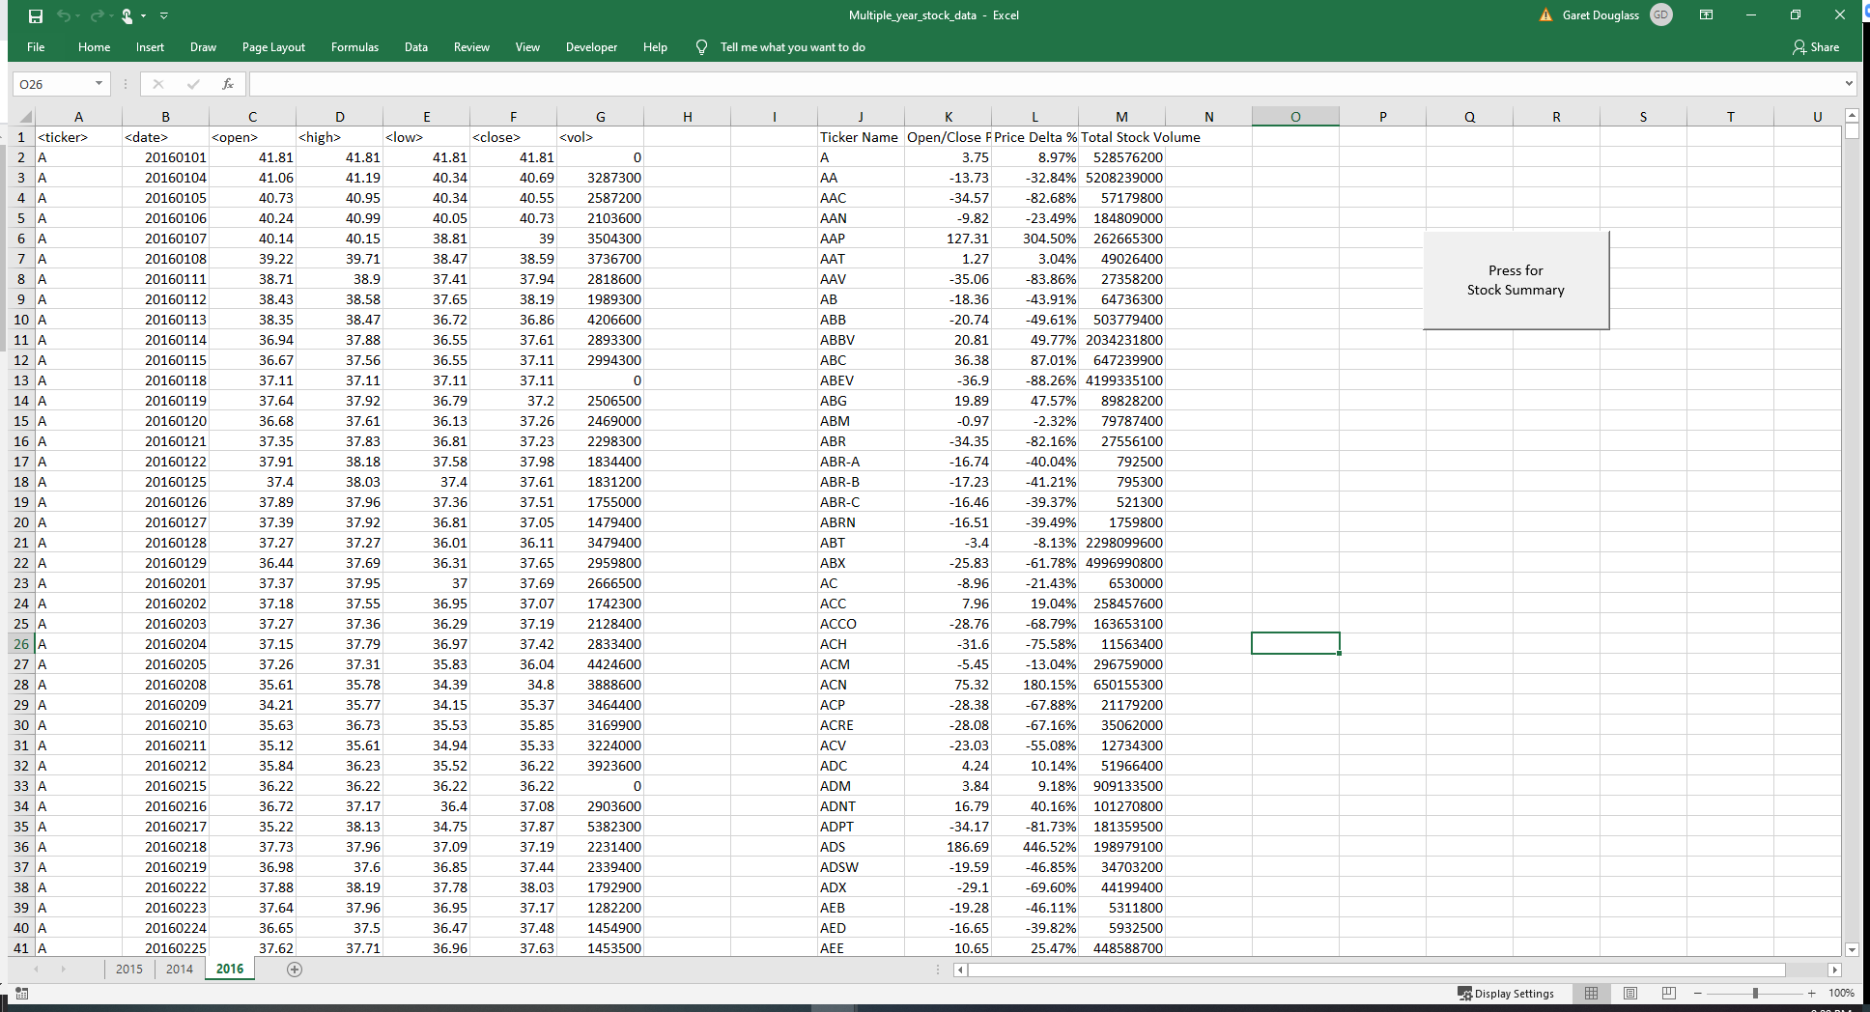

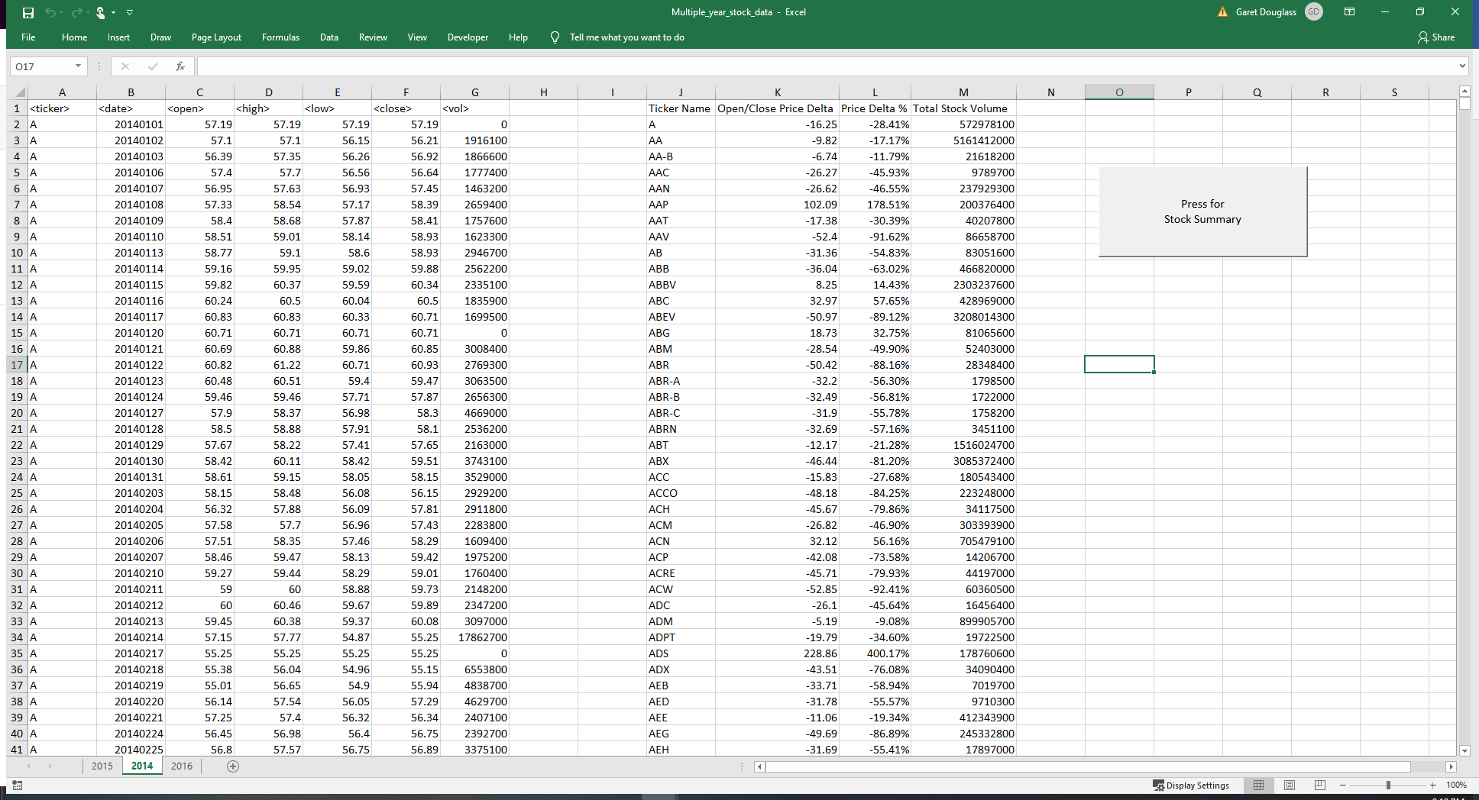

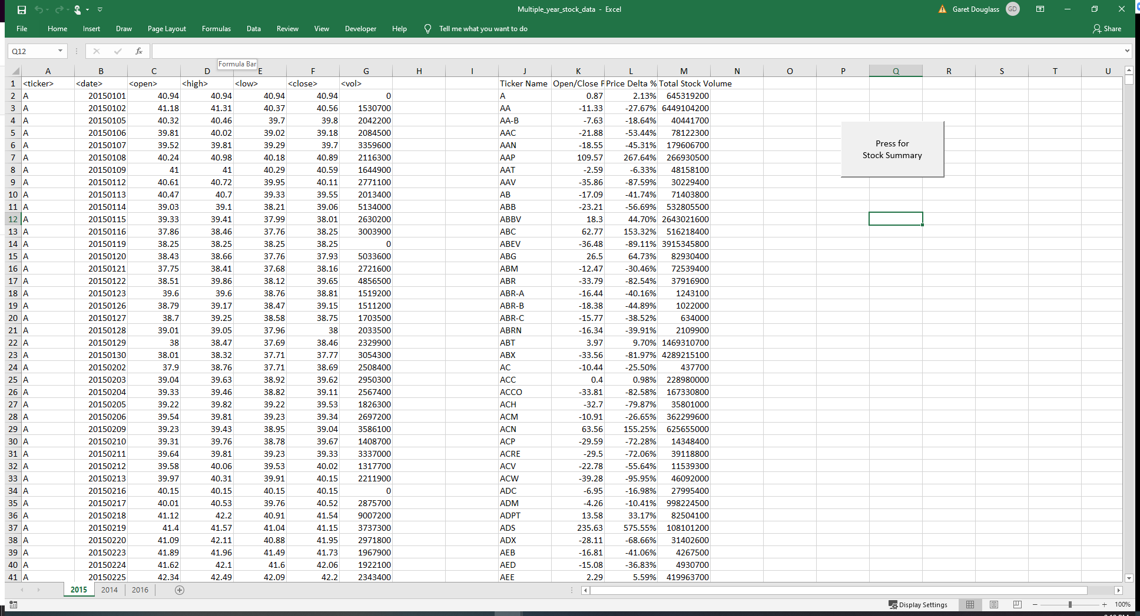

Sub stockticker()

'Establish stockticker name as text

Dim stockticker As String

'Establish Prices and Volume to allow decimals

Dim openprice As Double

Dim closeprice As Double

Dim volume As Double

volume = 0

'Track the ticker name location in the display table

Dim displayrow As Integer

displayrow = 2

'Prints Headers of display table

Cells(1, 10).Value = "Ticker Name"

Cells(1, 11).Value = "Open/Close Price Delta"

Cells(1, 12).Value = "Price Delta %"

Cells(1, 13).Value = "Total Stock Volume"

'Establish for loop for ticker names

For i = 2 To 70926

'Capture opening price for the first stocks opening price

If openprice = 0 Then

openprice = Cells(i, 3).Value

End If

'Checks to see if a change is stock ticker name and captures the closing price of a new stock

If Cells(i - 1, 1) = Cells(i, 1) And Cells(i + 1, 1).Value <> Cells(i, 1).Value Then

closeprice = Cells(i, 6).Value

'Captures the delta between the open and close price for each stock

pricedelta = closeprice - openprice

'Captures the percent change of the open and close price of each stock

pricedeltapercent = Round(((pricedelta / openprice) \* 100), 2)

'Sets stockticker Name

stockticker = Cells(i, 1).Value

'Captures stock volume for each stock ticker name

volume = volume + Cells(i, 7).Value

'Prints values for each stock ticker name in diplay table

Range("J" & displayrow).Value = stockticker

Range("K" & displayrow).Value = pricedelta

Range("L" & displayrow).Value = pricedeltapercent & "%"

Range("M" & displayrow).Value = volume

'Moves to the next row in display table

displayrow = displayrow + 1

'Resets volume to zero for next loop

volume = 0

'Adds stock volume if stock ticker name is the same

Else

volume = volume + Cells(i, 7).Value

End If

Next i

End Sub

v

