Luke Holmes

Design Document

**Team Members:**

Daia Elsalaymeh

Dennis Leancu

Janelle Cueto

Version 2.0

4/27/2017

**Luke Holmes**

|  |  |
| --- | --- |
| Game Genre : | Puzzle |
| Target Audience : | Kids from the ages of 8-14 |
| Appeals To : | Teenagers, mainly all ages |
| Platform : | PC |
| Player View : | 3rd Person |
| Graphics Engine : | Unity 3D engine |

**Key Concepts Summary:**

**Story**

* Leukocyte “Luke” Holmes, private investigator, is tasked with discovering the source of an infection in his city. Initially believed to be no cause for alarm, it turns out the infection is due to deadly virus, Marburg. Luke must decipher various clues and cryptic messages with his companions to put a stop to the virus.

**Game play**

* User controls Luke Holmes, and different objects within the scene
  + Point and click 3D adventure

**Player Actions**

* User controls Luke Holmes by clicking in the scene and he walks to the destination. The player can also pick up and observe objects. More actions stem from performing in mini-games.

**Formal Elements**

* Players
  + Single Player vs. Game
* Objectives
  + Exploration & Solution
* Procedures
  + Point and click & various mini games
* Rules
  + Each “city” has a certain number of obtainable clues
  + Fail a clue and it cannot be tried again
  + Winning requires certain number of total clues (difficulty level)
* Resources
  + Clues: Story progression
* Conflict
  + Primary: Stop Marburg from taking over the whole body
* Outcome
  + Primary: Marburg is either stopped in time or not
  + Secondary: Successful or not on puzzles/clues/mini-games

**Game Flow / Screens**

* Intro Cinematic
* Main Menu
  + Title Name
  + Start game
  + Options
* Game
  + Game overworld
    - Location
  + Mini-games
* End Credits

**Level Examples**

* Level 1
  + 1 room/game zone/scene to move around in
  + 1 easy-level puzzle/mini game to get them introduced to the game mechanics
  + Solving puzzles unlocks Level 2
* Level 2
  + 1 easy and 1 intermediate-level puzzle
  + After puzzles are solved, a second part is unlocked which contains an intermediate-level puzzle
  + Solving puzzles unlocks level 3
* Level 1 (Hidden)
  + Intermediate-level puzzles
  + Solving puzzles unlocks hidden game zone/scene in Level 2
* Level 2 (Hidden)
  + Intermediate-level & hard-level puzzles
  + Solving puzzles unlocks hidden game zone/scene in Level 3

**Art Style**

* Cartoon Style

**Textural Description of Game:**

**Fictional story background**

* Leukocyte “Luke” Holmes, private investigator, is tasked with discovering the source of an infection in his city. Initially believed to be no cause for alarm, it turns out the infection is due to deadly virus, Marburg. Luke must decipher various clues and cryptic messages with his companions to put a stop to the virus.

**Game purpose and story progression**

* Purpose
* Background
  + Luke Holmes is a private investigator. He is hired by others to investigate crime scenes and solve puzzles and mysteries.
* Introduction
  + Luke comes across a person whose home got infected by something... This person asks Luke to investigate what happened and if he can help get rid of the infection. This is where Luke discovers that the city is infected, and the government hires him to find the source of this infection.
* Main Plot
  + TBD

**Game play and player interaction example**

Below are interactions with a physical prototype:

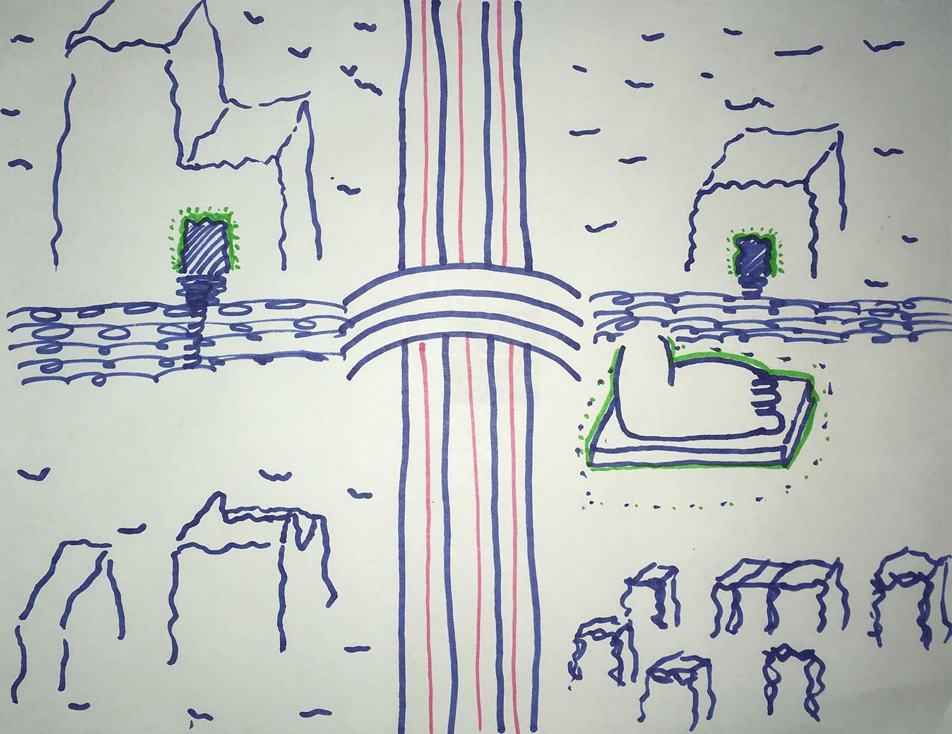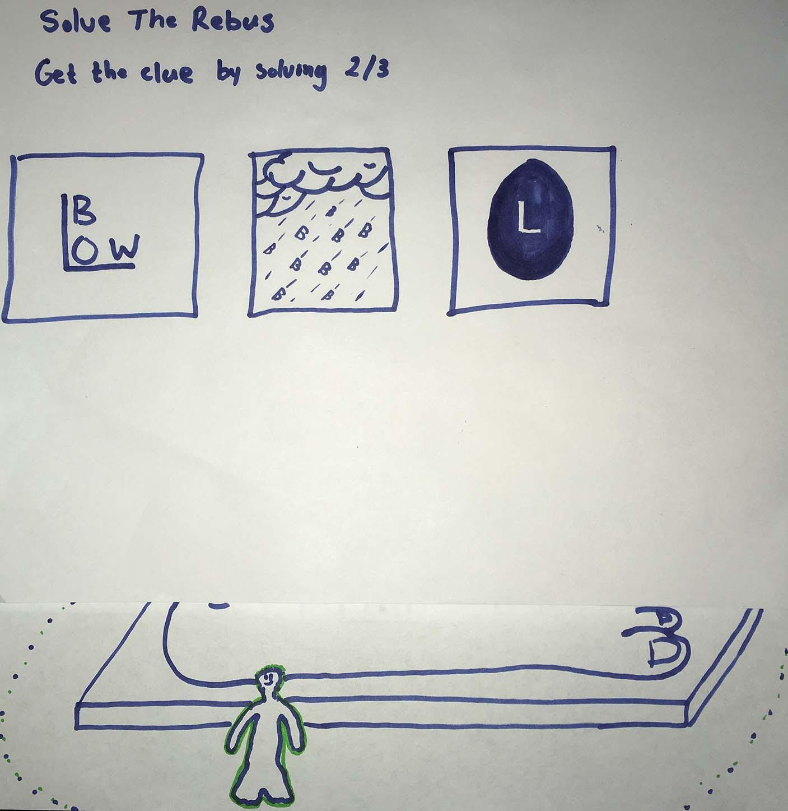 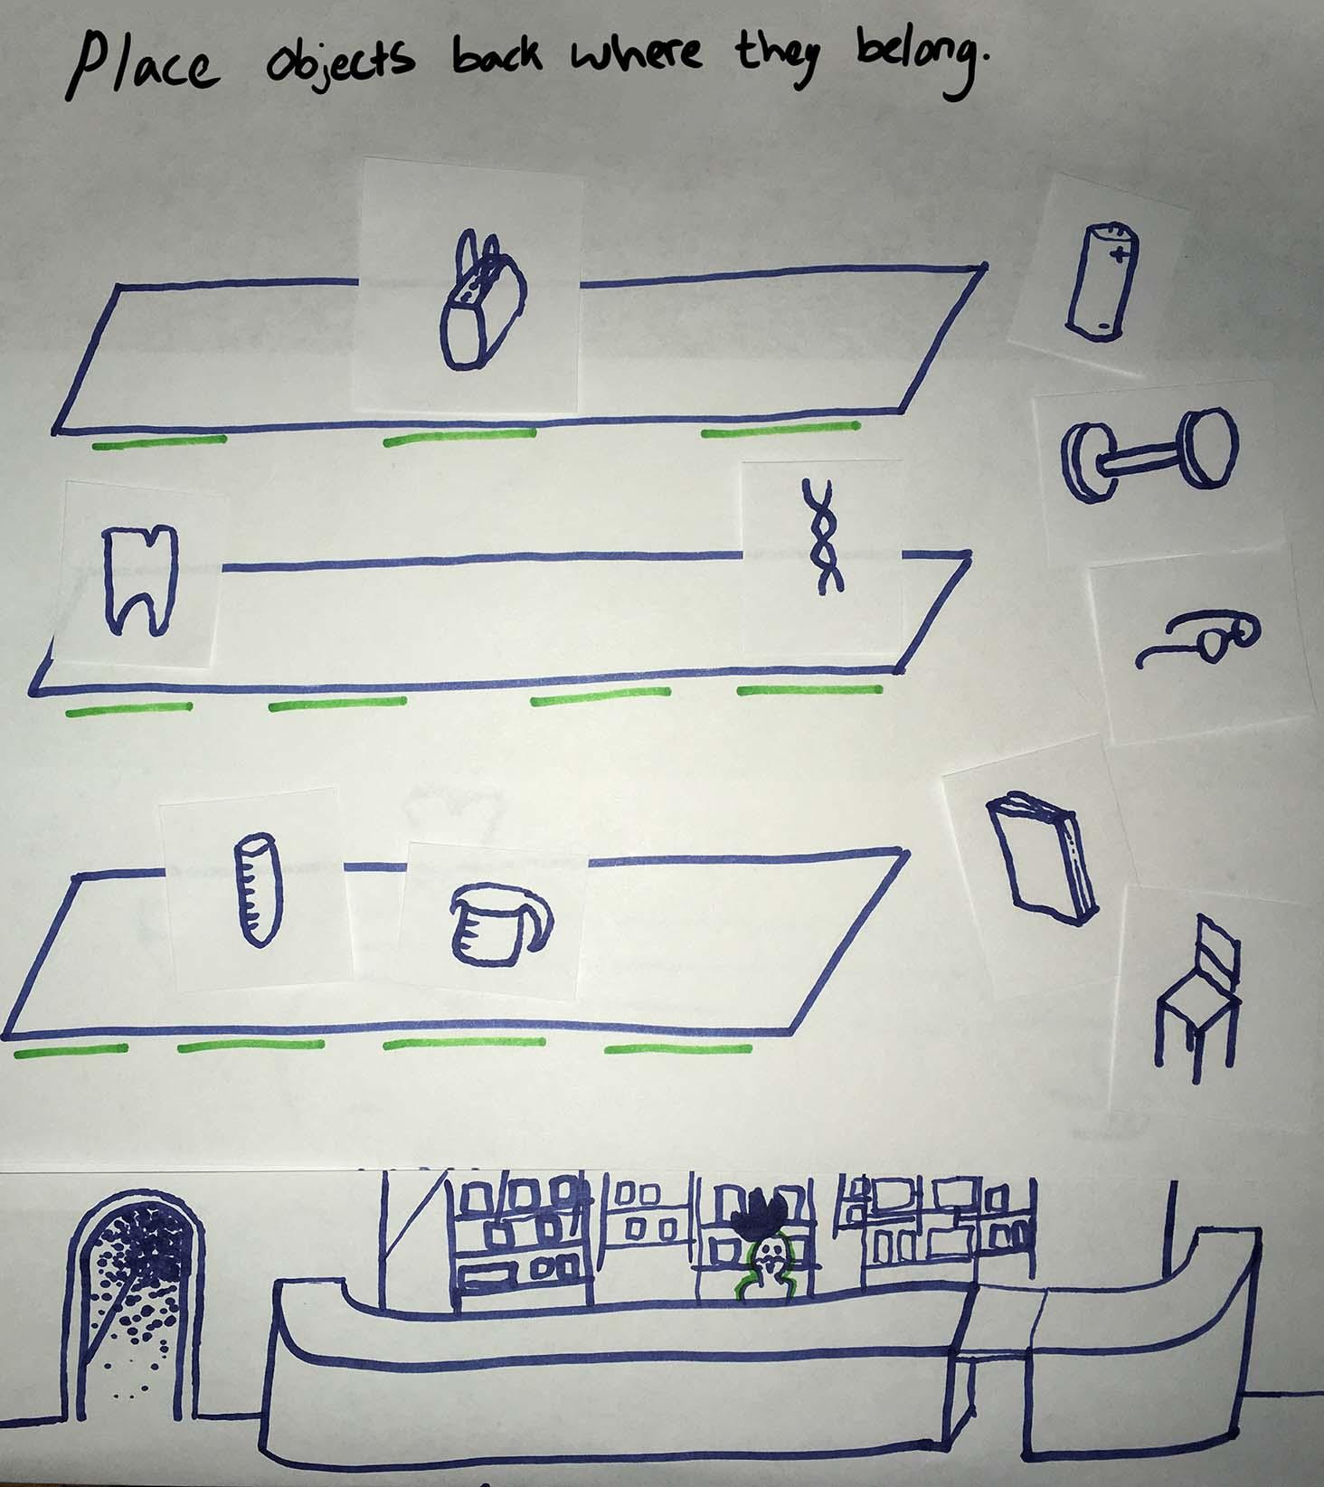

**Mindset**

* We want the player to feel clever and powerful. Since Luke Holmes is a private investigator, the player will solve puzzles in order to uncover the culprit and save the world. At the end of each puzzle/level, we want the player to feel that they are making progress towards defeating Marburg.

**Sound Design(for Assignment 9):**

**Examples for Critique**

* Hot Tin Roof: the Cat that Wore a Fedora
  + Background music: quiet and soft jazz track constantly playing, like music from old detective movies
  + Sound effects: sound of loading guns, opening doors, hopping/moving the player character around.
* L.A. Noir:
  + Background music: in certain places such as inside cafes and restaurants, jazz music plays in the background; jazz music also plays in the background for cutscenes of flashbacks in the game’s story; for investigation scenes, a darker and more dramatic song plays and it constantly plays as long as the player is within the investigation area.
  + NPCs and voice acting: Every interactable NPC has a voice, this is used for interrogation scenes and for input during game play as well as cut scenes.
  + Sound effects: a ‘jingle’ plays whenever you are around an observable object, after you’ve observed it, it ‘dings’ instead.

**Sound Design for Luke Holmes**

* Sound effects
  + Minigames and scene switches happen when you pass through a door
    - Door “closes” when you switch to the new scene
* Background music
  + Sweet Dreams - David Lewis Luong
    - Offers ‘jazzy’ and ‘detective movie era’ vibes to the game play
    - Makes the player feel like they’re playing the role of a detective
    - Plays during the Bar scene
  + Another World - David Lewis Luong
    - Plays during the House Investigation scene
  + Ambient Street Music
    - Plays in the first scene
    - Mimics the sound effects of a city since the story takes place in the city (much like Osmosis Jones)
  + Dikies - Tomppabeats
    - Plays during the main menu
    - Sets the tone for immersion

**Biographies:**

* **Name:** Dennis Aurelian Leancu

* **Year (Soph, Jun, Sen, Grad'N):** Super senior?

**\* Goals for this class:** I've always had ideas for games since I was a kid and want to learn enough from this class to make my own casual games on the side.

**\* Relevant upper-level computer science classes taken** **(databases, computer graphics, software engineering, networking, OS etc. or N/A)**: Databases, cloud computing, networking, UI Design.

* **Art/Design relevant classes or experience (digital media, storytelling, visual art, internships, etc.):** Was in a high intensity incubator at Microsoft that focused on design, social branding, and storytelling for building relevant branding and friendly interfaces for users. I'm pretty good with Photoshop, any video editing software, and FL Studio (music making software).

**\* Sw/Managerial Ninja skills:** Great developer. Hybrid scrum/agile processes are a great way to get ideas quickly off the ground.

**\* Role you'd like to play in a team:** I can do any role, but I like exploring the vision, setting, and characters of games. I think music & sound is an important part of games and I like to have a hand in how it contributes to way the game feels. That's the main thing that always intrigued me about games. If you're looking for someone to manage a team, you found him.

**\* Other things you want the class to know:** My hobby is being an audiophile, I like Belgian's and IPA's, and I really enjoy board games. On weekends I meet up with friends to play poker/cards and Dungeons&Dragons.

* **Name:** Janelle Cueto

* **Year (Soph, Jun, Sen, Grad'N):** Junior

**\* Goals for this class:** Learn about game design and techniques for making fun games

**\* Relevant upper-level computer science classes taken** **(databases, computer graphics, software engineering, networking, OS etc. or N/A)**: finishing CS core, currently taking AI, 401, and 362

* **Art/Design relevant classes or experience (digital media, storytelling, visual art, internships, etc.):** some drawing experience, beginner-level photoshopper. I also got some artsy graphic designer roommates from Columbia.

**\* Sw/Managerial Ninja skills:** I'm in a team outside of UIC working on 2D games also in Unity. And I'm a part time sales associate at Akira Block37 so I'm pretty good with people.

**\* Role you'd like to play in a team:** I'd like to do some story writing and artwork, really anything that needs to be done

**\* Other things you want the class to know:** Pineapple is not a good substitute for lime.

* **Name:** Daia Elsalaymeh

* **Year (Soph, Jun, Sen, Grad'N):** Undergrad Senior Year

**\* Goals for this class:** Learn how to make games properly

**\* Relevant upper-level computer science classes taken** **(databases, computer graphics, software engineering, networking, OS etc. or N/A)**: Networking and Databases

* **Art/Design relevant classes or experience (digital media, storytelling, visual art, internships, etc.):** none since Middle School....

**\* Sw/Managerial Ninja skills:** Had 2 technical CS internships

**\* Role you'd like to play in a team:** I would prefer to do work in unity instead of blender

**\* Other things you want the class to know:** I am a quick learner.

**Roles and Responsibilities:**

|  |  |
| --- | --- |
| **Name** | **Position(s)** |
| Daia Elsalaymeh | User Interface Design Engineer  Music and Sound Engineer  Developer |
| Dennis Leancu | Creative Director  Team Manager  Developer |
| Janelle Cueto | User Interface Design Engineer  Music and Sound Engineer  Developer |

**Technical Specs:**

**Repository:**

Unity Collaborate mirrored to GitHub

(https://github.com/GJGMFB/luke-holmes)

**Bug/Issue Tracking:**

GitHub

(<https://github.com/GJGMFB/luke-holmes/issues>)

**Final Slides:**

(<https://docs.google.com/presentation/d/1OPrDJizyfbT_rmrxJPVisCg171vU-7eh9pnK41ZqNuU/edit#slide=id.p4>)

**Final Video:**

[**https://youtu.be/V1lAxbi8HX0**](https://youtu.be/V1lAxbi8HX0)

**Cited Sources:**

Brain.obj:

-<http://www.blendswap.com/blends/view/75049>

Heart.obj:

-<https://sketchfab.com/models/24b736f75b29464f8b2a62eb6d421533#>

Kidney.obj

-<http://www.123dapp.com/smb-123D_Design/Anatomical-Kidney/2042872>

Liver.obj

-<http://www.123dapp.com/sculpt/liver/2353740>

Lung.obj

-<http://opengameart.org/content/human-lungs>

Skeleton.obj

-<https://free3d.com/3d-model/skeleton-81335.html>