George Ramos

EWD22 Class 12 Homework

1. 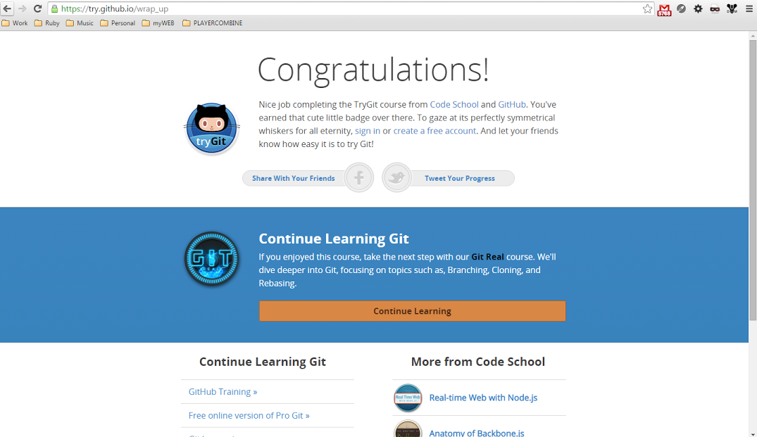

2.

| **Helper** | **HTTP Verb** | **Path** | **Controller#Action** |
| --- | --- | --- | --- |
| [**Path**](http://localhost:3000/photos)**/**[**Url**](http://localhost:3000/photos) |  |  |  |
| images_path | GET | /images(.:format) | images#index |
|  | POST | /images(.:format) | images#create |
| new_image_path | GET | /images/new(.:format) | images#new |
| edit_image_path | GET | /images/:id/edit(.:format) | images#edit |
| image_path | GET | /images/:id(.:format) | images#show |
|  | PATCH | /images/:id(.:format) | images#update |
|  | PUT | /images/:id(.:format) | images#update |
|  | DELETE | /images/:id(.:format) | images#destroy |
| product_comments_path | GET | /products/:product_id/comments(.:format) | comments#index |
|  | POST | /products/:product_id/comments(.:format) | comments#create |
| new_product_comment_path | GET | /products/:product_id/comments/new(.:format) | comments#new |
| edit_product_comment_path | GET | /products/:product_id/comments/:id/edit(.:format) | comments#edit |
| product_comment_path | GET | /products/:product_id/comments/:id(.:format) | comments#show |
|  | PATCH | /products/:product_id/comments/:id(.:format) | comments#update |
|  | PUT | /products/:product_id/comments/:id(.:format) | comments#update |
|  | DELETE | /products/:product_id/comments/:id(.:format) | comments#destroy |
| products_path | GET | /products(.:format) | products#index |
|  | POST | /products(.:format) | products#create |
| new_product_path | GET | /products/new(.:format) | products#new |
| edit_product_path | GET | /products/:id/edit(.:format) | products#edit |
| product_path | GET | /products/:id(.:format) | products#show |
|  | PATCH | /products/:id(.:format) | products#update |
|  | PUT | /products/:id(.:format) | products#update |
|  | DELETE | /products/:id(.:format) | products#destroy |

3. GEMS GEMS GEMS –

Gems are collections ruby files which add code to your rails application and allow for functionality implementations. They consist of code, rakefile, documentation, and gem specifications. When using the rake command on the gem it perform tasks specified in the rake file. Gems are hosted on <https://rubygems.org/> and are never deleted. You can find over 5 million and counting which will allow for custom functionality to your application.

User Login : <https://github.com/plataformatec/devise>

File Uploading : <https://github.com/thoughtbot/paperclip>