CS364/AM792 : Computer Vision

Assignment 2: Projective Geometry and RANSAC

20277970 GJS DU TOIT

26 Aug 2019

1. a)

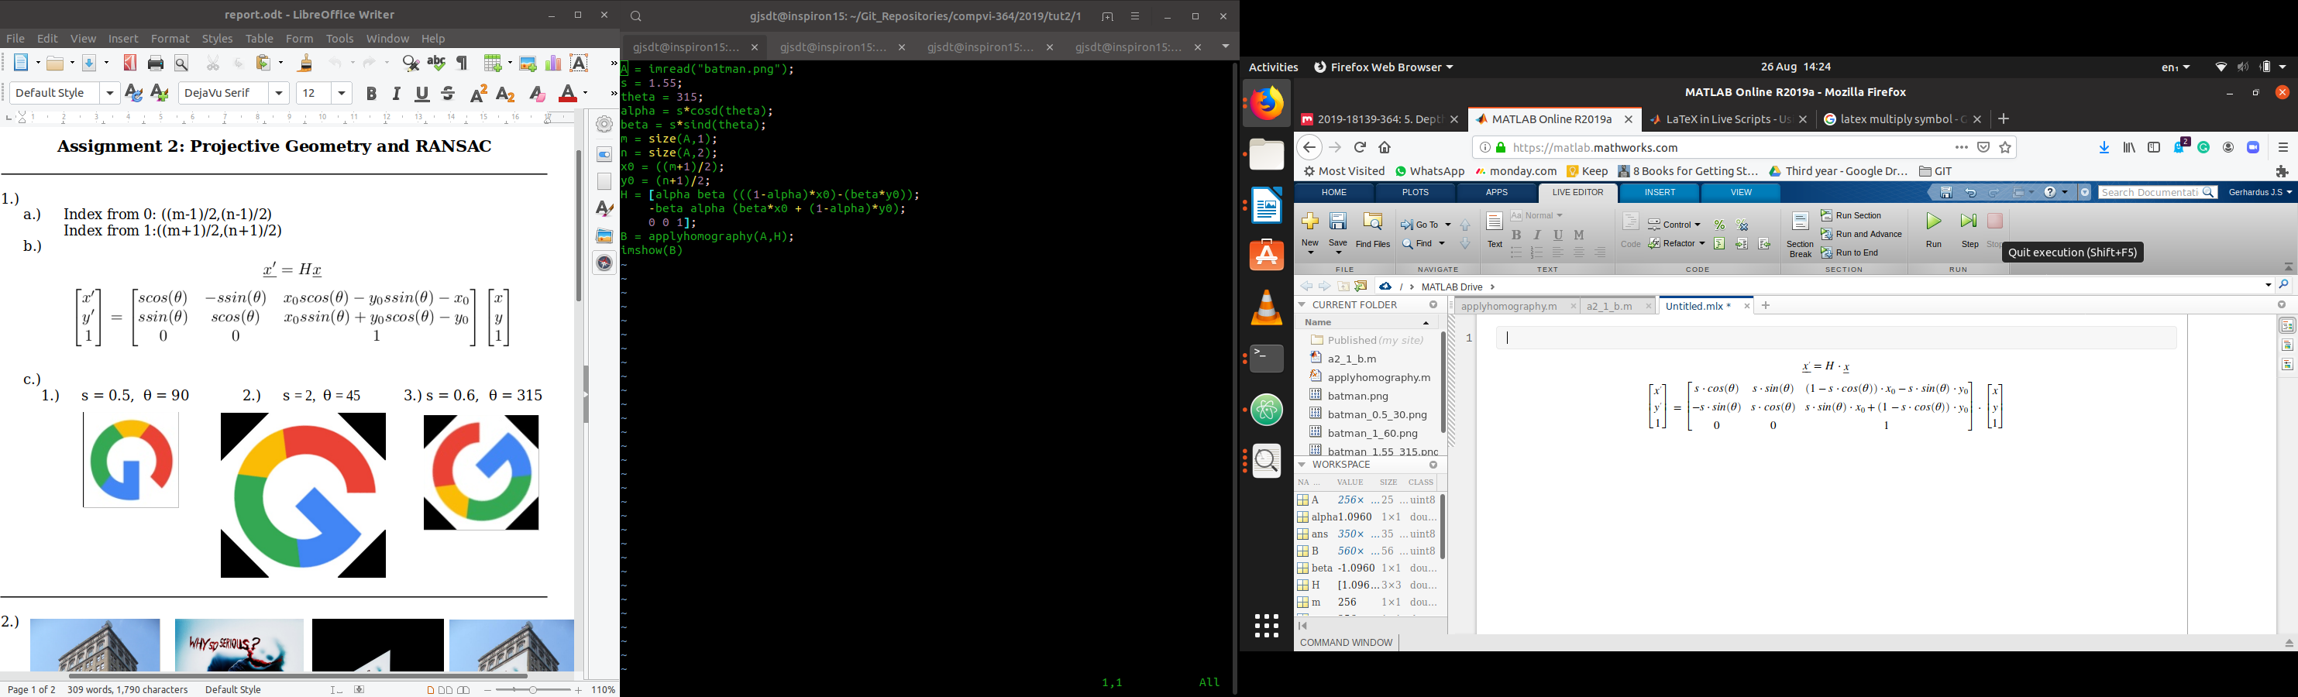

b)

  
scale: 2  
angle: 90[°](https://www.google.com/url?sa=t&rct=j&q=&esrc=s&source=web&cd=1&cad=rja&uact=8&ved=2ahUKEwjw38npxqDkAhXvRxUIHTfPAakQFjAAegQIAxAB&url=https%3A%2F%2Fwww.degreesymbol.net%2F&usg=AOvVaw27A1G6JS1IXxE9AUqbOZYf)

  
scale: 0.5  
angle: 30 [°](https://www.google.com/url?sa=t&rct=j&q=&esrc=s&source=web&cd=1&cad=rja&uact=8&ved=2ahUKEwjw38npxqDkAhXvRxUIHTfPAakQFjAAegQIAxAB&url=https%3A%2F%2Fwww.degreesymbol.net%2F&usg=AOvVaw27A1G6JS1IXxE9AUqbOZYf)

  
scale: 1.55  
angle: 315 [°](https://www.google.com/url?sa=t&rct=j&q=&esrc=s&source=web&cd=1&cad=rja&uact=8&ved=2ahUKEwjw38npxqDkAhXvRxUIHTfPAakQFjAAegQIAxAB&url=https%3A%2F%2Fwww.degreesymbol.net%2F&usg=AOvVaw27A1G6JS1IXxE9AUqbOZYf)

  
scale: 1  
angle: 60 [°](https://www.google.com/url?sa=t&rct=j&q=&esrc=s&source=web&cd=1&cad=rja&uact=8&ved=2ahUKEwjw38npxqDkAhXvRxUIHTfPAakQFjAAegQIAxAB&url=https%3A%2F%2Fwww.degreesymbol.net%2F&usg=AOvVaw27A1G6JS1IXxE9AUqbOZYf)

  
Original image - scale: 1

2.

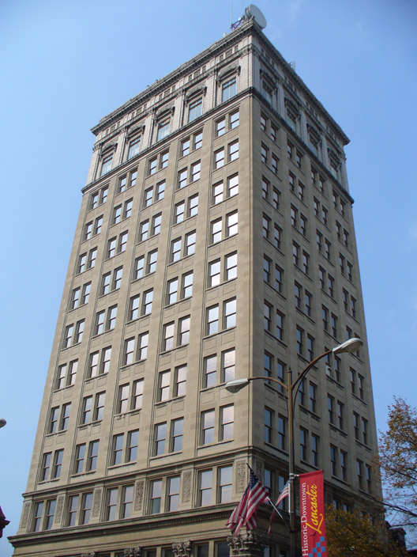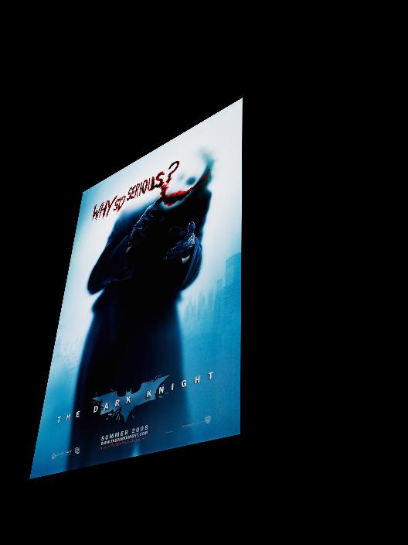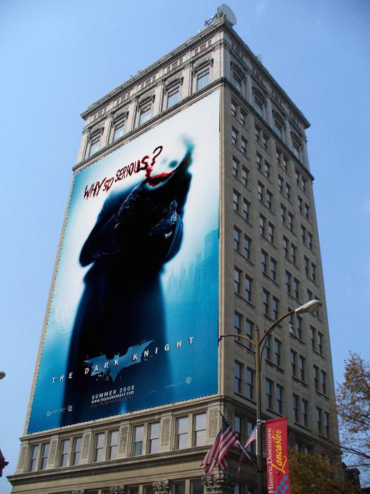

The pixels of the transformed image that do not contain data from the original poster, will be initialized to black. Therefore, when I selected the pixels from the griest.jpg image to be replaced by the pixels from the transformed image, I ignored all the black pixels and only used the rest. Another method would be to only take the pixels that are positioned in the space provided by the corner coordinates, into consideration when choosing pixels to overlay the image with. The homography matrix warps the image to correlate with the exact pixel coordinates provided, so the image origin will appear where the given coordinates suggests.

With the input image being transformed, the output might not have the same shape or dimensions as the input image (the output might be a larger image than the input image). When assuming that the output will have the same shape and dimensions as the input and performing billinear interpolation from within a matrix with the same dimensions, the output might lack some pixels that was transformed to appear out of the shape of the original image. A suitable size for the output image in this example would be a one that just big enough so that the poster fits on the building in griest.jpg.

Aliasing can arise when you sample a continuous signal or image and your sampling rate is not high enough to capture the amount of detail in your image. It can give you the wrong signal/image — an *alias.* The image contains structure at different scales — called “frequencies” — in the Fourier domain. The sampling rate must be high enough to capture the highest frequency in the image.

When interpolating an image, the original image has frequencies that are too high. We can solve this by filtering the image first, and then subsampling.

3. a)

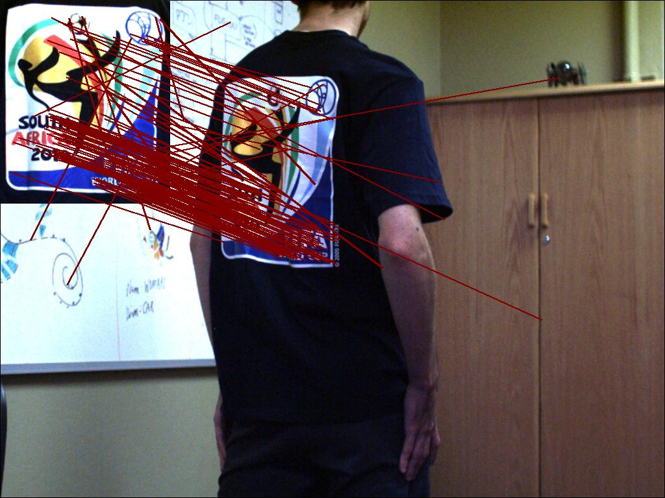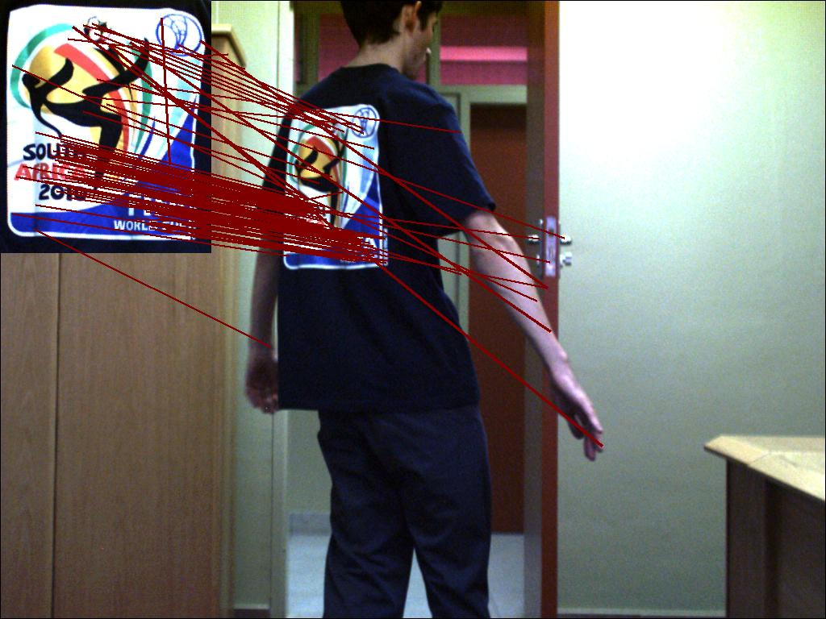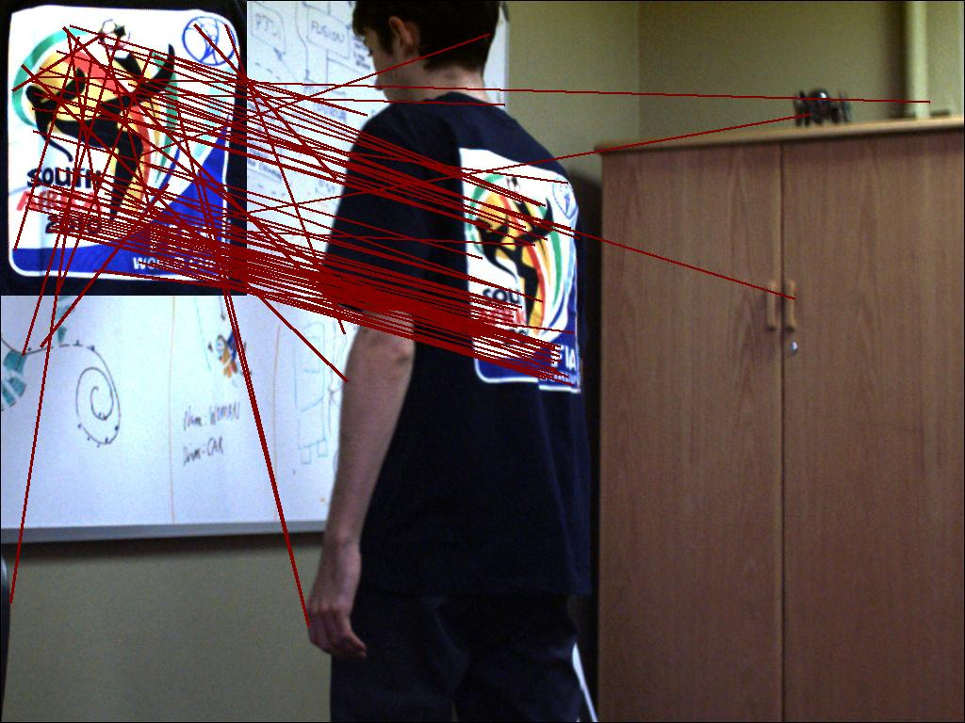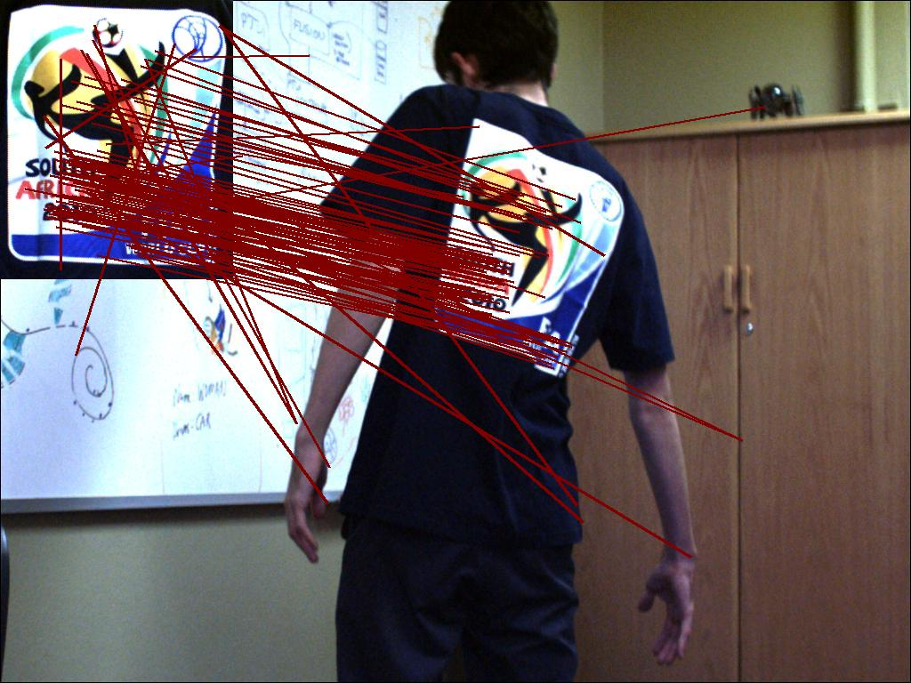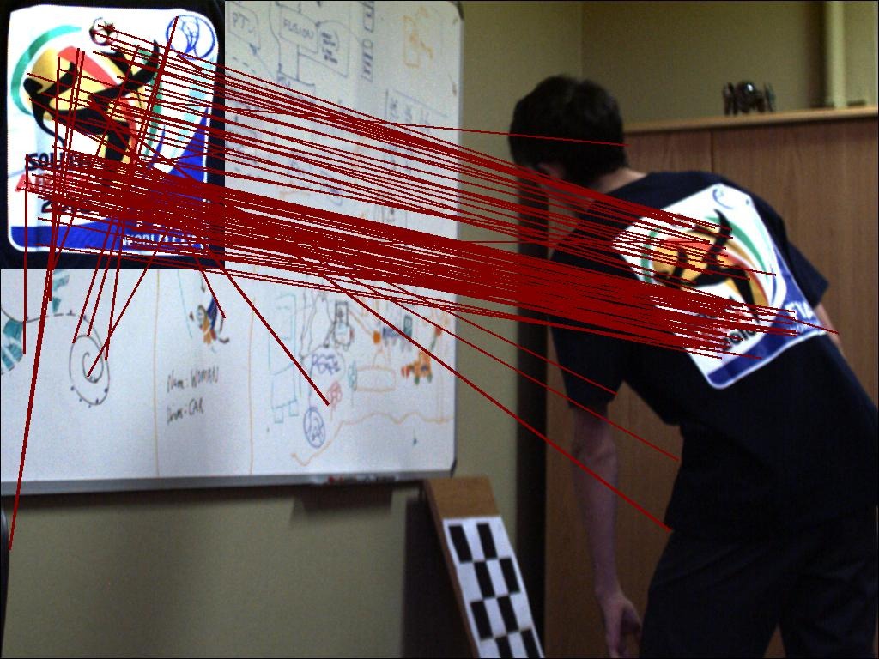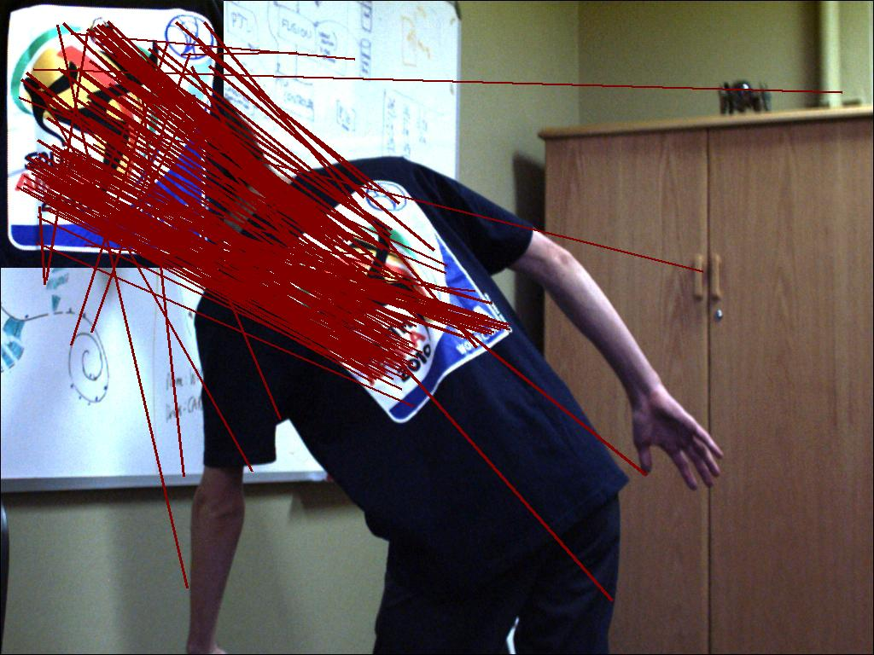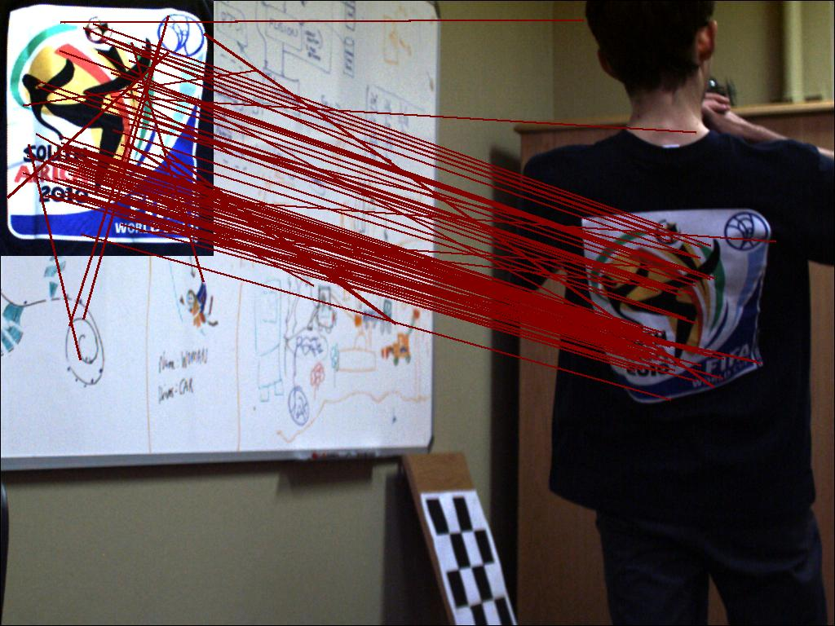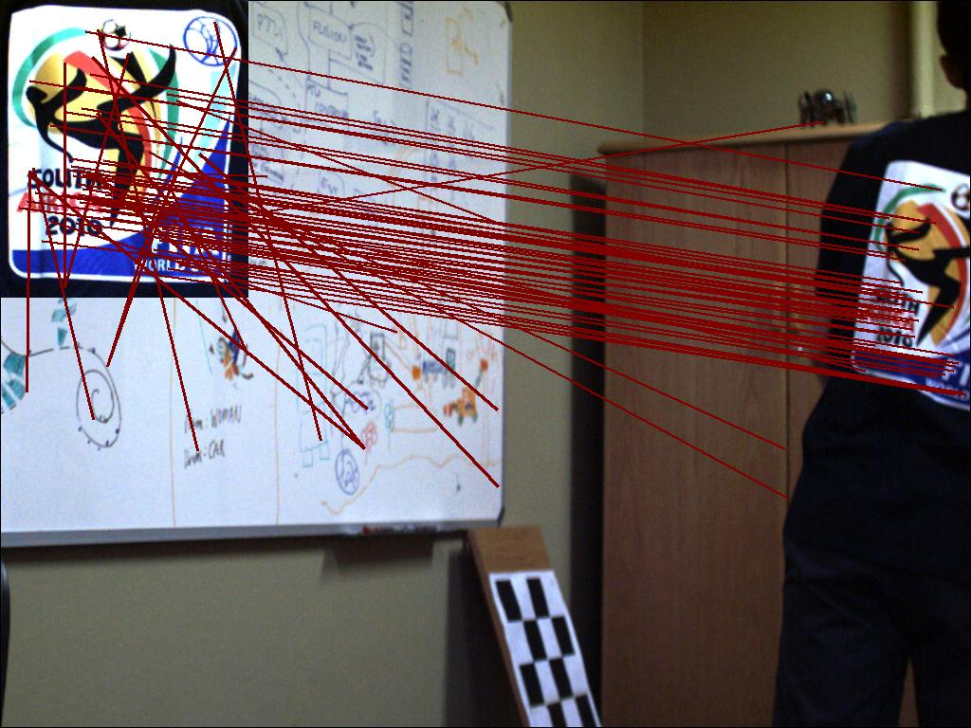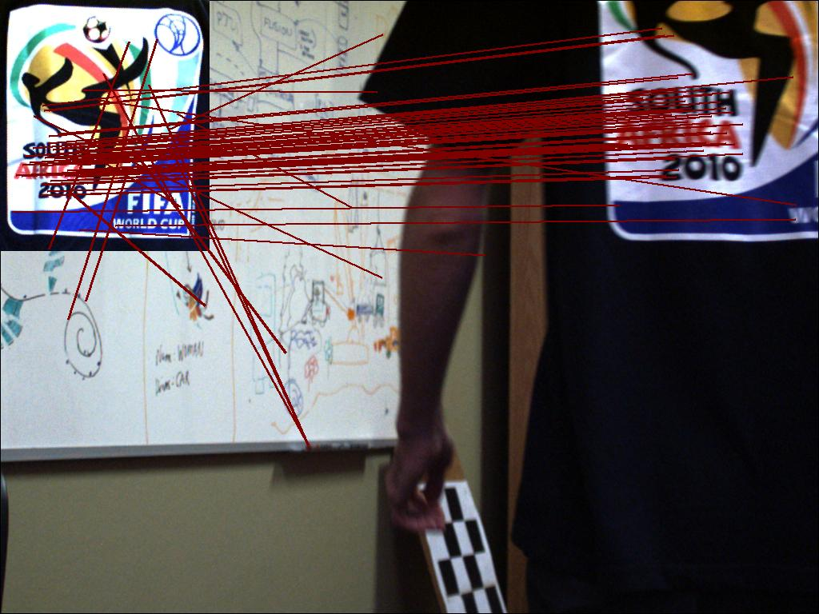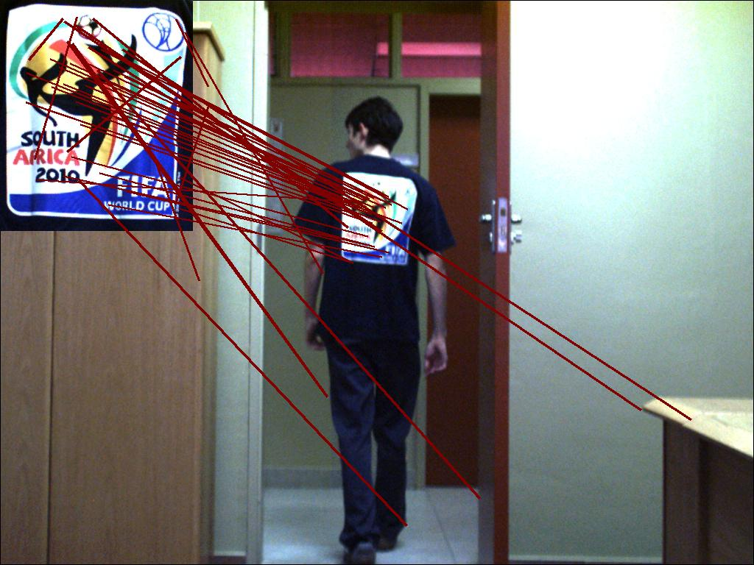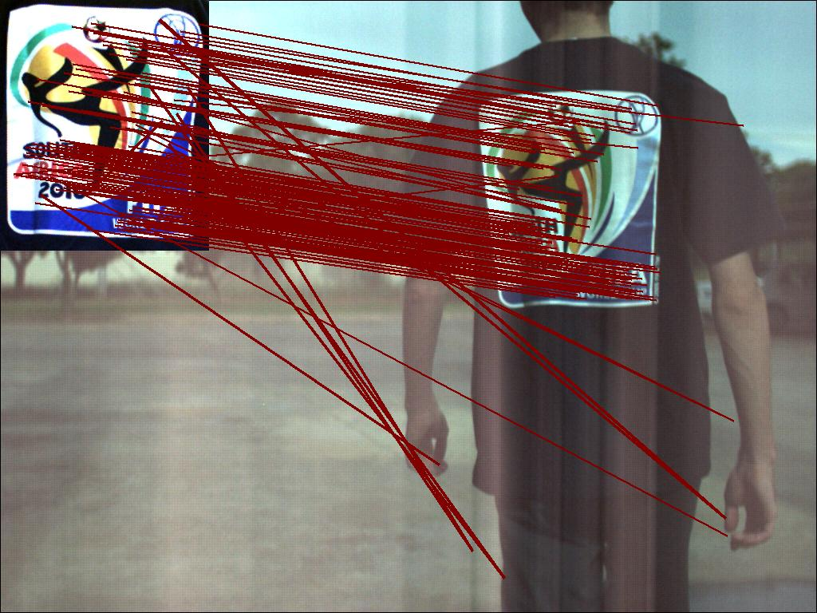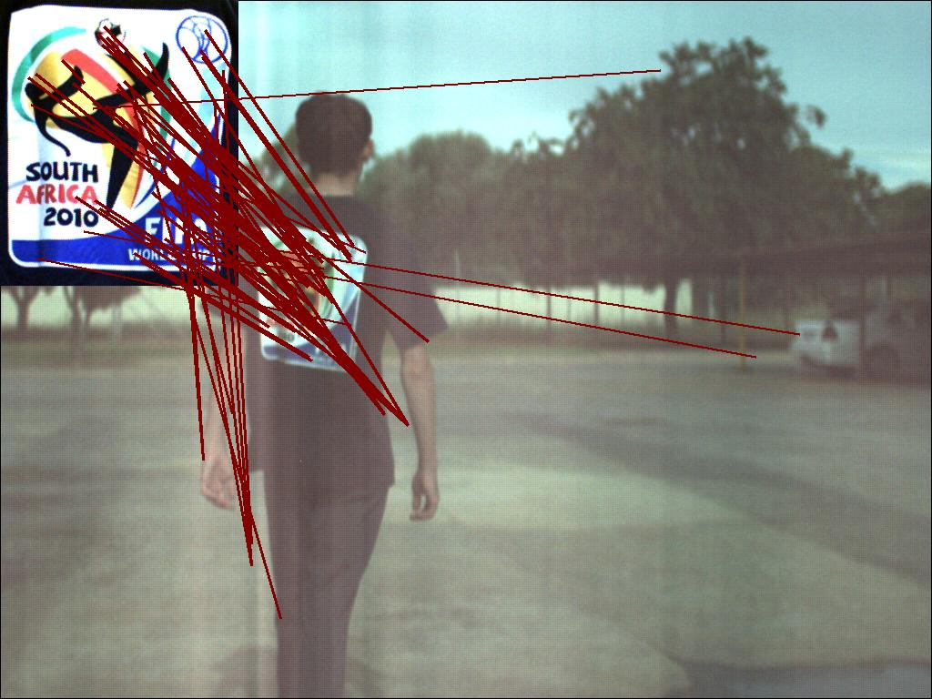

b)