CS364: Computer Vision
Computer Assignment 4
Gerhardus du Toit
20277970

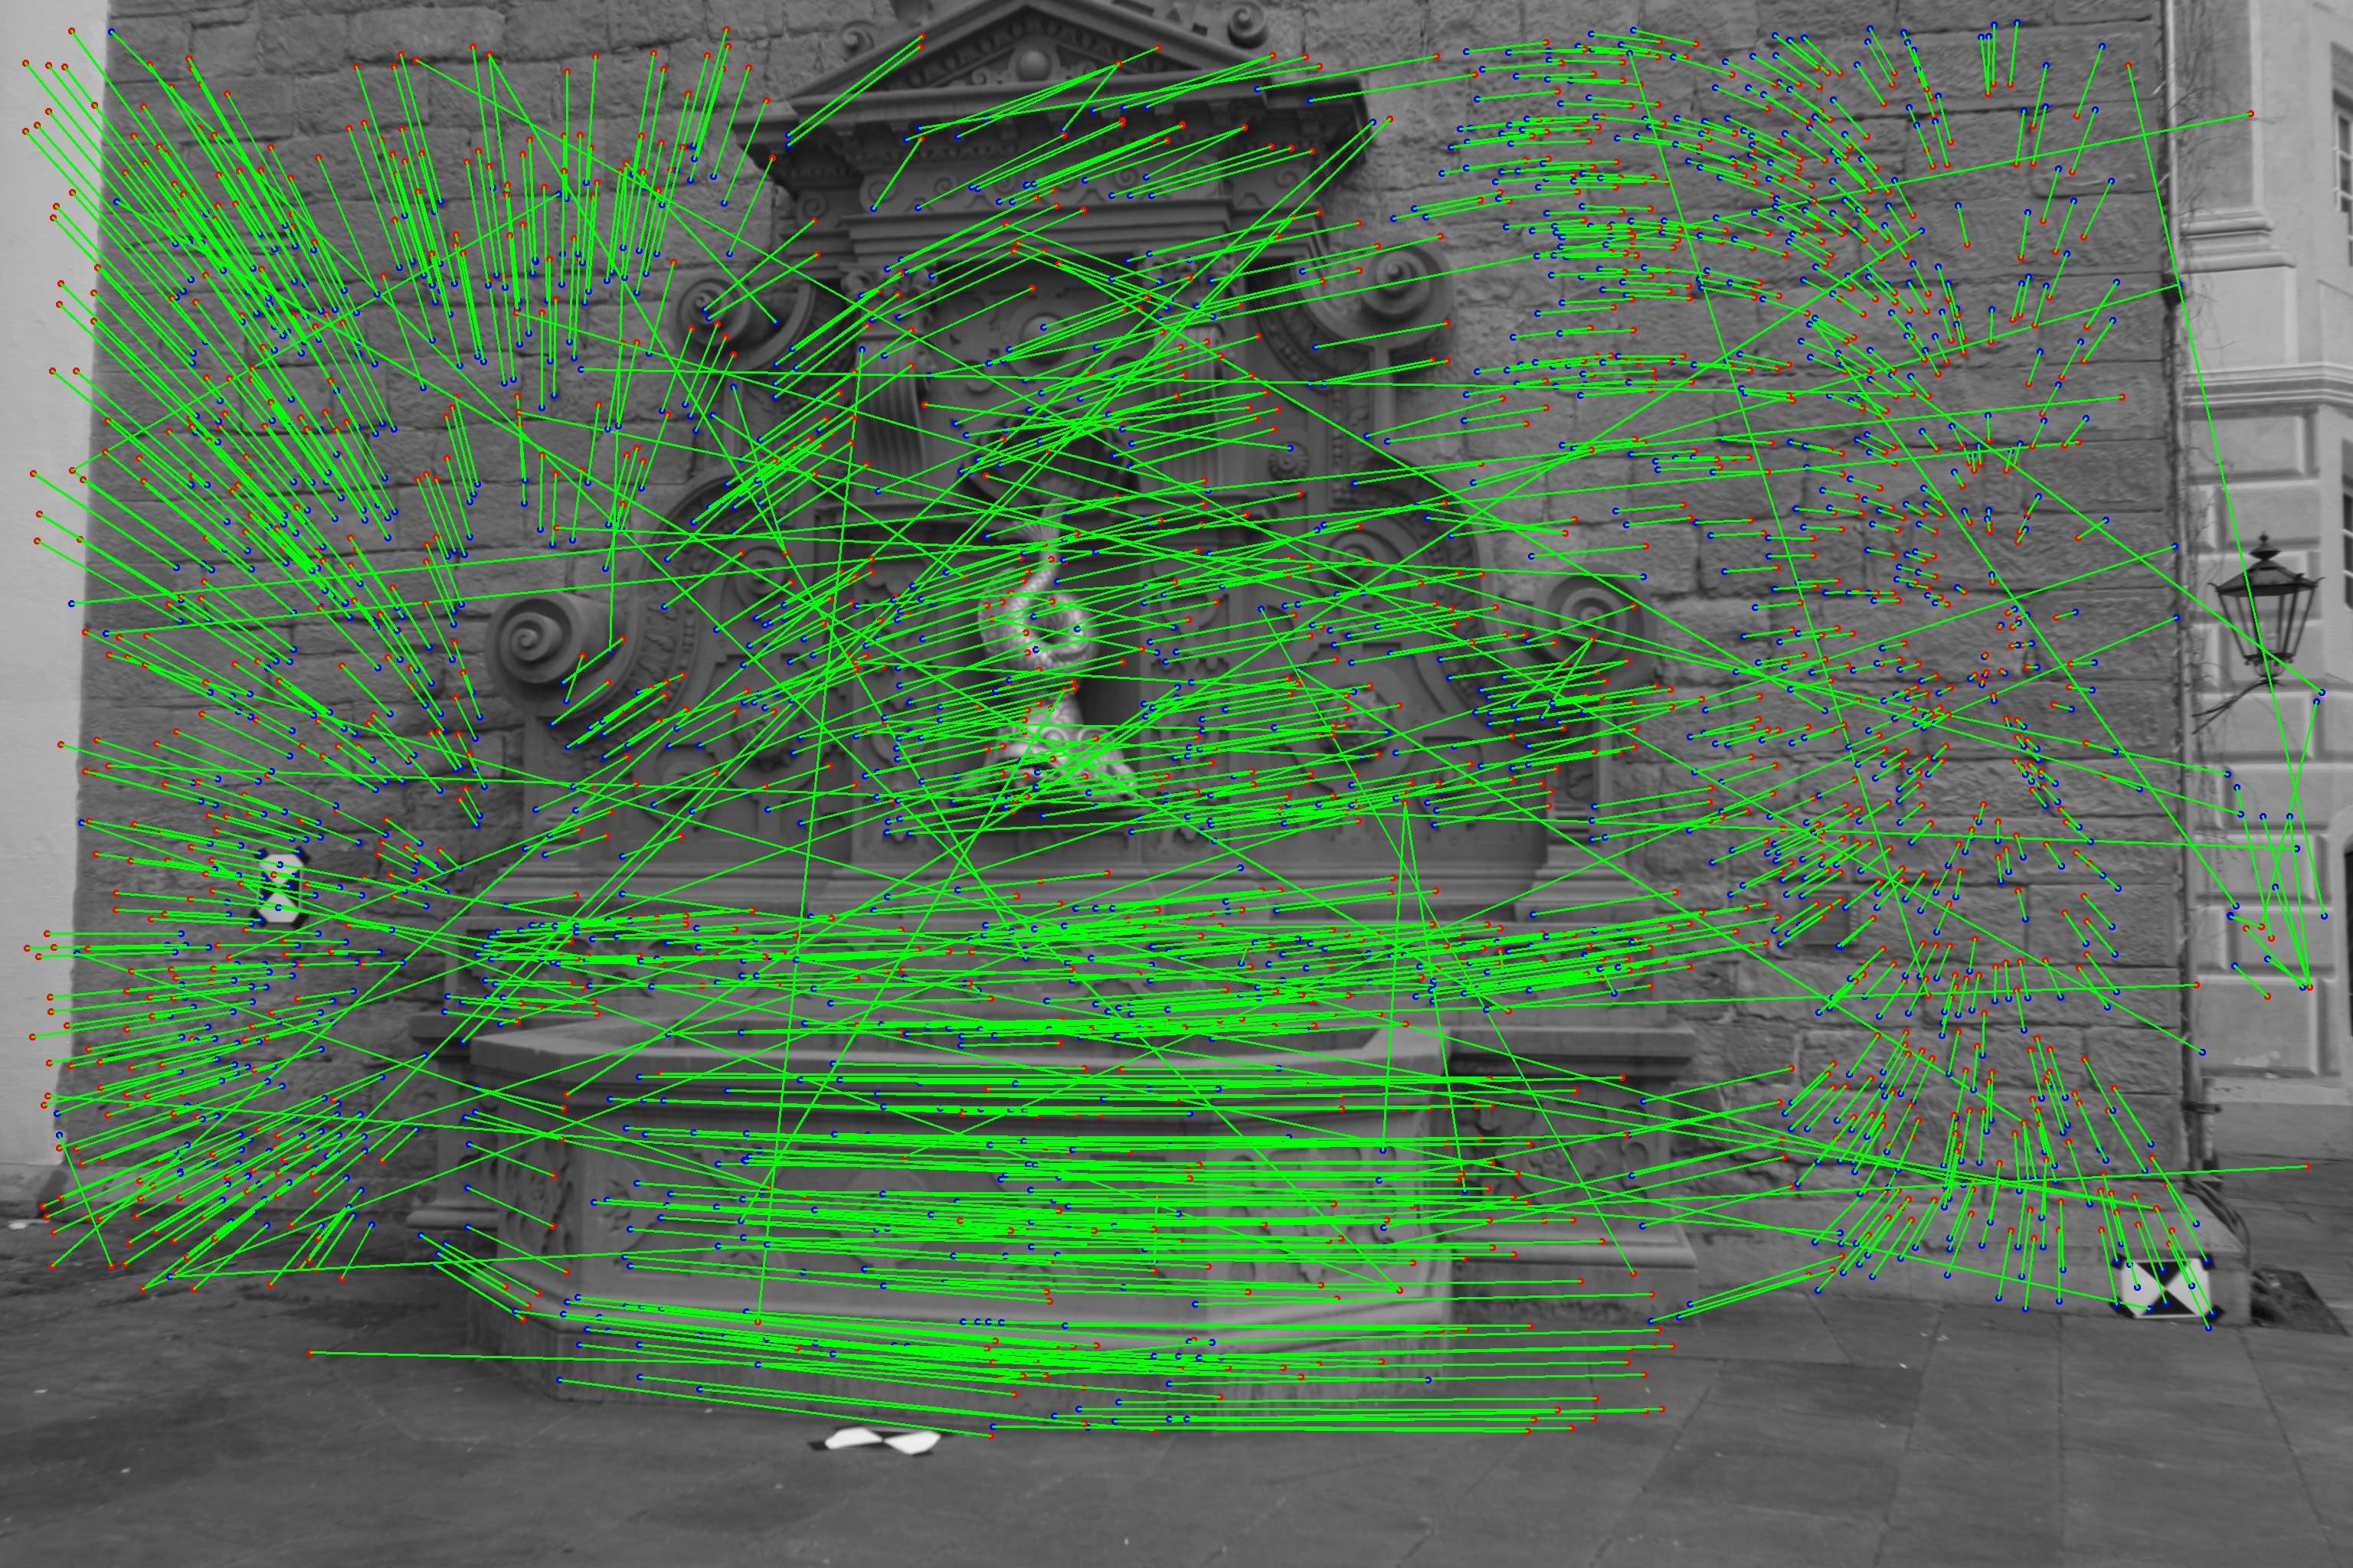
- a)

The image above displays all the feature correspondences over a greyscale version of image 1 (fountain1.jpg). The starting points (x_{i}) are indicated as red dots and the ending points (x_{i}’) as blue dots.

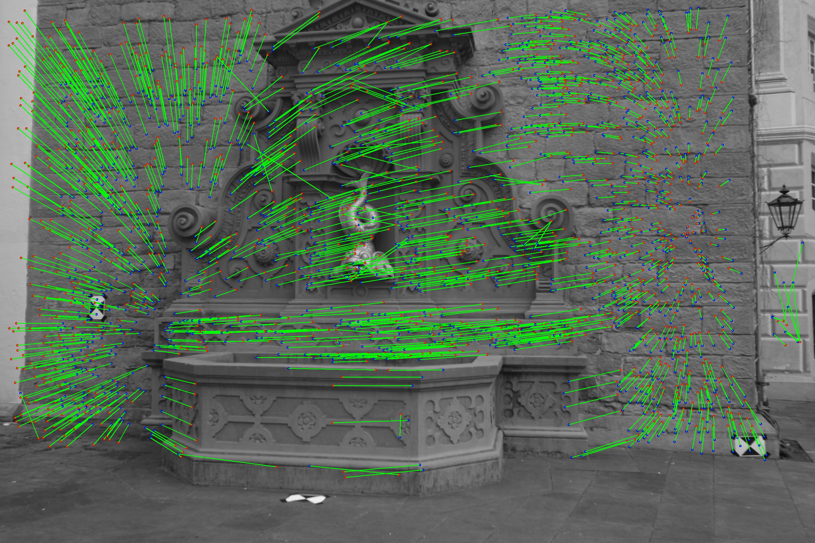
The second image displayed above are the feature correspondences with the outliers removed.
I removed the outliers by applying the interquartile rule and removing all matches with lengths beyond the upper bound of ~394 pixels.
1. b)
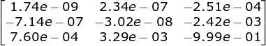
Fundamental matrix:

Inlier matches:

