**Hard Debiasing**

a) Neutralize: $\vec{w}≔{\left(\vec{w}-{\vec{w}}_{B}\right)}/{\left\|\vec{w}-{\vec{w}}_{B}\right\| , ∀ w∈N}$



b) Equalize: $\vec{w}≔v_{i}+\sqrt{1-{\left\|v_{i}\right\|}^{2}}\frac{{\vec{w}}_{B}-{μ_{i}}_{B}}{\left\|{\vec{w}}_{B}-{μ_{i}}_{B}\right\|}$



**Identify Bias Subspace**

1. $B≔$ first $k$ rows of $SVD\left(C\right)$

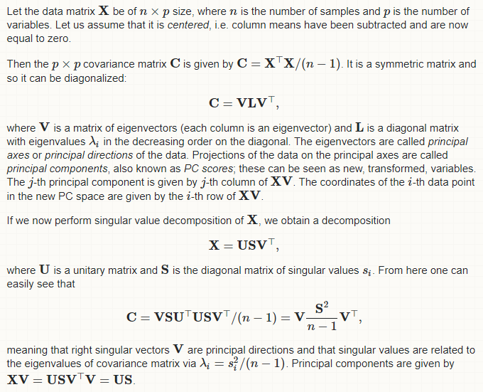

Reference: <https://bit.ly/2IJeAap>

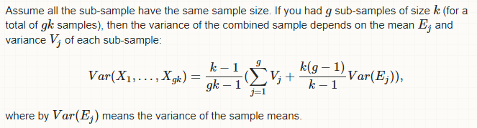

Reference: <https://bit.ly/2s6xqB9>

Paper assumptions: $Var\left(E_{j}\right)≈0$

Note: Removing the scalar ${\left(k-1\right)}/{\left(gk-1\right)}$ does not change the *eigenvectors* (i.e. the *principle-directions*). It only serves to scale up the *eigenvalues* equally, which does not change the order of the principle directions.