

**laboratory research**

**#3**

**IPC in FreeRTOS part 1: Queues**

Reporters: Juntao Gao

Date:2020-7-9

**Table of contents**

1 Description of the task 3

2 Specific implementation 3

2.1 The description of project creation 3

2.2 Compile and download 6

# 1 Description of the task

1. Read the FreeRTOS documentation about queue management
2. Create a new project
3. Create two task
4. Create one queue
5. One of the tasks flashes briefly LED when receiving information from the queue.
6. The second task writes any number to the queue and delayed 1 sec.
7. Write a report
8. Put the entire project (src) in GitHub, use .gitignore to avoid undesirable files

# 2 Specific implementation

## 2.1 The description of project creation

1、Create new STM32 project

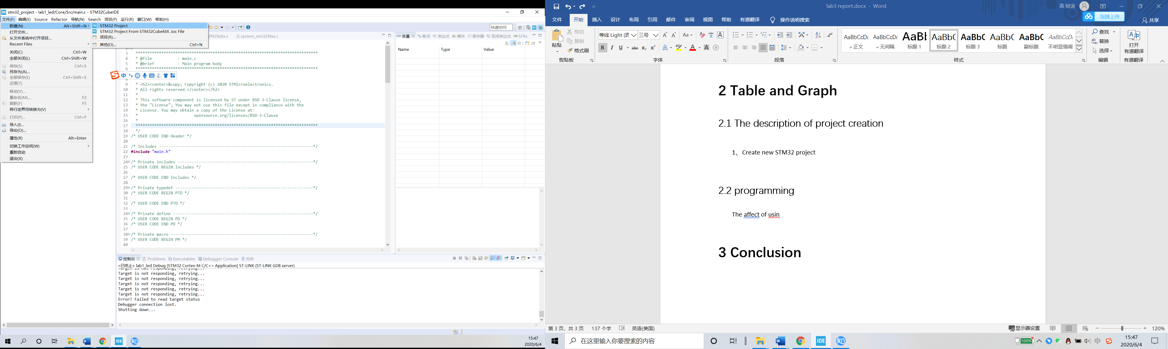

2、According to your hardware to select MCU

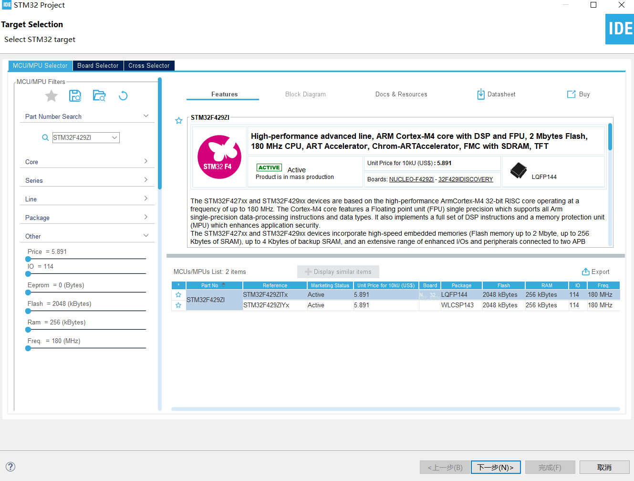

3、Select the name of your project

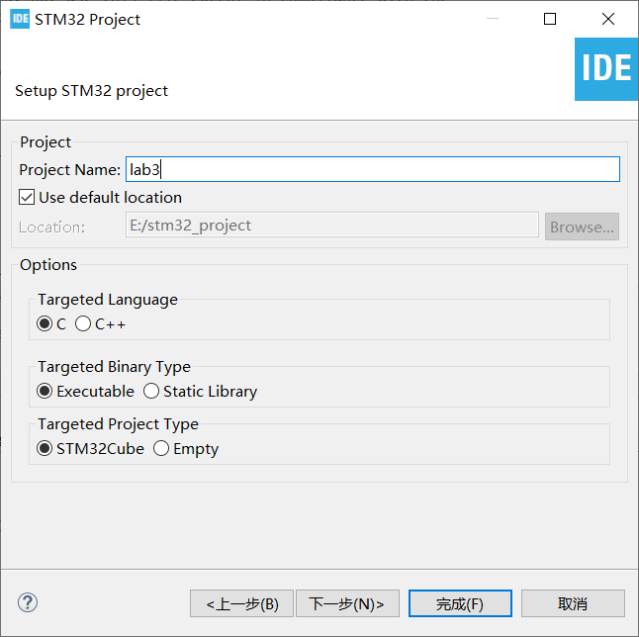

4、Switch IO port to the output.

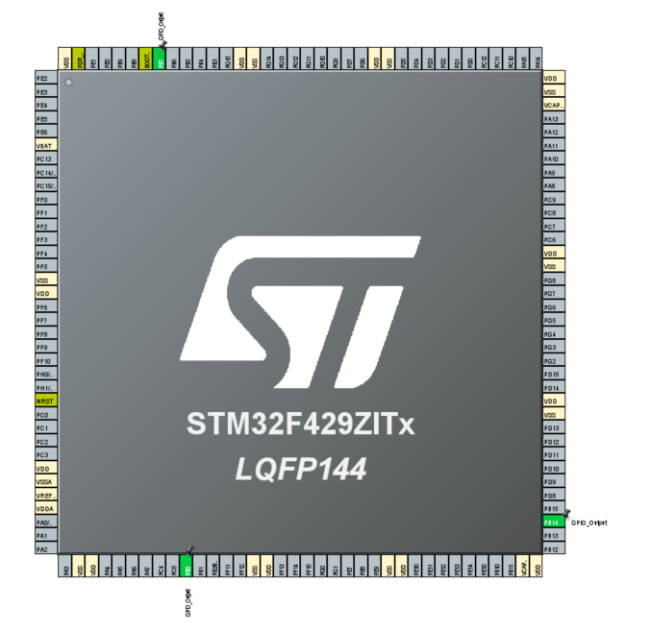

5、Set up Freertos

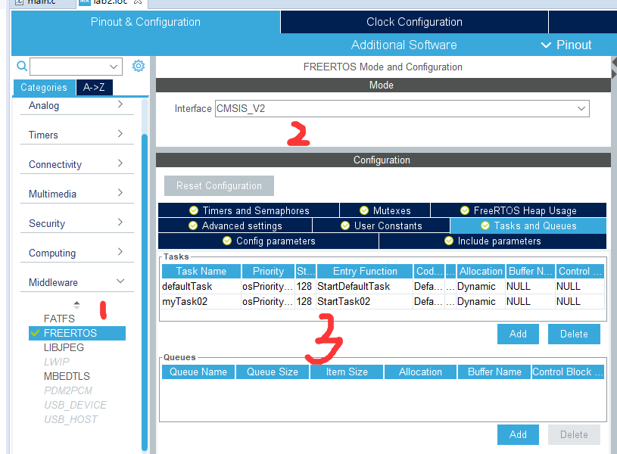

6、coding

Source code is on github

## 2.2 Compile and download

1、Compile

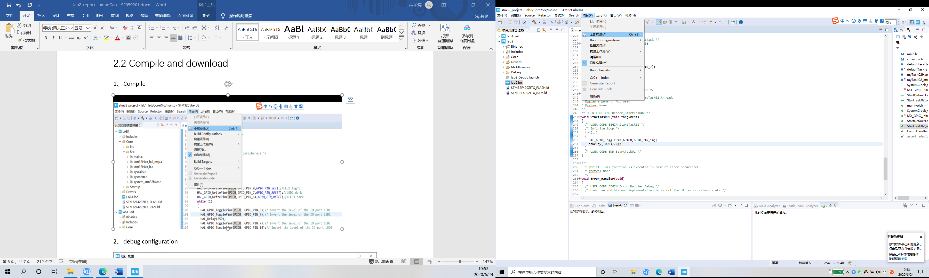

2、debug configuration

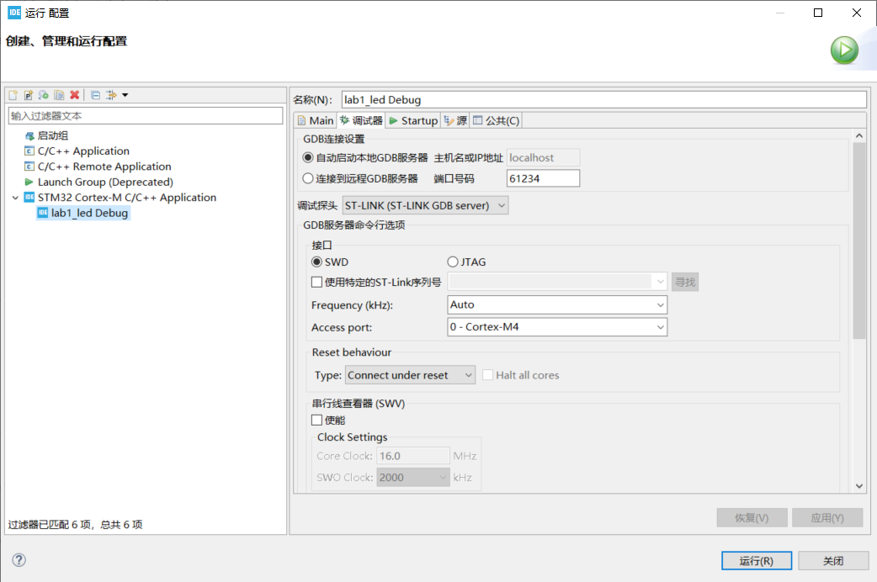

3、download

