

**laboratory research**

**#4**

**IPC in FreeRTOS part 2: Binary Semaphores, Counting Semaphores, Mutexes**

Reporters: Juntao Gao

Date:2020-7-24

**Table of contents**

1 Description of the task 3

2 Specific implementation 3

2.1 The description of project creation 3

2.2 Compile and download 7

3 Conclusion 8

# 1 Description of the task

**1.** Create three tasks.

**2.** Create two queues. The size of queues is 7 integer numbers. The first queue should

be used to transmit data from Task 1 to Task 2. The second queue should be used to

transmit data from Task 1 to Task 3.

**3.** Task 1 should increment the local integer variable “counter” once per second.

Task 1 sends the “counter” value to Task 2 once per second and to Task 3 once

per two seconds. The incrementing of “counter” variable should be paused if the

corresponding queue is full and resumed if the corresponding queue is not full.

**4.** Task 2 and Task 3 should toggle LED LD2 once per 500 ms. The number of toggling

is equal “counter” variable received using queue from Task 1. The LED is shared

resource between Task 2 and Task 3. Task 2 or Task 3 should work with the shared

LED using a counting semaphore.

# 2 Specific implementation

## 2.1 The description of project creation

1、Create new STM32 project

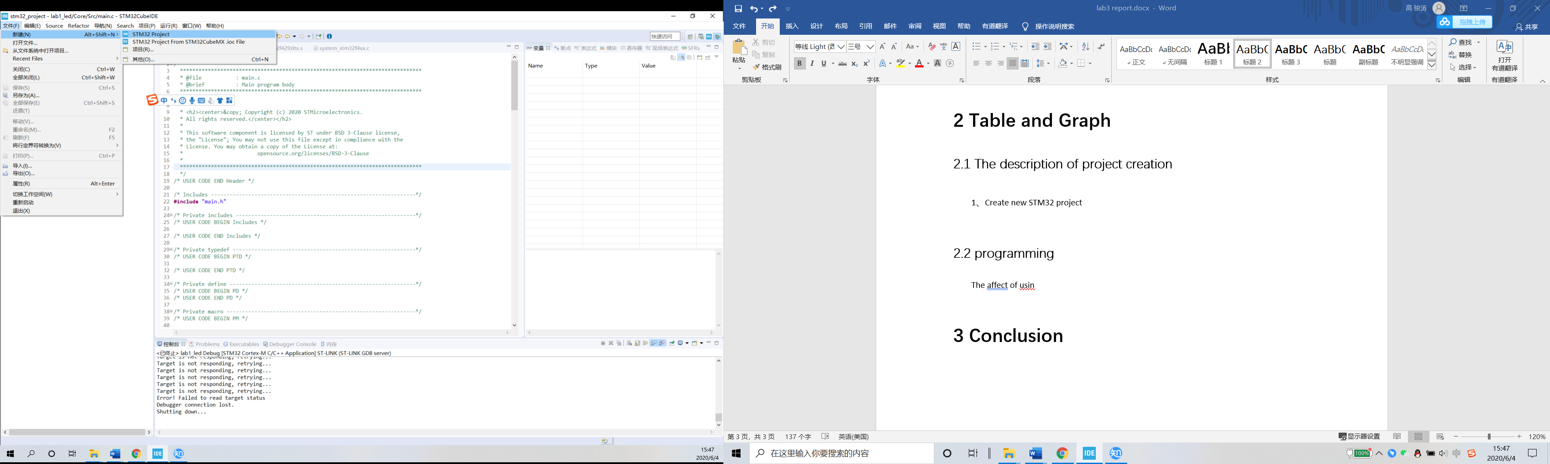

2、According to your hardware to select MCU

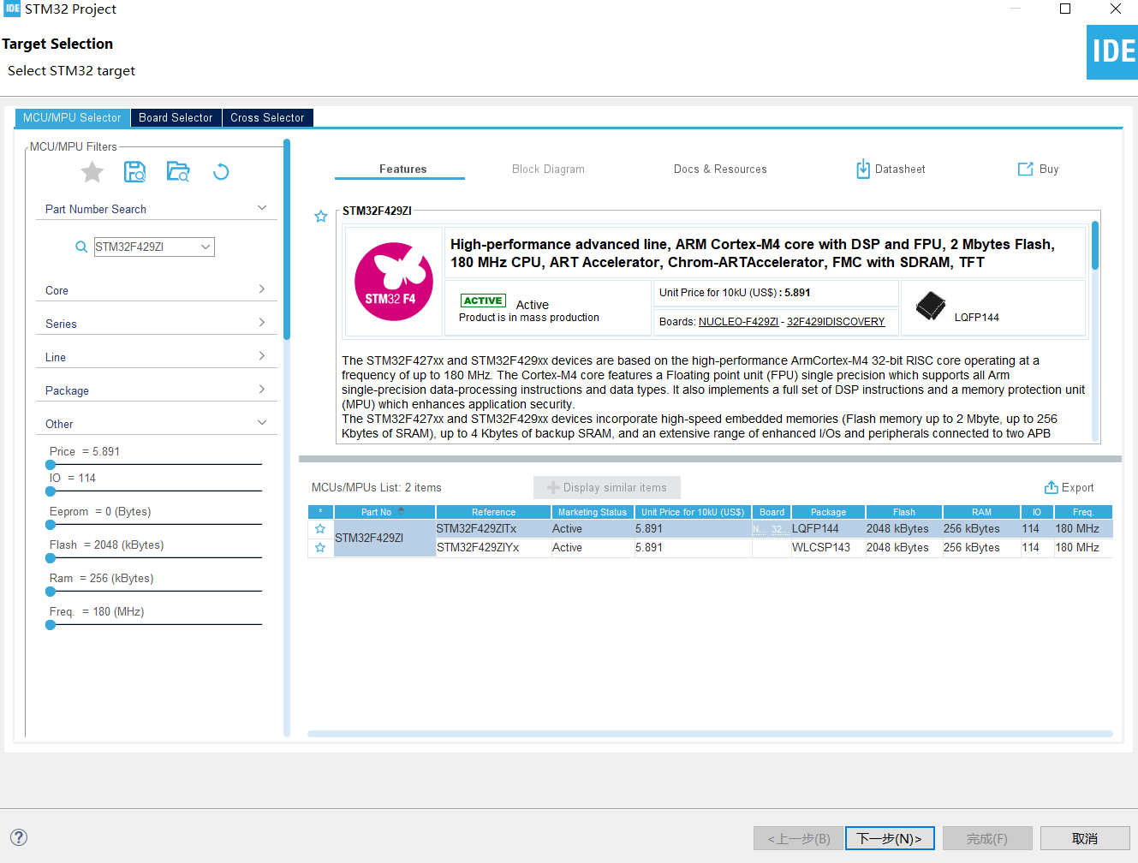

3、Select the name of your project

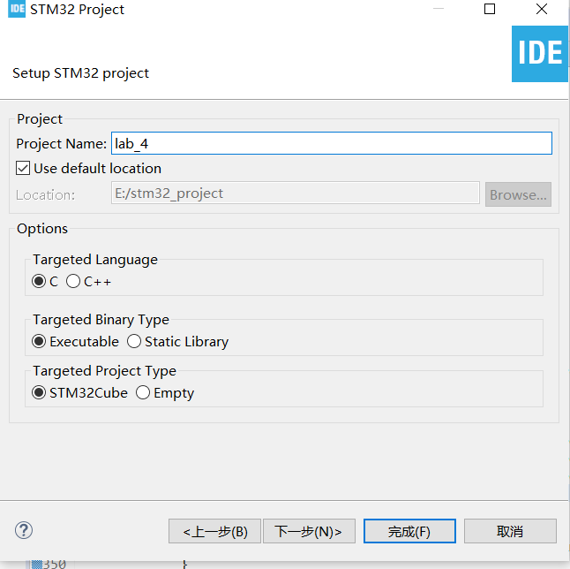

4、Switch IO port to the output.

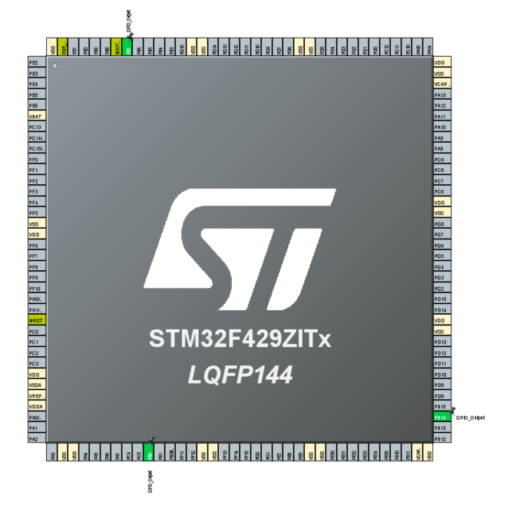

5、Set up Freertos

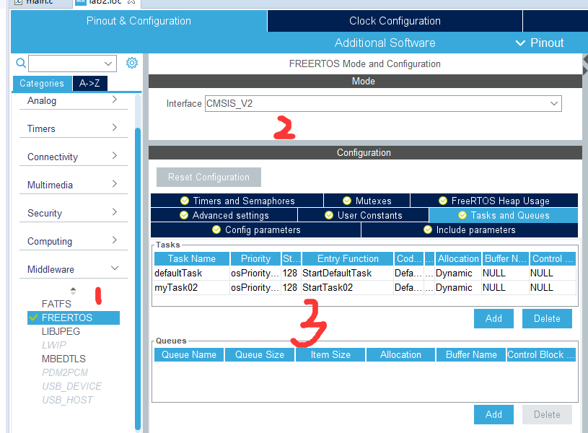

6、coding

Source code is on github

## 2.2 Compile and download

1、Compile

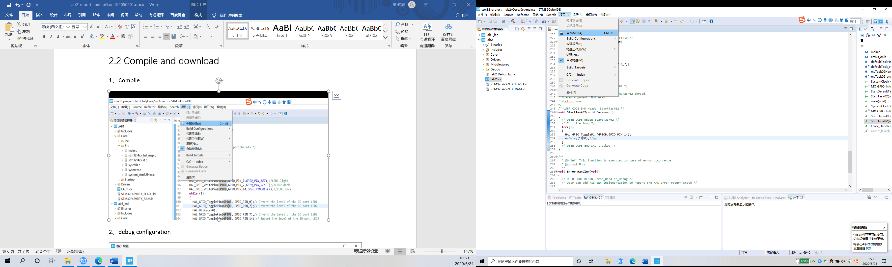

2、debug configuration

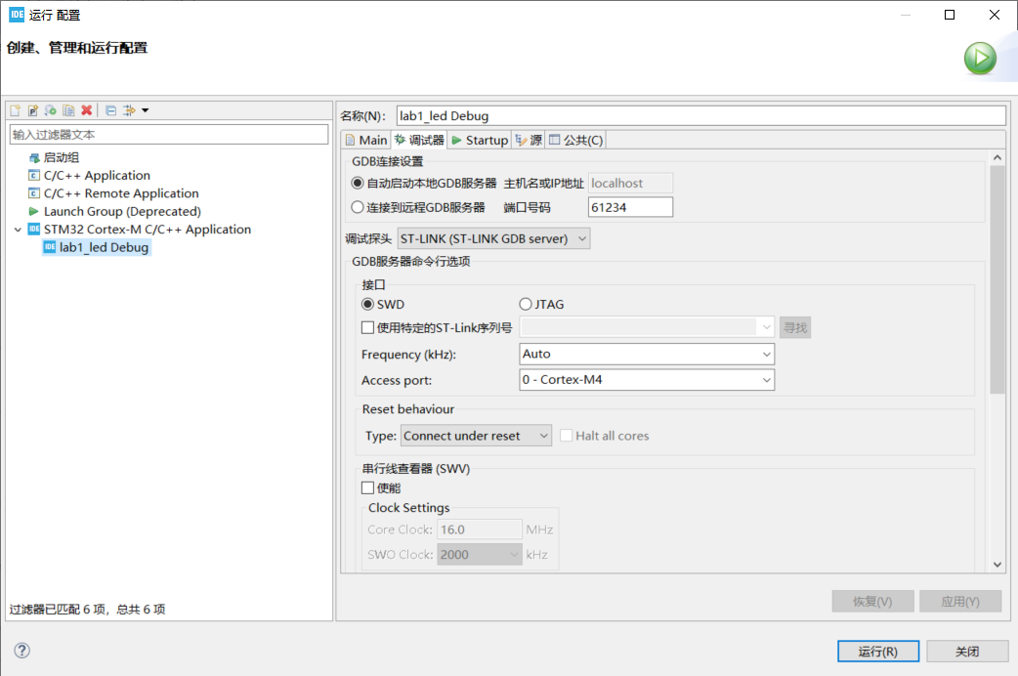

3、download

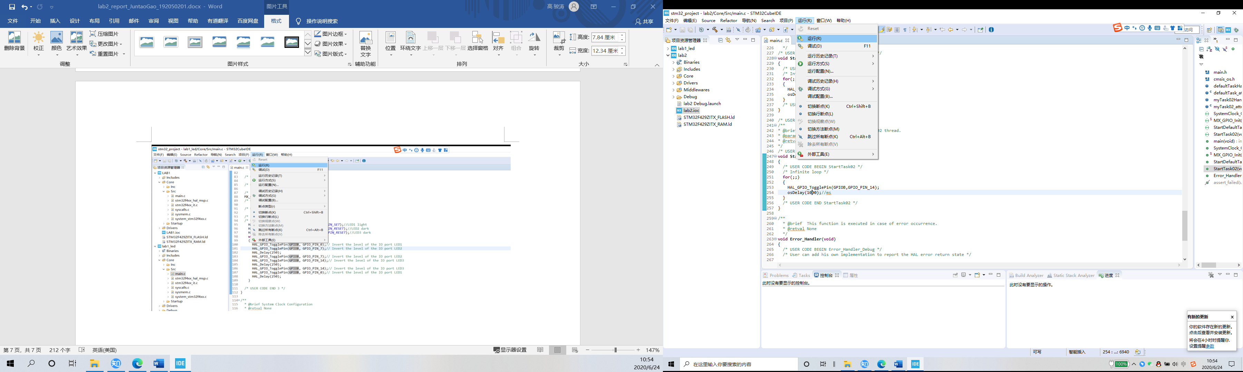

# 3 Conclusion

In this experiment, we set up three tasks and two queues. in task one, we transmit the count values to queue one and queue two, and read the values in the queues in task two and task three, and occupy LED2 resources together to make them blink. in order for task two and task three to share resources LED2 together, we use counting semaphores.