Software Requirements Specification
For
GO-Safe
Version 1.0

Prepared by: - Kodamasimham Aakash

NIIT University
Date: 8/17/2016
Table of Contents
Table of Contents ii
Revision History ii
1. Introduction 1
1.1 Purpose 1
1.2 Document Conventions 1
1.3 Intended Audience and Reading Suggestions 1
1.4 Product Scope 1
1.5 References 1
2. Overall Description 2
2.1 Product Perspective 2
2.2 Product Functions 2
2.3 User Classes and Characteristics 2
2.4 Operating Environment 2
2.5 Design and Implementation Constraints 2
2.6 User Documentation 2
2.7 Assumptions and Dependencies 3
3. External Interface Requirements 3
3.1 User Interfaces 3
3.2 Hardware Interfaces 3
3.3 Software Interfaces 3
3.4 Communications Interfaces 3
4. System Features 4
4.1 System Feature 1 4
4.2 System Feature 2 (and so on) 4
5. Other Nonfunctional Requirements 4
5.1 Performance Requirements 4
5.2 Safety Requirements 5
5.3 Security Requirements 5
5.4 Software Quality Attributes 5
5.5 Business Rules 5
6. Other Requirements 5
Appendix A: Glossary 5
Appendix B: Analysis Models 5
Appendix C: To Be Determined List 6

Revision History
Name | Date | Reason For Changes | Version
Group | 8/17/16 | Initiation of the project | V 1.0

Introduction
Transport is an integral part of our society. There are many companies that provide transport facility. The client have to contact the transport company and the company books the cab for the client at the date and time the client needs and sends to their location. The GO-Safe is a website that’s is giving the facility automate the process of booking a cab and will reduce time for both company and client. First, the company has to register the vehicles in the system. Then the client can book the cab for his required date and time. Or if the client want to share the cab with anyone, then the client can opt for sharing the cab. This will notify all the other clients that will be going in the same date and time to the location .Providing all the information and the fare will be calculated and will be shown there. The client can check and confirm it. Then the cab driver will serve the client/client’s on the client’s date and time. After that the client can give a feedback over the service he got. Then this feedback goes to the company and the company can check and take appropriate action future improvement.

Purpose
The purpose of the SRS document is to specify the software requirement for the GO-Safe. This document describes the project's target customer and software requirements. It defines how our team and customer’s see the product and its functionality.
This is the web based function version1.0 that is used for booking the cab and sharing the cabs. This document will have the whole functionality of the system. Specific design and implementation details will be specified in a future document. This helps us as a designer and developer to assist in a software delivery cycle (SDLC) process.

Document Conventions
All the text is in Times New Roman, and font for main heading is 18, for sub-main heading is 16 and the contact is of 14. The BOLD refers to as Type of function used in making this website.

Intended Audience and Reading Suggestions
This document is intended to be an open-source project so any one can read it.

Product Scope
The aim of the project is to automate the process of the system of booking the cab, and a new feature of sharing the cab, calculating the fare, connecting the clients and server the client / client’s. The details given by the companies and clients i.e. the data is stored in the database which is the center of all information are being held by company cab drivers and clients. This make the job easier who are involved in this.

References
http://www.heidisql.com/download.php

http://argouml.en.softonic.com/

Overall Description

Product Perspective
Go-Safe is the Transport facility. The system is replacement of certain other systems and combination of the some systems. As some companies are only providing the facility of booking the cab while the local cabs are used for sharing the cabs. So we have implemented this technique where we combine both the feature, where the client can use the service that is needed. The client can book the cab from the list of the vehicles given by the company or share the cab which are being used by other clients who want to share the fare and travel at the same date and time and even the location.
Use Case diagram:
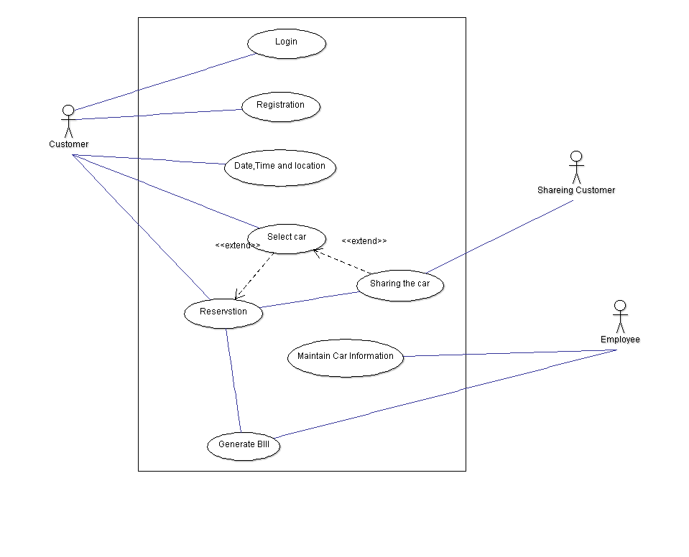

Product Functions
This system will give the following functions to the client:
- The client can book a cab from anywhere through the use of internet.
- With the specified date and time given by the client, this will produce/show the available cabs.
- This system also provides a function for sharing the cab among the clients only if the client that booked a cab want to share.
- The sharing will be shown to others if the client has opted for sharing the cab with others and the traveling date and time is same or nearly same.
- There we be email sent to the clients for cab booking and for sharing also. There will be a span of 1 hour to cancel the booked cab if the client unknowly or wrongly book a cab

User Classes and Characteristics
Here the clients/user will be defined upon the frequency of the service that is being used. Since we are having cab booking and cab sharing the main priority goes to sharing than booking. The main user who have to go frequently over a distance on a daily bases, then the sharing will lower the fare so there the user will have advantage over it other than booking a cab only for him on a daily bases. Since we are proving the information of the other users who are also willing to share the cab so that the user can confirm from their security. The cab booking will be used but not as much as the sharing one, as the cab booking is used if the user is traveling a long distance or want privacy. Even in both the cases the cab driver will be server the job well.

Operating Environment
Since “GO-Safe” is a website based so the environment that it will work is:
Client on Internet: Web Browser, Operating System (any)
Client on Intranet: Client software, Web Browser, Operating System (any)
Web Server: WAMP server, 000webhosting.com
Database: HEIDI SQL
Code Editor: Sublime Text Editor
Bootstrap: For making the web browser compatible in mobile view.
Php documentation: For defining function.
Development End: HTML, php, JavaScript

Design and Implementation Constraints
This system does require timing as for sharing a cab the timing and date should be same for booking. We are using the database over a single company as for initial starting. Here we have made an easy to use interface which does not require any much experience for the client. Used language English. We are making this on WAMP server over initial or 000webhosting.

User Documentation
There will be a navigation bar from which the user can contact with help-line for any doubt/help. This service will be 24/7.

Assumptions and Dependencies
The following are some assumptions and dependencies:
- If the company that we are undertaking is in a remote area and there the company is not using the internet, then we have to give them guidance over this and make them efficient as others.
- Even if the company is well known of the internet, but no human resources is available for updating the available or busy cabs regarding a particular company.
- Assuming, vehicles are already purchased and available for use.

External Interface Requirements

User Interfaces
The user interface will be done by using HTML and CSS. Since this is a website we are not using any keyboard shortcuts. While log-In if the client is typing wrong username or password then there will be an error generated. If the client want to cancel the booking there will be a span of 1 hour for canceling the booking using a specific button.

Hardware Interfaces
- Server side hardware:
- Hardware recommended by the software needed.
- Communication needed between the server and client request.
2. Client side hardware:
- Hardware for clients is the operating system and web browser.
- Communication hardware to communicate with the server

Software Interfaces
Server side software:
- Web server: WAMP server, 000webhosting.com
- Scripting tool: PHP, Sublime text editor
- Database tool: HEIDI SQL
- Operating system: Windows
Client side software:
- Web browser: ANY
- Operating System: ANY

Communications Interfaces
We are using WAMP as this is only for localhost for initial version. For another version we will use the 000webhosting and use that as a server and use a secure connection between server and clients.

System Features

System Feature 1
<Don’t really say “System Feature 1.” State the feature name in just a few words.>
4.1.1 Description and Priority
<Provide a short description of the feature and indicate whether it is of High, Medium, or Low priority. You could also include specific priority component ratings, such as benefit, penalty, cost, and risk (each rated on a relative scale from a low of 1 to a high of 9).>
4.1.2 Stimulus/Response Sequences
<List the sequences of user actions and system responses that stimulate the behavior defined for this feature. These will correspond to the dialog elements associated with use cases.>
4.1.3 Functional Requirements
<Itemize the detailed functional requirements associated with this feature. These are the software capabilities that must be present in order for the user to carry out the services provided by the feature, or to execute the use case. Include how the product should respond to anticipated error conditions or invalid inputs. Requirements should be concise, complete, unambiguous, verifiable, and necessary. Use “TBD” as a placeholder to indicate when necessary information is not yet available.>

<Each requirement should be uniquely identified with a sequence number or a meaningful tag of some kind.>

REQ-1:
REQ-2:

System Feature 2 (and so on)

Other Nonfunctional Requirements

Performance Requirements
We have made the website a user friendly based. The user does not need have any other special experience for knowing what to be done here and there. We have taken the outmost care for the UI to be easy use or access. And the user any use any browser to use our site.

Safety Requirements
We are using a sample website we are creating a server using the WAMP. If we implement it to the real world then we will use a certified safety.

Security Requirements
The client has to register to our website and the client can give the username and password of his choice (except if the username is already taken). The client logins from with that information. This way the profile and history of travels done by the client is safe with him.

Software Quality Attributes
We are giving a feedback which will define the company’s cab driver or vehicle status or etc. The management team would go over these feedback given by the client, and if a company is getting more bad reviews from the clients then we may cut-out the agreement with them as this may be making the clients un-happy.

Business Rules
The role of the company is to update the status of the cab, i.e. it is available or not. This can be done by employing a person to do this particular task for over some companies rather than each company. The employee will be updating about the cab status.

Other Requirements
We are taking a database over a single company, as for initial movement. Showing the cab available by them. As for initial situation we are not thinking about making it international available. We are using some objectives of the other companies like Ola, Uber for cab booking (except the GPS tracking) and the Cab-Ahead for cab sharing. We combine these two ideas and made the website for it.

Appendix A: Glossary
HTML: Hyper Text Markup Language
SQL: Structured Query Language
CSS: Cascading Style Sheets
Appendix B: Analysis Models
This is a user side USE Case Diagram:
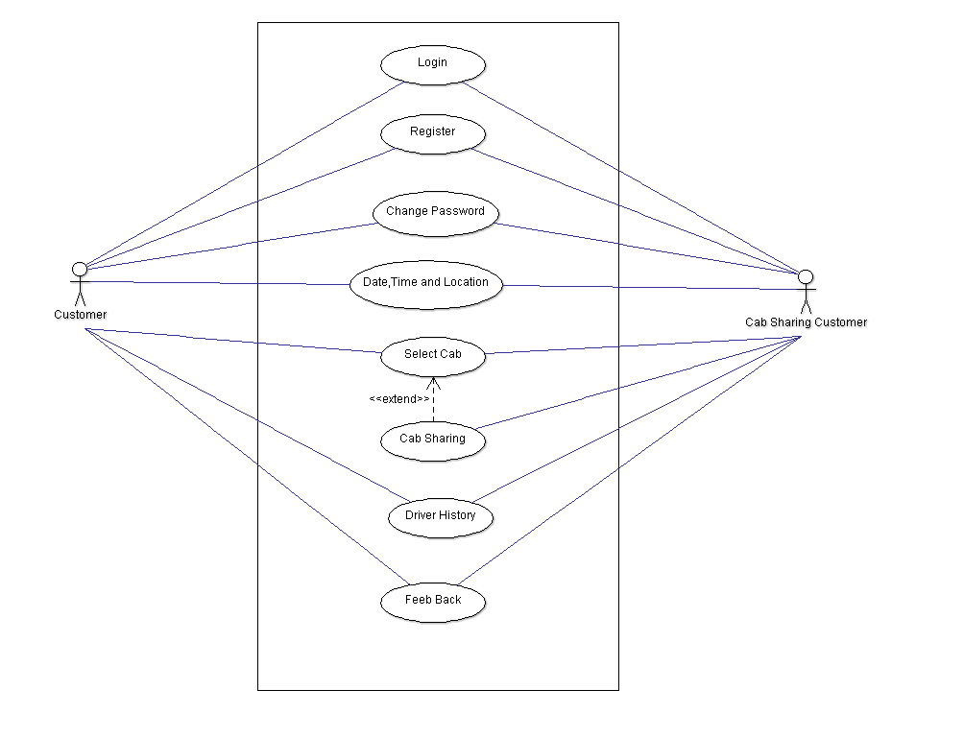
This is the Employee side:

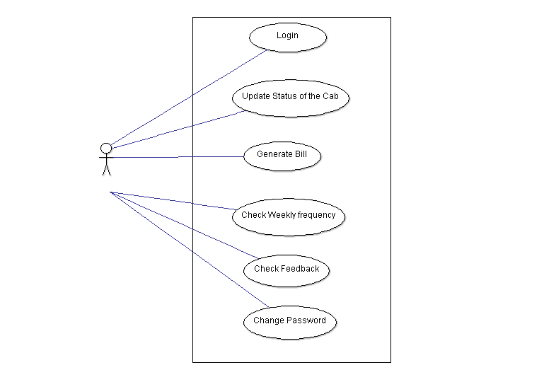

Appendix C: To Be Determined List
- Other sites can redirect to our page for transport like for going to railway station, airport, or even make a plan for tour.
- Should or should not make the transaction be done through a gateway or the client will direct pay to driver.

