Built-in Exception :

- C# .NET includes built-in exception classes for every possible error.
- The Exception class is the base class of all the exception classes.

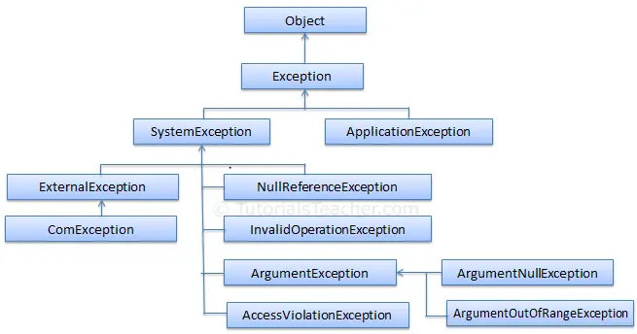
.

Built-in Exception Classes :

The following table lists important built-in exception classes in .NET.
Exception Class | Description
ArgumentException | Raised when a non-null argument that is passed to a method is invalid.
ArgumentNullException | Raised when null argument is passed to a method.
ArgumentOutOfRangeException | Raised when the value of an argument is outside the range of valid values.
DivideByZeroException | Raised when an integer value is divide by zero.
FileNotFoundException | Raised when a physical file does not exist at the specified location.
FormatException | Raised when a value is not in an appropriate format to be converted from a string by a conversion method such as Parse.
IndexOutOfRangeException | Raised when an array index is outside the lower or upper bounds of an array or collection.
InvalidOperationException | Raised when a method call is invalid in an object's current state.
KeyNotFoundException | Raised when the specified key for accessing a member in a collection is not exists.
NotSupportedException | Raised when a method or operation is not supported.
NullReferenceException | Raised when program access members of null object.
OverflowException | Raised when an arithmetic, casting, or conversion operation results in an overflow.
OutOfMemoryException | Raised when a program does not get enough memory to execute the code.
StackOverflowException | Raised when a stack in memory overflows.
TimeoutException | The time interval allotted to an operation has expired.

Exception Handling :

Exceptions in the application must be handled to prevent crashing of the program and unexpected result, log exceptions and continue with other functionalities.
C# provides built-in support to handle the exception using try, catch & finally blocks.

Syntax :

try
{
// put the code here that may raise exceptions
}
catch
{
// handle exception here
}
finally
{
// final cleanup code
}

try block :

Any suspected code that may raise exceptions should be put inside a try{ } block.

During the execution, if an exception occurs, the flow of the control jumps to the first matching catch block.

catch block :

The catch block is an exception handler block where you can perform some action such as logging and auditing an exception.

The catch block takes a parameter of an exception type using which you can get the details of an exception.

finally block :

The finally block will always be executed whether an exception raised or not.

Usually, a finally block should be used to release resources, e.g., to close any stream or file objects that were opened in the try block.

class Program
{
static void Main(string[] args)
{
try
{
Console.WriteLine("Enter a number: ");

var num = int.parse(Console.ReadLine());

Console.WriteLine($"Squre of {num} is {num * num}");
}
catch
{
Console.Write("Error occurred.");
}
finally
{
Console.Write("Re-try with a different number.");
}
}
}

In the above example, we wrapped this code inside a try block. If an exception occurs inside a try block, then the program will jump to the catch block.

Inside a catch block, we display a message to instruct the user about his mistake, and in the finally block, we display a message about what to do after running a program.

Note:
-------------------------------------------------------------------------------------------------------------------------------------------
A try block must be followed by catch or finally or both blocks. The try block without a catch or finally block will give a compile-time error.
----------------------------------------------------------------------------------------------------------------------

Exception Filters :

You can use multiple catch blocks with the different exception type parameters. This is called exception filters.

Exception filters are useful when you want to handle different types of exceptions in different ways.

Example: Exception Filters

class Program
{
static void Main(string[] args)
{
Console.Write("Please enter a number to divide 100: ");

try
{
int num = int.Parse(Console.ReadLine());

int result = 100 / num;

Console.WriteLine("100 / {0} = {1}", num, result);
}
catch(DivideByZeroException ex)
{
Console.Write("Cannot divide by zero. Please try again.");
}
catch(InvalidOperationException ex)
{
Console.Write("Invalid operation. Please try again.");
}
catch(FormatException ex)
{
Console.Write("Not a valid format. Please try again.");
}
catch(Exception ex)
{
Console.Write("Error occurred! Please try again.");
}
}

}

Note:
------------------------------------------------------------------------------------------------------------------------------------------
Multiple catch blocks with the same exception type are not allowed. A catch block with the base Exception type must be the last block.
------------------------------------------------------------------------------------------------------------------------------------------

Invalid catch Block :

A parameterless catch block and a catch block with the Exception parameter are not allowed in the same try-catch statements, because they both do the same thing.

Example: Invalid catch
try
{
//code that may raise an exception
}
catch //cannot have both catch and catch(Exception ex)
{
Console.WriteLine("Exception occurred");
}
catch(Exception ex) //cannot have both catch and catch(Exception ex)
{
Console.WriteLine("Exception occurred");
}

finally Block :
The finally block is an optional block and should come after a try or catch block.
The finally block will always be executed whether or not an exception occurred.
The finally block generally used for cleaning-up code e.g., disposing of unmanaged objects.

Example: finally Block
static void Main(string[] args)
{
FileInfo file = null;

try
{
Console.Write("Enter a file name to write: ");
string fileName = Console.ReadLine();
file = new FileInfo(fileName);
file.AppendText("Hello World!")
}
catch(Exception ex)
{
Console.WriteLine("Error occurred: {0}", ex.Message );
}
finally
{
// clean up file object here;
file = null;
}
}
Note:
------------------------------------------------------------------------------------------------------------------
Multiple finally blocks are not allowed. Also, the finally block cannot have the return, continue, or break keywords. It doesn't let control to leave the finally block.
----------------------------------------------------------------------------------------------------------------------------------------

Nested try-catch :

C# allows nested try-catch blocks. When using nested try-catch blocks, an exception will be caught in the first matching catch block that follows the try block where an exception occurred.

Example: Nested try-catch
static void Main(string[] args)
{
var divider = 0;

try
{
try
{
var result = 100/divider;
}
catch
{
Console.WriteLine("Inner catch");
}
}
catch
{
Console.WriteLine("Outer catch");
}
}

