**ER Diagram Justifications**

***TABLES:***

Table Conference:

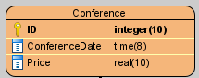

Table that saves the conferences.

* ID: Conference Identifier
* ConferenceDate: Conference Date
* Price: Conference Price

Table Participant:

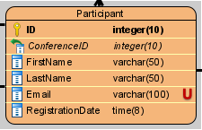

As there are several people who are participating this table will hold all the data common to all participants.

* ID: Participant ID
* ConferenceID: Conference ID (references the conference id that the participant will participate)
* FirstName: Participant First Name
* LastName: Participant Last Name
* Email: Participant Email (UNIQUE)
* RegistrationDate: Participant Registration Date (must precedes the conference date that the participant will participate)

Table PaymentType:

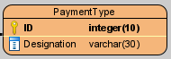

Table that saves the payment types.

* ID: Payment Type Identifier
* Designation: Payment Type Designation (visa,mastercard,cash,paypal,etc.)

Table Payment:

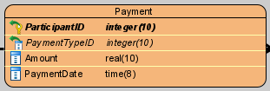

Table that saves the participants payments relating to the conferences.

* ParticipantID: Participant Identifier (references the participant id who made the payment)
* PaymentTypeID: Payment Type Identifier (references the payment type id with which payment was made)
* Amount: Payment Amount
* PaymentDate: Payment Date (must precedes the participant registration date)

Table ConferenceParticipant:



Table that saves the conference participants.

* ParticipantID: Participant Identifier (references the participant id)

Table Useer:

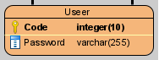

As there are several people who are users this table will hold all the data common to all users.

* Code: User Code
* Password: User Password

Table Administrator:

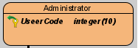

Table that saves the administrators.

* UseerCode: User Code (references the user code)

Table MemberRole:

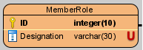

Table that saves the members roles.

* ID: Member Role Identifier
* Designation: Member Role Designation (UNIQUE)

Table MemberCommitte:

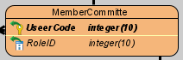

Table that saves the members committe.

* UseerCode: User Code (references the user code)
* RoleID: Member Role Identifier (references the role id that the member has)

Table TypeOpinion:

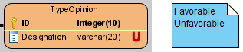

Table that saves the Opinion Type.

* ID: Opinion Type Identifier
* Designation: Opinion Type Designation (favorable **or** unfavorable)

Table Article:

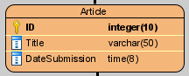

Table that saves the articles.

* ID: Article Identifier
* Title: Article Title
* DateSubmission: Article Date of Submission

Table ArticleReview:

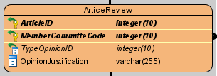

Table that saves the article reviews. This table exists as an intermediary between membercommitte and article, because there would be a many-to-many link between them. Thus, the model is normalized.

* ArticleID: Article Identifier (references the article id that had review)
* MemberCommitteCode: Member Committe Code (references the member committe code who did the review)
* TypeOpinionID: Type Opinion Identifier (references the type opinion id that that the member committe gave)
* OpinionJustification: Article Review Opinion Justification.

Table ArticleAuthor:

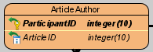

Table that saves the article authors.

* ParticipantID: Participant Identifier (references the participant id)
* ArticleID: Article Identifier (references the article id in which the author participated)

***Connections between Tables and Cardinalities:***

Payment and PaymentType:

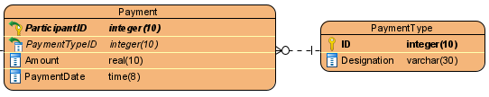

The payment has **one** payment type but a payment type can be used in **zero or more** payments.

Participant and Payment:

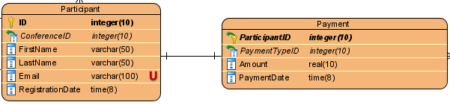

The participant makes **one** payment and a payment is from **one** participant.

Participant and Conference:

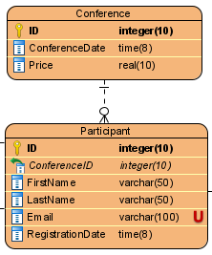

A conference can have **zero or more** participants, but a participant can only participate in **one** conference.

MemberCommitte and MemberRole:

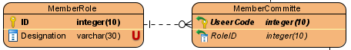

A member committee has **one** role but a role can be associated with **zero or more** members.

ArticleReview and TypeOpinion:

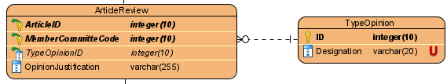

The article review has **one** type of opinion but the type of opinion may be based on several article reviews.

ArticleAuthor and Article:

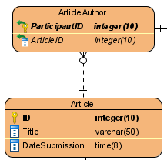

An article can be written by **zero or more** article authors but an article author can only write **one** article.