Customer Transaction Analysis
Data Analytics Project Report
Dataset: 50,000 card transactions, 1 January to 14 October 2023
Tools: Python (Pandas, NumPy, Matplotlib, SciPy), SQL, Excel, Power BI
Prepared by: Gautam Kurpatwar
GitHub: github.com/GK3210

Contents
1. Executive Summary
2. Business Problem and Objectives
3. Dataset Description
4. Methodology
5. Data Cleaning and Quality Assessment
6. Key Metrics
7. Analysis and Findings
8. Statistical Validation
9. Business Insights and Recommendations
10. Limitations
11. Tools, Reproducibility and Project Structure
12. Next Steps
13. Conclusion
Appendix A: SQL Queries

1. Executive Summary
This project analyses 50,000 customer card transactions worth $22.11 million, recorded over 287 days in 2023, to understand where revenue comes from and how spending varies by category, customer group and time. The work covers data cleaning, feature engineering, exploratory analysis, statistical testing, SQL, charts and a dashboard.

Headline results
- Travel generates 58.4% of revenue and Electronics 19.9%, together 78% of the total.
- Transaction counts are nearly equal across the six categories (about 8,300 each), so revenue differences come from ticket size: Travel averages $1,540 against $55 for Restaurant.
- The top 10% of transactions produce 47.8% of revenue, and all 4,304 transactions above $1,500 are Travel purchases.
- Gender, age, month and weekday show no statistically significant effect on spend (all p-values above 0.2).
- Every Customer ID appears once, so repeat-purchase, retention and lifetime value analysis are not possible with this dataset.

Dashboard overview
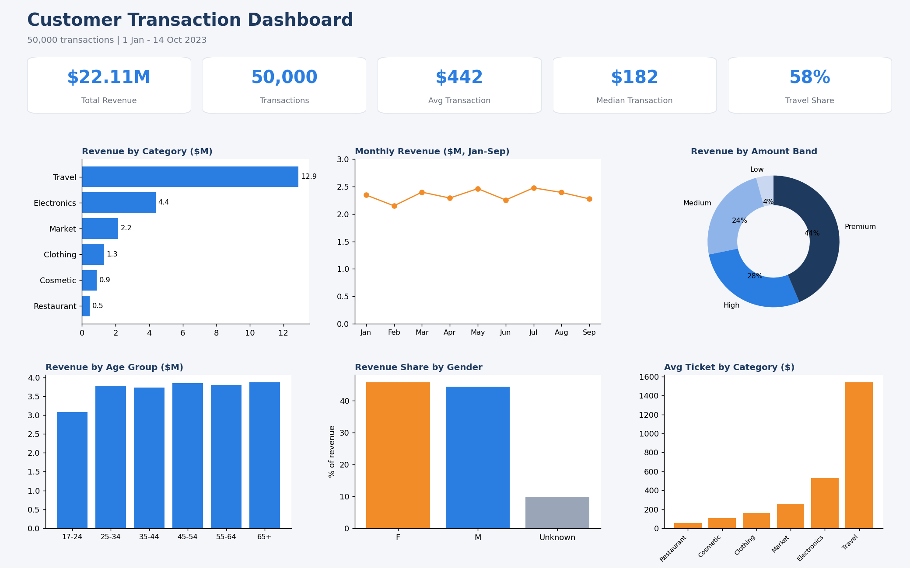
Figure 1: Customer transaction dashboard (KPI cards and key charts)

2. Business Problem and Objectives
A retail or payments business needs to know which categories and customer segments drive revenue so that marketing, product and risk teams can prioritise effort. Transaction data is the most direct record of customer behaviour, but raw rows do not answer business questions until they are cleaned, summarised and tested.

Questions answered
- How much revenue is generated, and which categories drive it?
- Do spending patterns differ by gender or age group?
- Is there a monthly or weekday pattern?
- How concentrated is revenue in large transactions and merchants?
- Are the differences we see statistically meaningful, or just noise?
- How clean is the data, and what can it not tell us?

3. Dataset Description
The dataset has 50,000 rows and 9 columns, with no duplicate records.
Column | Description
Customer ID | Customer identifier (50,000 unique values)
Name, Surname | Customer name
Gender | F or M; 5,047 values missing
Birthdate | 1948-11-02 to 2005-10-19 (customers aged 17 to 74 at transaction)
Transaction Amount | $5.01 to $2,999.88
Date | 2023-01-01 to 2023-10-14 (287 distinct days)
Merchant Name | 36,939 distinct merchants
Category | Restaurant, Market, Travel, Electronics, Clothing, Cosmetic

4. Methodology
The analysis followed a standard analytics workflow so that every number in this report can be reproduced from the code in the repository.
- Understand: profile columns, types, ranges and missing values.
- Clean: standardise column names, treat missing values, check for duplicates and invalid amounts.
- Engineer features: age at transaction, age group, month, weekday, weekend flag and amount band.
- Summarise: aggregate revenue, transaction count and average ticket by each dimension.
- Visualise: build charts and a one-page dashboard.
- Validate: test whether differences between groups are statistically significant.
- Interpret: translate findings into recommendations and state the limitations.

5. Data Cleaning and Quality Assessment
Check | Result | Action
Missing values | Only Gender: 5,047 rows (10.1%) | Labelled Unknown, rows kept
Duplicate rows | None | No action
Zero or negative amounts | None (minimum $5.01) | No action
Date validity | All dates within 2023-01-01 to 2023-10-14 | No action
Category labels | 6 consistent labels, no spelling variants | No action
Customer age | 17 to 74 years, plausible | No action
Text fields | Possible stray spaces | Trimmed

Gender was labelled Unknown rather than dropped so that revenue totals stay complete. The Unknown group has the same category mix and average ticket ($434) as the known groups, so keeping it does not bias results.

Features created
- Age at transaction (transaction date minus birthdate) and age group: 17-24, 25-34, 35-44, 45-54, 55-64, 65+.
- Month, weekday and a weekend flag from the transaction date.
- Amount band: Low (under $100), Medium ($100-500), High ($500-1,500), Premium (over $1,500).
The cleaned dataset is saved as data/processed/cleaned_transactions.csv and is ready to load into Power BI.

6. Key Metrics
KPI | Value
Total transactions | 50,000
Total revenue | $22.11 million
Average transaction | $442.12
Median transaction | $182.20
Distinct merchants | 36,939
Days covered | 287
Average transactions per day | about 174
Average revenue per day | about $77,000
Highest revenue day | 1 July 2023 ($115,721)

The mean is more than double the median, which shows that spend is strongly right-skewed by a small number of large purchases.
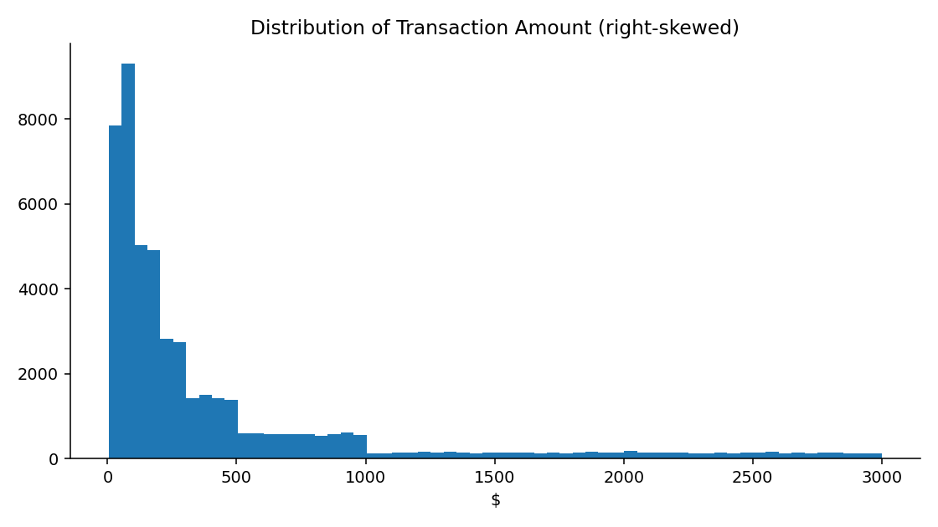
Figure 2: Distribution of transaction amounts

7. Analysis and Findings

7.1 Revenue by category
Category | Transactions | Revenue | Share | Avg ticket
Travel | 8,377 | $12.90M | 58.4% | $1,540
Electronics | 8,324 | $4.39M | 19.9% | $528
Market | 8,382 | $2.15M | 9.7% | $257
Clothing | 8,261 | $1.32M | 6.0% | $160
Cosmetic | 8,243 | $0.88M | 4.0% | $106
Restaurant | 8,413 | $0.46M | 2.1% | $55
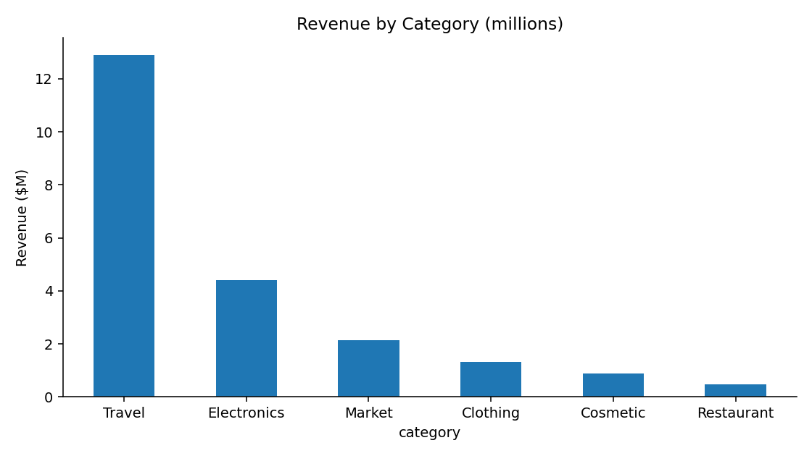
Figure 3: Revenue by category
Revenue is driven by ticket size, not volume. Travel and Electronics are the two categories that matter most commercially. Each category also sits in a distinct, bounded price range:
Category | Minimum | Q1 | Median | Q3 | Maximum
Restaurant | $10 | $33 | $55 | $78 | $100
Cosmetic | $10 | $60 | $107 | $154 | $200
Clothing | $20 | $88 | $160 | $230 | $300
Market | $5 | $131 | $259 | $380 | $500
Electronics | $50 | $292 | $530 | $763 | $1,000
Travel | $100 | $823 | $1,537 | $2,242 | $3,000

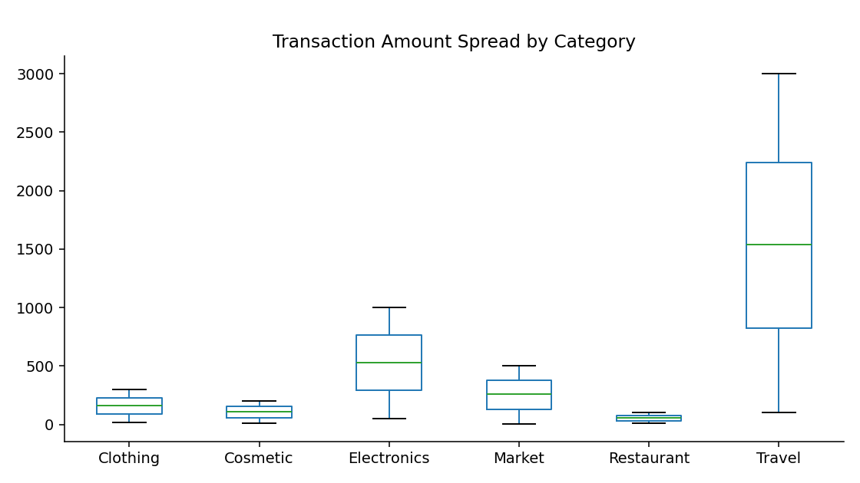
Figure 4: Spread of transaction amounts by category
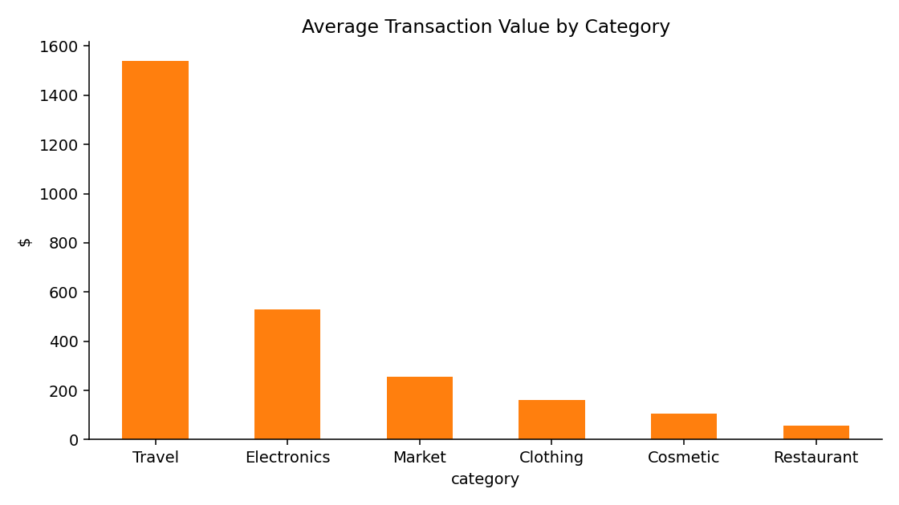
Figure 5: Average transaction value by category

7.2 Concentration in large transactions
Amount band | Transactions | Revenue | Revenue share
Low (under $100) | 16,630 | $0.94M | 4.3%
Medium ($100-500) | 21,732 | $5.29M | 24.0%
High ($500-1,500) | 7,334 | $6.24M | 28.2%
Premium (over $1,500) | 4,304 | $9.63M | 43.6%

The Premium band is 8.6% of transactions but 43.6% of revenue, and consists entirely of Travel purchases (51.4% of all Travel transactions exceed $1,500). Travel also makes up 62.1% of all transactions above $500. This is the segment with the highest value at risk from fraud, disputes or cancellation.

7.3 Gender
Group | Revenue share | Avg ticket | Transactions
Female | 45.8% | $445.52 | 22,713
Male | 44.3% | $440.42 | 22,240
Unknown | 9.9% | $434.31 | 5,047

Average tickets differ by less than $12 across the three groups, and within each category the female and male averages are within about $20 of each other.

7.4 Age
Age group | Transactions | Revenue | Share | Avg ticket
17-24 | 7,045 | $3.09M | 14.0% | $438
25-34 | 8,571 | $3.77M | 17.1% | $440
35-44 | 8,519 | $3.73M | 16.9% | $438
45-54 | 8,517 | $3.84M | 17.4% | $451
55-64 | 8,639 | $3.80M | 17.2% | $440
65+ | 8,709 | $3.87M | 17.5% | $445
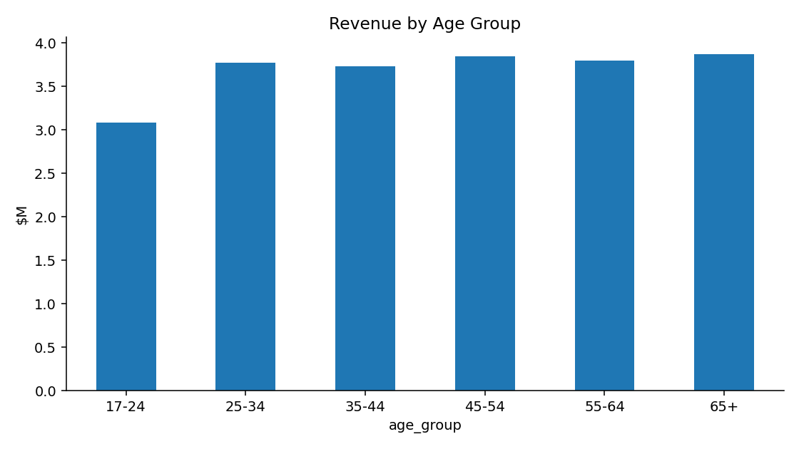
Figure 6: Revenue by age group
The 17-24 group has lower total revenue because it covers fewer birth years in the data, not because it spends less per transaction. The category mix is also similar across age groups.
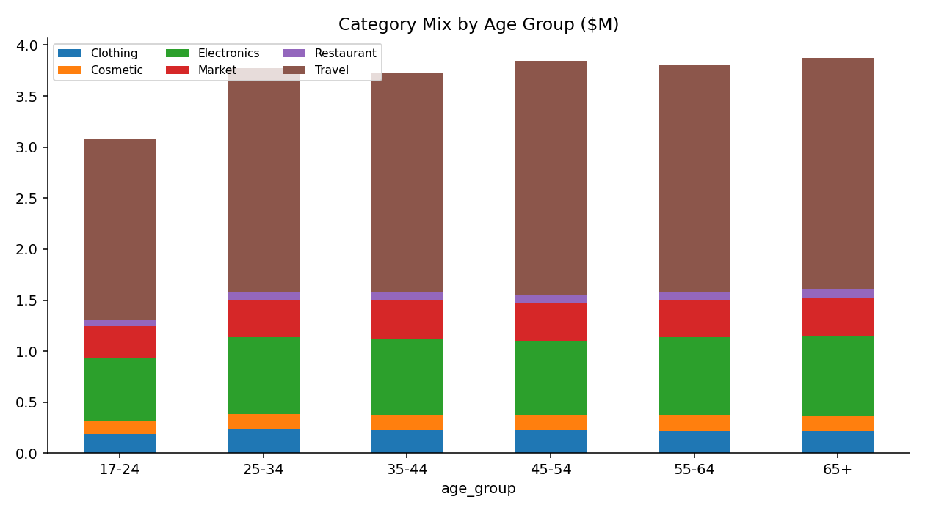
Figure 7: Category mix by age group

7.5 Time patterns
Month | Transactions | Revenue | Share | Avg ticket
January | 5,444 | $2.35M | 10.6% | $431
February | 4,854 | $2.15M | 9.7% | $443
March | 5,456 | $2.40M | 10.8% | $439
April | 5,091 | $2.29M | 10.4% | $450
May | 5,493 | $2.46M | 11.1% | $448
June | 5,258 | $2.25M | 10.2% | $429
July | 5,458 | $2.48M | 11.2% | $453
August | 5,399 | $2.39M | 10.8% | $443
September | 5,153 | $2.27M | 10.3% | $441
October (1-14 only) | 2,394 | $1.07M | 4.8% | $447

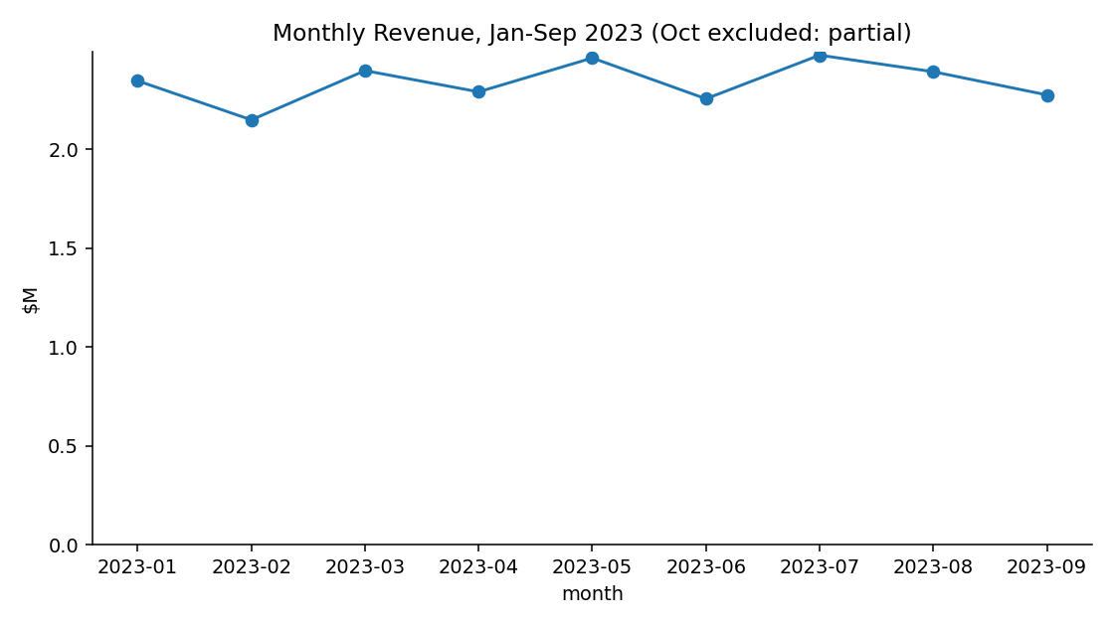
Figure 8: Monthly revenue, January to September 2023 (October excluded as a partial month)
Monthly revenue stays between $2.1M and $2.5M. February is lowest because it has fewer days. October covers only 1 to 14 October and should not be read as a decline.
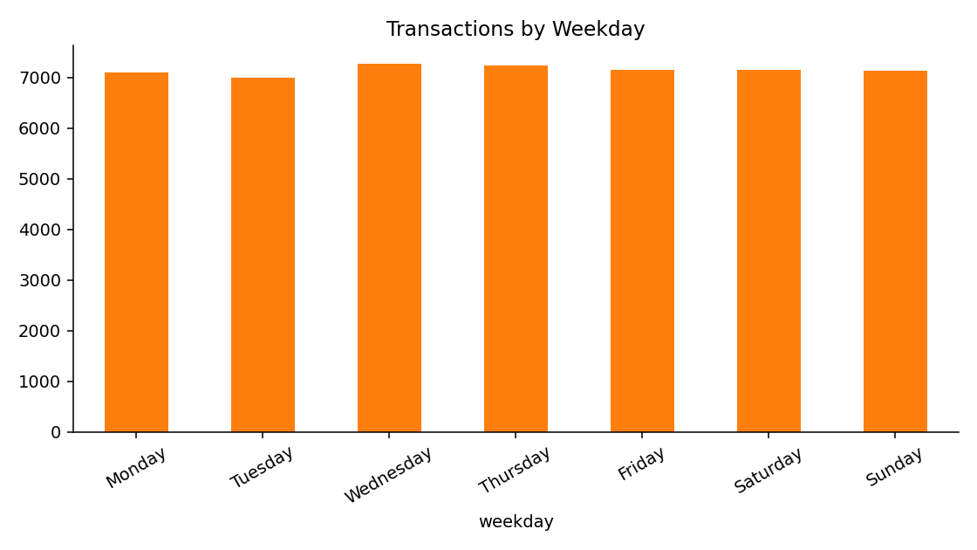
Figure 9: Transactions by weekday
Weekday volumes are flat. Monday has the highest average ticket ($459) and Tuesday the lowest ($432), but the statistical test in Section 8 shows this gap is within normal variation. Weekends account for 28.5% of transactions, close to the 2/7 expected from an even spread.

7.6 Merchants
There are 36,939 merchants for 50,000 transactions. A total of 32,907 merchants (89%) appear only once, only 33 have 30 or more transactions, and the ten largest merchants together account for just 1.3% of revenue. Merchant-level rankings are therefore not meaningful for decision-making in this dataset.

8. Statistical Validation
Visible differences between groups can be random noise, so each pattern was tested at the 5% significance level. The tests are in src/stats_tests.py.
Test | Method | p-value | Significant?
Spend by gender (F vs M) | Welch t-test | 0.392 | No
Spend by age group | One-way ANOVA | 0.721 | No
Spend by weekday | One-way ANOVA | 0.219 | No
Spend by month (Jan-Sep) | One-way ANOVA | 0.515 | No

The correlation between customer age and transaction amount is 0.003, which is effectively zero. None of the tested differences is statistically significant, so the visible gaps (for example Monday versus Tuesday) should not be used to drive decisions.

9. Business Insights and Recommendations

What the data says
- Revenue is determined by what is bought, not who buys it or when.
- A small share of large Travel and Electronics purchases carries most of the value.
- Demographic and calendar effects are statistically indistinguishable from noise.

Recommendations
- Prioritise Travel and Electronics in promotions, partnerships and fraud monitoring, as they carry 78% of value.
- Test cross-selling from Travel buyers into Electronics, and bundle low-ticket categories such as Restaurant and Cosmetic to raise basket size.
- Avoid gender or age-targeted campaigns on this evidence, since spend is statistically identical across groups.
- Add review rules for the Premium band (over $1,500), the highest value-at-risk segment.
- Capture gender at sign-up to reduce the 10% missing rate.
- Collect repeat-customer identifiers so retention and lifetime value can be measured.

10. Limitations
- Each Customer ID appears exactly once, so repeat purchase, retention, RFM and lifetime value analysis cannot be done.
- Amounts in each category fall within fixed ranges and the patterns are unusually uniform (equal category counts, flat spend by age and gender, randomly generated names). This suggests synthetic or sample data, so the findings demonstrate method rather than real business behaviour.
- The data has no time of day, location, payment method or product detail.
- October is a partial month and is excluded from trend views.

11. Tools, Reproducibility and Project Structure
Python 3 with Pandas, NumPy, Matplotlib, SciPy and openpyxl was used for cleaning, analysis, testing and charts. SQL queries replicate the key questions, and the cleaned CSV is ready to load into Power BI. Running src/analysis.py, src/dashboard.py and src/stats_tests.py regenerates every table, chart and test in this report.
Path | Purpose
data/raw/ | Original dataset (sample_dataset.csv)
data/processed/ | Cleaned and enriched dataset
src/analysis.py | Cleaning, feature engineering, summary tables, charts
src/dashboard.py | Builds the one-page dashboard image
src/stats_tests.py | Statistical significance tests
sql/queries.sql | Seven SQL queries for the same questions
powerbi/POWERBI_GUIDE.md | DAX measures and dashboard layout
outputs/ | Summary tables (Excel) and test results (CSV)
images/ | Charts and dashboard PNG files
reports/ | This report (DOCX and PDF)

12. Next Steps
- Build the interactive Power BI dashboard using the supplied DAX measures and add slicers for category, gender, month and age group.
- Repeat the analysis on data with repeat customers to add RFM segmentation, churn and lifetime value.
- Add an anomaly detection step (for example z-scores by category) to flag unusual high-value transactions.
- Automate the pipeline so that new monthly files are cleaned and reported without manual work.

13. Conclusion
Revenue in this dataset is determined by what is bought, not who buys it: Travel and Electronics dominate, a minority of large transactions carry nearly half of the value, and customer demographics and calendar effects add nothing that survives statistical testing. The most useful next step would be data that links purchases to repeat customers, which would enable segmentation, retention and lifetime value analysis.

Appendix A: SQL Queries
Selected queries from sql/queries.sql (MySQL style). The full file contains seven queries.

Revenue and share by category
SELECT category, COUNT(*) AS txns, ROUND(SUM(amount),2) AS revenue,
ROUND(AVG(amount),2) AS avg_ticket,
ROUND(100*SUM(amount)/SUM(SUM(amount)) OVER (),1) AS revenue_share_pct
FROM transactions GROUP BY category ORDER BY revenue DESC;

Monthly revenue with month-over-month change
WITH m AS (
SELECT DATE_FORMAT(date,'%Y-%m') AS month, SUM(amount) AS revenue
FROM transactions GROUP BY 1)
SELECT month, ROUND(revenue,0) AS revenue,
ROUND(100*(revenue - LAG(revenue) OVER (ORDER BY month))
/ LAG(revenue) OVER (ORDER BY month),1) AS mom_pct
FROM m ORDER BY month;

Share of revenue from the top 10% of transactions
WITH r AS (SELECT amount, NTILE(10) OVER (ORDER BY amount DESC) AS decile
FROM transactions)
SELECT ROUND(100*SUM(CASE WHEN decile=1 THEN amount END)/SUM(amount),1)
AS top10_pct_share FROM r;

