1、好大夫面试题

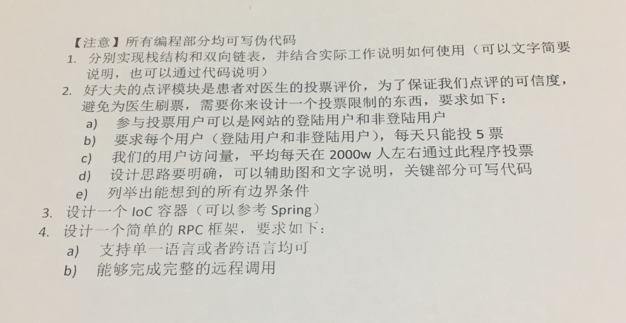

2、每日优鲜

###### Java Part

1. Which of the following Java method declarations are invalid?( )

A. private static methodA () {... ...}

B. abstract public static void methodB () ;

C. synchronized protected void methodC(){ ... ...}

D. abstract synchronized int methodD () ;

1. Given the following Java code: ( )

**public** **class** ClassA {

**public** **static** **void** main(String[] args){

ClassA classA = **new** ClassA();

String s = "Hello";

classA.modify(s);

System.*out*.println("Print out of the method: " + s);

}

**public** **void** modify(String s){

s = s + " world";

System.*out*.println("Print in the method: " + s);

}

}

What is the result of running ClassA?

Options:

1. Print in the method: Hello world

Print out of the method: Hello

1. Print in the method: Hello world

Print out of the method: Hello world

1. Print in the method: Hello

Print out of the method: Hello world

1. Print in the method: Hello

Print out of the method: Hello

1. The following code snippets show inheritance of Java language, which one of them doesn’t cause compiling error? ( )

Options:



**class** ClassA1{

**protected** **final** **void** method_A(){}

}

**class** ClassA2 **extends** ClassA1{

**protected** **void** method_A(){}

}

**class** ClassB1{

**private** **void** method_B() **throws** Exception{}

}

**class** ClassB2 **extends** ClassB1{

**public** **void** method_B() **throws** IOException{}

}

**class** ClassC1{

**protected** **void** method_C() **throws** IOException{}

}

**class** ClassC2 **extends** ClassC1{

**public** **void** method_C() **throws** Exception{}

}

**class** ClassD1{

**abstract** **void** method_D();

}

**class** ClassD2 **extends** ClassD1{

**public** **void** method_D(){}

}

1. Given the following Java code: ( )

public class Base {

public static int i = getInt(1);

public static int getInt(int i) {

System.out.print(i);

return i;

}

public static void main(String[] args) {

int i = getInt(2);

Base base = new Sub();

}

}

class Sub extends Base {

public static int i = getInt(3);

}

What would be the result of running the class Base?

A. 123

B. 132

C. 213

D. 32

1. Given the following method: ( )

public void example(){

try{

unsafe();

System.out.println("Test1");

}catch(SafeException e){

System.out.println("Test 2");

}finally{

System.out.println("Test 3");

}

System.out.println("Test 4");

}

Which will display if method unsafe () run without exception?

A. Test 1

B. Test 2

C. Test 3

D. Test 4

1. Given the following Java code: ( )

public class ThreadDemo implements Runnable {

public static synchronized void main(String[] args) {

Thread t1 = new Thread(new ThreadDemo());

Thread t2 = new Thread(new ThreadDemo());

t1.start();

t2.run();

System.out.println(Thread.currentThread().getName() + " :end");

}

static synchronized void printStart() {

System.out.println(Thread.currentThread().getName() + " :start");

}

public void run() {

printStart();

}

}

What would be the result of compiling and running the class?

Options:

A. main :end

Thread-0 :start

Thread-1 :start

B. Thread-0 :start

Thread-1 :start

main :end

C. main :start

main :end

Thread-0 :start

D. Thread-0 :start

Thread-0 :end

Thread-1 :start

Thread-1 :end

E. A deadlock may happen

7.假设有两个string型数组，如[“a”, “b”, “c” ...], [“c”, “b”, ..]， 如何快速找出两个数组的相同元素，写出伪代码

8.假设有这样一个需求，请描述设计思路

a. 给所有登录用户派发任务，任务完成后给用户发放积分，如一周内下三单，送100积分；充值余额5次，送1000积分

b. 不同会员等级的用户派发不同的任务，相同等级的用户派发的任务也可能不一样

c. 派发出去的任务以周为单元，如周三领取的任务，下周一还未完成的话重新派发新任务

d. 登录用户量每天200万左右