The proper font selection can take your visualization from good to great, and Tableau is here to help. Whether you're changing the font size, position, color, or direction, Tableau provides a wide range of customization options for your text.

When you make formatting changes at this level, they apply only to the view you're working on. See Format at the Workbook Level for how to make changes that apply to every view in your workbook.

To access worksheet-level format settings, select the **Format** menu, then choose the part of the view, such as **Font,** or **Border,** that you want to format.

Format fonts

Select **Format**> **Font**. A **Format Font** control pane will open. This control pane will let you customize the text in the view.

**Click the letters below for more information.**

## Format a field

In the view below, the **Month(Order Date)** field has been formatted so that the headers use the Tableau Semibold font, in blue. Notice that the header values along the Profit axis are not affected.

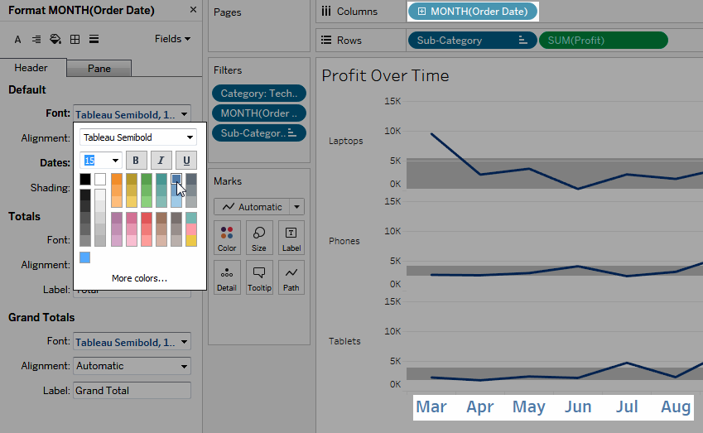

**To format a specific field:**

1. Right-click (control-click on Mac) the field and select **Format**.

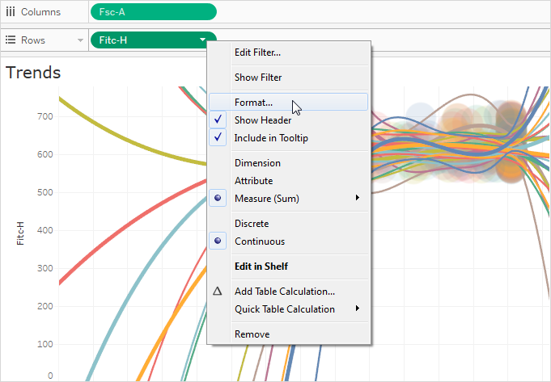

The **Format**pane opens to settings for the selected field.

1. Make your changes in the **Format**pane.

For discrete fields, such as Region or Customer Name, you can specify font and alignment properties for both header and pane areas. For continuous fields, such as Profit or Sales, you can format font properties for the pane and axis as well as number and tick mark colors. For more information about other axis options, see Edit Axes. The view is updated as you make changes so you can quickly see the colors and formats that work with your view.

## Format a field label

Field labels are row and column headings that indicate the data fields used to create a view. By default, Tableau shows field labels, but you can choose to hide them. When field labels are showing they appear in three different parts of the view: rows, columns, and the corner. The view below shows an example of each of these types of field labels.

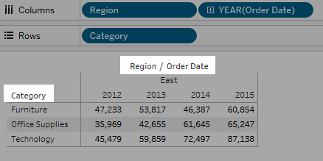

You can format the font, shading, alignment, and separators for each of these types of field labels.

**To format a specific field label:**

1. Right-click (control-click on Mac) the field label in the view and select **Format**.
2. In the **Format** pane, specify the settings of the font, shading, and alignment field labels.

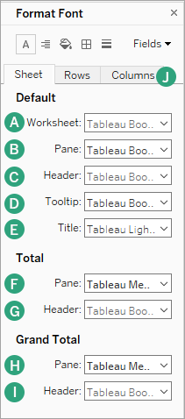

A. Worksheet

B. Pane

C. Header

D. Tooltip

E. Title

F. Total Pane

G. Total Header

H. Grand Total Pane

I. Grand Total Header

J. Row and Column Text Formatting

Format text alignment

Tableau uses visual best practices to determine how text is aligned in a view, but you can also customize text. For example, you can change the direction of header text so that it is horizontal (default) instead of vertical (up).

To format the text alignment, select **Format**> **Alignment**to open the text alignment pane.

[](javascript:void(0);)

For each text area you can specify the following alignment options:

**Horizontal**- Controls whether text aligns to the left, right, or center.

**Vertical Alignment** - Controls whether text aligns at the top, middle, or bottom.

**Direction** - Rotates text so that it runs horizontally (default), top-to-bottom (up), or bottom-to-top (down).

**Wrap**- Controls whether long headers wrap to the next line or are abbreviated. It does not control text marks in the visualization.

**Note:** If cells are not large enough to show more than one row of text, turning on wrapping will have no visible effect. If this happens, you can hover the cursor over a cell until a double-sided arrow appears, and then click and drag down to expand the cell size.

**Note**: Tableau adheres to regional standards when determining when to begin or end line breaks.

Format tooltips

Tooltips are details that appear when you rest the pointer over one or more marks in the view. Tooltips also offer convenient tools to quickly filter or remove a selection, select marks that have the same value or view underlying data. You can edit the tooltip to include both static and dynamic text. You can also modify which fields are included in the automatic tooltip.

**To edit a tooltip:**

1. Select **Worksheet**> **Tooltip**. Tooltips are specified for each sheet and can be formatted using the formatting tools along the top of the Edit Tooltip dialog box. Use the **Insert**menu at the top of the dialog box to add dynamic text such as field values, sheet properties, and more.

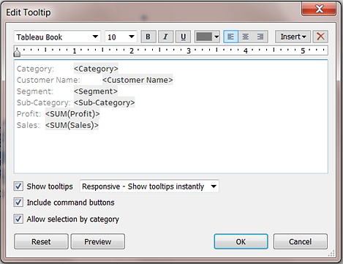

1. Use the formatting tools along the top of the Edit Tooltip dialog box.
2. (Optional) Use the **Insert**drop-down list at the top of the dialog box to add dynamic text such as field values, sheet properties, and more.

The **All Fields** option on the **Insert** menu adds all field names and values that are used in the view. Inserting the All Fields parameter updates the tooltip as you change the view. You can also use the All Fields option to exclude fields.

1. (Optional) Select the **Include command buttons** option to show filtering and view data options in the tooltip. For example, including command buttons will add **Keep Only**, **Exclude**, and **View Data** buttons to the bottom of the tooltip. These command buttons are available both in Tableau Desktop and when the view is published to the web or viewed on a mobile device.
2. (Optional) Select the **Allow selection by category** check box to select marks in a view that have the same value by clicking on a discrete field in a tooltip. For more information see Tooltips.

Edit worksheet titles, captions, and legend titles

1. Do one of the following:
   * On Tableau Server or Tableau Online web editing, double click the item you want to change.
   * On Tableau Desktop, Right-click (control-click on Mac) the item you want to change and select **Edit <item>**, for example, **Edit Title**.
   * On a worksheet, hover on the title, click the drop-down arrow on the right-hand side and select **Edit Title** or **Edit Caption** from the context menu.
2. In the Edit dialog box, modify the text and format the font, size, style, color, and alignment. Use the **Insert** menu to add dynamic text such as sheet properties and field values. Click **OK**.

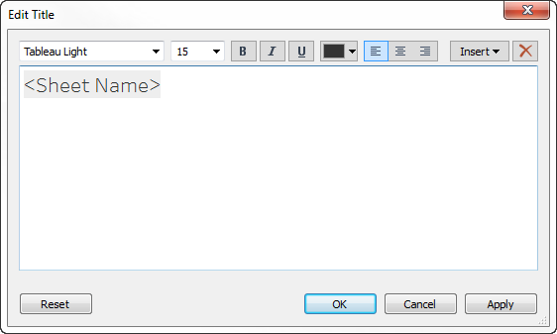

To reset the title back to the default, click **Reset**.

# Resize Tables and Cells

You can change the size of the rows, columns, and cells that compose a table. The best way to resize your table depends on the view type and the table components you want to resize.

## Use commands to resize rows and columns

1. Select **Format**> **Cell Size**.
2. Choose the **Taller**, **Shorter**, **Wider**, or **Narrower** command. To quickly apply these commands, see Shortcuts for resizing rows and columns (Tableau Desktop).

For example, in the view below, we used the **Wider** and **Taller** commands to make the view more readable.

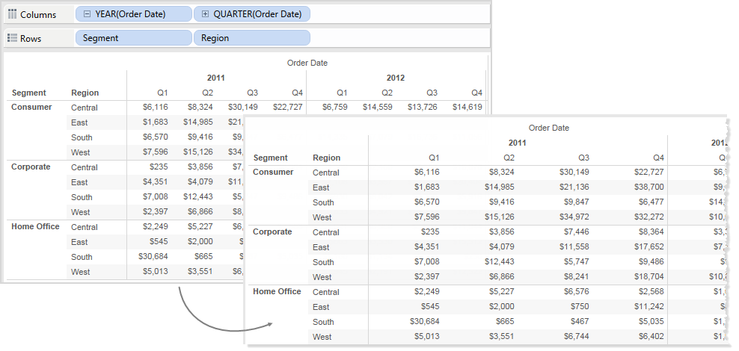

**Note:**For a given field, all members will have the same width and the same height. You can't resize individual field members.

## Manually resize rows and columns

To manually resize the widths or heights of row and column headers or axes:

1. Place your cursor over the vertical or horizontal border of a header or axis.
2. When you see the resize cursor https://help.tableau.com/current/pro/desktop/en-us/Img/symbol_horizdrag.png , click and drag the border left and right or up and down.

A graphic depicting how to manually resize a column by dragging
the border to the right or left.

## Resize an entire table

You can increase or decrease the size of the entire table by selecting **Bigger**or **Smaller**on the **Format**> **Cell Size** menu. For example, to increase the width of the columns and the height of the rows for the view shown below, you can select **Format**>**Cell Size** > **Bigger**. This option increases both the width and height of the panes in a visually appropriate way. Notice that the size of the row headers increases horizontally when you resize the table.

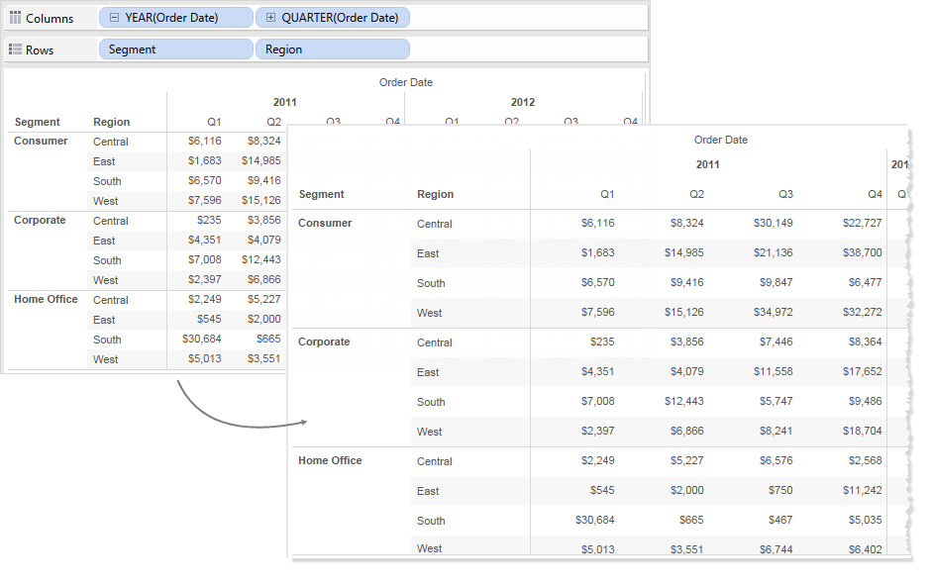

## Resize cells

Any table you can create in Tableau has the cell as its basic component. For a text table, the cell is what you would expect. It is the intersection of a row and a column, and is where the text is displayed. For more information, see Cells.

However, depending on the view you construct, identifying the cell is not always possible or useful, such as in the case of a scatter plot.

Manipulating cells to enhance your data view is useful when dimensions are the inner fields on both the **Rows**and **Columns**shelves. In this case, there are two shortcuts you can select on the **Format** > **Cell Size** menu:

* **Square Cell** – Adjusts the view so the cell has a 1:1 aspect ratio. This results in a square cell, which is useful for heat maps.
* **Text Cell** – Adjusts the view so the cell has a 3:1 aspect ratio. This is useful for text tables.

For example, you can see the text table below with **Square Cell** and **Text Cell** applied. **Text Cell**enforces a cell aspect ratio of 3:1 and results in a compact table that is easy to read.

|  |  |
| --- | --- |
| **Square Cell** | **Text Cell** |
| https://help.tableau.com/current/pro/desktop/en-us/Img/cellsize4.png | https://help.tableau.com/current/pro/desktop/en-us/Img/cellsize6.png |

The heat map shown below is modified by selecting **Square Cell** on the **Format**> **Cell Size**menu. This enforces a cell aspect ratio of 1:1 and results in a compact table that is easy to analyze. You can also use the **Size** slider on the **Marks** card to adjust the size of each mark.

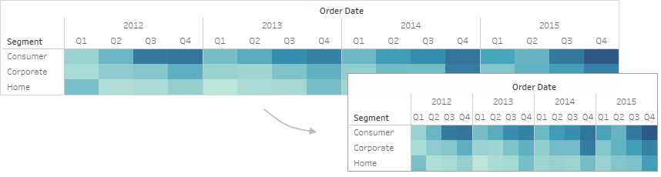

After changing the cell size, you can use **Ctrl+B** and **Ctrl+Shift+B** to decrease or increase the table size while maintaining the cell aspect ratio. On a Mac, the keystrokes are **Command-B** and **Shift-Command-B**.

In addition to the standard formatting, there are some other settings that define the table structure. You can modify these settings by selecting **Analysis**> **Table Layout** > **Advanced** to open the Table Options dialog box. There you can specify the aspect ratio, the default number format, row and column attributes, and the default label orientation for labels along the bottom of the view. While these settings apply to the whole view, some can be overridden using the **Format** pane.

## Set the aspect ratio

The aspect ratio refers to the ratio of the pane width to the pane height. You can choose to constrain the aspect ratio to a specified amount or not constrain it at all. An unconstrained axis range can be useful because it means that the axes don’t have to be the same length.

Anytime you manually resize a row or column, you are un constraining the aspect ratio. The aspect ratio setting only applies to views containing continuous axes on both the row and column shelves. Nominative axes are not affected by the aspect ratio settings.

## Set the default number format

You can define the number of decimal places to appear by default for numbers in the view. If you select **Automatic**, Tableau automatically decides the number of decimal places based on the data in the field. If you select **Manual,** you can decide to show up to 16 decimal places.

## Set row attributes

Select from the following row attributes:

* Maximum levels of row labels: determines the number of fields that can be added to the Rows shelf before the headers are combined on the same level.

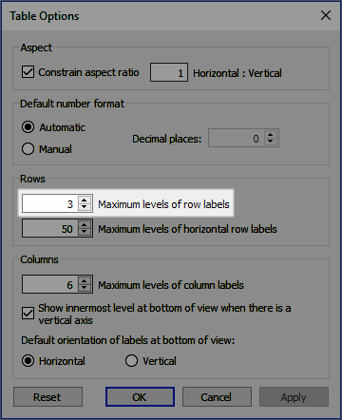

For example, if you set Maximum levels of row labels to 3 and place 5 discrete fields on the Rows shelf, then the first, second, and third row headers will appear in the same header, separated by commas (they will be combined at the same header level).

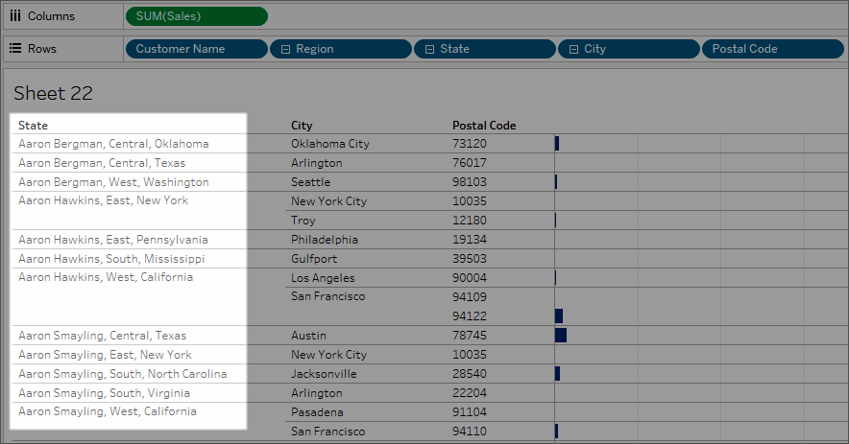

In this example, Customer Name, Region, State, City, and Postal Code are the 5 discrete fields on the Rows shelf. Maximum levels of row labels is set to 3. In the resulting view, Customer Name is combined with Region and State in the first column.

* Maximum levels of horizontal row labels: determines the number of fields that can be placed on the Rows shelf before headers are automatically oriented vertically rather than horizontally when the table doesn’t fit the view.

## Set column attributes

Select from the following column attributes:

* Maximum levels of column labels: determines the number of fields that can be placed on the Columns shelf before Tableau begins to combine the labels. For example, if you set Maximum levels of column labels to 8 and place 9 discrete fields on the Columns shelf, then the first and second column headers will appear in the same header, separated by a comma (they will be combined at the same header level).
* Show innermost level at bottom of view when there is a vertical axis: displays the innermost level of column headers at the bottom of the view (as opposed to the top) when a vertical axis is added to the view.
* Default orientation of labels at bottom of view: determines whether labels at the bottom of the view are oriented horizontally or vertically by default. You can toggle between the horizontal and vertical options by pressing Ctrl + L on your keyboard (Command-L on a Mac).