# VISVESVARAYA TECHNOLOGICAL UNIVERSITY

## BELAGAVI – 590018, Karnataka INTERNSHIP REPORT

#### ON

“Voice Classification using ML”

***Submitted in partial fulfilment for the award of degree(18CSI85)***

## BACHELOR OF ENGINEERING IN

## COMPUTER SCIENCE

## AND ENGINEERING

***Submitted by:***

#### DHARSHAN GOWDA G K

#### 4CA21CS022



Conducted at

**COMPSOFT TECHNOLOGIES**

# CAUVERY INSTITUTE OF TECHNOLOGY

**Department of Computer Science and Engineering**

**Approved by AICTE, New Delhi**

# Affiliated to VTU, Belagavi

**Siddaiahna Koppalu Gate, Sundahalli Mandya – 571401**

# CAUVERY INSTITUTE OF TECHNOLOGY

**Department of Computer Science and Engineering**

**Approved by AICTE, New Delhi**

# Affiliated to VTU, Belagavi

# Siddaiahna Koppalu Gate, Sundahalli Mandya –571401



**CERTIFICATE**

This is to certify that the Internship titled **“Voice Classification using ML”** carried out by **Mr. Dharshan Gowda G K,** a bonafide student of Cauvery Institute of Technology, in partial fulfillment for the award of **Bachelor of Engineering**, in **COMPUTER SCIENCE AND ENGINEERING** under Visvesvaraya Technological University, Belagavi, during the year 2023-2024. It is certified that all corrections/suggestions indicated have been incorporated in the report.

The project report has been approved as it satisfies the academic requirements in respect of Internship prescribed for the course Internship / Professional Practice (18CSI85)

#### Signature of Guide Signature of HOD Signature of Principal

**External Viva:**

Name of the Examiner Signature with Date

1)

2)

# D E C L A R A T I O N

I, **Dharshan Gowda G K**, third year student of Computer Science and Engineering, Cauvery Institute of Technology - 571401, declare that the Internship has been successfully completed, in **COMPSOFT TECHNOLOGIES**. This report is submitted in partial fulfillment of the requirements for award of Bachelor Degree in Computer Science and Engineering, during the academic year 2022-2023.

Date : :

Place : Mandya

USN : 4CA21CS022

NAME : DHARSHAN GOWDA G K

**OFFER LETTER**

**Dharshan Gowda G K**, 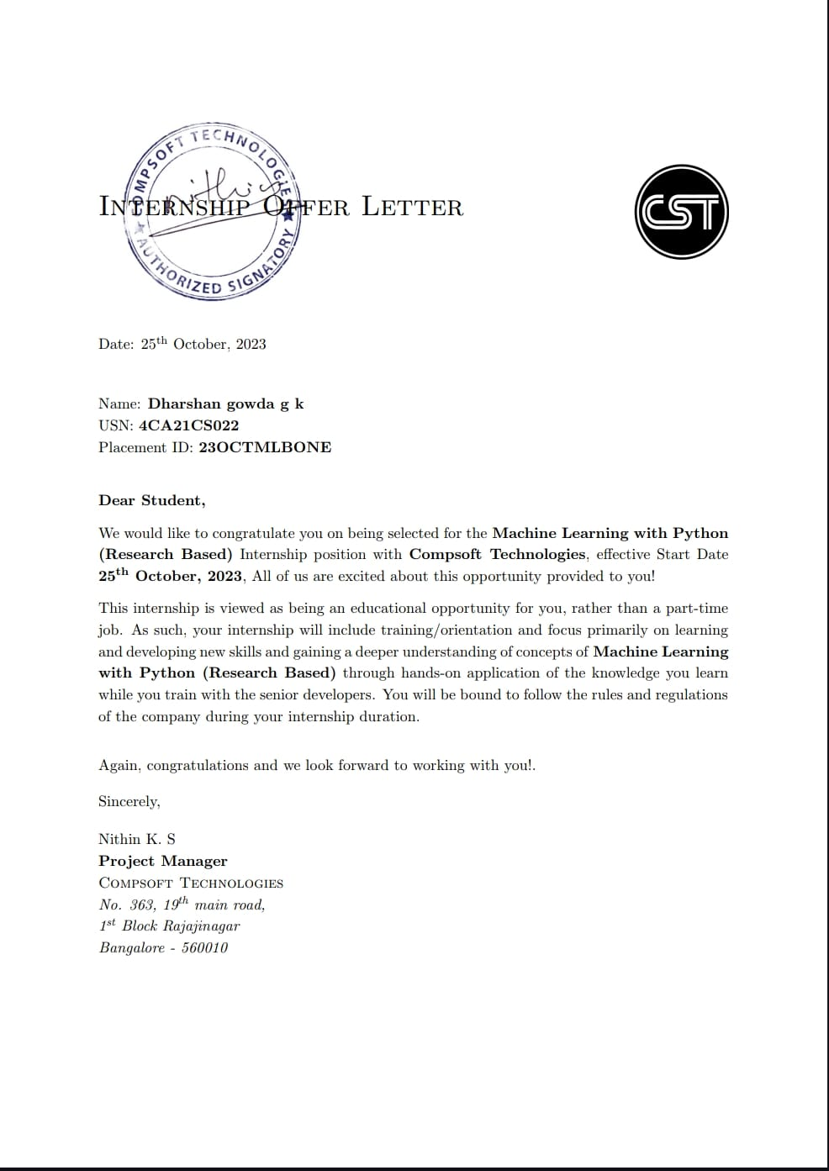

# A C K N O W L E D G E M E N T

This Internship is a result of accumulated guidance, direction and support of several important persons. We take this opportunity to express our gratitude to all who have helped us to complete the Internship.

We express our sincere thanks to our Principal – Dr. Srikantappa.A.S, for providing us adequate facilities to undertake this Internship.

We would like to thank our Head of Dept – prof. Akshatha.T.M, for providing us an opportunity to carry out Internship and for her valuable guidance and support.

We would like to thank our Software Services for guiding us during the period of internship.

We express our deep and profound gratitude to our guides, Assistant and Associate Professors, for their keen interest and encouragement at every step in completing the Internship.

We would like to thank all the faculty members of our department for the support extended during the course of Internship.

We would like to thank the non-teaching members of our dept, for helping us during the Internship.

Last but not the least, we would like to thank our parents and friends without whose constant help, the completion of Internship would have not been possible.

**DHARSHAN GOWDA G K**

**4CA21CS022**

# ABSTRACT

As human beings’ speech is amongst the most natural way to express ourselves. We depend so much on it that we recognize its importance when resorting to other communication forms like emails and text messages where we often use emojis to express the emotions associated with the messages. As emotions play a vital role in communication, the detection and analysis of the same is of vital importance in today’s digital world of remote communication. Emotion detection is a challenging task, because emotions are subjective. There is no common consensus on how to measure or categorize them.

We define a SER system as a collection of methodologies that process and classify speech signals to detect emotions embedded in them. Such a system can find use in a wide variety of application areas like interactive voice based-assistant or caller-agent conversation analysis. In this study we attempt to detect underlying emotions in recorded speech by analyzing the acoustic features of the audio data of recordings.

In the field of speech emotion recognition many techniques have been utilized to extract emotions from signals. including many well-established speech analysis and classification techniques. In the traditional way of speech emotion recognition features are extracted from the speech signals and then the features are selected which is collectively know as selection module and then the emotions are recognized this is a very lengthy and time taking process so this paper gives an overview of the deep learning technique which is based on a simple algorithm based on feature extraction and model creation which recognizes the emotion.

# Table of Contents

|  |  |  |
| --- | --- | --- |
| **Sl no** | **Description** | **Page no** |
| 1 | Company Profile | 8-9 |
| 2 | About the Company | 10-13 |
| [3](https://1.bp.blogspot.com/-dODuK8N5h1Q/Wlnyb3V9HFI/AAAAAAAACL4/WxQtCJ1pM5wccDABg4wIrTBUB0vlikXQQCLcBGAs/s1600/poly1.jpg) | Introduction | 14-15 |
| [4](https://1.bp.blogspot.com/-dODuK8N5h1Q/Wlnyb3V9HFI/AAAAAAAACL4/WxQtCJ1pM5wccDABg4wIrTBUB0vlikXQQCLcBGAs/s1600/poly1.jpg) | System Analysis | 16-17 |
| [5](https://1.bp.blogspot.com/-dODuK8N5h1Q/Wlnyb3V9HFI/AAAAAAAACL4/WxQtCJ1pM5wccDABg4wIrTBUB0vlikXQQCLcBGAs/s1600/poly1.jpg) | Requirement Analysis | 18-19 |
| 6 | Design [Analysis](https://4.bp.blogspot.com/-IOOxgPaXMVc/Wlj3LWvcnjI/AAAAAAAACKE/UeTFYvAxDmUDel5UBjdifeWaApB3-dXVgCLcBGAs/s1600/img1.jpg) | 20-21 |
| 7 | [Implementation](https://4.bp.blogspot.com/-IOOxgPaXMVc/Wlj3LWvcnjI/AAAAAAAACKE/UeTFYvAxDmUDel5UBjdifeWaApB3-dXVgCLcBGAs/s1600/img1.jpg) | 22-24 |
| 8 | Snapshots | 25-27 |
| 9 | Conclusion | 28-29 |
| 10 | References | 30-31 |

**CHAPTER 01**

# COMPANY PROFILE

# COMPANY PROFILE

## A Brief History of Compsoft Technologies

Compsoft Technologies, was incorporated with a goal “To provide high quality and optimal Technological Solutions to business requirements of our clients”. Every business is a different and has a unique business model and so are the technological requirements. They understand this and hence the solutions provided to these requirements are different as well. They focus on clients requirements and provide them with tailor made technological solutions. They also understand that Reach of their Product to its targeted market or the automation of the existing process into e-client and simple process are the key features that our clients desire from Technological Solution they are looking for and these are the features that we focus on while designing the solutions for their clients.

Sarvamoola Software Services. is a Technology Organization providing solutions for all web design and development, MYSQL, PYTHON Programming, HTML, CSS, ASP.NET and LINQ. Meeting the ever-increasing automation requirements, Sarvamoola Software Services. specialize in ERP, Connectivity, SEO Services, Conference Management, effective web promotion and tailor-made software products, designing solutions best suiting clients requirements.

Compsoft Technologies, strive to be the front runner in creativity and innovation in software development through their well-researched expertise and establish it as an out of the box software development company in Bangalore, India. As a software development company, they translate this software development expertise into value for their customers through their professional solutions.

They understand that the best desired output can be achieved only by understanding the clients demand better. Compsoft Technologies work with their clients and help them to define their exact solution requirement. Sometimes even they wonder that they have completely redefined their solution or new application requirement during the brainstorming session, and here they position themselves as an IT solutions consulting group comprising of high caliber consultants.

They believe that Technology when used properly can help any business to scale and achieve new heights of success. It helps improve its efficiency, profitability, reliability; to put it in one sentence “Technology helps you to Delight your customers” and that is what we want to achieve.

**CHAPTER 02**

**ABOUT THE COMPANY**

**2.ABOUT THE COMPANY**



The company’s involvement in race for digital transformation is on. In this globally connected on-demand world with rapid advancements in internet technologies, businesses worldwide are under constant pressure to add innovative real-time capabilities to their applications to respond to market opportunities.

Every business worldwide is building event-driven, real-time applications - from financial services, transportation, and energy, to retail, healthcare, and Gaming companies. Our endeavor is to make it easy to develop innovative real-time applications and efficient to operate them in production.

We have a proven record of building highly scalable, world-class consulting processes that offer tremendous business advantages to our clients in the form of huge cost-benefits, definitive results and consistent project deliveries across the globe. We prominently strive to improve your business by delivering the full range of competencies including operational performance, developing and applying business strategies to improve financial reports, defining strategic goals and measure and manage those goals along with measuring and managing them.

**VISION:** We are committed to going the extra mile to bring success to the clients consistently. We are dedicated to delivering the right people, solutions, and services to the clients that they require to meet their technology challenges and business goals.

**MISSION:** Optimizing client satisfaction with quality services. Delivering the most efficient and the best solution to our clients to every client leveraging leading technologies & industry best practices.

## Services of Compsoft Technologies.

It is believed that service and quality is the key to success, enabling business success driven by technology. Harnessing the power of technology, we create a measurable difference for our clients across various industries & multiple geographies.

**Development**

We develop responsive, functional and super-fast websites. We keep User Experience in mind while creating websites. A website should load quickly and should be accessible even on a small view-port and slow internet connection.

**Branding and Design**

We offer professional Graphic design, Brochure design & Logo design. We are experts in crafting visual content to convey the right message to the customers. We also design custom wraps for your products(also known as package designing).

**Search Engine Optimization**

We help you manage your SEO campaign more efficiently and effectively. We help you gain market share by leveraging our expertise. our holistic approach to identify anything that may be hurting your traffic or rankings and show you just how to outrank the competition.

**Content Writing**

We provide content writing services for blogs and product descriptions; our team helps you generate content to Increase your Brand Recall. We can amplify your marketing needs & help you reach your potential customers.

**Research**

We equip business leaders with indispensable insights, advice and tools to achieve their goals, our main area of research is in sentimental analysis, having published multiple papers on the same, we are in the process of creating a virtual bot that is intended to use our sentimental analysis data to provide real time replies.

**Embedded Systems and IOT**

CST works with Consumer Electronics, Lighting, Home Automation, Metering, Sensor-Technology, Home Appliance and Medical Device companies to help them create smart and connected products. Through its integrated Embedded and IoT services, Technosoft helps build intelligent & connected devices that can be remotely monitored and controlled while leveraging edge and cloud computing for a host of intelligent applications and analytics.

## Departments offered

Compsoft Technologies plays an essential role as an institute, the level of education, development of student’s skills are based on their trainers. If you do not have a good mentor then you may lag in many things from others and that is why we at Compsoft Technologies gives you the facility of skilled employees so that you do not feel unsecured about the academics. Personality development and academic status are some of those things which lie on mentor’s hands. If you are trained well then you can do well in your future and knowing its importance of Compsoft Technologies always tries to give you the best.

They have a great team of skilled mentors who are always ready to direct their trainees in the best possible way they can and to ensure the skills of mentors we held many skill development programs as well so that each and every mentor can develop their own skills with the demands of the companies so that they can prepare a complete packaged trainee.

* Core Java and Advanced Java
* Web services and development
* Dot Net Framework
* Python and Selenium Testing
* Conference / Event Management Service
* Academic Project Guidance and Software Training.

# [CHAPTER](https://1.bp.blogspot.com/-dODuK8N5h1Q/Wlnyb3V9HFI/AAAAAAAACL4/WxQtCJ1pM5wccDABg4wIrTBUB0vlikXQQCLcBGAs/s1600/poly1.jpg) 03 INTRODUCTION

**3. INTRODUCTION**

## Introduction to ML

## Machine learning is a type of artificial intelligence (AI) that provides computers the ability to learn without being explicitly programmed. Machine learning focuses on developing computer programs that can change when exposed to new data. In this article, we will see the basics of machine learning and the implementation of a simple machine learning algorithm using python. With machine learning, the computer learns study data and statistics. It is a step towards artificial intelligence (AI).

## Machine Learning is a program that analyzes data and learns to predict the outcome. Human beings are the most intelligent and advanced species on earth at the moment because can think, evaluate and solve complex problems. On the other hand, AI is still in its infancy stage and in many respects have not surpassed human intelligence. Then the question is what is machine learning needed? The most appropriate reason to do this is to “do data-driven decisions with efficiency and scale”. Recently, organizations have been investing a lot in newer technologies such as artificial intelligence, machine learning and deep learning key insights from data to perform multiple real-world tasks and solve problems. We can let's call it data-driven decisions made by machines, especially to automate the process. These data-driven decisions can be used instead of using programming logic in problems that cannot be inherently programmed. The fact is that we cannot do without human intelligence, but Another aspect is that we all need to solve real efficiency problems at scale. Hence the need for machine learning.

## Problem Statement

## Speech emotion recognition, SER for short, is the act of trying to recognize a person emotions and affective states from speech. It benefits from the fact that voice often it reflects basic emotions through tone and pitch. This is also an animal phenomenon like dogs and horses use to be able to understand human emotions. SER is hard because emotions are subjective and commenting on sound is difficult.

## Speech Emotion Recognition is one of the best python mini projects ever. The best example can be seen in call centers. If you've ever noticed, call center employees never speak the same way the way their way of presenting/talking to customers changes with customers. Now, this one does it happens to ordinary people too, but how is it relevant to call centers? Here is your answer, employees recognize customers' emotions from speech, so they can improve their service and convert more people. In this way, they use speech emotion recognition. Primary The goal of SER is to improve the human-machine interface. It can also be used for tracking psychophysiological state of a person on lie detectors. Lately the speech of emotions recognition is also used in medicine and forensic medicine.

# [CHAPTER](https://1.bp.blogspot.com/-dODuK8N5h1Q/Wlnyb3V9HFI/AAAAAAAACL4/WxQtCJ1pM5wccDABg4wIrTBUB0vlikXQQCLcBGAs/s1600/poly1.jpg) 4 SYSTEM ANALYSIS

**4. SYSTEM ANALYSIS**

## Existing System

An emotion recognition system based on digitized speech is comprised of three fundamental components signal preprocessing feature extraction and classification [01]. Acoustic preprocessing such as denoising as well as segmentation is carried out to determine meaningful units of this signal [02]. feature extraction is utilized to identify the rare event feature available in the signal. Lastly, the mapping of extracted feature vectors to relevant emotion is carried out by classifiers. In this section, a detailed discussion of speech signal processing, feature extraction, and classification is provided [03] Also, the differences between spontaneous and acted speech are discussed due to their relevance to the topic [04], [05]. Figure 1 depicts a simplified system utilized for speech-based emotion recognition. In the first stage of speech based signal processing, speech enhancement is carried out where the noisy components are removed. The second stage involves two parts, feature extraction, an feature selection. The required features are extracted from the preprocessed speech signal and the selection is made from.

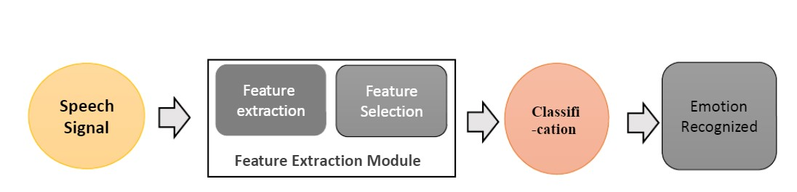

Figure 1 Traditional Speech Emotion Recognition System.

The extracted features. Such feature extraction and selection are usually based on the analysis of speech signals in the time and frequency domains. During the third stage, various classifiers such as GM Mand HMM, etc. are utilized for the classification of these features. Lastly, based on feature classification different emotions are recognized.

## Proposed System

In this system we can recognize emotions from speech. We used an MLP Classifier for this and made use of the sound file library to read the sound file, and the librosa library to extract features from it. As you’ll see, the model delivered an accuracy of 72.4%. That’s good enough for us yet.

## Objective of the System

## Its application work in different areas

## Its implementation as a desktop Application

## This application as software that can be use for Speech Recognition

## Developing software for speech recognition

## Speech recognition is a technology that able a computer to capture the words spoken by a human with a help of microphone

## To build a model to recognize emotion from speech using the librosa and sklearn libraries and the RAVDESS dataset.

# [CHAPTER](https://1.bp.blogspot.com/-dODuK8N5h1Q/Wlnyb3V9HFI/AAAAAAAACL4/WxQtCJ1pM5wccDABg4wIrTBUB0vlikXQQCLcBGAs/s1600/poly1.jpg) 05 REQUIREMENT ANALYSIS

**5. REQUIREMENT ANALYSIS**

## Hardware Requirement Specification

* Processor : Intel core i5 processer
* Memory : 15.6 GB
* Hard Disk : 40 GB
* 8 GB of RAM
* OS : Windows 8 or later

## Software Requirement Specification

* Programming Language : Python
* IDE : Visual Studio Code
* Open source dataset

# [CHAPTER](https://1.bp.blogspot.com/-dODuK8N5h1Q/Wlnyb3V9HFI/AAAAAAAACL4/WxQtCJ1pM5wccDABg4wIrTBUB0vlikXQQCLcBGAs/s1600/poly1.jpg) 06 DESIGN ANALYSIS

1. **DESIGN & ANALYSIS**

The representation of emotions can be done in two ways:

**Discrete Classification**: Classifying emotions in discrete labels like anger, happiness, boredom, etc.

**Dimensional Representation:** Representing emotions with dimensions such as Valence (on a negative to positive scale), Activation or Energy (on a low to high scale) and Dominance (on an active to passive scale)

Both these approaches have their pros and cons. The dimensional approach is more elaborate and gives more context to prediction but it is harder to implement and there is a lack of annotated audio data in a dimensional format. The discrete classification is more straightforward and easier to implement but it lacks the context of the prediction that dimensional representation provides. We have used the discrete classification approach in the current study for lack of dimensionally annotated data in the public domain.

**DATA SOURCES**

* RAVDESS: 2452 audio files, with 12 male speakers and 12 Female speakers, the lexical features (vocabulary) of the utterances are kept constant by speaking only 2 statements of equal lengths in 8 different emotions by all speakers.

Loading the dataset ;

There are set of 200 target words were spoken in the carrier phrase "Say the word 'by two

actresses (aged 26 and 64 years) and recordings were made of the set portraying each of seven

emotions (anger, disgust, fear, happiness, pleasant surprise, sadness, and neutral). There are 2800

data points (audio files) in total.

The dataset is organized such that each of the two female actor and their emotions are contain

within its own folder. And within that, all 200 target words audio file can be found. The format of

the audio file is in WAV format.

Loading the dataset ;

There are set of 200 target words were spoken in the carrier phrase "Say the word 'by two

actresses (aged 26 and 64 years) and recordings were made of the set portraying each of seven

emotions (anger, disgust, fear, happiness, pleasant surprise, sadness, and neutral). There are 2800

data points (audio files) in total.

The dataset is organized such that each of the two female actor and their emotions are contain

within its own folder. And within that, all 200 target words audio file can be found. The format of

the audio file is in WAV format.

Loading the dataset ;

There are set of 200 target words were spoken in the carrier phrase "Say the word 'by two

actresses (aged 26 and 64 years) and recordings were made of the set portraying each of seven

emotions (anger, disgust, fear, happiness, pleasant surprise, sadness, and neutral). There are 2800

data points (audio files) in total.

The dataset is organized such that each of the two female actor and their emotions are contain

within its own folder. And within that, all 200 target words audio file can be found. The format of

the audio file is in WAV format.

Loading the dataset ;

There are set of 200 target words were spoken in the carrier phrase "Say the word 'by two

actresses (aged 26 and 64 years) and recordings were made of the set portraying each of seven

emotions (anger, disgust, fear, happiness, pleasant surprise, sadness, and neutral). There are 2800

data points (audio files) in total.

The dataset is organized such that each of the two female actor and their emotions are contain

within its own folder. And within that, all 200 target words audio file can be found. The format of

the audio file is in WAV format.

Loading the dataset ;

There are set of 200 target words were spoken in the carrier phrase "Say the word 'by two

actresses (aged 26 and 64 years) and recordings were made of the set portraying each of seven

emotions (anger, disgust, fear, happiness, pleasant surprise, sadness, and neutral). There are 2800

data points (audio files) in total.

The dataset is organized such that each of the two female actor and their emotions are contain

within its own folder. And within that, all 200 target words audio file can be found. The format of

the audio file is in WAV format.

Loading the dataset ;

There are set of 200 target words were spoken in the carrier phrase "Say the word 'by two

actresses (aged 26 and 64 years) and recordings were made of the set portraying each of seven

emotions (anger, disgust, fear, happiness, pleasant surprise, sadness, and neutral). There are 2800

data points (audio files) in total.

The dataset is organized such that each of the two female actor and their emotions are contain

within its own folder. And within that, all 200 target words audio file can be found. The format of

the audio file is in WAV format.

Loading the dataset ;

There are set of 200 target words were spoken in the carrier phrase "Say the word 'by two

actresses (aged 26 and 64 years) and recordings were made of the set portraying each of seven

emotions (anger, disgust, fear, happiness, pleasant surprise, sadness, and neutral). There are 2800

data points (audio files) in total.

The dataset is organized such that each of the two female actor and their emotions are contain

within its own folder. And within that, all 200 target words audio file can be found. The format of

the audio file is in WAV format.

Loading the dataset ;

There are set of 200 target words were spoken in the carrier phrase "Say the word 'by two

actresses (aged 26 and 64 years) and recordings were made of the set portraying each of seven

emotions (anger, disgust, fear, happiness, pleasant surprise, sadness, and neutral). There are 2800

data points (audio files) in total.

The dataset is organized such that each of the two female actor and their emotions are contain

within its own folder. And within that, all 200 target words audio file can be found. The format of

the audio file is in WAV format.

Loading the dataset ;

There are set of 200 target words were spoken in the carrier phrase "Say the word 'by two

actresses (aged 26 and 64 years) and recordings were made of the set portraying each of seven

emotions (anger, disgust, fear, happiness, pleasant surprise, sadness, and neutral). There are 2800

data points (audio files) in total.

The dataset is organized such that each of the two female actor and their emotions are contain

within its own folder. And within that, all 200 target words audio file can be found. The format of

the audio file is in WAV format.

Loading the dataset ;

There are set of 200 target words were spoken in the carrier phrase "Say the word 'by two

actresses (aged 26 and 64 years) and recordings were made of the set portraying each of seven

emotions (anger, disgust, fear, happiness, pleasant surprise, sadness, and neutral). There are 2800

data points (audio files) in total.

The dataset is organized such that each of the two female actor and their emotions are contain

within its own folder. And within that, all 200 target words audio file can be found. The format of

the audio file is in WAV format.

Loading the dataset ;

There are set of 200 target words were spoken in the carrier phrase "Say the word 'by two

actresses (aged 26 and 64 years) and recordings were made of the set portraying each of seven

emotions (anger, disgust, fear, happiness, pleasant surprise, sadness, and neutral). There are 2800

data points (audio files) in total.

The dataset is organized such that each of the two female actor and their emotions are contain

within its own folder. And within that, all 200 target words audio file can be found. The format of

the audio file is in WAV format.

Loading the dataset ;

There are set of 200 target words were spoken in the carrier phrase "Say the word 'by two

actresses (aged 26 and 64 years) and recordings were made of the set portraying each of seven

emotions (anger, disgust, fear, happiness, pleasant surprise, sadness, and neutral). There are 2800

data points (audio files) in total.

The dataset is organized such that each of the two female actor and their emotions are contain

within its own folder. And within that, all 200 target words audio file can be found. The format of

the audio file is in WAV format.

Loading the dataset ;

There are set of 200 target words were spoken in the carrier phrase "Say the word 'by two

actresses (aged 26 and 64 years) and recordings were made of the set portraying each of seven

emotions (anger, disgust, fear, happiness, pleasant surprise, sadness, and neutral). There are 2800

data points (audio files) in total.

The dataset is organized such that each of the two female actor and their emotions are contain

within its own folder. And within that, all 200 target words audio file can be found. The format of

the audio file is in WAV format.

Loading the dataset ;

There are set of 200 target words were spoken in the carrier phrase "Say the word 'by two

actresses (aged 26 and 64 years) and recordings were made of the set portraying each of seven

emotions (anger, disgust, fear, happiness, pleasant surprise, sadness, and neutral). There are 2800

data points (audio files) in total.

The dataset is organized such that each of the two female actor and their emotions are contain

within its own folder. And within that, all 200 target words audio file can be found. The format of

the audio file is in WAV format.

Loading the dataset ;

There are set of 200 target words were spoken in the carrier phrase "Say the word 'by two

actresses (aged 26 and 64 years) and recordings were made of the set portraying each of seven

emotions (anger, disgust, fear, happiness, pleasant surprise, sadness, and neutral). There are 2800

data points (audio files) in total.

The dataset is organized such that each of the two female actor and their emotions are contain

within its own folder. And within that, all 200 target words audio file can be found. The format of

the audio file is in WAV format.

**FEATURES USED**

**MFCC (Mel Frequency Cepstral Coefficients)**

In the conventional analysis of time signals, any periodic component (for example, echoes) shows up as sharp peaks in the corresponding frequency spectrum (i.e. Fourier spectrum. This is obtained by applying a Fourier transform on the time signal). Any cepstrum feature is obtained by applying Fourier Transform on a spectrogram. The special characteristic of MFCC is that it is taken on a Mel scale which is a scale that relates the perceived frequency of a tone to the actual measured frequency. It scales the frequency in order to match more closely what the human ear can hear. The envelope of the temporal power spectrum of the speech signal is representative of the vocal tract and MFCC accurately represents this envelope.

**Mel Spectrogram**

A Fast Fourier Transform is computed on overlapping windowed segments of the signal, and we get what is called the spectrogram. This is just a spectrogram that depicts amplitude which is mapped on a Mel scale.

**Chroma**

A Chroma vector is typically a 12-element feature vector indicating how much energy of each pitch class is present in the signal in a standard chromatic scale.

# [CHAPTE](https://1.bp.blogspot.com/-dODuK8N5h1Q/Wlnyb3V9HFI/AAAAAAAACL4/WxQtCJ1pM5wccDABg4wIrTBUB0vlikXQQCLcBGAs/s1600/poly1.jpg)R 07 IMPLEMENTATION

1. **IMPLEMENTATION**

Implementation is the stage where the theoretical design is turned into a working system. The most crucial stage in achieving a new successful system and in giving confidence on the new system for the users that it will work efficiently and effectively.

The system can be implemented only after thorough testing is done and if it is found to work according to the specification. It involves careful planning, investigation of the current system and it constraints on implementation, design of methods to achieve the change over and an evaluation of change over methods a part from planning.

Two major tasks of preparing the implementation are education and training of the users and testing of the system. The more complex the system being implemented, the more involved will be the system analysis and design effort required just for implementation.

The implementation phase comprises of several activities. The required hardware and software acquisition is carried out. The system may require some software to be developed. For this, programs are written and tested. The user then changes over to his new fully tested system and the old system is discontinued.

## TESTING

The testing phase is an important part of software development. It is the Information zed system will help in automate process of finding errors and missing operations and also a complete verification to determine whether the objectives are met and the user requirements are satisfied. Software testing is carried out in three steps:

1. The first includes unit testing, where in each module is tested to provide its correctness, validity and also determine any missing operations and to verify whether the objectives have been met. Errors are noted down and corrected immediately.
2. Unit testing is the important and major part of the project. So errors are rectified easily in particular module and program clarity is increased. In this project entire system is divided into several modules and is developed individually. So unit testing is conducted to individual modules.
3. The second step includes Integration testing. It need not be the case, the software whose modules when run individually and showing perfect results, will also show perfect results when run as a whole.
4. DATA COLLECTION

The first step in implementing the Speech Emotion Recognition system is to collect audio samples under different emotional categories which can be used to train the model. The audio samples are usually wave or mp3 files and publically available for download.

1. DATA VISUALIZATION

Visualizing the data gives more understanding of the problem and the type of solution to be built. The distribution of classes, the number of instances under each category, the spread of the data, the correlation between the features and clustering are a few methods to visualize the data. Python and R provide statistical functions for data visualization.

1. DATA PREPARATION

After analyzing the data through various visualizations, the next step is to prepare data for processing. The steps of data preparation include fixing quality issues, standardization, and normalization. First, the data is checked for quality issues such as missing values , outliers invalid data and duplicate data. There were no missing values, invalid or duplicate values in the data.

**CHAPTER 08  
SNAPSHOTS**

* 1. **SNAPSHOTS**
* CODE SNIPPETS

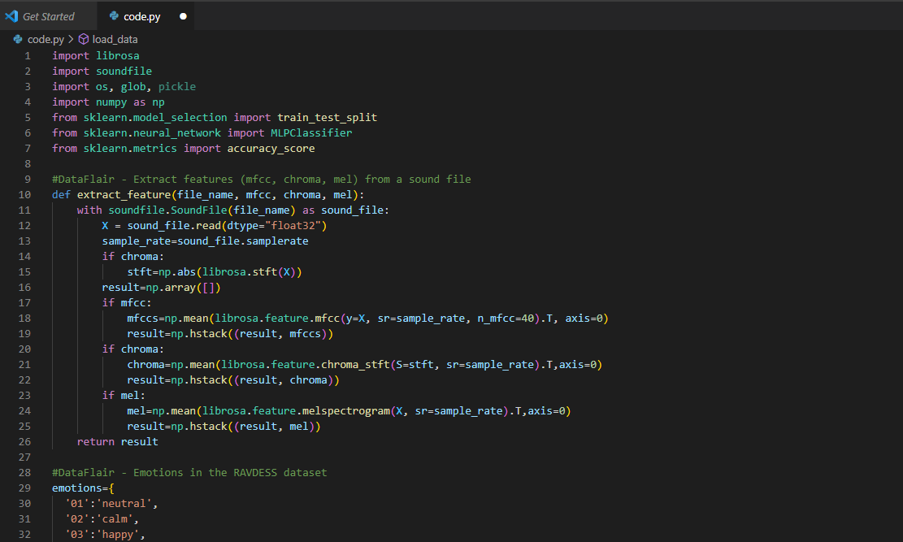

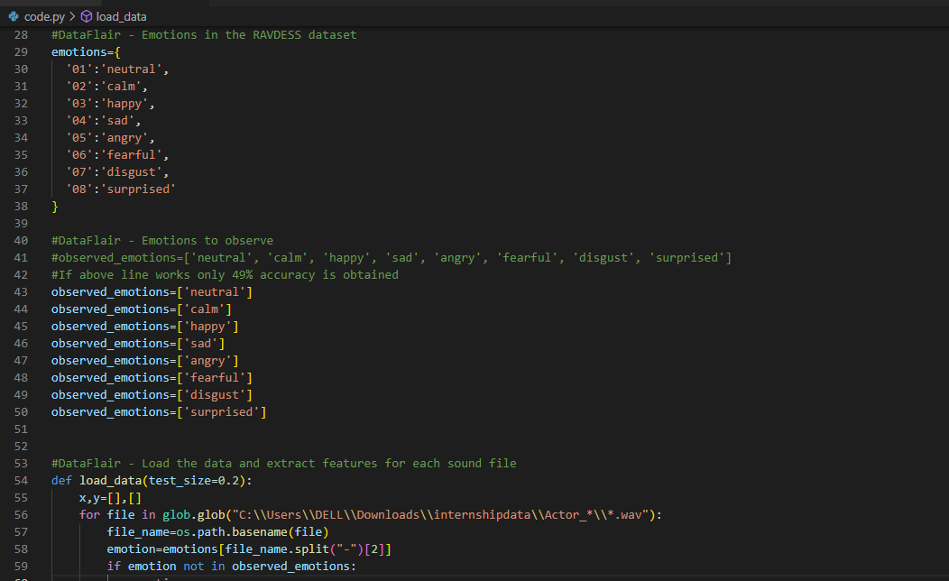

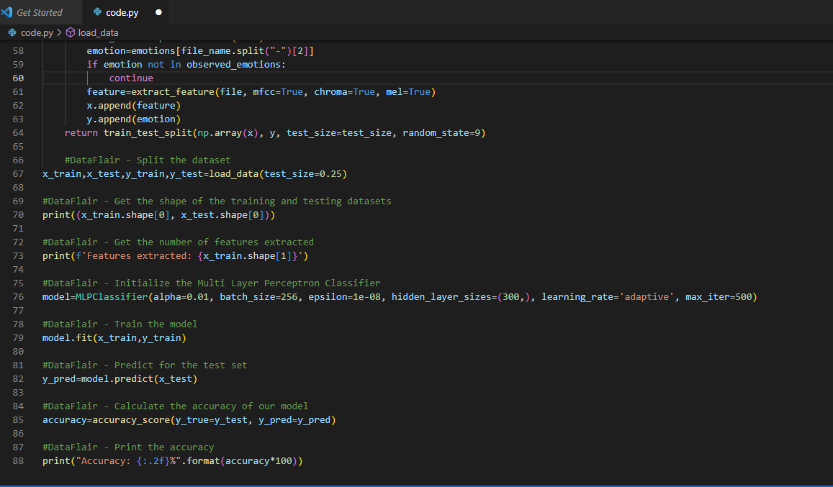

* TERMINAL SNIPPETS

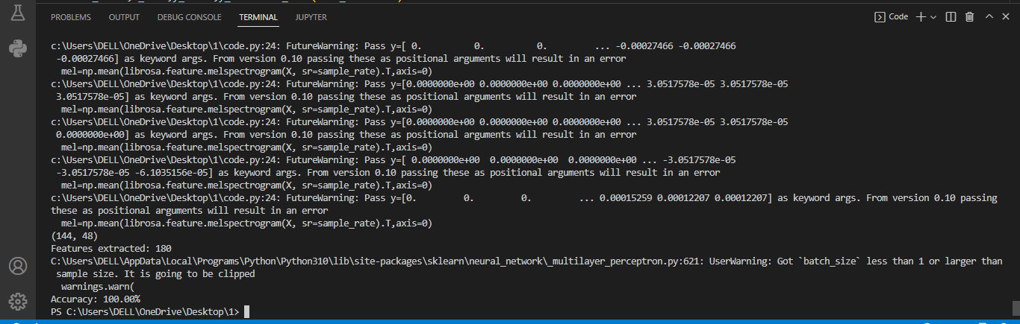

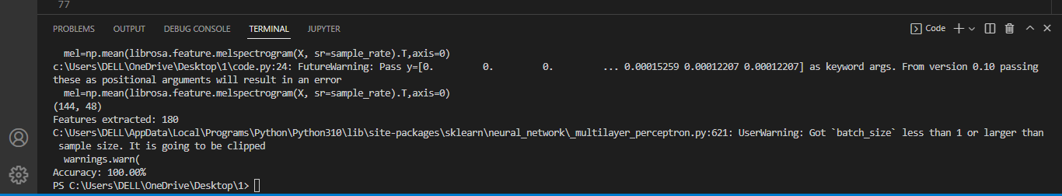

[**CHAPTE**](https://1.bp.blogspot.com/-dODuK8N5h1Q/Wlnyb3V9HFI/AAAAAAAACL4/WxQtCJ1pM5wccDABg4wIrTBUB0vlikXQQCLcBGAs/s1600/poly1.jpg)**R 09**

**CONCLUSION**

**9. CONCLUTION**

The package was designed in such a way that future modifications can be done easily. The following conclusions can be deduced from the development of the project:

* Automation of the entire system improves the efficiency
* It provides a friendly graphical user interface which proves to be better when compared to the existing system.
* It gives appropriate access to the authorized users depending on their permissions.
* It effectively overcomes the delay in communications.
* Updating of information becomes so easier
* System security, data security and reliability are the striking features.

The System has adequate scope for modification in future if it is necessary.

**CHAPTER 10**

**REFERENCES**

# 10. REFERENCES

# T. Vogt and E. André, "Comparing feature sets for acted and spontaneous speech in view of automatic emotion recognition," in Proc. IEEE Int. Conf. Multimedia Expo (ICME), Jul 2005, pp. 474-477.

# C.-N. Anagnostopoulos, T. Iliou, and L. Giannoukos, "Features and classifiers for emotion recognition from speech: A survey from 2000 to 2011," Artif. Intell. Rev., vol. 43, no. 2, pp.155-177, 2015

# A. Batliner, B. Schuller, D. Seppi, S. Steidl, L. Devillers, L. Vidrascu, T. Vogt, V. Aharonson, and N. Amir. "The automatic recognition of emotions in speech," in Emotion-Oriented Systems. Springer, 2011, pp. 71-99

# E. Mower, M. J. Mataric, and S. Narayanan, "A framework for automatic human emotion

# classification using emotion profiles," IEEE Trans. Audio, Speech, Language Process., vol. 19, no. 5, pp. 1057-1070, Jul. 2011.

# J. Han, Z. Zhang, F. Ringeval, and B. Schuller. "Prediction-based learning for continuous emotion recognition in speech." in Proc. IEEE Int. Conf. Acoust.. Speech Signal Process. (ICASSP), Mar. 2017, pp 5005-5009.

# <https://data-flair.training/blogs/python-mini-project-speech-emotion-recognition/>

# <https://www.studocu.com/in/document/chandigarh-university/disruptive-technologies-2/ser-final-report/27338335>

# <https://www.tutorialspoint.com/machine_learning_with_python/machine_learning_with_python_tutorial.pdf>

* 27. A. Batliner, B. Schuller, D. Seppi, S. Steidl, L. Devillers, L. Vidrascu, T. Vogt, V. Aharonson,
* and N. Amir, ``The automatic recognition of emotions in speech,'' in Emotion-Oriented
* Systems. Springer, 2011, pp. 71-99
* 28. E. Mower, M. J. Mataric, and S. Narayanan, ``A framework for automatic human emotion
* classification using emotion profiles,'' IEEE Trans. Audio, Speech, Language Process., vol.
* 19, no. 5, pp. 1057-1070, Jul. 2011.
* 29. J. Han, Z. Zhang, F. Ringeval, and B. Schuller, ``Prediction-based learning for continuous
* emotion recognition in speech,'' in Proc. IEEE Int. Conf. Acoust., Speech Signal Process.
* (ICASSP), Mar. 2017, pp. 5005-5009
* 27. A. Batliner, B. Schuller, D. Seppi, S. Steidl, L. Devillers, L. Vidrascu, T. Vogt, V. Aharonson,
* and N. Amir, ``The automatic recognition of emotions in speech,'' in Emotion-Oriented
* Systems. Springer, 2011, pp. 71-99
* 28. E. Mower, M. J. Mataric, and S. Narayanan, ``A framework for automatic human emotion
* classification using emotion profiles,'' IEEE Trans. Audio, Speech, Language Process., vol.
* 19, no. 5, pp. 1057-1070, Jul. 2011.
* 29. J. Han, Z. Zhang, F. Ringeval, and B. Schuller, ``Prediction-based learning for continuous
* emotion recognition in speech,'' in Proc. IEEE Int. Conf. Acoust., Speech Signal Process.
* (ICASSP), Mar. 2017, pp. 5005-5009
* T. Vogt and E. André, ``Comparing feature sets for acted and spontaneous speech in view of
* automatic emotion recognition,'' in Proc. IEEE Int. Conf. Multimedia Expo (ICME), Jul.
* 2005, pp. 474-477.
* T. Vogt and E. André, ``Comparing feature sets for acted and spontaneous speech in view of
* automatic emotion recognition,'' in Proc. IEEE Int. Conf. Multimedia Expo (ICME), Jul.
* 2005, pp. 474-477.

# 

# 