Table of Contents
Abstract 2
Introduction 3
Problem Description 3
Project Aims 3
Foundational Knowledge 3
Contextual Literature 3
Methods 4
Firing Rate Modelling 4
Haemodynamic Modelling 4
Neuroimaging 4
Model Validation 4
Parameter Optimisation 4
Control Condition 4
Serotonin Condition 4
Results 5
Discussion 6
Limitations 7
Future Work 8
Conclusion 9

Abstract

Introduction

Problem Description
Why is this needed?

Project Aims
Clearly Defined Aims

Foundational Knowledge
Neurons
Brains
Neuromodulators
Serotonin
Receptors

Contextual Literature
BBB
BOLD
TUS
Computational modelling
What isn’t happening, and how does this project close those holes

Methods

Firing Rate Modelling
Brain modelled as a network of populations
Populations are networks
Populations communicate locally with currents
The E population then communicates across the network with currents
A FIGURE SHOWING THIS WOULD BE REALLY USEFUL
Synaptic Gating Variables control the passing of currents
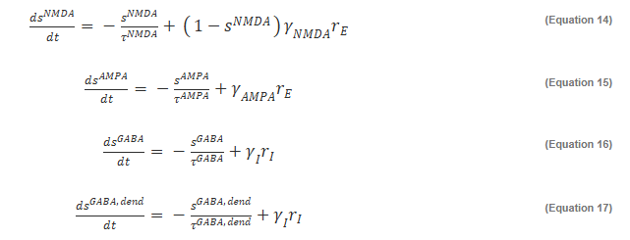
Ornstein-Uhlenbeck process for noise, unique per population. This and background current drive the system
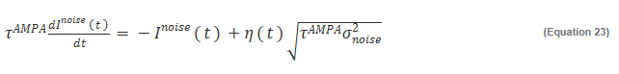
Mechanistic analysis of serotonin requires the model to maintain local circuit complexity, to capture
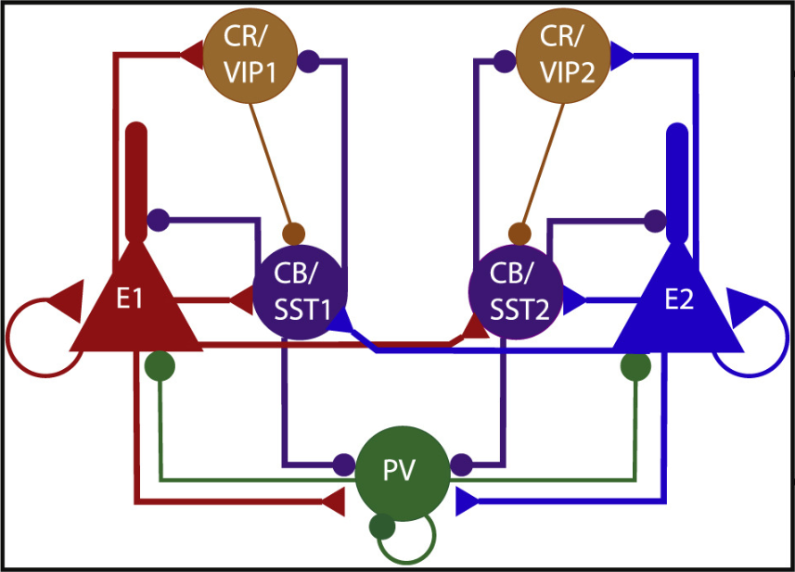

Haemodynamic Modelling

Neuroimaging

Model Validation

Parameter Optimisation

Control Condition

Serotonin Condition

Results

Validation
Heuristics
Patterns

Optimisation Control
Parameter analysis
Performance analysis

Optimisation Serotonin

Discussion

Summary of results

What’s interesting?

Weaknesses
Limitations
Future works

Value to the Field

Conclusion

