Graph:

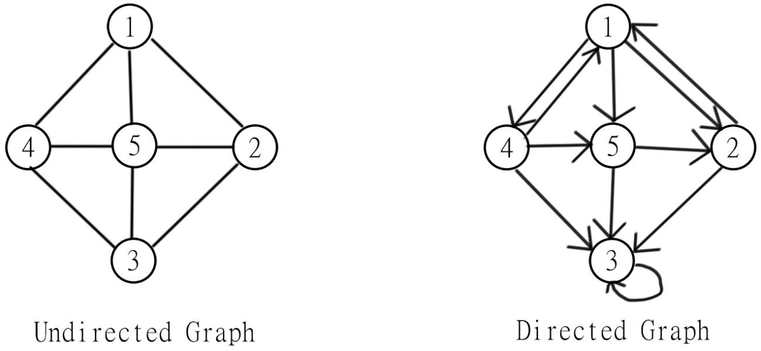

* Undirected Graph

|  |  |  |  |  |  |
| --- | --- | --- | --- | --- | --- |
|  | 1 | 2 | 3 | 4 | 5 |
| 1 | 0 | 1 | 1 | 1 | 1 |
| 2 | 1 | 0 | 1 | 1 | 1 |
| 3 | 1 | 1 | 0 | 1 | 1 |
| 4 | 1 | 1 | 1 | 0 | 1 |
| 5 | 1 | 1 | 1 | 1 | 0 |

The degrees of the nodes 1, 2, 3, 4: 3

The degrees of the node 5: 4

* 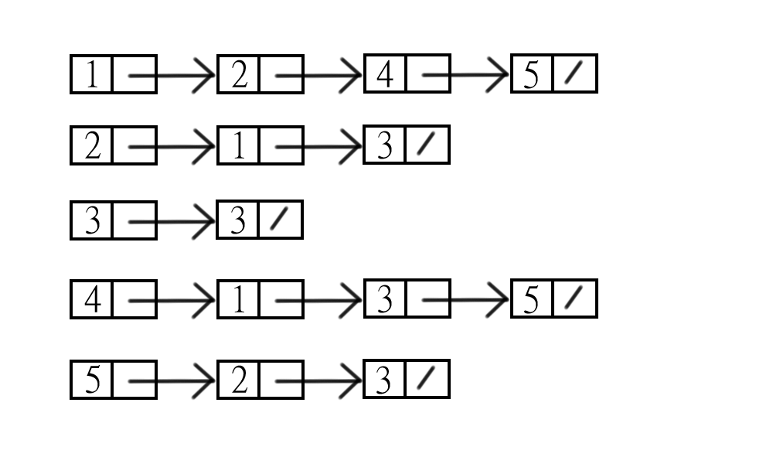Directed Graph

|  |  |  |  |  |  |  |  |
| --- | --- | --- | --- | --- | --- | --- | --- |
| Start\End | | 1 | 2 | | 3 | 4 | 5 |
| 1 | | 0 | 1 | | 0 | 1 | 1 |
| 2 | | 1 | 0 | | 1 | 0 | 0 |
| 3 | | 0 | 0 | | 1 | 0 | 0 |
| 4 | | 1 | 0 | | 1 | 0 | 1 |
| 5 | | 0 | 1 | | 1 | 0 | 0 |
|  | Indegree | | | Outdegree | | | | Degree |
| 1 | 2 | | | 3 | | | | 5 |
| 2 | 2 | | | 2 | | | | 4 |
| 3 | 4 | | | 0 | | | | 4 |
| 4 | 1 | | | 3 | | | | 4 |
| 5 | 2 | | | 2 | | | | 4 |

#指自己算Indegree