PERSONAL BUSINESS MANAGEMENT SYSTEM (PBMS)
PBMS – Chit Fund Module
Individual System Architecture

Client: Dhavanam Finance
Solution Provider: Florix Technologies Pvt. Ltd.
Derived From: PBMS Module-Wise System Architecture, v1.0
September 2026

Document Information
Field | Detail
Document Title | PBMS – Chit Fund Module: Individual System Architecture
Module | Chit Fund
Client | Dhavanam Finance
Solution Provider | Florix Technologies Pvt. Ltd.
Source Document | PBMS Module-Wise System Architecture, v1.0
Document Status | Draft — for architecture review
Version | 1.0
Date | September 2026

Table of Contents

1. Module Purpose & Scope
The Chit Fund Module digitizes the complete chit scheme lifecycle across multiple concurrent Chit Schemes and Groups — configuration, Profile-based member enrollment, installment collection, automatic penalty on overdue installments, auction / bidding outcomes, prize distribution, next-cycle collection recalculation, and scheme closure.

The module manages:
- Multiple concurrent Chit Schemes
- Multiple Groups within schemes
- Scheme / Group configuration
- Profile-based member enrollment
- Installment collection
- Automatic penalty when an installment is overdue
- Auction / bidding outcomes
- Prize distribution
- Next-cycle collection amount recalculation
- Scheme / Group closure

Governing rules
- Members are enrolled using existing Profile IDs. The module does not maintain separate member identity records.
- A Group contains configuration such as: start date, duration, collection amount, frequency, capacity, penalty percentage, and prize / dividend structure.
- Penalty is applied automatically when an installment is overdue.
- Auction / bidding outcomes are recorded.
- Prize distribution is recorded.
- The next collection amount is recalculated from the auction / prize outcome.
- The exact numeric formula for the next collection amount is not specified and remains TBC.
- Scheme / Group requires an approval step before activation.
- Closure / settlement is Administrator-only.

2. Component Architecture
The diagram below shows the components owned by the Chit Fund Module, the Shared Platform Services it consumes, and the Central Financial Transaction Engine, which is the sole financial posting boundary.
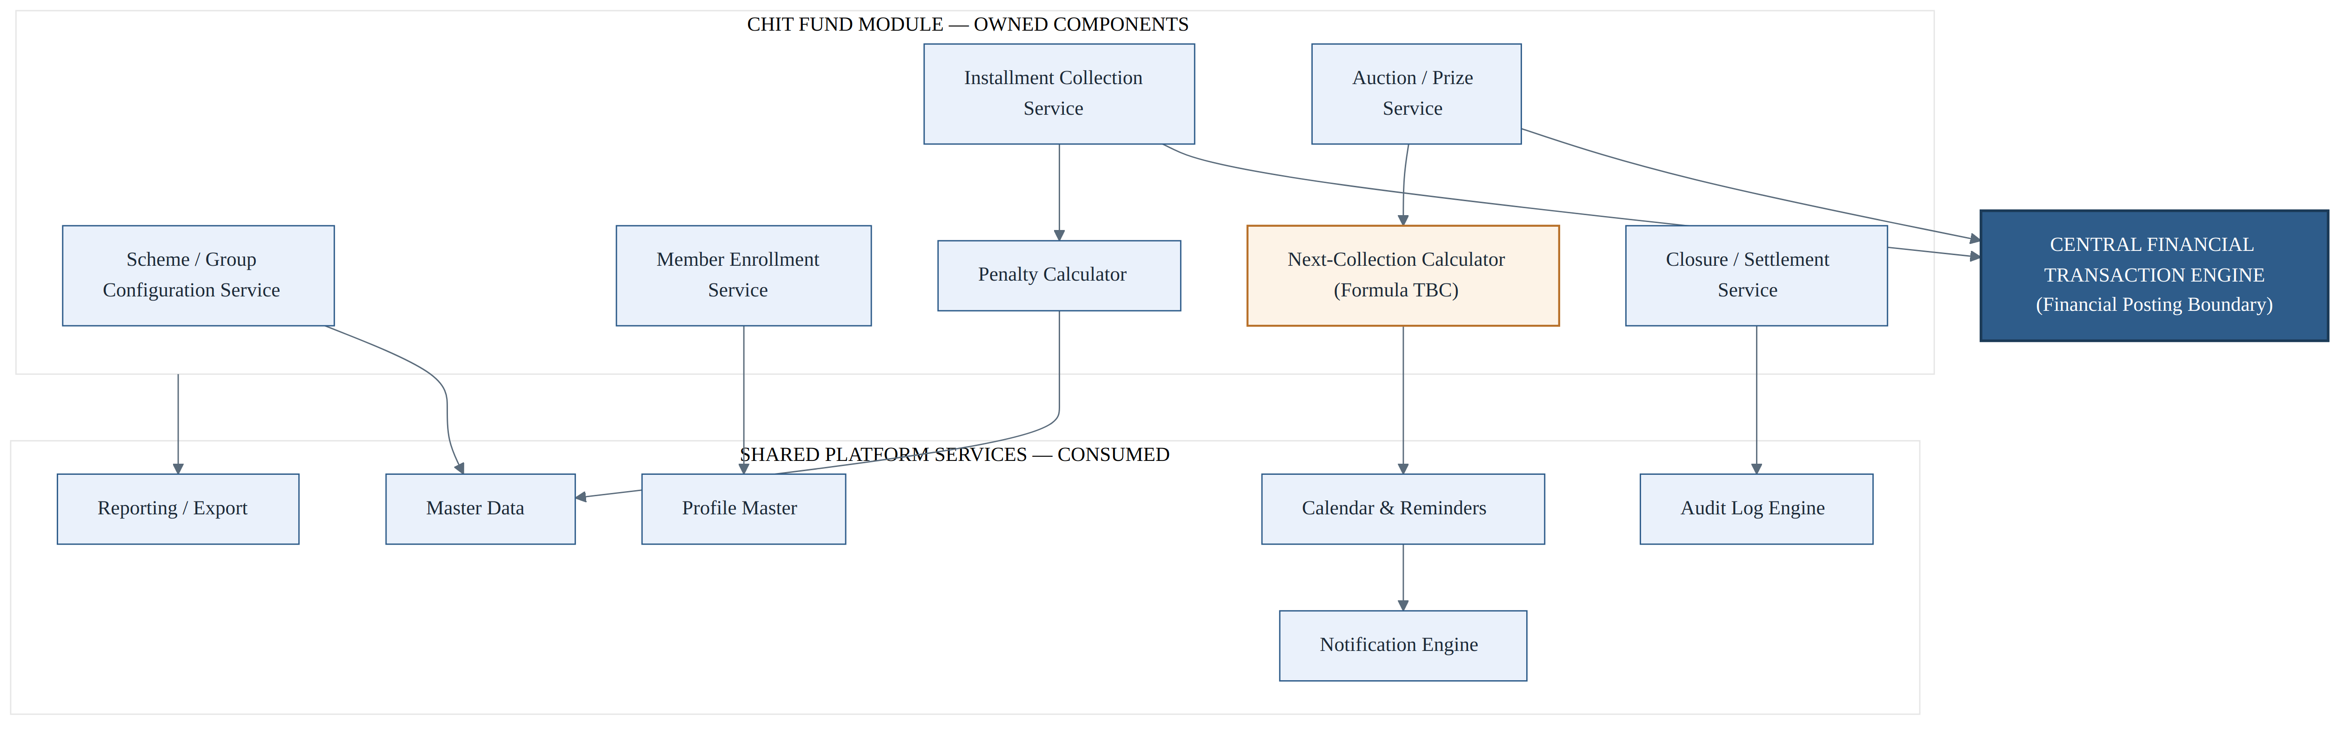
Figure 2.1 — Chit Fund Module component architecture

Chit Fund Module — Owned Components
- Scheme / Group Configuration Service
- Member Enrollment Service
- Installment Collection Service
- Penalty Calculator
- Auction / Prize Service
- Next-Collection Calculator — Formula TBC
- Closure / Settlement Service

Shared Platform Services — Consumed
- Profile Master
- Master Data
- Calendar & Reminders
- Notification Engine
- Audit Log Engine
- Reporting / Export

Central Financial Transaction Engine
The Central Financial Transaction Engine is represented as the financial posting boundary — it alone classifies transactions as Accounted / Non-Accounted and posts to the Cash Book, Bank Book, and Central Ledger.

Defined Relationships
- Member Enrollment → Profile Master
- Scheme / Group Configuration → Master Data
- Installment Collection → Central Financial Transaction Engine
- Installment Collection → Penalty Calculator
- Penalty Calculator → Master Data
- Auction / Prize Service → Central Financial Transaction Engine
- Auction / Prize Service → Next-Collection Calculator
- Next-Collection Calculator → Calendar & Reminders
- Calendar & Reminders → Notification Engine
- Closure / Settlement → Audit Log Engine
- Chit Fund Module → Reporting / Export

3. Data Ownership
Chit Fund Owns | Referenced Only — Owned Elsewhere
Chit Scheme record | Profile ID for each member — owned by Profile Master
Chit Group record — configuration and status | Penalty-rate / collection-frequency values — owned by Master Data
Chit Member enrollment — Group ID + Profile ID | Installment / prize-disbursement postings — owned by Central Financial Engine
Installment collection history | Audit trail — owned by Audit Log Engine
Auction / prize records per cycle | —

4. Inputs & Outputs

Inputs
- Group configuration parameters
- Profile ID for member enrollment
- Installment collection entries
- Auction winner and prize amount per cycle

Outputs
- Transaction-raise requests for installments and prize disbursements to the Central Financial Transaction Engine
- Updated member ledgers and due status
- Recalculated next-collection amount and schedule
- Audit events
- Chit Fund reports

5. Scheme / Group Lifecycle Workflow
The workflow below traces a Chit Scheme from configuration through the recurring installment / auction cycle to closure.
Figure 5.1 — Chit Scheme / Group lifecycle workflow
Each cycle begins once a Group is configured and approved and members are enrolled via Profile. An installment is raised and collected; if the installment is overdue, an automatic penalty is applied before the cycle proceeds to auction. Once a winner is declared and the prize is distributed, the next collection amount is auto-calculated (formula TBC) and the cycle repeats for the next installment. When the scheme is complete, it moves to Closure / Settlement.

6. Financial Posting / Installment Collection Transaction Sequence
Participants: Employee (Chit Group UI), Chit Fund Module, Central Financial Transaction Engine, Cash Book / Bank Book, Central Ledger.
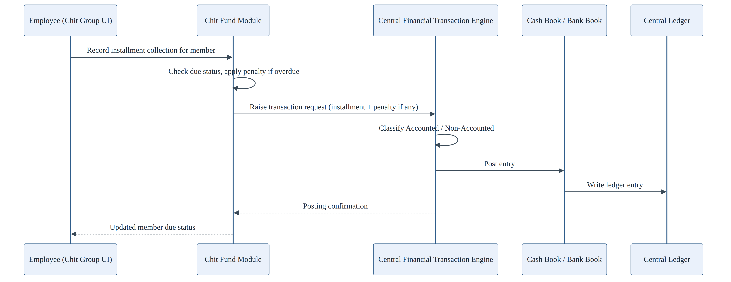
Figure 6.1 — Installment collection transaction sequence
The Employee records an installment collection for a member. The Chit Fund Module checks due status and applies a penalty if the installment is overdue, then raises a transaction request (installment plus penalty, if applicable) to the Central Financial Transaction Engine. The Engine classifies the transaction as Accounted / Non-Accounted, posts the entry to the Cash Book / Bank Book, and the Central Ledger entry is written. A posting confirmation returns to the Chit Fund Module, which shows the updated member due status to the Employee.

7. Dependencies
Upstream — Chit Fund Depends On | Downstream — Depends On Chit Fund
Profile Master | Executive Dashboard
Master Data | Chit Fund reports
Central Financial Transaction Engine | Global Search
Calendar & Notification Engine
Audit Log Engine

8. RBAC Touchpoints
Action | Role Required
Configure scheme / group | Administrator
Approve group | Administrator only
Enroll member | Employee or Administrator
Installment collection | Employee or Administrator
Auction winner / prize | Employee or Administrator (approval pattern TBC)
Close scheme / group | Administrator only
The auction / prize approval pattern — whether it requires a gate analogous to loan sanction — is not yet defined and remains TBC.

9. Ownership Boundary
Chit Fund Owns | Chit Fund Must Not Own
Scheme configuration | Authentication
Group configuration and status | RBAC enforcement
Member enrollment | Profile identity storage
Installment collection history | Cash Book
Auction / prize records | Bank Book
Penalty calculation | Central Ledger
Next-collection calculation | Notification delivery
Scheme / Group lifecycle | Calendar scheduling mechanics
— | Audit log storage
— | Reporting infrastructure
— | Financial posting
The module computes the penalty and the recalculated next-collection figure, then raises the financial transaction to the Central Financial Transaction Engine.

10. Open Architecture Questions / TBC
OPEN ARCHITECTURE QUESTIONS — TBC
1. Exact numeric formula relating prize amount, dividend structure, and the next collection amount — TBC. This is the single most consequential open item for the Chit Fund Module and must not be invented or assumed.
2. Auction / prize approval gate — whether auction / prize entries require an approval gate analogous to loan sanction — TBC.
3. Member notification model — whether members are notified of auction outcomes directly, and the recipient model for that notification — TBC.
None of the above items are resolved by this document. They remain open architecture decisions pending confirmation with chit-operations stakeholders.

