PERSONAL BUSINESS MANAGEMENT SYSTEM (PBMS)
PBMS – Finance Module
Individual System Architecture

Client: Dhavanam Finance
Solution Provider: Florix Technologies Pvt. Ltd.
Derived From: PBMS High-Level System Architecture Document, v1.0
Module-Wise Architecture Series • Finance (Lending) Module

Document Information
This section records the identifying details of the document and its scope boundary.
Field | Detail
Document Title | PBMS – Finance Module: Individual System Architecture
Module | Finance (Lending)
Client | Dhavanam Finance
Solution Provider | Florix Technologies Pvt. Ltd.
Derived From | PBMS High-Level System Architecture Document, v1.0 — PBMS Module-Wise System Architecture
Document Type | Individual (single-module) system architecture — companion to the platform-wide High-Level System Architecture Document
Scope Statement | This document describes the Finance Module only. Other PBMS modules (Chit Fund, Rental, Expense, Investment, Receivables & Payables) are out of scope and are referenced only where a shared platform dependency crosses the boundary.

How This Document Relates to the Platform
The Personal Business Management System (PBMS) is described as one integrated platform in the High-Level System Architecture Document. This companion document breaks that platform apart module by module, so each business module has its own standalone system architecture. This document presents the Finance Module's architecture on a standalone basis.
A business module never implements authentication, RBAC, audit logging, notifications, document storage, search, reporting infrastructure, financial posting logic, the Cash Book, the Bank Book, the Central Ledger, or Profile identity. It raises business events and transaction requests to the Central Financial Transaction Engine and consumes Shared Platform Services — it never builds these itself. This boundary rule governs every section of this document.

Table of Contents

1. Module Purpose & Scope 4
2. Component Architecture 4
3. Data Ownership 6
4. Inputs & Outputs 6
5. Loan Lifecycle Workflow 7
6. Financial Posting / Collection Transaction Sequence 8
7. Dependencies 9
8. RBAC Touchpoints 9
9. Ownership Boundary 9
10. Open Architecture Questions / TBC 10

1. Module Purpose & Scope
The Finance Module manages the complete loan lifecycle — customer onboarding through approval, sanction, disbursement, collection, top-up, and closure — with official (Accounted) and non-accounted interest tracked as two permanently separate streams throughout. Finance is the most financially complex module and is architecturally the first module built once the platform's foundational layers (Infrastructure, Data Schema, Auth/RBAC, Shared Services, Central Financial Engine) are in place.

In Scope
The Finance Module manages:
- Loan application
- Approval / sanction
- Disbursement
- Collection
- Interest recalculation
- Top-up
- NPA classification
- Closure

Governing Business Rules
The following rules govern the Finance Module and are preserved without modification:
- Accounted / Official Interest and Non-Accounted Interest are separate streams.
- Interest is calculated on pending principal.
- Interest is recalculated when principal is collected.
- Up to 2 guarantors and 1 co-borrower can be associated through existing Profile IDs.
- Employees submit loan applications.
- Administrator sanctions / approves loans.
- Administrator closes loans.
- Zero balance does NOT automatically close a loan.
- Top-up uses the SAME Loan ID.
- NPA classification occurs after the configured overdue interval, with the source stating the default as 3 months.

2. Component Architecture
The diagram below shows the components the Finance Module owns, the Shared Platform Services it consumes, and its interaction with the Central Financial Transaction Engine.
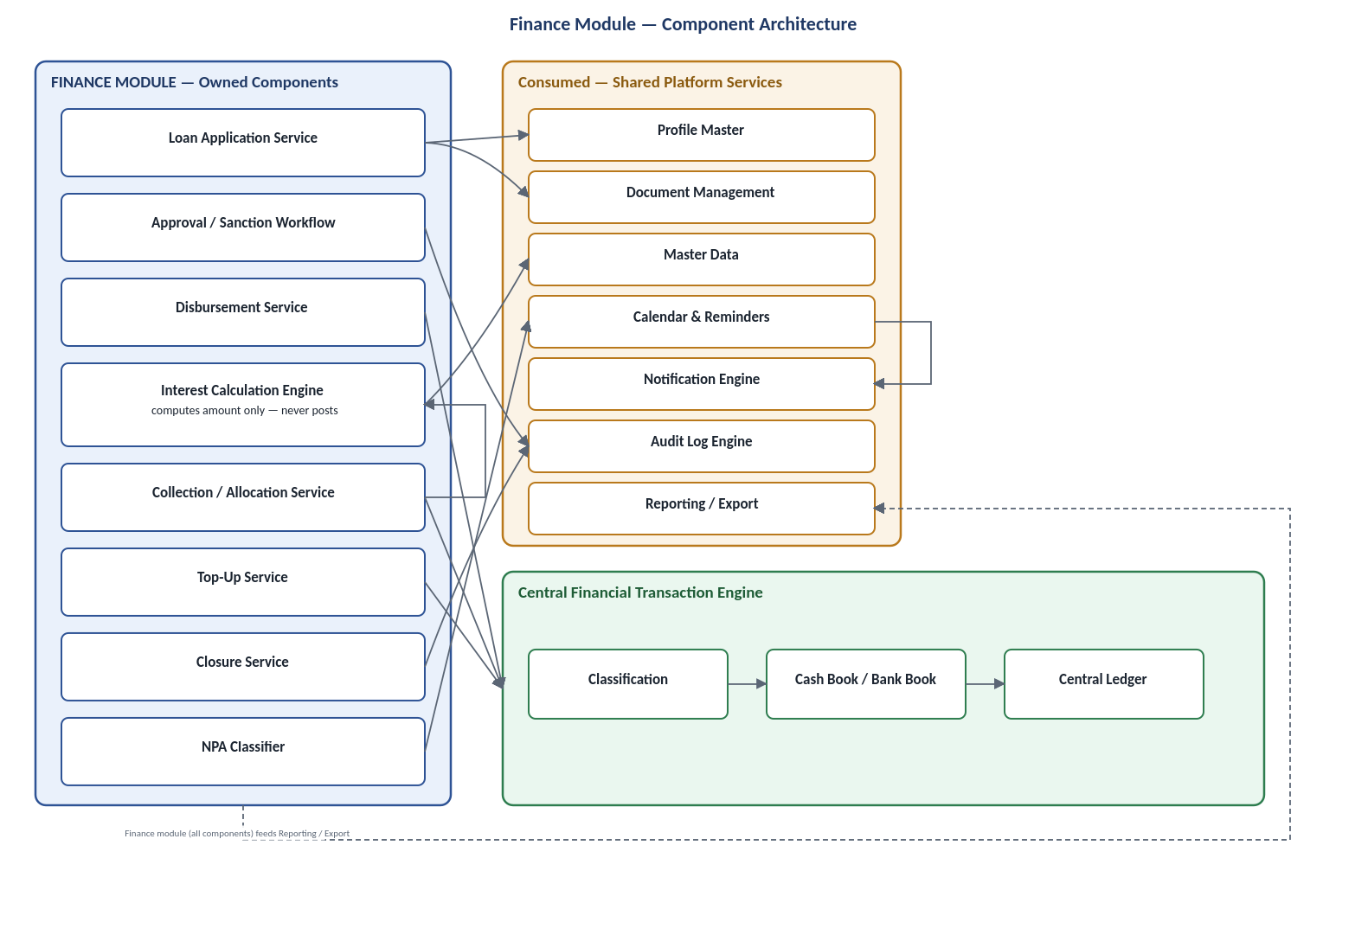
Figure 1 — Finance Module Component Architecture

Finance Module — Owned Components
- Loan Application Service
- Approval / Sanction Workflow
- Disbursement Service
- Interest Calculation Engine — computes amount only, never posts
- Collection / Allocation Service
- Top-Up Service
- Closure Service
- NPA Classifier

Shared Platform Services Consumed by Finance
- Profile Master
- Master Data
- Document Management
- Calendar & Reminders
- Notification Engine
- Audit Log Engine
- Reporting / Export

Central Financial Transaction Engine
The Central Financial Transaction Engine handles Classification → Cash Book / Bank Book → Central Ledger. The Finance Module raises transaction requests to this engine; it never posts to the Cash Book, Bank Book, or Ledger itself.

3. Data Ownership
The table below distinguishes entities the Finance Module owns from entities it only references, which are owned elsewhere on the platform.
FINANCE OWNS | REFERENCED ONLY — OWNED ELSEWHERE
Loan record — status, principal, interest terms by stream, collateral, collection schedule, top-up history | Profile ID for borrower, up to 2 guarantors and 1 co-borrower — owned by Profile Master
Loan collection / transaction history | Cash Book / Bank Book / Central Ledger entries — owned by Central Financial Engine
Guarantor / co-borrower link records | Interest type, loan type, collection frequency, penalty rule values — owned by Master Data
NPA classification state per loan | Document binaries — owned by Document Management
— | Audit trail — owned by Audit Log Engine

4. Inputs & Outputs

Inputs
- Profile ID(s) for borrower / guarantor(s) / co-borrower
- Loan terms:
  - Principal
  - Interest rate / frequency per stream
  - Collection frequency
  - First collection date
- Collateral / security details
- Collection entries:
  - Amount
  - Allocation
  - Mode
  - Date

Outputs
- Loan ID on sanction
- Transaction-raise requests to the Central Financial Transaction Engine
- Receipts
- Audit events
- Loan-lifecycle data feeding the Executive Dashboard and Finance reports

5. Loan Lifecycle Workflow
The diagram below shows the complete loan lifecycle, from Profile selection through Closure, Top-Up, and NPA Classification.
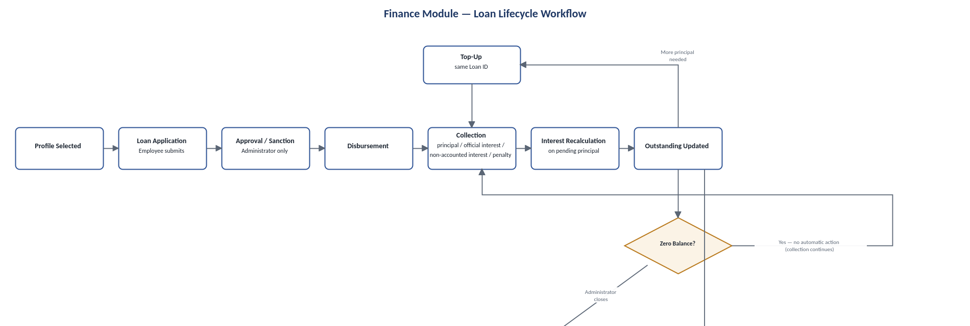
Figure 2 — Finance Module Loan Lifecycle Workflow

Workflow Description
- Profile Selected
- Loan Application — Employee submits
- Approval / Sanction — Administrator only
- Disbursement
- Collection (principal / official interest / non-accounted interest / penalty)
- Interest Recalculation (on pending principal)
- Outstanding Updated
From Outstanding Updated, the workflow branches three ways:
- A. Zero Balance? — Yes: no automatic action. Administrator closes → Closure.
- B. More principal needed — Top-Up (same Loan ID) → Collection.
- C. Overdue beyond interval — NPA Classification.

6. Financial Posting / Collection Transaction Sequence
The sequence diagram below shows how a collection transaction is recorded, allocated, raised to the Central Financial Transaction Engine, posted, and confirmed.
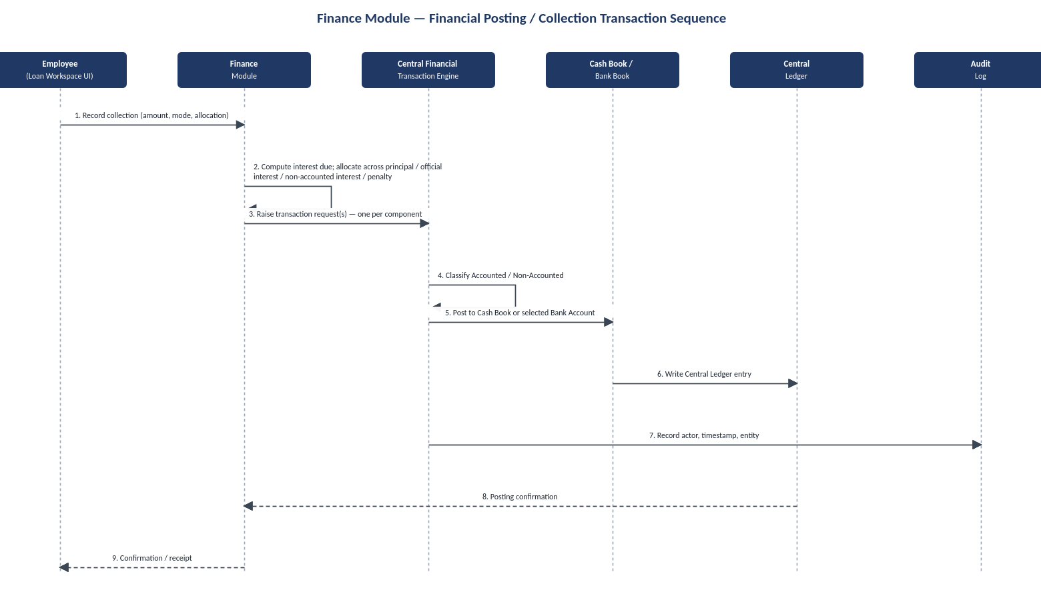
Figure 3 — Finance Module Financial Posting / Collection Transaction Sequence

Participants
- Employee (Loan Workspace UI)
- Finance Module
- Central Financial Transaction Engine
- Cash Book / Bank Book
- Central Ledger
- Audit Log

Sequence
- Employee records collection
- Finance computes interest due
- Finance allocates collection across: Principal, Official interest, Non-accounted interest, Penalty
- Finance raises transaction request(s)
- Central Financial Transaction Engine classifies Accounted / Non-Accounted
- Central Financial Transaction Engine posts to Cash Book or selected Bank Account
- Central Ledger entry is written
- Audit Log records actor, timestamp and entity
- Posting confirmation returns to Finance
- Finance provides confirmation / receipt to Employee

7. Dependencies
UPSTREAM — FINANCE DEPENDS ON | DOWNSTREAM — DEPENDS ON FINANCE
Profile Master  Master Data  Central Financial Transaction Engine  Document Management  Calendar & Notification Engine  Audit Log Engine | Executive Dashboard  Finance reports  Global Search (loan records)

8. RBAC Touchpoints
Action | Role Required
Submit loan application | Employee or Administrator
Sanction / approve loan | Administrator only
Disburse | Employee (post-sanction) or Administrator
Record collection | Employee or Administrator
Top-up | Employee submits, Administrator approves
Close loan | Administrator only
Delete / void any historical record | Not permitted — non-destructive only
Important: Finance declares which actions are restricted, but the permission check itself is enforced by the shared RBAC service and is not re-implemented inside Finance.

9. Ownership Boundary
FINANCE OWNS | FINANCE MUST NOT OWN
Loan entity  Lifecycle state  Interest-calculation formulas  Allocation rules  NPA rule  What is due, when, and which stream it belongs to  Marking sanction / closure as Administrator-restricted | Cash / Bank / Ledger balances  Borrower identity data beyond a Profile ID reference  RBAC permission-check mechanism

10. Open Architecture Questions / TBC
OPEN ARCHITECTURE QUESTIONS — TBC
These items are unresolved by design. No assumptions, recommendations, or answers are provided here.
- Exact concurrency / locking behavior when two collections post against the same loan simultaneously — TBC, engineering-level decision.
- Whether Accounted / Non-Accounted classification is an explicit choice at every collection screen or defaulted with override — UX pattern TBC.
- Session-level correction of a misclassified entry post-posting — TBC.

