PERSONAL BUSINESS MANAGEMENT SYSTEM (PBMS)
PBMS – Rental Module
Individual System Architecture

Client: Dhavanam Finance
Solution Provider: Florix Technologies Pvt. Ltd.
Derived From: PBMS Module-Wise System Architecture, v1.0
September 2026

Document Information
Field | Detail
Document Title | PBMS – Rental Module: Individual System Architecture
Module | Rental
Client | Dhavanam Finance
Solution Provider | Florix Technologies Pvt. Ltd.
Source Document | PBMS Module-Wise System Architecture, v1.0
Document Status | Draft — for architecture review
Version | 1.0
Date | September 2026

Table of Contents

1. Module Purpose & Scope
The Rental Module manages residential and commercial rental properties under a two-level parent/child structure, or as standalone properties, covering tenants, agreements, rent/maintenance collection, occupancy, and lease lifecycle.

The module manages:
- Residential rental properties
- Commercial rental properties
- Two-level parent/child property structure
- Standalone properties without hierarchy
- Tenants
- Rental agreements
- Rent collection
- Maintenance collection
- Combined Rent + Maintenance collection
- Occupancy
- Lease renewal
- Rent revision
- Notice management
- Lease closure

Governing rules
- Properties can exist under a two-level parent/child structure (e.g., a parent building containing multiple child flats/shops/units), or as standalone properties without hierarchy.
- Parent-level figures — total units, occupied, vacant, expected rent, and total outstanding — are derived at read time from child-property data. The parent record must never hold its own independently-updatable copy of these totals.
- All rent, maintenance, tenant, agreement, dues, and ledger data lives at the child-property level, even when summarized at the parent level.
- Tenants are registered against an existing Profile. There is no separate tenant identity form inside Rental.
- Three collection types exist: Rent only, Maintenance only, and Rent + Maintenance combined.
- Maintenance remains an obligation independent of rent even when collected together.
- Tenant allocation automatically changes occupancy status.
- The module supports lease renewal, rent revision, notice management, and lease closure.

2. Component Architecture
The diagram below shows the components owned by the Rental Module, the Shared Platform Services it consumes, and the Central Financial Transaction Engine, which is the sole financial posting boundary.
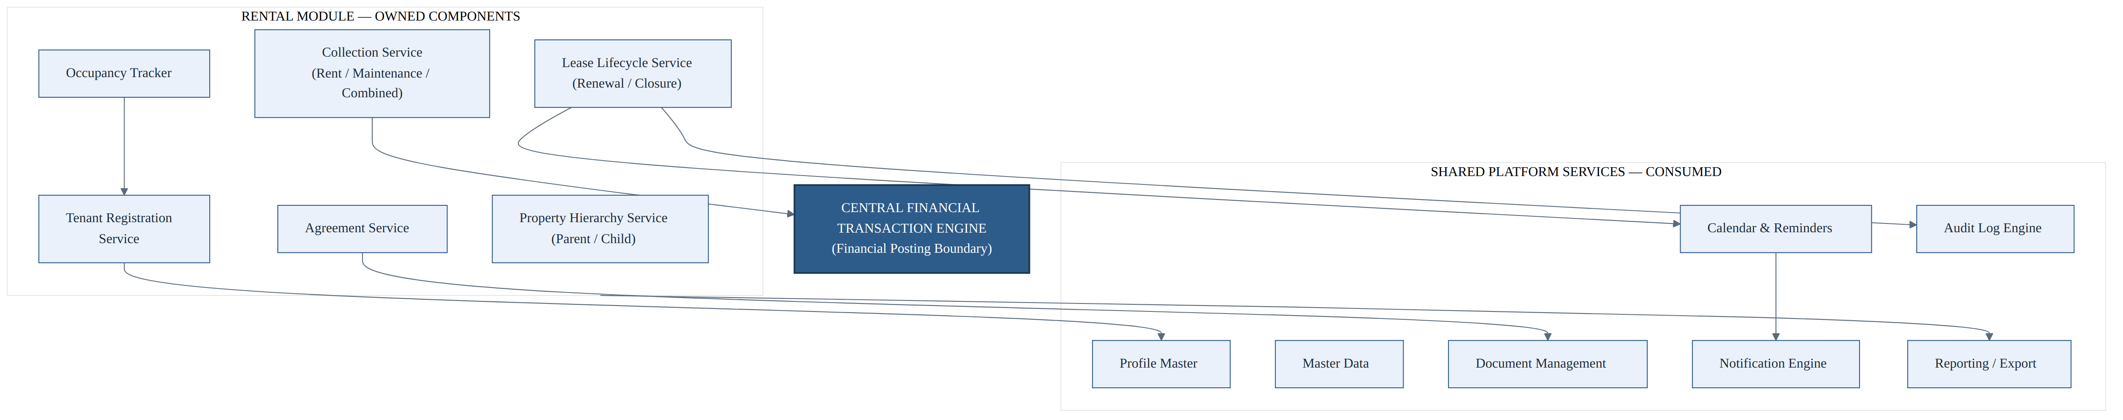
Figure 2.1 — Rental Module component architecture

Rental Module — Owned Components
- Property Hierarchy Service — Parent / Child
- Tenant Registration Service
- Agreement Service
- Collection Service — Rent / Maintenance / Combined
- Occupancy Tracker
- Lease Lifecycle Service — Renewal / Closure

Shared Platform Services — Consumed
- Profile Master
- Master Data
- Document Management
- Calendar & Reminders
- Notification Engine
- Audit Log Engine
- Reporting / Export

Central Financial Transaction Engine
The Central Financial Transaction Engine is represented as the financial posting boundary — it alone classifies transactions as Accounted / Non-Accounted and posts to the Cash Book, Bank Book, and Central Ledger.

Defined Relationships
- Tenant Registration Service → Profile Master
- Agreement Service → Document Management
- Collection Service → Central Financial Transaction Engine
- Occupancy Tracker → Tenant Registration Service
- Lease Lifecycle Service → Audit Log Engine
- Lease Lifecycle Service → Calendar & Reminders
- Calendar & Reminders → Notification Engine
- Rental Module → Reporting / Export

3. Data Ownership
Rental Owns | Referenced Only — Owned Elsewhere
Parent Property record — identity / configuration only; no stored totals | Profile ID for each tenant — owned by Profile Master
Child Property record — rent, maintenance, tenant link, agreement, dues, ledger data | Payment modes — owned by Master Data
Tenant record — Property ID + Profile ID | Document types — owned by Master Data
Rental Agreement record | Rent / maintenance postings — owned by Central Financial Engine
Rent / Maintenance collection history | Agreement file binaries — owned by Document Management
Derived, never stored parent-level roll-ups: total units, occupied, vacant, expected rent, total outstanding — computed at read time from child-property data | Audit trail — owned by Audit Log Engine
Parent-level figures are never independently stored or updated — they are always computed from child-property data at read time.

4. Inputs & Outputs

Inputs
- Property attributes
- Profile ID for tenant registration
- Agreement terms
- Collection entries — rent and/or maintenance, mode, date

Outputs
- Transaction-raise requests to the Central Financial Transaction Engine
- Updated tenant ledger
- Occupancy status
- Rental reports — portfolio-level and unit-level

5. Property / Tenancy Lifecycle Workflow
The workflow below traces a property from setup through tenancy, the recurring rent-schedule / collection cycle, and lease renewal or closure.
Figure 5.1 — Property / tenancy lifecycle workflow
A property — parent/child or standalone — is linked to a tenant via Profile, and an agreement is created. A rent schedule generates dues, which are collected as Rent, Maintenance, or Combined, updating payment history. When the lease is renewed, the cycle returns to the due/collection stage; when the lease is closed, the property becomes available again and occupancy is reset.

6. Financial Posting / Rent-Maintenance Collection Transaction Sequence
Participants: Employee (Property UI), Rental Module, Central Financial Transaction Engine, Cash Book / Bank Book, Central Ledger.
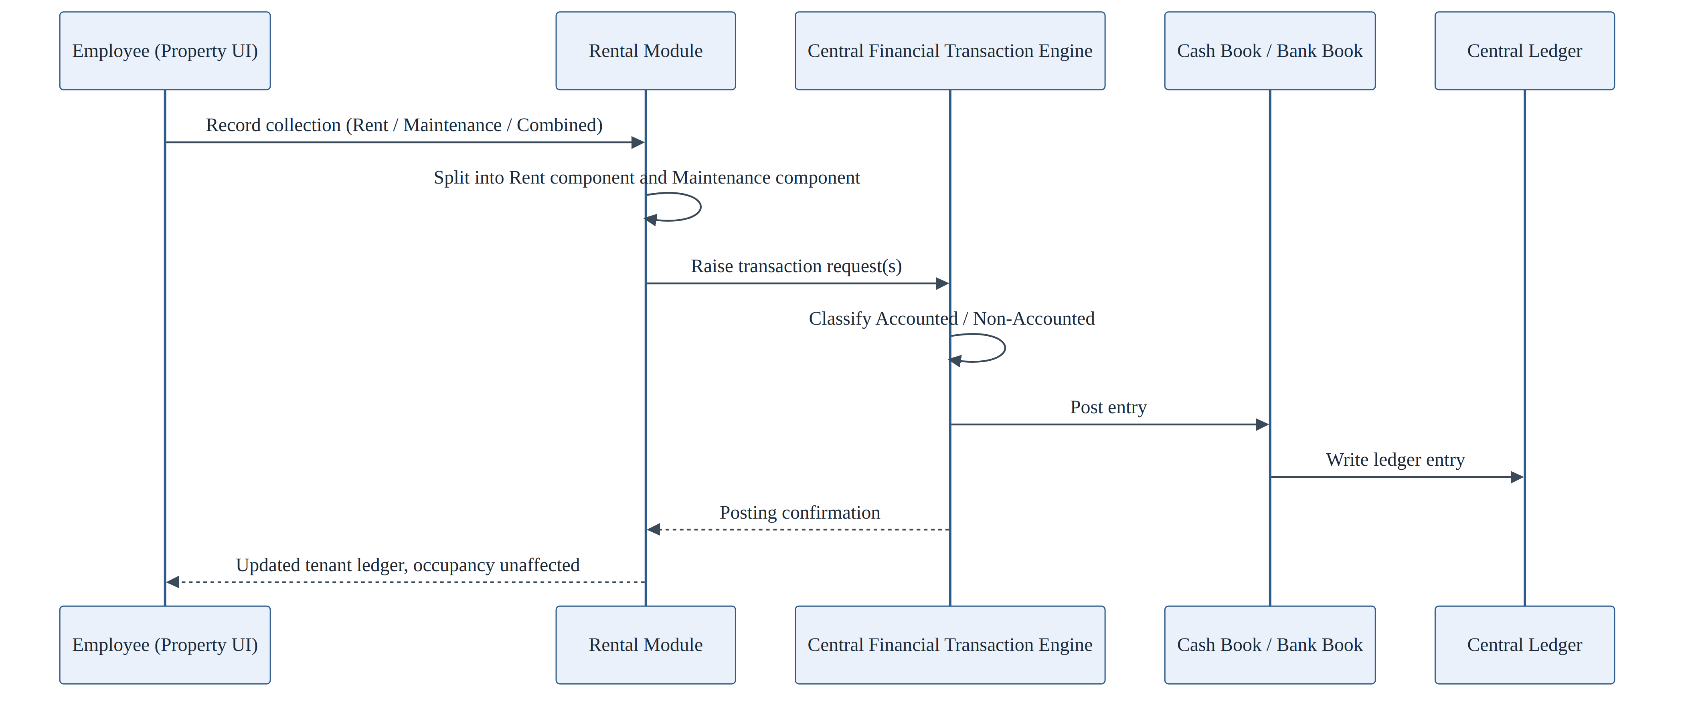
Figure 6.1 — Rent / maintenance collection transaction sequence
The Employee records a collection (Rent, Maintenance, or Combined). The Rental Module splits the collection into its Rent component and Maintenance component, then raises the corresponding transaction request(s) to the Central Financial Transaction Engine. The Engine classifies the transaction as Accounted / Non-Accounted and posts the entry to the Cash Book / Bank Book; the Central Ledger entry is written. A posting confirmation returns to the Rental Module, which shows the updated tenant ledger to the Employee. Occupancy is unaffected by the financial posting itself.

7. Dependencies
Upstream — Rental Depends On | Downstream — Depends On Rental
Profile Master | Executive Dashboard
Master Data | Rental reports
Central Financial Transaction Engine | Global Search
Document Management
Calendar & Notification Engine
Audit Log Engine

8. RBAC Touchpoints
Action | Role Required
Create parent / child property | Administrator (typical)
Register tenant | Employee or Administrator
Create / renew agreement | Employee or Administrator
Record collection | Employee or Administrator
Close lease | Employee or Administrator — no explicit approval gate documented beyond general RBAC

9. Ownership Boundary
Rental Owns | Rental Must Not Own
Property data | Cash / Bank / Ledger posting — owned by Central Financial Engine
Tenancy data | Tenant identity data beyond a Profile ID reference — owned by Profile Master
Agreement data | An independently-updatable copy of parent-level totals
Occupancy rules | —
Parent-level roll-up computation rules | —
Which figures are derived at parent level | —
The parent-level totals must remain derived from child-property data and must never become separately stored or independently-updatable totals — this is the single most important invariant for this module.

10. Open Architecture Questions / TBC
OPEN ARCHITECTURE QUESTIONS — TBC
1. No explicit approval gate is documented for lease closure or rent revision beyond general RBAC — confirm whether one is required.
2. Notice-management workflow details, including notice periods and escalation, are not fully specified — TBC.
None of the above items are resolved by this document. They remain open architecture decisions pending confirmation with rental-operations stakeholders.

