MedAssitAI: Medical Symptom Analysis &

Disease Prediction System

Submitted By
Name: Diksha
Team: 2
Role: Fronted

Project Overview
During this milestone, I worked on the frontend development of the MedAssist AI project. My primary responsibility was to set up the React application, organize the project structure, and begin developing the user interface. The aim was to create a clean and modular frontend that can be easily connected with the backend in future milestones.

Work Completed

1. React Project Setup
I created the frontend project using React and Vite. After installing the required dependencies, I verified that the application was running successfully on the local development server.

2. Project Structure
I organized the project into separate folders such as components, pages, routes, services, hooks, and context. This modular structure keeps the project organized and makes future development easier.
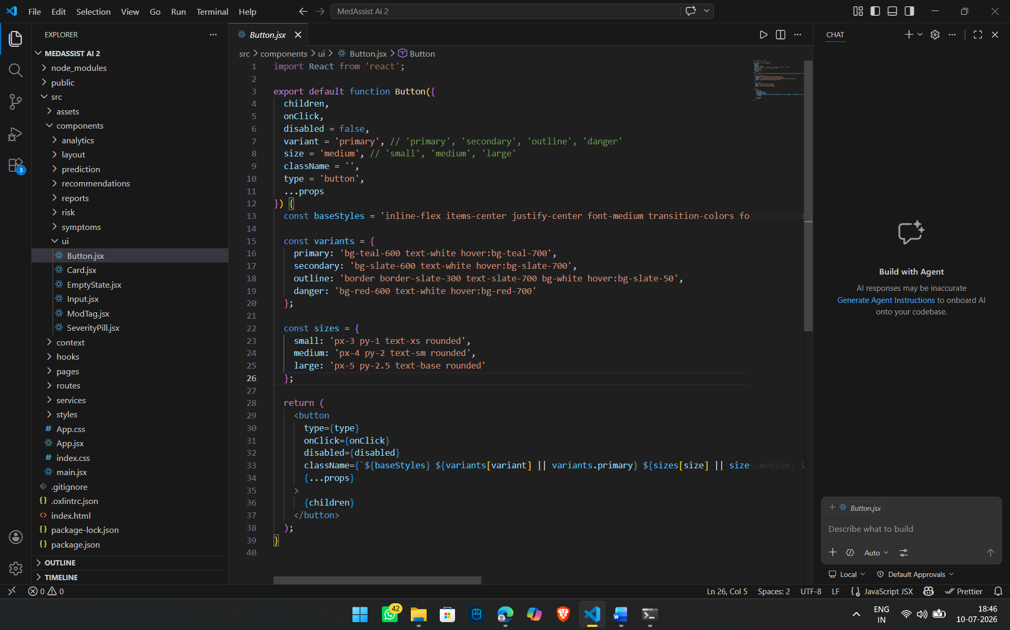

3. Routing Setup
I configured React Router to enable navigation between different pages of the application. This allows users to move between screens without reloading the page.
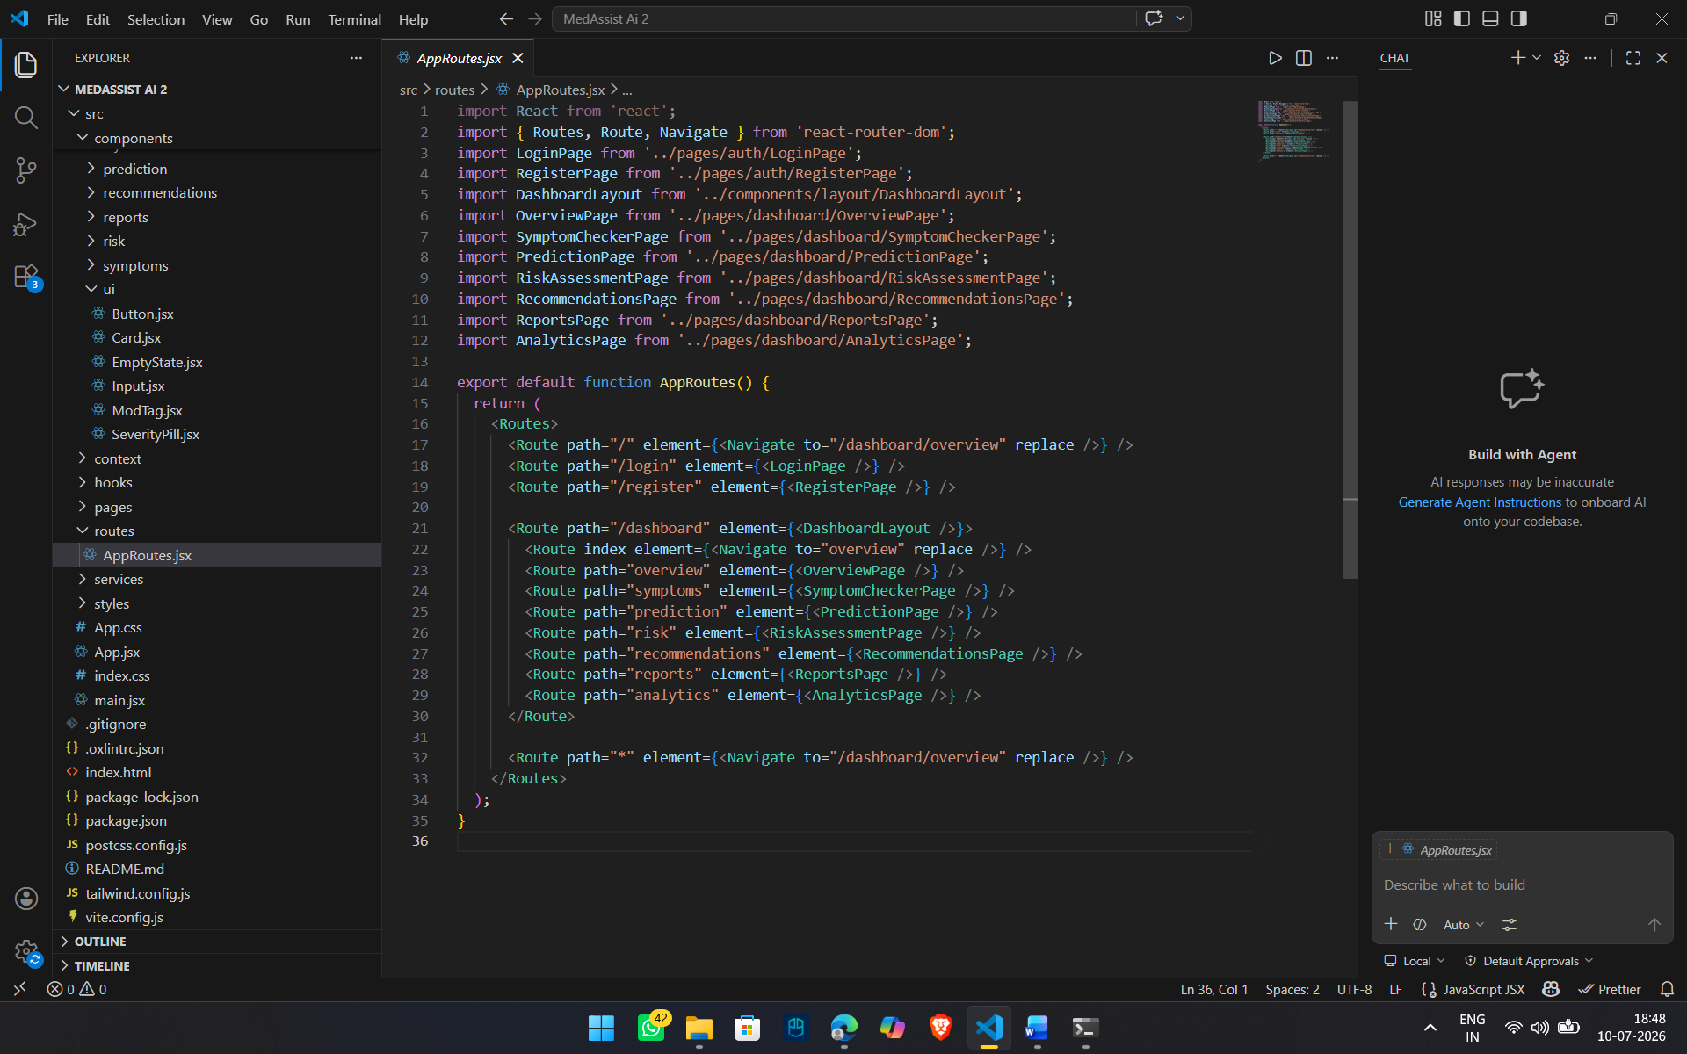

4. Reusable Components
I created reusable UI components that can be used across multiple pages. This reduces code duplication and makes the application easier to maintain.
Examples include:
- Sidebar
- Navigation Bar
- Buttons
- Cards
- Input Fields
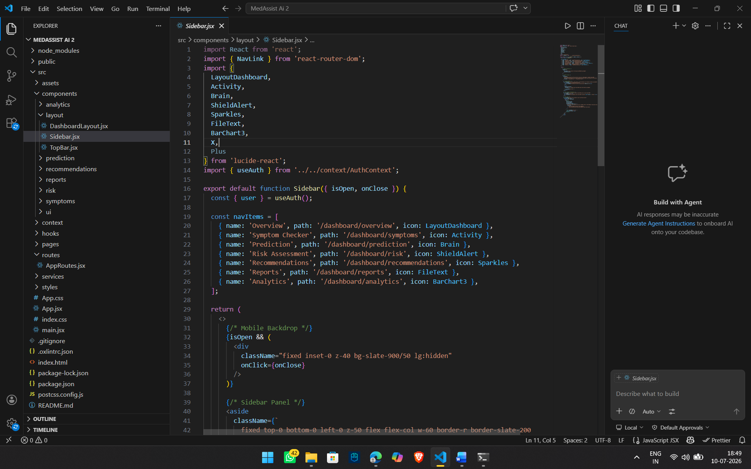

5. Dashboard Layout
I designed the basic dashboard layout by combining the sidebar and navigation bar into a common layout that can be reused across different dashboard pages.
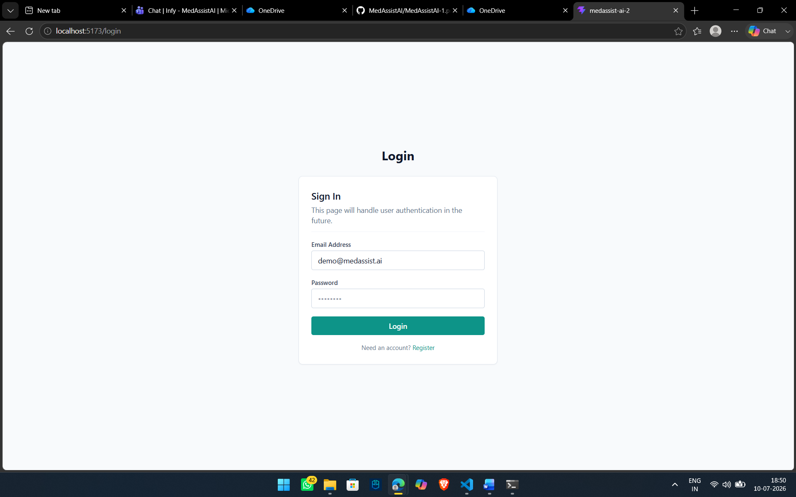
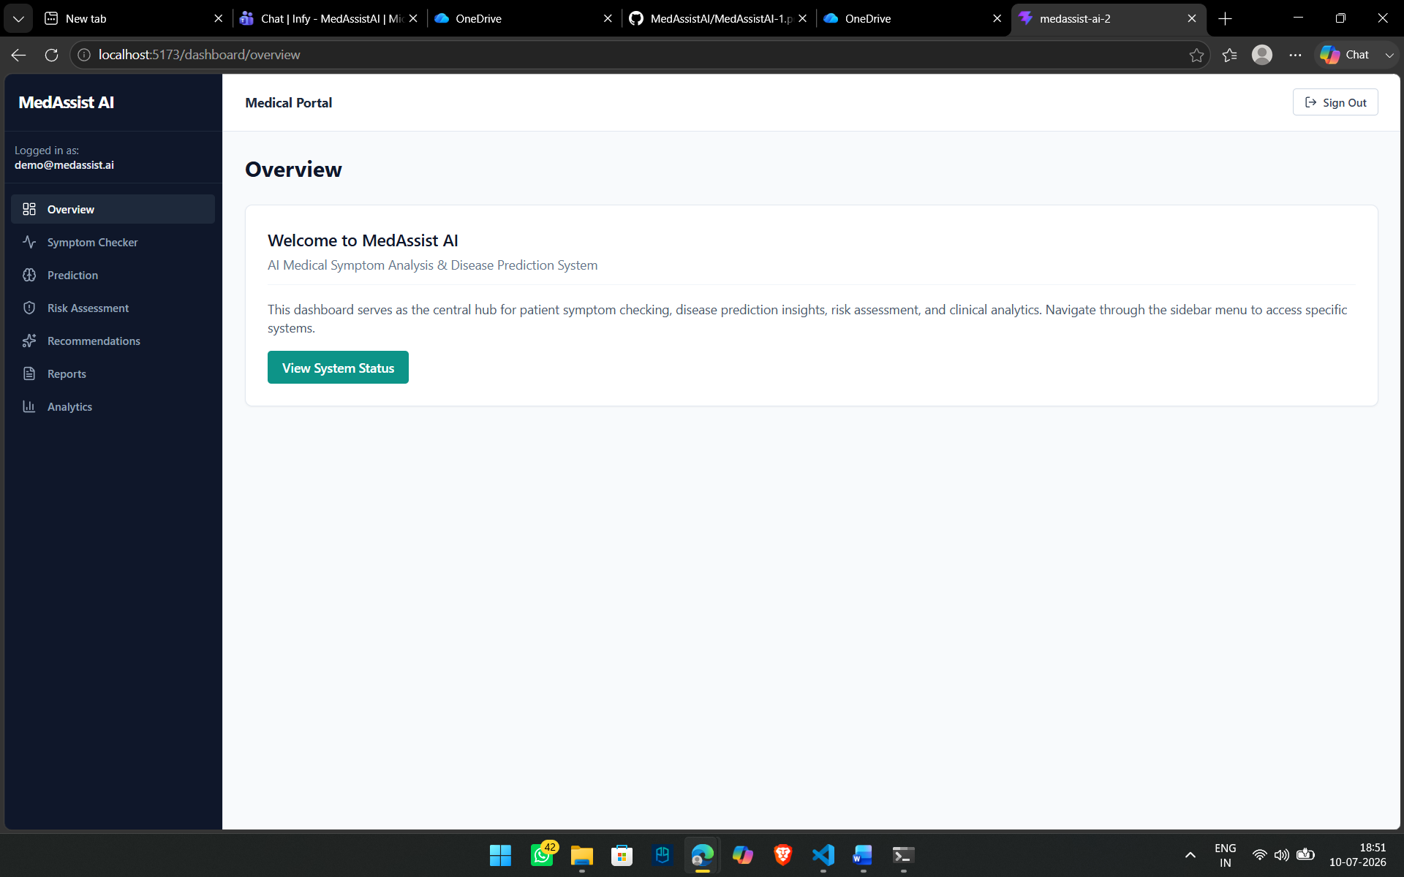

6. Authentication Structure
I added the basic authentication context to manage user login information throughout the application. This will simplify authentication handling during backend integration.
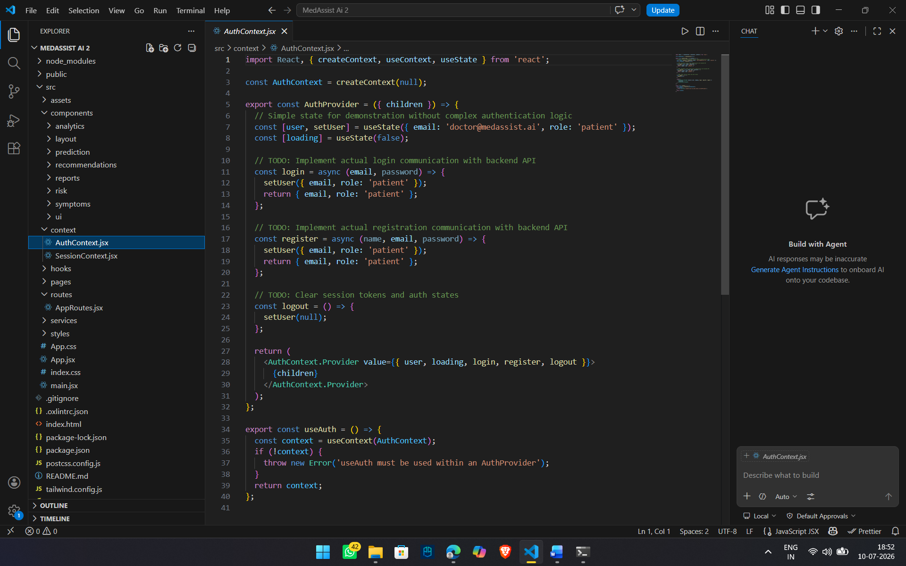

7. API Folder Structure
A separate services folder was created to organize future API calls for authentication, prediction, analytics, and reports. At this stage, the structure has been prepared for backend integration.
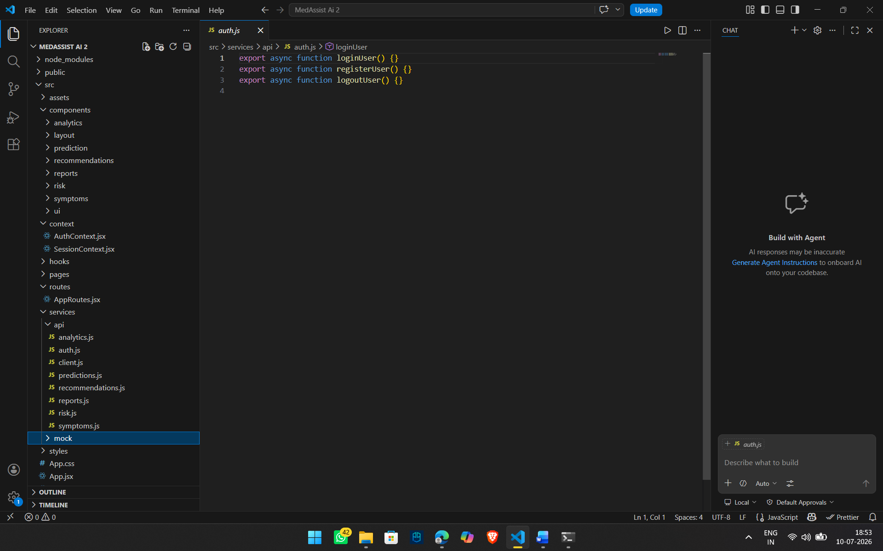

Learning Outcome
Through this milestone, I learned how to organize a React project using a modular folder structure, implement routing, create reusable components, and prepare the frontend for future backend integration.

Conclusion
In this milestone, I focused on building the basic frontend structure of the MedAssist AI project. I successfully set up the React application, organized the project folders, and developed the initial user interface components. The frontend is still a work in progress, and additional features, backend integration, and testing will be completed in the next phase of development.

