MedAssist AI
Frontend & Cloud Milestone Documentation
Prepared By: SHAIK DAIMEL BASITH
B.Tech – Computer Science & Engineering (Artificial Intelligence & Machine Learning)
ANITS, Visakhapatnam

Role
Frontend Developer & Cloud Engineer

Internship
Infosys Springboard Internship

Project
MedAssist AI – AI Powered Healthcare Prediction System

Table of Contents
Section |  | Page
1. Project Description |  | 1
2. Technologies Used |  | 2
3. Environment Setup |  | 3
4. Frontend Architecture |  | 4
5. Landing Page Development |  | 5
6. Authentication Module |  | 6
7. Dashboard Module |  | 7
8. Symptom Checker Module |  | 8
9. AI Prediction Module |  | 9
10. Reports Module |  | 10
11. Profile Management |  | 11
12. Docker Containerization |  | 12
13. Challenges & Solutions |  | 13
14. Conclusion |  | 14

1. Project Description

MedAssist AI is an AI-powered healthcare web application designed to assist users in identifying possible diseases based on the symptoms they provide. The application offers a simple, responsive, and user-friendly interface that enables users to enter their symptoms, view AI-generated disease predictions, access previous reports, and manage their personal health profile.

For this milestone, my assigned role was Frontend Developer & Cloud Engineer. My primary responsibility was to design and develop the complete frontend interface using React.js, ensuring that the application is responsive, modular, and easy to maintain. The frontend was developed with reusable components and client-side routing to provide a smooth user experience.

In addition to frontend development, I configured the project for Docker-based deployment, enabling the application to run consistently across different environments. This milestone focused on building the complete user interface while preparing the project for future backend API integration and machine learning model deployment.

Objectives of this Milestone
- Develop a responsive healthcare web interface using React.js.
- Create reusable UI components for better maintainability.
- Implement client-side navigation using React Router.
- Design authentication pages for Login and Registration.
- Develop Dashboard, Symptom Checker, Prediction, Reports, and Profile modules.
- Configure Docker and Docker Compose for containerized deployment.
- Prepare the frontend for backend API integration.

2. Technologies Used

The MedAssist AI frontend was developed using modern web technologies to ensure scalability, responsiveness, and maintainability.
Technology | Purpose
React.js | Building reusable frontend components
Vite | Fast development server and optimized build tool
React Router DOM | Client-side navigation between pages
JavaScript (ES6+) | Application logic and functionality
HTML5 | Web page structure
CSS3 | Styling and responsive layouts
Chart.js | Dashboard analytics and graphical visualization
Local Storage | Persisting user profile information
Docker | Containerizing the frontend application
Docker Compose | Managing Docker containers
Git & GitHub | Version control and collaboration
Visual Studio Code | Source code editor
Development Environment
- Operating System: Windows 11
- IDE: Visual Studio Code
- Runtime Environment: Node.js
- Package Manager: npm
- Browser Used: Google Chrome
- Container Platform: Docker Desktop

3. Environment Setup
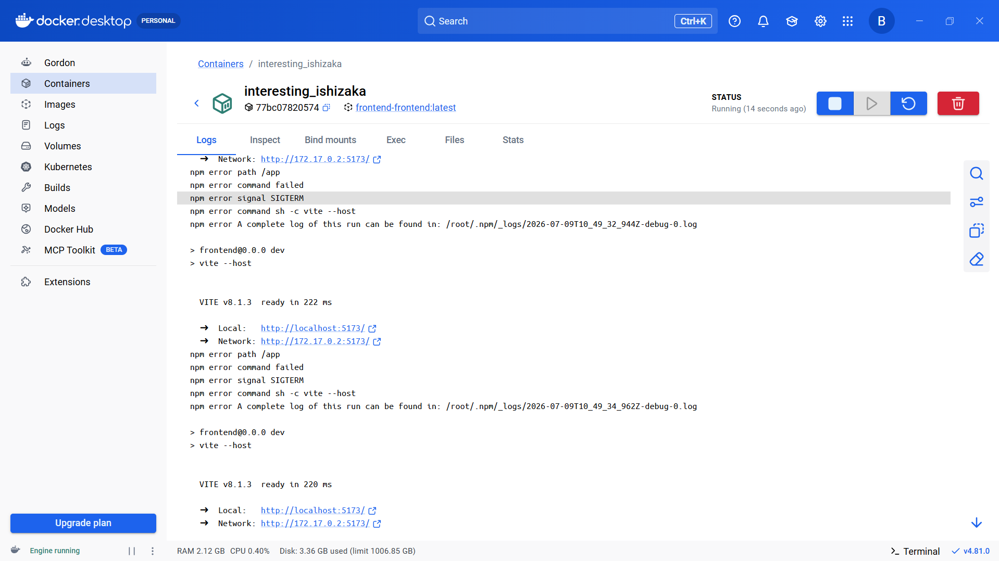
Development Environment:
• Visual Studio Code
• Node.js & npm
• React + Vite
• Docker Desktop
• Git & GitHub
Commands used:
npm install
npm run dev
docker compose up --build
docker compose up
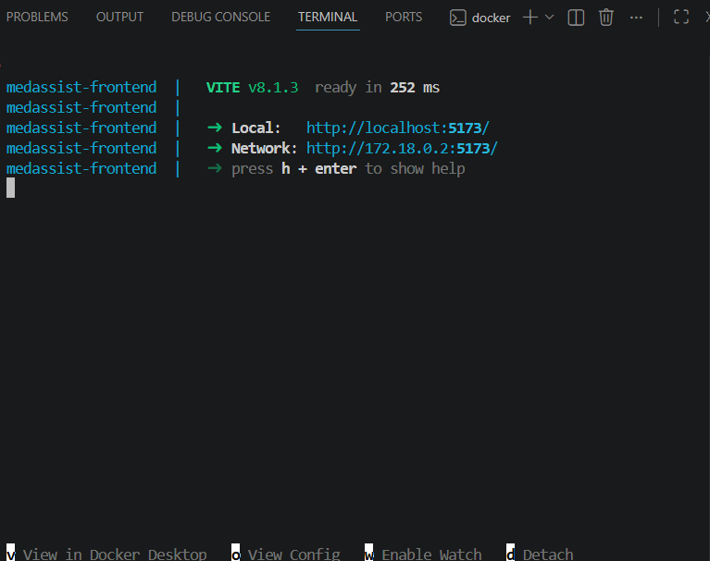
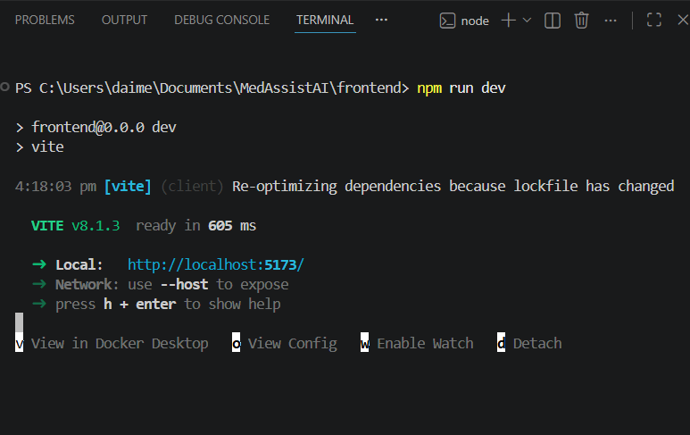

4. Frontend Architecture
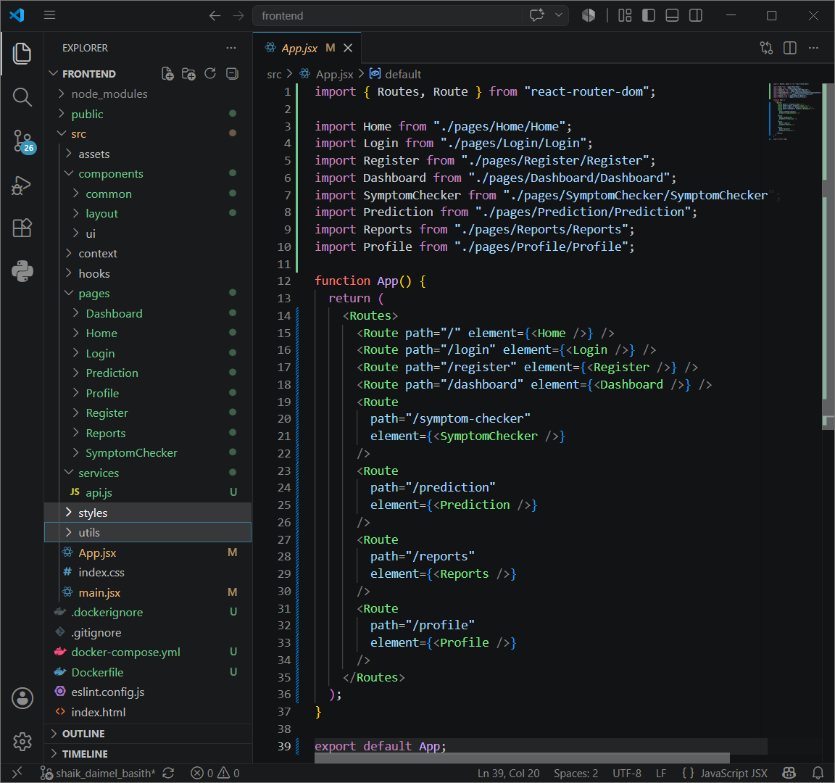
Implemented modular folder structure:
components/
pages/
services/
hooks/
context/
styles/
Reusable Layout component with Sidebar Navigation and shared UI.

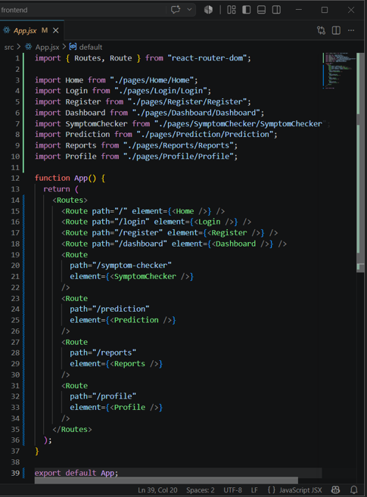
5. Landing Page Development
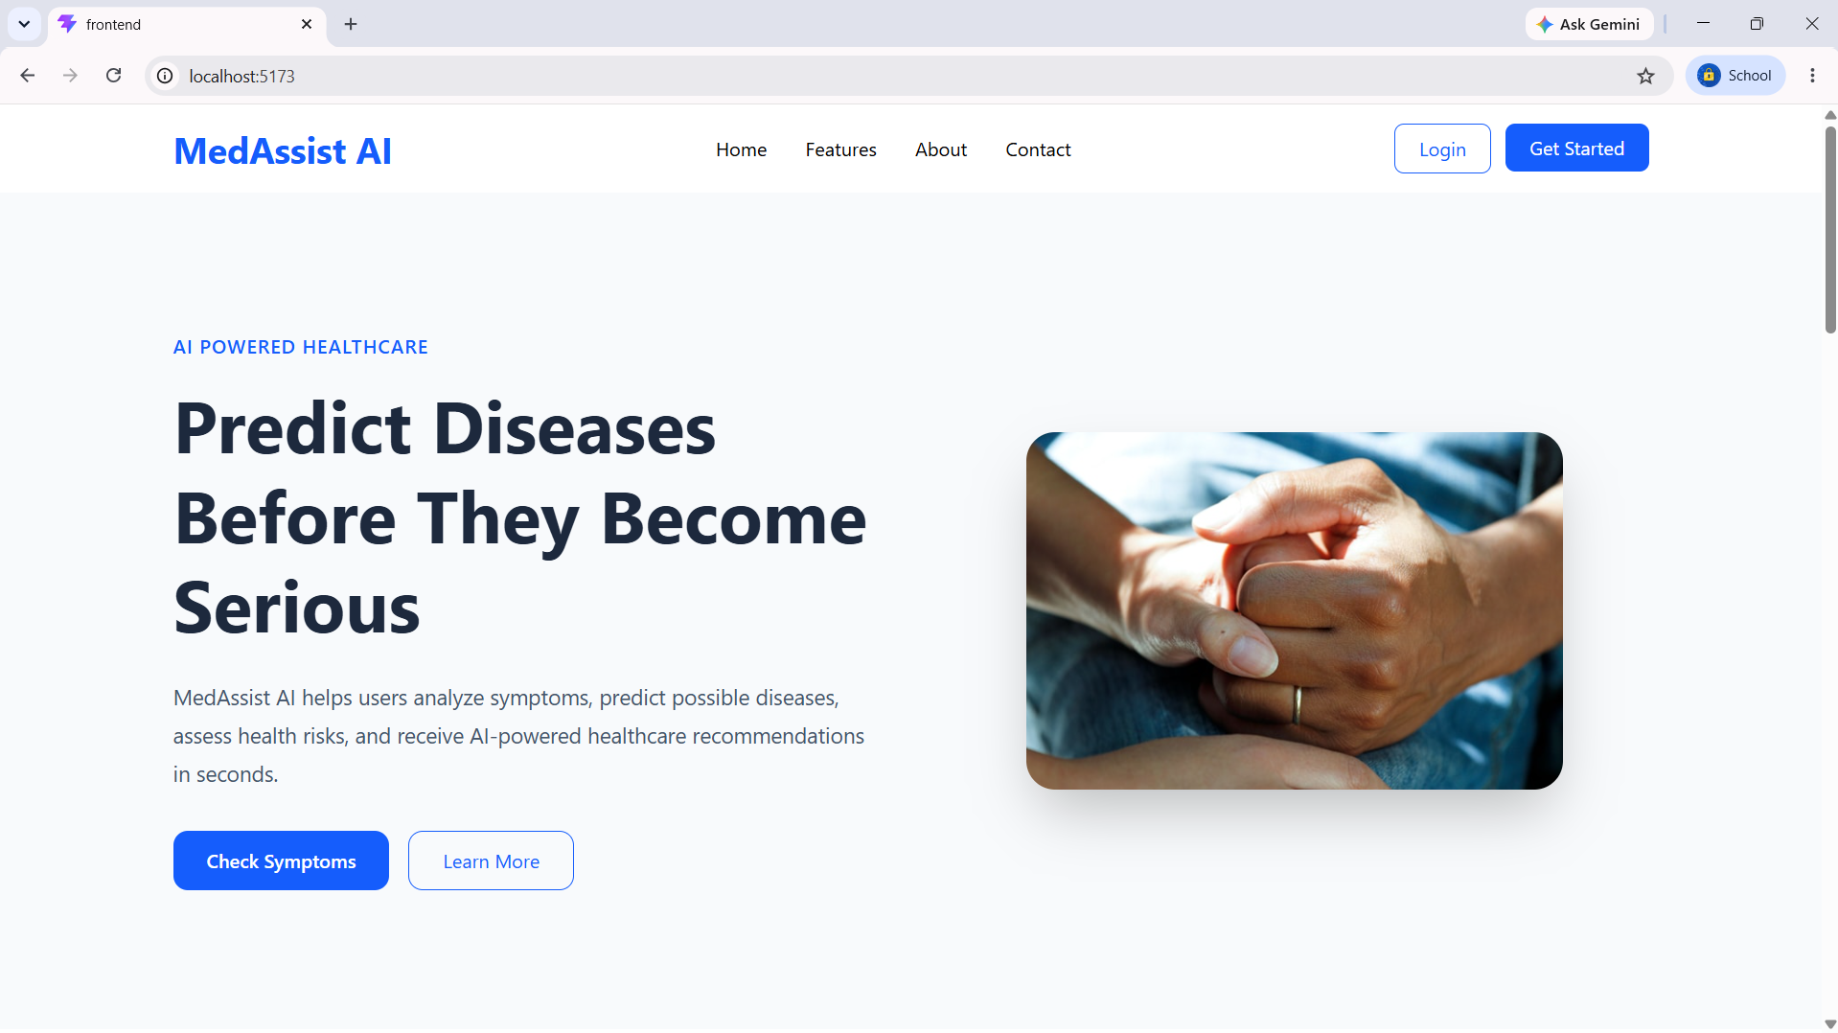
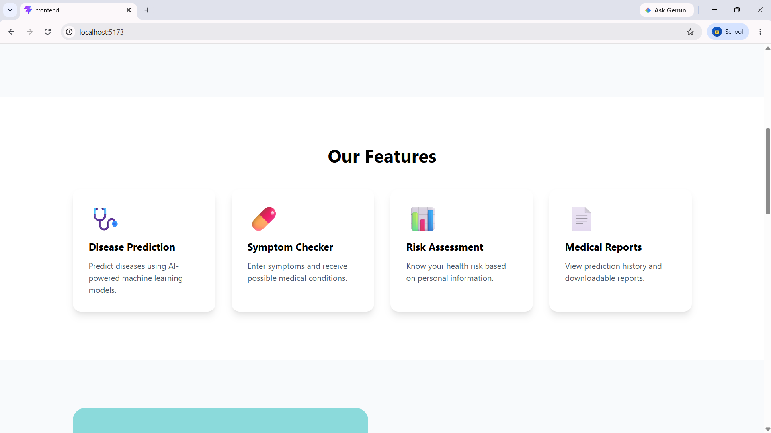
Implemented Hero, About, Features, How It Works, Testimonials and Footer sections.
Responsive design created using Tailwind CSS.
Healthcare illustration integrated from public folder.
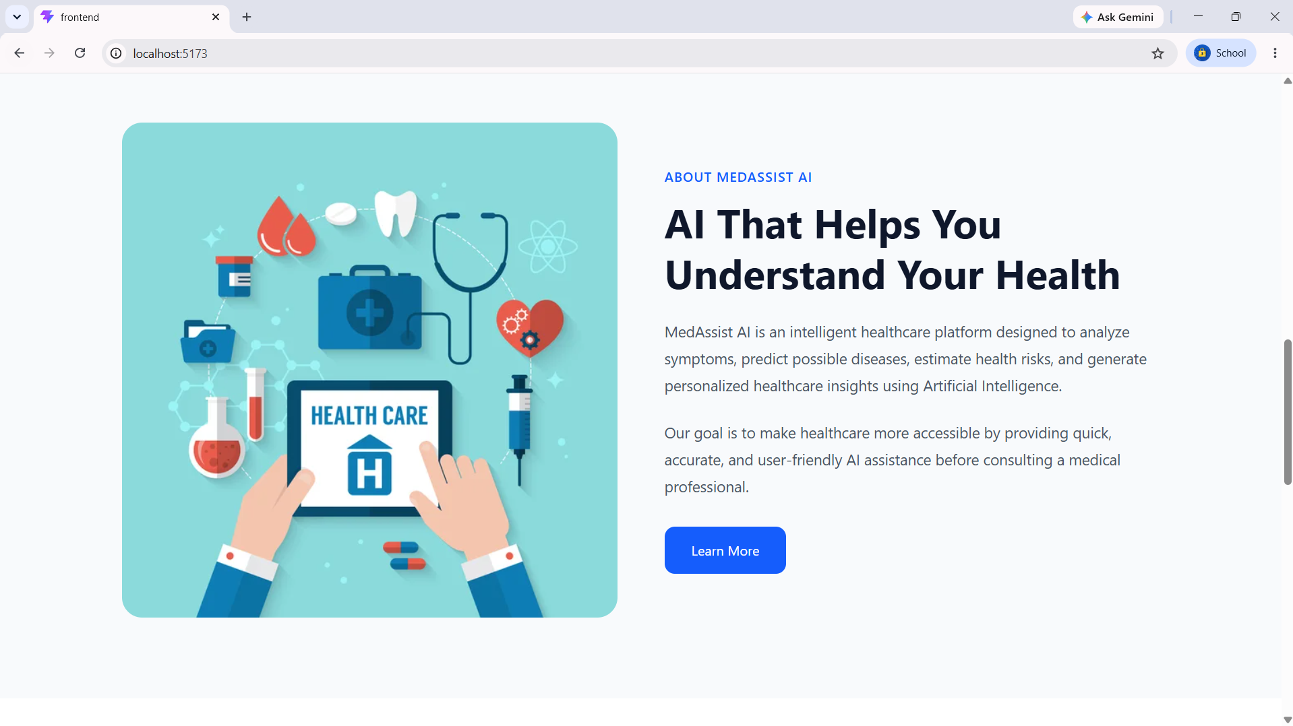
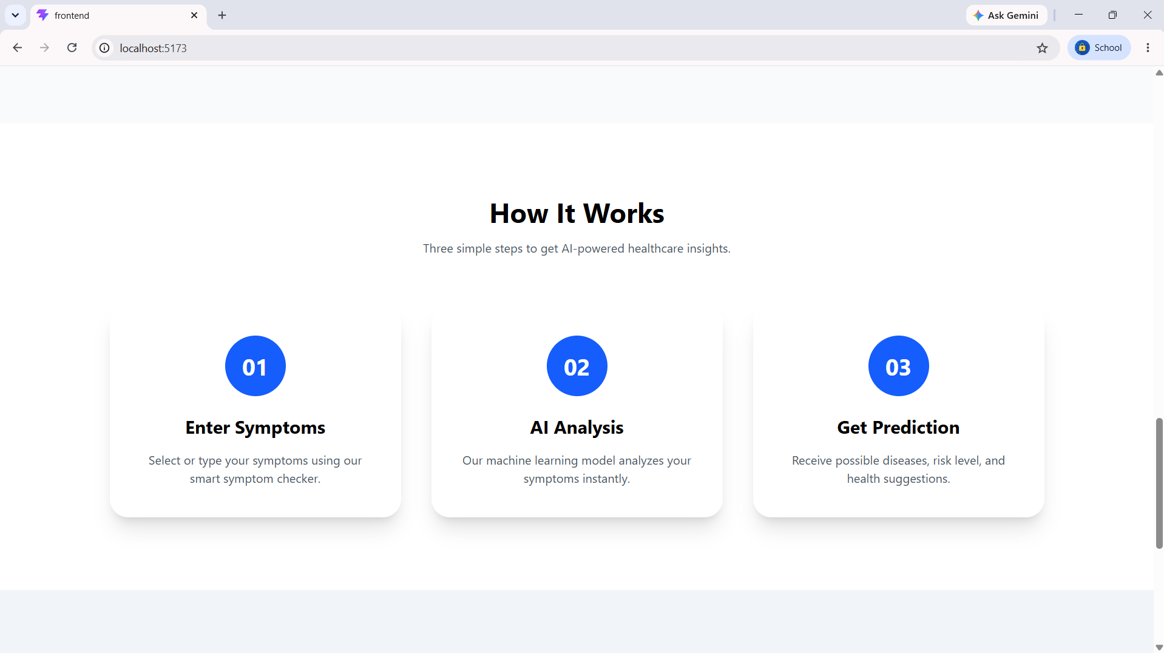
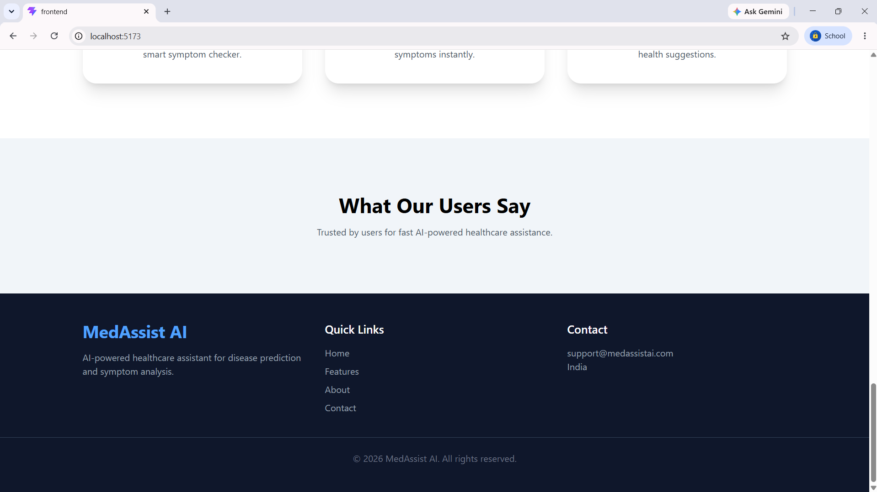

6. Authentication Module
Designed Login and Registration pages with modern responsive UI.
Prepared structure for backend authentication integration.
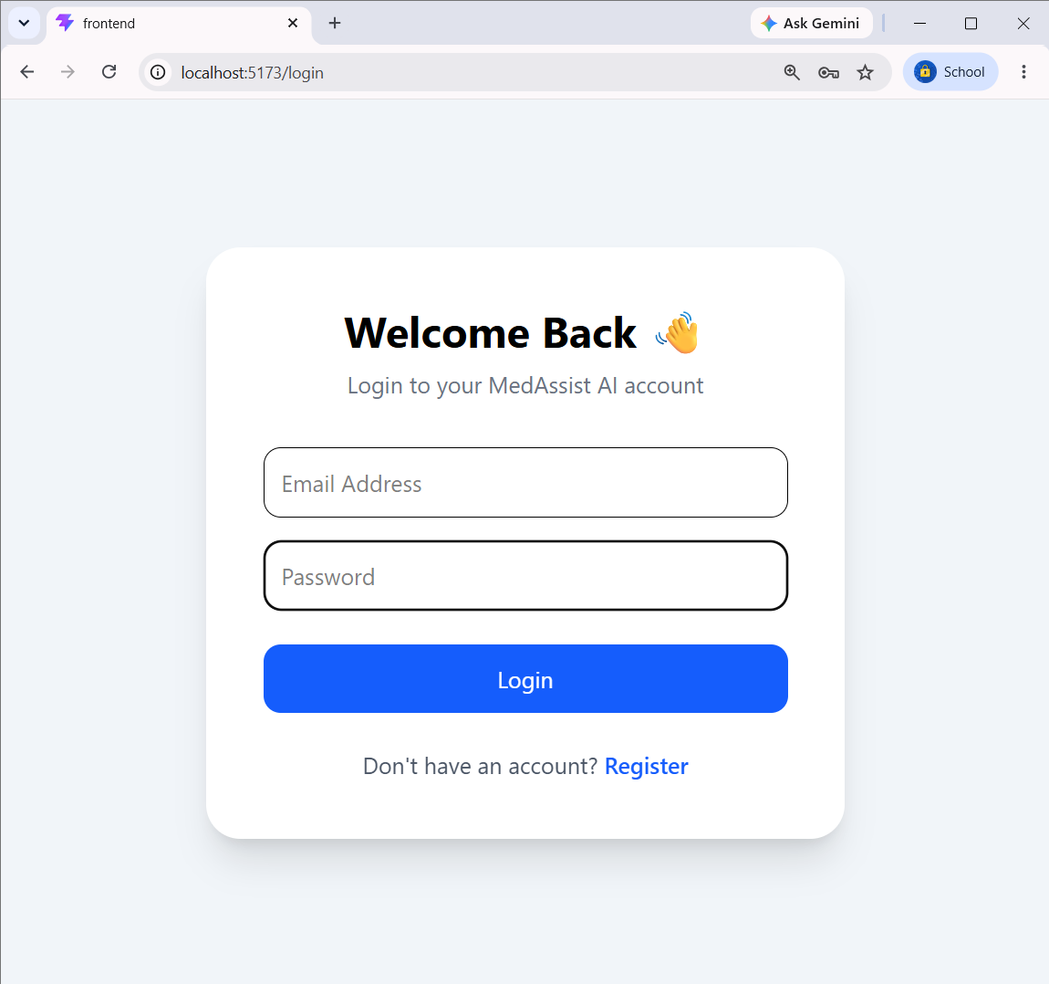
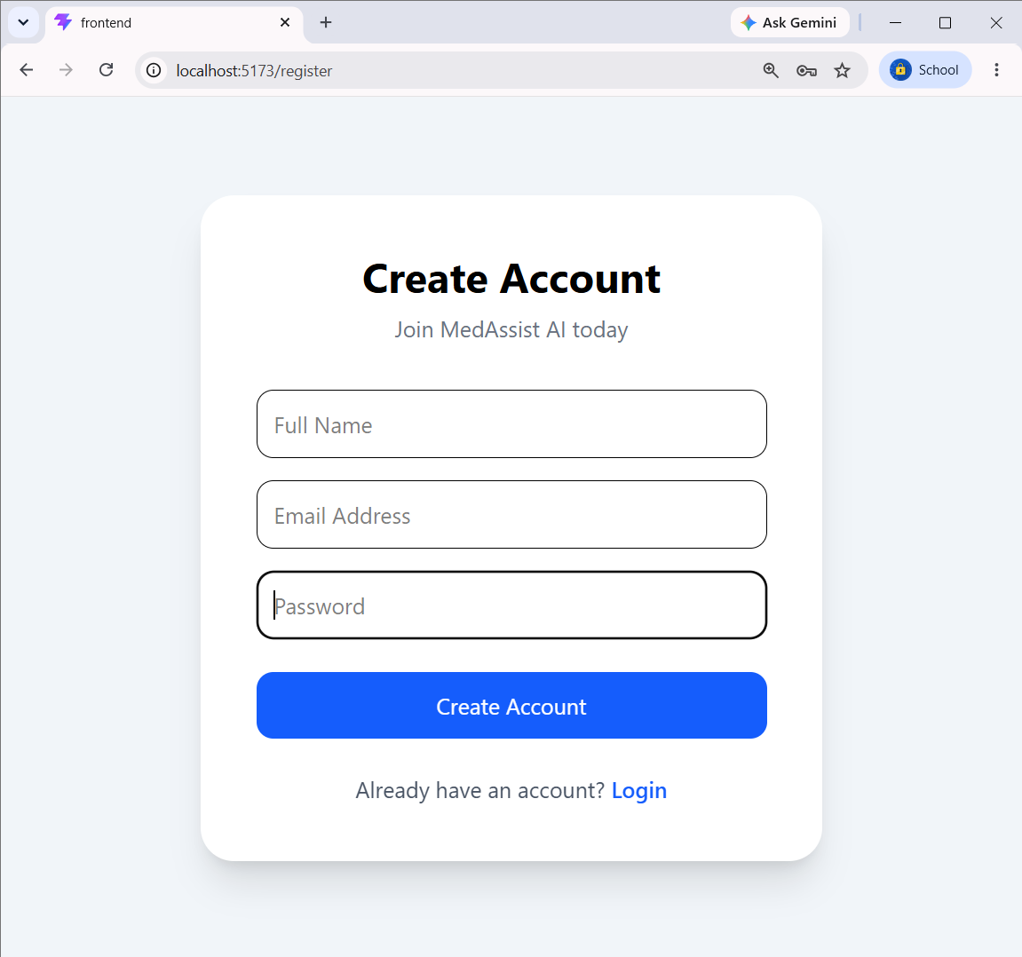

7. Dashboard Module
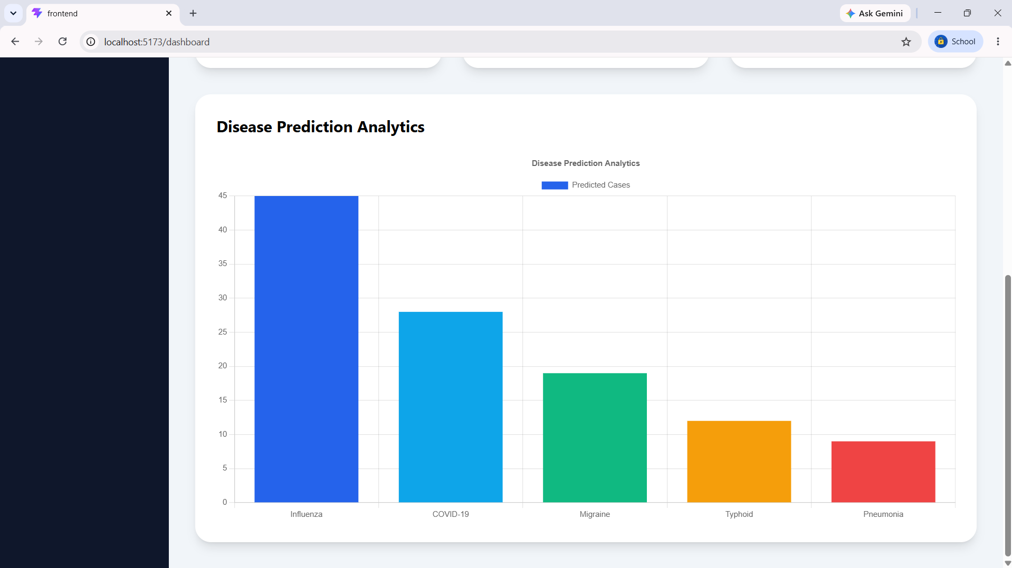
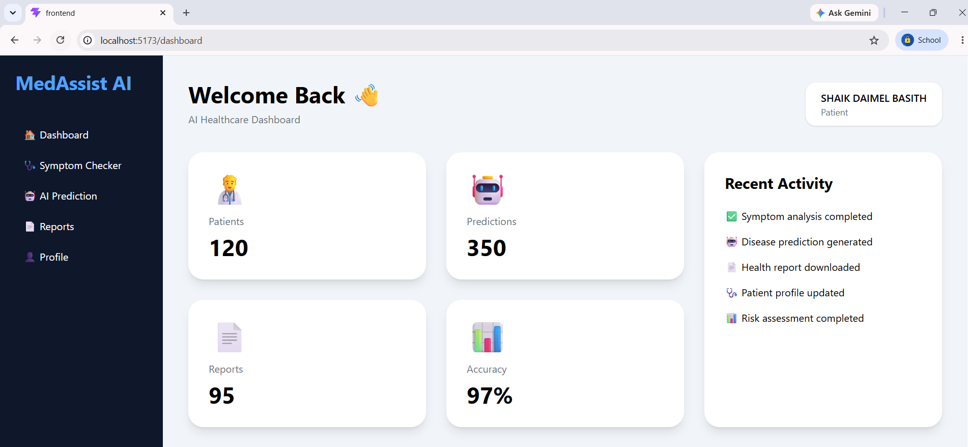
Developed Dashboard with:
• Sidebar Navigation
• Statistic Cards
• Recent Activity Panel
• Disease Analytics using Chart.js Bar Chart.

8. Symptom Checker Module
Created symptom selection interface with:
• Age
• Gender
• Height
• Weight
• Multiple symptom selection
Navigation implemented to Prediction page.
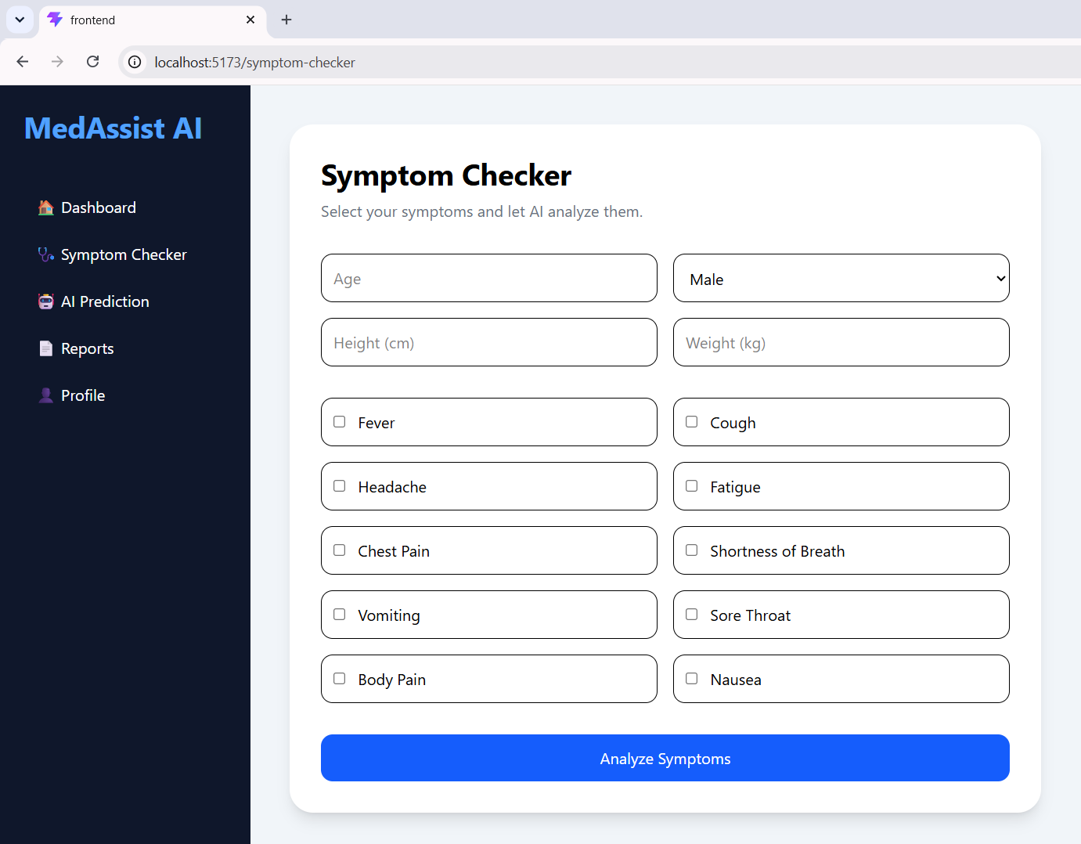
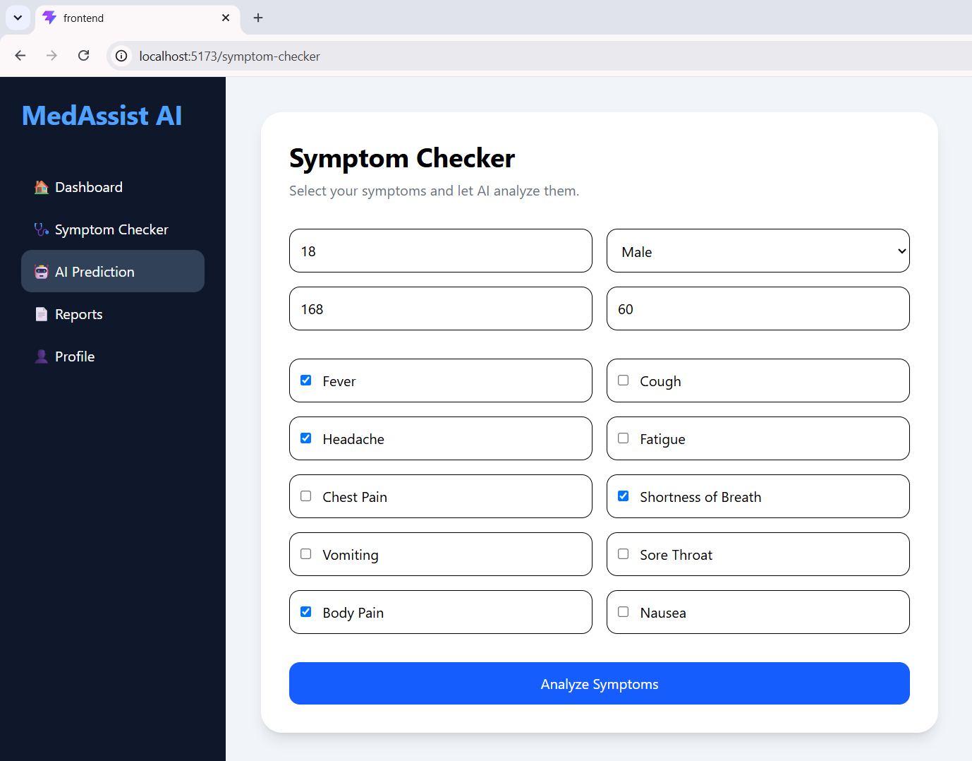

9. AI Prediction Module
Displays:
• Selected Symptoms
• Predicted Disease
• Confidence Score
• Severity
• AI Recommendation
Currently connected using frontend mock data.
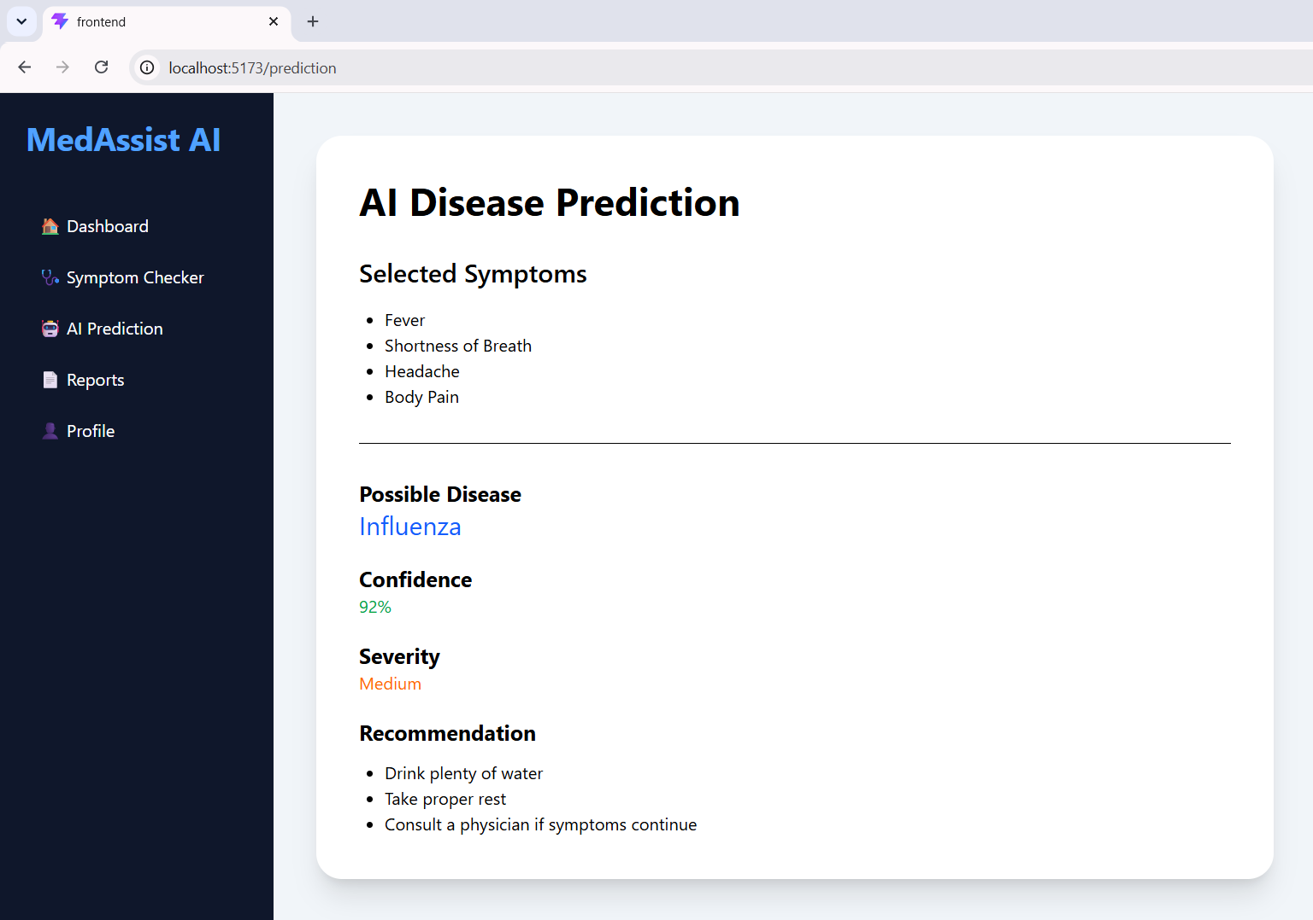

10. Reports Module
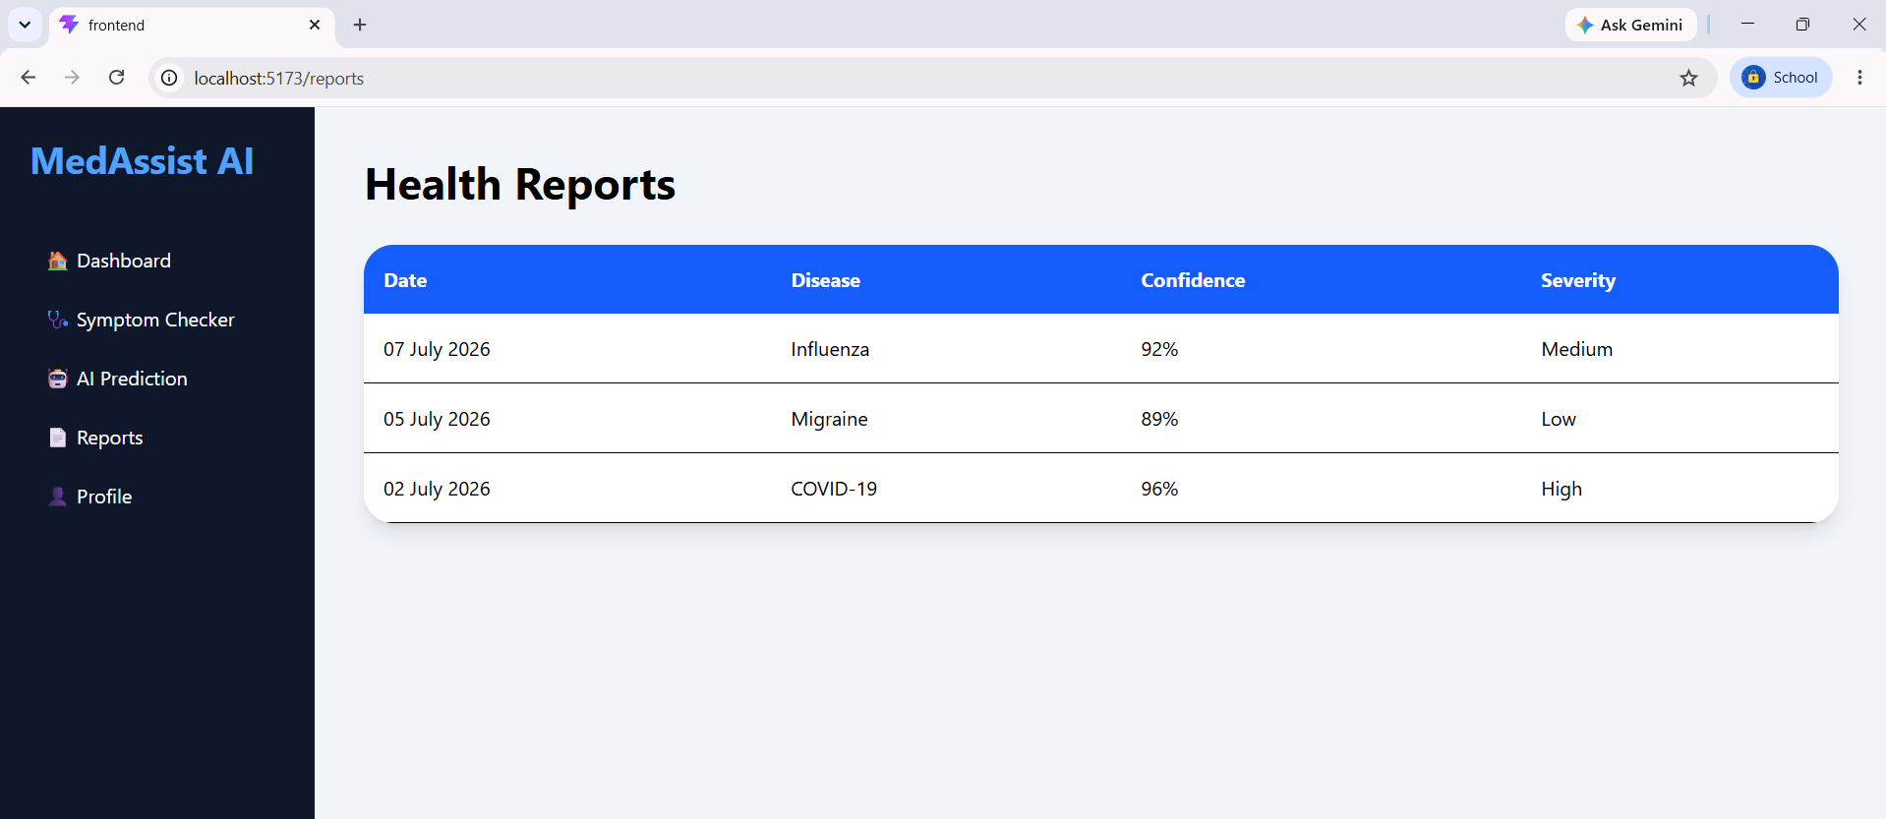
Created Reports page UI for displaying patient reports and future downloadable reports. Working of Reports Module

The Reports Module provides users with a centralized view of their previously generated AI health prediction reports. Each report displays important information such as the prediction date, detected disease, confidence score, and severity level. This enables users to track their health assessment history and review previous prediction results whenever required.
The interface is designed using a responsive table layout to ensure clear visualization of report details across different screen sizes. The module is structured in a way that allows seamless integration with the backend, where future versions will retrieve report data dynamically from a database and support downloading reports in PDF format.
Key Features:
- Displays prediction history in a tabular format.
- Shows prediction date, disease name, confidence percentage, and severity level.
- User-friendly and responsive interface.
- Prepared for backend API integration.
- Designed to support future report download functionality.

11. Profile Management
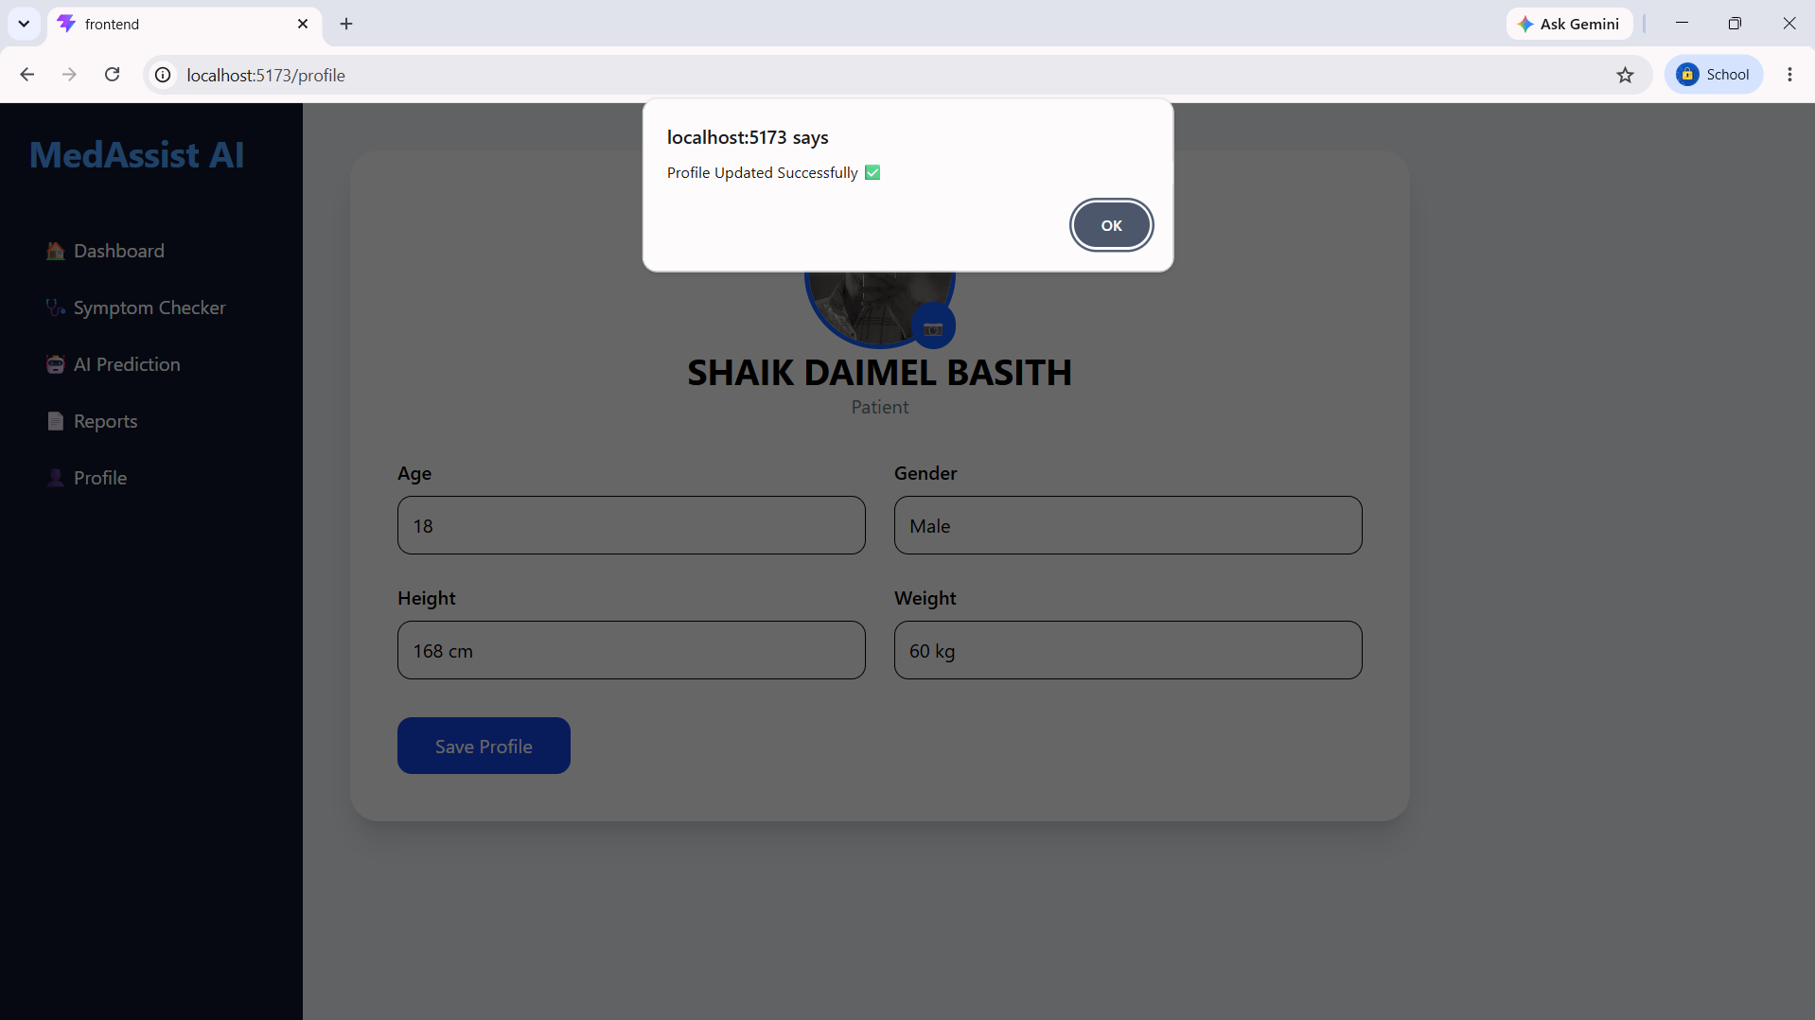
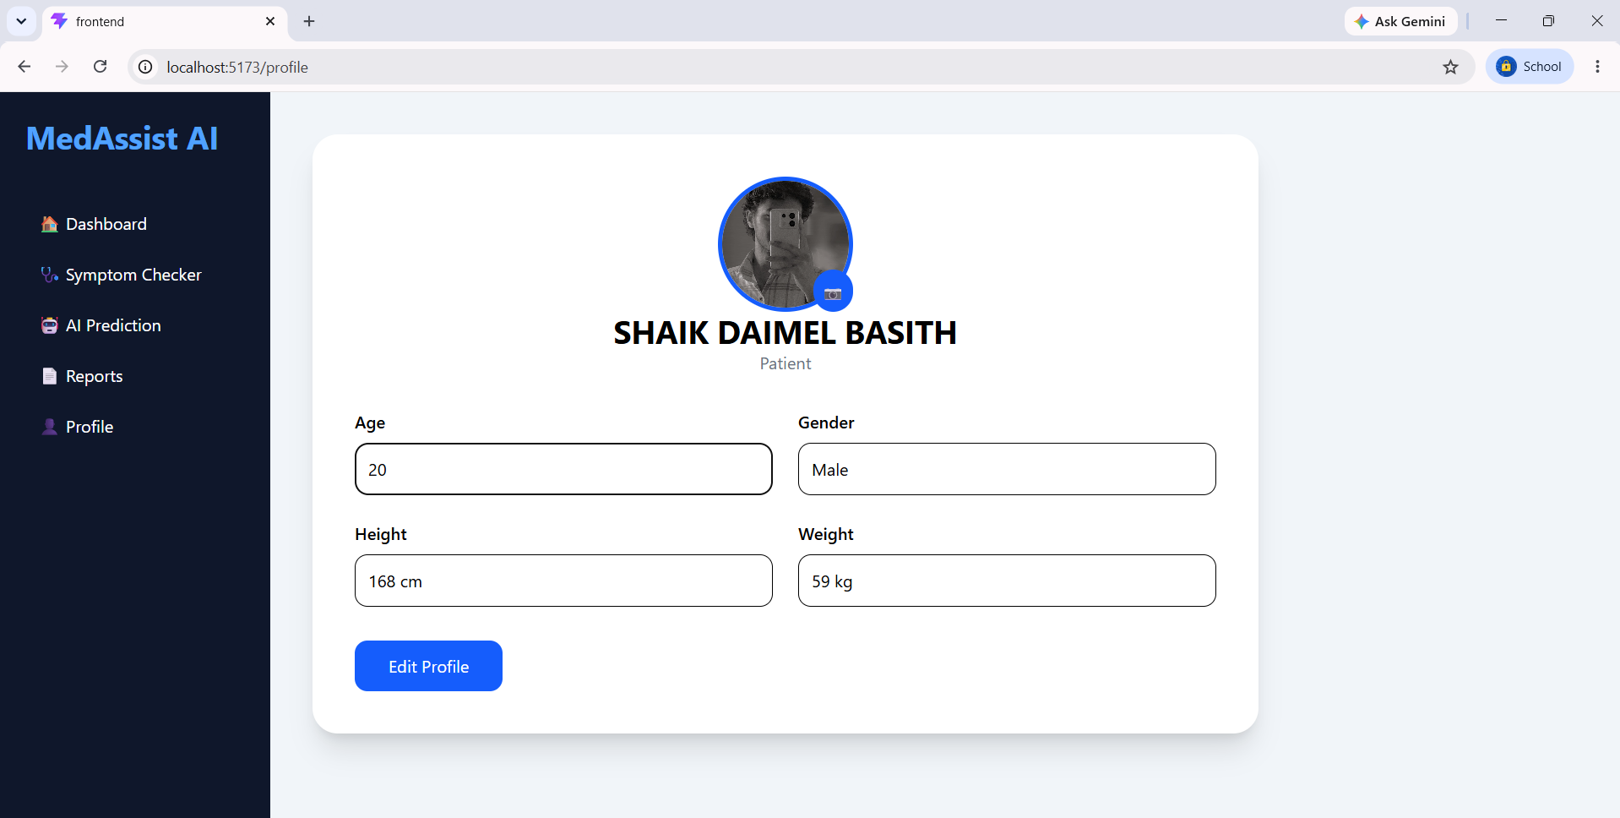
Implemented editable profile.
Implemented profile image upload.
Stored profile information and image using browser Local Storage so data persists after refresh.

12. Docker Containerization
Created:
• Dockerfile
• docker-compose.yml
• .dockerignore
Successfully executed frontend inside Docker container using Docker Desktop.
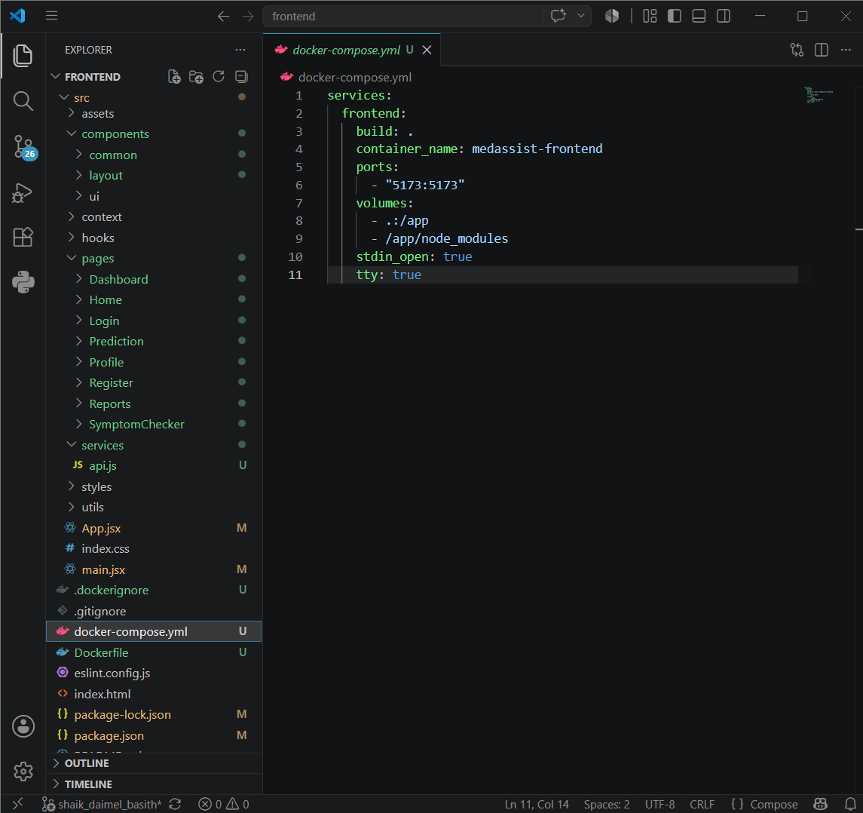
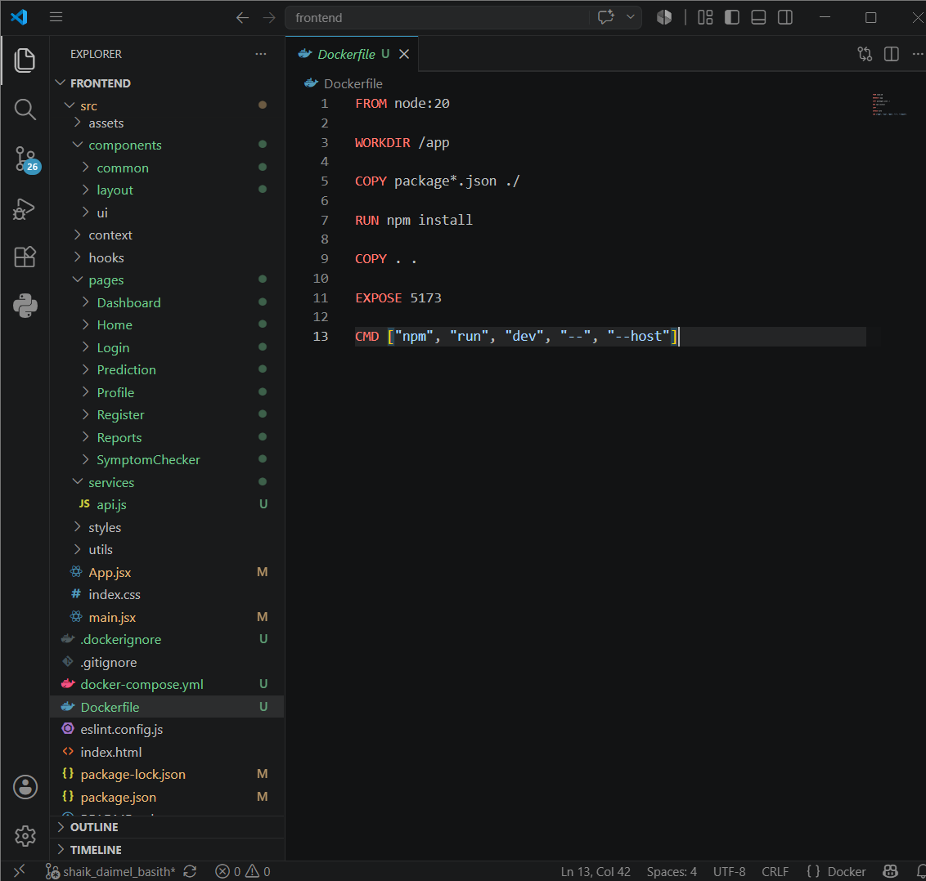

13. Challenges & Solutions

Challenges Faced
During the development of the MedAssist AI Frontend and Cloud module, several technical challenges were encountered. Configuring React Router for smooth navigation between multiple pages required careful route management and component organization. Integrating the common sidebar layout across dashboard pages while maintaining responsive design also required additional styling adjustments.

Another challenge was implementing persistent user profile information. Initially, profile details were lost after refreshing the page. This issue was resolved by storing user information using the browser's Local Storage. Static asset loading inside the React application also required modifications to the folder structure and public asset references.

While containerizing the application, Docker build errors occurred due to dependency installation and configuration issues. These were resolved by updating the Dockerfile, configuring docker-compose correctly, and verifying the application inside Docker Desktop.

Solutions Implemented
- Configured React Router for seamless page navigation.
- Developed reusable layout components for consistency.
- Implemented Local Storage for persistent profile data.
- Corrected image asset paths using the public directory.
- Optimized Dockerfile and docker-compose configuration.
- Successfully tested the frontend application inside Docker containers.
- Verified responsive design across desktop and mobile screen sizes.

14. Conclusion

The Frontend Development and Cloud Engineering milestone for the MedAssist AI project has been completed successfully. A complete and responsive frontend application was developed using React.js and Vite, providing an intuitive user interface for healthcare prediction. The application includes a landing page, user authentication screens, dashboard, symptom checker, AI prediction module, health reports page, and profile management functionality.

Cloud deployment support was implemented using Docker and Docker Compose, enabling the frontend to run consistently in a containerized environment. The application was tested successfully in both local and Docker environments, ensuring portability and ease of deployment.

This milestone establishes a strong foundation for the next phase of the project, where backend APIs, machine learning models, and database connectivity will be integrated to provide real-time disease prediction and personalized healthcare recommendations. The completed frontend architecture is modular, scalable, and ready for future enhancements.

Outcome
- Successfully developed a responsive React-based frontend.
- Implemented modular architecture with reusable components.
- Configured client-side routing using React Router.
- Designed user-friendly healthcare interfaces.
- Containerized the frontend using Docker.
- Prepared the application for backend integration and deployment.

