VisionInspect AI: Manufacturing Defect
Detection & Quality Inspection System
Database Module — Week 1&2 Documentation

Prachi Parimita Panda
Table of Contents Page No
1. Project Description 3
2. Module Objective 3
3. Existing Backend Analysis 3
4. Database Schema 4
5. Database Connection Workflow 5
6. Collections Overview 6
7. Current Progress 6
8. Conclusion 6

1. Project Description
VisionInspect AI is an AI-powered manufacturing quality inspection system designed to automate product inspection and defect analysis. The system allows users to upload product images, detect manufacturing defects, classify defect types, calculate severity, and generate inspection reports.
The project consists of multiple modules, including Data Preprocessing, Machine Learning Model, Frontend Interface, Database, and Authentication System, built by a team of five members. My assigned responsibility is the Database module.
2. Module Objective
The objective of this module is to design and set up the data storage layer that the entire VisionInspect AI application depends on — covering user accounts, inspection records, reports, and manufacturing context data.
For Week 1&2 of Milestone 1, the objective was to choose a suitable database technology, design the collection schema, build the connection layer between the backend and the database, and verify that the whole chain works end-to-end.
3. Existing Backend Analysis
The VisionInspect AI backend is built using FastAPI. Before designing the database, I analysed what data the other modules would need to store: authentication needs user accounts and roles; the inspection module needs a record per uploaded image with the model's prediction; the quality-control module needs pass/fail and severity fields; and the analytics module needs production context such as batch, line, and shift.
This analysis was used to choose MongoDB Atlas as the database technology and to design the collection schema, connection layer, and initialization workflow described in the following sections.
4. Database Schema
The database uses Beanie, an asynchronous Object-Document Mapper, so each collection is defined as a typed Python class rather than a loose dictionary. The core collection is users, which stores login and role information for every account:
Field Name | Data Type | Description | Example
email | EmailStr | Unique identifier for login (unique-indexed). | qe1042@vi.ai
hashed_password | str | Encrypted user password, never stored in plain text. | ********
role | str | User role controlling access. | quality_engineer
approval_status | str | Tracks admin approval for new accounts. | approved

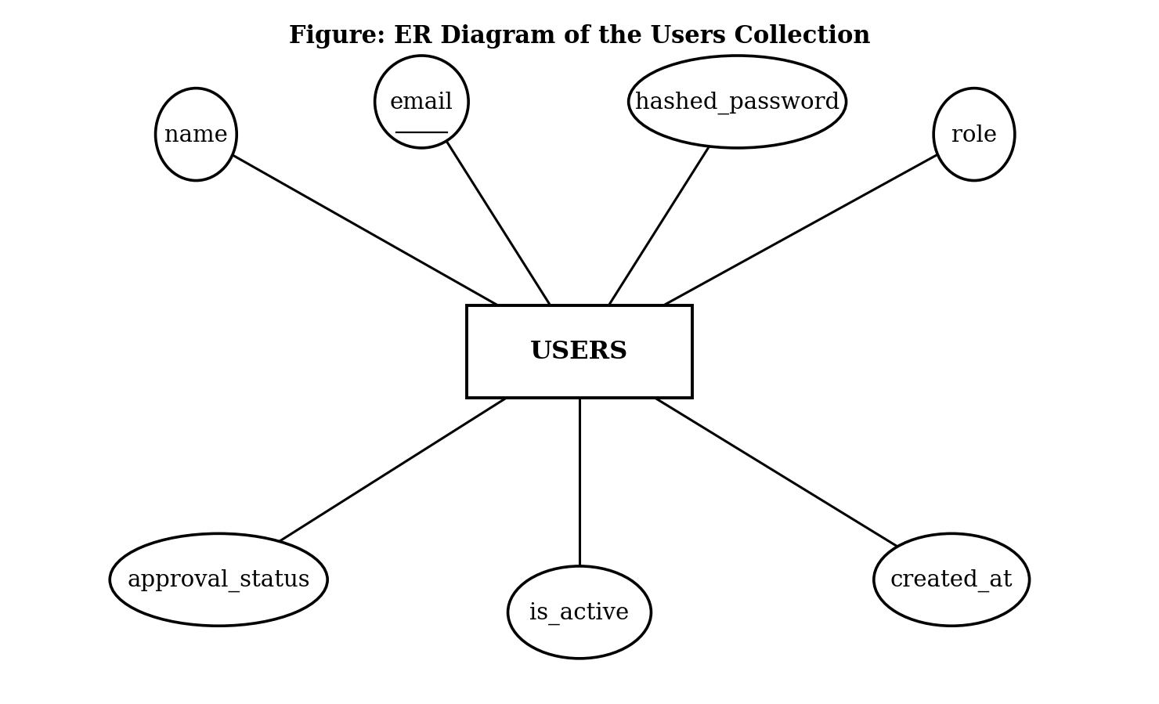
The ER diagram represents the users collection used for authentication. The email attribute is unique-indexed, while hashed_password and role are used for verifying identity and controlling role-based access.
5. Database Connection Workflow
The database connection workflow describes what happens when the FastAPI application starts, from loading configuration through to the database being ready for use:
- The FastAPI application starts.
- Configuration is loaded from the .env file (MONGODB_URI, MONGODB_DATABASE).
- The application attempts to connect to MongoDB Atlas.
- If the connection succeeds, all nine collections are registered through init_beanie().
- If the connection fails, the error is logged so it can be corrected before the app is used.
- Once registered, the database is ready for the rest of the application to read and write data.
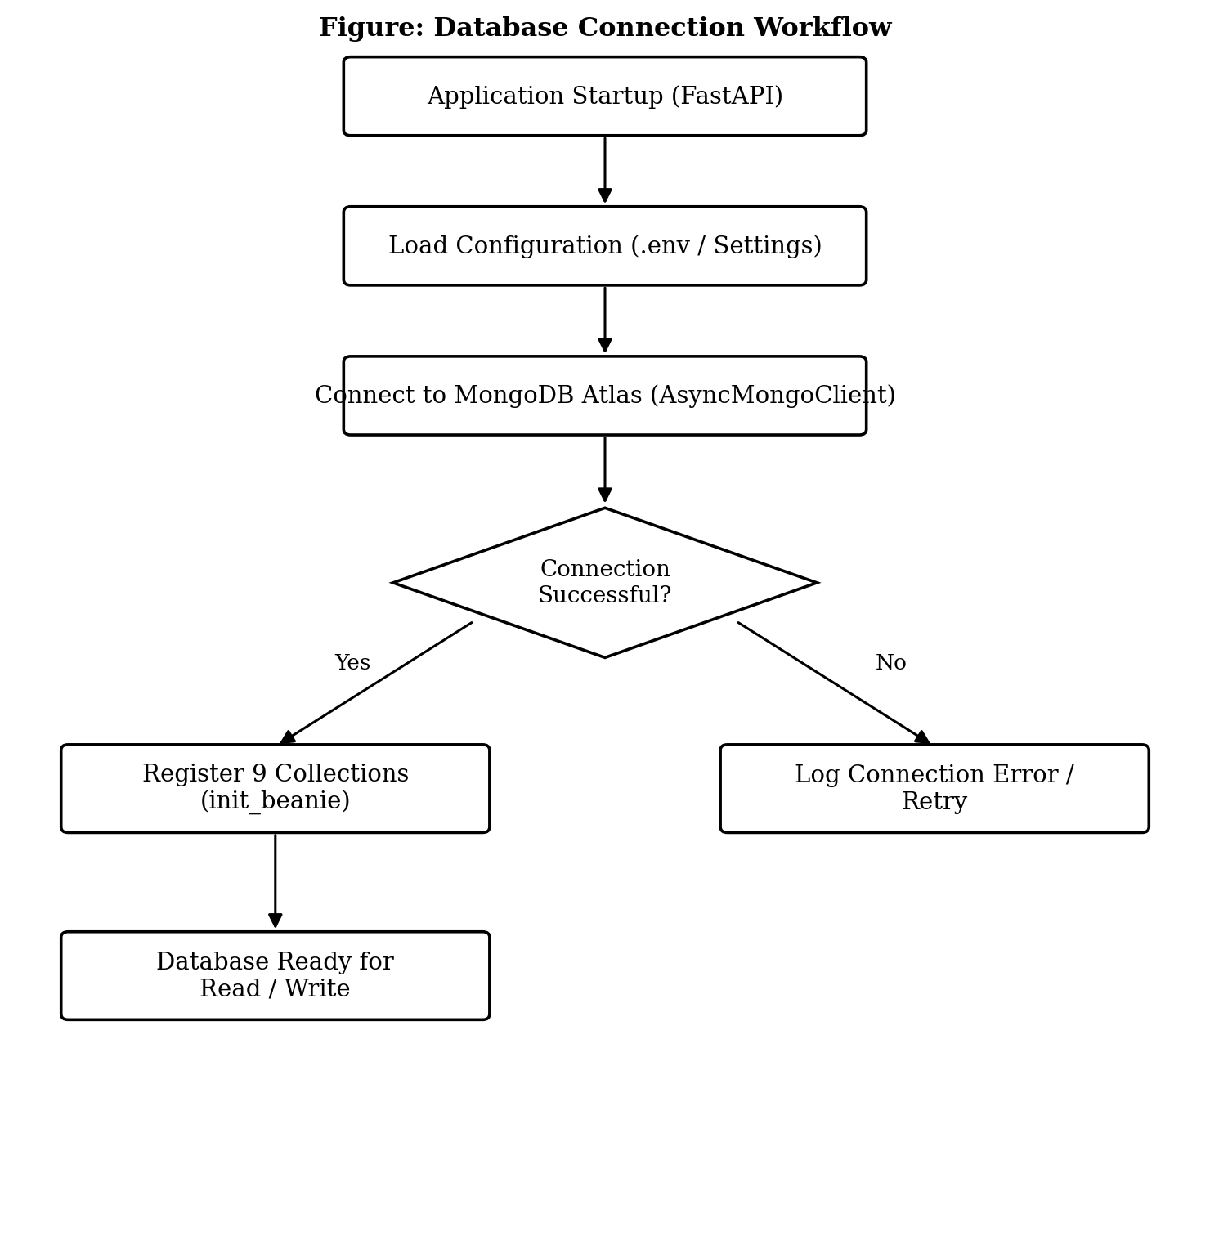
6. Collections Overview
In addition to users, eight further collections were designed to support the full application:
Collection | Purpose
users | Login accounts — name, email, password (hashed), role, approval status.
inspections | One record per image checked — defect found, confidence, severity, pass/fail.
reports | Link to the generated PDF report for an inspection.
model_versions | Which AI model version produced a given prediction.
audit_logs | History of who performed which action, and when.
rework_tickets | Repair/rework tasks created when a product fails inspection.
products | Basic details of each product type being inspected.
production_lines | The factory line a product was inspected on.
batch_records | Groups inspections by production batch and shift.
7. Current Progress
The following tasks have been completed for Milestone 1, Week 1&2:
- Analysed the data requirements of the other project modules.
- Selected MongoDB Atlas and Beanie as the database technology.
- Designed the users schema and the remaining eight collections.
- Built the configuration and connection layer (config.py, db/mongodb.py).
- Registered all collections through init_beanie() and added a unique index on email.
- Verified the setup end-to-end using a seed/verification script.
Backend integration with the authentication and inspection modules will continue in the following weeks.
8. Conclusion
The Database module provides a structured and verified storage foundation for the VisionInspect AI system. The schema design, connection layer, and collection registration completed in Week 1 &2 establish a stable base for the rest of the team to build the authentication, inspection, and analytics features on top of.

