VisionInspect AI
Manufacturing Defect Detection & Quality Inspection System
Milestone 2 Progress Report

Report Details
Field | Detail
Project | VisionInspect AI
Name | SHABAREESHAN S
Team | TEAM 3

Manufacturing Defect Detection & Quality Inspection System
This document presents the testing and evaluation of the AI-based quality inspection system using the generated VisionInspect AI inspection report.

1. Introduction
Quality inspection is an important stage in manufacturing. Manual inspection is time consuming and may produce inconsistent results. Our project uses an AI-based anomaly detection model to automatically inspect product images, identify defects, and generate a detailed inspection report. The aim is to improve inspection speed, consistency, and product quality.

2. Objective
• Validate the AI model using sample product images.
• Verify that the system correctly classifies products as Good or Defective.
• Generate an automated inspection report.
• Evaluate confidence, severity, anomaly score and final decision.

3. Testing Methodology
The input bottle image was provided to the VisionInspect AI system. The PaDiM baseline model compared the image with learned normal product patterns. Based on feature comparison, the model generated prediction, confidence score, anomaly score, severity score, severity level, heatmap and quality decision.

4. Test Results
The generated report shows:
Prediction: Good
Inspection Result: PASS
Confidence Score: 82.2%
Severity Score: 25.18
Severity Level: Low
Anomaly Score: 1.056
Recommended Action: Product generally acceptable.
Interpretation:
Confidence Score indicates how certain the AI is about its prediction. Severity Score measures the seriousness of the detected anomaly. Severity Level categorizes the severity as Low, Medium or High. Anomaly Score measures how different the product is from a normal product. Since the anomaly score stayed below the decision threshold, the product passed inspection.

5. Analysis
The heatmap highlighted no significant abnormal regions, supporting the prediction of a good product. The AI completed the inspection automatically and produced a detailed report including production information, model information, quality summary and explainability notes. Such reports help quality engineers make faster decisions while reducing manual inspection effort.

6. Conclusion
The testing phase successfully demonstrated that the proposed system can inspect manufacturing products automatically. The AI correctly classified the sample bottle as Good and generated a comprehensive inspection report. The project shows the potential of AI-based inspection systems for improving manufacturing quality, reducing inspection time and supporting reliable quality assurance.

Inspection Report (Attached)
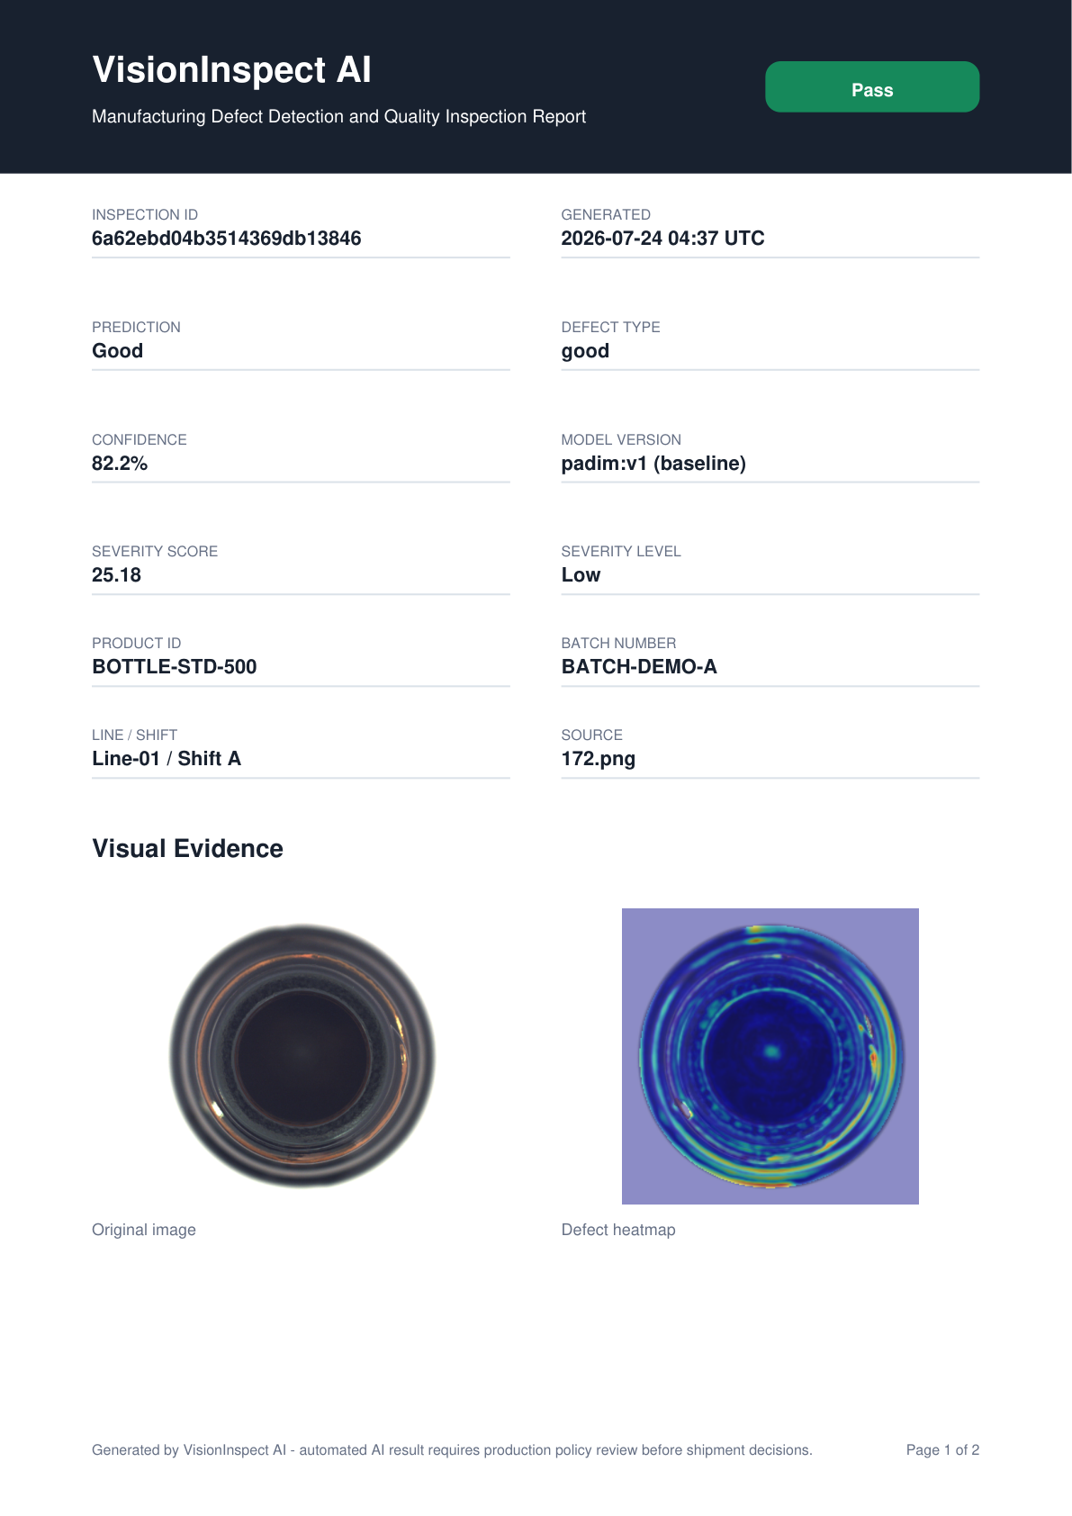
Figure 1: VisionInspect AI Inspection Report - Page 1

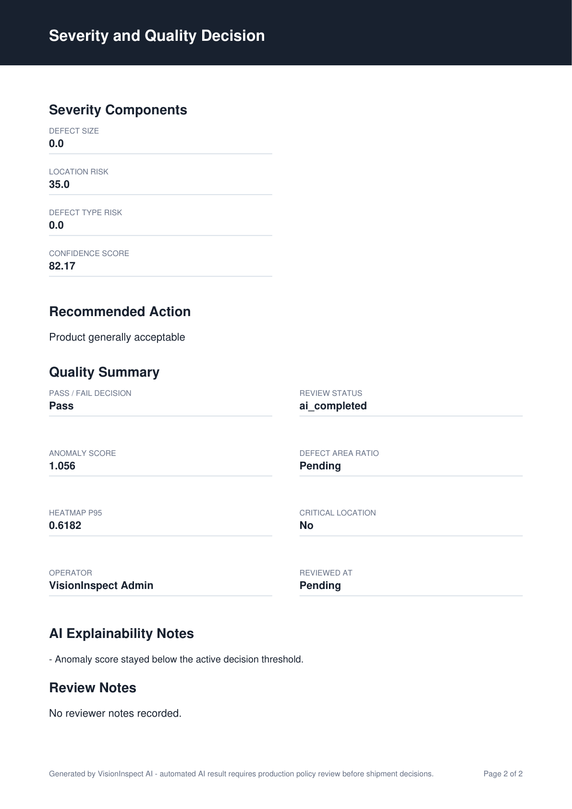
Figure 2: VisionInspect AI Inspection Report - Page 2

