VisionInspect AI: Manufacturing Defect Detection & Quality Inspection System

Pavani Ojili

Table of Contents | Page No
1. Project Description | 3
2. Module Objective | 3
3. Existing Frontend Analysis | 3
4. Role-Based Authentication | 4
5. Database Schema | 4
6. Authentication Workflow | 5
7. API Design | 7
8. Current Progress | 8
9. Conclusion | 8

1. Project Description
VisionInspect AI is an AI-powered manufacturing quality inspection system designed to automate product inspection and defect analysis. The system allows users to upload product images, detect manufacturing defects, classify defect types, and generate inspection reports.
The project consists of multiple modules, including Data Preprocessing, Machine Learning Model, Frontend Interface, Database, and Authentication System. My assigned responsibility is the Database & Role-Based Authentication module.

2. Module Objective
The objective of this module is to design a secure role-based authentication system that allows only authorized users to access the VisionInspect AI application.
The authentication module verifies user credentials and identifies the user's role before granting access to the appropriate interface. It also provides the foundation for future backend integration.

3. Existing Frontend Analysis
The VisionInspect AI project includes a frontend login interface that allows users to securely access the application. The login page requires users to enter their Employee ID, Password, and select their role before authentication.
The current implementation supports two user roles: Quality Engineer and Factory Supervisor. The frontend performs role selection, input validation, and mock authentication to demonstrate the login process before backend integration.
For Milestone 1, I analyzed the existing frontend authentication flow to understand how user credentials are processed. This analysis was used to design the database schema, authentication workflow, and Login API for future backend integration.
Figure 1: Login Page of VisionInspect AI
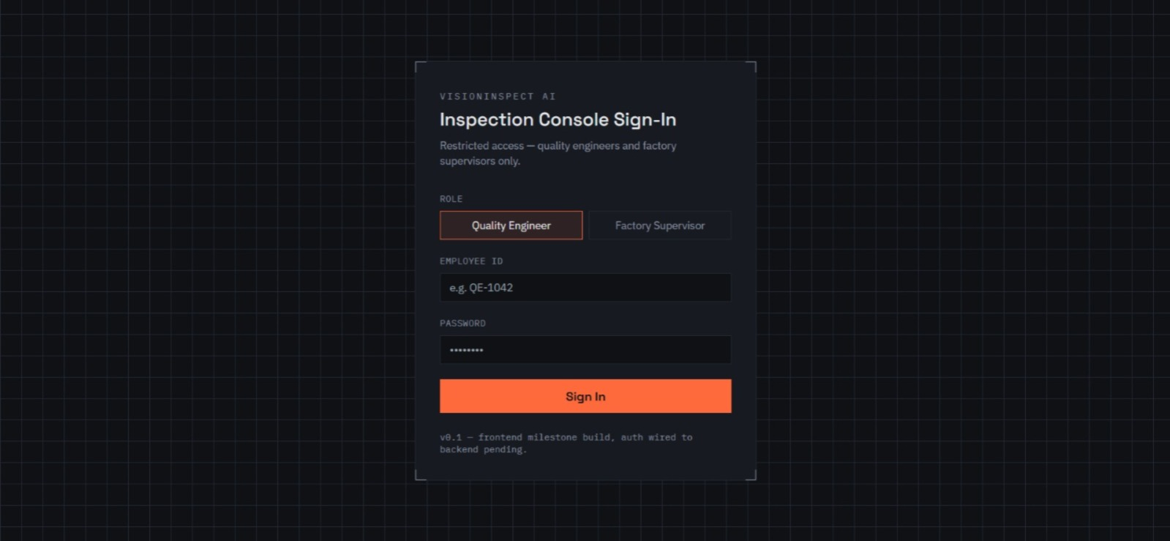
Figure 1 shows the login interface of the VisionInspect AI system. Users authenticate by entering their Employee ID, Password, and selecting their assigned role (Quality Engineer or Factory Supervisor). After clicking Sign In, the authentication request is sent to the Login API for credential verification.

4. Role-Based Authentication
The authentication module is designed to provide secure access to the VisionInspect AI system based on user roles.
The proposed user roles are:
- Quality Engineer
- Factory Supervisor
Each user is authenticated using login credentials. After successful authentication, the system identifies the user's role and provides appropriate access to the application.
For Milestone 1, the authentication flow and role management approach have been designed and documented.

5. Database Schema
The authentication system requires a Users table to store user login information.
The proposed database schema consists of the following fields:
Field Name | Data Type | Description | Example
employee_id | VARCHAR | Primary Key (Unique Employee Identifier) | QE-1042
password | VARCHAR | User password | ********
role | VARCHAR | User role (Quality Engineer / Factory Supervisor) | quality_engineer

Figure 2: ER Diagram of the Users Entity
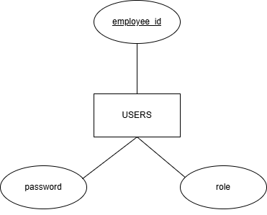
The ER diagram represents the Users entity used for authentication. The employee_id attribute acts as the Primary Key, while password and role are used for user authentication and role-based authorization.

6. Authentication Workflow
The authentication workflow is designed as follows:
- User opens the login page.
- User enters Employee ID and Password.
- User selects the appropriate role.
- The authentication system verifies the entered credentials.
- If the credentials are valid, the user is granted access according to the assigned role.
- If the credentials are invalid, an authentication error message is displayed.

Figure 3: Authentication Workflow
User

Login Page

Enter Employee ID, Password, Role

POST /auth/login

Database Verification

Backend Authentication

Credentials Valid?

Yes No
Display Login Error
Access Dashboard

Figure 4: Successful Login to Inspection Dashboard
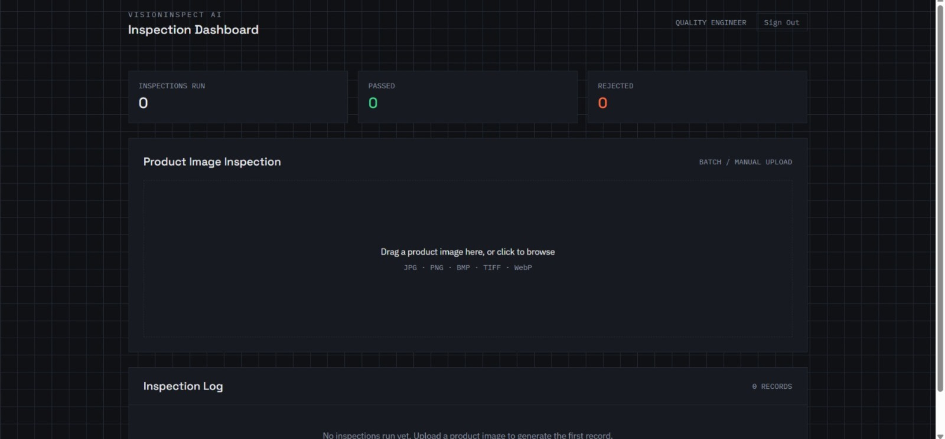

7. API Design
The proposed authentication API is designed to support secure login between the frontend and backend.

Login API
Endpoint
POST /auth/login

Request Parameters
- Employee ID
- Password
- Role

Expected Response
Success
- Authentication Successful
- User Role
- Login Status
Failure
- Invalid Employee ID
- Incorrect Password
- Unauthorized Access
The backend implementation of this API will be integrated in future development phases.

API Endpoint | HTTP Method | Input | Output
/auth/login | POST | Employee ID, Password, Role | Login Success / Failure

The frontend sends the Employee ID, Password, and Role to the /auth/login endpoint. The backend validates the credentials using the database and returns a success or failure response.

8. Current Progress
The following tasks have been completed for Milestone 1:
- Analyzed the existing frontend authentication interface.
- Designed the Users database schema.
- Prepared the authentication workflow.
- Designed the authentication API.
- Documented the Database & Role-Based Authentication module.
Backend implementation and database integration will be carried out in future milestones.

9. Conclusion
The Database & Role-Based Authentication module provides a structured approach for secure user authentication within the VisionInspect AI system.
The proposed database schema, authentication workflow, and API design establish a strong foundation for future backend implementation while supporting secure and role-based access to the application.

