VisionInspect AI: Manufacturing Defect Detection & Quality Inspection System

Pavani Ojili

Table of Contents | Page No.
1. Database Technologies | 3
1.1 PostgreSQL | 3
1.2 MongoDB | 3
2. Database Requirements | 3
2.1 Users Table | 3
2.2 Products Table | 3
2.3 Inspections Table | 4
2.4 Inspection Results Collection (MongoDB) | 4
3. Database Relationships | 5
4. Database Architecture | 6
5. Database Schema | 7
6. ER (Entity Relationship) Diagram | 8
7. Explanation of ER Diagram | 9

1. Database Technologies
PostgreSQL
• PostgreSQL is a relational database management system used to store structured data.
• It stores user information, product details, and inspection records.
• It ensures data integrity using primary keys and foreign keys..
MongoDB
• MongoDB is a NoSQL database used to store semi-structured and unstructured data.
• It stores AI-generated inspection results, including defect type, anomaly score, severity score, and recommended action.
• It provides flexibility for storing varying inspection results without requiring a fixed schema.

2. Database Requirements

The VisionInspect AI project uses PostgreSQL to manage structured relational data. The database is designed to maintain user information, product details, and inspection records. Each table has a specific purpose, and relationships between the tables are established using primary and foreign keys to ensure data consistency and integrity.

PostgreSQL
Table: Users
Column Name | Data Type | Constraint | Description
employee_id | VARCHAR(20) | PRIMARY KEY | Unique employee ID used for login
password | VARCHAR(255) | NOT NULL | Encrypted user password
role | VARCHAR(30) | NOT NULL | User role (Admin, Quality Engineer, Supervisor)

The Users table stores employee login credentials and user roles. It is used for authentication and role-ba-sed access control. Each employee is identified by a unique Employee ID.

Table: Products
Column Name | Data Type | Description
product_id | SERIAL | Unique product ID
product_name | VARCHAR(100) | Product name
category | VARCHAR(50) | Product category

The Products table stores details of the products being inspected. Each product has a unique Product ID along with its name and category.

Table: Inspections
Column Name | Data Type | Description
inspection_id | SERIAL | Unique inspection ID
employee_id | VARCHAR(20) | Employee who performed the inspection
product_id | INT | Product being inspected
image_name | VARCHAR(255) | Uploaded image name

The Inspections table records every inspection performed in the system. It connects the Users and Products tables using foreign keys and stores information such as the uploaded image used for inspection.

MongoDB

Collection: Inspection Results
This collection stores the AI-generated inspection results after a product image has been analyzed. Unlike PostgreSQL, MongoDB provides a flexible document structure that is suitable for storing varying inspection outputs.
Field Name | Data Type | Description
inspection_id | INT | Reference to the inspection record
defect_type | VARCHAR(100) | Type of defect detected by the AI model
anomaly_score | FLOAT | AI-generated anomaly/confidence score
recommended_action | VARCHAR(100) | Suggested action based on the inspection result

Database Relationships

Table | Primary Key | Foreign Key
Users | employee_id | —
Products | product_id | —
Inspections | inspection_id | employee_id → Users(employee_id), product_id → Products(product_id)
Inspection_Results (MongoDB) | _id (MongoDB default) | inspection_id (logical reference to Inspections)
The VisionInspect AI database uses primary keys and foreign keys to maintain relationships between relational tables.
- The Users table is linked to the Inspections table through the employee_id foreign key.
- The Products table is linked to the Inspections table through the product_id foreign key.
- The Inspection_Results collection in MongoDB is associated with the Inspections table using the inspection_id, allowing each inspection to be connected with its corresponding AI-generated result.
This design ensures data consistency while combining the strengths of PostgreSQL and MongoDB.

Database Architecture
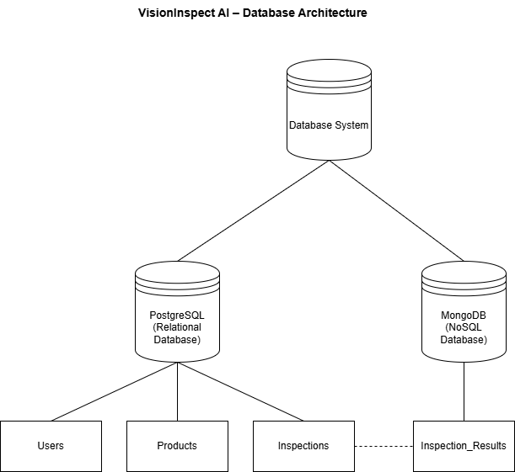

The VisionInspect AI project follows a hybrid database architecture by integrating PostgreSQL and MongoDB.
- PostgreSQL is used to store structured relational data such as Users, Products, and Inspections. It maintains relationships between entities using primary and foreign keys, ensuring data consistency and integrity.
- MongoDB is used to store AI-generated inspection results, including defect type, anomaly score, and recommended action. Its flexible document model makes it suitable for storing varying AI outputs.
This hybrid approach combines the reliability of relational databases with the flexibility of NoSQL databases, resulting in an efficient and scalable data management system.
Database Schema
The database schema represents the structure of the PostgreSQL tables (Users, Products, and Inspections) and the MongoDB collection (Inspection_Results). It shows the primary keys, foreign keys, and how the tables are connected to maintain data consistency and support AI-generated inspection results.

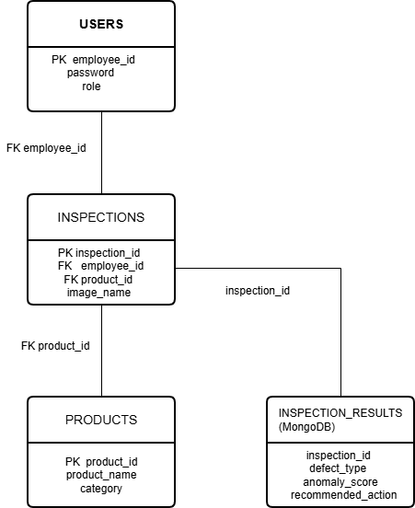
ER (Entity Relationship) Diagram
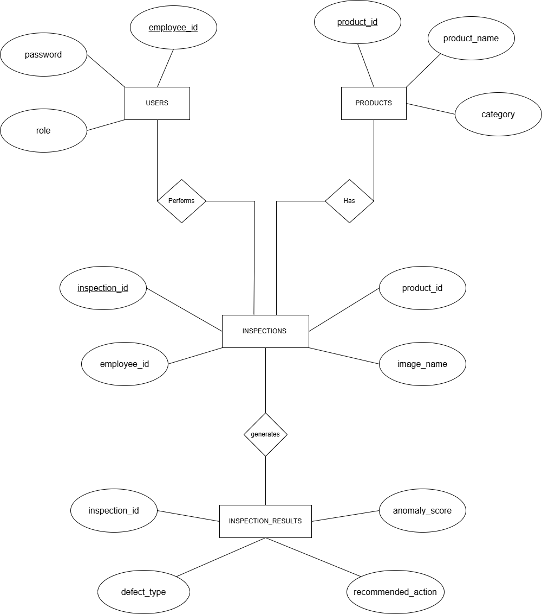

The ER (Entity Relationship) Diagram represents the relationships between the entities used in the VisionInspect AI database.
- Users stores employee information, including login credentials and roles.
- Products stores information about the products being inspected.
- Inspections records each inspection and connects the Users and Products tables through foreign keys.
- Inspection_Results stores the AI-generated inspection results and is logically linked to the Inspections table using the inspection_id.

Relationships
- One User can perform many Inspections (1 : M).
- One Product can have many Inspections (1 : M).
- One Inspection generates one Inspection Result (1 : 1).
The ER diagram provides a clear visualization of the database structure and the relationships between different entities, making the system easier to understand and maintain.

