VisionInspect AI
Manufacturing Defect Detection

Backend Development Report

Project | VisionInspect AI
Role / Module | Member 2 - Backend Developer
Technology Stack | Python, FastAPI, Pydantic, JWT, MongoDB Integration
Prepared By | Aritra Mukherjee
Submission Date | 10/07/2026

Table of Contents
1. Project Description
2. Objective
3. Member 2 Scope
4. Environment Setup
5. Backend File Structure
6. Backend Workflow
7. Backend Modules Implemented
8. API Routes
9. Request and Response Validation
10. Backend Services
11. Security and Authentication
12. Testing Responsibility
13. Screenshot Placeholders
14. Conclusion

1. Project Description
VisionInspect AI is an AI-powered manufacturing defect detection and quality inspection platform. The system allows users to upload product images, inspect them using AI-based detection, classify defect types, calculate severity, generate quality decisions, create rework tickets, and view reports and analytics.
This document focuses on the Backend Developer module assigned to Member 2. The backend developer is responsible for building and maintaining the FastAPI application layer that connects the frontend with the database, AI/ML pipeline, cloud storage, reports, analytics, and user management features.
The backend provides REST APIs consumed by the frontend. It handles request validation, authentication, authorization, image upload processing, inspection workflow coordination, and response formatting.

2. Objective
The objective of the backend module is to build a secure, modular, and maintainable API layer for the VisionInspect AI platform.
- Create FastAPI endpoints for all major modules.
- Handle frontend API requests and return structured JSON responses.
- Validate request and response data using Pydantic schemas.
- Manage authentication, authorization, and role-based access control.
- Connect API routes with backend services, database logic, and AI/ML prediction functions.
- Process uploaded images and coordinate the inspection workflow.
- Support reports, analytics, rework, users, and model settings APIs.
- Keep all APIs properly structured, testable, and easy to maintain.

3. Member 2 Scope
Member 2 is responsible for the main backend application logic and owns the following folders and files:
backend/
|-- main.py
|-- requirements.txt
`-- app/
|-- routes/
|-- schemas/
|-- services/
|-- security.py
|-- dependencies.py
`-- serializers.py

Member 2 works closely with:
- Member 1 for frontend API integration.
- Member 3 for database models and MongoDB connection.
- Member 4 for AI/ML prediction functions.
- Member 5 for analytics, reports, severity logic, and model metrics.

4. Environment Setup
The backend was developed using Python and FastAPI. The setup is designed for local development, API testing, and smooth integration with the frontend and AI/ML modules.
Area | Tools / Technologies
Backend Framework | Python, FastAPI, Uvicorn
Data Validation | Pydantic
Authentication | JWT, bcrypt password hashing
File Upload Support | python-multipart
Image Processing Support | OpenCV / Pillow integration support
Testing | Pytest, Postman
Development Tools | Visual Studio Code, Git, GitHub, Python virtual environment

Important backend configuration:
- requirements.txt contains all backend dependencies.
- main.py starts the FastAPI application.
- Environment variables are loaded through backend configuration files.
- Backend APIs are consumed by the frontend services layer.
Screenshot Space 1: Backend Project Open in VS Code

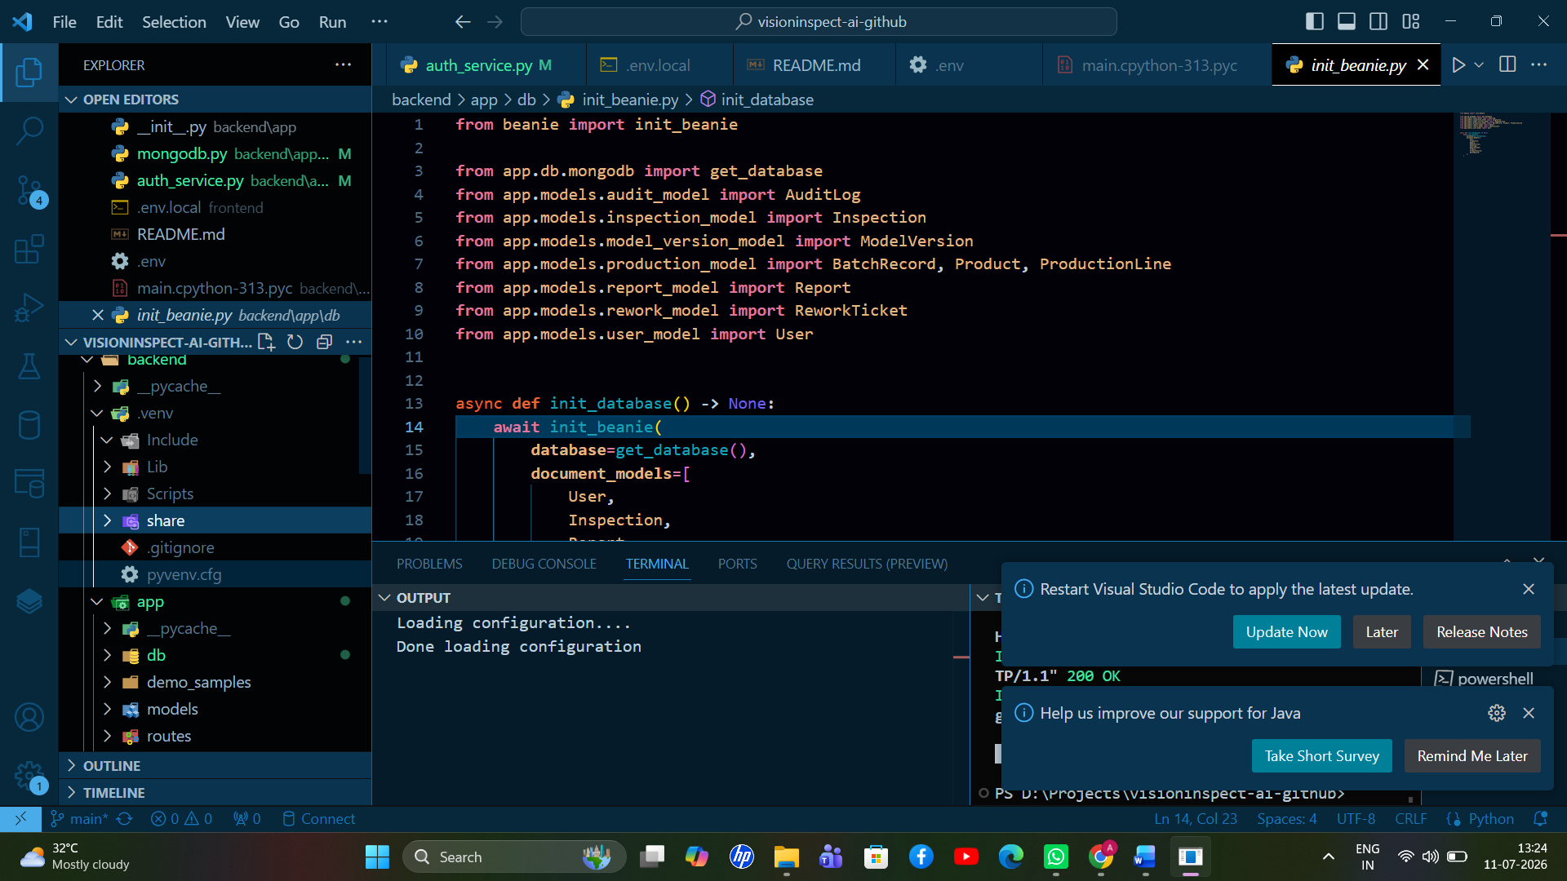

5. Backend File Structure
Member 2 owns the backend API structure shown below. The codebase is divided into route files, schema files, service files, and shared utilities to keep the backend modular.
backend/
|-- main.py
|-- requirements.txt
`-- app/
|-- routes/
| |-- analytics_routes.py
| |-- auth_routes.py
| |-- camera_routes.py
| |-- inspection_routes.py
| |-- model_routes.py
| |-- report_routes.py
| |-- rework_routes.py
| `-- user_routes.py
|
|-- schemas/
| |-- analytics_schema.py
| |-- auth_schema.py
| |-- inspection_schema.py
| |-- report_schema.py
| |-- rework_schema.py
| `-- user_schema.py
|
|-- services/
| |-- analytics_service.py
| |-- audit_service.py
| |-- camera_service.py
| |-- cloudinary_service.py
| |-- inspection_service.py
| |-- model_settings_service.py
| |-- prediction_service.py
| |-- report_service.py
| |-- rework_service.py
| `-- severity_service.py
|
|-- security.py
|-- dependencies.py
`-- serializers.py

File / Folder | Responsibility
main.py | Entry point of the backend. It creates the FastAPI app instance, enables CORS, includes route files, defines the health-check endpoint, and starts the backend API layer.
requirements.txt | Contains backend dependencies for FastAPI server, MongoDB connection, authentication, image processing, AI/ML integration, and testing.
routes/ | Contains API endpoint definitions. Routes receive frontend requests, validate input, call service functions, and return structured JSON responses.
schemas/ | Contains Pydantic models for validating incoming data and defining consistent API response formats.
services/ | Contains business logic for inspection flow, database communication, AI/ML calls, analytics, reports, and rework workflows.
security.py | Handles password hashing, password verification, JWT token generation, JWT decoding, and authentication validation.
dependencies.py | Provides reusable FastAPI dependencies such as current-user retrieval, protected routes, and role checks.
serializers.py | Converts MongoDB records into frontend-friendly JSON by converting ObjectId values and cleaning database response objects.

6. Backend Workflow

6.1 General API Workflow
1. Frontend sends request to a FastAPI endpoint.
2. Route receives the request.
3. Pydantic schema validates the request body.
4. Authentication dependency checks JWT token if required.
5. Route calls the related service.
6. Service performs business logic.
7. Service communicates with database, AI model, or cloud storage if needed.
8. Result is formatted through serializers.
9. Backend returns JSON response to frontend.

6.2 Inspection Workflow
1. User uploads image from frontend.
2. inspection_routes.py receives the image and metadata.
3. Backend validates file format and request data.
4. inspection_service.py coordinates inspection processing.
5. prediction_service.py sends the image to the AI/ML pipeline.
6. AI/ML pipeline returns prediction, defect type, confidence, anomaly score, and heatmap.
7. severity_service.py calculates severity score and severity level.
8. inspection_service.py generates quality decision.
9. Result is stored in MongoDB.
10. Final response is returned to frontend.

6.3 Authentication Workflow
1. User submits email and password.
2. auth_routes.py receives credentials.
3. Backend checks whether user exists.
4. Password is verified using bcrypt.
5. Account approval/status is checked.
6. JWT token is generated.
7. Token is returned to frontend.
8. Frontend uses token for protected API requests.
Screenshot Space 2: FastAPI Swagger / API Documentation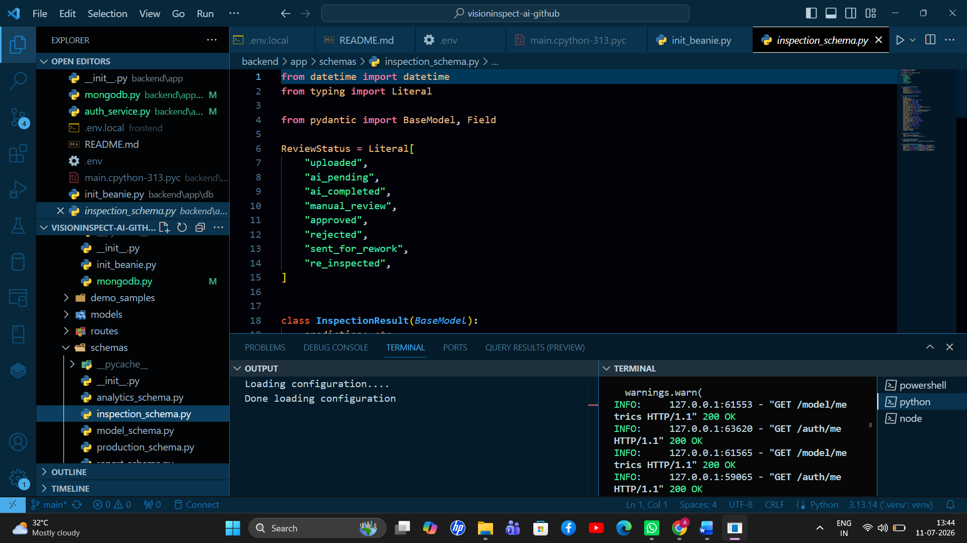

7. Backend Modules Implemented
Module | Files | Main Features
7.1 Authentication Module | auth_routes.py, auth_schema.py, security.py, dependencies.py | - User registration  - User login  - Password verification  - JWT token generation  - Current user API  - Protected route access
7.2 User API Module | user_routes.py, user_schema.py | - Get users  - Approve users  - Reject users  - Update roles  - Manage account status
7.3 Inspection API Module | inspection_routes.py, inspection_schema.py, inspection_service.py, prediction_service.py | - Upload image  - Validate image  - Inspect image  - Store inspection result  - Fetch inspection history  - Fetch inspection details  - Update metadata  - Add review action  - Batch inspection support
7.4 Camera Simulation API Module | camera_routes.py, camera_service.py | - Fetch sample camera images  - Simulate production-line capture  - Send simulated image for inspection

Module | Files | Main Features
7.5 Rework API Module | rework_routes.py, rework_schema.py, rework_service.py | - Create rework ticket  - List rework tickets  - Update ticket status  - Add notes  - Complete rework item
7.6 Report API Module | report_routes.py, report_schema.py, report_service.py | - Generate inspection report  - List reports  - Access report details  - Store report metadata
7.7 Analytics API Module | analytics_routes.py, analytics_schema.py, analytics_service.py | - Dashboard summary  - Defect statistics  - Severity distribution  - Pass/fail counts  - Line performance  - Rework summary
7.8 Model Settings API Module | model_routes.py, model_settings_service.py | - Model metadata API  - Model metrics API  - Threshold settings API  - Update decision thresholds

Screenshot Space 3: Authentication / Login API Test
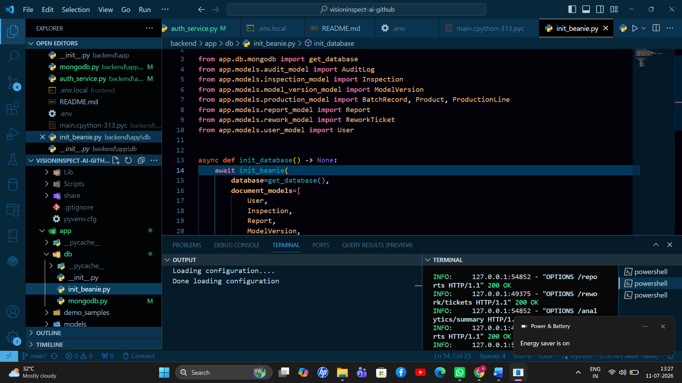ere.

8. API Routes
The backend exposes the following main route groups. These routes are consumed by the frontend services layer and are connected internally with schemas, services, authentication dependencies, and serializers.
Route Group | Purpose
/auth | Registration, login, current user, and authentication.
/users | User listing, approval, rejection, and role management.
/inspections | Image upload, inspection, inspection history, review, and metadata updates.
/camera | Camera simulation and sample image inspection.
/rework | Rework ticket creation and status tracking.
/reports | Report generation and report listing.
/analytics | Dashboard statistics and manufacturing analytics.
/models | Model metadata, metrics, and threshold settings.
/health | Health check to verify whether the backend server is running.

Screenshot Space 4: Inspection API Response
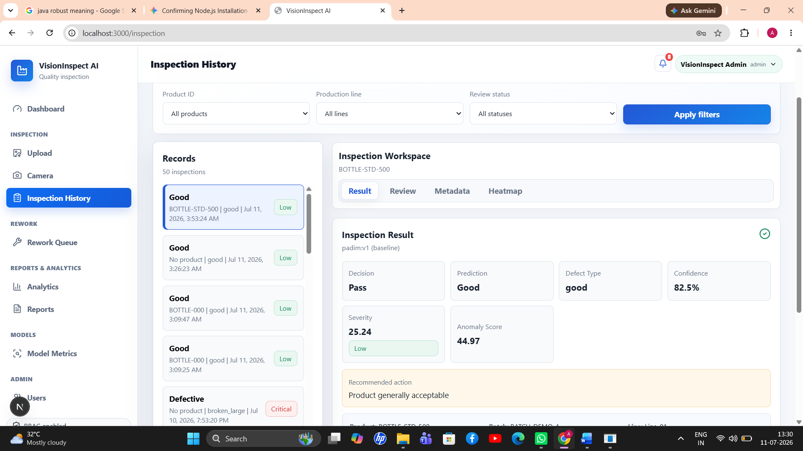

9. Request and Response Validation
Pydantic schemas are used to validate data before it reaches service logic and to keep output formats consistent for the frontend.
- Prevent invalid request data.
- Keep API response structure consistent.
- Make frontend-backend integration easier.
- Reduce runtime errors.
- Improve maintainability.
Schema Example | Validation Responsibility
auth_schema.py | Login request, register request, token response.
inspection_schema.py | Inspection response, metadata update, review action.
rework_schema.py | Rework ticket data and status update.
user_schema.py | User response, role update, and approval request.

10. Backend Services
Services contain the main backend logic. Routes should remain clean by calling service functions rather than directly handling business logic inside endpoint definitions.
Service File | Responsibility
analytics_service.py | Calculates dashboard and analytics data.
audit_service.py | Records important user and system actions.
camera_service.py | Handles camera simulation logic.
cloudinary_service.py | Uploads files to Cloudinary and returns URLs.
inspection_service.py | Manages the full inspection flow.
model_settings_service.py | Stores and retrieves threshold settings and model metadata.
prediction_service.py | Calls AI/ML prediction logic and formats model output.
report_service.py | Generates and manages reports.
rework_service.py | Creates and updates rework tickets.
severity_service.py | Calculates severity score and severity level.

11. Security and Authentication
The backend uses JWT-based authentication to secure user access and protect private routes.
- Password hashing using bcrypt.
- JWT token generation after successful login.
- Protected routes using dependencies.
- Role-based access control.
- Account approval check.
- User status validation.
Role | Access Example
Quality Engineer | Upload and inspect images.
Factory Supervisor | Review inspections and manage rework.
Quality Manager | Access analytics and model metrics.
Admin | Manage users and approvals.

12. Testing Responsibility
Member 2 is mainly responsible for backend API and authentication tests.
tests/
|-- test_api.py
`-- test_auth.py

Testing responsibilities include:
- Test backend health endpoint.
- Test login/register APIs.
- Test protected endpoints.
- Test authentication token behavior.
- Test API response format.
- Test invalid request handling.
- Test role-based access where required.
Member 2 also supports integration testing with Member 1 for frontend API calls, Member 3 for database-related API behavior, Member 4 for prediction API behavior, and Member 5 for analytics and reports APIs.

13. Screenshot Placeholders
The following spaces are intentionally left for screenshots. Replace each box with the required screenshot before final submission.
Screenshot 5: Rework / Reports API Response
Past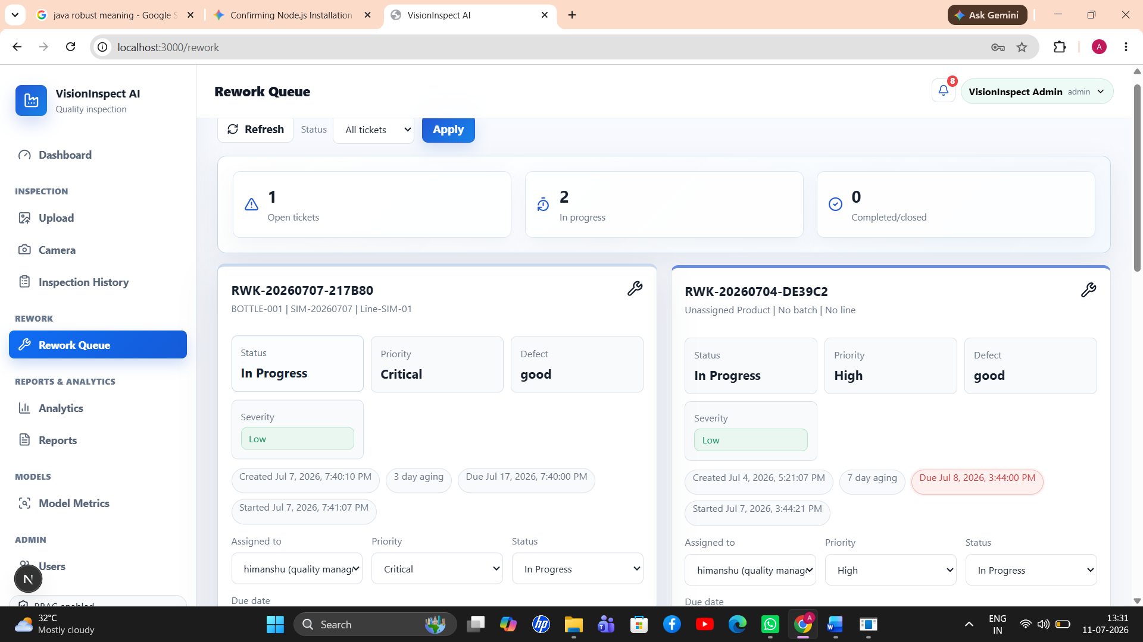

Screenshot 6: Analytics Dashboard API Response
Pas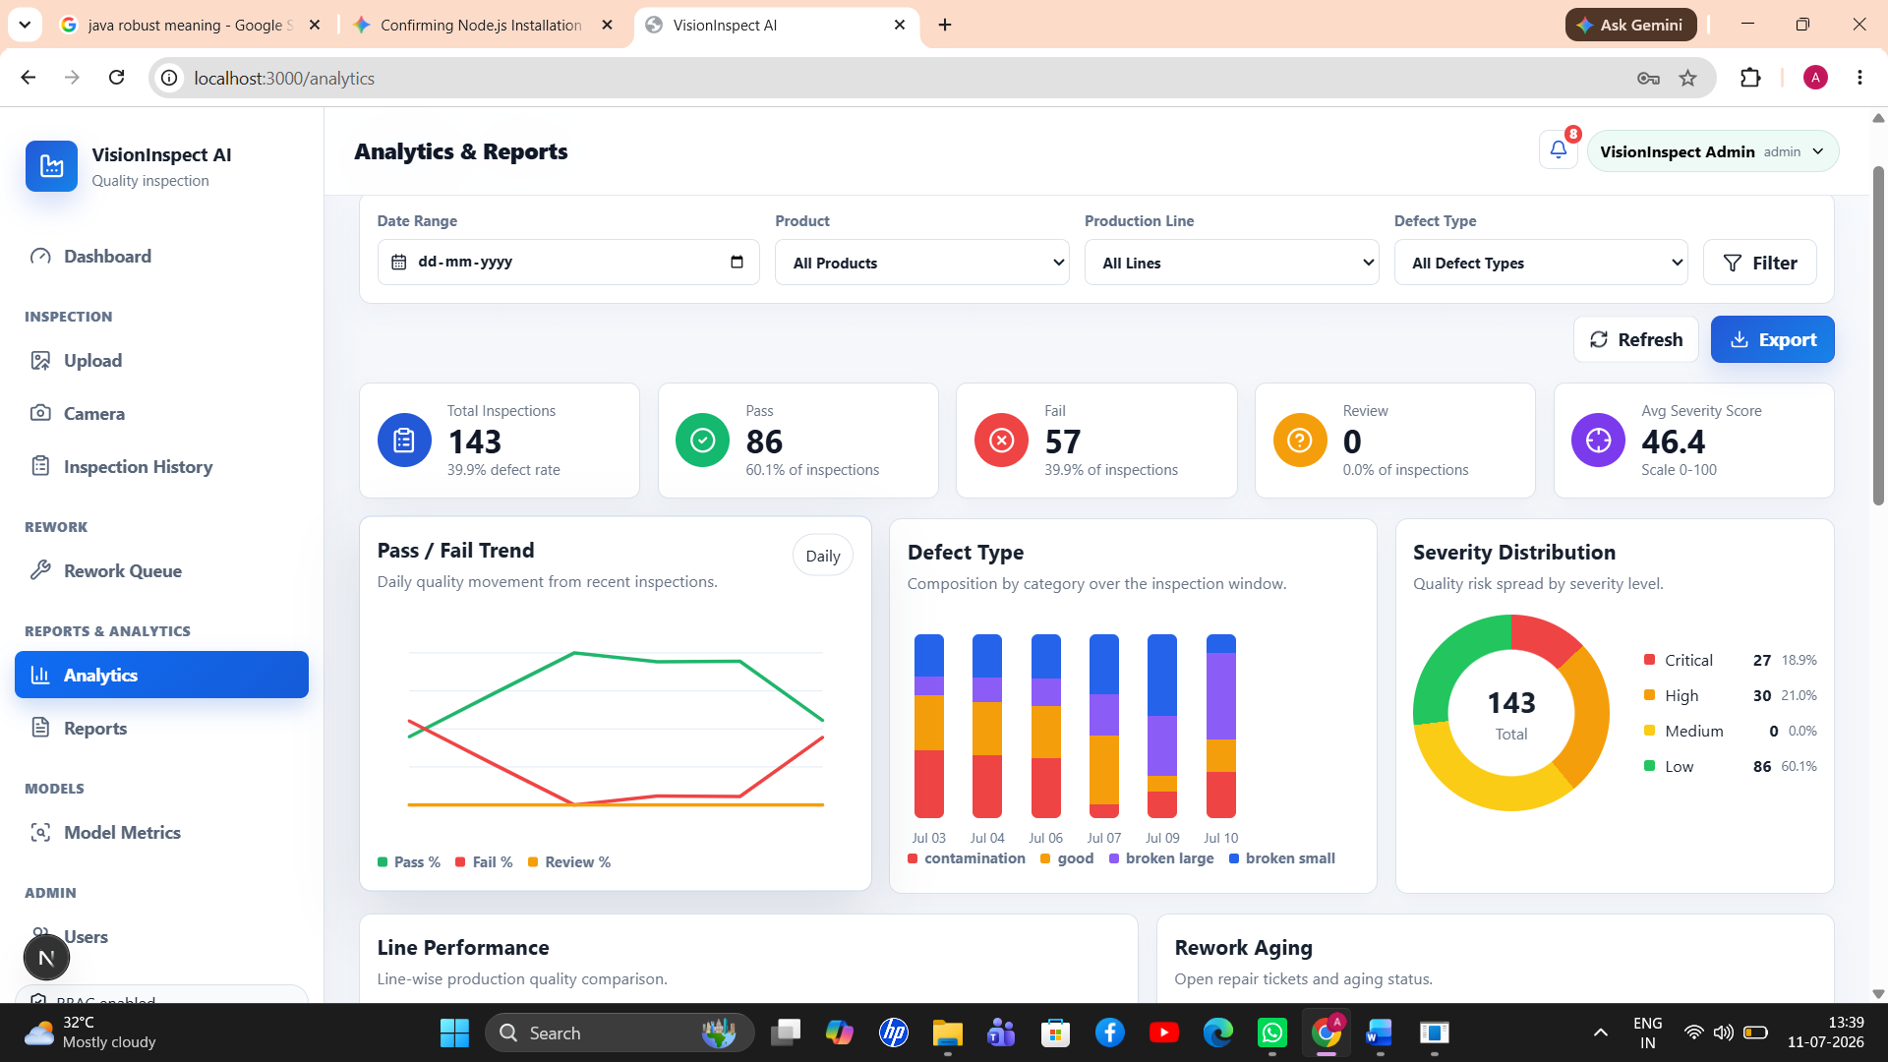.

Screenshot 7: Pytest / Backend Test Output
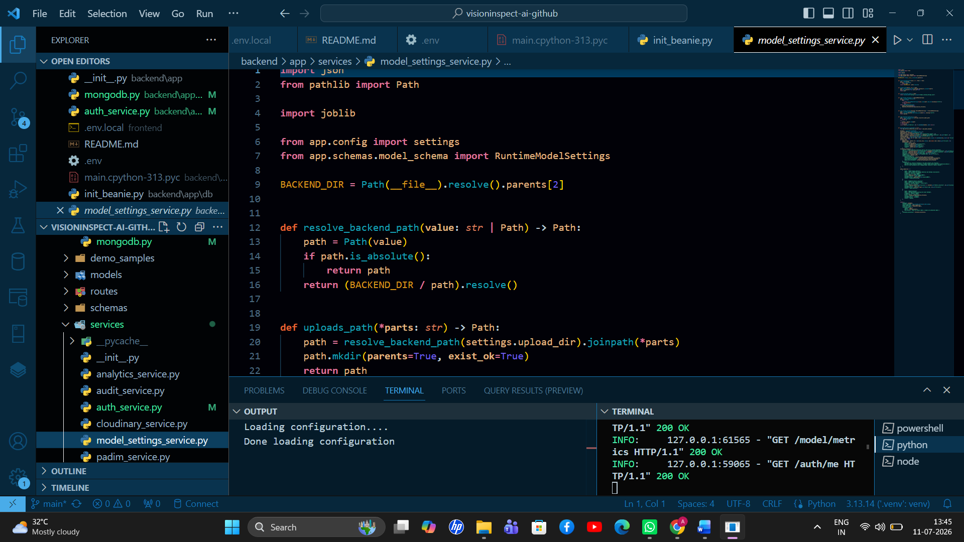

Screenshot 8: MongoDB / Database Record Verification
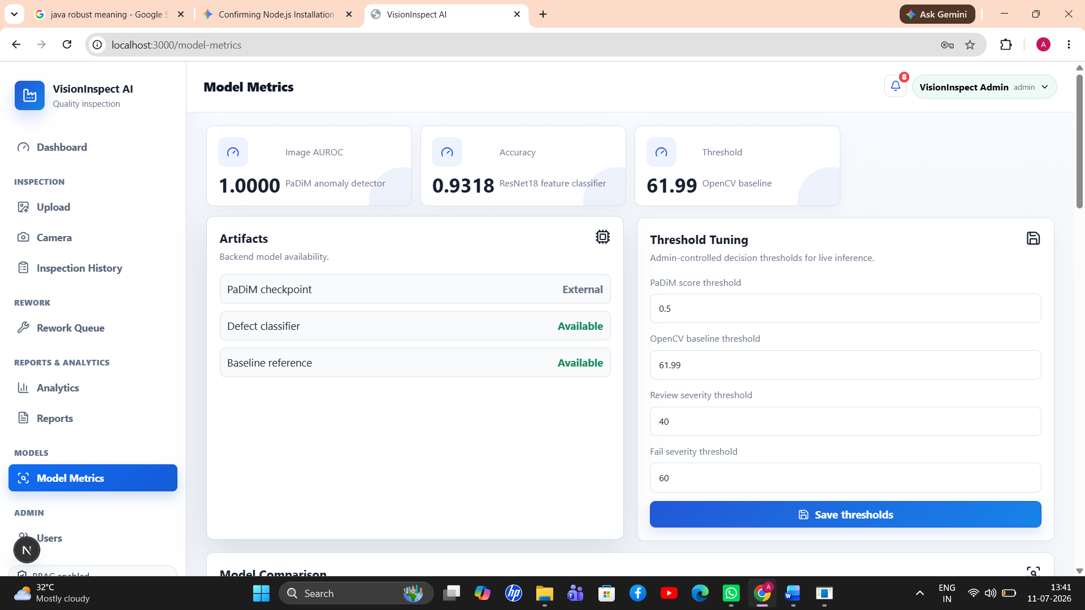

14. Conclusion
The Backend Developer module is responsible for the main API layer of VisionInspect AI. It connects the frontend with the database, AI/ML pipeline, analytics logic, reports, rework workflow, and user management system.
The backend is organized using a clean FastAPI structure with separate routes, schemas, services, security utilities, dependencies, and serializers. This separation makes the system easier to maintain, test, and extend.
Member 2’s work is essential because the backend acts as the central communication and processing layer of the complete VisionInspect AI platform.

