MILESTONE 3 EVALUATION
Testing & Report Generation
VisionInspect AI – Manufacturing Defect Detection & Quality Inspection System
Name: SHABAREESH S
Team: Team 3
Role: Testing & Report Generation

1. Introduction
Our project uses AI and computer vision to inspect manufacturing products and identify defects. My role in the project is mainly focused on testing the inspection results and generating the quality inspection report.

2. My Role
- Test the product inspection workflow.
- Check whether the AI prediction is generated correctly.
- Verify confidence score, anomaly score and severity score.
- Check the final PASS/FAIL decision.
- Generate and verify the inspection report.
- Make sure the report contains the important inspection details.

3. Milestone 3 – My Work
Milestone 3 includes defect classification, severity scoring, quality assessment and production quality reports. My work is related to testing these outputs and checking whether the generated report correctly represents the inspection result. fileciteturn1file0L165-L179

4. Testing Process
- Upload the product image.
- Run the AI-based inspection.
- Check the prediction and defect type.
- Check confidence and anomaly scores.
- Check severity score and severity level.
- Verify the PASS/FAIL decision.
- Generate the final inspection report.

5. Important Testing Parameters
Parameter | Meaning
Confidence Score | Shows how confident the AI is about its prediction.
Anomaly Score | Shows how different the product is from a normal product.
Severity Score | Shows the seriousness of the detected defect.
Severity Level | Categorizes the severity as Low, Medium, High or Critical.
PASS/FAIL | Final quality decision of the inspection.

6. Severity Assessment
The project specification uses defect size, defect location, defect type and detection confidence for severity assessment. The defined severity levels are Critical, High, Medium and Low. fileciteturn1file0L67-L109
The purpose of severity assessment is to understand the quality risk and support an appropriate quality decision.

7. Sample Test Result
The sample VisionInspect AI report used for testing contains the following result:
Test Parameter | Sample Result
Prediction | Good
Confidence Score | 82.2%
Severity Score | 25.18
Severity Level | Low
Anomaly Score | 1.056
Final Decision | PASS
Recommended Action | Product generally acceptable

8. Report Generation
After testing, the system generates a quality inspection report. The report provides the inspection ID, product information, prediction, confidence, severity information, anomaly result, visual evidence and final quality decision. This makes the AI result easier for the quality team to review.

9. Simple Test Cases
Test Case | Expected Result | Status
Product image upload | Image accepted | Pass
AI prediction | Prediction generated | Pass
Confidence score | Score displayed | Pass
Severity assessment | Score and level displayed | Pass
Anomaly detection | Anomaly result displayed | Pass
Quality decision | PASS/FAIL generated | Pass
Report generation | Complete report generated | Pass

10. Sample Inspection Report
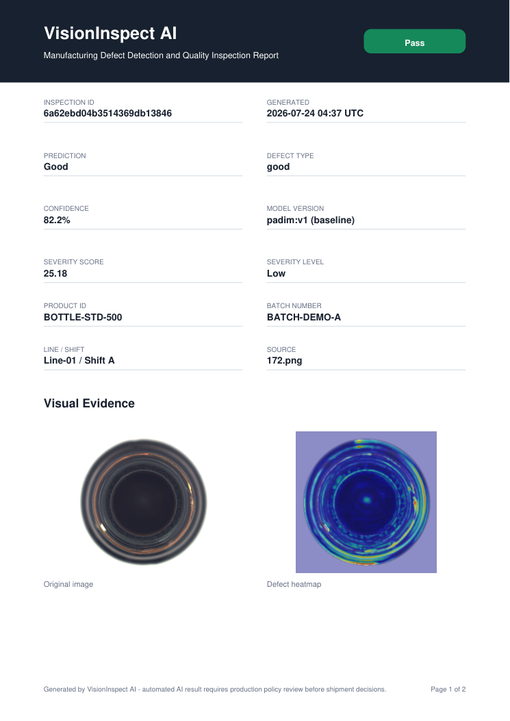
Figure 1: Generated Inspection Report

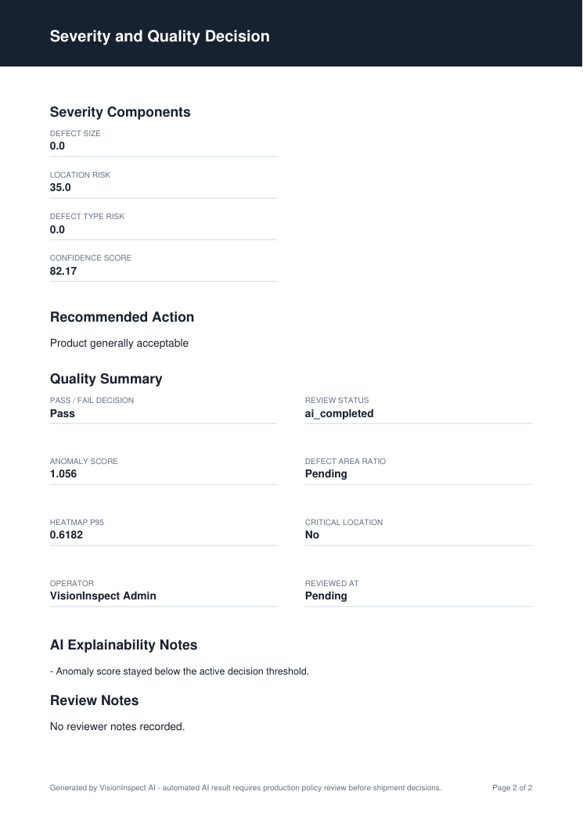
Figure 2: Generated Inspection Report

11. Testing Checklist
☐ Product image is processed successfully.
☐ Prediction is generated.
☐ Confidence score is available.
☐ Anomaly score is available.
☐ Severity score and level are available.
☐ PASS/FAIL decision is generated.
☐ Inspection report is generated correctly.
☐ Report contains the required quality information.

12. Conclusion
My role in Milestone 3 is to test the inspection results and generate the quality inspection report. The testing checks the AI prediction, confidence, anomaly score, severity assessment and final quality decision. The generated report provides a clear summary of the inspection result and supports the quality-control process. The project specification identifies quality assessment, severity reports and production quality reports as Milestone 3 outcomes. fileciteturn1file0L175-L179

