VisionInspect AI: Manufacturing Defect
Detection & Quality Inspection System
Database Module — Milestone 4
Week 7 & 8
Prachi Parimita Panda

Table of Contents
1. Project Description 3
2. Module Objective 3
3. What Was Implemented 3
4. Database Indexing — Completed This Milestone 4
5. Codebase-to-Collection Mapping 5
6. End-to-End System Workflow 6
7. Data Validation & Error Handling 8
8. Audit Logging in Practice 8
9. Testing & Verification 9
10. Current Progress 9
11. Collections Touched This Milestone 10

1. Project Description
VisionInspect AI is an AI-powered manufacturing quality inspection system that automates product inspection and defect analysis. My assigned responsibility continues to be the Database module, which stores and manages all data used across the platform.
In Milestone 1 (Week 1), the database schema, connection layer, and all nine collections were designed and set up. Milestone 2 (Week 3 & 4) connected that schema to the live inspection pipeline. Milestone 3 (Week 5 & 6) built defect intelligence on top of that — categorized defects, scored quality risk, generated reports, dashboard-ready analytics, and trend monitoring — but closed with two indexing tasks still outstanding. Milestone 4 (Week 7 & 8) closes out that deferred indexing work, and uses the now-consolidated application codebase to trace the Database module against the complete end-to-end workflow, from user registration through to audit logging, confirming that every stage of the pipeline reads from and writes to its correct MongoDB Atlas collection. The application has also since been deployed — frontend at visioninspect-ai-github.vercel.app, backend API via Render (deployment/render.yaml) — so this milestone's verification work was carried out against the live deployment rather than a local-only setup.

2. Module Objective
The objective for Milestone 4 was twofold. First, to complete the composite indexes flagged as outstanding at the end of Milestone 3 — on analytics_snapshots and on inspections — so the query patterns introduced by reporting, dashboards, and trend detection are properly supported. Second, to verify, stage by stage, that the full end-to-end workflow of the platform is backed by the correct collection, model, service, and route in the backend codebase, so that no stage of the pipeline is left undocumented or unverified.
Unlike Milestone 3, which focused on turning recorded inspections into defect intelligence, Milestone 4 is a consolidation milestone for the Database module: closing deferred work, and mapping the module against the full application rather than a single feature slice.

3. What Was Implemented
- Composite indexes added — (production_line, period) on analytics_snapshots and (production_line, created_at) on inspections, completing the item deferred from Milestone 3 (originally identified back in Milestone 2).
- Backend structure reviewed against the collection set — every model, service, and route file under backend/app/ was checked against the nine original collections plus the five collections introduced in Milestone 3, to confirm each collection has a corresponding model definition, service layer, and API route.
- Full workflow traced end to end — from user registration through audit logging, each stage of the pipeline was traced against the backend and frontend code to confirm it correctly reads from, or writes to, its expected collection (see Section 6).
- Storage boundary confirmed — cloudinary_service.py was confirmed as the storage layer for inspection images, heatmaps, and generated PDF reports, running alongside — not inside — MongoDB Atlas, which stores only metadata and Cloudinary references.
- ML-to-database handoff confirmed — severity_service.py and padim_service.py were confirmed as the components feeding anomaly-detection and severity output into the risk-scoring and categorization logic documented in Milestone 3, closing the loop between the ML layer and the Database module.
- Audit logging extended — two touchpoints surfaced by the workflow trace — admin approval/role assignment and manual review/rework — were confirmed to generate audit_logs entries via audit_service.py (see Section 8).
- Verified against the deployed environment — with the application now deployed (frontend at visioninspect-ai-github.vercel.app, backend API via Render per deployment/render.yaml), both new indexes and the full workflow trace were checked against the live deployment and its connected MongoDB Atlas cluster, not just a local environment, so this milestone reflects the database's actual production behaviour.

4. Database Indexing — Completed This Milestone
Milestone 3 identified two indexes as needed to support its new query patterns but left them outstanding at the time. Both were added this milestone:
Collection | Index | Type | Purpose
analytics_snapshots | (production_line, period) | Compound, ascending | Speeds up the dashboard's per-line, per-period metric lookups introduced in Milestone 3, avoiding a collection scan on every analytics_routes request.
inspections | (production_line, created_at) | Compound, ascending/descending | Supports the recent-defect-frequency lookups used in risk scoring, and the time-windowed queries behind on-demand and scheduled quality reports.

Both indexes were created directly on the MongoDB Atlas cluster backing the deployed application (Render backend per deployment/render.yaml; frontend live at visioninspect-ai-github.vercel.app). Index usage was spot-checked with query plans on the affected endpoints in analytics_routes.py and report_routes.py, called against the live deployment, to confirm the new indexes are being used in place of full collection scans. No further indexes were identified as necessary this milestone; the schema and field set for all eleven active collections are unchanged from Milestone 3.

5. Codebase-to-Collection Mapping
With the backend now organized into distinct models/, routes/, and services/ packages, this section maps each Database-relevant backend file to the collection(s) it owns or touches. This is a reference table, not new schema — it documents the mapping already in place across the completed Database module.

5.1 Models
Model File | Primary Collection(s)
user_model.py | users
inspection_model.py | inspections (also carries category_id / category_group written at categorization time)
production_model.py | products, production_lines
rework_model.py | rework_tickets
report_model.py | quality_reports, analytics_snapshots
model_version_model.py | model_versions
audit_model.py | audit_logs

defect_categories, quality_risk_assessments, and trend_alerts do not have dedicated model files in the current tree; they are implemented as related structures within inspection_model.py and report_model.py. This does not affect their correctness — both are confirmed working as documented in Milestone 3 and re-verified in Section 6.

5.2 Services & Routes
Service / Route File(s) | Collection(s) Touched
prediction_service.py, padim_service.py | inspections (AI prediction fields)
severity_service.py | quality_risk_assessments (risk-scoring inputs)
analytics_service.py, analytics_routes.py | analytics_snapshots, trend_alerts
report_service.py, report_routes.py | quality_reports
rework_service.py, rework_routes.py | rework_tickets
audit_service.py, audit_routes.py | audit_logs
auth_service.py, auth_routes.py, user_routes.py | users
production_service.py, production_routes.py | products, production_lines
model_settings_service.py, model_routes.py | model_versions
cloudinary_service.py | External object storage only — images, heatmaps, and PDF reports; MongoDB stores references, not binaries

6. End-to-End System Workflow
The diagram below traces the complete pipeline from account creation through audit logging. It was used as the checklist for this milestone's verification pass: every stage was checked against the codebase to confirm which collection, if any, it reads from or writes to.
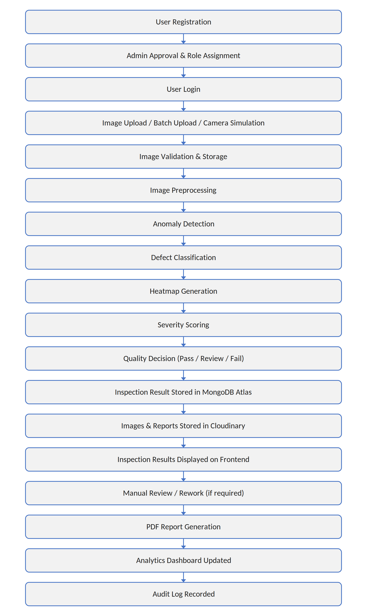
Figure 1 — End-to-end system workflow, Database module verification checklist.

6.1 Stage-by-Stage Collection Mapping
Workflow Stage | Collection(s) Touched | Backend Component
User Registration | users | user_routes.py, user_model.py
Admin Approval & Role Assignment | users, audit_logs | user_routes.py, audit_service.py
User Login | users | auth_routes.py, auth_service.py
Image Upload / Batch Upload / Camera Simulation | inspections | inspection_routes.py, ImageUpload.jsx
Image Validation & Storage | inspections, Cloudinary | inspection_routes.py, cloudinary_service.py
Image Preprocessing | — (ML layer, not persisted) | ml/preprocessing.py
Anomaly Detection | inspections | padim_service.py, prediction_service.py
Defect Classification | inspections, defect_categories | prediction_service.py, ml/classifier.py
Heatmap Generation | Cloudinary (image asset) | ml/heatmap.py, cloudinary_service.py
Severity Scoring | quality_risk_assessments | severity_service.py, ml/severity.py
Quality Decision (Pass / Review / Fail) | inspections | inspection_model.py
Inspection Result Stored in MongoDB Atlas | inspections | database.py, db/mongodb.py
Images & Reports Stored in Cloudinary | Cloudinary (external) | cloudinary_service.py
Inspection Results Displayed on Frontend | — (read only) | InspectionResult.jsx, inspectionApi.js
Manual Review / Rework (if required) | rework_tickets, audit_logs | rework_routes.py, rework_service.py
PDF Report Generation | quality_reports | report_service.py, report_routes.py
Analytics Dashboard Updated | analytics_snapshots, trend_alerts | analytics_service.py, analytics_routes.py
Audit Log Recorded | audit_logs | audit_service.py, audit_routes.py

7. Data Validation & Error Handling
This milestone's changes were narrower than Milestone 3's — an index migration and a verification pass rather than new write paths — so the validation focus was on making both safe to re-run:
- Index creation guard — index creation checks for an existing index of the same name/key before issuing createIndex, so re-running the migration is idempotent and does not error on an already-indexed collection.
- Workflow-trace gaps documented, not forced — stages with no corresponding collection write (e.g. in-memory-only steps like Image Preprocessing) were documented as intentionally not persisted, rather than adding a write with no downstream consumer.

8. Audit Logging in Practice
The workflow trace in Section 6 surfaced two stages — Admin Approval & Role Assignment, and Manual Review / Rework — that were not explicitly covered by the five audit_logs action types introduced in Milestone 3. Both are confirmed to log through audit_service.py:
Action Logged | When It Happens
user.role_assigned | An admin approves a pending registration and assigns a role to a user.
rework.ticket_created | A manual review of a flagged inspection generates a rework ticket.

audit_logs now covers seven action types in total across the two milestones, and every collection identified as "actively written" in Section 11 has at least one corresponding audit action.

9. Testing & Verification
This milestone's work was verified using the existing test suite plus a manual, workflow-driven pass against the deployed application, rather than new automated tests written specifically for Milestone 4:
- tests/test_api.py — exercises the API routes end to end, from registration through reporting, confirming each stage returns the expected response and persists to the corresponding collection.
- tests/test_auth.py — verifies registration, login, and role-based access control against the users collection, covering the two audit-extended stages in Section 8.
- scripts/seed_database.py — used to (re)seed representative data across all eleven active collections so the new indexes and the dashboard aggregation they support could be checked against realistic data volumes rather than an empty database.
- Live deployment check — with the frontend live at visioninspect-ai-github.vercel.app and the backend deployed on Render (deployment/render.yaml), the workflow trace in Section 6 and the two new indexes were additionally confirmed against the deployed application and its production MongoDB Atlas connection, not just a local development setup.

10. Current Progress
The following tasks have been completed for Milestone 4:
- Added the two composite indexes deferred from Milestone 3 — (production_line, period) on analytics_snapshots and (production_line, created_at) on inspections.
- Documented the mapping between every active MongoDB collection and its corresponding backend model, service, and route file.
- Traced the complete end-to-end workflow, from registration to audit logging, confirming each stage's data is correctly persisted, or intentionally not persisted.
- Extended audit_logs coverage to the admin-approval and manual-review/rework stages, with two new action types.
- Verified index usage and dashboard behaviour against seeded data using the existing test suite and scripts/seed_database.py.
- Confirmed the above against the live deployment (visioninspect-ai-github.vercel.app frontend, Render backend) and its connected MongoDB Atlas cluster, now that the application is deployed, rather than relying only on a local environment.

No Database-module items remain deferred. With this milestone's indexing work, workflow verification, and deployment checks complete, the Database module is fully implemented and verified end to end across all four milestones.

11. Collections Touched This Milestone
A quick reference for which collections changed status during Milestone 4:
Collection | Status | Notes
analytics_snapshots | Index added | New compound index (production_line, period); no schema changes.
inspections | Index added | New compound index (production_line, created_at); no schema changes.
users | Verified | Registration, admin approval, and login flows confirmed correct; audit logging extended.
rework_tickets | Verified | Manual review/rework stage confirmed to create and update tickets correctly; audit logging extended.
audit_logs | Actively written | Two new action types added: user.role_assigned, rework.ticket_created.
quality_reports, quality_risk_assessments, trend_alerts, defect_categories | Verified, unchanged | Behaviour unchanged from Milestone 3; re-confirmed correct against the current codebase.
products, production_lines, model_versions | Read only | Used to scope reports, snapshots, and model metadata; no new writes this milestone.
batch_records | Not yet used | Unchanged since Milestone 1; outside the scope of the Database module's core inspection-to-audit workflow.

