Manufacturing Defect Detection & Quality Inspection System

SHABAREESHAN S
TEAM 3

Table of Content
1. Introduction
2. Dataset Description
3. Data Exploration
4. Data Preprocessing
5. Data Analysis
6. Testing
7. Test Cases
8. Conclusion

INTRODUCTION
VisionInspect AI is an AI-powered manufacturing quality inspection platform designed to detect defects from product images. The system helps automate visual inspection by analyzing product images, identifying defects, classifying defect types, generating heatmaps, calculating severity scores, and producing inspection reports.
The platform is built for manufacturing industries, quality assurance teams, production supervisors, and factory managers who need a centralized system to monitor product quality and reduce manual inspection effort.
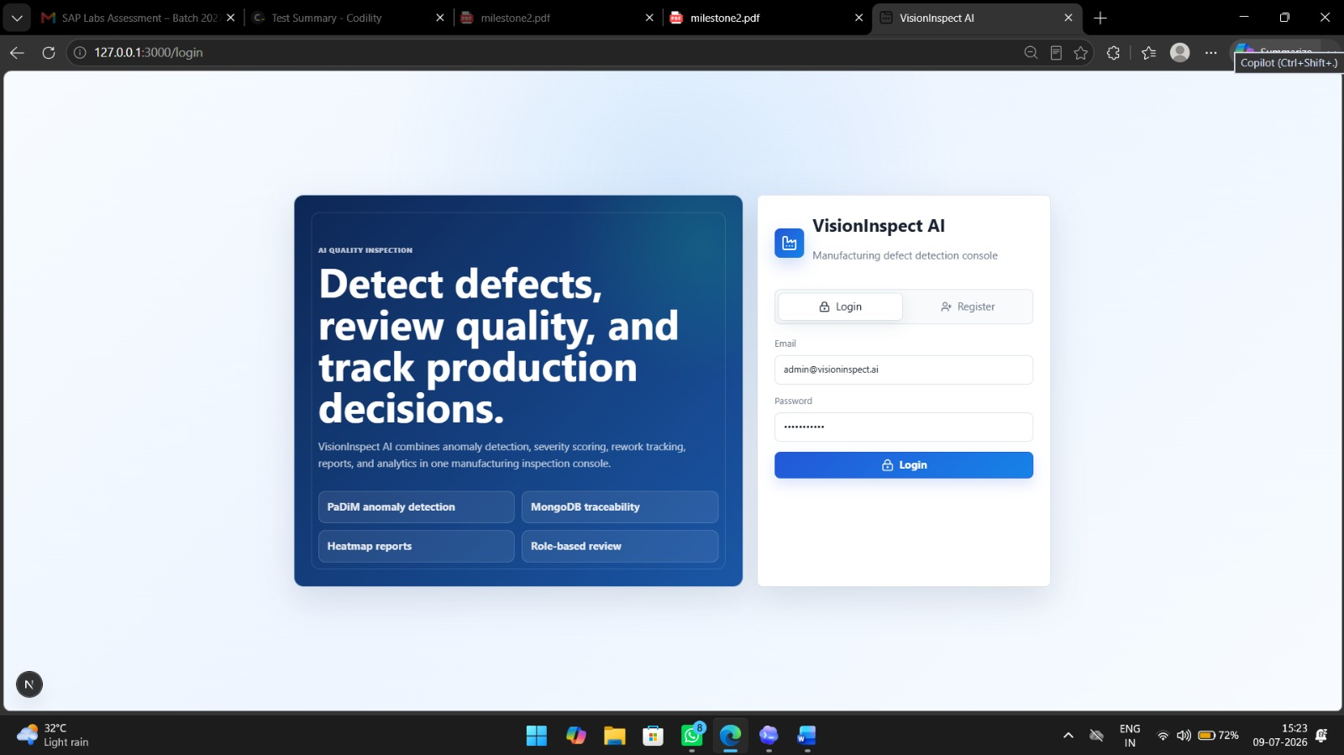

Dataset Description

- Dataset Used (MVTec AD Dataset - Bottle Category)
- Defect Classes
  - Good
  - Broken Large
  - Broken Small
  - Contamination
- Dataset Folder Structure

Data Exploration

Mention the analysis you performed:
- Verified dataset structure
- Checked image formats
- Checked image dimensions
- Identified defect categories
- Compared good and defective images
- Studied ground truth masks

Data Preprocessing

Include the preprocessing steps:
- Image Reading
- Image Resizing
- Grayscale Conversion
- Noise Removal
- Contrast Enhancement
- Normalization
You can also add a simple preprocessing workflow:

Data Analysis

This is your main contribution.
Include:
- Number of good images
- Number of defective images
- Distribution of defect types
- Image size analysis
- Class imbalance (if any)
- Sample image comparison
Add charts such as:
- Bar Chart (Defect Classes)
- Pie Chart (Good vs Defective)
- Sample Images
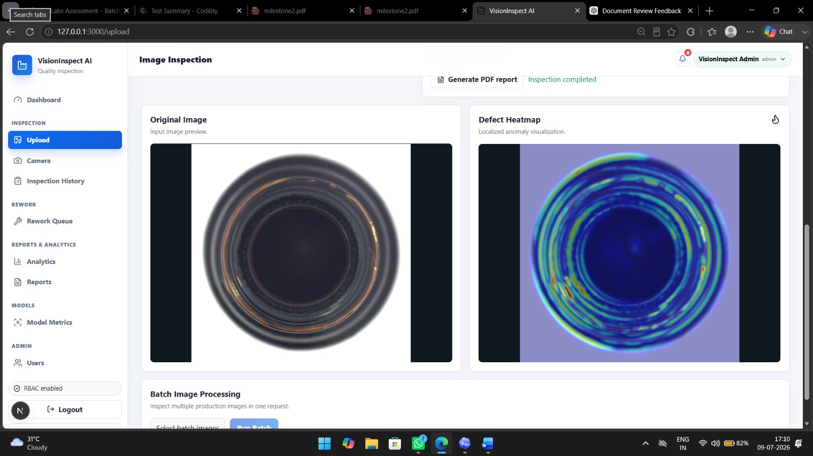

Testing

Mention the testing performed.
Module Testing
- Image Upload Testing
- Image Validation
- API Testing
- Frontend Page Testing
- Backend Endpoint Testing
Functional Testing
Module | Test Case | Expected Result | Status
Login | Valid Login | Login Successful | Pass
Image Upload | Upload JPG | Image Uploaded | Pass
Dashboard | Open Dashboard | Dashboard Loads | Pass
Backend API | Get Response | 200 OK | Pass
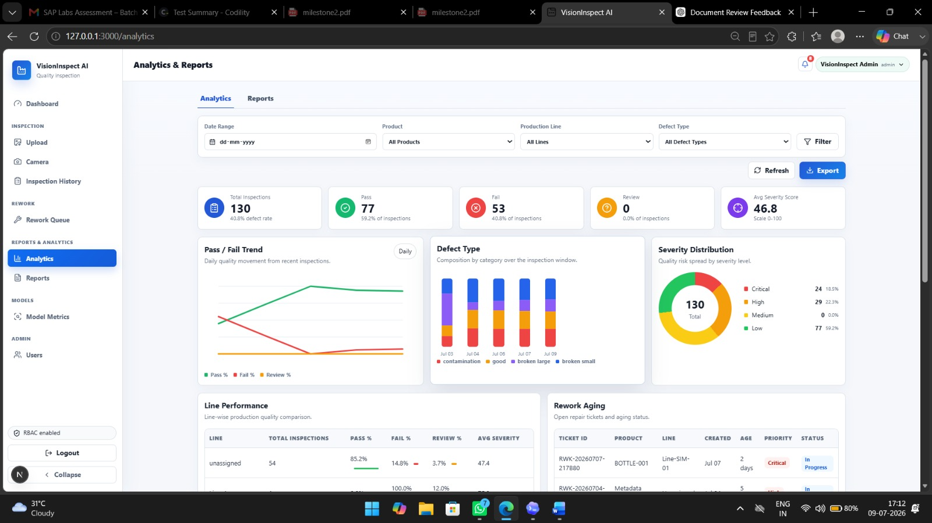

Test Cases

Test ID | Test Description | Expected Result | Status
TC01 | User Login | Login Success | Pass
TC02 | Upload Valid Image | Image Uploaded | Pass
TC03 | Upload Invalid File | Error Message | Pass
TC04 | Open Dashboard | Dashboard Opens | Pass

Conclusion

The data analysis phase helped us understand the dataset structure and defect categories. Preprocessing prepared the images for future AI model training. Frontend and backend functionalities were tested successfully, and the system is ready for the next milestone, where AI model integration and defect detection will be implemented.

