VISIONINSPECT AI
AI/ML MODULE | MILESTONE 1
Data Foundation and
Portable Baseline Detection
Multi-category MVTec AD validation, image preprocessing, normal-memory scoring, residual localization, and baseline evaluation

Submission field | Details
Project | VisionInspect AI
Assigned module | Member 4 - AI/ML
Prepared by | Himanshu Sekhar Parhi
Mentor | Sai Jyoteesh
Programme | Infosys Springboard Programme
Document version | Milestone 1 Submission - Version 1.0
Submission date | 25 July 2026

Document Control
This report is the final-submission record for Milestone 1 of the VisionInspect AI Member 4 module. It documents the data and portable anomaly-detection foundation that later milestones build upon.
Milestone status: Completed and verified. All 15 categories have valid dataset records and portable runtime profiles; the focused software tests pass.
Control item | Recorded value
Milestone | 1 - Data Foundation and Portable Baseline
Primary notebooks | 01_system_and_dataset_overview.ipynb; 02_portable_baseline_detector.ipynb
Dataset | MVTec AD, all 15 object and texture categories
Runtime scope | Portable CPU anomaly detection using ResNet18 ONNX and OpenCV
Evidence state | Notebook outputs executed and stored inline
Focused tests | 9 passed, 1 skipped in 5.83 seconds
Repository branch | Himanshu-parhi-ai/ml

Milestone Snapshot
Value | Meaning
15 | MVTec categories verified
5,354 | Real industrial benchmark images
3,629 | Normal training images
1,725 | Normal and defective test images
0 | Missing expected defect masks
15 | Portable normal-profile artifacts
42.62 MB | Shared ResNet18 ONNX feature extractor
11.08 MB | Combined category normal-profile storage

Table of Contents
Section | Page
1. Executive Summary | 3
2. Milestone Scope and Acceptance Criteria | 4
3. System Context and Architecture | 5
4. Technology Stack and Repository Mapping | 6
5. MVTec AD Dataset Foundation | 7
6. Data Loading and Validation | 10
7. Image Processing and Preprocessing | 11
8. Portable Baseline Detector Design | 13
9. Baseline Inference Walkthrough | 15
10. Baseline Evaluation Results | 17
11. Testing and Reproducibility | 20
12. Risks, Limitations, and Mitigations | 22
13. Milestone Completion and Handover | 23
References | 24
Appendix A. Code and Artifact Inventory | 25
Appendix B. Evidence Index | 26

List of Figures
Figure | Description
1 | Milestone 1 development and runtime workflow
2 | MVTec AD category directory contract
3 | MVTec AD image counts used by VisionInspect AI
4 | Real defective examples from all 15 supported categories
5 | Object-aware preprocessing evidence
6 | Portable detector architecture and dual-gate decision
7 | Normal and defective portable baseline evidence
8 | Portable baseline F1 and AUROC by category
9 | Focused Milestone 1 automated test result

1. Executive Summary
VisionInspect AI is a manufacturing quality-inspection platform that converts product images into traceable evidence. Milestone 1 establishes the AI/ML foundation required before advanced anomaly models, defect subtype classifiers, severity scoring, and backend integration can be trusted. The milestone validates the complete MVTec AD dataset, defines a consistent data contract, prepares category-specific normal representations, and implements a portable Good/Defective detector.
The portable detector is deliberately hybrid. A shared ImageNet-pretrained ResNet18 exported to ONNX produces a 512-dimensional global image embedding. The image anomaly score is the cosine distance to the nearest embedding in that category's normal memory. In parallel, OpenCV compares the preprocessed image with the category's normal mean and variability profile to localize unusual regions. A product is marked defective only when the global score exceeds its calibrated threshold and a cleaned spatial residual mask remains.
Why the hybrid design matters: Global deep features detect appearance changes, while spatial residuals prove that the change can be localized. Requiring both signals reduces false alarms from harmless global variation.
The dataset audit verified 5,354 images across all 15 MVTec categories: 3,629 normal training images and 1,725 test images. Every one of the 1,258 defective test images in the local copy has its expected pixel-level mask. The committed portable baseline reports an unweighted category mean F1 of 0.8196 and mean AUROC of 0.8631. Performance varies significantly by category; that variation is documented rather than hidden and provides the improvement agenda for Milestone 2.

1.1 Key outcomes
- A dynamic dataset loader supports every MVTec category and defect-folder label.
- Image validation records split, label, target, dimensions, channels, path, and mask path.
- Reusable preprocessing covers resize, grayscale conversion, denoising, CLAHE contrast enhancement, foreground masking, cropping, alignment, and padded resizing.
- Each category has a compact normal profile containing mean, variability, foreground mask, and normal embedding memory.
- The shared ONNX ResNet18 feature extractor avoids requiring PyTorch for portable inference.
- A dual-gate decision combines calibrated global anomaly scoring with localized residual evidence.
- Notebook evidence and focused tests confirm the milestone can be reproduced without generating external report files.

2. Milestone Scope and Acceptance Criteria

2.1 Objective
The objective of Milestone 1 is to create a reliable and portable foundation that can ingest a product image, understand its category context, compare it with learned normal appearance, localize suspicious differences, and return a preliminary Good/Defective result with supporting evidence.

2.2 Included work
- Digital-image representation and channel handling needed by the runtime.
- Complete 15-category MVTec AD inventory and directory validation.
- Dynamic record collection for train, test, labels, targets, dimensions, and masks.
- General and object-aware image-preprocessing functions.
- Category-specific normal mean, standard deviation, foreground mask, and embedding memory.
- Shared ResNet18 ONNX feature extraction and nearest-normal cosine scoring.
- Brightness-corrected normalized residual localization and connected-component cleanup.
- Category-specific global and residual thresholds.
- Dual-gate Good/Defective decision, detection confidence, mask, and heatmap.
- Baseline validation metrics, focused tests, reproducibility steps, and limitations.

2.3 Explicitly deferred
- PaDiM/PatchCore training, benchmarking, promotion, and OpenVINO advanced inference are documented in Milestone 2.
- Defect subtype classification, explainability policy, severity scoring, and QA action mapping are documented in Milestone 3.
- Unified multi-category orchestration, backend-ready payloads, full artifact integrity checks, and production-readiness validation are documented in Milestone 4.

2.4 Acceptance criteria
Criterion | Verification condition | Status
Dataset discovery | All 15 categories found with train and test structures | Met
Record integrity | Image dimensions, channels, labels, targets, and mask paths available | Met
Mask coverage | No expected defect mask missing in the verified local dataset | Met
Portable profiles | One runnable normal_profile.npz per category | Met
Feature runtime | Shared ResNet18 ONNX artifact loads without PyTorch | Met
Decision evidence | Score, threshold, residual map, mask, heatmap, and prediction returned | Met
Software validation | Focused Milestone 1 test suite passes | Met
Documentation | Real notebook outputs included with source mapping | Met

3. System Context and Architecture
Milestone 1 contains an offline preparation path and a runtime inspection path. Offline preparation uses only normal training images to establish category-specific normal appearance. Runtime inspection compares a new image with that stored normal evidence. This separation keeps training work out of the web request path and makes inference repeatable.
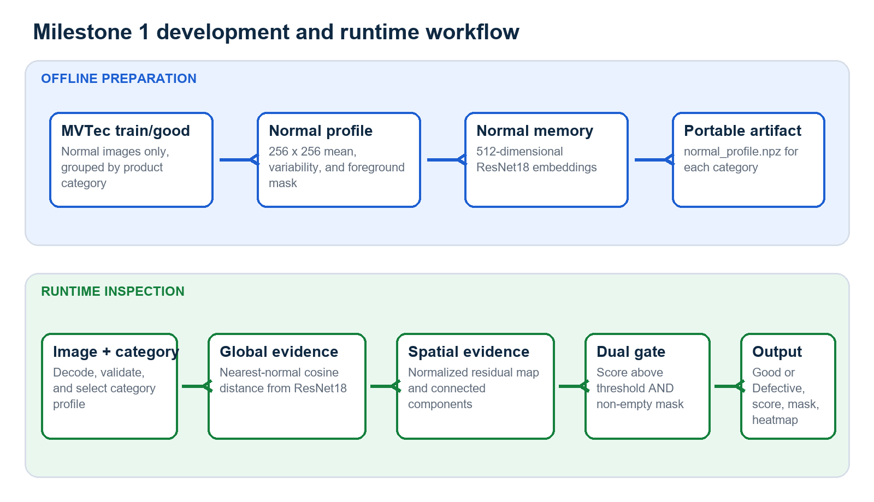
Figure 1. Milestone 1 development and runtime workflow
Source: Generated from the implemented module flow.

3.1 Offline preparation
- Collect all `train/good` images for one category.
- Convert images to the stable 256 x 256 grayscale residual representation.
- Calculate pixel-wise normal mean and standard deviation.
- Create a foreground mask to suppress the bright background.
- Run the shared ResNet18 extractor and normalize the 512-dimensional embeddings.
- Save mean, standard deviation, mask, and embedding bank into `normal_profile.npz`.

3.2 Runtime inspection
- Read and validate the uploaded image.
- Load the profile and thresholds for the selected category.
- Compute nearest-normal embedding distance as the global anomaly score.
- Compute a normalized residual map relative to normal mean and variability.
- Remove tiny residual components and create a binary mask.
- Apply the dual gate and return prediction, confidence, mask, and heatmap.

4. Technology Stack and Repository Mapping

4.1 Technology stack
Technology | Milestone 1 role | Reason selected
Python | Core implementation language | Readable, testable, and well supported for computer vision
OpenCV | Decoding, preprocessing, residual maps, morphology, connected components, heatmaps | Fast CPU operations and transparent image-processing behavior
NumPy | Image/profile arrays, normalization, vector operations | Efficient numerical representation of image evidence
Pandas | Dataset records and evaluation tables | Consistent tabular inspection and validation
Pillow | RGB image loading for feature extraction | Portable image interface used by the feature pipeline
ResNet18 | 512-dimensional global feature representation | Strong pretrained visual representation with moderate runtime cost
ONNX + OpenCV DNN | Portable ResNet18 execution | Removes PyTorch from the baseline serving path
scikit-learn | Metric calculation and threshold validation support | Established validation utilities
Jupyter | Inline experiments, tables, figures, and evidence | Reproducible milestone demonstration
Pytest | Software behavior validation | Automated regression protection

4.2 Repository responsibility map
File or artifact | Responsibility
ml/config.py | Dataset, model, and category paths
ml/dataset_loader.py | Dynamic MVTec records and image/mask metadata
ml/preprocessing.py | Core resize, grayscale, denoise, CLAHE, and edge operations
ml/object_preprocessing.py | Foreground mask, crop, alignment, padded resize, and classifier view
ml/baseline_detector.py | Normal profiles, embedding scores, residual maps, masks, metrics, and heatmaps
ml/classifier.py | Shared ResNet18 ONNX feature runtime
ml/inference.py | Baseline inference contract and two-gate decision helper
ml/model_registry.py | Category artifacts and thresholds
models/inference/resnet18_features.onnx | Shared portable feature extractor
models/**/normal_profile.npz | Category normal profiles and embedding memories
notebooks/01_* | Dataset and system evidence
notebooks/02_* | Portable baseline process evidence
tests/test_dataset_loader.py | Dataset discovery validation
tests/test_preprocessing.py | Preprocessing behavior validation
tests/test_baseline_detector.py | Score, mask, profile, and decision validation

5. MVTec AD Dataset Foundation

5.1 Dataset role
MVTec AD is an industrial anomaly-detection benchmark containing 5,354 high-resolution images from five texture and ten object categories [1]. Normal images are available for learning normal appearance. Test folders contain normal and anomalous images, while defective samples have pixel-accurate region annotations. This structure matches the central manufacturing challenge: defects are uncommon and may not be known before deployment.
Usage boundary: The dataset is used as an educational and research benchmark. Its license conditions must be reviewed before commercial reuse or redistribution.
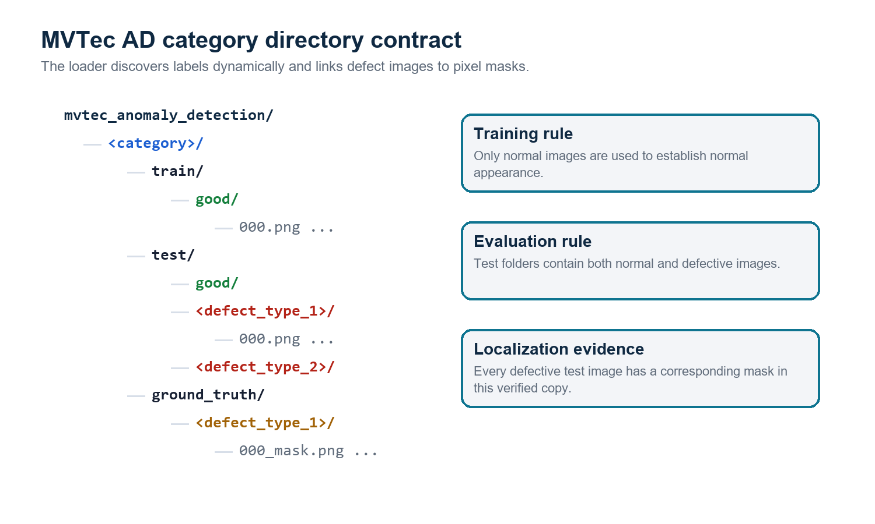
Figure 2. MVTec AD category directory contract
Source: Implemented loader contract and verified dataset layout.

5.2 Verified dataset inventory
Category | Train good | Test good | Defective | Defect types | Masks
bottle | 209 | 20 | 63 | 3 | 63
cable | 224 | 58 | 92 | 8 | 92
capsule | 219 | 23 | 109 | 5 | 109
carpet | 280 | 28 | 89 | 5 | 89
grid | 264 | 21 | 57 | 5 | 57
hazelnut | 391 | 40 | 70 | 4 | 70
leather | 245 | 32 | 92 | 5 | 92
metal_nut | 220 | 22 | 93 | 4 | 93
pill | 267 | 26 | 141 | 7 | 141
screw | 320 | 41 | 119 | 5 | 119
tile | 230 | 33 | 84 | 5 | 84
toothbrush | 60 | 12 | 30 | 1 | 30
transistor | 213 | 60 | 40 | 4 | 40
wood | 247 | 19 | 60 | 5 | 60
zipper | 240 | 32 | 119 | 7 | 119
TOTAL | 3,629 | 467 | 1,258 | - | 1,258
Table 1. Verified local dataset inventory. Defective image count and mask count both equal 1,258; missing expected masks = 0.
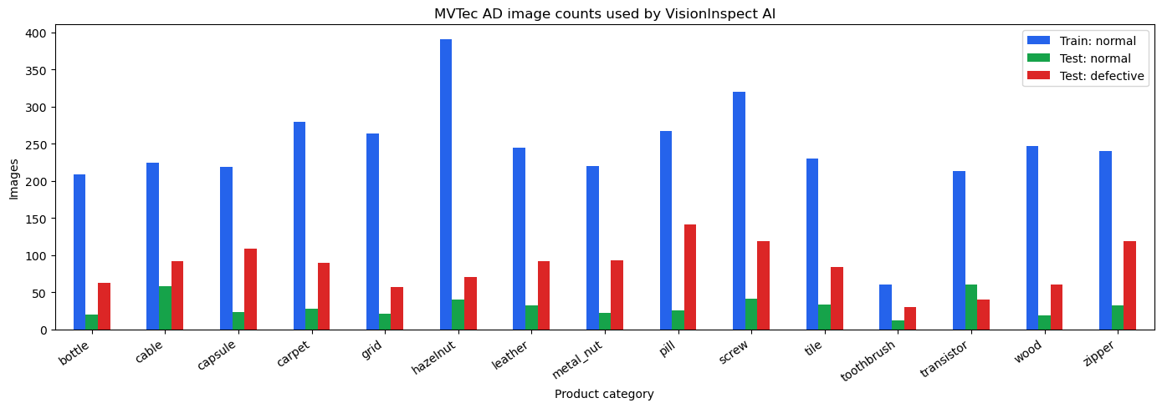
Figure 3. MVTec AD image counts used by VisionInspect AI
Source: Executed Notebook 01 output.
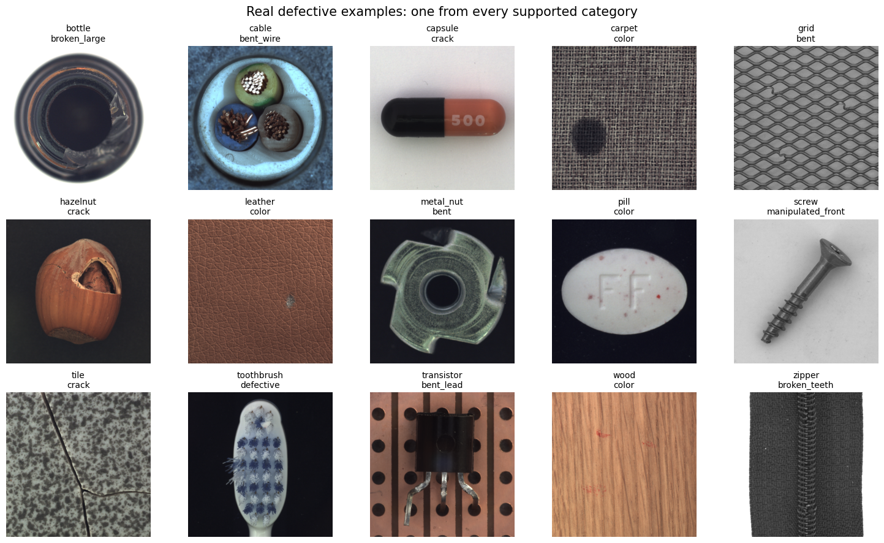
Figure 4. Real defective examples from all 15 supported categories
Source: Executed Notebook 01 output using the local MVTec AD dataset.

6. Data Loading and Validation

6.1 Dataset record contract
The loader does not hard-code bottle defect names. It inspects each category's `test` directories dynamically and emits a consistent record for every image. Normal records receive target 0 and defective records receive target 1. Defective mask paths are resolved using the `<image_stem>_mask.png` naming convention.
Field | Value | Purpose
split | train or test | Prevents training/evaluation leakage
label | good or category-specific defect name | Retains the original MVTec folder label
target | 0 or 1 | Binary Good/Defective evaluation
target_name | good or defective | Readable binary target
is_defective | Boolean | Direct runtime/evaluation filter
image_path | Absolute or resolved image path | Image retrieval
mask_path | Mask path or null | Pixel-level localization evidence
width, height | Decoded dimensions | Image-quality and shape validation
channels | 1 or 3 | Grayscale/RGB compatibility

6.2 Validation checks
- The category directory must contain the expected train/test structure.
- Only supported image files are considered by the notebook evidence pipeline.
- Every image is decoded before dimensions and channels are accepted.
- A normal image must not receive a ground-truth defect mask.
- A defective image is linked to the expected category/ground_truth subtype folder.
- Dataset health summaries expose missing masks rather than silently ignoring them.
- The training set is treated as normal-only for anomaly-profile creation.

6.3 Data quality findings
Check | Observed value | Interpretation
Category coverage | 15 of 15 | Complete
Total image count | 5,354 | Matches the published MVTec AD total
Normal training images | 3,629 | Available for normal-only profile creation
Normal test images | 467 | Available for specificity evaluation
Defective test images | 1,258 | Available for recall and F1 evaluation
Ground-truth masks | 1,258 | One expected mask for every defective image
Missing masks | 0 | No integrity issue found
Image channels | 1 or 3 | Loader handles grayscale and color categories

7. Image Processing and Preprocessing

7.1 Image representation
A decoded image is a numerical array. A color image normally has shape `(height, width, 3)` and stores blue, green, and red intensity channels in OpenCV order. A grayscale image has shape `(height, width)`. Pixel intensities are represented from 0 to 255 before normalization. These dimensions and channels are recorded by the dataset loader so incompatible or unreadable files can be identified early.

7.2 Core residual preprocessing
Stage | Implementation | Reason
Resize | 256 x 256 using area interpolation | Stable profile and residual dimensions
Grayscale | BGR to single intensity channel | Reduces residual comparison complexity
Denoise | 5 x 5 Gaussian blur | Suppresses isolated sensor/pixel noise
Contrast | CLAHE, clip limit 2.0, 8 x 8 tiles | Improves local structure under uneven contrast
Brightness correction | Median foreground offset | Reduces global illumination mismatch
Variability normalization | Absolute residual / (normal std + 15) | Downweights naturally variable pixels
Foreground masking | Otsu threshold on normal mean | Excludes bright background
Component cleanup | 8-connected regions, minimum area 4 pixels | Removes tiny residual noise

7.3 Object-aware preprocessing utilities
The module also provides foreground extraction, largest-component selection, bounding-box padding, elongated-object alignment, aspect-ratio-preserving resize, and LAB/CLAHE contrast enhancement. These functions improve input consistency and are reused by later classification paths. The current portable residual score remains a full-frame 256 x 256 comparison; the object-aware view is documented separately to avoid claiming that every preprocessing utility is applied in every detector branch.
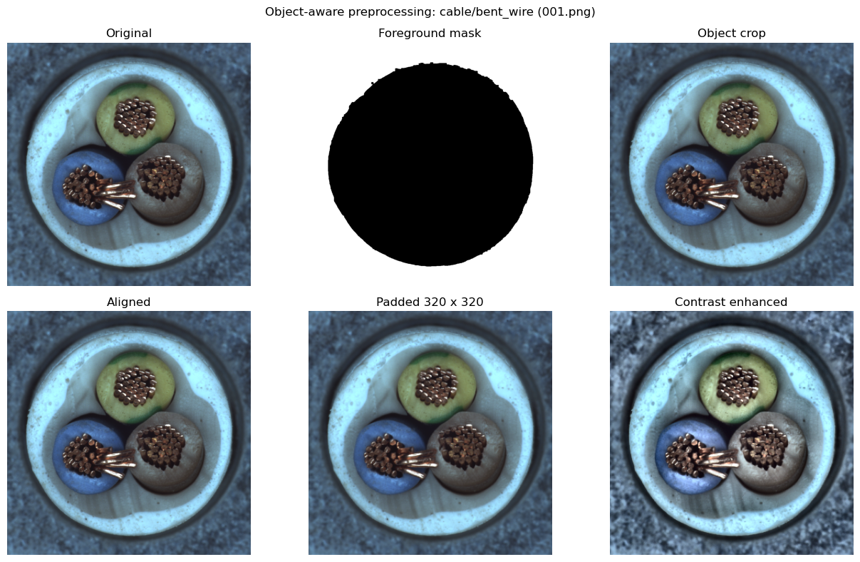
Figure 5. Object-aware preprocessing evidence
Source: Executed Notebook 02 on a real cable bent-wire image.

7.4 Preprocessing safeguards
- Unreadable images raise a clear file error instead of propagating an empty array.
- Empty crops cannot be resized.
- Foreground fallback retains the full image when segmentation is unreliable.
- Nearly square texture images are not forced through elongated-object rotation.
- Aspect ratio is preserved when constructing the padded classifier view.
- The baseline profile verifies that mean, variability, and mask shapes agree.

8. Portable Baseline Detector Design
The portable baseline is the first complete anomaly detector in the project. It is designed to run on CPU from committed artifacts and to expose understandable intermediate evidence. It is more capable than a plain pixel-difference rule because the final decision combines deep global appearance with local residual structure.
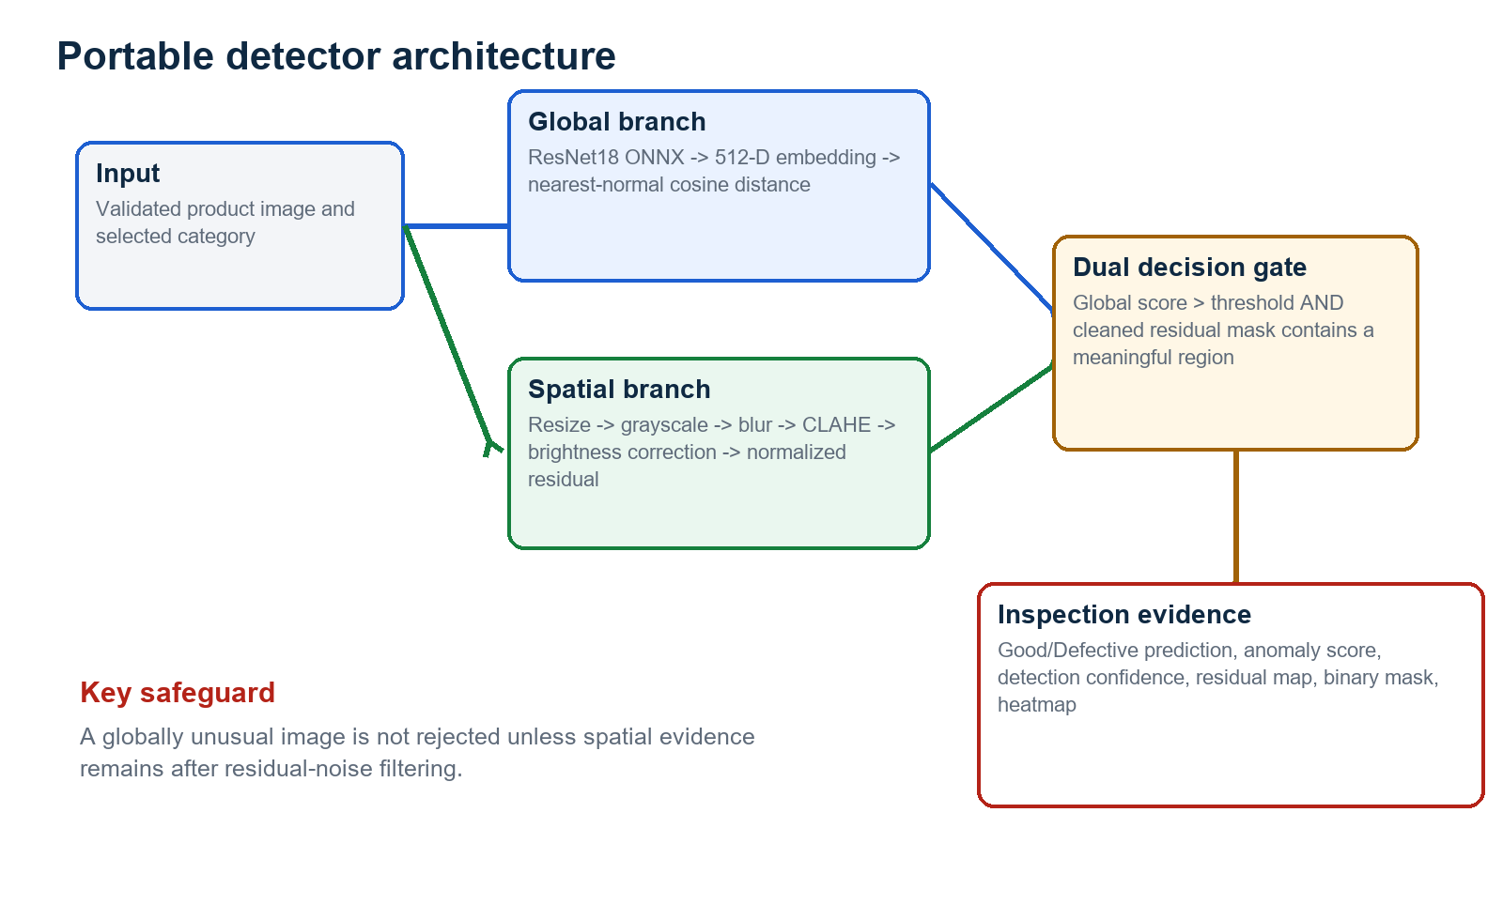
Figure 6. Portable detector architecture and dual-gate decision
Source: Implemented functions in ml/baseline_detector.py and ml/inference.py.

8.1 Category normal profile
For each category, `normal_profile.npz` stores four runtime arrays. The cable profile, used in the detailed notebook walkthrough, contains a 256 x 256 normal mean, 256 x 256 normal variability image, 256 x 256 foreground mask, and a 224 x 512 normal embedding bank. The first dimension of the embedding bank corresponds to the 224 cable `train/good` images.
Profile field | Representation | Runtime role
mean | float32, 256 x 256 | Expected normal grayscale appearance
std | float32, 256 x 256 | Normal pixel variability
foreground_mask | boolean, 256 x 256 | Stable product pixels
embedding_bank | float32, N x 512 | Normalized normal ResNet18 embeddings

8.2 Global anomaly score
The shared ResNet18 [2] is loaded from `models/inference/resnet18_features.onnx` using OpenCV DNN. The final classification layer is removed, producing a 512-dimensional embedding. Both the incoming embedding and the stored normal bank are L2-normalized. The anomaly score is one minus the highest cosine similarity to any normal embedding.
normalized_feature = feature / ||feature||
normalized_bank = bank / ||bank||
global_score = 1 - max(normalized_feature @ normalized_bank.T)

8.3 Spatial normalized residual
The residual branch compares the preprocessed image with normal mean appearance. A median brightness offset is calculated only over foreground pixels. The corrected absolute difference is divided by normal variability plus a fixed floor of 15 to avoid unstable division in nearly constant areas. Gaussian smoothing and foreground masking produce the final residual map.
brightness_offset = median((image - mean)[foreground])
residual = abs(image - brightness_offset - mean) / (std + 15)
residual = gaussian_blur(residual)
residual[background] = 0

8.4 Connected-component cleanup and dual gate
Pixels above the category residual threshold form candidate anomaly regions. OpenCV connected-component analysis [3] removes components smaller than four pixels. The final baseline decision is deliberately stricter than score-only classification.
is_defective = (global_score > category_global_threshold)
and (cleaned_residual_mask contains at least one pixel)
Decision safeguard: A score can be above or below its threshold independently of residual noise. The product becomes Defective only when both global and spatial evidence agree.

9. Baseline Inference Walkthrough

9.1 Cable profile configuration
Setting | Value
Category | cable
Global detector | ResNet18 normal-memory cosine distance
Global score threshold | 0.041518
Residual threshold | 1.298446
Normal embeddings | 224 x 512
Residual resolution | 256 x 256
Execution device | CPU through OpenCV DNN

9.2 Normal versus defective evidence
Image | Expected | Global score | Residual p99 | Mask pixels | Predicted | Confidence
good/000.png | Good | 0.040136 | 1.5574 | 1,870 | Good | 55.14%
bent_wire/001.png | Defective | 0.066544 | 1.4363 | 1,119 | Defective | 57.50%
The normal image contains residual pixels, but its global score remains below 0.041518, so the dual gate returns Good. The bent-wire image exceeds the global threshold and retains a localized residual mask, so it returns Defective. This comparison demonstrates why score and mask must be interpreted together.
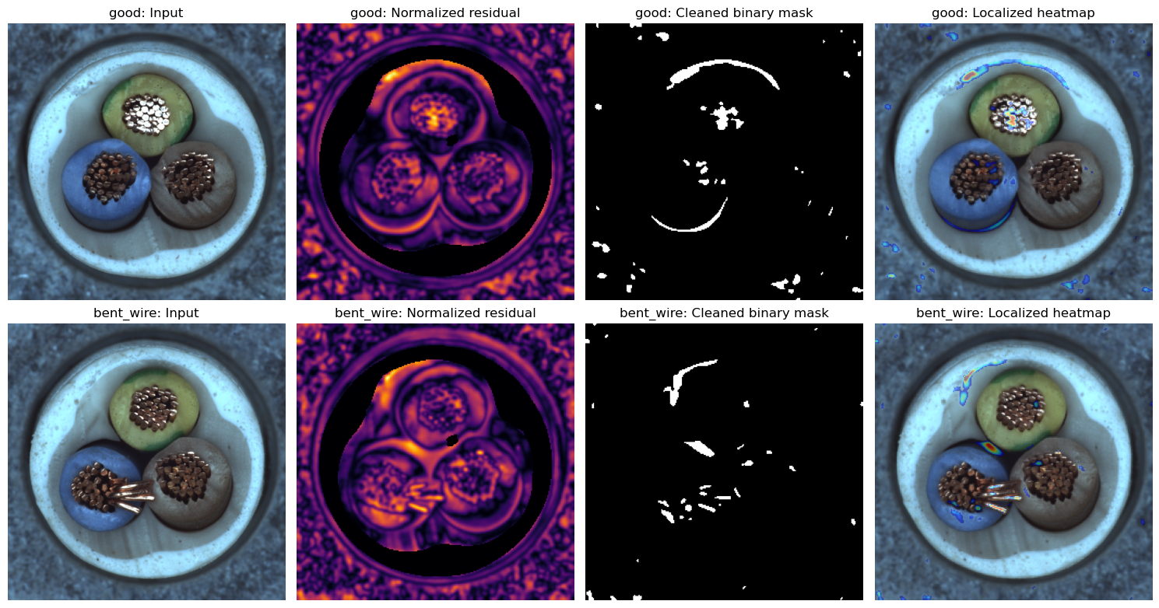
Figure 7. Normal and defective portable baseline evidence
Source: Executed Notebook 02; real MVTec cable images.

9.3 Runtime outputs
Output | Meaning
anomaly_score | Nearest-normal cosine distance
residual_score | 99th percentile of foreground normalized residual
decision_threshold | Category-specific global threshold
is_defective | Result of global-plus-spatial dual gate
detection_confidence | Score-distance confidence estimate
anomaly_map | Continuous normalized residual map
pred_mask | Cleaned binary defect region
heatmap | Localized visual overlay
detector_kind | Runtime engine description

10. Baseline Evaluation Results

10.1 Evaluation protocol
The committed normal-profile metadata records five-fold stratified balanced-threshold validation on labelled MVTec test images. Fold thresholds are estimated from each development partition, and the production threshold maximizes sensitivity plus specificity on all labelled images after evaluation. The reported numbers are category-level validation records and must not be described as a separate untouched factory test set.
Aggregate view | Score
Unweighted mean accuracy | 0.7726
Unweighted mean precision | 0.9168
Unweighted mean recall | 0.7504
Unweighted mean specificity | 0.8285
Unweighted mean balanced accuracy | 0.7895
Unweighted mean F1 | 0.8196
Unweighted mean AUROC | 0.8631
Interpretation: The high mean precision (0.9168) shows that positive baseline predictions are often correct, while mean recall (0.7504) confirms that some defects are missed. Milestone 2 addresses this recall gap with stronger spatial anomaly models.
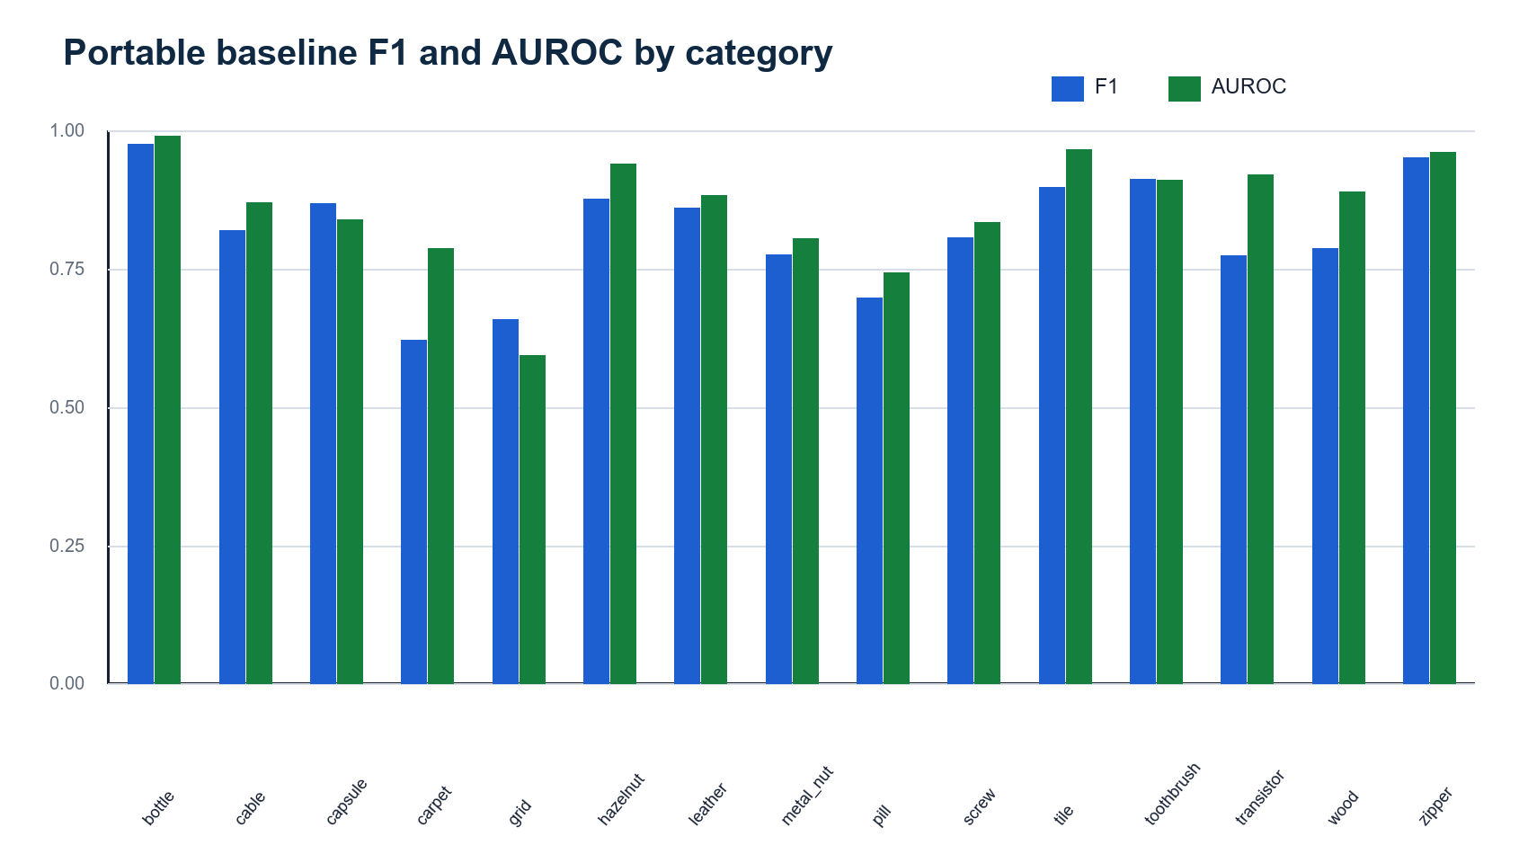
Figure 8. Portable baseline F1 and AUROC by category
Source: Committed model_metadata.json records for all 15 categories.

10.2 Category-level metrics
Category | Accuracy | Precision | Recall | Specificity | F1 | AUROC
bottle | 0.9639 | 0.9688 | 0.9841 | 0.9000 | 0.9764 | 0.9913
cable | 0.7933 | 0.8765 | 0.7717 | 0.8276 | 0.8208 | 0.8711
capsule | 0.7955 | 0.9271 | 0.8165 | 0.6957 | 0.8683 | 0.8396
carpet | 0.5641 | 0.9130 | 0.4719 | 0.8571 | 0.6222 | 0.7885
grid | 0.5769 | 0.8000 | 0.5614 | 0.6190 | 0.6598 | 0.5940
hazelnut | 0.8545 | 0.9500 | 0.8143 | 0.9250 | 0.8769 | 0.9414
leather | 0.8145 | 0.9726 | 0.7717 | 0.9375 | 0.8606 | 0.8845
metal_nut | 0.6957 | 0.9531 | 0.6559 | 0.8636 | 0.7771 | 0.8060
pill | 0.5808 | 0.8901 | 0.5745 | 0.6154 | 0.6983 | 0.7444
screw | 0.7375 | 0.8889 | 0.7395 | 0.7317 | 0.8073 | 0.8350
tile | 0.8632 | 0.9595 | 0.8452 | 0.9091 | 0.8987 | 0.9672
toothbrush | 0.8810 | 0.9630 | 0.8667 | 0.9167 | 0.9123 | 0.9111
transistor | 0.8200 | 0.7750 | 0.7750 | 0.8500 | 0.7750 | 0.9217
wood | 0.7215 | 0.9318 | 0.6833 | 0.8421 | 0.7885 | 0.8895
zipper | 0.9272 | 0.9821 | 0.9244 | 0.9375 | 0.9524 | 0.9617

10.3 Calibrated thresholds
Category | Global score threshold | Residual pixel threshold
bottle | 0.009110 | 1.459192
cable | 0.041518 | 1.298446
capsule | 0.008157 | 0.542293
carpet | 0.011741 | 1.045642
grid | 0.016833 | 1.079766
hazelnut | 0.063510 | 0.607121
leather | 0.013332 | 0.736192
metal_nut | 0.028916 | 0.596241
pill | 0.026076 | 0.266804
screw | 0.017529 | 2.178845
tile | 0.047957 | 1.296797
toothbrush | 0.015306 | 0.798744
transistor | 0.032319 | 2.115497
wood | 0.058633 | 1.216930
zipper | 0.010643 | 0.790813

10.4 Findings
- Bottle is the strongest portable category in the recorded evaluation (F1 0.9764; AUROC 0.9913).
- Zipper, toothbrush, tile, hazelnut, and capsule also show strong portable F1 values.
- Carpet, grid, and pill remain the weakest baseline categories and require advanced-model improvement.
- Precision is generally higher than recall, indicating a conservative detector that still misses some real anomalies.
- Thresholds differ substantially across categories, confirming that one universal threshold would be inappropriate.
- The portable baseline is suitable as an explainable fallback and integration path, not as the final accuracy ceiling.

11. Testing and Reproducibility

11.1 Focused automated tests
The focused Milestone 1 command runs the dataset loader, preprocessing, and baseline detector test modules. Nine tests passed. One dataset-dependent loader test skipped under the isolated test configuration when its expected external dataset path was unavailable; this is a controlled skip, not a failed assertion.
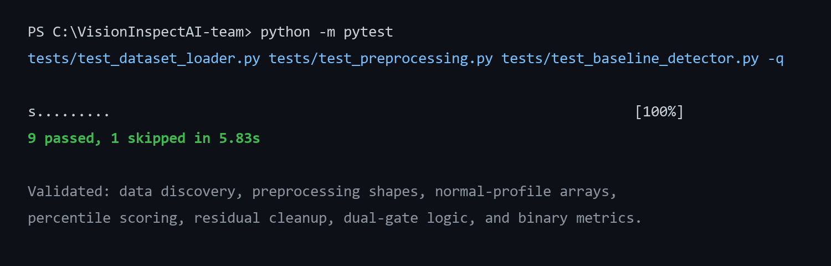
Figure 9. Focused Milestone 1 automated test result
Source: Focused automated test command output.
Test area | Behavior protected
Dataset loader | Discovers MVTec records when the configured dataset is present
Pipeline shapes/types | Preprocessing returns expected dimensions and dtypes
Grayscale handling | Existing grayscale images remain valid
Defect-mask crop | Object preprocessing can use a supplied defect mask
Threshold helper | Threshold and binary prediction behavior
Percentile scoring | Anomaly score uses the configured percentile
Noise cleanup | Tiny residual components are removed
Dual gate | A high score without localized mask cannot fail the product
Saved profile | Required runtime arrays exist in a normal profile
Binary metrics | Accuracy, precision, recall, F1, and matrix calculation

11.2 Notebook reproducibility
python -m pip install -r requirements-ai.txt
$env:MVTEC_DATASET_ROOT = 'C:\path\to\mvtec_anomaly_detection'
jupyter nbconvert --to notebook --execute --inplace notebooks/01_system_and_dataset_overview.ipynb
jupyter nbconvert --to notebook --execute --inplace notebooks/02_portable_baseline_detector.ipynb
Both notebooks resolve the dataset through `MVTEC_DATASET_ROOT` or known local project paths. Their important figures, tables, and predictions are stored inline. They do not write screenshots, charts, CSV files, or report JSON to external result folders.

11.3 Portable artifact requirements
Artifact | Recorded size | Purpose
resnet18_features.onnx | 42.62 MB | Shared global feature extractor
15 normal_profile.npz files | 11.08 MB combined | Category mean/std/mask/embedding memory
category_model_registry.json | Small JSON | Category paths and thresholds
model_metadata.json per category | Small JSON | Metrics and evaluation provenance

12. Risks, Limitations, and Mitigations
Risk | Impact | Mitigation
Category variability | A single portable method performs unevenly across textures and objects | Use category-specific thresholds; promote PaDiM/PatchCore in Milestone 2
False negatives | Mean recall is lower than mean precision; weak categories miss defects | Do not use baseline alone for safety-critical acceptance
Dataset-to-factory gap | MVTec lighting and products may not match a real factory | Collect factory-specific normal and defect evidence before production
Full-frame residual | Pose/background variation can affect residual maps | Use controlled camera setup and evaluate object-aware alignment
Threshold provenance | Validation uses labelled MVTec test images | Describe as project validation, not an untouched production test
Confidence interpretation | Baseline confidence is a threshold-margin estimate, not calibrated probability | Keep anomaly score and threshold visible; calibrate later
Mask threshold sensitivity | Pixel regions vary with residual threshold | Evaluate IoU/Dice and advanced localization in Milestone 2
License | MVTec reuse is subject to dataset terms | Do not redistribute dataset or assume commercial permission

12.1 Engineering decisions that reduce risk
- Category selection is mandatory so the wrong normal profile is not used silently.
- Global and residual thresholds are stored per category.
- Unreadable images fail with a clear exception.
- Shape consistency is checked before applying a profile.
- Tiny connected components are removed before geometry is reported.
- The dual gate prevents score-only rejection without spatial evidence.
- Metrics and protocols remain attached to model metadata.
- Weak categories are explicitly listed for advanced-model improvement.

13. Milestone Completion and Handover

13.1 Completed deliverables
Deliverable | Evidence | Status
Dataset foundation | 15 categories, 5,354 images, zero missing expected masks | Complete
Loader contract | Dynamic labels, targets, shapes, channels, and mask paths | Complete
Preprocessing | Core residual and object-aware utilities | Complete
Normal profiles | 15 category profiles with normal memory | Complete
Portable feature runtime | ResNet18 ONNX through OpenCV DNN | Complete
Baseline detector | Global score, residual map, mask, heatmap, and dual gate | Complete
Calibration evidence | Category thresholds and validation metrics | Complete
Notebook evidence | Two executed milestone notebooks with inline outputs | Complete
Focused testing | 9 passed and 1 controlled skip | Complete
Documentation | Final Milestone 1 report with source/evidence map | Complete

13.2 Handover to Milestone 2
Milestone 1 hands forward a validated multi-category dataset contract, reusable preprocessing, portable profiles, shared ONNX features, calibrated baseline scores, masks, and heatmaps. Milestone 2 can therefore concentrate on stronger anomaly modelling rather than repeating data preparation. It will train and compare PaDiM and PatchCore, evaluate image and pixel metrics, calibrate advanced thresholds, and export supported models to OpenVINO.

13.3 Final outcome
Milestone conclusion: VisionInspect AI now has a complete, portable, explainable Good/Defective baseline for all 15 MVTec categories. The foundation is reproducible and application-ready, while its measured limitations clearly define the need for advanced anomaly models in the next milestone.

References
[1] P. Bergmann, M. Fauser, D. Sattlegger, and C. Steger, 'MVTec AD - A Comprehensive Real-World Dataset for Unsupervised Anomaly Detection,' CVPR, 2019. https://www.mvtec.com/research-teaching/datasets/mvtec
[2] K. He, X. Zhang, S. Ren, and J. Sun, 'Deep Residual Learning for Image Recognition,' Proceedings of CVPR, 2016, pp. 770-778. https://openaccess.thecvf.com/content_cvpr_2016/html/He_Deep_Residual_Learning_CVPR_2016_paper.html
[3] OpenCV Documentation, 'Structural Analysis and Shape Descriptors: Connected Components.' https://docs.opencv.org/doc/doxygen/html/d3/dc0/group__imgproc__shape.html
[4] VisionInspect AI Member 4 source repository, branch Himanshu-parhi-ai/ml, files under ml/, models/, notebooks/, scripts/, and tests/.
[5] VisionInspect AI executed notebooks: 01_system_and_dataset_overview.ipynb and 02_portable_baseline_detector.ipynb.

Appendix A. Code and Artifact Inventory
Type | Path | Milestone 1 responsibility
Source | ml/config.py | Dataset/model roots and default category
Source | ml/dataset_loader.py | Dynamic MVTec DataFrame records
Source | ml/preprocessing.py | Core image-processing functions
Source | ml/object_preprocessing.py | Foreground, crop, alignment, and padding
Source | ml/baseline_detector.py | Profiles, scores, masks, metrics, and heatmaps
Source | ml/classifier.py | ResNet18 ONNX feature extraction
Source | ml/inference.py | Baseline prediction and dual-gate behavior
Source | ml/model_registry.py | Category thresholds and portable artifacts
Artifact | models/inference/resnet18_features.onnx | Shared 512-D feature extractor
Artifact | models/inference/normal_profile.npz | Bottle normal profile
Artifact | models/categories/*/normal_profile.npz | Remaining category profiles
Artifact | models/category_model_registry.json | Portable category configuration
Notebook | notebooks/01_system_and_dataset_overview.ipynb | Dataset evidence
Notebook | notebooks/02_portable_baseline_detector.ipynb | Baseline process evidence
Test | tests/test_dataset_loader.py | Loader behavior
Test | tests/test_preprocessing.py | Preprocessing behavior
Test | tests/test_baseline_detector.py | Baseline behavior

Appendix B. Evidence Index
Evidence | Source | What it proves
Dataset count and health table | Notebook 01 | All category counts, dimensions, channels, and missing masks
Category distribution chart | Notebook 01 | Train-normal, test-normal, and defective volumes
15-category sample grid | Notebook 01 | Real MVTec defective images
Profile array table | Notebook 02 | Mean/std/mask/embedding-memory shapes
Object-aware preprocessing grid | Notebook 02 | Original through enhanced view
Normal/defect score table | Notebook 02 | Threshold, residual, mask pixels, prediction, confidence
Residual and heatmap grid | Notebook 02 | Input, residual map, cleaned mask, localized heatmap
Category baseline metrics | Category model metadata | Accuracy, precision, recall, specificity, F1, AUROC
Focused test output | Pytest | 9 passed and 1 controlled skip
End of Milestone 1 documentation.

