VISIONINSPECT AI
AI/ML MODULE | MILESTONE 2
Advanced Anomaly Detection,
Localization, and Calibration
PaDiM and PatchCore selection, OpenVINO inference, threshold calibration, heatmaps, mask evaluation, and practical runtime evidence

Submission field | Details
Project | VisionInspect AI
Assigned module | Member 4 - AI/ML
Prepared by | Himanshu Sekhar Parhi
Mentor | Sai Jyoteesh
Programme | Infosys Springboard Programme
Document version | Milestone 2 Submission - Version 1.0
Submission date | 1 August 2026

Document Control
This report records Milestone 2 of the VisionInspect AI Member 4 module. It documents the transition from the portable baseline to category-specific PaDiM and PatchCore anomaly models, calibrated decisions, defect localization, and practical advanced-runtime evidence.
Submission sequence: Milestone 1 - 25 July 2026; Milestone 2 - 1 August 2026; Milestone 3 - 8 August 2026; Milestone 4 - 15 August 2026. This report is the second practical stage in that weekly progression.
Milestone status: Completed and verified. All 15 categories have recorded advanced-model metrics and registry selections; cable has a committed OpenVINO runtime and spatial calibrator; focused Milestone 2 tests pass.
Control item | Recorded value
Milestone | 2 - Advanced Anomaly Detection, Localization, and Calibration
Primary notebooks | 03_advanced_anomaly_detectors.ipynb; 05_localization_and_explainability.ipynb; 07_training_benchmarking_and_calibration.ipynb
Selected models | 12 PaDiM categories; 3 PatchCore categories
Advanced executable | Cable PatchCore OpenVINO IR with spatial calibrator
Evaluation state | Category metrics, candidate benchmarks, calibrated thresholds, and holdout records stored in metadata
Focused tests | 14 passed, 1 skipped in 4.12 seconds
Repository branch | Himanshu-parhi-ai/ml

Milestone Snapshot
Value | Meaning
15 | MVTec categories with advanced model records
12 | PaDiM registry selections
3 | PatchCore registry selections
0.9554 | Mean recorded image AUROC
0.9442 | Mean recorded image F1
0.9737 | Mean recorded pixel AUROC
0.5402 | Mean recorded pixel F1
0.9670 | Cable OpenVINO spatial-calibrator F1

Table of Contents
Section | Page
1. Executive Summary | 2
2. Milestone Scope and Acceptance Criteria | 3
3. Advanced Anomaly Detection Concepts | 4
4. Implementation Architecture | 5
5. Category Model Registry and Artifact Status | 6
6. Training, Benchmarking, and Model Promotion | 8
7. Threshold Calibration and Evaluation Protocol | 9
8. Advanced Model Evaluation Results | 11
9. Practical Advanced Inference Demonstration | 12
10. Localization and Explainability | 13
11. Runtime Portability and Fallback Behavior | 14
12. Testing and Reproducibility | 15
13. Risks, Limitations, and Mitigations | 16
14. Milestone Completion and Handover | 17
References | 17
Appendix A. Code and Artifact Inventory | 18
Appendix B. Evidence Index | 18

List of Figures
Figure | Description
1 | Advanced model development and runtime workflow
2 | PaDiM and PatchCore representation concepts
3 | Promoted advanced model by category
4 | Recorded advanced-model evaluation by category
5 | Candidate comparison on benchmarked categories
6 | Threshold calibration and model promotion
7 | Cable OpenVINO spatial calibrator confusion matrix
8 | Cable PatchCore OpenVINO practical inference
9 | Localization and explainability evidence
10 | Focused Milestone 2 automated test result

1. Executive Summary
Milestone 2 strengthens VisionInspect AI from a portable anomaly baseline into a category-aware advanced inspection system. The implementation uses Anomalib-based PaDiM and PatchCore training, compares model candidates, stores one selected model family and calibrated threshold per product category, and exposes a shared runtime contract containing an image-level anomaly score, pixel anomaly map, binary mask, detection confidence, and fallback status.
The model registry promotes PaDiM for 12 MVTec categories and PatchCore for cable, hazelnut, and screw. Across the 15 recorded advanced-model evaluations, the unweighted mean image AUROC is 0.9554, image F1 is 0.9442, pixel AUROC is 0.9737, and pixel F1 is 0.5402. The difference between high pixel AUROC and moderate pixel F1 is important: models rank suspicious pixels effectively, but exact binary region overlap remains sensitive to thresholding and defect geometry.
Cable provides the practical deployment demonstration because its selected PatchCore model is committed as OpenVINO IR and paired with a portable ExtraTrees spatial calibrator. On the executed bent-wire example, the engine returned Defective with anomaly score 0.808486, 100% detection confidence, a 6.11% defect-area estimate, severity 77.0 (High), Fail decision, and no fallback. The calibrator's five-fold out-of-fold evaluation produced F1 0.9670 from 150 labelled cable test images.
Evidence boundary: The repository stores model-selection metadata for all categories, but heavy PaDiM/PatchCore `.ckpt` files are intentionally not committed. The report therefore distinguishes recorded training evaluation from currently executable source-control artifacts.

1.1 Key outcomes
- A single registry controls category, model family, artifact paths, and decision thresholds.
- PaDiM and PatchCore candidates are benchmarked using image and pixel metrics before promotion.
- Advanced thresholds use a stratified calibration/holdout protocol rather than arbitrary values.
- Cable OpenVINO inference uses global and spatial anomaly-map evidence through a 72-value calibrator feature vector.
- Heatmaps, masks, overlap metrics, critical-location geometry, and explainability fields are available for QA review.
- Missing or failed advanced artifacts trigger a recorded portable-baseline fallback.
- Tests protect localization, calibration helpers, runtime artifacts, prediction contracts, and fallback behavior.

2. Milestone Scope and Acceptance Criteria

2.1 Objective
The Milestone 2 objective is to train and evaluate stronger one-class anomaly models, choose the most suitable detector per MVTec category, convert useful model outputs into QA evidence, and prepare a runtime path that remains usable when heavyweight training artifacts are unavailable.

2.2 Included work
- PaDiM and PatchCore model construction through Anomalib.
- Category-specific training on `train/good` data.
- Candidate benchmarking using image AUROC/F1 and pixel AUROC/F1.
- Promotion of the strongest recorded candidate to the category registry.
- Stratified threshold calibration and holdout evaluation.
- OpenVINO export and CPU inference for the cable advanced model.
- Spatial calibration from anomaly score and anomaly-map statistics.
- Heatmap, mask, IoU, Dice, coverage, area, center, and critical-zone evidence.
- Explicit advanced-to-portable fallback semantics.

2.3 Excluded or deferred work
- Defect subtype classification and severity policy are documented in Milestone 3.
- Backend orchestration, batch integration, and final end-to-end validation are documented in Milestone 4.
- This milestone does not implement YOLO-style object detection; anomaly maps localize unusual regions.
- Factory camera, PLC, and MES connections remain outside the AI/ML milestone scope.
- Heavy checkpoint distribution and external model storage are deployment concerns, not source-code evidence.

2.4 Acceptance criteria
Criterion | Verification condition | Status
Advanced model definitions | PaDiM and PatchCore construct successfully from the shared trainer | Met
Category selection | Every supported category resolves to one promoted model kind | Met
Evaluation evidence | Image and pixel metrics are stored for all 15 categories | Met
Calibration | Category thresholds and holdout metrics are persisted where calibration was run | Met
Localization | Runtime returns anomaly map, mask, heatmap, and geometry | Met
Practical runtime | Cable advanced OpenVINO inference completes without fallback | Met
Failure behavior | Unavailable advanced artifacts produce explicit fallback metadata | Met
Software validation | Focused advanced/localization/runtime tests pass | Met

3. Advanced Anomaly Detection Concepts

3.1 Why one-class anomaly detection
Industrial defect datasets rarely enumerate every failure that may occur. PaDiM and PatchCore therefore learn normal appearance from defect-free training images and treat deviations at inference time as anomalies. This matches MVTec AD's normal-only training split and allows the detector to identify previously unseen defect patterns without requiring a closed list of defect classes.
Important distinction: Advanced anomaly detection answers whether and where an image differs from learned normal appearance. It does not by itself name the manufacturing defect subtype; that responsibility belongs to the Milestone 3 classifier.
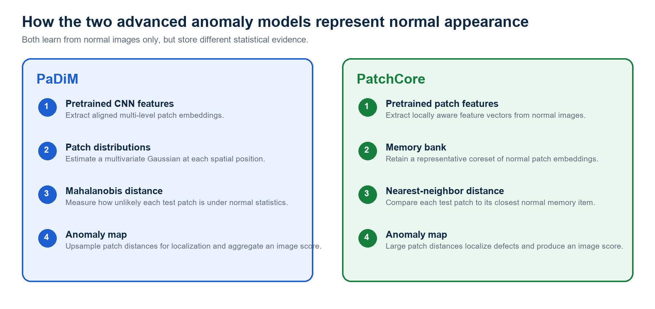
Figure 2. PaDiM and PatchCore representation concepts
Source: Implementation concepts aligned with the referenced PaDiM and PatchCore papers.

3.2 PaDiM role
PaDiM uses pretrained CNN patch embeddings and models the normal feature distribution at each spatial location with a multivariate Gaussian. Test patches receive Mahalanobis-distance anomaly values. The project uses PaDiM as the selected model for 12 categories because it provides strong image-level detection, dense anomaly maps, and comparatively compact normal statistics.

3.3 PatchCore role
PatchCore stores a representative memory bank of normal patch features. At inference, each test patch is compared with nearby normal memory items, and large nearest-neighbor distances indicate anomalies. Candidate benchmarks promoted PatchCore for cable, hazelnut, and screw because it improved their recorded image and/or localization metrics.
Property | PaDiM | PatchCore
Training labels | Normal images only | Normal images only
Normal representation | Per-location Gaussian distributions | Representative patch-memory coreset
Patch score | Mahalanobis distance | Nearest-neighbor feature distance
Outputs | Image score and dense anomaly map | Image score and dense anomaly map
Project selection | 12 categories | Cable, hazelnut, screw
Primary limitation | Alignment and covariance assumptions | Larger memory/checkpoint footprint

4. Implementation Architecture
Training and serving are deliberately separated. Training scripts create model and calibration evidence. The runtime reads only the promoted registry entry for the selected category, attempts the available advanced engine, and returns a stable dictionary consumed by later quality-control stages.
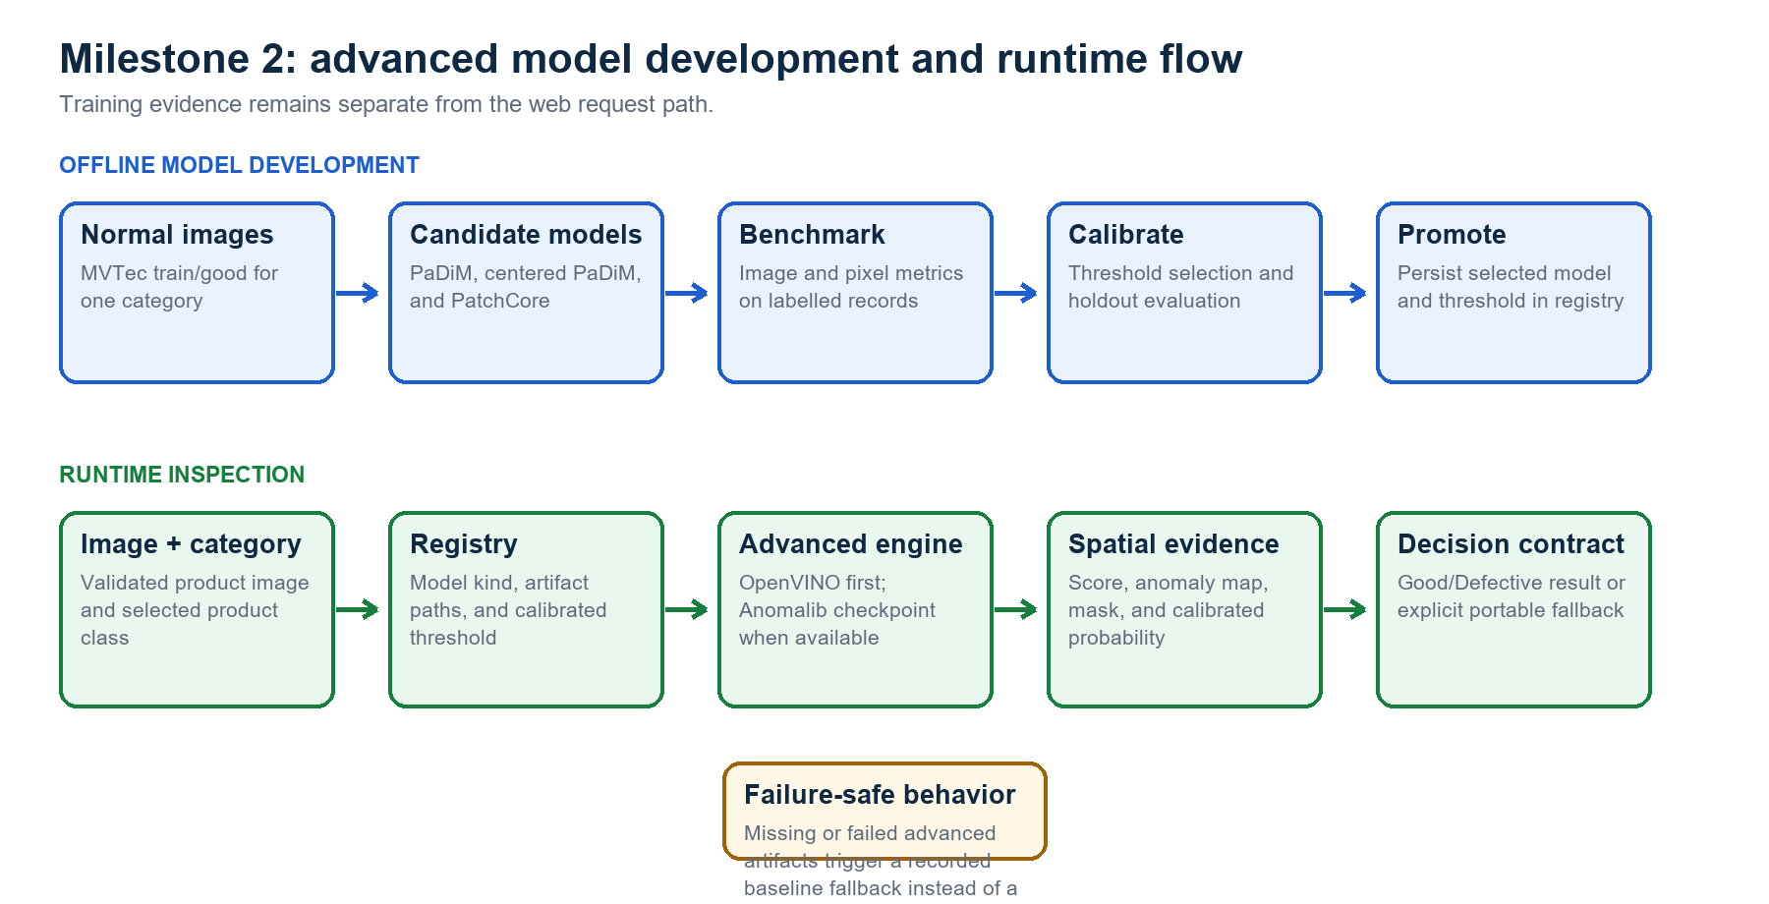
Figure 1. Advanced model development and runtime workflow
Source: Generated from `ml/` and `scripts/` control flow.

4.1 Core implementation modules
Module | Milestone 2 responsibility
ml/anomalib_trainer.py | Construct MVTec datamodule, preprocessing, PaDiM/PatchCore model, and Engine
ml/model_registry.py | Resolve category, model family, artifacts, thresholds, and runtime readiness
ml/padim_detector.py | Load Anomalib/OpenVINO engines, produce score/map/mask, and apply spatial calibrator
ml/inference.py | Choose advanced or portable path and construct the backend-ready inspection contract
ml/heatmap.py | Normalize/colorize maps, overlay masks, and calculate localization metrics
ml/object_preprocessing.py | Foreground extraction, crop, alignment, padding, and contrast utilities

4.2 Runtime result contract
Output field | Meaning
engine | Actual engine, such as `patchcore_openvino`, `padim`, or portable baseline
anomaly_score | Global measure of deviation from normal appearance
decision_threshold | Category-specific threshold stored in the registry/metadata
decision_basis | Score threshold or spatial calibrator
detection_confidence | Confidence attached to Good/Defective detection
anomaly_map | Dense floating-point spatial anomaly evidence
pred_mask | Binary suspicious region used for geometry and heatmap creation
fallback_used / reason | Explicit record when advanced inference cannot run

5. Category Model Registry and Artifact Status
The category registry prevents a cable image from silently using a bottle model. Every request must resolve a supported category, after which the registry supplies model kind, checkpoint path, optional OpenVINO path, optional spatial calibrator, portable profile, classifier artifact, and calibrated thresholds.
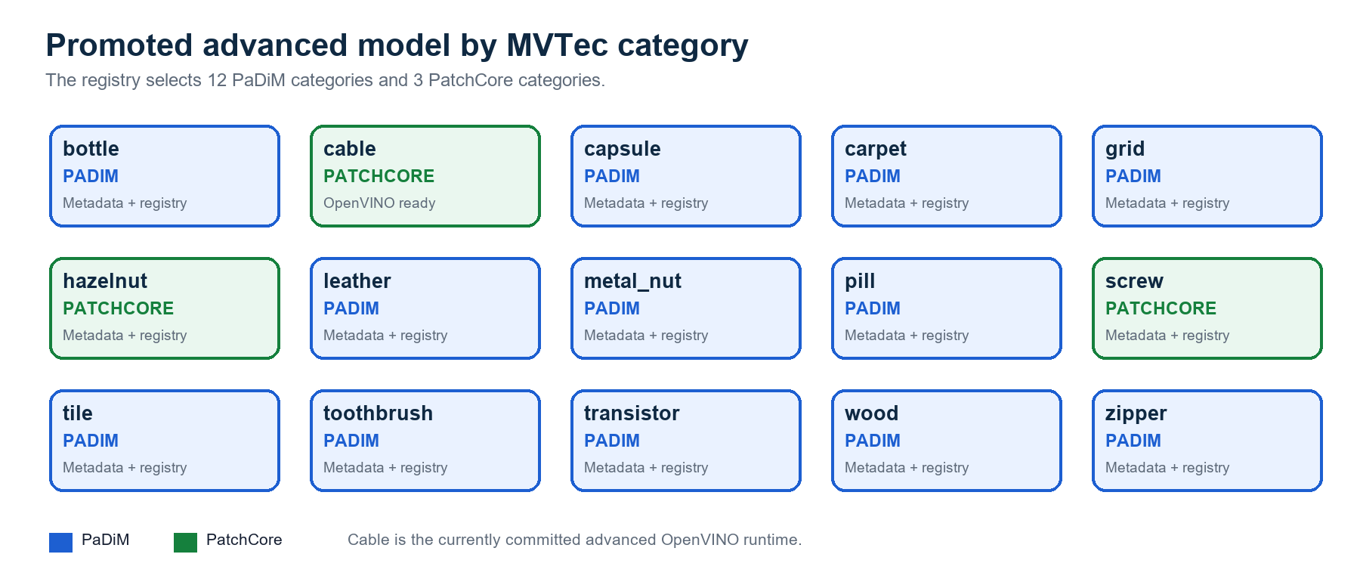
Figure 3. Promoted advanced model by category
Source: Current `models/category_model_registry.json` selections.

5.1 Registry summary
Category | Selected | Threshold | Image F1 | Pixel F1 | Advanced artifact state
bottle | padim | 0.500053 | 0.9764 | 0.7141 | Checkpoint reference
cable | patchcore | 0.513668 | 0.9274 | 0.6147 | Cable OpenVINO
capsule | padim | 0.500863 | 0.9554 | 0.4267 | Checkpoint reference
carpet | padim | 0.616156 | 0.9724 | 0.5656 | Checkpoint reference
grid | padim | 0.487125 | 0.9298 | 0.4019 | Checkpoint reference
hazelnut | patchcore | 0.481546 | 0.9640 | 0.6424 | Checkpoint reference
leather | padim | 0.499993 | 0.9945 | 0.3675 | Checkpoint reference
metal_nut | padim | 0.500032 | 0.9735 | 0.7619 | Checkpoint reference
pill | padim | 0.523497 | 0.9459 | 0.5451 | Checkpoint reference
screw | patchcore | 0.416284 | 0.9407 | 0.3717 | Checkpoint reference
tile | padim | 0.474012 | 0.9212 | 0.5253 | Checkpoint reference
toothbrush | padim | 0.544603 | 0.9355 | 0.6088 | Checkpoint reference
transistor | padim | 0.500030 | 0.8434 | 0.6679 | Checkpoint reference
wood | padim | 0.532627 | 0.9516 | 0.4304 | Checkpoint reference
zipper | padim | 0.500006 | 0.9316 | 0.4597 | Checkpoint reference
Table 1. Promoted model and threshold by category. `Checkpoint reference` means the registry and evaluation metadata are committed while the heavyweight `.ckpt` file is outside this submission branch.

5.2 Artifact availability
Artifact group | Count | State | Interpretation
Advanced checkpoint references | 15 | Configured in registry | 0 `.ckpt` files committed in this branch
Cable OpenVINO IR | 1 | Executable | `model.xml` plus 27.45 MB `model.bin`
Cable spatial calibrator | 1 | Executable | Portable ExtraTrees `.npz` artifact
Advanced metric records | 15 | Available | Stored in category `model_metadata.json`
Portable normal profiles | 15 | Executable | Fallback runtime for every category

6. Training, Benchmarking, and Model Promotion

6.1 Reproducible script sequence
Script | Responsibility
train_category_models.py | Train PaDiM and create portable normal profiles
benchmark_category_models.py | Compare current, centered-PaDiM, and PatchCore candidates
promote_category_benchmarks.py | Copy the strongest candidate and update registry metadata
calibrate_category_thresholds.py | Select score thresholds and evaluate holdout behavior
export_openvino.py | Convert available advanced checkpoints to OpenVINO IR
python scripts/train_category_models.py --categories cable,hazelnut,screw
python scripts/benchmark_category_models.py --categories cable,hazelnut,screw
python scripts/promote_category_benchmarks.py --categories cable,hazelnut,screw
python scripts/calibrate_category_thresholds.py --categories cable,hazelnut,screw --mode advanced
python scripts/export_openvino.py

6.2 Candidate benchmark evidence
Candidate comparisons are stored for cable, grid, hazelnut, and screw. The promotion decision considers image detection and pixel localization together; a model is not selected from a single headline number without its spatial behavior.
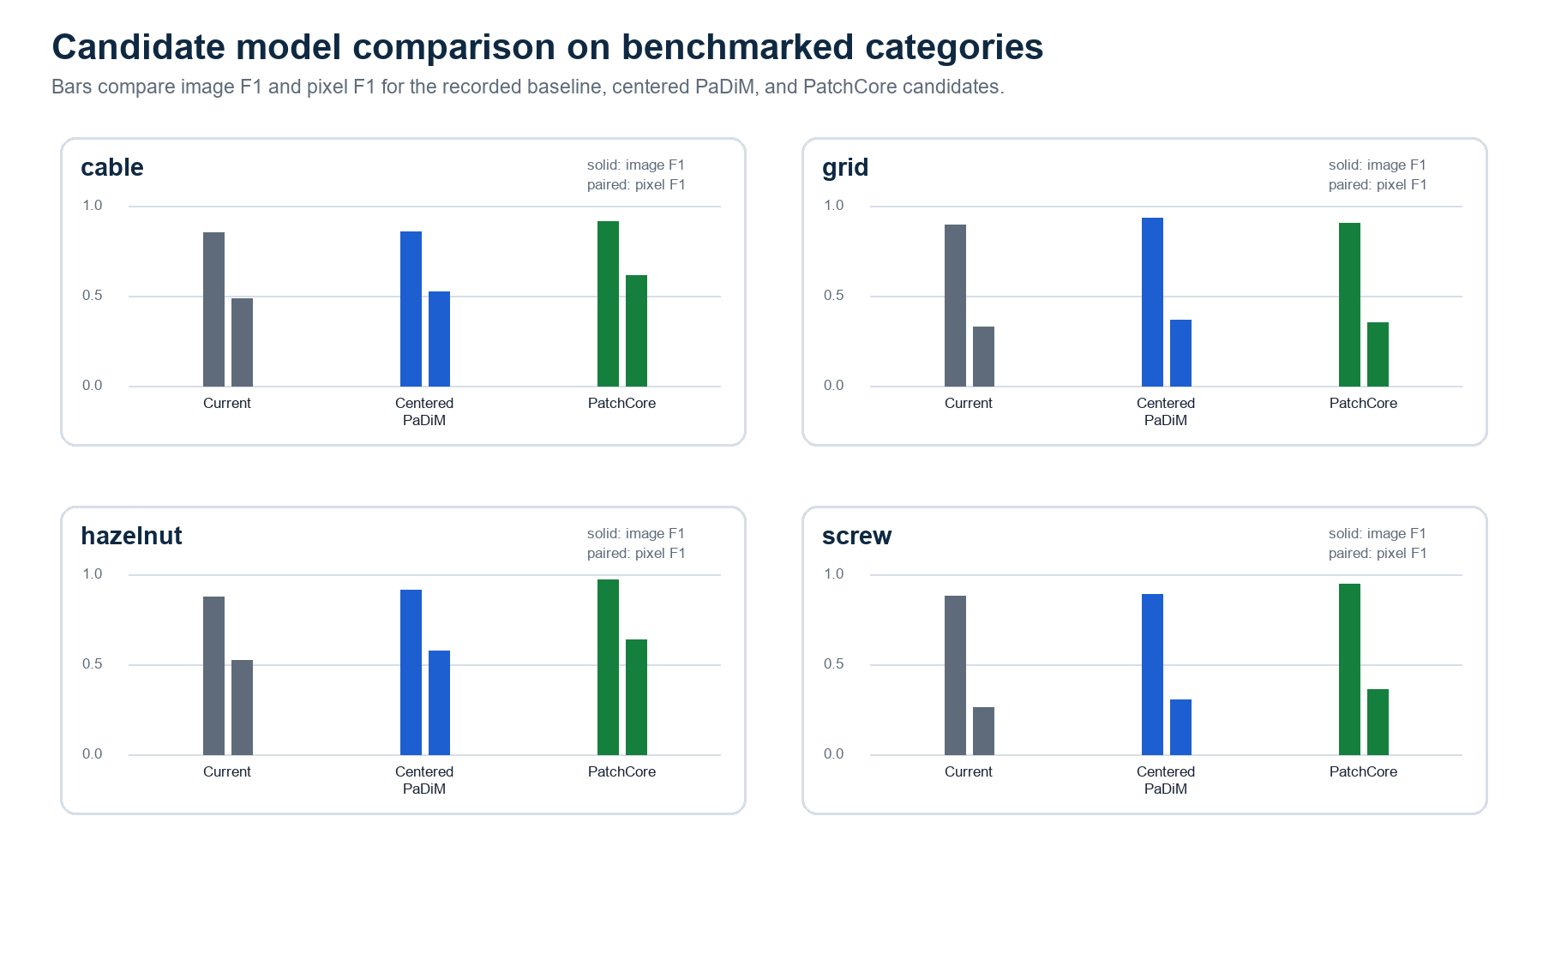
Figure 5. Candidate comparison on benchmarked categories
Source: Current category `benchmark_comparison` metadata.
Category | Candidate | Image AUROC | Image F1 | Pixel AUROC | Pixel F1
cable | baseline | 0.8774 | 0.8558 | 0.9683 | 0.4860
cable | padim_center_roi | 0.9048 | 0.8617 | 0.9649 | 0.5282
cable | patchcore | 0.9670 | 0.9167 | 0.9816 | 0.6156
grid | baseline | 0.8864 | 0.9000 | 0.9583 | 0.3316
grid | padim_center_roi | 0.9607 | 0.9381 | 0.9676 | 0.3710
grid | patchcore | 0.9148 | 0.9057 | 0.9608 | 0.3545
hazelnut | baseline | 0.8832 | 0.8767 | 0.9763 | 0.5267
hazelnut | padim_center_roi | 0.9321 | 0.9178 | 0.9773 | 0.5787
hazelnut | patchcore | 0.9961 | 0.9718 | 0.9880 | 0.6403
screw | baseline | 0.8307 | 0.8845 | 0.9841 | 0.2641
screw | padim_center_roi | 0.8764 | 0.8923 | 0.9813 | 0.3066
screw | patchcore | 0.9664 | 0.9496 | 0.9918 | 0.3649

6.3 Promotion findings
- Cable PatchCore increased recorded image F1 from 0.8558 to 0.9167 and pixel F1 from 0.4860 to 0.6156.
- Hazelnut PatchCore increased recorded image F1 from 0.8767 to 0.9718 and pixel F1 from 0.5267 to 0.6403.
- Screw PatchCore increased recorded image F1 from 0.8845 to 0.9496 and pixel F1 from 0.2641 to 0.3649.
- Grid retained PaDiM because centered PaDiM produced the strongest recorded image F1 (0.9381), while PatchCore did not dominate its spatial result.

7. Threshold Calibration and Evaluation Protocol

7.1 Advanced score calibration
For 14 category records, the advanced threshold is selected on a 30% stratified development partition from labelled MVTec test folders and evaluated on the remaining 70% stratified holdout. The calibration script supports F1 or balanced-accuracy objectives. Bottle retains its earlier recorded threshold and model metrics but does not contain the later split-based calibration section, so aggregate holdout values use 14 categories rather than 15.
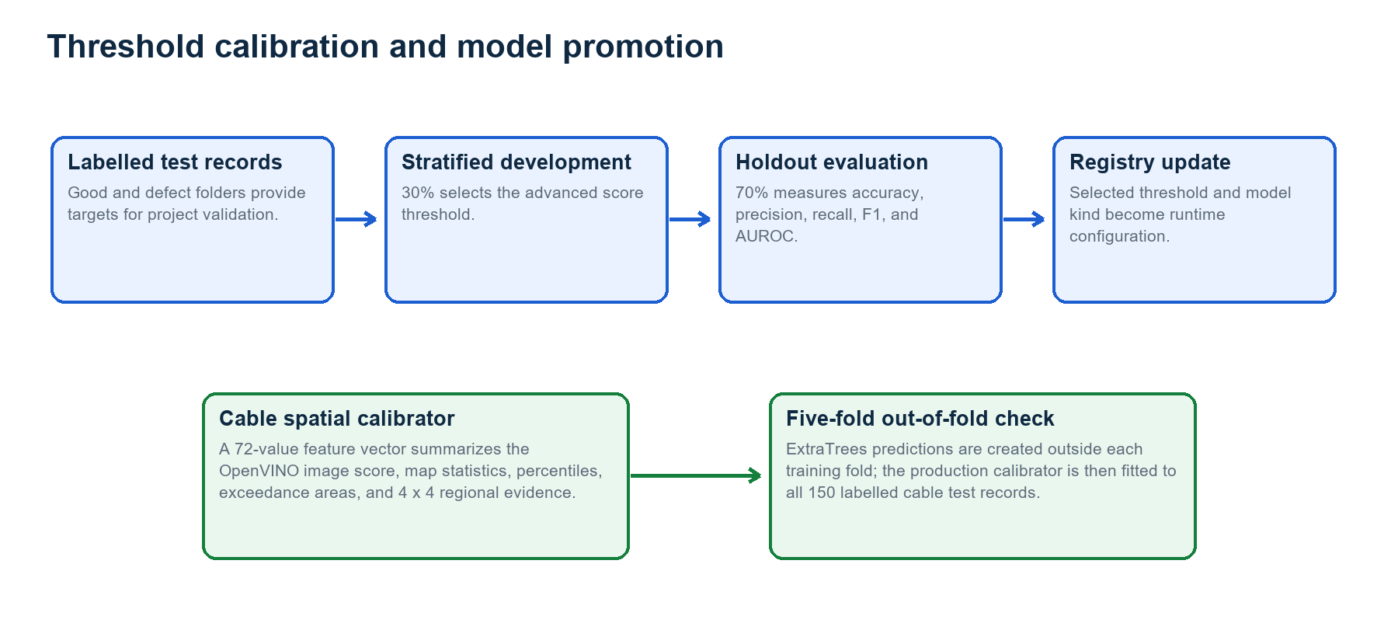
Figure 6. Threshold calibration and model promotion
Source: Implemented by `calibrate_category_thresholds.py` and registry update logic.
Category | Model | Threshold | Accuracy | Precision | Recall | F1 | AUROC
cable | patchcore | 0.513668 | 0.8857 | 0.9643 | 0.8438 | 0.9000 | 0.9703
capsule | padim | 0.500863 | 0.9032 | 0.9146 | 0.9740 | 0.9434 | 0.8636
carpet | padim | 0.616156 | 0.8902 | 1.0000 | 0.8548 | 0.9217 | 0.9927
grid | padim | 0.487125 | 0.8909 | 0.8864 | 0.9750 | 0.9286 | 0.9550
hazelnut | patchcore | 0.481546 | 0.9481 | 0.9412 | 0.9796 | 0.9600 | 0.9964
leather | padim | 0.499993 | 1.0000 | 1.0000 | 1.0000 | 1.0000 | 1.0000
metal_nut | padim | 0.500032 | 0.9506 | 0.9429 | 1.0000 | 0.9706 | 0.9758
pill | padim | 0.523497 | 0.8718 | 0.9118 | 0.9394 | 0.9254 | 0.8535
screw | patchcore | 0.416284 | 0.9018 | 0.9000 | 0.9759 | 0.9364 | 0.9713
tile | padim | 0.474012 | 0.8537 | 0.8615 | 0.9492 | 0.9032 | 0.9528
toothbrush | padim | 0.544603 | 0.8667 | 0.8696 | 0.9524 | 0.9091 | 0.8413
transistor | padim | 0.500030 | 0.8714 | 0.7879 | 0.9286 | 0.8525 | 0.9541
wood | padim | 0.532627 | 0.9107 | 0.9318 | 0.9535 | 0.9425 | 0.9821
zipper | padim | 0.500006 | 0.8774 | 0.9494 | 0.8929 | 0.9202 | 0.8620
Holdout aggregate: Across the 14 split-calibrated categories, mean holdout accuracy is 0.9016, mean precision is 0.9187, mean recall is 0.9442, mean F1 is 0.9295, and mean AUROC is 0.9408.

7.2 Cable spatial calibration
The cable OpenVINO runtime adds a second decision layer. A 72-value vector summarizes the global score, anomaly-map moments, ten percentiles, nine threshold-exceedance ratios, and three statistics from each cell of a 4 x 4 spatial grid. An ExtraTrees classifier converts that evidence into a defective probability. Five-fold out-of-fold predictions assess the calibrator before the final portable forest is fitted on all 150 labelled cable test records.
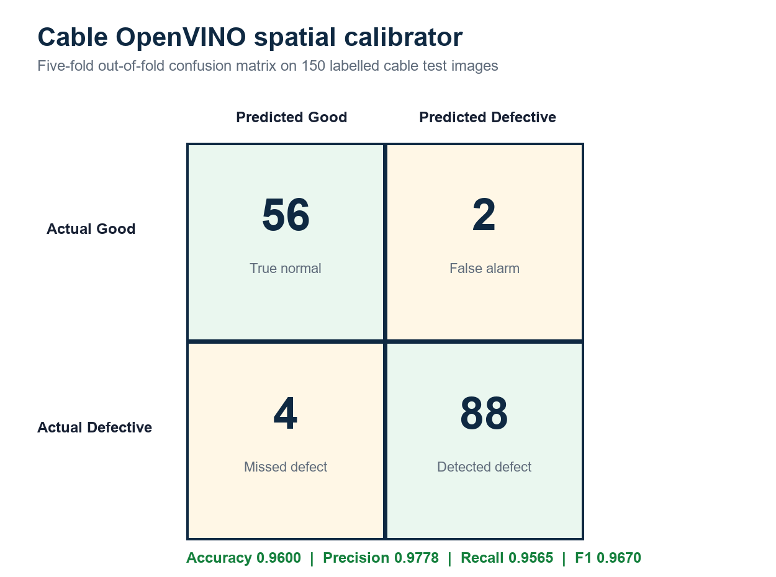
Figure 7. Cable OpenVINO spatial calibrator confusion matrix
Source: Recorded `openvino_spatial_calibration` metadata.
Cable defect subtype | Out-of-fold detection recall
bent_wire | 100.00%
cable_swap | 100.00%
combined | 100.00%
cut_inner_insulation | 100.00%
cut_outer_insulation | 100.00%
missing_cable | 100.00%
missing_wire | 80.00%
poke_insulation | 80.00%

7.3 Evaluation boundary
These metrics are project validation records derived from labelled MVTec test folders. They are suitable for comparing candidates and calibrating the demonstration system, but they must not be described as an untouched factory acceptance test. A production release requires factory-specific images collected under the target camera, lighting, product orientation, and process conditions.

8. Advanced Model Evaluation Results

8.1 Aggregate view
Aggregate metric | Recorded value
Unweighted mean image AUROC | 0.9554
Unweighted mean image F1 | 0.9442
Unweighted mean pixel AUROC | 0.9737
Unweighted mean pixel F1 | 0.5402
Minimum category image F1 | 0.8434 (transistor)
Maximum category image F1 | 0.9945 (leather)
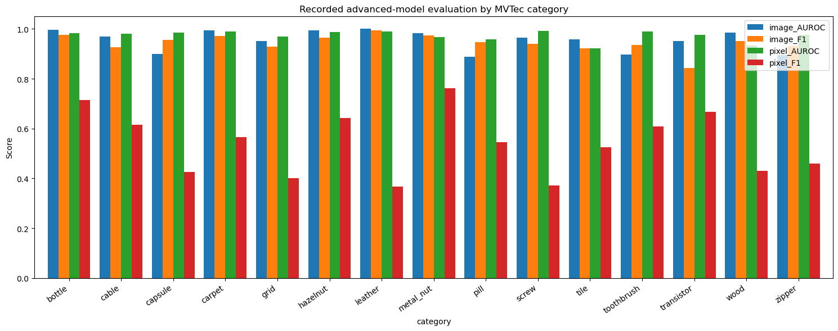
Figure 4. Recorded advanced-model evaluation by category
Source: Executed Notebook 03 using current category model metadata.

8.2 Category metrics
Category | Model | Image AUROC | Image F1 | Pixel AUROC | Pixel F1
bottle | padim | 0.9968 | 0.9764 | 0.9820 | 0.7141
cable | patchcore | 0.9695 | 0.9274 | 0.9815 | 0.6147
capsule | padim | 0.8991 | 0.9554 | 0.9848 | 0.4267
carpet | padim | 0.9952 | 0.9724 | 0.9896 | 0.5656
grid | padim | 0.9524 | 0.9298 | 0.9699 | 0.4019
hazelnut | patchcore | 0.9950 | 0.9640 | 0.9881 | 0.6424
leather | padim | 1.0000 | 0.9945 | 0.9897 | 0.3675
metal_nut | padim | 0.9839 | 0.9735 | 0.9679 | 0.7619
pill | padim | 0.8882 | 0.9459 | 0.9588 | 0.5451
screw | patchcore | 0.9650 | 0.9407 | 0.9918 | 0.3717
tile | padim | 0.9574 | 0.9212 | 0.9232 | 0.5253
toothbrush | padim | 0.8972 | 0.9355 | 0.9907 | 0.6088
transistor | padim | 0.9525 | 0.8434 | 0.9770 | 0.6679
wood | padim | 0.9842 | 0.9516 | 0.9343 | 0.4304
zipper | padim | 0.8942 | 0.9316 | 0.9754 | 0.4597

8.3 Interpretation
- All 15 categories have recorded image AUROC above 0.88; the mean is 0.9554.
- Fourteen of 15 categories have recorded image F1 above 0.92; transistor is the lowest at 0.8434.
- Pixel AUROC is strong across categories, indicating useful ranking of suspicious pixels.
- Pixel F1 varies from 0.3675 to 0.7619, so mask thresholding and exact boundary overlap remain the largest localization weakness.
- Metal nut has the strongest recorded pixel F1 (0.7619), while leather and screw show that excellent image detection does not guarantee exact segmentation overlap.
- Model selection is category-specific because texture variation, object alignment, and defect scale affect the two algorithms differently.

9. Practical Advanced Inference Demonstration

9.1 Demonstration setup
Item | Value
Category | cable
Input | Real MVTec cable test image from a defect folder
Selected detector | PatchCore
Execution engine | OpenVINO CPU
Decision basis | Spatial calibrator
Fallback | Not used
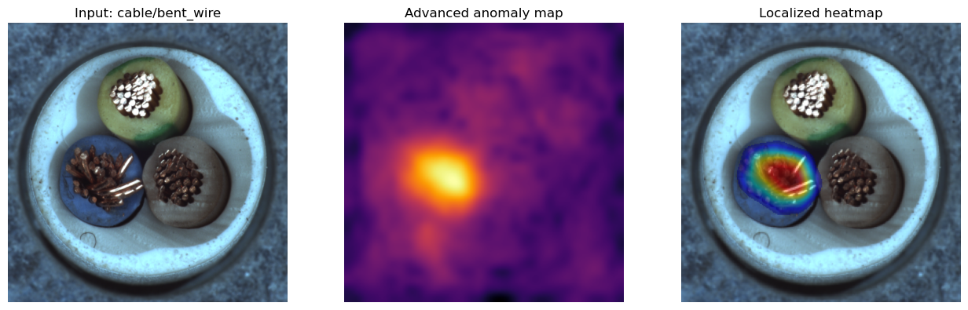
Figure 8. Cable PatchCore OpenVINO practical inference
Source: Executed Notebook 03 on a real MVTec cable image.

9.2 Raw result summary
Output field | Observed value
active_inference_engine | patchcore_openvino
prediction | Defective
defect_type | bent_wire
anomaly_score | 0.808486
detection_confidence | 1.0000
classification_confidence | 0.7967
defect_area_ratio | 0.0611 (6.11%)
severity | 77.0 - High
quality decision | Fail
model_used | patchcore:v1 (patchcore_openvino)
fallback_used | false
What the practical output proves: The selected category resolved to its promoted engine, the advanced model produced both global and spatial evidence, and the request completed without invoking the portable fallback. The subtype, severity, and QA fields are shown only to demonstrate the downstream interface; their implementation and evaluation belong to Milestone 3.

10. Localization and Explainability

10.1 Shared localization contract
PaDiM, PatchCore OpenVINO, and the portable detector all return an anomaly map and predicted mask through the same interface. The heatmap module normalizes the map for display, overlays it on the source image, overlays binary masks, and compares predicted regions with MVTec ground truth. This common contract lets the frontend and severity logic remain independent of the selected anomaly engine.
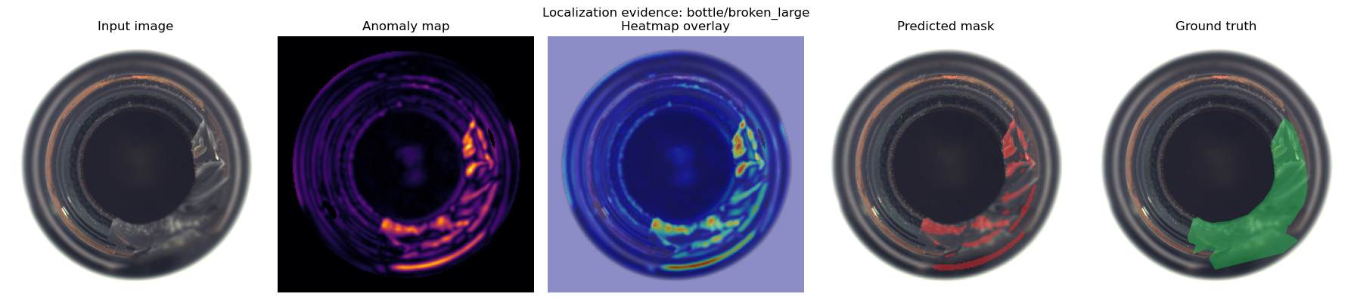
Figure 9. Localization and explainability evidence
Source: Executed Notebook 05 on bottle/broken_large using the shared localization contract.

10.2 Demonstrated overlap and geometry
Measure | Observed value | Interpretation
IoU | 0.2977 | Intersection divided by union of predicted and ground-truth regions
Dice | 0.4588 | Twice the overlap divided by combined mask area
Ground-truth coverage | 0.3073 | Fraction of labelled defect pixels captured
Ground-truth area ratio | 0.1089 | Labelled defect area relative to image
Predicted area ratio | 0.0370 | Predicted suspicious area relative to image
Predicted center | x=0.6649, y=0.6854 | Normalized defect-mask centroid
Critical location | True | Predicted region intersects configured center/edge critical zones

10.3 Explainability fields used later
Field | QA meaning
Heatmap P95 | 95th percentile anomaly-map intensity
Defect area | Fraction of predicted-mask pixels
Critical zone | Whether the mask intersects product-configured QA zones
Decision threshold | Exact threshold applied by the active detector/calibrator
Decision basis | Spatial calibrator or direct score threshold
Fallback status | Whether the result came from the requested advanced model
Notes | Human-readable reasons for Good, Defective, Review, or Fail behavior
Localization finding: The demonstrated mask does not cover the entire labelled bottle defect. This is not hidden: the IoU, Dice, and coverage values quantify the gap and justify continued localization refinement.

11. Runtime Portability and Fallback Behavior

11.1 Advanced engine selection
- Validate the image path and selected MVTec category.
- Read the category's model family, threshold, and artifact paths from the registry.
- Use the OpenVINO model when a complete `.xml` and `.bin` pair exists.
- Otherwise load the PaDiM/PatchCore `.ckpt` through Anomalib when present.
- Return score, map, mask, confidence, and engine metadata.
- If advanced inference raises `PadimInferenceError`, run the category portable baseline and set `fallback_used=true` with the reason.

11.2 Source-control packaging
Artifact | Branch state | Runtime/documentation role
Category metadata | Committed | Metrics, thresholds, benchmark comparison, and provenance
Category registry | Committed | Runtime model selection and artifact paths
Cable OpenVINO IR | Committed | Executable CPU advanced detector
Cable calibrator | Committed | Portable spatial decision model
PaDiM/PatchCore checkpoints | Excluded | Heavy training artifacts regenerated or distributed separately
Portable normal profiles | Committed | Fallback coverage for all categories

11.3 Why fallback is not silent
A missing advanced checkpoint must not be reported as if PaDiM or PatchCore ran. The result records the actual engine, fallback flag, and failure reason. This protects demos and deployments from overstating the active model and lets administrators distinguish model-quality errors from packaging or infrastructure errors.
{
"active_inference_engine": "portable_baseline",
"fallback_used": true,
"fallback_reason": "PaDiM checkpoint not found: ..."
}

12. Testing and Reproducibility

12.1 Focused automated tests
The focused command validates heatmap behavior, mask overlap metrics, k-fold helpers, portable artifact availability, advanced prediction contracts, OpenVINO spatial features, explainability, and explicit fallback semantics. Fourteen tests passed. One controlled skip covers an environment-dependent artifact case and is not a failed assertion.
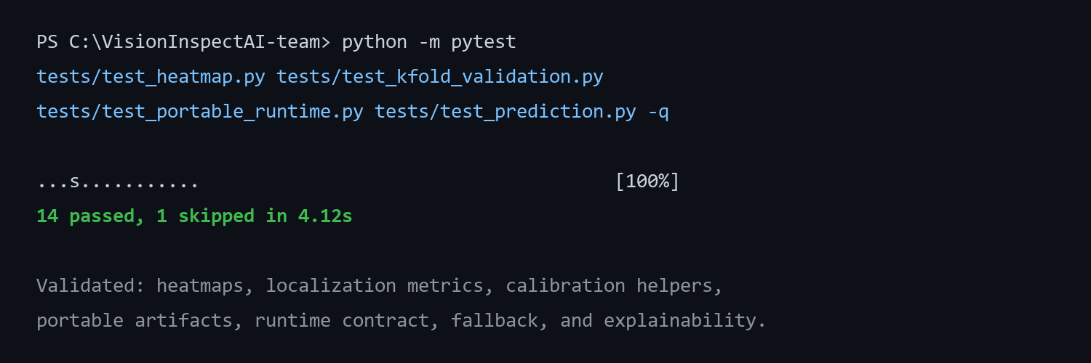
Figure 10. Focused Milestone 2 automated test result
Source: Focused automated test command output.
Test area | Behavior protected
Heatmap normalization | Finite, correctly shaped anomaly visualizations
Zero-map behavior | Good images do not receive a false blue heatmap tint
Mask metrics | IoU, Dice, and overlay behavior
K-fold utilities | Stable threshold and metric aggregation helpers
Portable runtime | Every category has baseline artifacts when advanced files are absent
OpenVINO features | Fixed-length finite spatial feature vector
Prediction contract | Detection confidence remains separate from subtype confidence
Explainability | Decision basis, threshold, and spatial evidence are described
Fallback | Missing advanced artifact is recorded rather than hidden

12.2 Notebook reproduction
python -m pip install -r requirements-ai.txt
$env:MVTEC_DATASET_ROOT = 'C:\path\to\mvtec_anomaly_detection'
jupyter nbconvert --to notebook --execute --inplace notebooks/03_advanced_anomaly_detectors.ipynb
jupyter nbconvert --to notebook --execute --inplace notebooks/05_localization_and_explainability.ipynb
jupyter nbconvert --to notebook --execute --inplace notebooks/07_training_benchmarking_and_calibration.ipynb
The notebooks read real MVTec data and committed metadata, show evidence inline, and do not write screenshot, CSV, JSON report, or chart files to external result folders. Heavy training is performed intentionally through scripts rather than rerun every time the presentation notebooks execute.

13. Risks, Limitations, and Mitigations
Risk | Impact | Mitigation
Missing heavy checkpoints | Most promoted advanced models cannot run from this branch alone | Distribute artifacts separately or export additional OpenVINO models; retain explicit baseline fallback
Single advanced deployment | Only cable has committed OpenVINO IR | Prioritize export/parity checks for the next most valuable categories
Pixel F1 variation | Exact masks may under-cover or over-cover defects | Tune pixel thresholds and evaluate IoU/Dice per category and subtype
Validation provenance | Metrics use labelled MVTec test folders | Describe as project validation and run factory-specific acceptance testing later
Category selection error | Wrong category uses wrong normal representation | Require category input and reject unsupported/mismatched records
Model confidence | Distance-based confidence is not a safety probability | Keep score and threshold visible and calibrate with production data
Lighting and pose shift | Factory conditions may alter anomaly maps | Control acquisition and collect line-specific normal data
Runtime latency | Patch memory and first model load can be costly | Use cached compiled OpenVINO runtime and warm service instances
Dataset license | MVTec data cannot be assumed commercially redistributable | Keep dataset outside source control and review license conditions

13.1 Engineering controls already implemented
- Registry validation rejects unsupported categories.
- OpenVINO requires a complete XML/BIN pair before runtime readiness is reported.
- Checkpoint-loading and prediction errors use a dedicated `PadimInferenceError`.
- Runtime outputs identify the actual engine and fallback state.
- Anomaly maps and masks remain available for manual QA review.
- Threshold provenance and benchmark results remain attached to model metadata.
- Weak pixel-level results and incomplete checkpoint packaging are explicitly documented.

14. Milestone Completion and Handover

14.1 Completed deliverables
Deliverable | Evidence | Status
Advanced model definitions | PaDiM and PatchCore through Anomalib | Complete
Category registry | 15 promoted model selections and thresholds | Complete
Candidate benchmarking | Stored comparisons for cable, grid, hazelnut, and screw | Complete
Advanced evaluation | Image/pixel metrics for all 15 categories | Complete
Threshold calibration | 14 category holdout records plus bottle legacy metrics | Complete
Advanced runtime | Cable PatchCore OpenVINO and spatial calibrator | Complete
Localization | Map, mask, heatmap, overlap, area, and critical-zone evidence | Complete
Fallback behavior | Explicit advanced-to-portable runtime path | Complete
Notebook evidence | Three executed Milestone 2 notebooks with inline output | Complete
Focused testing | 14 passed and 1 controlled skip | Complete

14.2 Handover to Milestone 3
Milestone 2 hands forward a category-aware binary anomaly decision, detection confidence, anomaly score, localized mask, heatmap, area ratio, centroid, critical-zone status, engine identity, and fallback provenance. Milestone 3 adds defect subtype classification and severity/QA decision policy to this evidence. It must keep detection confidence separate from subtype confidence and must not invent a subtype when the classifier artifact is missing or uncertain.

14.3 Final outcome
Milestone conclusion: VisionInspect AI now has a measured advanced anomaly-detection layer across all 15 MVTec categories, category-specific model promotion, calibrated decisions, explainable localization, one executable advanced OpenVINO path, and a transparent portable fallback. The remaining packaging and pixel-overlap limitations are quantified and carried into later milestones.

References
[1] T. Defard, A. Setkov, A. Loesch, and R. Audigier, 'PaDiM: a Patch Distribution Modeling Framework for Anomaly Detection and Localization,' ICPR Workshops, 2021. https://arxiv.org/abs/2011.08785
[2] K. Roth, L. Pemula, J. Zepeda, B. Scholkopf, T. Brox, and P. Gehler, 'Towards Total Recall in Industrial Anomaly Detection,' CVPR, 2022, pp. 14318-14328. https://openaccess.thecvf.com/content/CVPR2022/html/Roth_Towards_Total_Recall_in_Industrial_Anomaly_Detection_CVPR_2022_paper.html
[3] Anomalib documentation, Engine, model training, prediction, post-processing, and OpenVINO export. https://anomalib.readthedocs.io/
[4] OpenVINO documentation, model preparation and Intermediate Representation. https://docs.openvino.ai/2025/documentation.html
[5] P. Bergmann, M. Fauser, D. Sattlegger, and C. Steger, 'MVTec AD - A Comprehensive Real-World Dataset for Unsupervised Anomaly Detection,' CVPR, 2019. https://www.mvtec.com/research-teaching/datasets/mvtec
[6] VisionInspect AI Member 4 source repository, branch Himanshu-parhi-ai/ml, files under ml/, models/, notebooks/, scripts/, and tests/.
[7] VisionInspect AI executed notebooks 03, 05, and 07 plus category model metadata.

Appendix A. Code and Artifact Inventory
Type | Path | Milestone 2 responsibility
Source | ml/anomalib_trainer.py | Build advanced datamodule, model, preprocessor, and engine
Source | ml/padim_detector.py | Anomalib/OpenVINO prediction and spatial calibration
Source | ml/model_registry.py | Category model selection and artifact readiness
Source | ml/inference.py | Advanced selection, fallback, and output contract
Source | ml/heatmap.py | Heatmaps, overlays, IoU, and Dice
Script | scripts/train_category_models.py | Train category models
Script | scripts/benchmark_category_models.py | Compare advanced candidates
Script | scripts/promote_category_benchmarks.py | Promote selected candidate
Script | scripts/calibrate_category_thresholds.py | Calibrate score/spatial decisions
Script | scripts/export_openvino.py | Export checkpoints to OpenVINO IR
Artifact | models/category_model_registry.json | Selected model and threshold per category
Artifact | models/categories/*/model_metadata.json | Metrics, calibration, and benchmark provenance
Artifact | models/exported/cable/weights/openvino/model.xml + model.bin | Executable cable advanced model
Artifact | models/categories/cable/openvino_calibrator.npz | Portable cable spatial calibrator
Notebook | notebooks/03_advanced_anomaly_detectors.ipynb | Registry, metrics, and advanced runtime evidence
Notebook | notebooks/05_localization_and_explainability.ipynb | Ground-truth localization evidence
Notebook | notebooks/07_training_benchmarking_and_calibration.ipynb | Scripts, benchmarks, and calibration evidence
Test | tests/test_heatmap.py | Heatmap and localization behavior
Test | tests/test_kfold_validation.py | Validation helpers
Test | tests/test_portable_runtime.py | Artifact and fallback portability
Test | tests/test_prediction.py | Advanced runtime and explainability contract

Appendix B. Evidence Index
Evidence | Source | What it proves
Model-selection diagram | Registry + metadata | 12 PaDiM and 3 PatchCore selections
Advanced metric chart | Notebook 03 | All-category image and pixel evaluation
Candidate benchmark chart/table | Notebook 07 metadata | Why selected candidates were promoted
Calibration diagram/table | Notebook 07 + script | Threshold development and holdout protocol
Cable confusion matrix | Cable metadata | Spatial-calibrator out-of-fold behavior
Advanced runtime panel | Notebook 03 | OpenVINO score, anomaly map, and localized heatmap
Raw inference table | Notebook 03 | Backend-ready advanced result fields
Localization panel | Notebook 05 | Input, map, heatmap, predicted mask, and ground truth
Overlap/geometry table | Notebook 05 | IoU, Dice, coverage, area, centroid, and critical zone
Focused test output | Pytest | 14 passed and 1 controlled skip
End of Milestone 2 documentation.

