VISIONINSPECT AI
AI/ML MODULE | MILESTONE 3
Defect Subtype Classification,
Severity Scoring, and QA Decisions
Category-specific classifier runtimes, confidence separation, weighted severity, conservative release policy, and practical decision evidence

Submission field | Details
Project | VisionInspect AI
Assigned module | Member 4 - AI/ML
Prepared by | Himanshu Sekhar Parhi
Mentor | Sai Jyoteesh
Programme | Infosys Springboard Programme
Document version | Milestone 3 Submission - Version 1.0
Submission date | 8 August 2026

Document Control
This report records Milestone 3 of the VisionInspect AI Member 4 module. It documents how a detected anomaly is assigned a category-specific defect subtype, how evidence is converted into a weighted severity score, and how the runtime produces a conservative Pass, Review, or Fail decision.
Submission sequence: Milestone 1 - 25 July 2026; Milestone 2 - 1 August 2026; Milestone 3 - 8 August 2026; Milestone 4 - 15 August 2026. This report is the third practical stage in that weekly progression.
Milestone status: Completed. Every supported category has a defect-only subtype classifier artifact and recorded metrics; all classifier labels have explicit severity mappings; confidence values remain separated; and focused classifier, severity, prediction, and preprocessing tests pass.
Control item | Recorded value
Milestone | 3 - Defect Subtype Classification, Severity Scoring, and QA Decisions
Primary notebooks | 04_defect_subtype_classification.ipynb; 06_severity_and_qa_decision.ipynb
Classifier coverage | 15 categories; 73 category-label pairs; 48 unique defect subtype names
Runtime engines | 2 fine-tuned ResNet18 ONNX; 1 portable forest; 12 scikit-learn bundles
Decision policy | Severity weights 30/25/25/20; Review threshold 40; Fail threshold 60
Focused tests | 20 passed in 4.86 seconds
Repository branch | Himanshu-parhi-ai/ml

Milestone Snapshot
Value | Meaning
15 | Supported categories with classifier artifacts
73 | Category-specific subtype labels
48 | Unique defect subtype names
0.8925 | Mean recorded classifier accuracy
0.8931 | Mean recorded classifier macro F1
53 | Explicit defect risk mappings, including aliases and fallback labels
20 | Focused automated tests passed

Table of Contents
Section | Page
1. Executive Summary | 3
2. Milestone Scope and Acceptance Criteria | 4
3. Position in the Inspection Pipeline | 5
4. Classification Dataset and Problem Definition | 6
5. Feature Engineering and Runtime Architecture | 8
6. Training, Evaluation, and Model Promotion | 9
7. Category Coverage and Classifier Metrics | 10
8. Practical Defect Subtype Demonstration | 12
9. Confidence and Uncertainty Handling | 13
10. Severity Scoring Framework | 14
11. Quality Decision Policy | 16
12. Practical Severity and QA Demonstration | 16
13. Testing and Reproducibility | 17
14. Risks, Limitations, and Mitigations | 19
15. Milestone Completion and Handover | 20
References | 20
Appendix A. Defect Subtype Taxonomy | 21
Appendix B. Code and Artifact Inventory | 22
Appendix C. Evidence Index | 23

List of Figures and Key Terms
Figure | Description
1 | Milestone 3 classification, severity, and QA flow
2 | Category classifier runtime priority
3 | Subtype feature and classifier architecture
4 | Recorded classifier metrics by category
5 | Cable subtype classifier confusion matrix
6 | Practical subtype predictions on real MVTec images
7 | Detection and subtype confidence separation
8 | Weighted severity framework
9 | Severity component contribution examples
10 | Runtime QA decision policy
11 | Practical bottle severity and QA decision
12 | Focused Milestone 3 automated test result

Key terms
Term | Meaning in VisionInspect AI
Anomaly detection | Determines whether the product is Good or Defective.
Subtype classification | Names a known defect only after a defect has been detected.
Detection confidence | Confidence in the binary anomaly decision; used by severity.
Subtype confidence | Confidence in the selected defect label; used for interpretation.
Severity | Weighted quality-impact score from 0 to 100.
QA decision | Operational Pass, Review, or Fail result.
Unknown defect | Conservative label used when subtype evidence is unavailable or conflicting.

1. Executive Summary
Milestone 3 converts anomaly evidence into an interpretable manufacturing outcome. The binary anomaly detector remains responsible for Good versus Defective. Only defective images proceed to a category-specific subtype classifier. That classifier names one known failure pattern, returns class probabilities, and keeps its confidence separate from the anomaly detector's confidence. The resulting evidence is combined with defect area and critical-zone overlap to produce a severity score and operational quality decision.
Classifier records cover all 15 MVTec categories, 73 category-label pairs, and 48 unique subtype names. The unweighted mean recorded accuracy is 0.8925 and mean macro F1 is 0.8931. Two weak categories, capsule and wood, use fine-tuned ResNet18 classifiers exported to ONNX. Cable uses a 173 KB portable forest. The remaining categories use promoted scikit-learn pipelines with shared ResNet18 ONNX features and engineered image evidence.
The severity framework implements the project formula exactly: size 30%, location 25%, defect type 25%, and detection confidence 20%. Scores from 0-39 are Low, 40-59 Medium, 60-79 High, and 80-100 Critical. The runtime then applies a conservative release rule: severity at least 60 fails, severity at least 40 requires review, and any detected anomaly below 40 also requires review instead of being automatically passed.
Practical evidence: Notebook 04 demonstrates correct subtype predictions for cable, capsule, bottle, and wood using three runtime engines. Notebook 06 demonstrates a real broken-large bottle result with severity 79.02 (High) and a Fail decision.

1.1 Key outcomes
- Defect subtype classification is performed only after a binary defect is detected.
- The category registry selects the correct classifier artifact and runtime engine.
- Classifier evaluation uses macro F1, class reports, and confusion matrices rather than accuracy alone.
- Detection confidence and subtype confidence remain distinct throughout inference.
- Every active classifier label has an explicit severity risk score.
- A conservative unknown_defect path prevents unsupported subtype claims.
- Operational Pass, Review, and Fail decisions are derived from configurable severity thresholds.

2. Milestone Scope and Acceptance Criteria

2.1 Objective
The Milestone 3 objective is to classify known defect subtypes after anomaly detection, preserve uncertainty honestly, score product impact consistently, and generate a quality-control action that can be consumed by the application workflow.

2.2 Included work
- Defect-only labelled dataset construction from MVTec test defect folders.
- Category-specific feature engineering and classifier model selection.
- Fine-tuned ResNet18 classifiers for capsule and wood, exported to ONNX.
- Portable forest export for cable and scikit-learn bundle support for other categories.
- Class probabilities, subtype confidence, and unknown-defect fallback behavior.
- Weighted severity components, levels, recommendations, and QA decision thresholds.
- Practical subtype and decision demonstrations using real MVTec images.

2.3 Excluded or deferred work
- Binary anomaly training and heatmap localization belong to Milestone 2.
- Backend persistence, batch processing, frontend review, reports, and deployment belong to Milestone 4.
- The classifier does not discover a new semantic subtype outside its trained label set.
- Severity is an engineering policy score, not a certified safety or regulatory assessment.
- Factory-specific severity weights and critical zones require production-owner approval.

2.4 Acceptance criteria
Criterion | Verification condition | Status
Classifier coverage | Each supported category resolves to a committed subtype classifier artifact | Met
Defect-only contract | Good is excluded from subtype label sets | Met
Evaluation | Accuracy, macro F1, class report, and confusion matrix are recorded | Met
Portability | Promoted CNN classifiers execute from ONNX; cable has compact forest runtime | Met
Uncertainty | Missing/conflicting classifier evidence returns unknown_defect with a reason | Met
Severity coverage | All classifier labels have explicit risk mappings | Met
QA policy | Pass, Review, and Fail decisions follow configured thresholds | Met
Software tests | Focused classifier, severity, prediction, and preprocessing tests pass | Met

3. Position in the Inspection Pipeline
Milestone 3 consumes the binary and spatial evidence produced by Milestone 2. It does not repeat anomaly detection. The classifier receives the selected category, image, and defect mask. Severity receives the defect type, defect geometry, critical-zone status, and detection confidence. The quality policy converts the score into a release action.
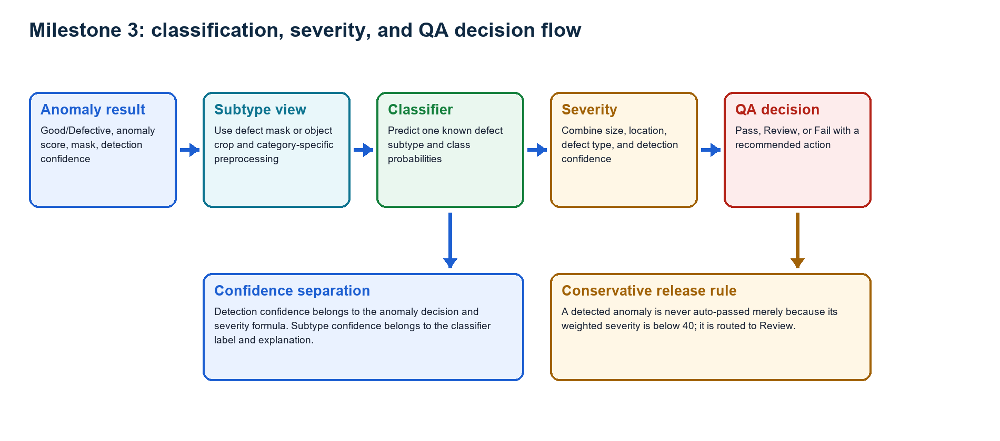
Figure 1. Milestone 3 classification, severity, and QA decision flow
Source: Generated from the active inference, classifier, and severity control flow.

3.1 Runtime contract between milestones
Boundary | Fields and responsibility
Input from Milestone 2 | category, is_defective, anomaly score, detection confidence, anomaly map, predicted mask
Classifier output | defect_type, classification_confidence, class_probabilities, classifier_engine or error
Geometry output | defect area ratio, centroid, detected regions, critical-zone overlap
Severity output | weighted component scores, total score, level, recommendation
QA output | Pass, Review, or Fail plus a release/rework recommendation
Handover to Milestone 4 | backend-ready dictionary, explainability notes, and display fields

4. Classification Dataset and Problem Definition

4.1 Why classification is defect-only
Good/Defective is already decided by the anomaly detector. Including good as a subtype would duplicate that decision and create contradictory cases. Therefore every subtype classifier is trained only from labelled defect folders, and every stored bundle records `defect_only=true`. If the anomaly detector says Good, the runtime returns defect_type=good without running a defect classifier.

4.2 Dataset construction
- Select the MVTec product category supplied by the inspection request.
- Load labelled images from category/test/<defect_subtype> and exclude test/good.
- Resolve the matching ground-truth mask when available.
- Build a classifier view from the full object, defect crop, or ROI evidence required by the feature mode.
- Preserve the category label order in the model artifact and metadata.

4.3 Coverage
Category | Subtype count | Defect-only labels
bottle | 3 | broken_large, broken_small, contamination
cable | 8 | bent_wire, cable_swap, combined, cut_inner_insulation, cut_outer_insulation, missing_cable, missing_wire, poke_insulation
capsule | 5 | crack, faulty_imprint, poke, scratch, squeeze
carpet | 5 | color, cut, hole, metal_contamination, thread
grid | 5 | bent, broken, glue, metal_contamination, thread
hazelnut | 4 | crack, cut, hole, print
leather | 5 | color, cut, fold, glue, poke
metal_nut | 4 | bent, color, flip, scratch
pill | 7 | color, combined, contamination, crack, faulty_imprint, pill_type, scratch
screw | 5 | manipulated_front, scratch_head, scratch_neck, thread_side, thread_top
tile | 5 | crack, glue_strip, gray_stroke, oil, rough
toothbrush | 1 | defective
transistor | 4 | bent_lead, cut_lead, damaged_case, misplaced
wood | 5 | color, combined, hole, liquid, scratch
zipper | 7 | broken_teeth, combined, fabric_border, fabric_interior, rough, split_teeth, squeezed_teeth
Evaluation boundary: Most classical classifier metrics are out-of-fold predictions from the labelled MVTec test defect folders. Capsule and wood use stratified holdout evaluation. These are project validation records, not the official MVTec anomaly-detection benchmark and not independent factory acceptance results.

5. Feature Engineering and Runtime Architecture
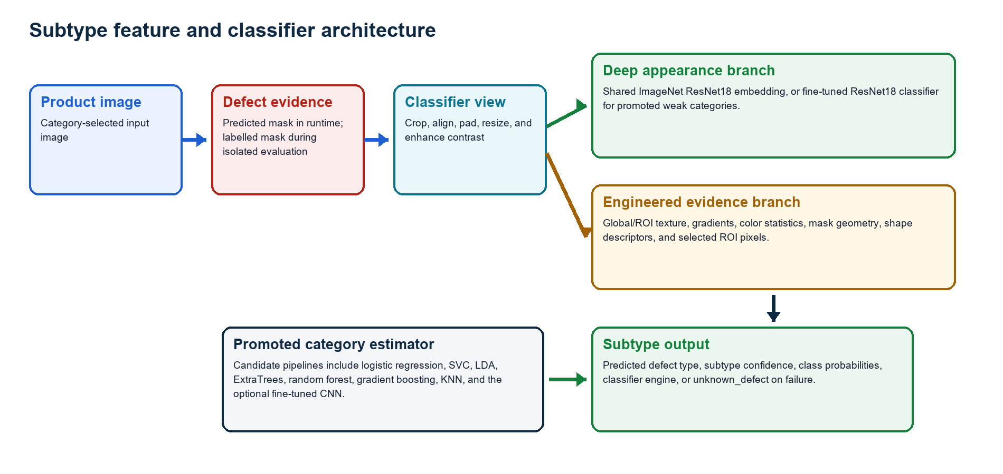
Figure 3. Subtype feature and classifier architecture
Source: Generated from `ml/classifier.py`, `ml/cnn_classifier.py`, and `ml/defect_classifier.py`.

5.1 Feature modes
Feature mode | Evidence represented | Current use
global_texture | Shared ResNet18 embedding plus global texture statistics | Bottle and toothbrush
global_roi_texture | Global embedding plus mask-guided ROI texture and geometry | Most structured categories
global_roi_pixel_texture | Embedding, ROI texture/shape, and selected ROI pixel evidence | Grid
handcrafted_roi_shape_texture | Portable OpenCV texture, gradient, color, ROI, and shape features | Cable
cnn_heatmap_object_crop | Fine-tuned ResNet18 on full/object/defect views | Capsule and wood

5.2 Runtime priority
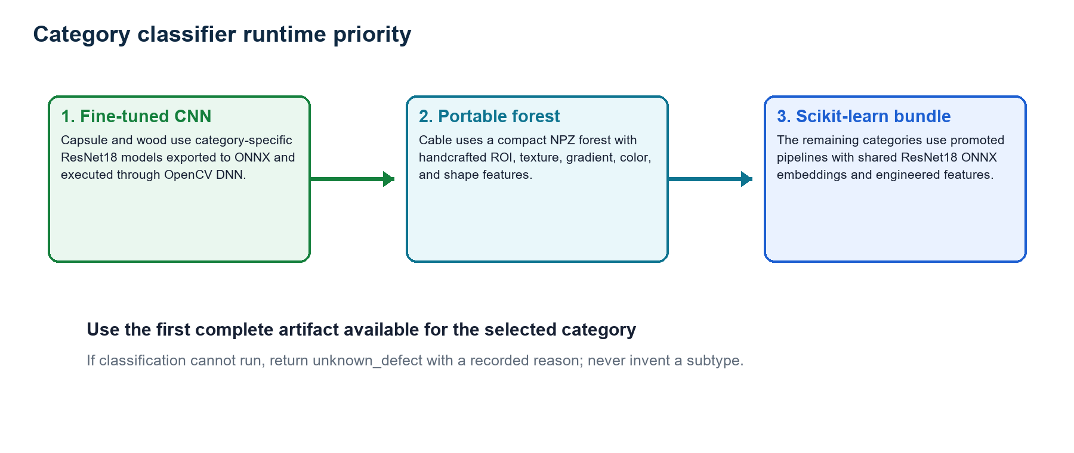
Figure 2. Category classifier runtime priority
Source: Actual priority implemented by `classify_defect_type`.

5.3 Portable artifacts
Artifact | Path | Size/count | Role
Shared ResNet18 feature model | models/inference/resnet18_features.onnx | 44.69 MB | Deep embedding for scikit-learn bundles
Capsule CNN | models/categories/capsule/cnn_defect_classifier.onnx | 44.71 MB | Fine-tuned ONNX subtype classifier
Wood CNN | models/categories/wood/cnn_defect_classifier.onnx | 44.71 MB | Fine-tuned ONNX subtype classifier
Cable compact classifier | models/categories/cable/defect_classifier_runtime.npz | 173 KB | Portable forest and scaling data
Category bundles | models/defect_classifier.pkl and models/categories/*/*.pkl | 15 artifacts | Promoted production estimators and metadata

6. Training, Evaluation, and Model Promotion

6.1 Classical classifier path
- Extract the configured global, ROI, texture, shape, or pixel features.
- Choose a stratified fold count supported by the smallest subtype class.
- Compare candidate estimators using mean macro F1, with accuracy as secondary evidence.
- Generate out-of-fold predictions for the selected estimator and calculate the confusion matrix and class report.
- Refit the promoted estimator on all labelled defect images and store the bundle and metadata.
Candidate family | Models considered
Linear | Logistic regression with several C values; shrinkage LDA; SGD log-loss
Kernel/distance | RBF SVC and K-nearest neighbors
Ensemble | ExtraTrees, random forest, and gradient boosting
Single-subtype | Constant DummyClassifier when the category has only one known defect subtype

6.2 Fine-tuned CNN path
- Use a 70/30 stratified defect-only split.
- Load ImageNet ResNet18 weights; freeze early layers and train layer4 plus a dropout classification head.
- Apply small brightness/contrast jitter and affine augmentation.
- Use weighted sampling and weighted cross-entropy with 0.05 label smoothing.
- Select the best epoch by holdout macro F1 with early stopping.
- Export the promoted model to ONNX opset 17 and execute through OpenCV DNN.

6.3 Promotion controls
Control | Behavior
Category-specific comparison | A candidate replaces the current classifier only when its recorded macro F1 improves, unless explicitly forced
Artifact completeness | ONNX requires both model and JSON metadata; compact forest requires a valid NPZ
Registry update | Only the promoted artifact path is added to category_model_registry.json
Runtime parity | Tests compare compact forest probabilities with the original scaled scikit-learn pipeline
Defect-only invariant | Model artifacts and tests verify that good is absent from subtype labels

7. Category Coverage and Classifier Metrics

7.1 Aggregate view
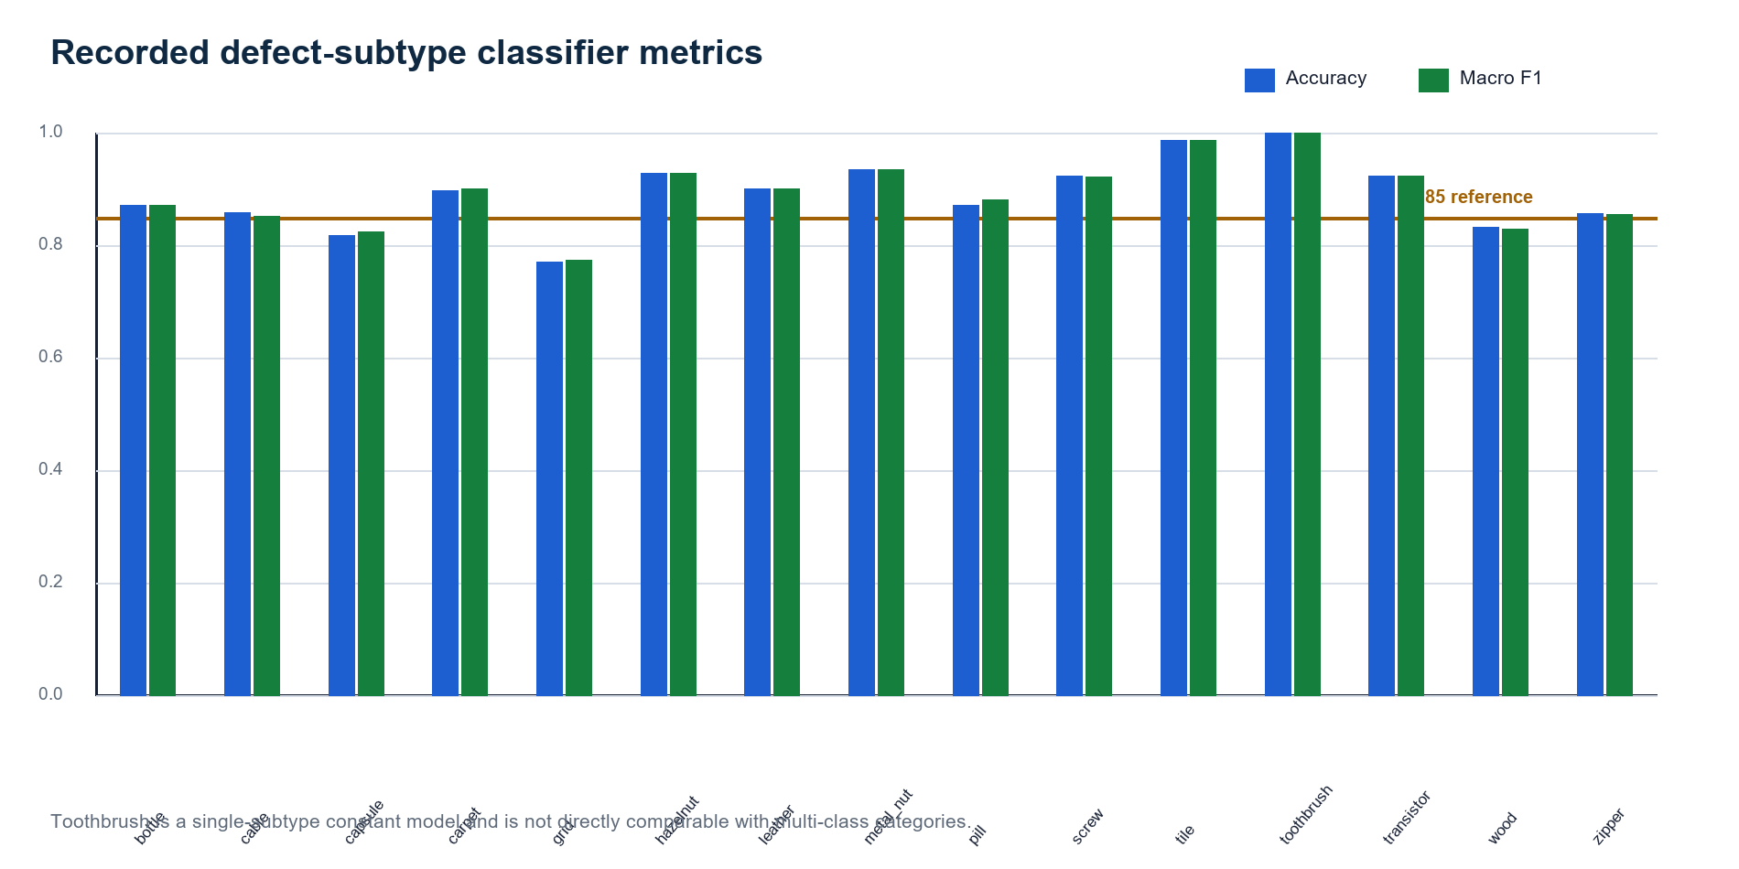
Figure 4. Recorded defect-subtype classifier metrics by category
Source: Current category model metadata; blue is accuracy and green is macro F1.
Category | Active engine | Classes | Accuracy | Macro F1 | Selected estimator
bottle | Scikit-learn bundle | 3 | 0.8730 | 0.8719 | extra_trees
cable | Portable forest | 8 | 0.8587 | 0.8529 | random_forest
capsule | ResNet18 ONNX | 5 | 0.8182 | 0.8250 | resnet18_finetuned_weighted_cross_entropy
carpet | Scikit-learn bundle | 5 | 0.8989 | 0.9009 | lda_shrinkage
grid | Scikit-learn bundle | 5 | 0.7719 | 0.7742 | random_forest
hazelnut | Scikit-learn bundle | 4 | 0.9286 | 0.9295 | extra_trees
leather | Scikit-learn bundle | 5 | 0.9022 | 0.9017 | extra_trees
metal_nut | Scikit-learn bundle | 4 | 0.9355 | 0.9357 | lda_shrinkage
pill | Scikit-learn bundle | 7 | 0.8723 | 0.8828 | lda_shrinkage
screw | Scikit-learn bundle | 5 | 0.9244 | 0.9233 | extra_trees
tile | Scikit-learn bundle | 5 | 0.9881 | 0.9875 | logistic_c0.01
toothbrush | Scikit-learn bundle | 1 | 1.0000 | 1.0000 | constant
transistor | Scikit-learn bundle | 4 | 0.9250 | 0.9246 | logistic_c0.01
wood | ResNet18 ONNX | 5 | 0.8333 | 0.8294 | resnet18_finetuned_weighted_cross_entropy
zipper | Scikit-learn bundle | 7 | 0.8571 | 0.8568 | svc_rbf_c5

7.2 Interpretation
- All-category mean accuracy is 0.8925; mean macro F1 is 0.8931.
- Excluding the single-subtype toothbrush constant model, the 14 multi-class categories average 0.8848 accuracy and 0.8854 macro F1.
- Eleven of fourteen multi-class categories record macro F1 at or above 0.85.
- Grid is the weakest recorded classifier at macro F1 0.7742; capsule records 0.8250 and wood 0.8294.
- Tile has the strongest comparable multi-class result at macro F1 0.9875.
- Toothbrush accuracy/F1 of 1.0 reflects one known defect subtype and must not be interpreted as a difficult multi-class result.

7.3 Cable class-level evidence
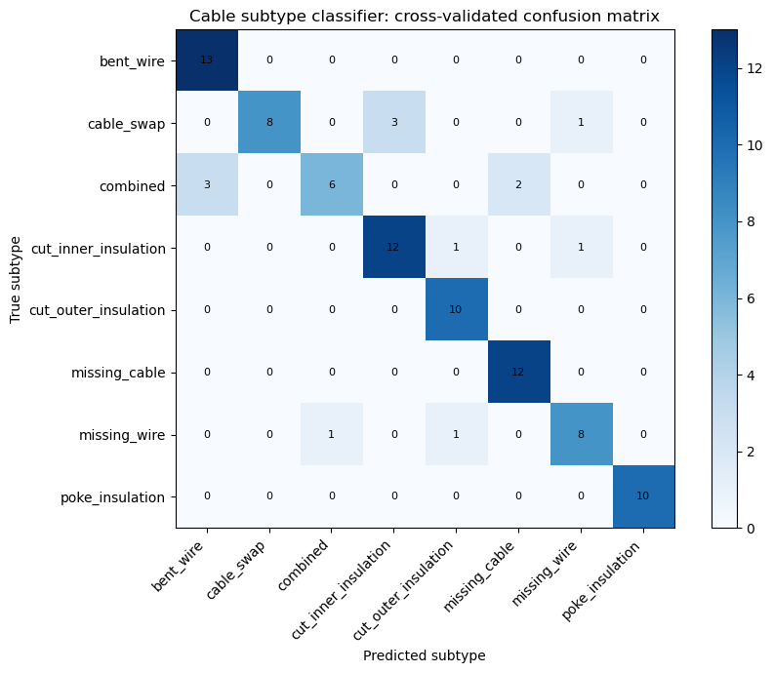
Figure 5. Cable subtype classifier cross-validated confusion matrix
Source: Executed Notebook 04 using recorded out-of-fold predictions.
Cable records accuracy 0.8587 and macro F1 0.8529 across eight subtypes. Bent wire, cut outer insulation, missing cable, and poke insulation are recovered cleanly in the recorded matrix. Most errors are concentrated among visually related combined, cable-swap, inner-insulation, missing-wire, and missing-cable patterns.

8. Practical Defect Subtype Demonstration

8.1 Demonstration design
Notebook 04 selects one real labelled MVTec defect image from cable, capsule, bottle, and wood. It supplies the labelled mask to isolate and demonstrate the subtype classifier itself. In the complete application runtime, the predicted anomaly mask is supplied instead. The isolated demonstration therefore proves classifier execution and label handling, not end-to-end localization quality.
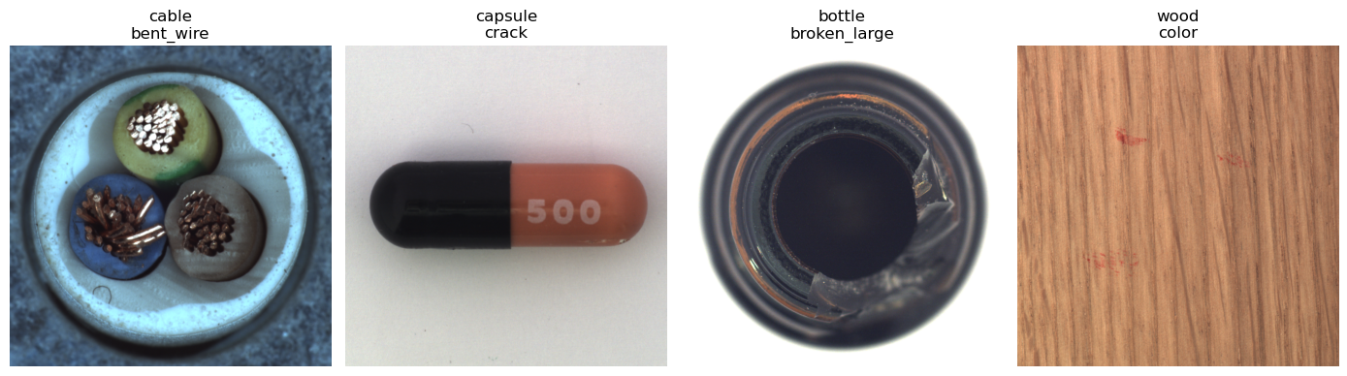
Figure 6. Practical subtype predictions on real MVTec images
Source: Executed Notebook 04; displayed labels are the expected defect folders.
Category | Expected | Predicted | Subtype confidence | Engine | Interpretation
cable | bent_wire | bent_wire | 0.4133 | portable_forest | Correct, but low subtype confidence
capsule | crack | crack | 0.9922 | fine_tuned_resnet18_onnx | Correct
bottle | broken_large | broken_large | 0.9967 | scikit_learn_bundle | Correct
wood | color | color | 0.9944 | fine_tuned_resnet18_onnx | Correct
What the demonstration proves: All three runtime paths execute from committed artifacts and return the expected subtype on the selected images. The cable result also demonstrates why subtype confidence must remain visible: the label is correct, but 41.33% confidence is not strong enough to present as certainty.

9. Confidence and Uncertainty Handling
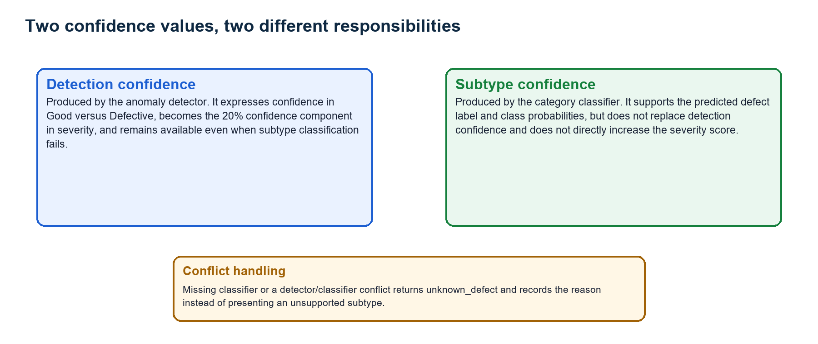
Figure 7. Detection confidence and subtype confidence separation
Source: Implemented by `classify_prediction`, `inspect_image`, and explainability output.

9.1 Why separation matters
An anomaly detector can be confident that an image is defective while the subtype classifier is uncertain about which defect is present. Combining those values would overstate subtype certainty or weaken the binary defect decision. VisionInspect AI therefore uses detection confidence in severity and reports subtype confidence only with the predicted label and class-probability distribution.

9.2 Unknown-defect behavior
Condition | Returned type | Safety behavior
Classifier artifact missing | unknown_defect | Record artifact path error; preserve binary defect decision
Classifier runtime error | unknown_defect | Record exception text; require manual classification
Detector says Defective but classifier says good | unknown_defect | Record conflicting decisions; do not reuse the classifier's good probability
Classifier succeeds | Known subtype | Store subtype confidence and complete class probabilities
Detector says Good | good | Do not invoke a defect subtype classifier
Current limitation: The runtime does not yet apply a category-specific minimum subtype-confidence threshold. Low-confidence labels remain visible through their probability, while the conservative Review/Fail decision continues to depend on anomaly evidence and severity.

10. Severity Scoring Framework

10.1 Formula
Severity Score = (Size x 0.30) + (Location x 0.25) + (Defect Type x 0.25) + (Detection Confidence x 0.20)
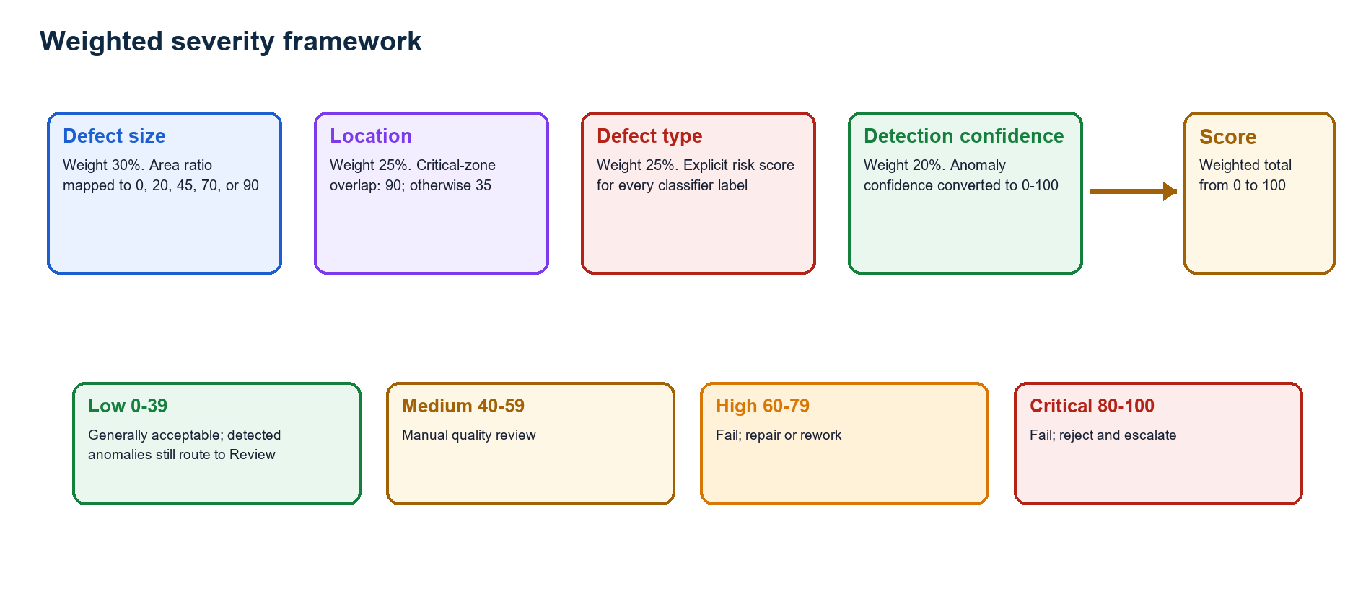
Figure 8. Weighted severity framework
Source: Implemented by `ml/severity.py`.

10.2 Component rules
Component | Weight | Current scoring rule
Size | 30% | Area <=0: 0; <0.5%: 20; <2%: 45; <5%: 70; otherwise 90
Location | 25% | Critical-zone overlap: 90; non-critical location: 35
Defect type | 25% | Explicit policy value from 0 to 95 for all active classifier labels
Detection confidence | 20% | Detector confidence converted to a bounded 0-100 score

10.3 Severity levels
Level | Score | Default recommendation
Low | 0-39 | Product generally acceptable; detected anomaly still routes to Review
Medium | 40-59 | Inspection review required
High | 60-79 | Repair or rework recommended
Critical | 80-100 | Reject product and trigger quality inspection workflow

10.4 Worked examples
Case | Severity score | Level | Direct level decision | Final runtime decision
Normal product | 0.00 | Low | Pass | Pass
Small scratch | 37.90 | Low | Pass | Review because a defect was detected
Contamination | 53.20 | Medium | Review | Review
Large critical crack | 92.65 | Critical | Fail | Fail
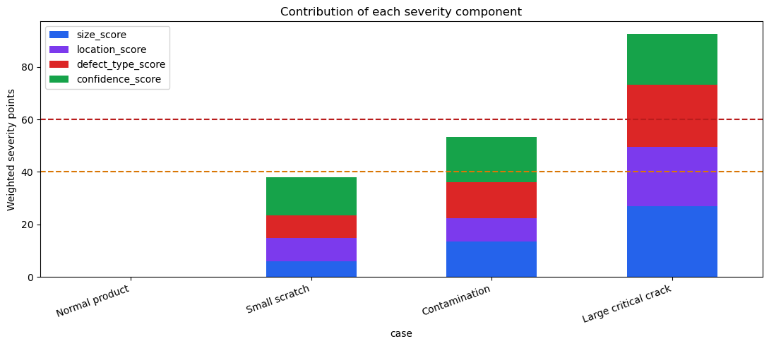
Figure 9. Severity component contribution examples
Source: Executed Notebook 06; dashed lines show Review and Fail thresholds.

11. Quality Decision Policy
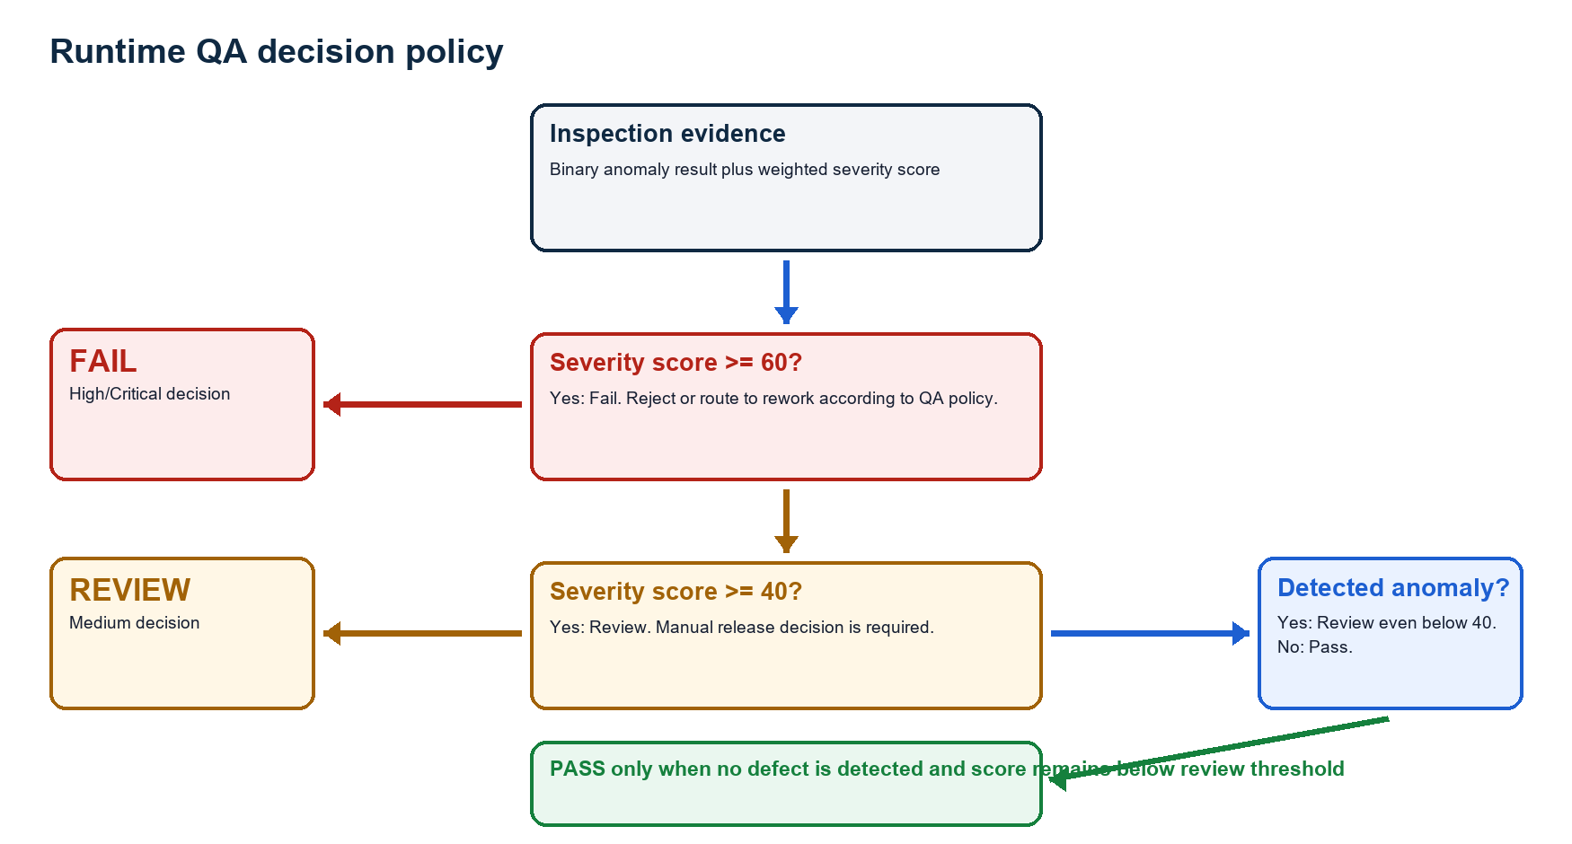
Figure 10. Runtime QA decision policy
Source: Implemented by `apply_quality_decision` with configurable review and fail thresholds.

11.1 Decision order
- If severity score is at least the fail threshold (default 60), return Fail.
- Otherwise, if severity score is at least the review threshold (default 40), return Review.
- Otherwise, if an anomaly was detected, return Review even though the weighted score is Low.
- Return Pass only when no defect is detected and the score remains below the review threshold.

11.2 Recommended actions
Decision | Runtime recommendation | Operational meaning
Pass | Product generally acceptable | Release subject to plant policy
Review | Manual quality review required before release | Engineer inspects image, heatmap, metadata, and confidence
Fail | Reject product or send to rework based on QA policy | Create rejection/rework workflow in the application

12. Practical Severity and QA Demonstration

12.1 Executed example
Notebook 06 executes the portable bottle pipeline on `bottle/test/broken_large/000.png` and then exposes only the fields needed to explain classification, severity, and the quality decision. The example uses a configured center critical zone.
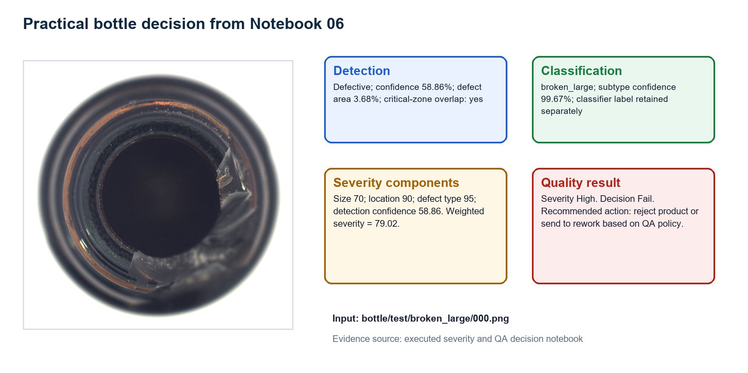
Figure 11. Practical bottle severity and QA decision
Source: Executed Notebook 06 using a real MVTec broken-large bottle image.
Field | Observed value | Interpretation
Binary prediction | Defective | Anomaly score exceeded the active threshold
Subtype | broken_large | Subtype confidence 99.67%
Detection confidence | 58.86% | Used as the severity confidence component
Defect area | 3.68% | Size score 70
Critical location | True | Location score 90
Defect-type risk | 95 | broken_large policy mapping
Severity | 79.02 - High | Below Critical, above Fail threshold
Decision | Fail | Reject or route to rework according to QA policy
Decision trace: The 99.67% subtype confidence does not become the confidence severity input. The score correctly uses the 58.86% detection confidence, preserving the distinction between confidence that a defect exists and confidence about its name.

13. Testing and Reproducibility

13.1 Focused automated tests
The focused suite validates stored classifier artifacts, portable ONNX priority, compact forest probability parity, feature reuse, confidence separation, unknown-defect handling, severity mappings, quality decisions, and classifier-view preprocessing. Twenty tests pass.
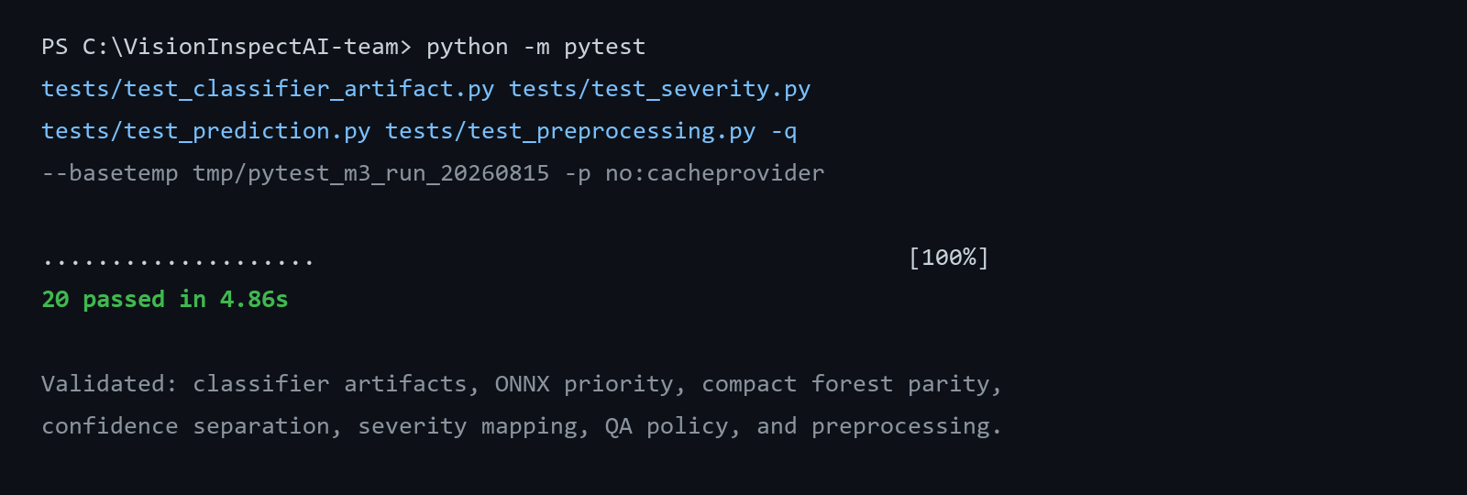
Figure 12. Focused Milestone 3 automated test result
Source: Focused automated test command output.
Test area | Behavior protected
Classifier artifact | Bottle and category bundles load with labels and defect-only metadata
ONNX priority | Promoted CNN artifact is selected before lower-priority classifiers
CNN inference | Capsule and wood ONNX artifacts return valid probabilities
Compact forest parity | Portable NPZ probabilities match the scaled scikit-learn pipeline
Feature reuse | Precomputed global features avoid duplicate deep extraction
Confidence contract | Detection and subtype confidence remain separate
Unknown defect | Missing classifier does not invent a defect subtype
Severity mapping | Every stored classifier label has an explicit risk score
Good result | Good prediction has zero defect severity and Pass
Preprocessing | Mask-guided classifier crop remains correctly shaped

13.2 Notebook reproduction
python -m pip install -r requirements-ai.txt
$env:MVTEC_DATASET_ROOT = 'C:\path\to\mvtec_anomaly_detection'
jupyter nbconvert --to notebook --execute --inplace notebooks/04_defect_subtype_classification.ipynb
jupyter nbconvert --to notebook --execute --inplace notebooks/06_severity_and_qa_decision.ipynb
Both notebooks show tables, plots, class probabilities, and decision evidence inline. They do not export external screenshots, CSV reports, or chart files.

14. Risks, Limitations, and Mitigations
Risk | Impact | Mitigation
Validation provenance | Most classical metrics use out-of-fold predictions on labelled MVTec test defects | Treat as project validation and collect an untouched factory acceptance set
Mask dependence | Subtype features can degrade when the predicted anomaly mask is inaccurate | Evaluate classifier performance with predicted masks, not only labelled masks
Low subtype confidence | Best class can be weak even when the label is correct | Add category-specific abstention thresholds and route uncertain cases to manual classification
Unseen subtype | Closed classifiers cannot name a defect outside their label set | Use unknown_defect, retain heatmap evidence, and add labelled examples before retraining
Single-subtype metric | Toothbrush 1.0 score is structurally easy and not comparable | Report the constant-model protocol explicitly
Weak categories | Grid, capsule, and wood remain below 0.85 macro F1 | Collect more examples, improve masks/crops, and compare calibrated classifiers
Probability calibration | Classifier probabilities may be overconfident | Measure calibration error and apply Platt/isotonic/temperature scaling
Severity policy | Generic weights may not match every product's safety impact | Make risk maps and critical zones product-owner controlled and versioned
Artifact size | Three ResNet18 ONNX files consume about 134 MB | Share the common backbone where practical and evaluate quantization after parity testing

14.1 Controls already implemented
- Category selection prevents cross-product classifier use.
- Good is excluded from defect subtype labels.
- Unknown-defect fallback records missing, failed, or conflicting classifier evidence.
- Detection and subtype confidence are returned as separate fields.
- Severity mappings cover every currently stored classifier label.
- Detected anomalies cannot be auto-passed solely because of a Low severity score.
- ONNX and compact artifacts are tested for runtime availability and parity.

15. Milestone Completion and Handover

15.1 Completed deliverables
Deliverable | Evidence | Status
Defect-only category classifiers | 15 committed category artifacts | Complete
Subtype taxonomy | 73 category-label pairs; 48 unique names | Complete
Portable CNN runtime | Capsule and wood ResNet18 ONNX artifacts | Complete
Portable forest runtime | Cable compact NPZ artifact | Complete
Classifier evaluation | Accuracy, macro F1, class reports, and confusion matrices | Complete
Confidence handling | Separate detection/subtype confidence and unknown-defect path | Complete
Severity framework | 30/25/25/20 weighting and complete risk map | Complete
QA decision policy | Pass/Review/Fail rules and recommendations | Complete
Practical evidence | Four subtype examples and one complete severity decision | Complete
Focused testing | 20 passed | Complete

15.2 Handover to Milestone 4
Milestone 3 hands forward a category-specific defect type, subtype confidence, class probabilities, weighted severity components, severity score and level, Pass/Review/Fail decision, recommended action, and uncertainty notes. Milestone 4 connects that contract to backend APIs, persistence, image/report storage, frontend review workflows, analytics, batch processing, and deployment-oriented validation.

15.3 Milestone outcome
Milestone conclusion: VisionInspect AI now turns localized anomaly evidence into a named defect, an auditable severity calculation, and a conservative quality-control action. The implementation remains transparent about classifier confidence, evaluation provenance, weak categories, and the distinction between project policy and factory-certified acceptance rules.

References
[1] Scikit-learn documentation, model selection, pipelines, ensemble classifiers, classification metrics, and confusion matrices. https://scikit-learn.org/stable/
[2] PyTorch and Torchvision documentation, ResNet18, transfer learning, weighted sampling, and model export. https://pytorch.org/docs/stable/ and https://pytorch.org/vision/stable/
[3] OpenCV documentation, DNN ONNX inference and image processing. https://docs.opencv.org/
[4] ONNX documentation, portable neural-network representation. https://onnx.ai/
[5] P. Bergmann, M. Fauser, D. Sattlegger, and C. Steger, 'MVTec AD - A Comprehensive Real-World Dataset for Unsupervised Anomaly Detection,' CVPR, 2019. https://www.mvtec.com/research-teaching/datasets/mvtec
[6] VisionInspect AI Member 4 source: ml/classifier.py, ml/cnn_classifier.py, ml/defect_classifier.py, ml/severity.py, ml/inference.py, model registry, and category metadata.
[7] VisionInspect AI executed notebooks 04_defect_subtype_classification.ipynb and 06_severity_and_qa_decision.ipynb.

Appendix A. Defect Subtype Taxonomy
Category | Count | Supported subtype labels
bottle | 3 | broken_large, broken_small, contamination
cable | 8 | bent_wire, cable_swap, combined, cut_inner_insulation, cut_outer_insulation, missing_cable, missing_wire, poke_insulation
capsule | 5 | crack, faulty_imprint, poke, scratch, squeeze
carpet | 5 | color, cut, hole, metal_contamination, thread
grid | 5 | bent, broken, glue, metal_contamination, thread
hazelnut | 4 | crack, cut, hole, print
leather | 5 | color, cut, fold, glue, poke
metal_nut | 4 | bent, color, flip, scratch
pill | 7 | color, combined, contamination, crack, faulty_imprint, pill_type, scratch
screw | 5 | manipulated_front, scratch_head, scratch_neck, thread_side, thread_top
tile | 5 | crack, glue_strip, gray_stroke, oil, rough
toothbrush | 1 | defective
transistor | 4 | bent_lead, cut_lead, damaged_case, misplaced
wood | 5 | color, combined, hole, liquid, scratch
zipper | 7 | broken_teeth, combined, fabric_border, fabric_interior, rough, split_teeth, squeezed_teeth
The registry contains 73 category-specific labels representing 48 unique names. Shared names such as crack, color, cut, hole, scratch, and combined are scored consistently by the severity policy.

Appendix B. Code and Artifact Inventory
Type | Path | Milestone 3 responsibility
Source | ml/classifier.py | Feature extraction, candidate estimators, selection, training, and portable forest export
Source | ml/cnn_classifier.py | Fine-tuned ResNet18 training, augmentation, evaluation, and ONNX export
Source | ml/defect_classifier.py | Runtime priority, ONNX/forest/bundle inference, probabilities, and caching
Source | ml/severity.py | Risk map, weighted formula, levels, and recommendations
Source | ml/inference.py | Confidence separation, unknown-defect handling, geometry, severity, and QA decision
Script | scripts/train_category_classifiers.py | Train and promote classical category subtype classifiers
Script | scripts/train_finetuned_cnn_classifiers.py | Train, compare, export, and promote optional CNN classifiers
Artifact | models/category_model_registry.json | Classifier path and runtime selection per category
Artifact | models/inference/resnet18_features.onnx | Portable shared deep feature extractor
Artifact | models/categories/capsule/cnn_defect_classifier.onnx | Capsule fine-tuned subtype model
Artifact | models/categories/wood/cnn_defect_classifier.onnx | Wood fine-tuned subtype model
Artifact | models/categories/cable/defect_classifier_runtime.npz | Cable compact forest runtime
Artifact | models/defect_classifier.pkl and category bundles | Promoted estimator, feature mode, labels, and metadata
Notebook | notebooks/04_defect_subtype_classification.ipynb | Coverage, metrics, confusion matrix, and live subtype predictions
Notebook | notebooks/06_severity_and_qa_decision.ipynb | Formula, examples, policy, and practical decision
Test | tests/test_classifier_artifact.py | Classifier runtime and artifact behavior
Test | tests/test_severity.py | Formula, levels, Good behavior, and label-map coverage
Test | tests/test_prediction.py | Confidence contract and unknown-defect behavior
Test | tests/test_preprocessing.py | Mask-guided classifier-view preprocessing

Appendix C. Evidence Index
Evidence | Source | What it proves
Pipeline diagram | Inference/classifier/severity source | Stage boundaries and data flow
Runtime priority diagram | ml/defect_classifier.py | ONNX, compact forest, and bundle selection
Feature architecture | Classifier sources | Deep and engineered evidence used by subtypes
Metric chart/table | Category metadata | All-category accuracy and macro F1
Cable confusion matrix | Notebook 04 | Class-level errors across eight cable subtypes
Four practical subtype images | Notebook 04 | Three runtime engines returning expected labels
Confidence diagram | ml/inference.py | Detection confidence remains separate from subtype confidence
Severity formula/chart | Notebook 06 and severity source | Weighted score and worked examples
QA decision flow | ml/inference.py | Pass, Review, Fail, and conservative anomaly override
Practical bottle decision | Notebook 06 | Traceable High severity and Fail decision
Focused test output | Pytest | 20 passing classifier/severity/prediction/preprocessing tests
End of Milestone 3 documentation.

