VISIONINSPECT AI
AI/ML MODULE | MILESTONE 4
System Integration, Portable Deployment,
and Operational Delivery
End-to-end inspection orchestration, persistence, review and rework, reporting, analytics, security, deployment configuration, and system handover

Submission field | Details
Project | VisionInspect AI
Assigned module | Member 4 - AI/ML, integrated with the full platform
Prepared by | Himanshu Sekhar Parhi
Mentor | Sai Jyoteesh
Programme | Infosys Springboard Programme
Document version | Milestone 4 Submission - Version 1.0
Submission date | 15 August 2026

Document Control
This report records Milestone 4 of VisionInspect AI. It explains how the AI/ML outputs developed in Milestones 1 to 3 are connected to the FastAPI backend, MongoDB records, image storage, Next.js user interface, reviewer workflow, rework tickets, PDF reports, analytics, audit history, and portable deployment configuration.
Submission sequence: Milestone 1 - 25 July 2026; Milestone 2 - 1 August 2026; Milestone 3 - 8 August 2026; Milestone 4 - 15 August 2026. This report completes the weekly progression from data and detection to an operational inspection platform.
Milestone status: Completed for the project scope. The application exposes the full inspection workflow, all 15 category runtimes are portable, the backend and frontend build successfully, and 50 automated tests pass.
Control item | Recorded value
Milestone | 4 - System Integration, Portable Deployment, and Operational Delivery
Primary notebooks | 08_multicategory_end_to_end_inference.ipynb; 10_artifacts_testing_and_integration.ipynb
Application layers | Next.js frontend; FastAPI backend; MongoDB; local/Cloudinary media storage
Runtime coverage | 15 MVTec categories; portable baseline and defect classifier artifacts
Inspection modes | Manual image, batch up to 20 images, and camera simulation
Operational outputs | History, manual review, rework, PDF report, analytics, audit logs
Software checks | 50 Python tests passed; Next.js production build passed
Repository branch | Himanshu-parhi-ai/ml

Milestone Snapshot
Value | Meaning
15 / 15 | Product categories with runnable compact anomaly artifacts
15 / 15 | Categories with subtype classifier artifacts
30 | Images exercised in the two-image-per-category integration smoke run
0 | Runtime errors in that smoke run
20 | Maximum images accepted by one batch request
8 | MongoDB document types registered by the application
50 | Automated Python tests passed
13 / 13 | Static pages generated by the frontend production build

Table of Contents
Section | Page
1. Executive Summary | 3
2. Milestone Scope and Acceptance Criteria | 4
3. Integrated System Architecture | 5
4. ML-to-Backend Runtime Contract | 6
5. Image Acquisition and Inspection Orchestration | 8
6. Persistence, Media Storage, and Traceability | 9
7. Frontend Inspection and Review Experience | 9
8. Batch Inspection and Camera Simulation | 10
9. Rework, Reports, Analytics, and Audit History | 11
10. Authentication, Roles, and Security Controls | 12
11. Portable Runtime and Deployment Configuration | 13
12. Practical End-to-End Demonstration | 14
13. Software Testing and Build Results | 16
14. Operational Limits and Mitigations | 17
15. Milestone Completion and Project Handover | 17
References | 18
Appendix A. API Inventory | 18
Appendix B. Persistence and Configuration Map | 19
Appendix C. Deliverable and Evidence Index | 19

List of Figures and Key Terms
Figure | Description
1 | Integrated VisionInspect AI system architecture
2 | ML-to-application output contract
3 | Single-image inspection request sequence
4 | Human review and rework flow
5 | Portable deployment topology
6 | All-category portable inference smoke run
7 | Executed anomaly map and heatmap
8 | Executed backend-ready result
9 | Full Python test result
10 | Frontend production build result

Key terms
Term | Meaning in VisionInspect AI
Inspection contract | Stable set of values and images returned by the ML runtime to the backend.
Operational record | MongoDB inspection document that links evidence, metadata, decision, and review state.
Portable runtime | Committed compact artifacts that run without a large Anomalib checkpoint.
Camera simulation | Repeatable inspection of bundled or local MVTec sample frames; not a physical PLC camera.
Rework ticket | Tracked action item created when a reviewer sends an inspection for repair.
Audit event | Actor, action, entity, metadata, and timestamp retained for traceability.

1. Executive Summary
Milestone 4 turns the model pipeline into a usable quality-inspection system. A user signs in, selects a product category, uploads an image or starts a simulated camera frame, and supplies production context. The backend validates the request, executes the category-specific ML pipeline, stores visual evidence, saves a complete inspection record, and returns an interpretable result to the frontend.
The result contains the Good/Defective prediction, anomaly score, separate detection and subtype confidence values, defect type, defect area, heatmap, severity components, severity level, Pass/Review/Fail decision, recommendation, active runtime, and fallback status. One inspection identifier links this evidence with the uploader, product, batch, line, shift, reviewer notes, rework ticket, generated report, analytics, and audit events.
The clone-and-run path uses compact category profiles, a shared ResNet18 ONNX feature extractor, and category-specific classifiers. Large PaDiM or PatchCore checkpoints remain optional. This design allows the website to work without the complete MVTec dataset while keeping a clear upgrade path for a compute-capable server.
Verified result: The all-category notebook processed 30 real MVTec images across 15 categories with 0 runtime errors. The full project test suite passed 50 tests, and the Next.js production build completed successfully.

1.1 Delivered outcome
- A stable end-to-end contract connects model output to the backend and frontend.
- Manual, batch, and simulated-camera inspection share the same inference and persistence path.
- Review, rework, reporting, analytics, and audit history use saved inspection data.
- JWT authentication, account approval, and role-based page/action controls are implemented.
- Local-first storage and compact model artifacts support portable execution after cloning.
- Deployment definitions are present for a Vercel frontend and Render backend.

2. Milestone Scope and Acceptance Criteria

2.1 Objective
The objective is to connect the complete AI/ML pipeline to an operational manufacturing workflow and make the project understandable, traceable, testable, and portable for demonstration and handover.

2.2 Included work
- FastAPI orchestration for image validation, category selection, model execution, storage, and response serialization.
- MongoDB documents for users, inspections, reports, rework, products, lines, batches, and audit logs.
- Next.js pages for login, upload, camera simulation, history, rework, reports, analytics, model metrics, and users.
- Manual, batch, and camera-simulation input workflows.
- Reviewer actions, rework ticket lifecycle, PDF report generation, and production analytics.
- Portable runtime selection, model health reporting, environment configuration, and cloud deployment definitions.
- Full automated test run and frontend production build check.

2.3 Scope boundaries
- Camera acquisition is simulated with stored frames; direct industrial camera, PLC, and SCADA control is outside this submission.
- Anomaly localization is implemented through anomaly maps and heatmaps; there is no separate YOLO object detector.
- MVTec data demonstrates the workflow but is not redistributed with the repository.
- The system provides engineering quality recommendations; factory release policy remains a human responsibility.
- Advanced checkpoints are optional because their size and compute requirements exceed the portable default path.

2.4 Acceptance criteria
Criterion | Completion condition | Status
Authenticated workflow | Protected pages require a valid user token | Met
Inspection orchestration | Valid image and category produce a persisted structured result | Met
Input modes | Manual, batch, and camera simulation use the same result contract | Met
Traceability | Inspection includes product/batch/line/shift/operator/source and timestamps | Met
Human control | Authorized reviewer can approve, reject, or create a rework ticket | Met
Reporting | A two-page PDF can be generated from a stored inspection | Met
Analytics | Dashboard summary and CSV export use inspection records and filters | Met
Portability | All 15 categories expose runnable compact artifacts | Met
Software checks | Python tests and frontend production build complete | Met

3. Integrated System Architecture
VisionInspect AI separates responsibilities by layer. The frontend manages user interaction. FastAPI owns security, request validation, orchestration, persistence, and operational APIs. The ML package owns image analysis and returns evidence. MongoDB and media storage retain the quality record. This separation allows each layer to change without duplicating model logic.
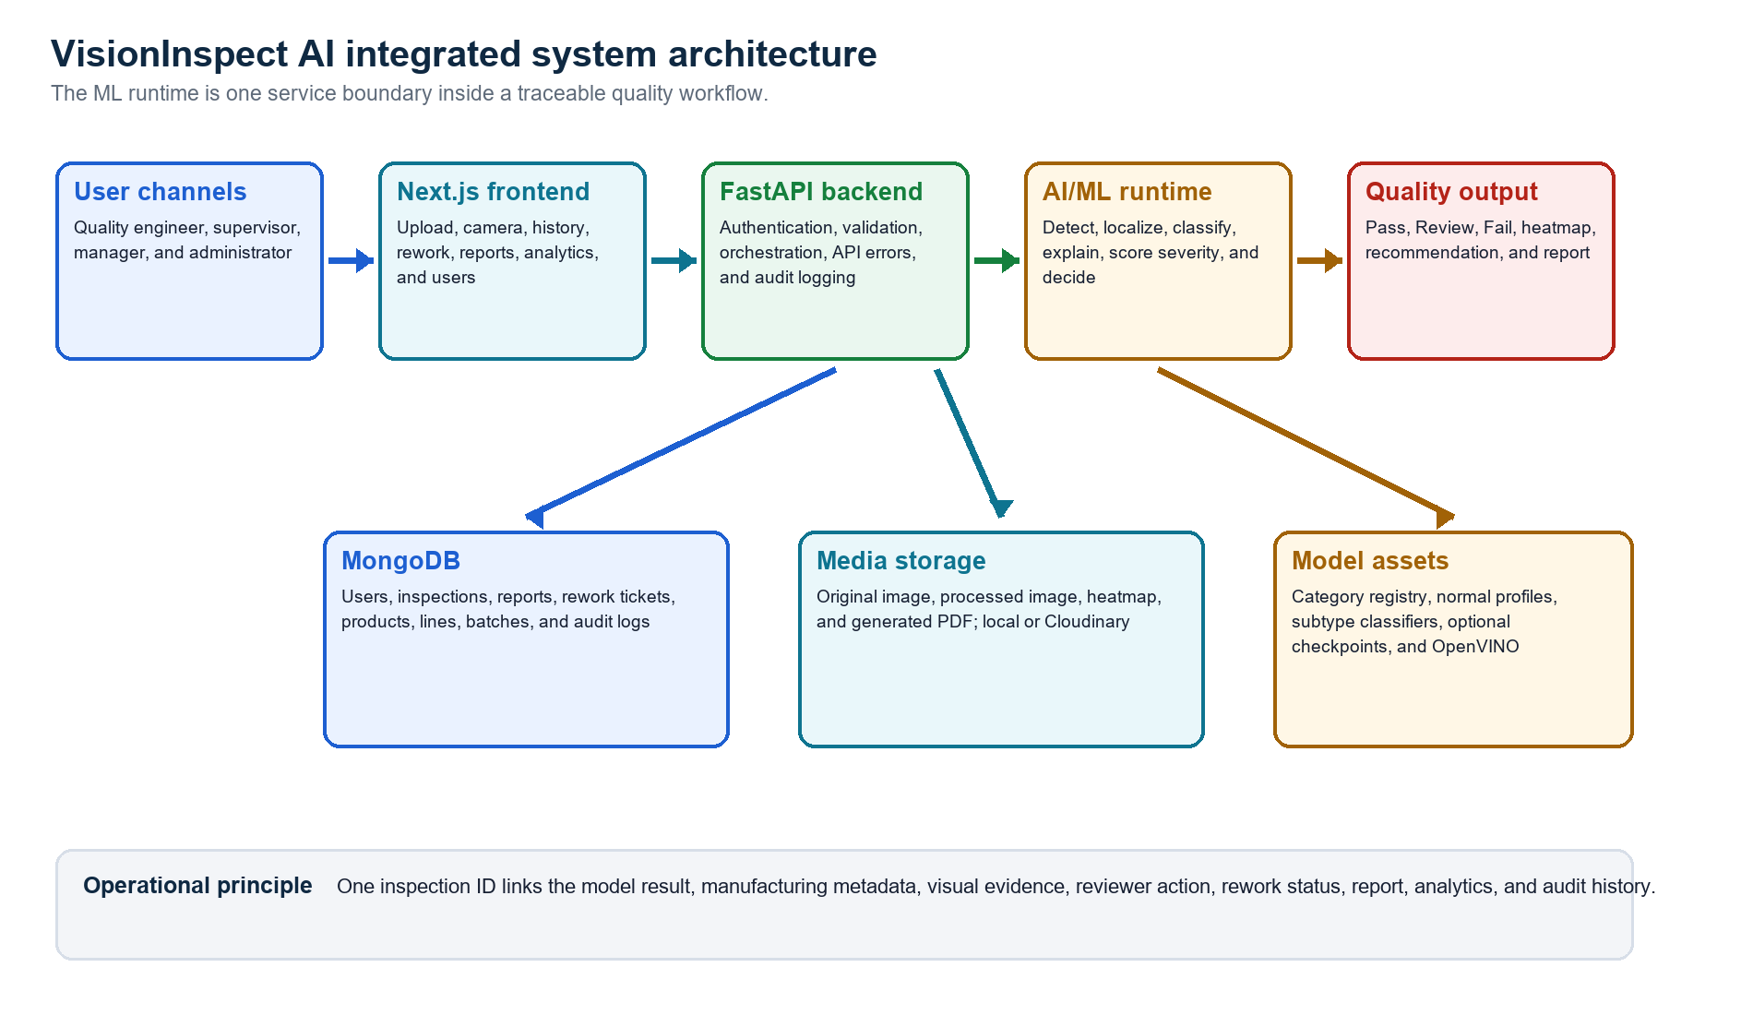
Figure 1. Integrated VisionInspect AI system architecture
Source: Generated from the implemented frontend, FastAPI routes and services, ML runtime, MongoDB documents, and storage service.

3.1 Layer responsibilities
Layer | Primary responsibility
Frontend | Collect input, call APIs, show progress/errors, visualize result, support human actions
Backend | Authenticate, validate, orchestrate ML/storage, persist records, expose reports and analytics
AI/ML | Preprocess, detect anomaly, classify subtype, localize, explain, score severity, decide
MongoDB | Retain users, production context, inspections, review/rework, reports, analytics source, audit events
Media storage | Publish original/processed images, heatmaps, and generated report files
Deployment | Build frontend, run backend, inject secrets/configuration, expose health checks

3.2 Design decision
Single source of model logic: The frontend does not reproduce anomaly thresholds or severity calculations. It displays fields returned by the backend. The backend calls the shared `ml.inference.inspect_image` function, which keeps model behavior consistent across notebooks, CLI use, tests, and the website.

4. ML-to-Backend Runtime Contract
The backend supplies an image path, normalized product category, optional critical zones, and active threshold settings. The ML runtime returns arrays for visual storage and JSON-safe values for the inspection document. The backend removes large arrays from the API payload after saving the processed image and heatmap.
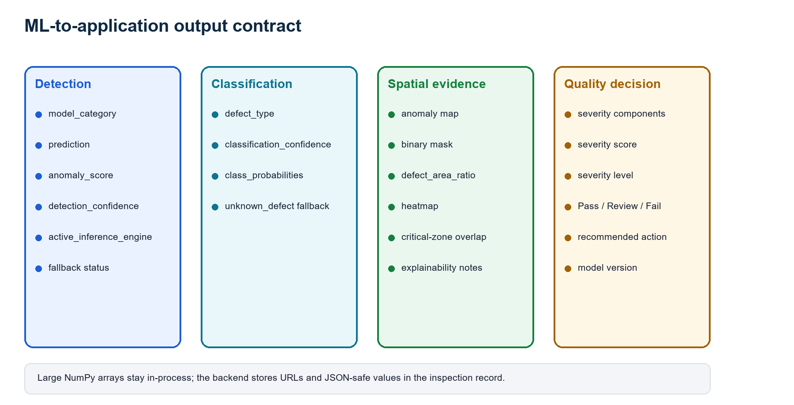
Figure 2. ML-to-application output contract
Source: Generated from `ml/inference.py`, `ml/predict.py`, `backend/app/services/prediction_service.py`, and the inspection model.
Contract group | Fields
Input | image path; category; critical zones; detector/classifier paths; runtime thresholds
Binary detection | prediction; anomaly score; detection confidence; active engine; fallback state
Subtype | defect type; subtype confidence; class probabilities; classifier error when present
Localization | anomaly map; predicted mask; defect area; centroid; regions; critical overlap; heatmap
Quality | severity components; score; level; Pass/Review/Fail; recommendation
Operations | model version; processed image; explainability notes; runtime timing

4.1 Confidence handling
Detection confidence describes confidence in Good versus Defective and is the confidence term used in severity. Classification confidence describes confidence in the subtype label. If subtype evidence is unavailable or conflicts with a detected anomaly, the runtime returns `unknown_defect` instead of inventing a category.

5. Image Acquisition and Inspection Orchestration
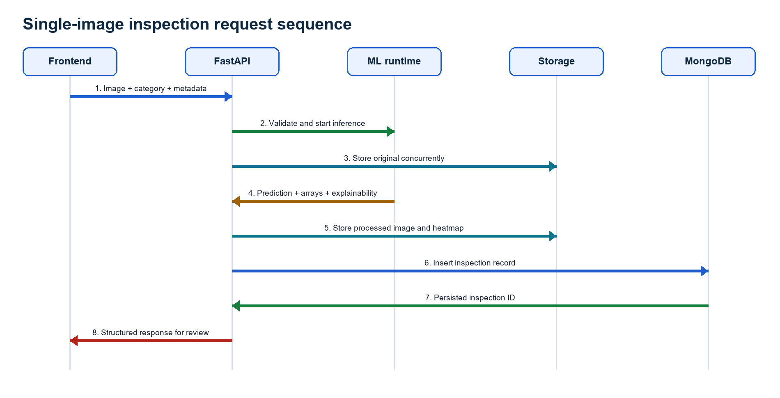
Figure 3. Single-image inspection request sequence
Source: Generated from the `/inspections/inspect` route and prediction/storage services.

5.1 Request processing
Step | Processing action
1 | The frontend sends one image, the selected category, and production metadata as multipart form data.
2 | The backend checks file extension, non-empty content, maximum size, and whether OpenCV can decode the image.
3 | Blank metadata is filled with traceable defaults without overwriting user-entered values.
4 | Original-image storage and ML inference start concurrently to reduce request time.
5 | The category registry resolves the normal profile, classifier, metadata, optional checkpoint, and optional OpenVINO export.
6 | Inference returns detection, classification, localization, severity, QA decision, explainability, and visual arrays.
7 | Processed image and heatmap are saved; local URLs or Cloudinary URLs are returned.
8 | One inspection document is inserted, an audit event is recorded, and the serialized response is sent to the frontend.

5.2 Input validation and errors
Condition | Status | Behavior
Unsupported extension | 400 | PNG, JPG/JPEG, BMP, TIFF, and WebP are accepted
Empty or undecodable file | 400 | Request stops before model execution
File above configured limit | 413 | Default maximum is 10 MB
Missing category artifacts | 500 | Actionable runtime-artifact message is returned
Online storage timeout | 503 | Production message asks the user to retry
Frontend request timeout | 408 | User sees a clear long-running request message

6. Persistence, Media Storage, and Traceability
MongoDB is the operational source of truth. Media files remain outside the database and are referenced by URL and local path. This prevents large binary arrays from expanding inspection documents while preserving the evidence needed by the frontend and PDF reports.
MongoDB document | Stored purpose
users | Identity, role, approval status, active state, login and approval timestamps
inspections | Images, prediction, classification, severity, metadata, review and rework links
reports | Inspection link, report URL/path, type, and generation time
rework_tickets | Ticket number, assignment, priority, due date, status, and resolution
products | Product ID, category, critical zones, and active state
production_lines | Line ID, name, location, and active state
batch_records | Batch, product, line, shift, and status
audit_logs | Actor, role, action, entity, metadata, and timestamp

6.1 Media storage
- Development default: files are kept under backend uploads and served through `/uploads`.
- Online option: Cloudinary stores original, processed, and heatmap assets when explicitly enabled.
- Report downloads are authenticated and regenerated from the inspection if the local PDF is missing.
- Partial failures trigger best-effort rollback of local and Cloudinary assets.
- Inspection and batch records do not expire automatically; historical QA data is retained.

6.2 Traceability chain
Stage | Trace fields
Acquisition | uploader, source type, source label, original URL
Production | category, product, batch, line, shift, operator
AI | model, engine, scores, class probabilities, heatmap, explanation
Quality | decision, recommendation, reviewer, notes, review time
Corrective action | rework ticket, assignee, due date, priority, resolution
History | created/updated times plus audit events

7. Frontend Inspection and Review Experience
The Next.js interface presents the application as a working quality console rather than a notebook viewer. `AppShell` verifies the stored token, retrieves the current user, redirects unauthenticated users to login, and blocks pages outside the user's role.
Page | Operational purpose
Login | Sign in or submit a role-based registration request
Dashboard | Quality KPIs and recent inspection activity
Upload | Manual image, metadata, batch input, result, heatmap, and report action
Camera | Select category/defect stream and inspect sequential simulated frames
Inspection History | Filter records, view evidence, update metadata, and review result
Rework Queue | Track ticket priority, assignee, due date, status, age, and resolution
Analytics | Filter and visualize quality trends, severity, defect type, and line performance
Reports | List and download authenticated inspection reports
Model Metrics | View artifact status, category metrics, and adjust runtime thresholds
Users | Approve/reject registrations and manage role-appropriate accounts

7.1 Inspection result presentation
- Original image and generated heatmap are shown together.
- Prediction, defect type, two confidence values, anomaly score, severity, and decision are separated clearly.
- Explainability states the threshold, defect area, heatmap intensity, critical-zone result, and reason for Pass/Review/Fail.
- Slow requests, server timeouts, validation failures, request IDs, and network failures are presented with actionable messages.
- Review controls appear only to authorized roles and require notes for rework.

7.2 Workflow states
The upload page moves through Image selected, Context added, Completed, and Ready states. These labels describe progress rather than acting as inactive navigation buttons. Loading indicators and disabled actions prevent accidental duplicate inspection or report requests.

8. Batch Inspection and Camera Simulation

8.1 Batch inspection
A batch request accepts one to twenty images. Every image is processed through the same single-inspection function, which guarantees the same validation, category runtime, metadata completion, persistence, storage, and audit behavior. Individual failures are returned beside successful records rather than cancelling the whole batch.
Batch summary field | Meaning
Requested | Number of files submitted
Succeeded / failed | Files that produced records versus per-file errors
Good / Defective | Binary anomaly outcomes
Pass / Review / Fail | Operational QA decisions
Critical | Inspections at the highest severity level
Average confidence | Mean detection confidence across successful inspections

8.2 Camera simulation
Camera simulation reads real category test images when the dataset is available and falls back to bundled bottle frames when it is not. The user chooses a category and optional defect stream, then the frontend requests sequential frames. Each frame becomes an ordinary persisted inspection with source type `camera_simulation`.
Scope statement: Camera simulation proves the acquisition and inspection loop in a repeatable way. It is not a physical industrial camera driver and does not claim PLC timing, trigger, or line-control integration.

9. Rework, Reports, Analytics, and Audit History

9.1 Human review and rework
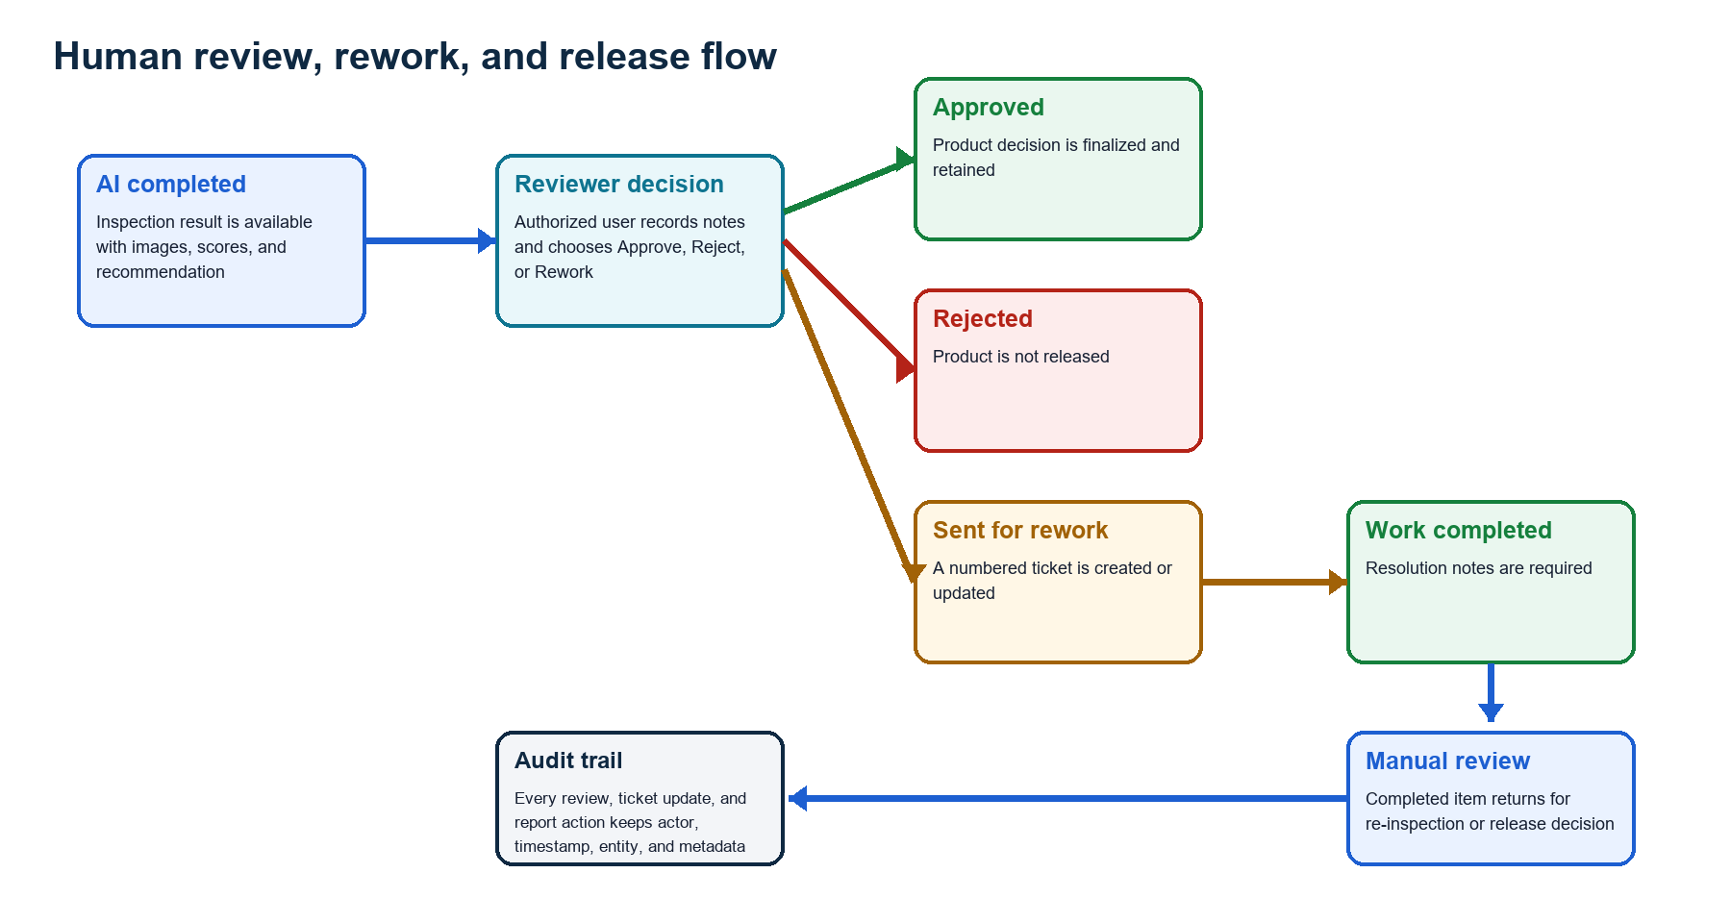
Figure 4. Human review, rework, and release flow
Source: Generated from inspection and rework routes, document models, and role controls.
Sending an item to rework does more than change a label. The backend creates or updates a numbered ticket, copies product and defect context, calculates priority from severity, records assignment and due date, and links the ticket back to the inspection. Completing or closing a ticket requires resolution notes and returns the inspection to manual review.

9.2 PDF reports
ReportLab generates a two-page A4 report. Page 1 contains decision, prediction, defect type, confidence, model version, severity, production metadata, original image, and heatmap. Page 2 contains severity components, action, quality summary, explainability, reviewer information, and review notes.

9.3 Analytics
Analytics group | Returned information
KPI | Total, Good, Defective, Pass, Review, Fail, defect rate, confidence, severity, critical count
Distributions | Defect type, severity, review status, line, shift, and source type
Trends | Daily totals, rates, defect types, and severity levels
Line performance | Pass/review/fail rate, defect rate, average severity
Filters | Date range, product, production line, and defect type
Export | Authenticated CSV of inspection records

9.4 Audit history
Login, registration, approval, inspection completion, camera actions, metadata changes, reviewer actions, rework ticket changes, report generation, user management, and production-catalog changes are recorded as audit events.

10. Authentication, Roles, and Security Controls

10.1 Account lifecycle
Step | Account action
1 | A new user provides name, email, password, and requested role.
2 | The account is stored as pending and inactive.
3 | An authorized manager reviews and approves or rejects the request.
4 | Approved users receive a JWT after password verification.
5 | Protected APIs decode the token, load the active user, and check required roles.

10.2 Role matrix
Role | Main application access
Quality engineer | Dashboard, upload, camera, own/history inspections, reports, permitted review actions
Factory supervisor | Engineer access plus rework queue, analytics, and managed engineer accounts
Quality manager | Supervisor access plus model metrics/settings and broader user management
Administrator | All application pages and account roles

10.3 Security behavior
- Passwords are bcrypt hashes; plain passwords are not stored.
- JWTs use expiry and a configurable secret key.
- CORS origins are configuration-driven.
- Responses include request identifiers and security headers such as `X-Content-Type-Options: nosniff`.
- Users cannot view other users' inspections unless their role permits wider access.
- Production secrets belong in hosting environment variables and are excluded from source control.

11. Portable Runtime and Deployment Configuration
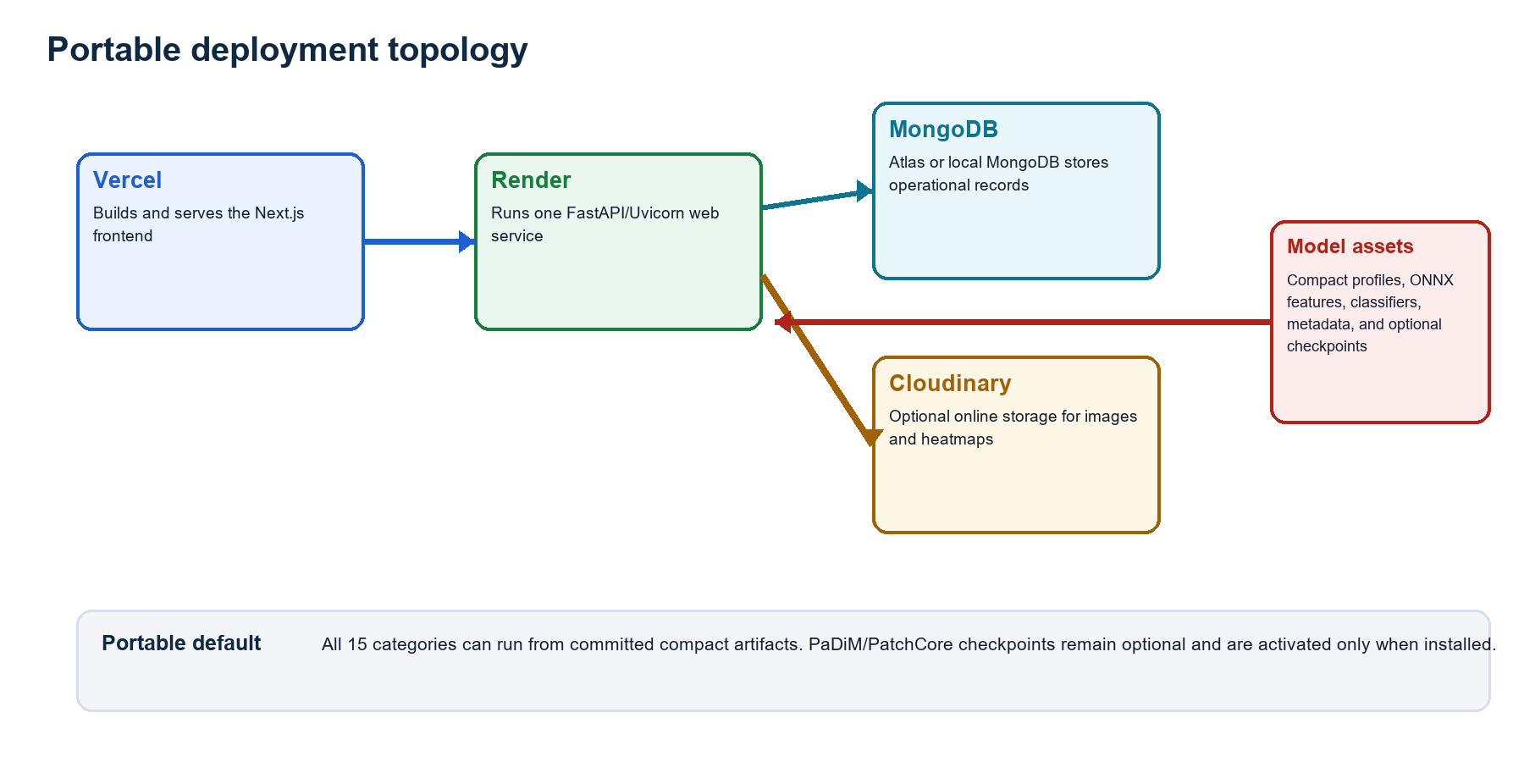
Figure 5. Portable deployment topology
Source: Generated from `.env.example`, `deployment/render.yaml`, `frontend/vercel.json`, backend settings, and the model registry.

11.1 Runtime selection
Mode | Availability | Coverage | Purpose
Portable hybrid | Included | All 15 categories | Normal memory + OpenCV spatial evidence + subtype classifier
OpenVINO | Conditional | Categories with exported XML/BIN | CPU-optimized advanced inference
PaDiM/PatchCore | Conditional | Category checkpoint available | Learned anomaly scoring and localization
Fallback | Automatic | Advanced artifact unavailable/fails | Portable detector keeps inspection available and reports fallback

11.2 Local operation
The local path uses Python 3.13.5, Node.js 20 or later, MongoDB, a root `.env`, backend requirements, and frontend packages. The frontend defaults to `http://localhost:8000`; Cloudinary and the complete MVTec dataset are optional for website use.

11.3 Cloud deployment
Layer | Service | Configuration responsibility
Frontend | Vercel | Next.js build; `NEXT_PUBLIC_API_BASE_URL` points to backend
Backend | Render | Python 3.13.5; Uvicorn; `/health` service check; one worker
Database | MongoDB Atlas | Connection URI and database name supplied as secrets
Media | Cloudinary | Enabled explicitly with three credentials and storage flag
Models | Repository/runtime volume | Compact artifacts included; advanced checkpoints installed separately when required
Operational note: A free backend instance can cold-start after inactivity. Model warm-up, compact artifacts, and concurrent storage reduce avoidable delay, while hosting capacity still determines peak response time.

12. Practical End-to-End Demonstration

12.1 All-category integration run
Notebook 08 executes the same portable orchestration used by the application on one normal and one defective image from each of the 15 MVTec categories. It processed 30 images with 0 runtime errors. The median measured inference time was 168.4 ms and the 95th percentile was 540.6 ms on the development machine.
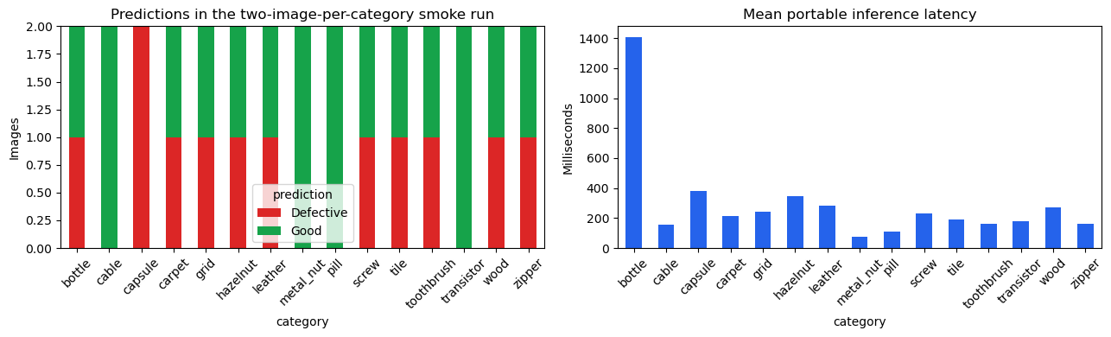
Figure 6. All-category portable inference smoke run
Source: Executed output from `08_multicategory_end_to_end_inference.ipynb`.
Interpretation: The 25 matching binary outcomes out of 30 images are a small integration sample, not a formal accuracy estimate. Category metrics and limitations remain in the model evaluation notebook and earlier milestone reports.

12.2 Detailed inspection
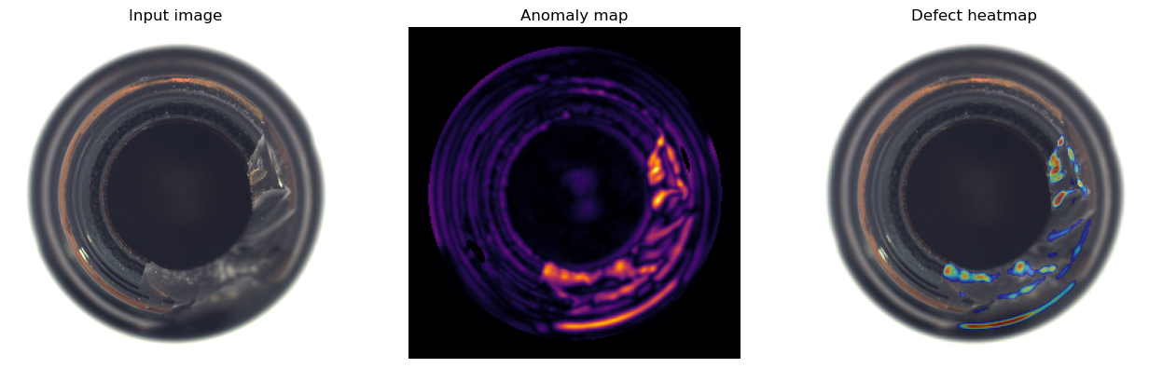
Figure 7. Executed anomaly map and heatmap
Source: Real MVTec bottle image processed by the portable runtime in Notebook 08.
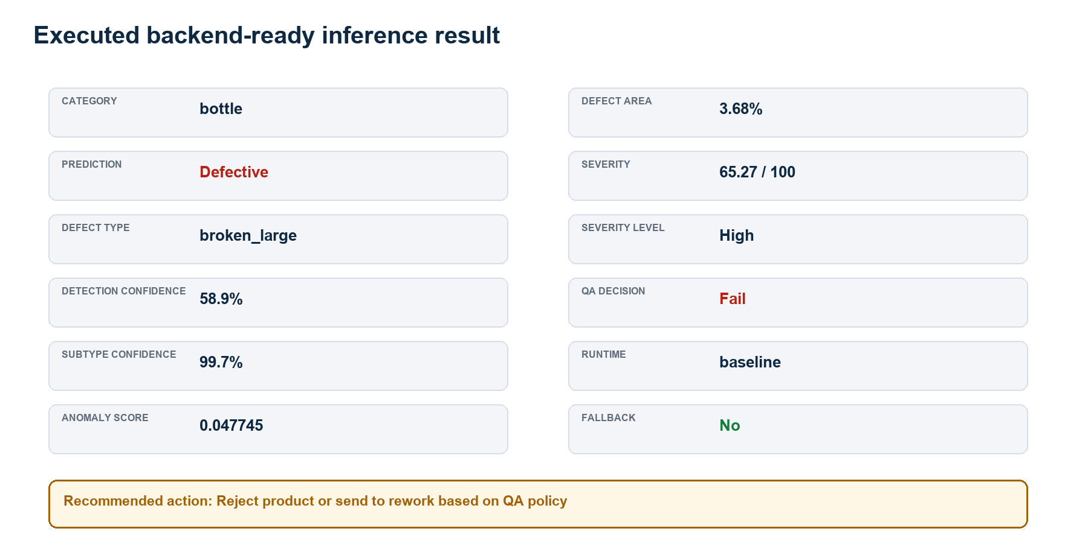
Figure 8. Executed backend-ready result
Source: Values extracted from the executed notebook output contract.
The representative broken-large bottle result was detected as Defective, classified as broken_large, assigned High severity, and sent to Fail. The result includes separate detection and subtype confidence values, a defect-area estimate, engine name, fallback state, and a recommended quality action.

13. Software Testing and Build Results

13.1 Python test suite
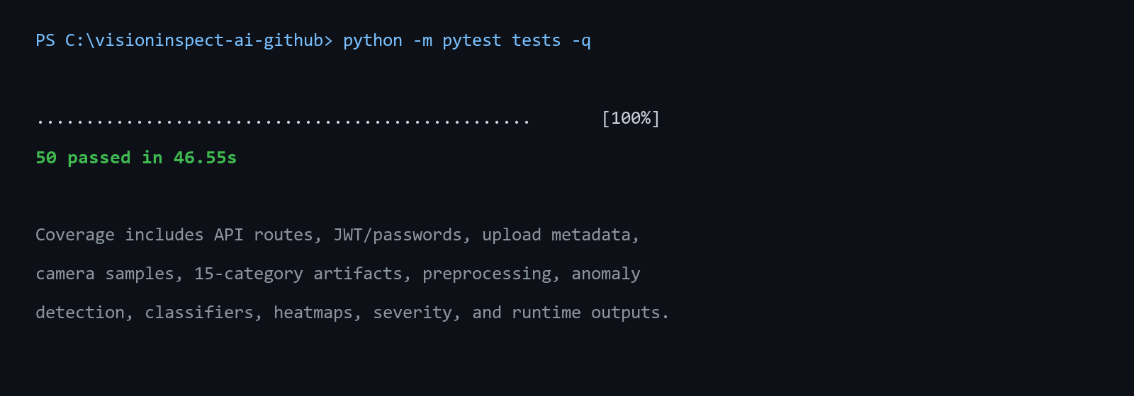
Figure 9. Full Python test result
Source: Executed in the full VisionInspect AI repository on 15 August 2026.
Test group | Behavior checked
API and security | Health/live/ready, error structure, OpenAPI routes, JWT, password hashing
Data and preprocessing | Dataset discovery, image shapes/types, grayscale and mask-guided crops
Detection | Thresholds, percentile score, residual cleanup, dual-gate decision
Classification | Artifact loading, ONNX priority, PyTorch-free CNN, compact forest parity
Localization and severity | Heatmap shapes, untinted good images, mask metrics, formula and mappings
Portability | 15 category artifacts, SHA-256 descriptors, Render dependencies, no TTL expiry
Application integration | Automatic metadata, storage concurrency, camera samples, backend-ready result

13.2 Frontend production build
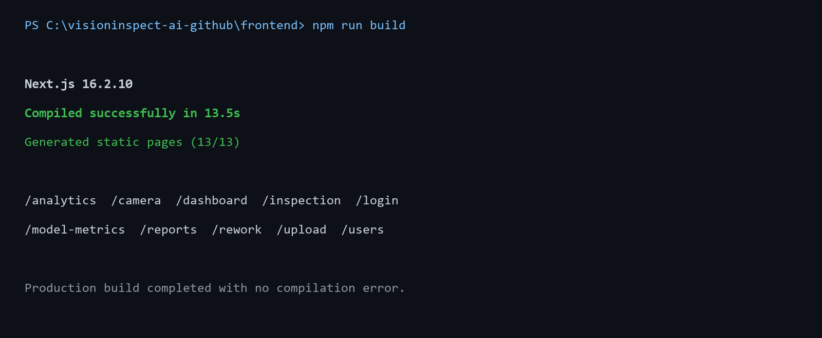
Figure 10. Frontend production build result
Source: Executed with Next.js 16.2.10 on 15 August 2026.
The build compiled successfully in 13.5 seconds and generated all application routes. This confirms that the delivered frontend source can be compiled for hosting with the current dependency lock file.

14. Operational Limits and Mitigations
Risk or limit | Impact | Mitigation
Factory domain shift | MVTec images do not represent every factory camera and product | Collect target-line data, recalibrate thresholds, and monitor drift
Category quality varies | One model configuration is not equally strong for every category | Use category-specific metrics and promote improved checkpoints selectively
Unknown subtype | Classifier only knows labels present in training data | Return unknown_defect and require manual review
Free hosting latency | Cold start and limited CPU can delay requests | Warm runtime, compact artifacts, request timing, retry message, paid compute when needed
Local media durability | Ephemeral hosting may lose local uploads | Enable Cloudinary or persistent object storage for online operation
Camera scope | Simulation does not prove physical trigger timing | Add vendor SDK/RTSP/PLC integration as a separate factory phase
Safety policy | Severity weights are project rules, not certification | Factory QA owner approves weights, zones, and release thresholds
Advanced artifact size | PaDiM/PatchCore checkpoints are large | Install on compute server or model store; keep compact runtime for portability

14.1 Monitoring points
- Track model engine, fallback status, inference/storage/total time, and request ID per inspection.
- Monitor category-level defect rate, confidence, severity, manual-review frequency, and line trends.
- Inspect false-positive and false-negative examples before changing thresholds.
- Retain reviewer and rework outcomes so model results can be compared with human decisions.

15. Milestone Completion and Project Handover

15.1 Completed deliverables
Deliverable | Completed content
Integrated inference service | Category-aware runtime, storage, timing, explainability, and stable response schema
Operational APIs | Auth, users, inspections, batch/camera, reports, rework, analytics, model, production, audit, health
Persistence layer | Eight MongoDB document types with retained quality history
Frontend workflows | Protected pages for inspection, review, corrective action, reporting, analytics, and administration
Portable model package | 15 category profiles/classifiers plus shared ONNX and optional advanced engines
Configuration | Safe environment template, Python pin, Render definition, Vercel definition
Quality checks | 50 passing Python tests and successful production frontend build
Documentation | Four sequential milestone reports and executable notebooks

15.2 Handover instructions
Step | Handover action
1 | Clone the repository and create a private `.env` from `.env.example`.
2 | Install backend requirements and frontend packages using the documented versions.
3 | Start MongoDB, then start FastAPI and Next.js on the configured ports.
4 | Sign in with a development account or request registration approval.
5 | Select a category, upload a matching image, and confirm result, heatmap, history, and report behavior.
6 | Run the Python tests and frontend production build before changing the model or application code.
7 | Install advanced checkpoints only on a suitable compute environment and keep portable fallback enabled.

15.3 Completion statement
Milestone outcome: VisionInspect AI now demonstrates the complete path from image acquisition and AI inference to an auditable manufacturing quality decision. The delivered system is suitable for academic demonstration, team handover, portable local use, and further factory-specific calibration and integration.

References
Reference | Use in this report
Project source | VisionInspect AI full-stack repository and Member 4 AI/ML branch, inspected 15 August 2026
Dataset | MVTec Anomaly Detection dataset: 15 product categories with normal training images, test defects, and masks
Frameworks | FastAPI, Next.js, React, MongoDB/Beanie, OpenCV, NumPy, scikit-learn, ONNX/OpenVINO, Anomalib
Milestone 1 | Data Foundation and Portable Baseline - 25 July 2026
Milestone 2 | Advanced Anomaly Detection and Localization - 1 August 2026
Milestone 3 | Defect Classification, Severity Scoring, and QA Decisions - 8 August 2026

Appendix A. API Inventory
API group | Main routes
Auth | POST /auth/register; POST /auth/login; POST /auth/token; GET /auth/me
Users | GET/POST /users; approve; reject; update; reset password
Inspection | POST inspect; POST batch-inspect; GET camera samples/categories; POST camera simulate; list/get/update/review
Production | GET catalog; POST products; POST lines; POST batches
Rework | List/get/create/update tickets; lookup by inspection
Reports | Create report; authenticated download; list/get reports
Analytics | Filtered summary and authenticated CSV export
Models | Metrics, runtime settings read, runtime settings update
Audit | Filtered audit-log list
Health | Service summary, liveness, and readiness checks

Appendix B. Persistence and Configuration Map
Configuration area | Environment variables
Application | APP_NAME, ENVIRONMENT, SECRET_KEY, ACCESS_TOKEN_EXPIRE_MINUTES
URLs/CORS | FRONTEND_URL, BACKEND_URL, CORS_ORIGINS, NEXT_PUBLIC_API_BASE_URL
Database | MONGODB_URI, MONGODB_DATABASE
Media | USE_CLOUDINARY_STORAGE, Cloudinary credentials, timeout, UPLOAD_DIR
Inference | USE_PADIM_INFERENCE, USE_OPENVINO_INFERENCE, device/accelerator, artifact paths
Performance | OPENCV_NUM_THREADS, WARM_MODEL_ON_STARTUP
Limits | MAX_UPLOAD_SIZE_MB
Development account | BOOTSTRAP_ADMIN_ENABLED plus private account values
Secret handling: `.env.example` contains placeholders and safe local defaults. Real MongoDB, Cloudinary, JWT, and production account credentials must be supplied privately and must not be committed or printed in documentation.

Appendix C. Deliverable and Evidence Index
Evidence | Source | Purpose
Architecture and sequence diagrams | Implemented routes, services, models, and runtime code | System boundaries and data movement
All-category smoke chart | Notebook 08 | One normal and one defective image exercised for every category
Heatmap and anomaly map | Notebook 08 | Real image localization output
Backend-ready result | Notebook 08 JSON output | Complete scalar contract consumed by the application
Full pytest result | Project test suite | 50 passing backend, ML, portability, and integration tests
Frontend build result | Next.js production build | Application pages compile for hosting
Milestone 4 report | This document | Integration, operations, limits, and handover
End of Milestone 4 documentation.

