Intelligent Cognitive Alarm Platform
Flutter Mobile App — Milestone (1)
Prepared by: Prerana Mishra · Role: Flutter Mobile Development (UI/UX & Backend Integration)

1. Project Description

The Intelligent Cognitive Alarm Platform is a mobile application designed to help users wake up more effectively by combining alarm scheduling with cognitive challenges. Instead of simply dismissing an alarm, users must complete tasks such as math problems, memory games, or riddles to ensure they are fully awake. I was responsible for developing the Flutter mobile application, including UI/UX implementation, state management, local notifications, and Firebase authentication integration. The application uses Flutter with Riverpod for state management, Flutter Local Notifications for alarm scheduling, Firebase Authentication for secure user login, and is being enhanced with Hive for local data persistence and go_router for improved navigation. The app has also been rebranded as "Nuera — Wake Your Mind," with a custom animated splash screen, a dark-themed UI, and a home dashboard offering Quick Actions (Add Alarm, Analytics).

2. Environment Setup
The mobile app was developed and tested locally using the following setup:
- IDE: Android Studio with the Flutter/Dart plugins
- Test device: Realme physical device (Android 12, API 31)
- Package manager: Flutter/Dart pub, npm (for Firebase CLI tooling)
- Version control: Git-based team repository
- Key packages: flutter_riverpod 2.6.1, flutter_local_notifications 19.5.0, flutter_timezone 4.1.1, firebase_core, firebase_auth, google_sign_in 7.2.0
During setup, an Android SDK download failure (TLS "bad_ecord_mac" / tag-mismatch errors while fetching SDK Platform 34/35/36) blocked builds temporarily. This was a network-level interception issue rather than a code issue, and was resolved by retrying the SDK download — after which Gradle builds completed successfully and the app installed and launched on the test device.
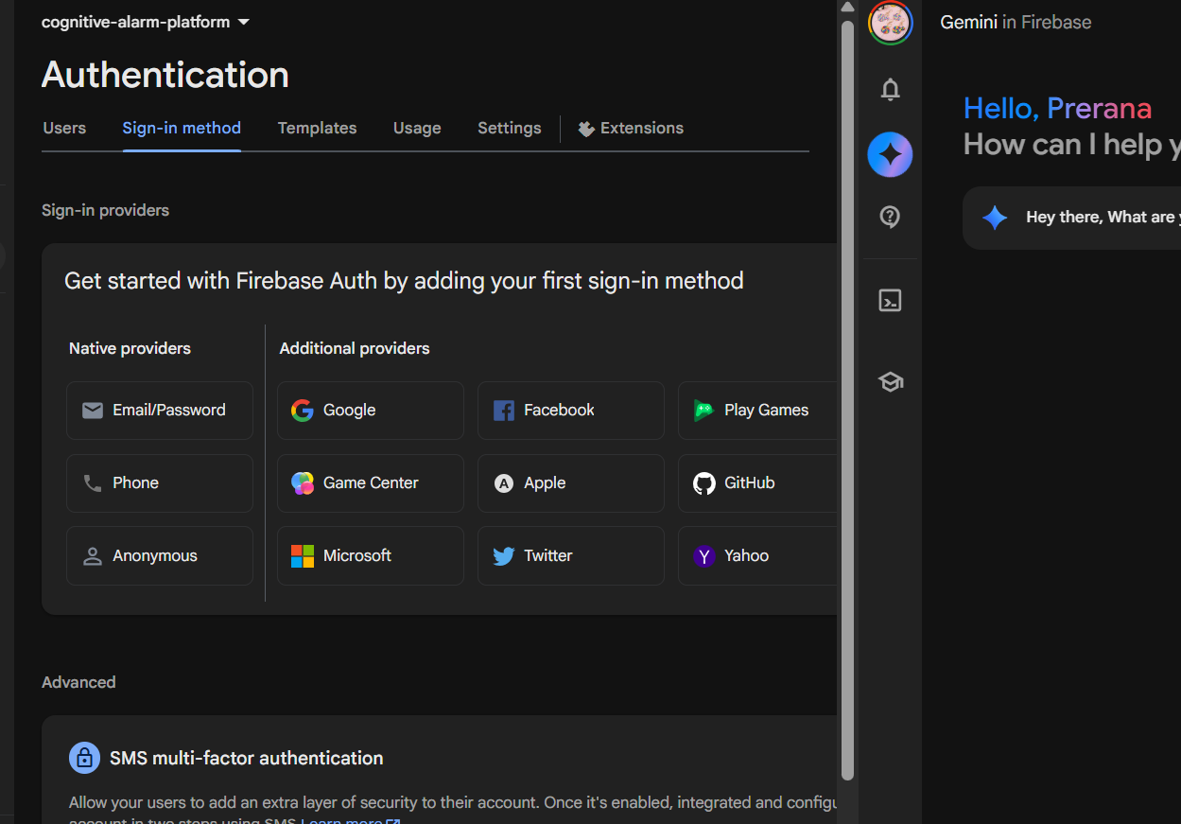
Figure 1: Android SDK Platform Manager — required SDK platforms (34/35/36) after resolving the download issue.

3. Work Completed So Far

3.1 Code Review & Bug Fixes
A review of the initial app scaffold identified several compile-time and logic bugs. All were fixed:
- ✅ home_screen.dart — added missing Flutter and AlarmListScreen imports (would not compile).
- ✅ app_theme.dart — corrected BorderRadiusGeometry.circular() (invalid) to BorderRadius.circular().
- ✅ register_screen.dart — restored missing @override on the build() method.
- ✅ login_screen.dart / register_screen.dart — added TextEditingControllers to all input fields (previously unreadable input) and removed leftover, unrelated state copied from another screen.
- ✅ app.dart — fixed the navigation entry point, which was skipping the Splash and Login screens entirely and loading Home directly.

3.2 Shared Alarm State (Riverpod)
The Add Alarm and Alarm List screens originally used local, disconnected state — alarms created on one screen never appeared on the other, and the enable/disable switch was non-functional. This was rebuilt using flutter_riverpod:
- ✅ Added id and isEnabled fields plus a copyWith() method to AlarmModel.
- ✅ Created AlarmListNotifier / alarmListProvider (StateNotifierProvider) as the single source of truth for alarms.
- ✅ AddAlarmScreen now saves new alarms into shared state and schedules a real local notification per alarm.
- ✅ AlarmListScreen now renders the live alarm list and the enable/disable switch is fully functional.
Result: the full in-app flow now works end to end — Splash → Login → Home → Add Alarm → Alarm List, with alarms persisting across screens (in-memory) and triggering local notifications.

3.3 Google Sign-In Integration (in progress)
Working towards allowing users to sign in with their Google account in addition to email/password. Progress so far:
- ✅ Created a Firebase project (cognitive-alarm-platform) and connected it to the Flutter app via the FlutterFire CLI.
- ✅ Registered the Android app (package: com.example.smart_alarm_system) on the Firebase project.
- ✅ Generated and registered the debug SHA-1 / SHA-256 signing certificate fingerprints, required for Google Sign-In on Android.
- ✅ Enabled Google as a sign-in provider in Firebase Authentication.
- ✅ Added firebase_core, firebase_auth, and google_sign_in dependencies; google-services.json and firebase_options.dart are generated and populated with valid OAuth client IDs.
- ✅ Implemented Firebase.initializeApp() in main.dart, an AuthService (Google sign-in / sign-out logic, matched to the google_sign_in v7 API), and a Riverpod authStateProvider.
- ✅ Wired a "Sign in with Google" button into both the Login and Register screens, with loading and error states.
- ⏳ Verified the app builds and runs successfully on the physical test device (Realme, Android 12) after resolving the SDK/network issue.
Remaining: on-device testing of the Google Sign-In flow itself, and replacing the placeholder Google icon with the official Google logo asset.

4. Firebase & Backend Setup Evidence
Figure 2: Firebase project created and connected to the app.
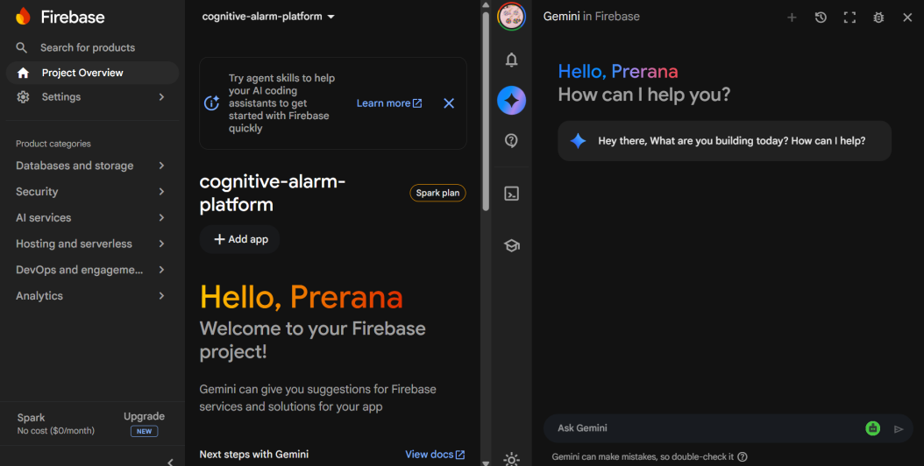
cognitive-alarm-platform project dashboard (Firebase Console).
Figure 3: Android app registered on the Firebase project.
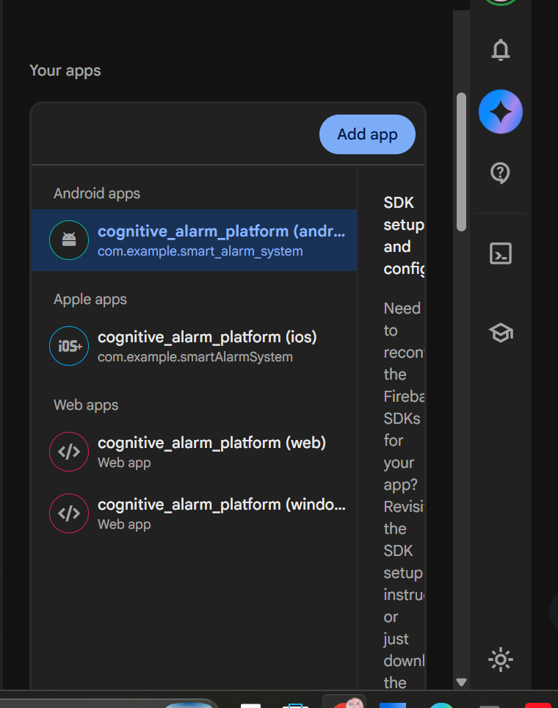
Android, iOS, and Web apps auto-registered via the FlutterFire CLI.
Figure 4: SHA certificate fingerprints registered for Google Sign-In.
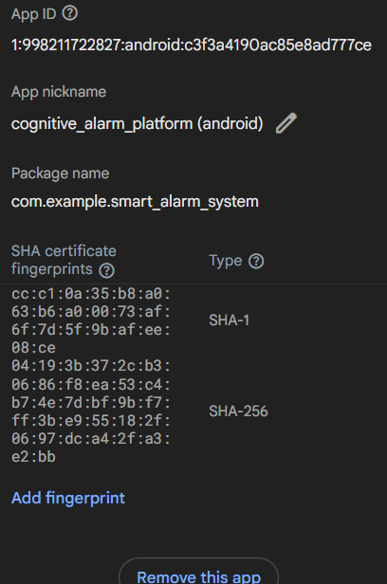
Debug SHA-1 and SHA-256 fingerprints added under app settings, required for the OAuth client to be generated.

5. App Screenshots (On-Device)
Live screenshots captured from the physical test device (Realme, Android 12), showing the working app flow end to end — from the Nuera splash screen, through login and the home dashboard, to creating an alarm with a cognitive challenge, viewing the alarm list, and the alarm notification firing.
Figure 5: Splash screen — Nuera brand intro.
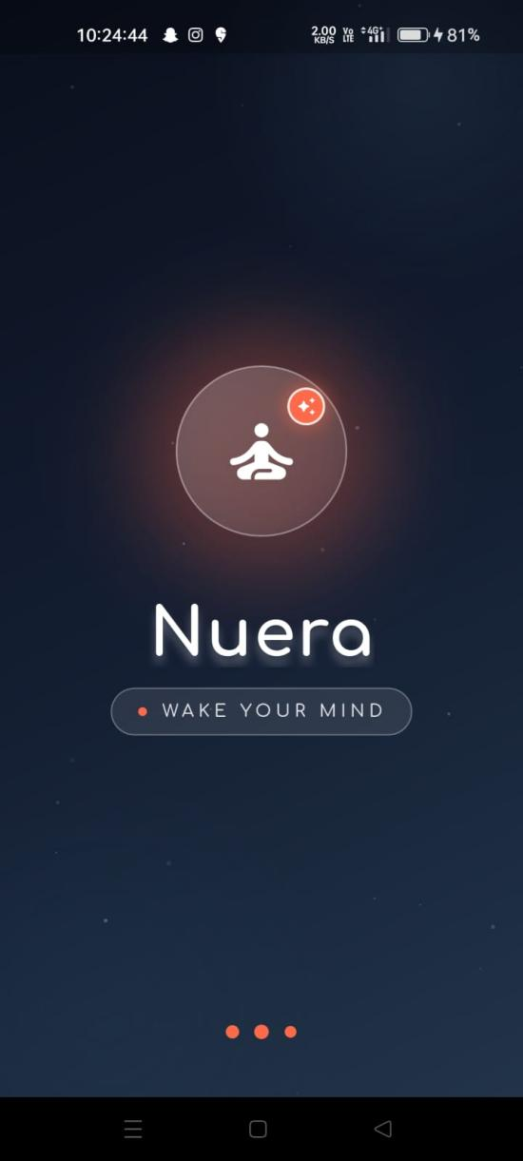
The app has been rebranded "Nuera — Wake Your Mind," with an animated logo mark and tagline shown on launch.
Figure 6: Login screen and home dashboard.
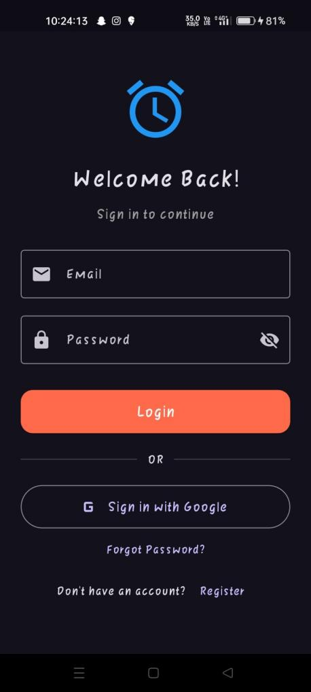  Login screen | 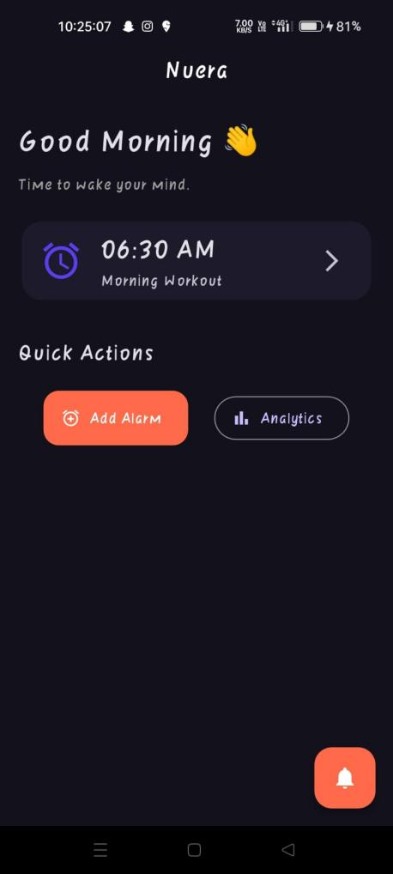  Home dashboard
Figure 7: Add Alarm screen and empty Alarm List.
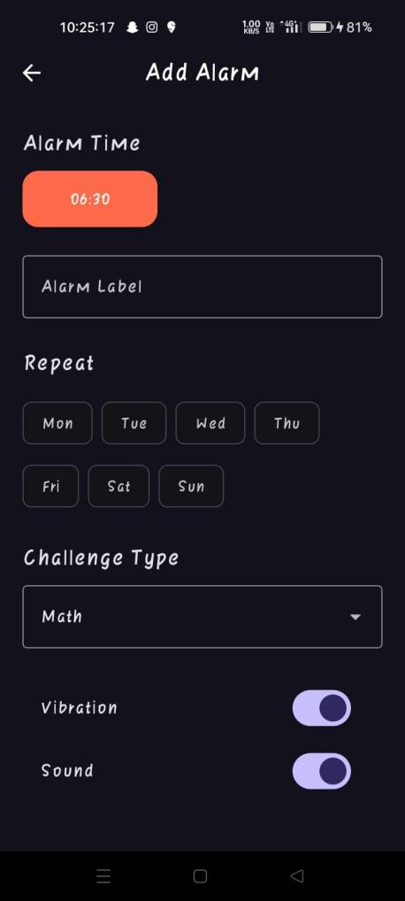  Add Alarm — filled form | 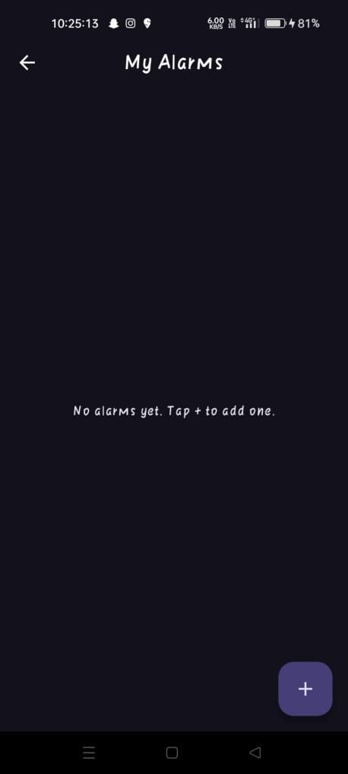  My Alarms — empty state
Figure 8: Add Alarm — Challenge Type selection and save.
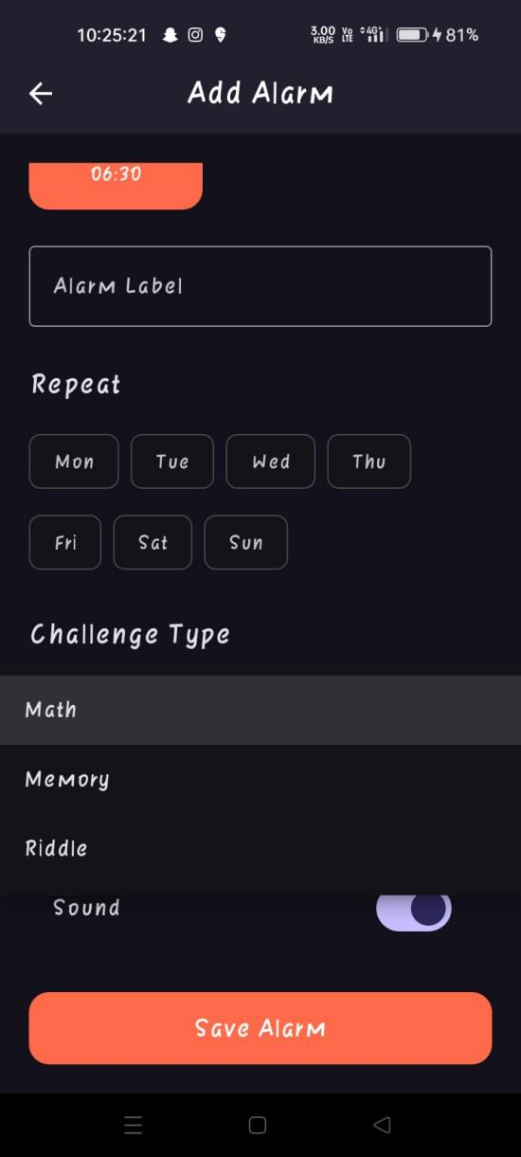
Challenge Type dropdown expanded (Math / Memory / Riddle), with Sound toggle and the Save Alarm button — the core wake-up-challenge mechanic driving the alarm dismissal flow.
Figure 9: Local notification firing on-device at the scheduled alarm time.
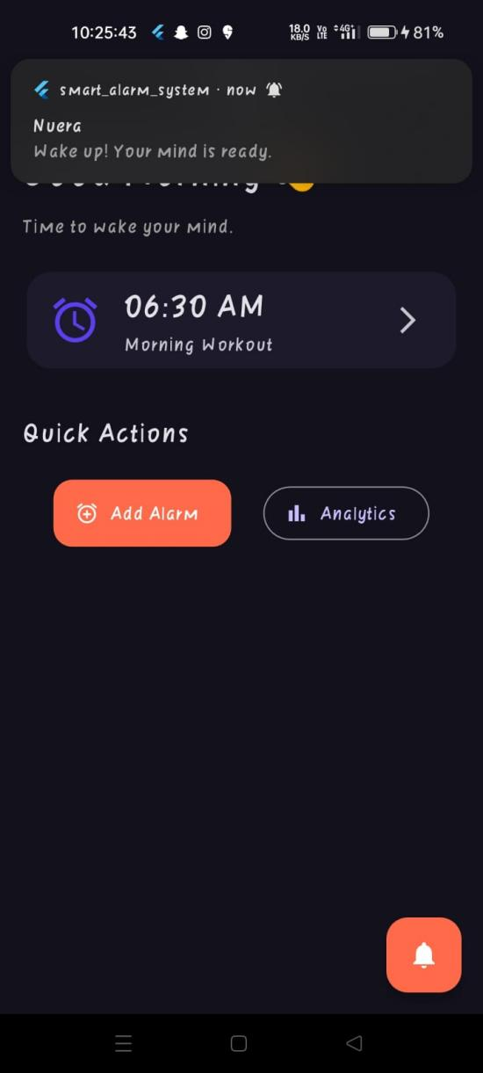
"Nuera — Wake up! Your mind is ready." notification, confirming flutter_local_notifications is correctly scheduling and firing alarms.

6. Build Verification
Successful debug build and install output from the test device, confirming the app compiles and launches after all fixes and the Firebase integration were added:
√ Built build\app\outputs\flutter-apk\app-debug.apk
Installing build\app\outputs\flutter-apk\app-debug.apk...
D/FlutterJNI: flutter (null) was loaded normally!
I/flutter: Using the Impeller rendering backend (Vulkan).
I/flutter: Using the Impeller rendering backend (OpenGLES).

7. Current Status & Next Steps

Completed
- Core navigation flow: Splash → Login → Home → Add Alarm → Alarm List
- Shared, reactive alarm state via Riverpod, with working local notifications
- Firebase project, Android app registration, and Google Sign-In provider setup
- AuthService, auth provider, and UI wiring for Google Sign-In

Pending
- On-device testing of the Google Sign-In flow end to end
- Hive persistence — alarms currently reset on app restart
- go_router migration — navigation currently uses Navigator.push/MaterialPageRoute

8. App Theming & Design System
The Nuera rebrand introduces a dedicated color system (NueraColors) and light/dark ThemeData defined in app_theme.dart, applied consistently across buttons, cards, and input fields. The dark theme — seen throughout the Section 5 screenshots — is the default under ThemeMode.system on the test device.
Swatch | Token | Usage
 | NueraColors.indigo  #5B3FF0 | Primary seed color for the light/dark ColorScheme; used for focused input borders and the splash logo ring.
 | NueraColors.indigoDeep  #241B5C | Light-theme app bar foreground and title text color, for contrast against the light surface.
 | NueraColors.dawnCoral  #FF6B4A | Primary accent — Add Alarm CTA, floating action buttons, dark-theme elevated buttons, splash glow and pulsing dots.
 | NueraColors.dawnAmber  #FFB020 | Secondary warm accent reserved for future warning/highlight states.
 | NueraColors.mindGreen  #34D399 | Reserved success/positive-state color for future analytics and streak indicators.
 | NueraColors.surfaceLight  #F7F6FB | Light-theme scaffold background.
 | NueraColors.surfaceDark  #13111C | Dark-theme scaffold background — the near-black base seen in the on-device screenshots.

9. Code Architecture Overview
The codebase is organized by feature (auth, alarm, home) with shared theming, services, and providers under core/. The table below summarizes the key files reviewed or authored as part of this milestone.
File | Responsibility
main.dart | App bootstrap — initializes Firebase, the local-notification service, and requests notification permission before launching NueraApp inside a Riverpod ProviderScope.
app.dart | Root MaterialApp widget — wires AppTheme.lightTheme / darkTheme, sets ThemeMode.system, and sets SplashScreen as the initial route.
core/themes/app_theme.dart | Defines the NueraColors palette and the light/dark ThemeData (buttons, cards, input decoration) used across the app.
core/services/notification_service.dart | Wraps flutter_local_notifications — initializes timezones/channels, and exposes showNotification() and scheduleNotification() (zonedSchedule).
core/services/auth_service.dart | Wraps FirebaseAuth + GoogleSignIn — exposes signInWithGoogle(), signOut(), currentUser, and an authStateChanges stream.
core/providers/auth_provider.dart | Riverpod providers: authServiceProvider (AuthService instance) and authStateProvider (StreamProvider<User?>).
core/routes/app_routes.dart | Central route-name constants (splash, login, register, home), staged ahead of the go_router migration.
features/auth/screens/splash_screen.dart | Animated Nuera splash screen — logo scale/fade-in, shimmering title, pulsing glow, and pulsing-dots loader, before navigating to LoginScreen.
features/auth/screens/login_screen.dart | Email/password + “Sign in with Google” UI; delegates to AuthService via authServiceProvider and routes to HomeScreen on success.
features/auth/screens/register_screen.dart | Account-creation UI with matching Google Sign-In option; local password-confirmation check before submit.
features/alarm/models/alarm_model.dart | AlarmModel — id, time, label, challengeType, vibration, sound, isEnabled, with a copyWith() for immutable updates.
features/alarm/providers/alarm_provider.dart | AlarmListNotifier (StateNotifier<List<AlarmModel>>) and alarmListProvider — single source of truth for add/toggle/remove alarm actions.
features/alarm/screens/add_alarm_screen.dart | Add Alarm form — time picker, label, repeat-day chips, challenge-type dropdown, vibration/sound toggles; saves to alarmListProvider and schedules a local notification.
features/alarm/screens/alarm_list_screen.dart | Renders the live alarm list from alarmListProvider with an enable/disable Switch per alarm and a FAB into AddAlarmScreen.
features/home/screens/home_screen.dart | Home dashboard — greeting, next-alarm summary card, and the Quick Actions row (Add Alarm, Analytics).

10. Conclusion
The Flutter mobile app for the Intelligent Cognitive Alarm Platform now has a working core flow: users can move from Splash through Login to Home, create alarms with local notifications, and see them reflected live in the alarm list with functional enable/disable controls. Initial scaffold bugs have been resolved, and the Google Sign-In integration is largely complete on the Firebase/configuration side, with the Dart-side authentication logic implemented and ready for on-device verification. Remaining work — Hive persistence and the go_router migration — is scoped and ready to be picked up next.

